Supplementary information Figures
Supplementary Fig. 1
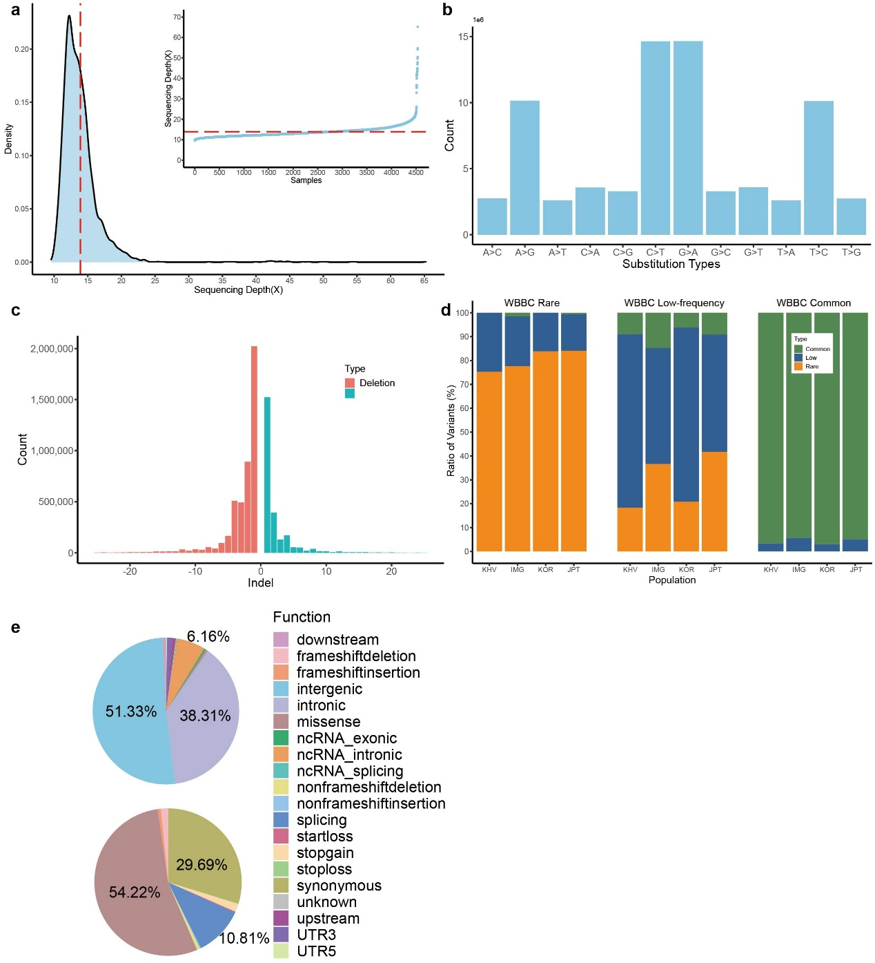
Supplementary Fig. 1. The basic statistics of samples and variants in the WBBC-cohort. a The sequencing depth of all 4,480 samples. The central red dot lines are the median. The inner chart represents the sequencing depth by sorted samples. The area plot indicates the density of sequencing depth. b Histogram of the SNVs substitute types in all chromosomes. c Distribution of the length of INDELs variants. d The difference of allele frequency between WBBC and East Asian populations in rare (MAF < 0.5%), low-frequency (0.5% ≤ MAF ≤ 5%) and common variants (MAF > 5%). e Functional annotations of all novel variants were absent in dbSNP Build 151. The proportion of each category was filled with a different color. The upper pie chart showed all the 20 classification terms. The bottom pie chart only displayed the variants in the coding and splice regions (10bp from exon-intron boundary).

Supplementary Fig. 2
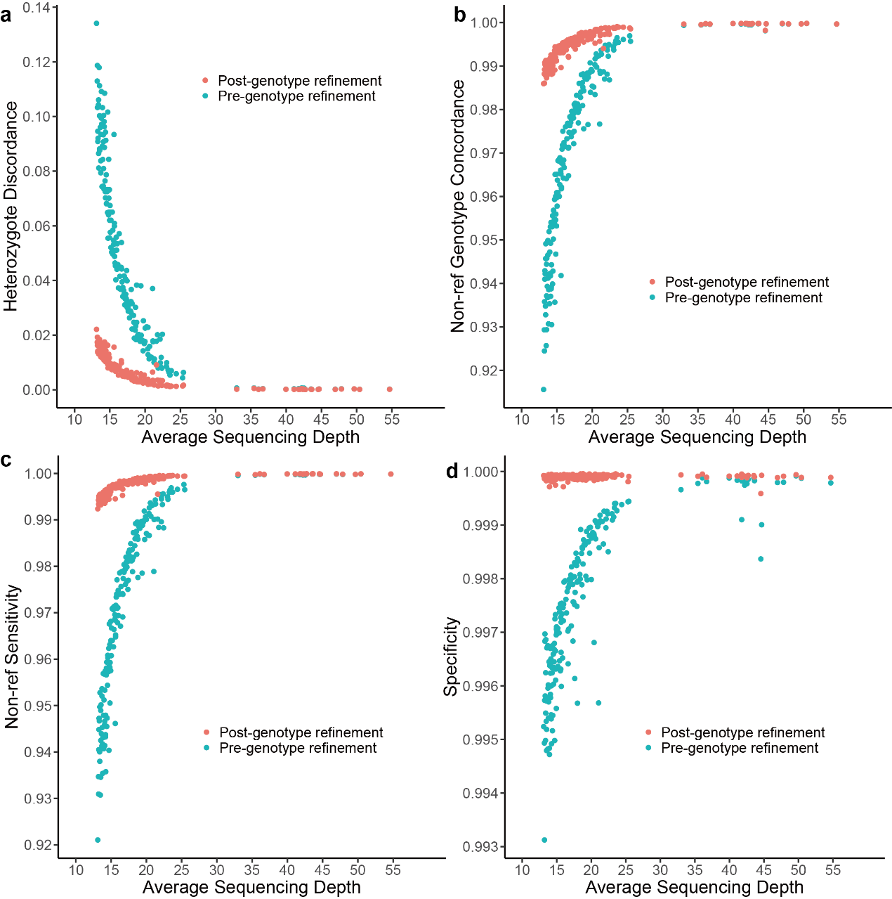
Supplementary Fig. 2. A comparison of the genotype concordance between WGS and SNP array data. a Heterozygote discordance rate. b Non-reference genotype concordance. c Non-reference sensitivity. d Specificity. The LD-based genotype refinement was conducted by BEAGLE software version 5.1. The red dots indicate the average proportion of post-genotype refinement and the green dots denote the raw genotype calls.

Supplementary Fig. 3
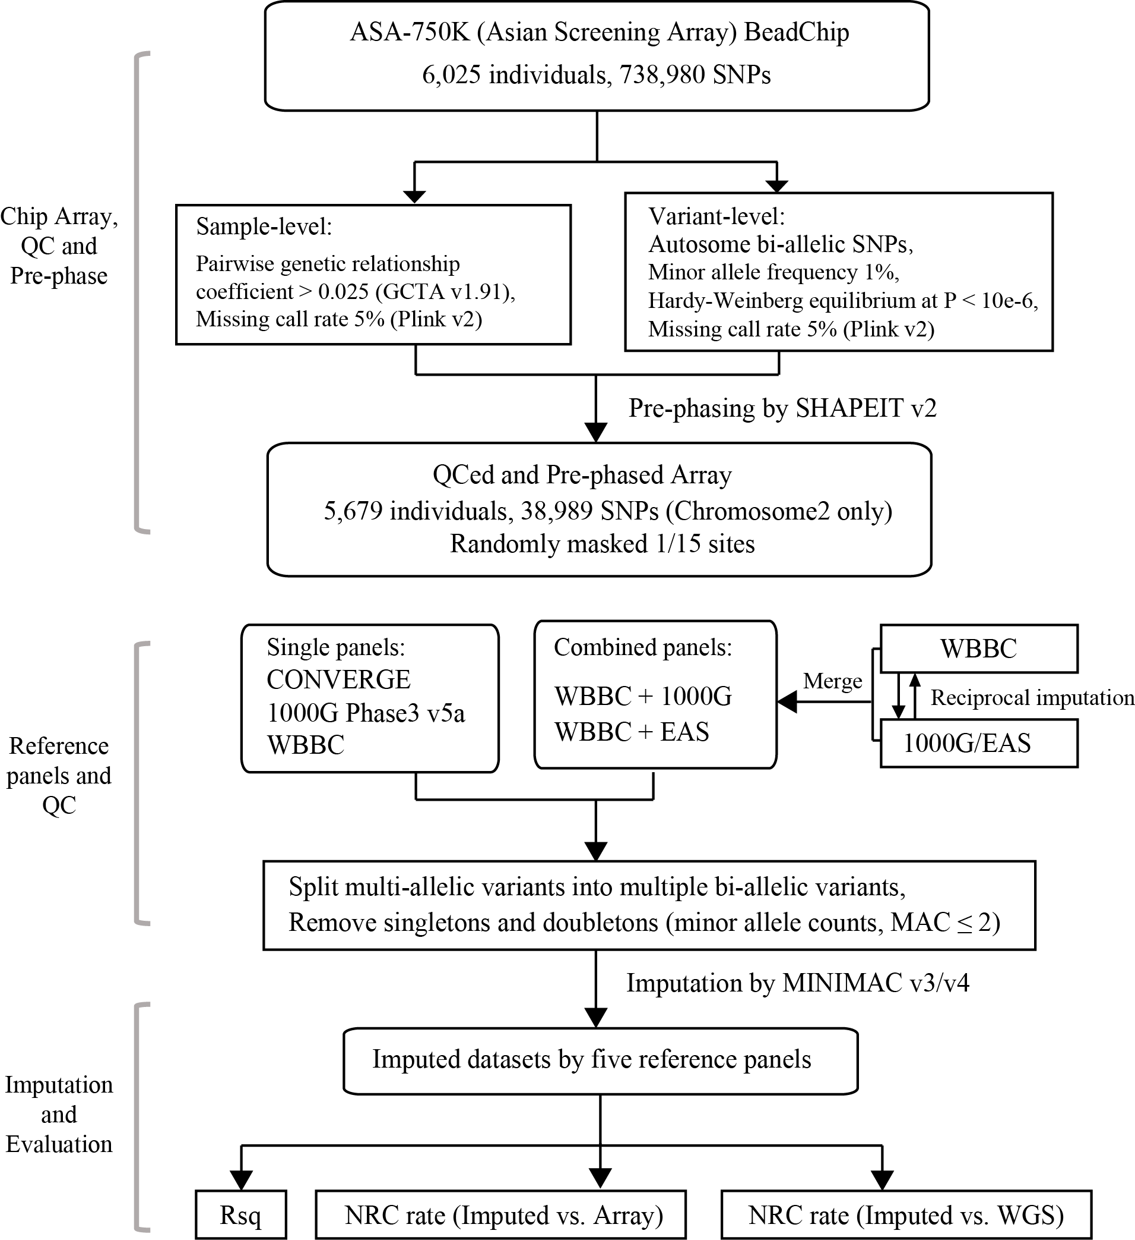
Supplementary Fig. 3. Imputation evaluation workflow. Rsq: R-square value calculated by Minimac4. NRC rate: non-reference allele genotype concordance rate. 1000G included 3,284,591 variants and 5,008 haplotypes; CONVERGE included 1,115,342 variants and 23,340 haplotypes. The WBBC included 2,089,508 variants and 8,610 haplotypes. The WBBC+1000G combined panel consisted of 13,618 haplotypes with 4,450,989 variants. The WBBC+EAS combined panel consisted of 9,618 haplotypes with 2,411,382 variants.
Supplementary Fig. 4
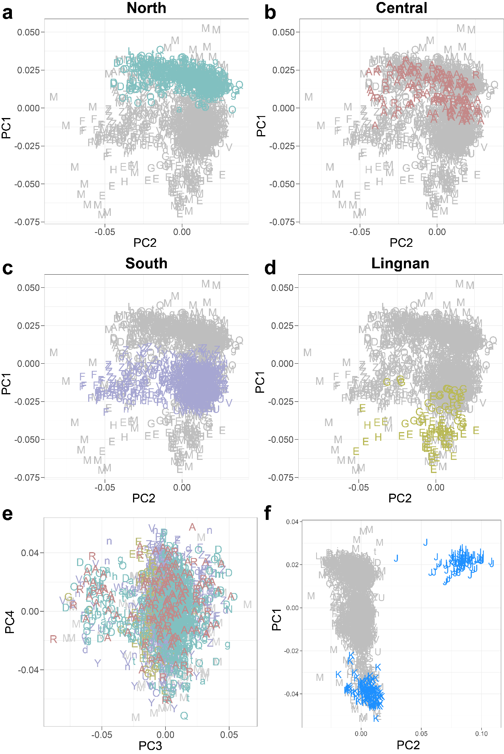
Supplementary Fig. 4. Principal Component Analysis (PCA). The administrative divisions are shown by the distinct letters. Minority people are marked with “M”. The Han Chinese populations can be classified into four subgroups: a North Han (cyan color), b Central Han (dark-red color), c South Han (purple color), d Lingnan Han (golden color). e PC3 and PC4 analysis. f PCA of Chinese, JPT, and KHV individuals from the 1000 Genomes Projects. The blue “J” represents the JPT individuals, while “K” indicates the KHV individuals.
Supplementary Fig. 5
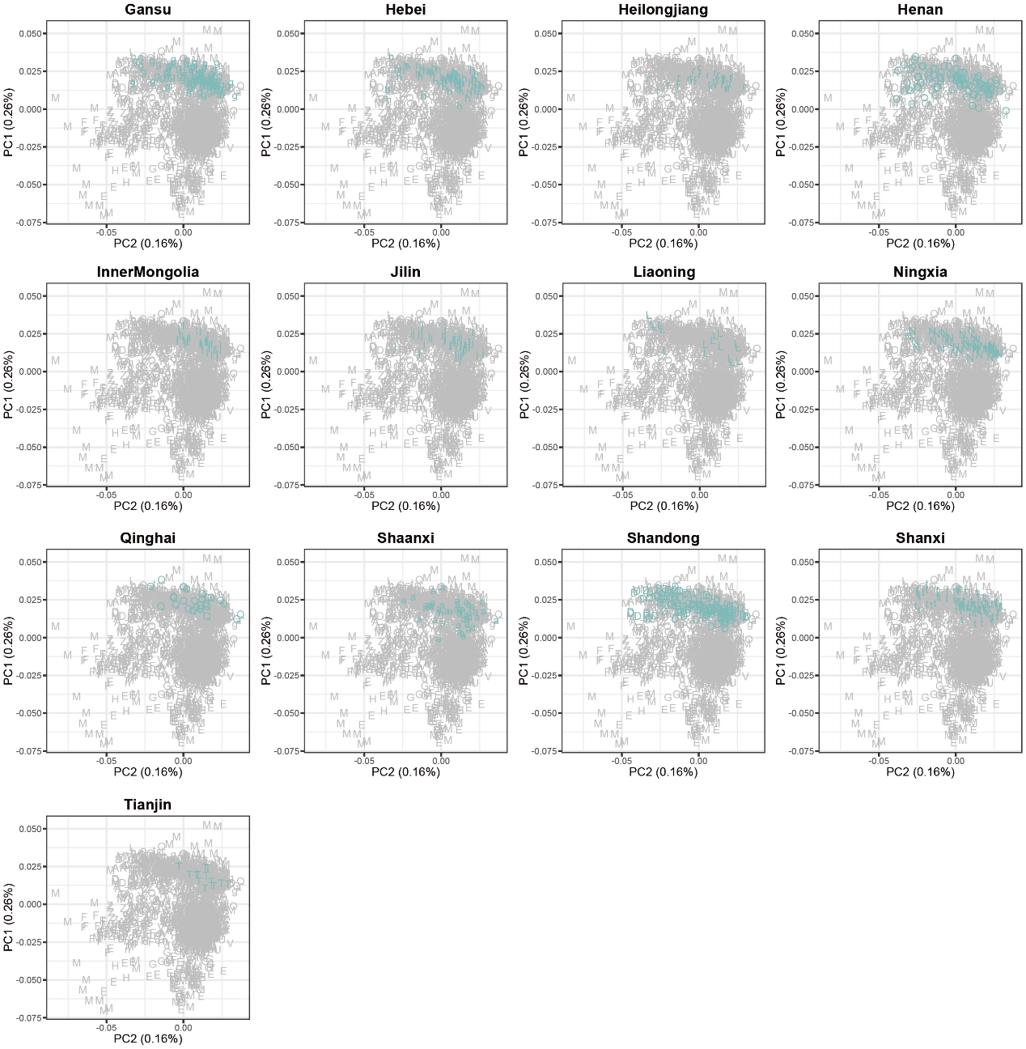
Supplementary Fig. 5. PCA of North Han Chinese samples. Each letter represents one administrative division. The individuals are highlighted in cyan color in north regions, including Gansu (g), Hebei (h), Heilongjiang (r), Henan (O), Inner Mongolia (I), Jilin (j), Liaoning (L), Ningxia (N), Qinghai (Q), Shaanxi (a), Shandong (D), Shanxi (t) and Tianjin (T).

Supplementary Fig. 6
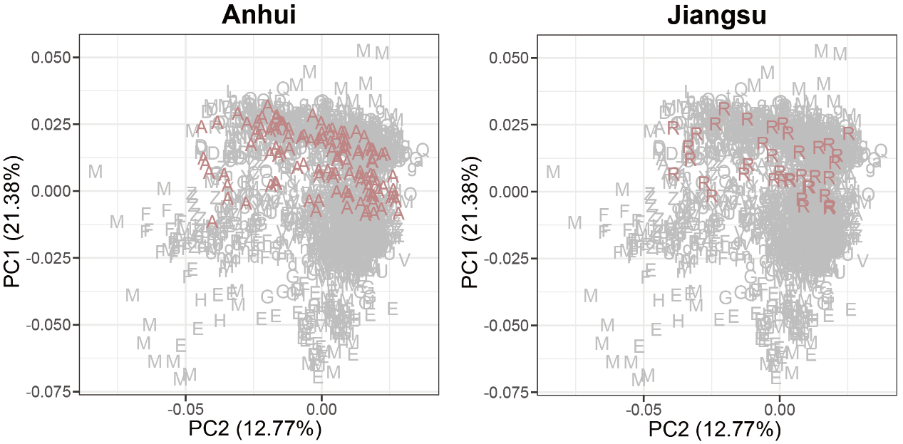
Supplementary Fig. 6. PCA of Central Han Chinese samples. Each letter represents one administrative division. The individuals are highlighted in dark-red for the central regions of Anhui (A) and Jiangsu (R).

Supplementary Fig. 7
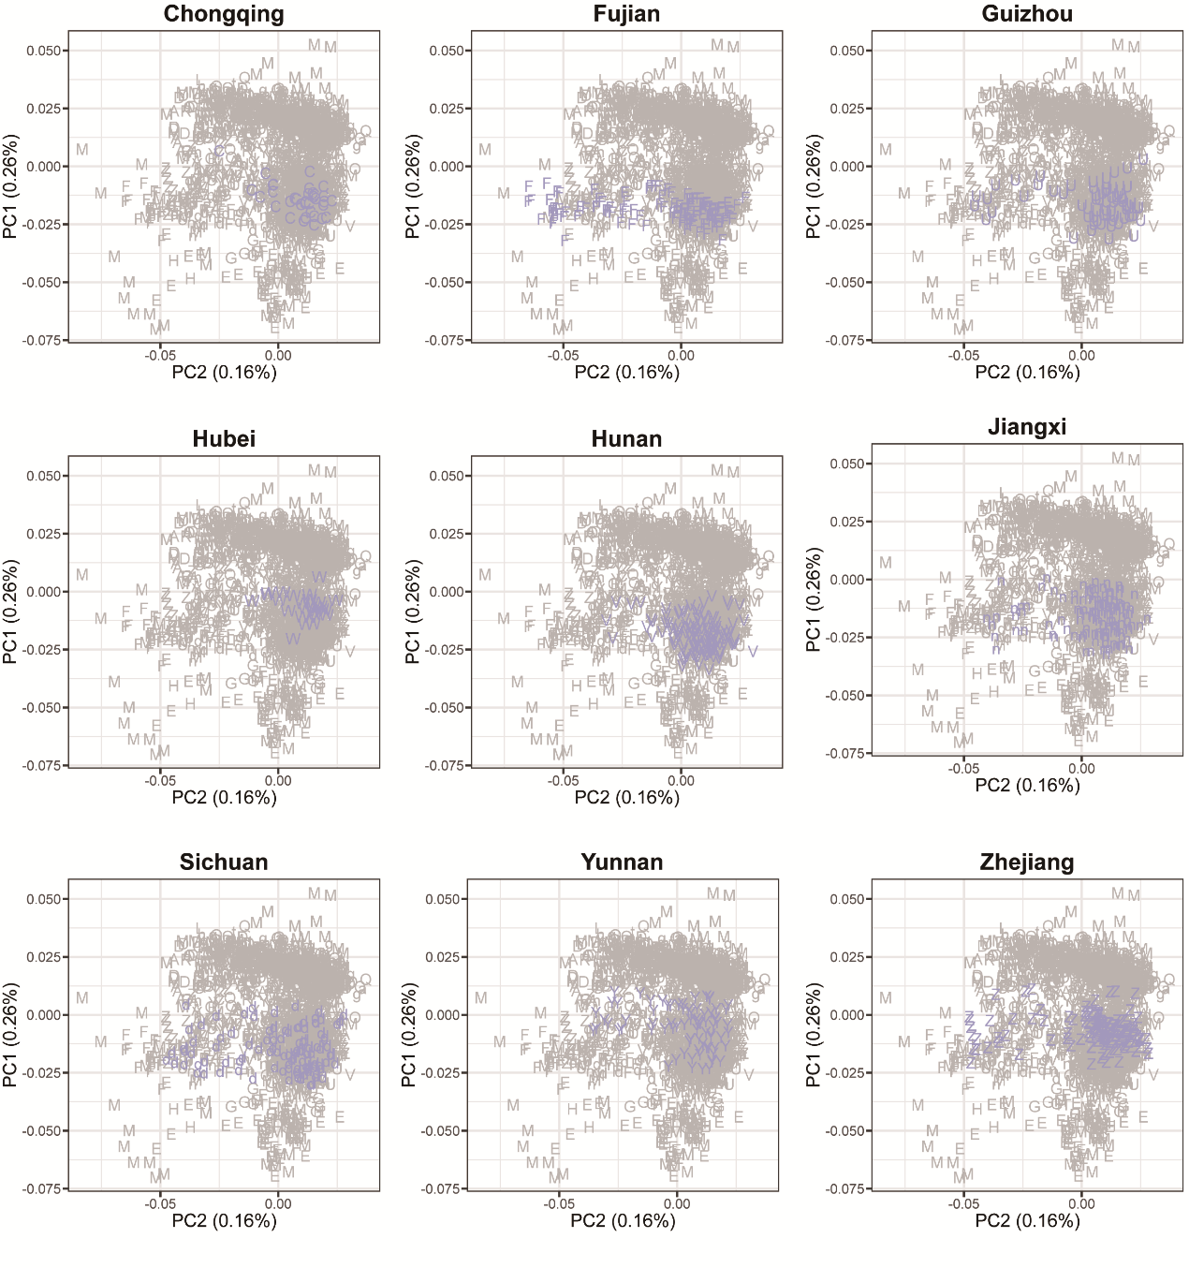
Supplementary Fig. 7. PCA of South Han Chinese samples. Each letter represents one administrative division. The individuals are highlighted in purple c for the southern regions of Chongqing (C), Fujian (F), Guizhou (U), Hubei (W), Hunan (V), Jiangxi (n), Sichuan (d), Yunnan (Y) and Zhejiang (Z).

Supplementary Fig. 8
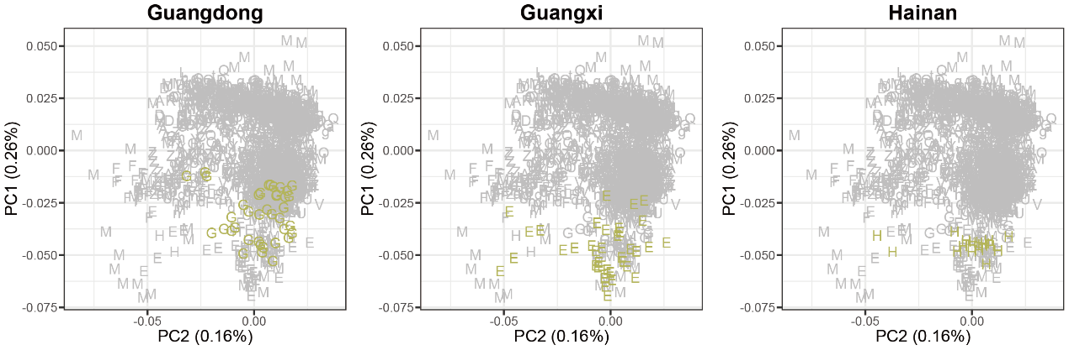
Supplementary Fig. 8. PCA of Lingnan Han Chinese samples. Each letter represents one administrative division. The individuals are highlighted in golden color for the Lingnan regions of Guangxi (E), Guangzhou (G) and Hainan (H).

Supplementary Fig. 9
Supplementary Fig. 9. ADMIXTURE analysis of the Han Chinese, CHB, CHS, CDX, KHV and JPT individuals from the 1000 Genomes Projects. The Han Chinese (2,056 individuals) was selected from our WBBC cohort. CHB (103 individuals) is a Han Chinese in Beijing. CHS (105 individuals) is Han Chinese from southern China. CDX (93 individuals) is Chinese Dai in Xishuangbanna. KHV (99 individuals) is Vietnamese from Kinh in Ho Chi Minh City. JPT (104 individuals) is Japanese in Tokyo. The provinces and regions are shown on the left.

Supplementary Fig. 10
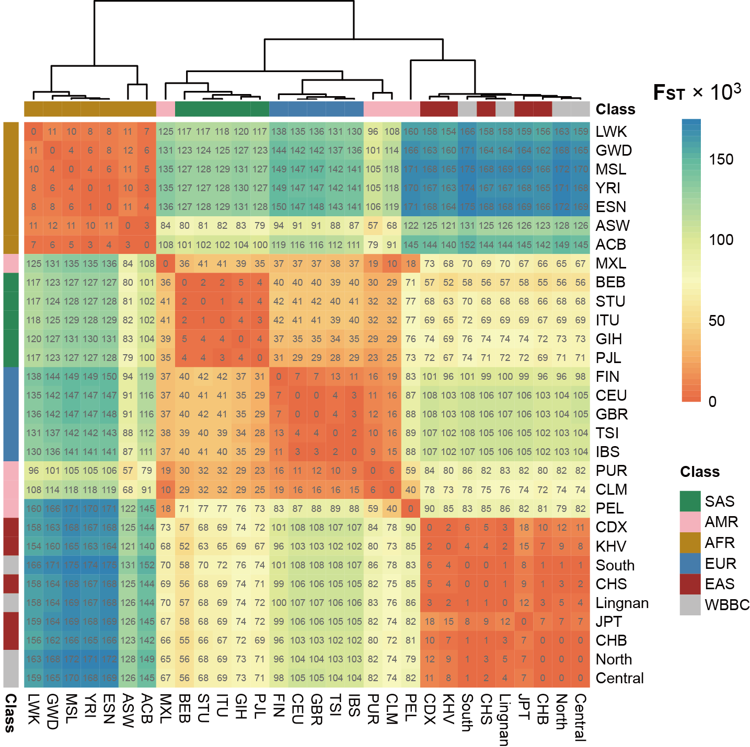
Supplementary Fig. 10. Pairwise F_{ST} between the WBBC and 1KG Project populations. Numbers in each rectangle mean the pairwise F_{ST} value times 1,000. The bars on the top and left show the population classifications. SAS, AMR, AFR, EUR, and EAS are five continent-level ancestry groups of the 1KG Project.

Supplementary Fig. 11
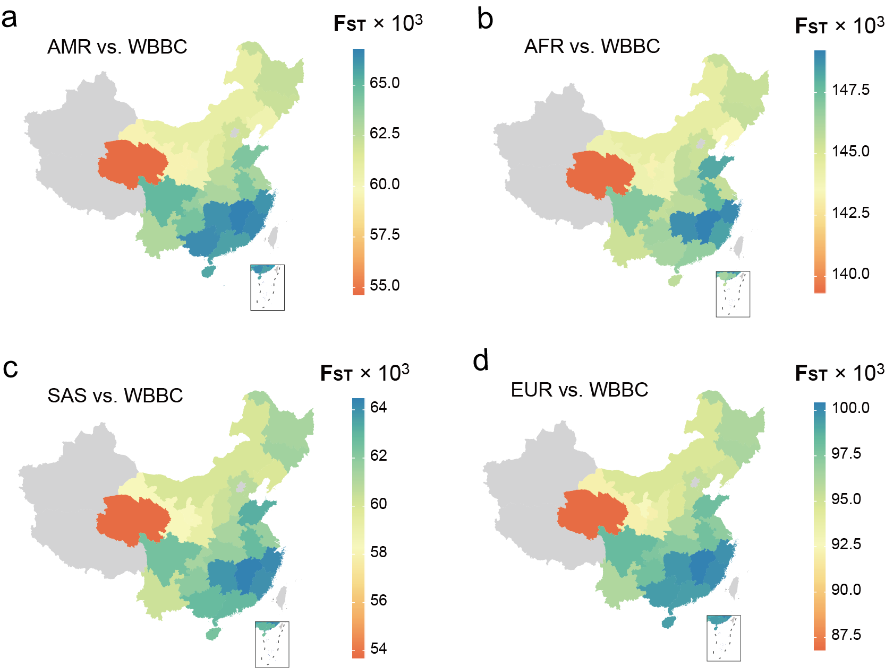
Supplementary Fig. 11. Geographic patterns of pairwise F_{ST} using the 1KG as a reference. Using the four non-Chinese continent-level ancestry groups of the 1KG Project as the reference, including a AMR. b AFR. c SAS. d EUR. We further investigated the geographic patterns of F_{ST} in the 27 administrative divisions. Regions in grey were not sampled.

Supplementary Fig. 12
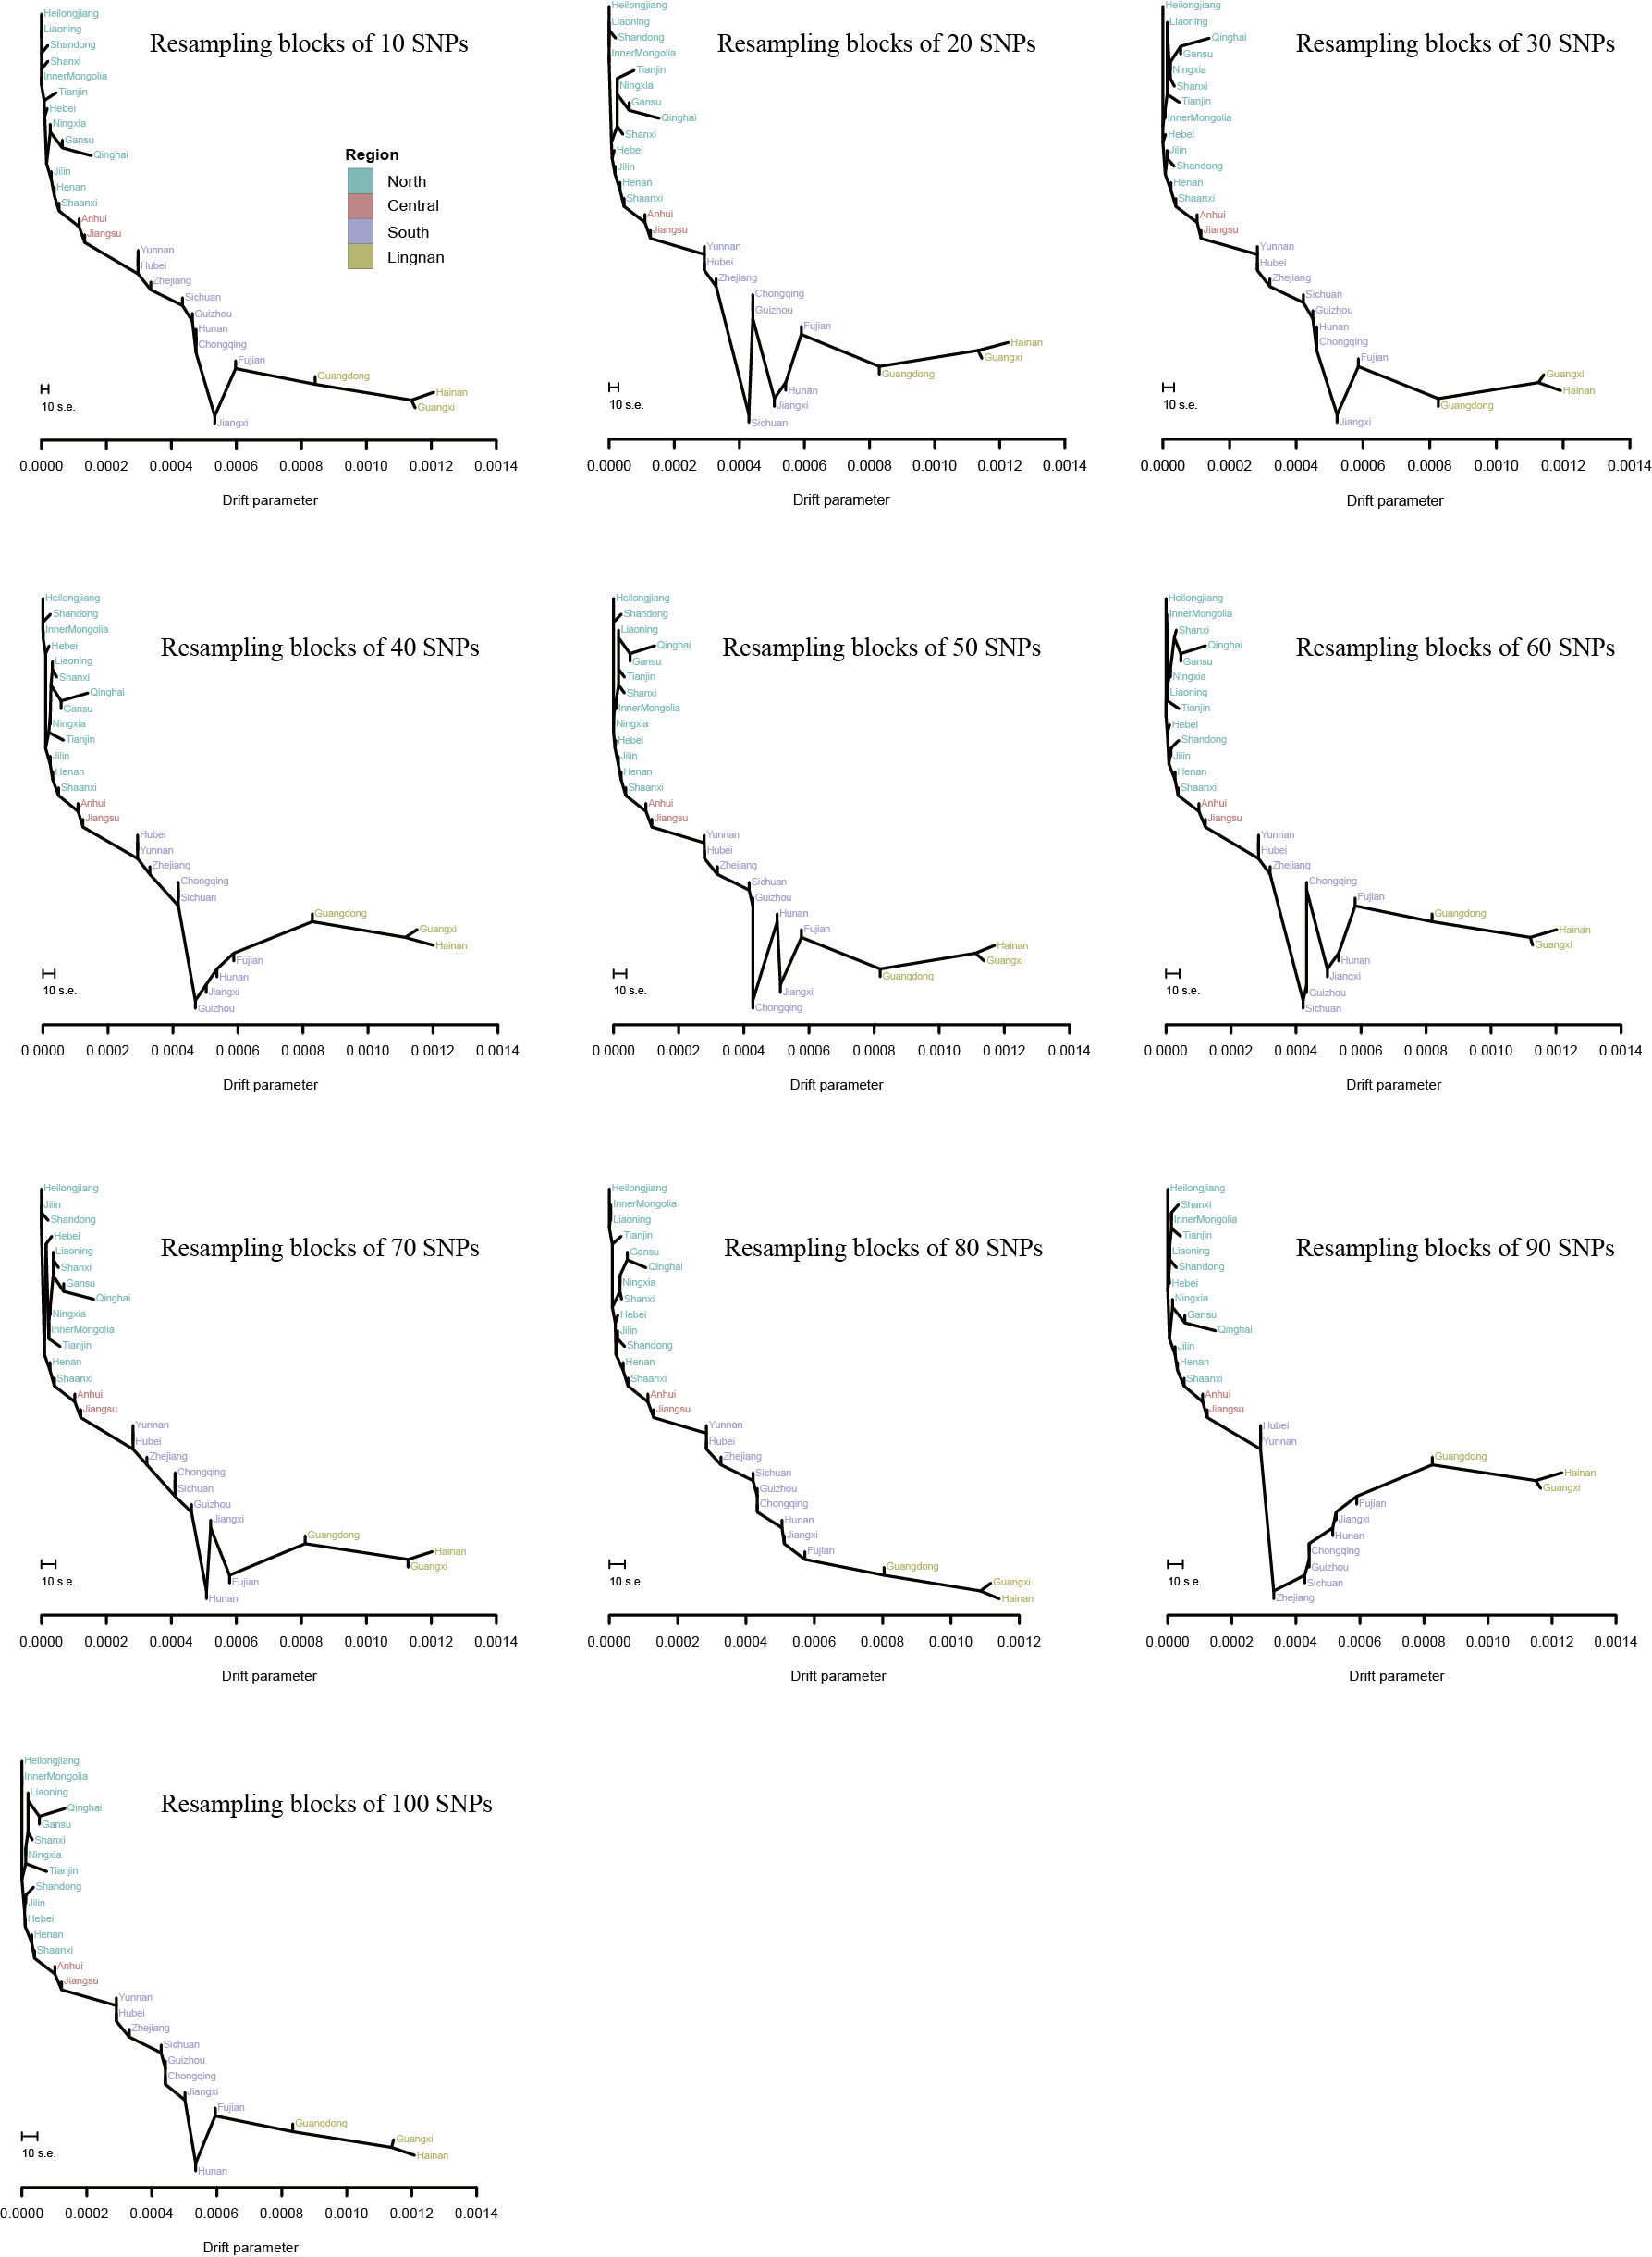
Supplementary Fig. 12. Bootstrap replicates for the tree topology in 27 administrative divisions. The bootstrap replicates were generated by the -bootstrap -k flag of TreeMix software. The plots were y-axis free. The scale bar shows ten times the average standard error of the entries in the sample covariance matrix for the estimated drift parameter.
Supplementary Fig. 13
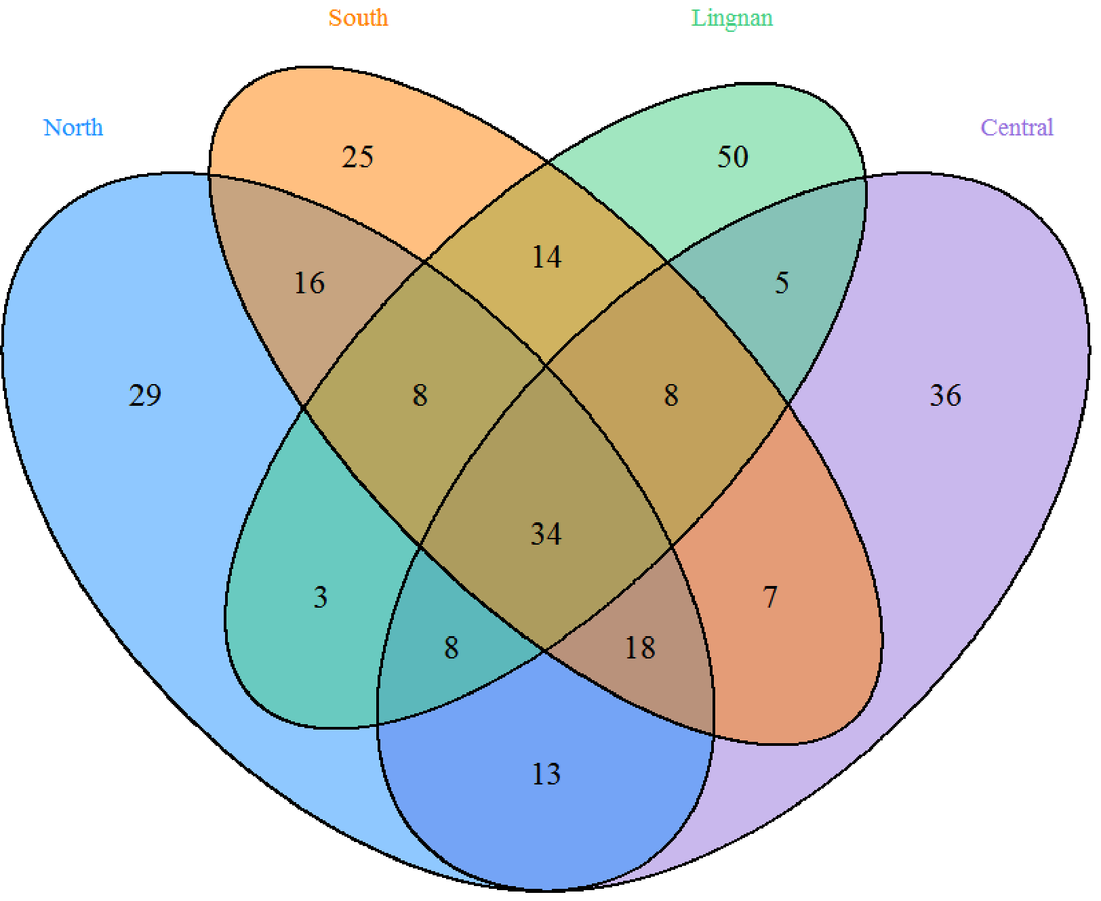
Supplementary Fig. 13. The number of genomic regions with significant selection signatures.
Sharing of genomic regions with higher iHS signals among four subgroups. The number listed within the Venn Diagram indicates the numbers of 200 kb non-overlapping genomic windows in the top 1% of the fraction of SNVs with |iHS| >2.

Supplementary Fig. 14
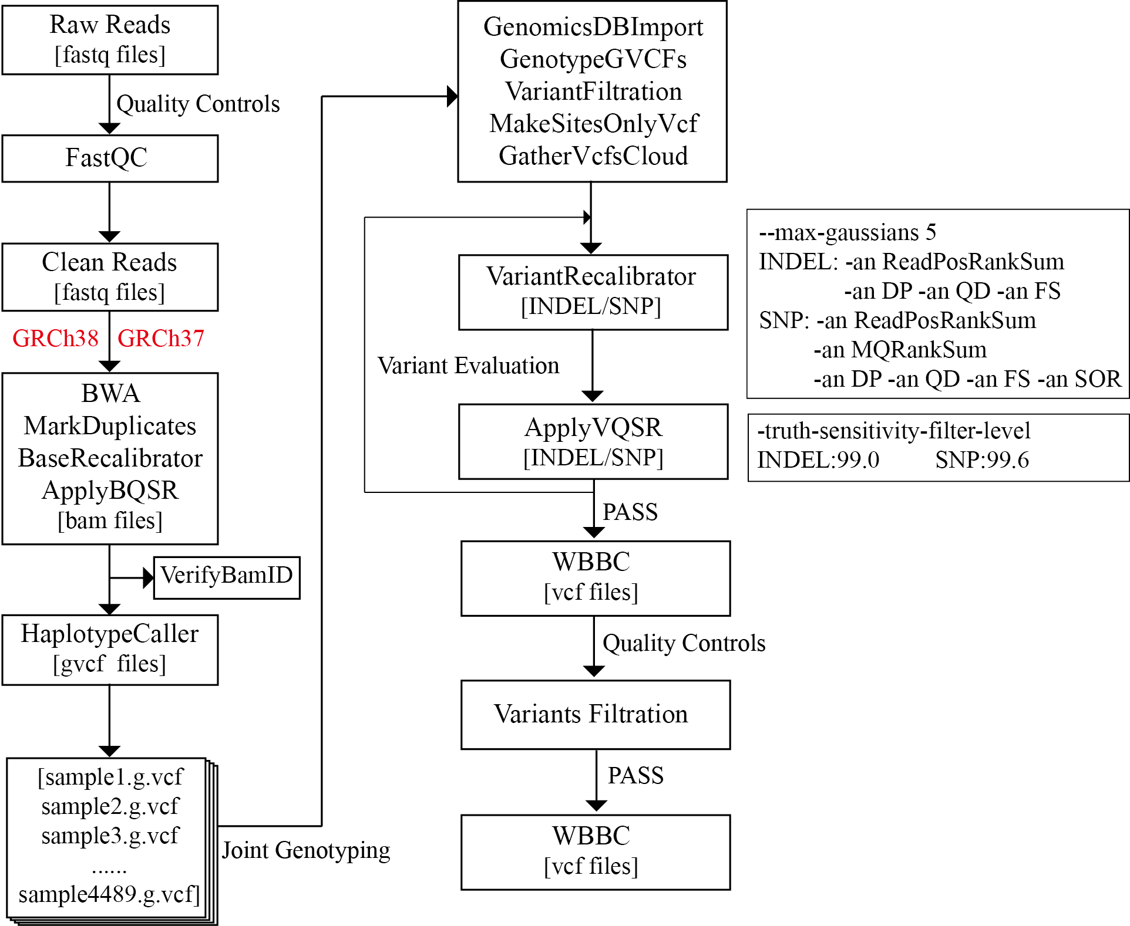
Supplementary Fig. 14. Schematic representation of whole-genome sequencing analysis pipelines. The BWA and GATK4 recommendation pipeline and variant analysis strategy were performed on the WBBC-cohort dataset with the GRCh38 and GRCh37 human reference genome, respectively.

Supplementary Fig. 15
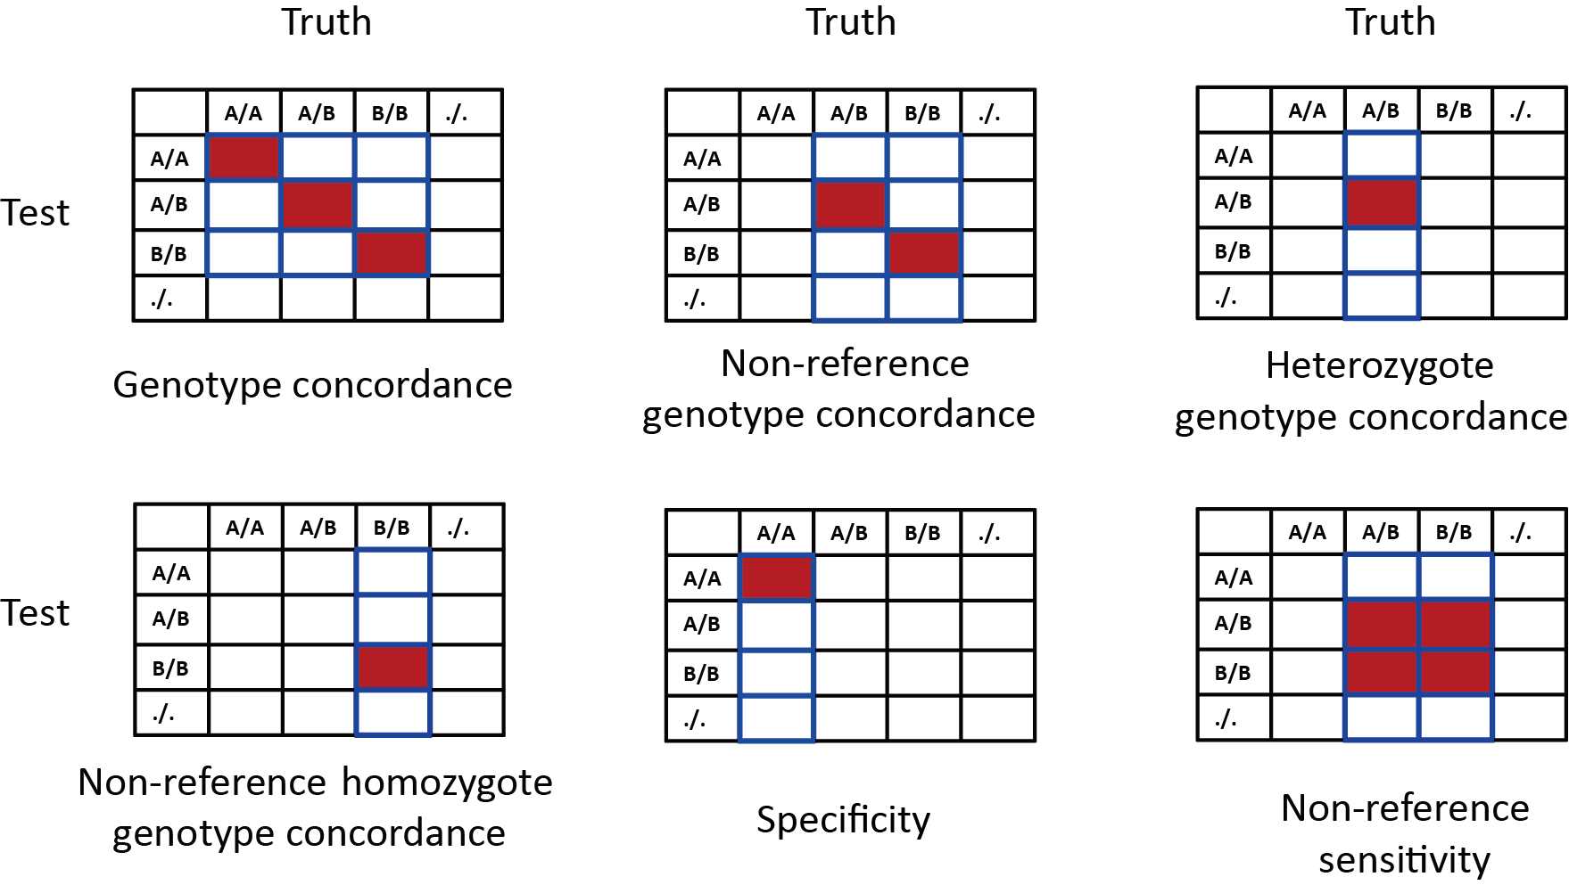
Supplementary Fig. 15. Definition of genotype concordance, specificity, and sensitivity. Letter A represents reference allele while B represents non-reference (NR) allele. The dot means missing called allele. For each metric, the value equals to the corresponding red rectangles divided by all rectangles with a blue border.

Supplementary Tables
Supplementary Table 1. Geographic distribution of all the WBBC cohort samples. The individuals were recruited from 29 of the 34 administrative divisions of the People's Republic of China (PRC)

Supplementary Table 2. Summary of autosomal variants in each individual in the WBBC cohort

Supplementary Table 3. Statistics of variants in 4,480 individuals

Supplementary Table 4. Top 50 of phenotypes and number of variants of the allele frequency difference between WBBC and EUR in the NHGRI-EBI Catalog database

Supplementary Table 5. Comparison of the difference of variants allele frequency between WBBC and 1000 Genome Project population

Supplementary Table 6. Comparison of the difference of variants allele frequency between WBBC and East Asian population

Supplementary Table 7. Average number of autosomal variants in each genome of four regions

Supplementary Table 8. The pathogenic and likely pathogenic variants were recorded by Clinvar in the 1,151 healthy individuals

Supplementary Table 9. SNVs with significant selection signatures by SDS analysis in the Han Chinese population

Supplementary Table 10. Pair-wise Fst values for 27 provinces of China in WBBC

Supplementary Table 11. Pair-wise Fst values for 26 populations in 1KG Phase3 and four regions of China in WBBC

Supplementary Table 12. Pair-wise Fst values for 27 provinces of China in WBBC and four continent groups in 1KG Phase3

Supplementary Table 13. Top 1% of non-overlapping genomic windows was identified for positive selection in the North Han Chinese population using the iHS statistic

Supplementary Table 14. Top 1% of non-overlapping genomic windows was identified for positive selection in the Central Han Chinese population using the iHS statistic

Supplementary Table 15. Top 1% of non-overlapping genomic windows was identified for positive selection in the South Han Chinese population using the iHS statistic

Supplementary Table 16. Top 1% of non-overlapping genomic windows was identified for positive selection in the Lingnan Han Chinese population using the iHS statistic

Supplementary Table 17. Gene Ontology (GO) analysis of candidate genes in top 1% genomic regions with positive selection by iHS statistic

Supplementary Table 18. KEGG enrichment pathway for candidate genes in top 1% genomic regions with positive selection by iHS statistic

