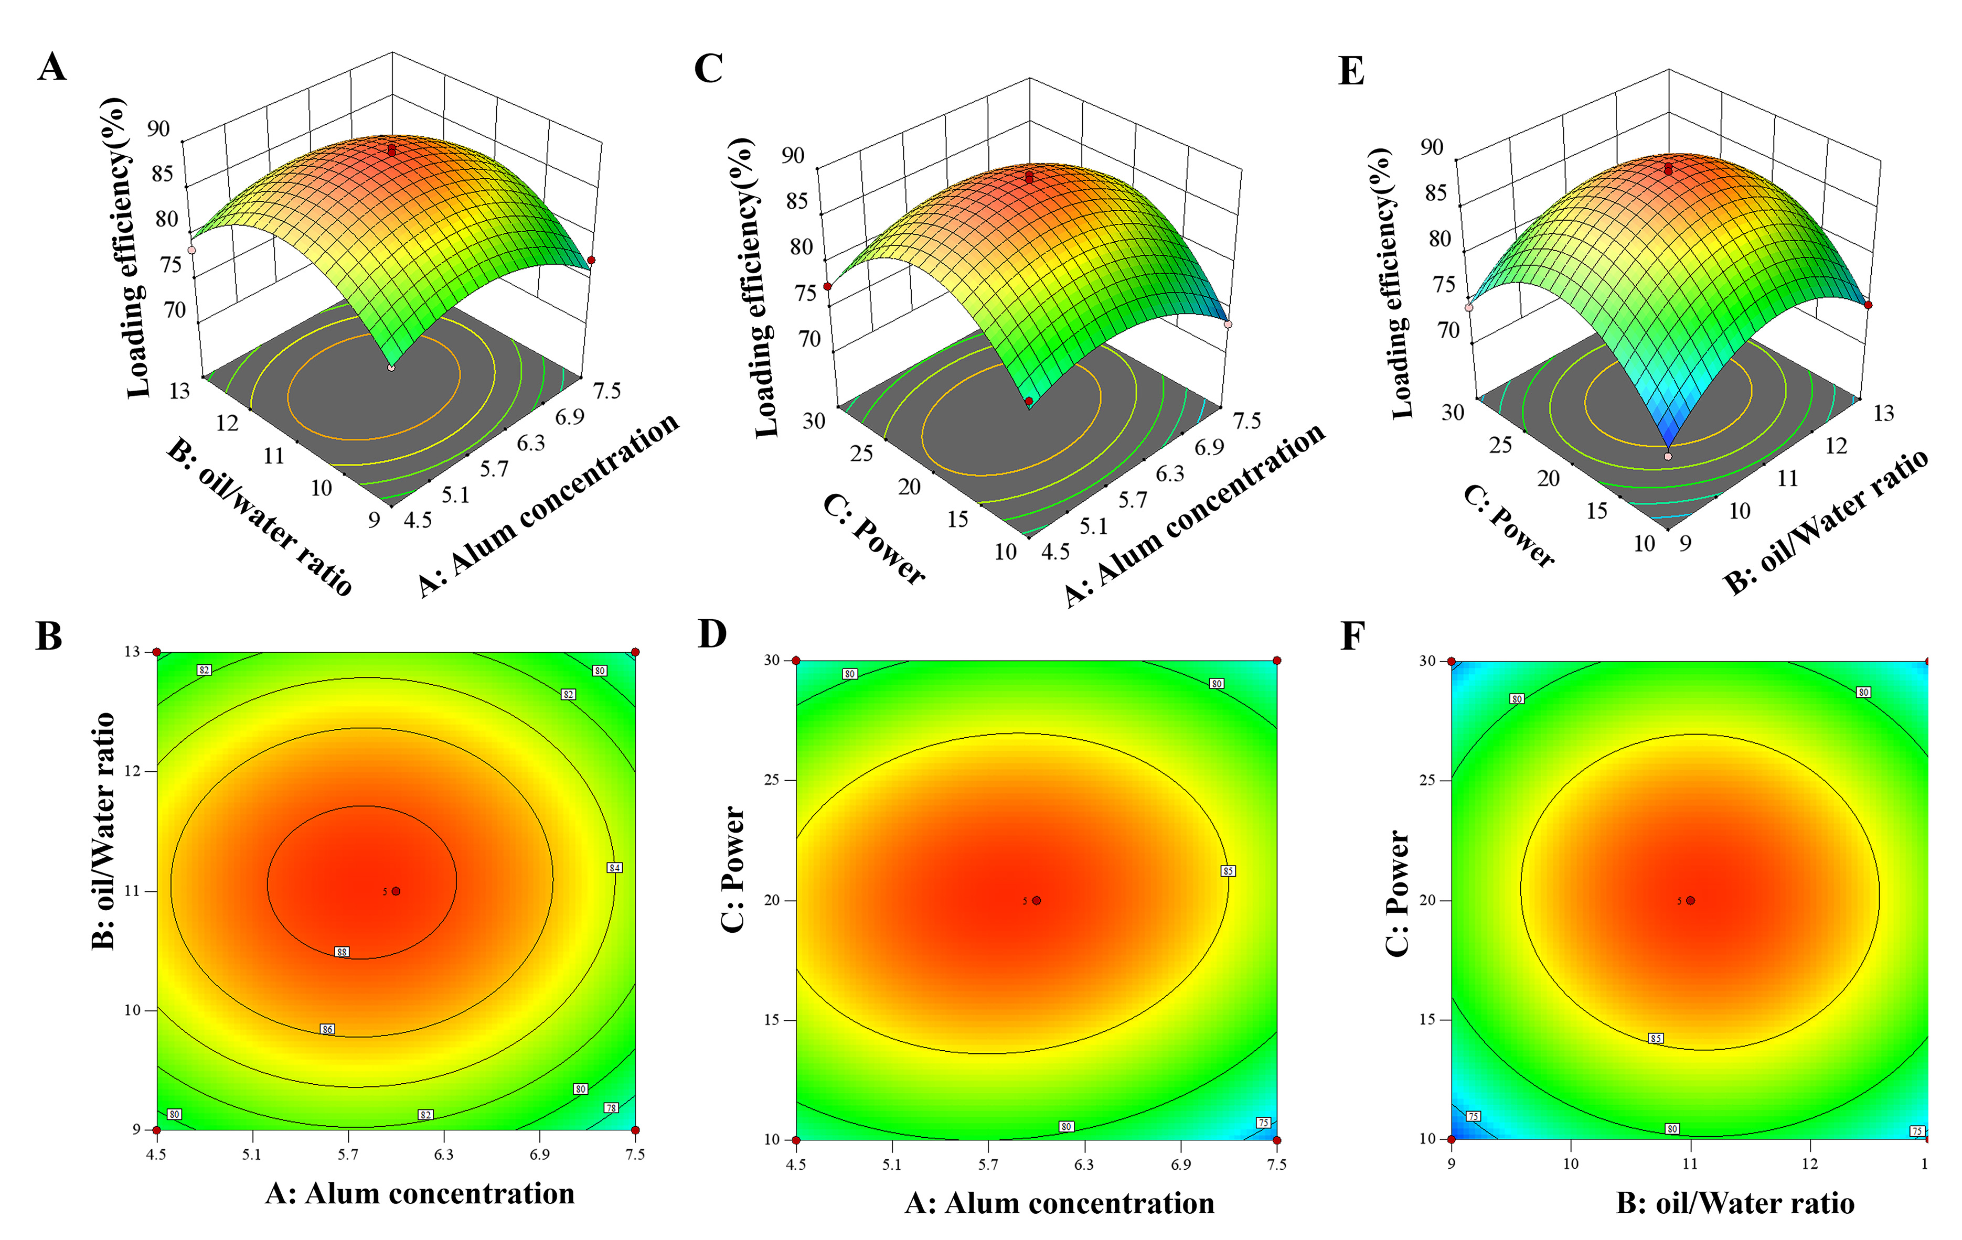
Figure S1. Response surface (A.C.E) of Y=f(A,B, C) and contour (B.D.F)

