Nanosized octahedral LiNi_{0.5}Mn_{1.5}O₄ with predominant (111) facet as high performance cathode for Lithium-ion batteries
Haibo Rong ^{a*}, Binglu Deng ª, Dongchu Chen ^{a,b,*} Min Chen ª
ª College of Materials Science and Energy Engineering, Foshan University, Foshan, 528000, Guangdong, China
^{b} Guangdong Key Laboratory for Hydrogen Energy Technologies，Foshan University, Foshan, 528000, Guangdong, China

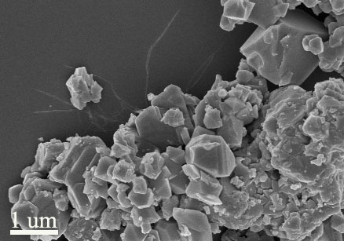
Fig.S1 SEM image of the B-LNMO

 | Ni / mg L⁻¹ | Mn / mg L⁻¹
B-LNMO | 0.465 | 1.84
O-LNMO | 0.056 | 0.025
Table.S1. Concentration of Ni and Mn that deposited on the lithium anode extracted from the cells with B-LNMO and O-LNMO cathodes, respectively.

