Supplementary Information
Spinal-inspired artificial tactile interneuron with high-order burst spiking for intelligent edge interfaces

Fanfan Li^{1,2}†, Zhanglu Yan³†, Jiayi Mao², Guolei Liu², Huihui Ren^{1,2}, Bangbang Qin², Zhongfang Zhang², Haiyue Zhang², Yiyang Shen², Zeqi Zheng⁴, Weilong Feng², Dingwei Li², Yingjie Tang², Saisai Wang⁵, Yaochu Jin⁴, Tao Luo⁶, Weng-Fai Wong³, Hong Wang⁷*, Bowen Zhu^{2,5}*

Affiliations
¹School of Materials Science and Engineering, Zhejiang University, Hangzhou 310027, China.
²Zhejiang Key Laboratory of 3D Micro/Nano Fabrication and Characterization, Department of Electronic and Information Engineering, School of Engineering, Westlake University, Hangzhou, Zhejiang 310030, China.
³School of Computing, National University of Singapore, 117417, Singapore.
⁴Department of Artificial Intelligence, School of Engineering, Westlake University, Hangzhou 310030, China.
⁵Westlake Institute for Optoelectronics, Westlake University, Hangzhou 311421, China.
⁶Institute of High Performance Computing, Agency for Science, Technology and Research, 138632, Singapore.
⁷Key Laboratory of Wide Band Gap Semiconductor Technology, School of Microelectronics, Xidian University, Xi'an, 710071 China.

†These authors contributed equally: Fanfan Li, Zhanglu Yan
*Corresponding authors. Emails: hongwang@xidian.edu.cn (H.W.); zhubowen@westlake.edu.cn (B.Z.)

Supplementary Note 1. Preparation of sensors.
(Ⅰ) Vertically aligned gold nanowires (v-AuNWs) sensors fabrication
The fabrication process for v-AuNWs strain sensors began with the creation of shadow masks. A semiconductor laser cutter (XTool M1) was used to laser-cut hollow serpentine patterns into a vinyl sheet (CircutTM) at 20% power and 30% speed. These shadow masks were then adhered to clean glass slides, which served as substrates. The substrate surfaces were first cleaned with 75% ethanol and then treated with air plasma for 3 minutes to enhance surface hydrophilicity. Next, the substrates were immersed in a 0.002 wt% ATPES (Innochem) ethanol solution for two hours to functionalize the surfaces with amino groups. For gold seed deposition, the substrates were soaked in a citrate-stabilized gold seed solution containing NaC (33.7 mM, Sigma-Aldrich), HAuCl₄ (25 mM, Sinopharm), and NaBH₄ (0.1 M, Innochem) for two hours. Once the gold seeds were adsorbed, the substrates were immersed in a premixed gold nanowire growth solution composed of MBA (60 mM, Aladdin), HAuCl₄ (25 mM, Sinopharm), and L-AA (40 mM, Aladdin) for 15 minutes, forming a patterned conductive film with gold nanowires. After removing the masks, the substrates were spin-coated three times with a thin layer of SEBS (0.21 wt%, Sigma-Aldrich) premixed with toluene (Sinopharm) at 800 rpm for 40 seconds each time. This was followed by curing at 40°C for 20 minutes. Finally, the patterned conductive film coated with SEBS was peeled off from the glass slides, completing the fabrication process.

(Ⅱ) Polypyrrole (PPy) resistive pressure sensor fabrication and characterization
The fabrication of PPy-based resistive pressure sensors involves several steps. First, a recessed pyramid-shaped silicon mold is prepared using photolithography and anisotropic etching to create micro-pyramidal films. PDMS is then fabricated by mixing the elastomer base and crosslinker in a 10:1 weight ratio, degassing the mixture for two minutes in a planetary centrifugal mixer (THINKY ARE-310), and spin-coating it onto the silicon mold at 700 rpm for 60 seconds. The coated PDMS is cured at 80°C for one hour, cut with a scalpel, and peeled off from the mold. The patterned PDMS substrates are treated with oxygen plasma for three minutes, followed by the addition of 30 µL of N-(3-Trimethoxysilylpropyl) pyrrole on a glass slide in a vacuum desiccator, which is then kept under vacuum at 0.9 bar for three hours at 70°C. For the chemical oxidation polymerization of pyrrole, a 0.1 M pyrrole monomer and 1 M HCl solution (PPy/HCl solution) is prepared by adding the pyrrole monomer dropwise into the HCl solution, and a similar preparation is done for a mixture of FeCl₃ and HCl (FeCl₃/HCl solution). The PDMS substrate is immersed in the PPy/HCl solution, and after 10 minutes at 2-5°C, the FeCl₃/HCl solution is added to the PPy/HCl solution, mixed thoroughly, and kept at 2-5°C for 25 minutes to allow polymerization. The resulting PPy/PDMS film is rinsed with ethanol and dried under N₂ flow. Finally, the PPy/PDMS micro-pyramidal films are laminated onto the interdigitated electrodes of a flexible PCB and encapsulated with transparent medical tape, completing the fabrication of the PPy-based resistive pressure sensors. A motorized test stand system with a force gauge (Mark-10 ESM303) was used to apply and record loads, while resistance measurements were taken using a source meter (Keithley 2636A).

Supplementary Note 2. Circuit modeling and burst feature extraction.
For each sensory branch, the membrane voltage V_{m}(t) across the memristor–capacitor network is derived from Kirchhoff’s Current Law (KCL). The equivalent circuit can be modeled as a series resistor R_{L} feeding a memristive element with resistance R_{NbO2} in parallel with a capacitor C_{m}. Applying KCL yields the first-order differential equation:
During the charging phase, the device is in the high-resistance state (R_{NbO2} = R_{off}), with the initial condition V_{m} (0)=V_{hold}. Solving Eq. (S) gives:
Here, denotes the parallel combination of two resistances:
When V_{m}(t) reaches the threshold V_{th} at t = t_{r}, we obtain the rising time:
Once the device switches to the low-resistance state (R_{NbO2} = R_{on}), the initial condition becomes V_{m} (0)=V_{th}. The membrane voltage during discharge is:
When V_{m}(t) decays back to V_{hold} at t = t_{f}, the falling time is:
The intrinsic oscillation period for each branch is determined by the sum of the charging and discharging times:
The instantaneous branch voltage V_{m}(t) and state R_{NbO2}(t) are used to compute the fused node voltage.
The fusion node voltage V_{fusion} is calculated from the parallel combination of three modality branches and a fixed shunt resistor 𝑅_{0,fusion} :
Where V_{m,i}(t) is the membrane voltage of the i-th NbO₂ branch at time t during charging or discharging and R_{t,i}(t) is the dynamic resistance of the i-th NbO₂ device at time t, switching between R_{on} and R_{off} depending on the threshold condition. .
The interneuron integrates the fused signal with a gain 𝐴_{𝑉}​, producing .The second-stage memristor obeys the same dynamics as Eqs. (2–6), with its own load resistance and capacitor C_{out}, resulting in the output voltage:
Where V_{mem} (t) is the membrane potential of the second-stage interneuron in the circuit, and
R_{t}⁽²⁾(t) is the dynamic resistance of the second-stage NbO₂ neuron used in the output stage.
Spike times {𝑡_{𝑘}} are identified from 𝑉_{out}(𝑡). From these, the temporal coding features are computed:
Inter-spike interval (ISI):
Intra-burst interval (IBI):
Mean burst interval (MBI):
ISI_{k} denotes the mean inter-spike interval within a burst, IBI_{j} represents the inter‑burst interval between adjacent high‑density spike clusters j and j + 1, and MBI_{j} is the mean burst interval between consecutive bursts j and j + 1. N_{spikes} refers to the total number of spikes in a burst sequence and is used to encode stimulus intensity information and is the burst duration.

Supplementary Note 3. Evolutionary neural architecture search.
Require: Search space S, population size N = 4000, generations G = 25, elite size K = 8, mutations per elite M = 12
Ensure: Best architecture α*
Phase 1: Initial Population Generation
1: P₀ ← ∅
2: for i = 1 to N do
3: α_{i} ← RandomGenerateArchit()
4: P₀ ← P0 ∪ {αi}
5: end for
Phase 2: Population Evaluation
6: R₀ ← ∅
7: for each α ∈ P₀ do
8: acc, params ← TrainAndEvaluate(α)
9: if acc ≥ 80% and params ≤ 10⁶ then
10: score ← CalculateScore(acc, params)
11: R₀ ← R₀ ∪ {(α, acc, params, score)}
12: end if
13: end for
Phase 3: Evolutionary Optimization
14: E₀ ← SelectTopK(R₀, K)
15: for g = 1 to G do
16: P_{g} ← E_{g−1}
17: for each α ∈ E_{g−1} do
18: for m = 1 to M do
19: if rand() < 0.8 then
20: α' ← AggressiveMutation(α)
21: else
22: α_{other} ← RandomSelect(E_{g−1})
23: α' ← Crossover(α, α_{other})
24: end if
25: P_{g} ← P_{g} ∪ {α'}
26: end for
27: end for
28: R_{g} ← EvaluatePopulation(P_{g})
29: E_{g} ← SelectTopK(R_{g}, K)
30: if max(acc ∈ R_{g}) > 90% then
31: break {Early termination}
32: end if
33: end for
34: return α*

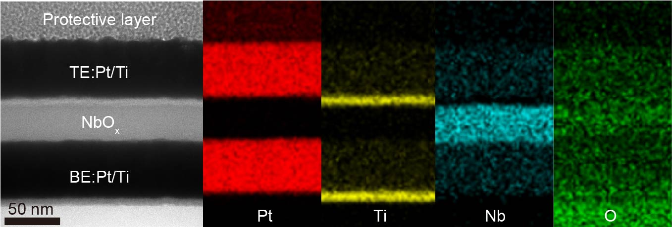

Supplementary Fig. 1. Energy-dispersive X-ray spectroscopy (EDS) mapping results of the NbO_{x} memristor stack.

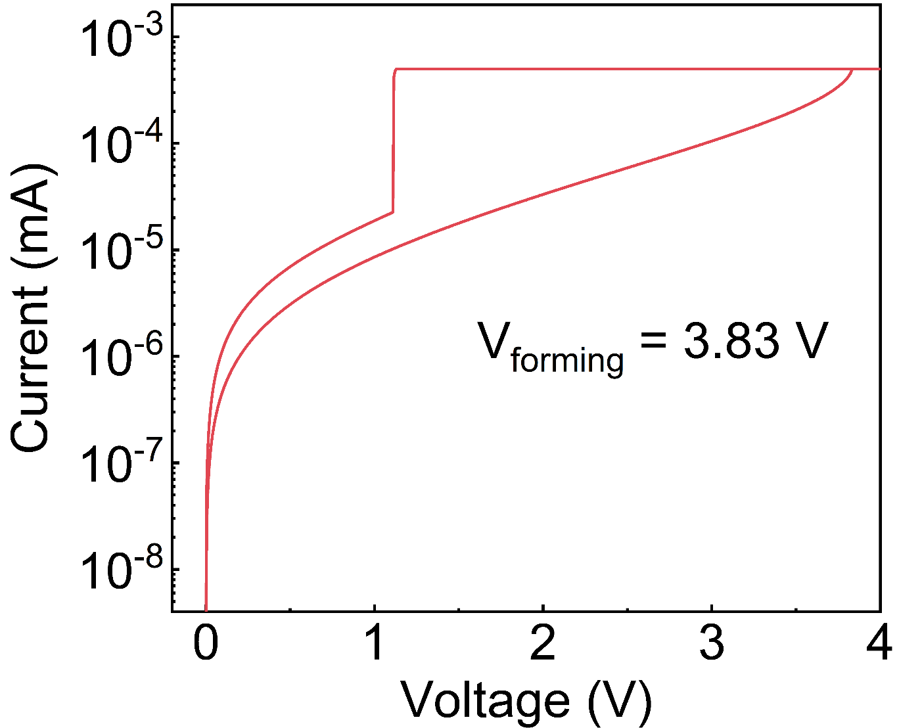

Supplementary Fig. 2. Electroforming process of the NbO_{x} memristor. A forming voltage with a compliance current of 0.5 mA was applied to enable stable threshold switching behaviors.

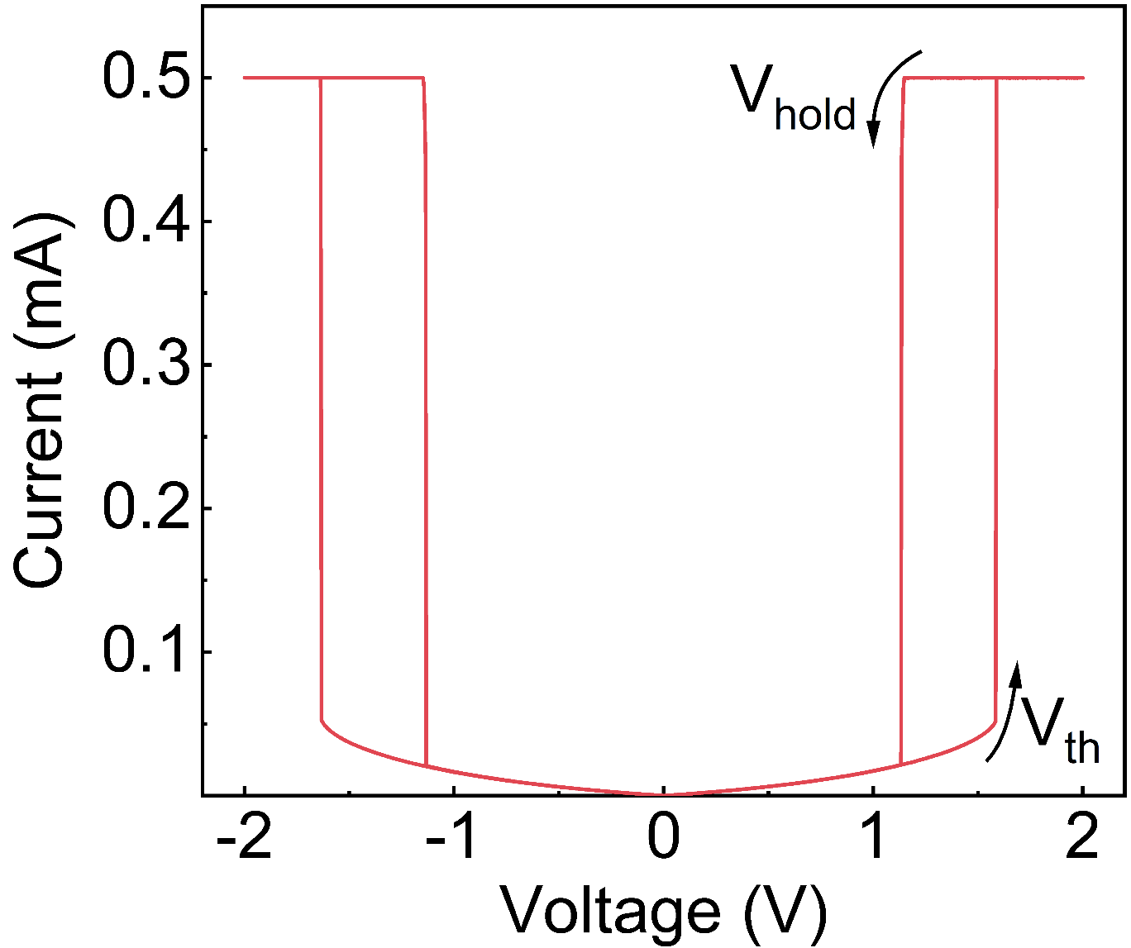

Supplementary Fig. 3. Typical bipolar behavior can be observed in the NbO_{x} Mott memristor.

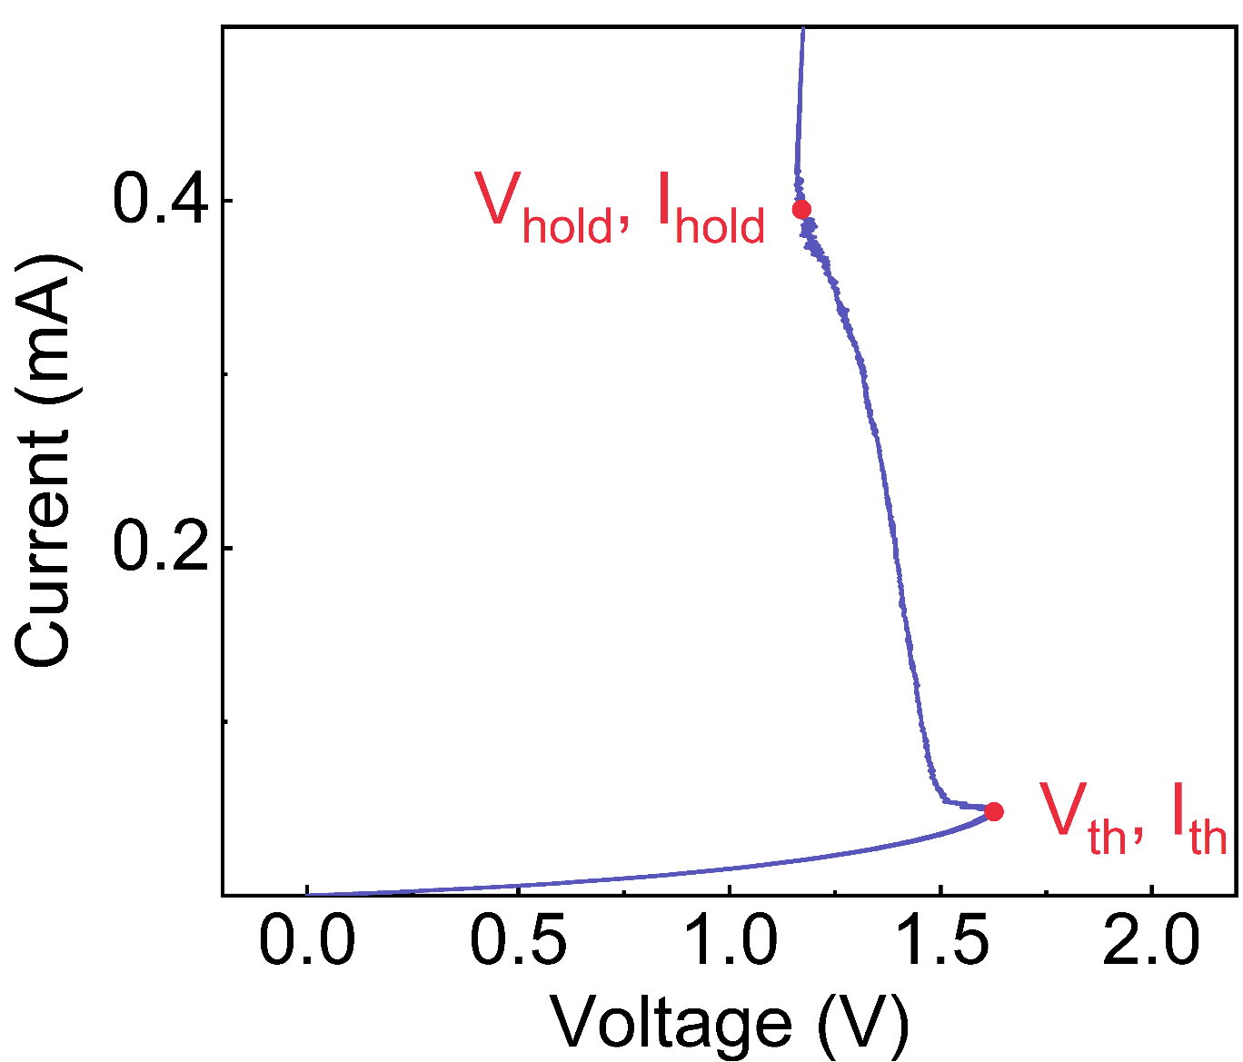

Supplementary Fig. 4. Current-controlled negative differential resistance (NDR) characteristics of the NbO_{x} memristor under current sweep mode.
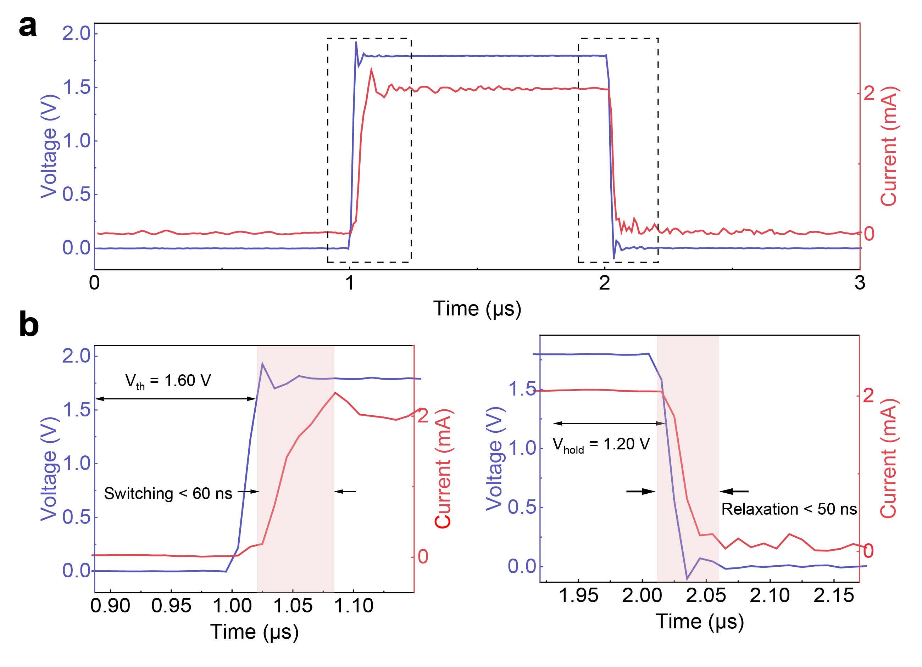

Supplementary Fig. 5. Transient switching response of the NbO_{x} memristor. a, The applied voltage-pulse 1.8 V, 1 μs) input (blue curve) and the corresponding current response (red curve) during threshold switching operation. b, The switching speed is less than 60 ns from the HRS to the LRS (left) and less than 50 ns from the LRS to the HRS (right).

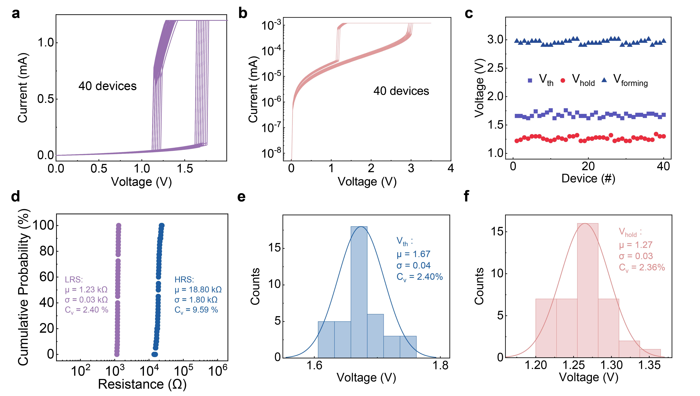
Supplementary Fig. 6. Device-to-device variation in 40 NbO_{x} devices. a, Current-voltage (I-V) curves showing threshold switching characteristics of 40 NbO_{x} memristors with a 1 μm × 1 μm working area. b, Electroforming operation of the 40 NbO_{x} memristor. c, V_{th}, V_{hold} and V_{forming} of the 40 NbO_{x} memristors. d, Variation of R_{LRS} and R_{HRS} among the 40 devices. e,f, Statistical analysis of V_{th} (e) and V_{hold} (f) variability in 40 NbO_{x} memristors.

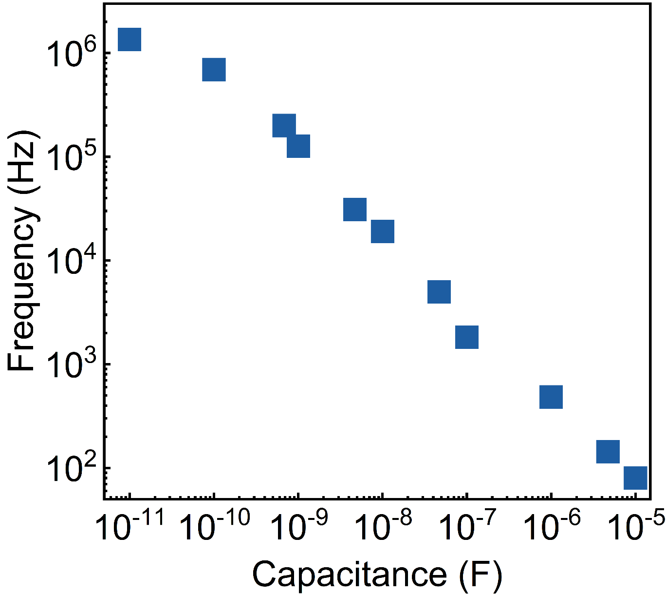
Supplementary Fig. 7. Output frequency changes of the NbO_{x} memristor as a function of the parallel capacitor value. Increasing the capacitance reduces the spiking frequency, attributed to a longer charging time to reach the threshold.

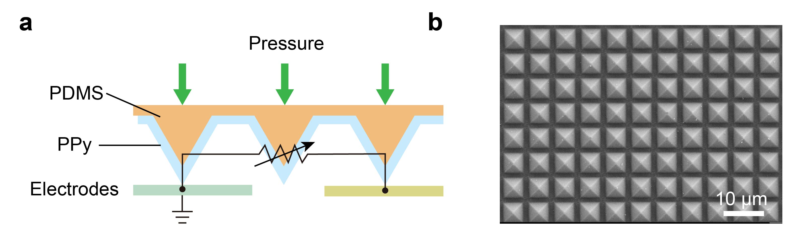
Supplementary Fig. 8. The working mechanism of the PPy pressure sensor. a, The working mechanism involves an increase in pressure, which increases the contact area between the PPy micro-pyramids and the electrodes. This increased contact area leads to a reduction in the sensor resistance. b, SEM image of the micro-pyramidal structure of the PPy pressure sensor.

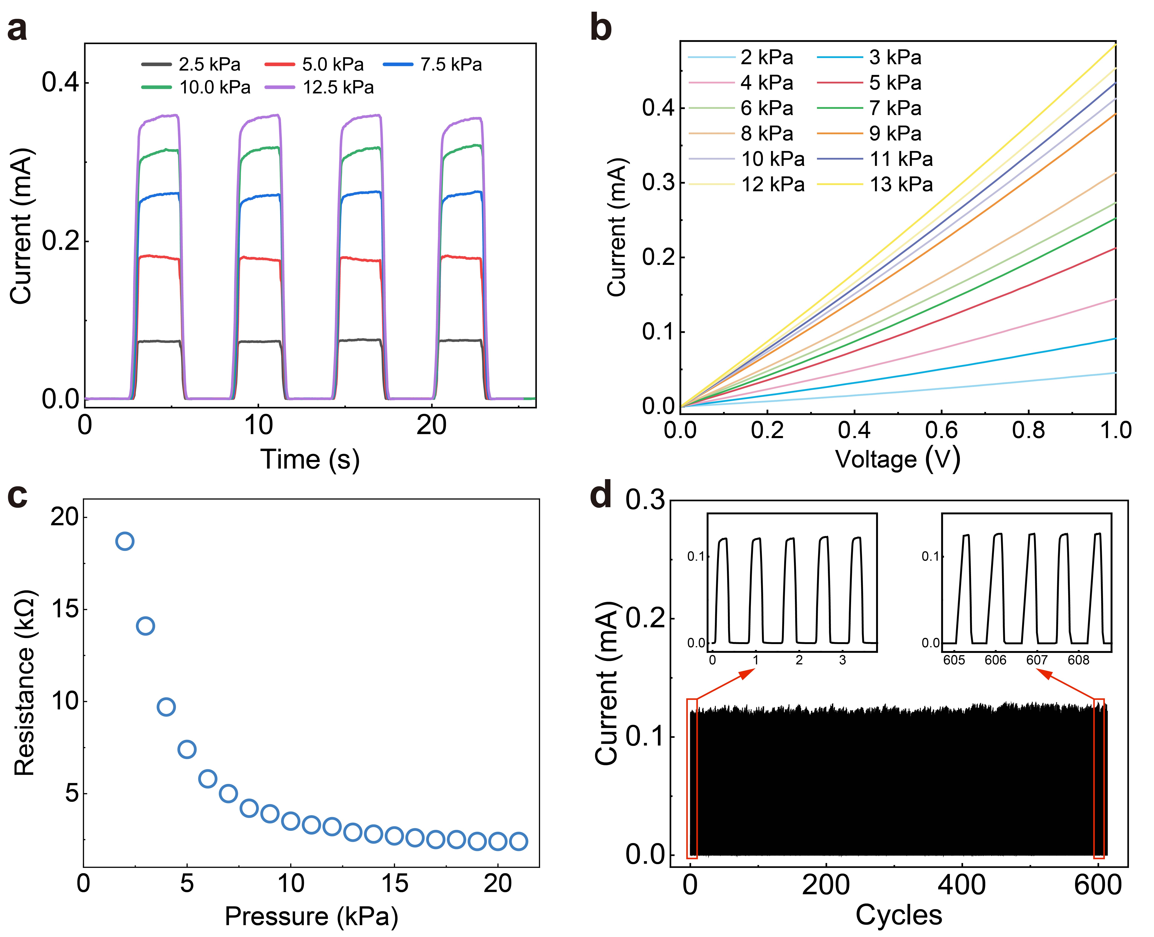

Supplementary Fig. 9. Electrical characteristics of the PPy pressure sensor. a, Current response under cyclic pressure loading in the range of 2.5–12.5 kPa. b, Linear I–V behavior of the sensor under different applied pressures. c, Resistance as a function of applied pressure. d, Cycling stability of the pressure response over 600 cycles at 10.0 kPa.

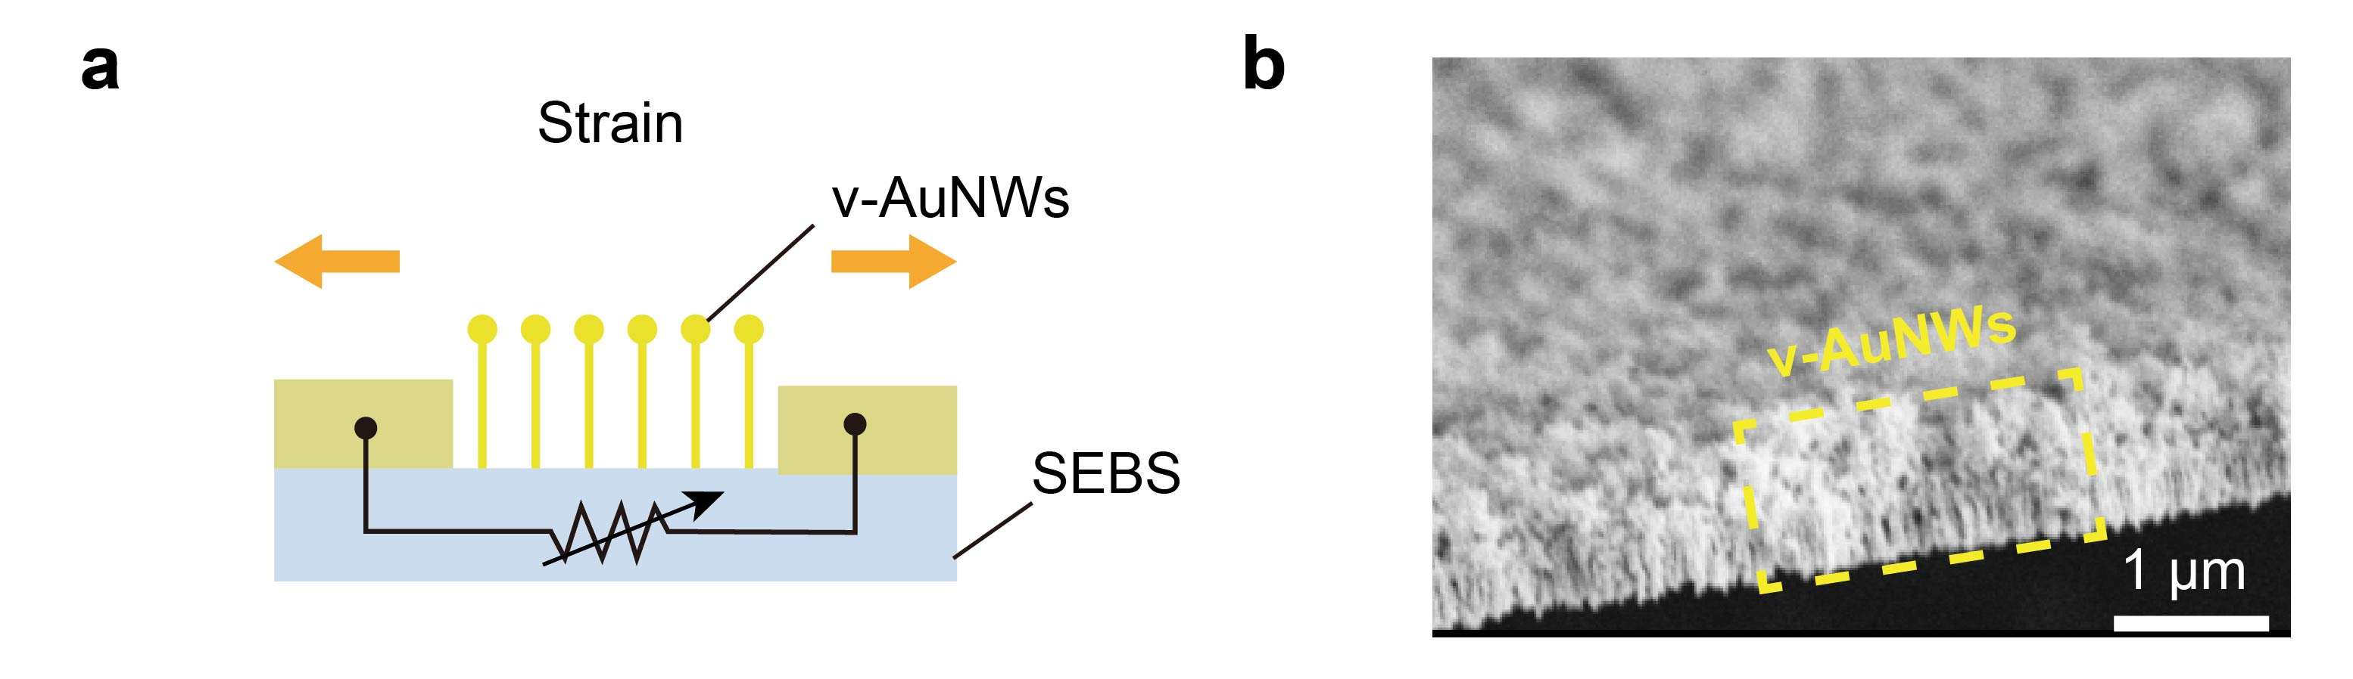
Supplementary Fig. 10. The working mechanism of the v-AuNWs strain sensor. a, Simplified model of the strain sensor. b, Cross-sectional SEM of v-AuNWs/ITO conductive glass.

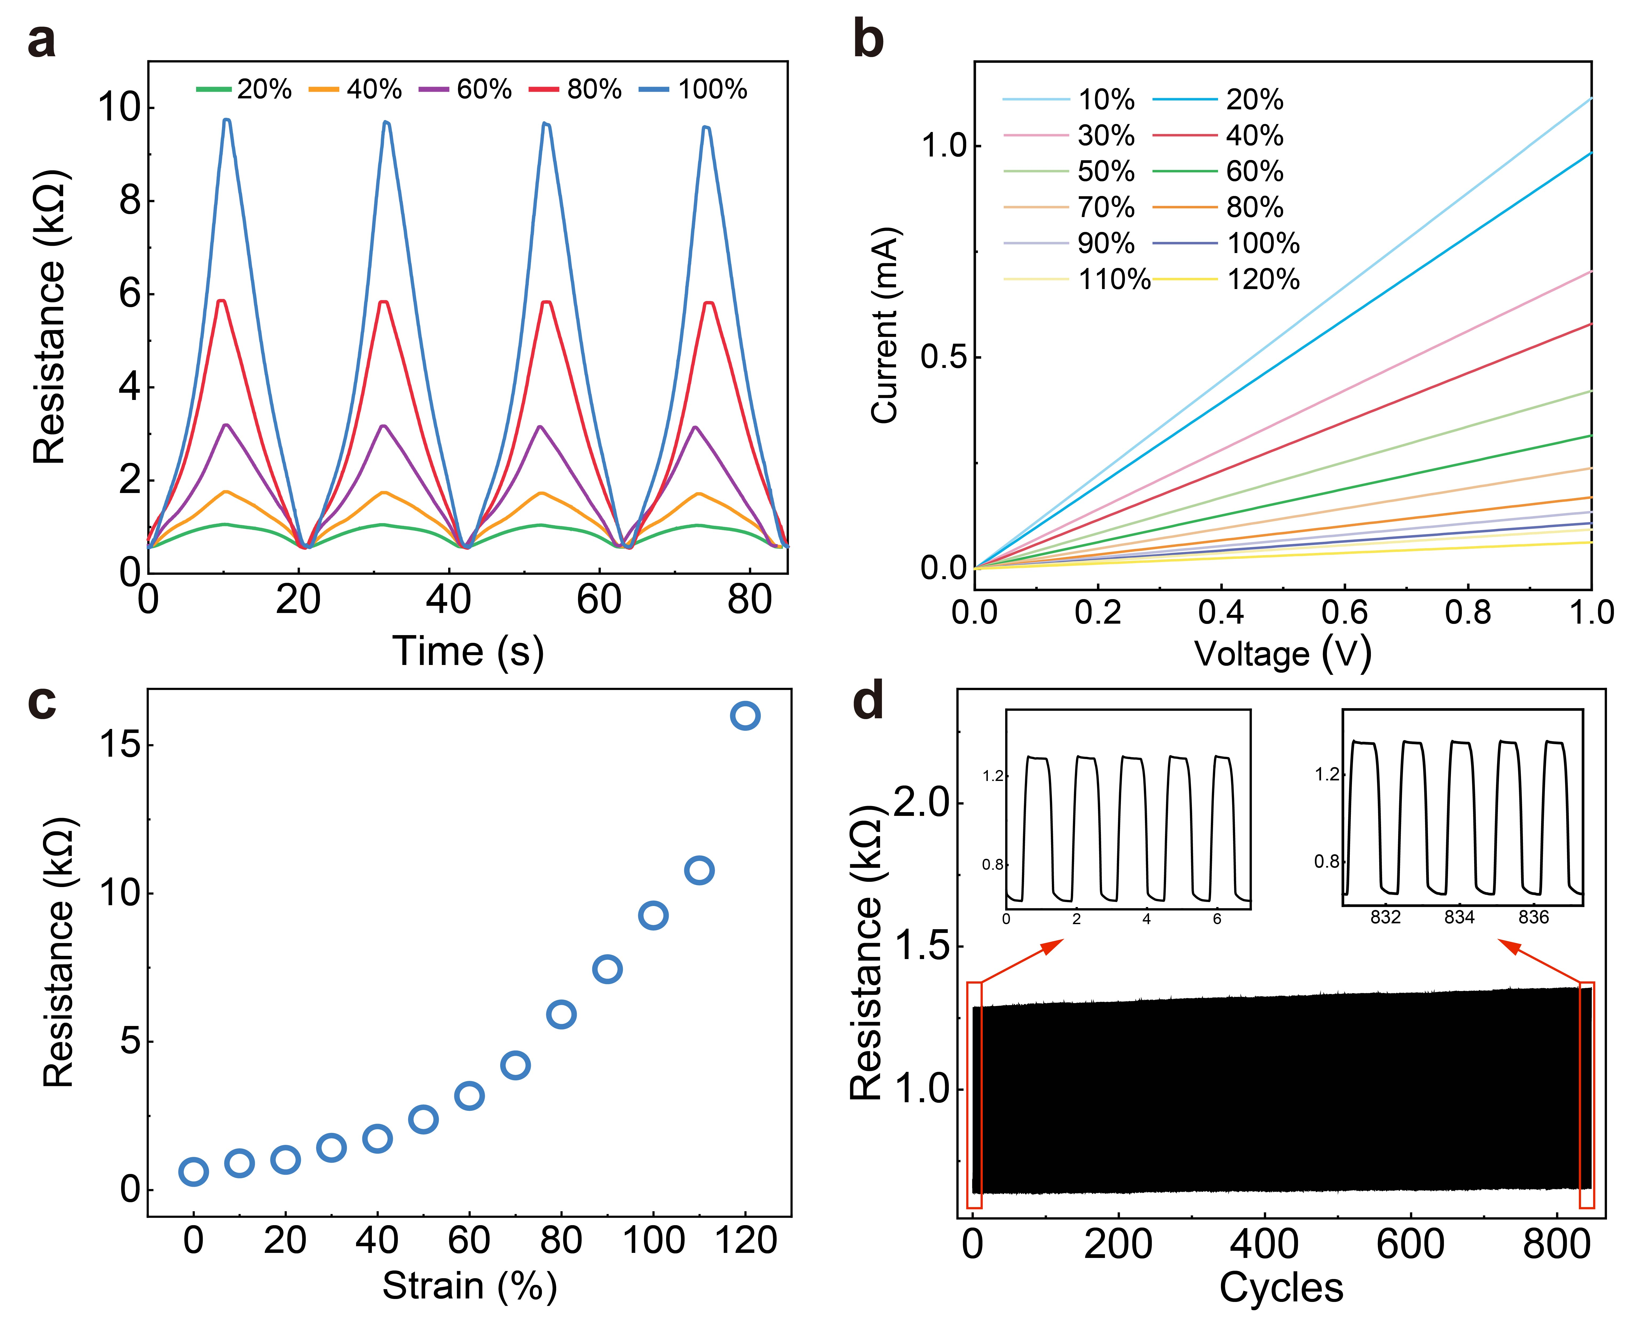
Supplementary Fig. 11. Electrical characteristics of the strain sensor. a, Strain resistance response curves under a triangular strain profile show the sensor is stable and can undergo various dynamic loads. The magnitudes of the respective peak strains are 20%, 40%, 60%, 80% and 100%. b, I-V curves of the strain sensor under 10%-120% strain, exhibiting linear behavior. c, The resistance changes of the v-AuNWs strain sensor in the 0–100% strain range. d, A durability test of 800 cycles at 24% strain shows the strain sensor response is stable and regular, with a nearly constant base resistance.
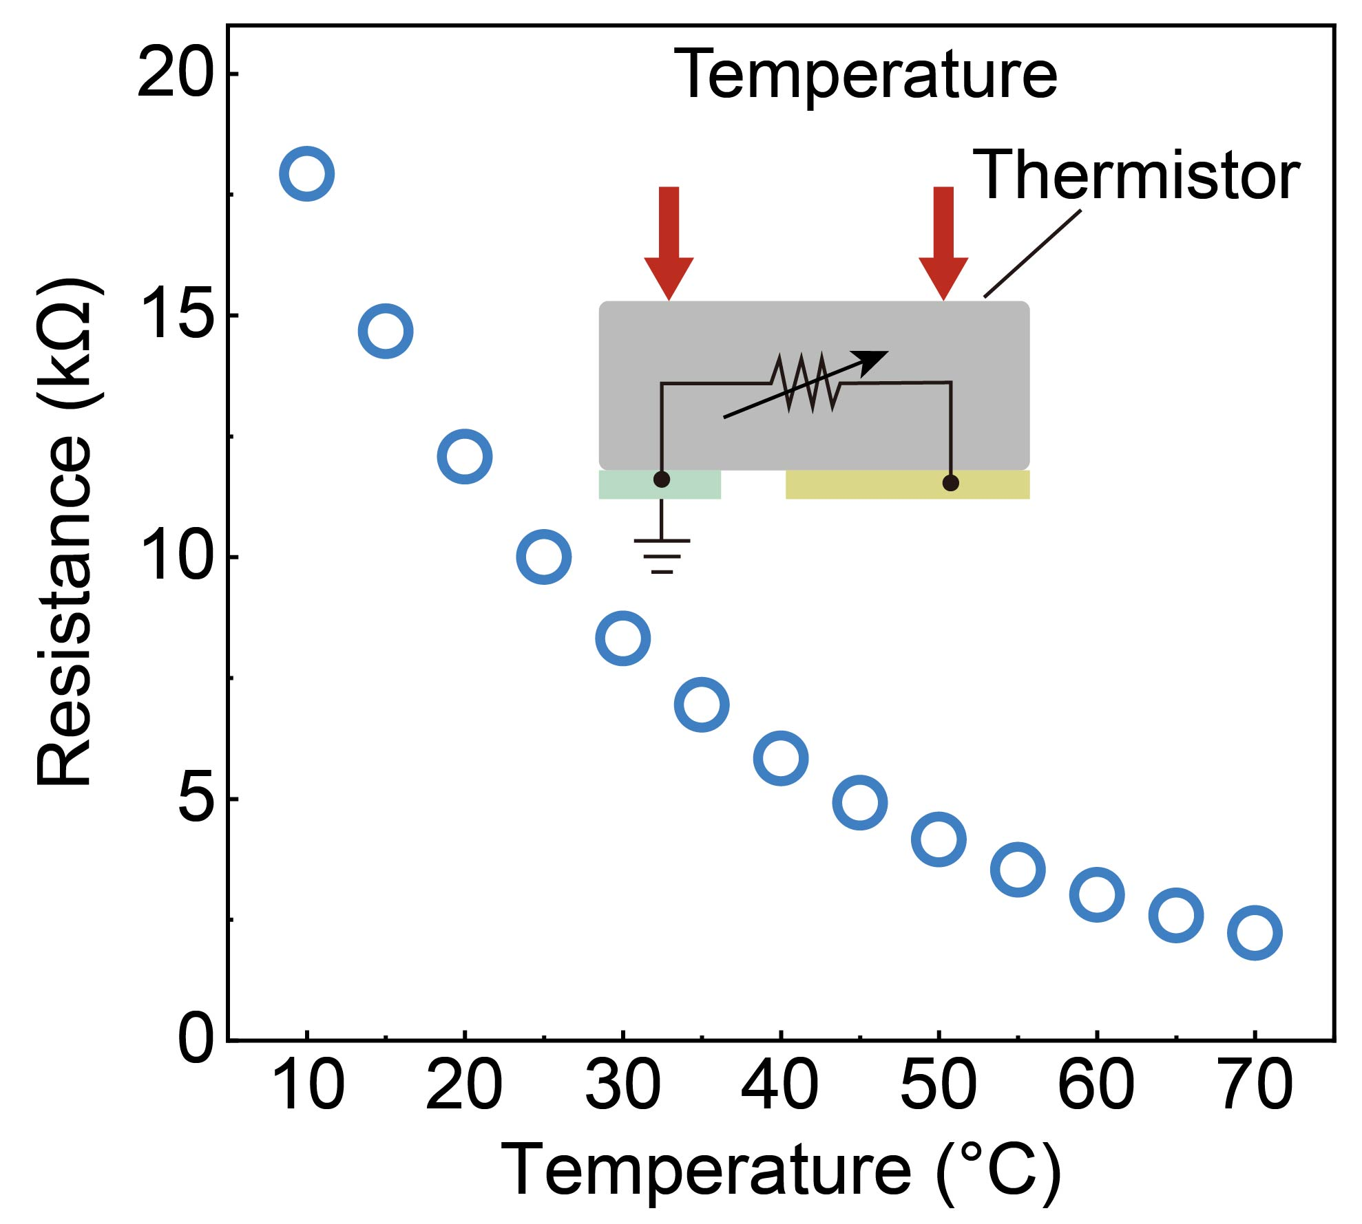
Supplementary Fig. 12. The resistance changes of the temperature sensor in the range of 10–70 °C. The commercial thermistor used was a muRata NCP15XH103F03RC.

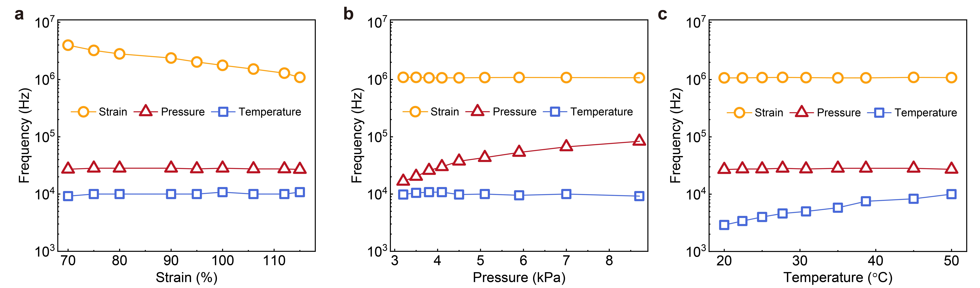
Supplementary Fig. 13. Frequency response of AMIN under varying strain, pressure, and temperature stimuli. a, Output frequency of AMIN as a function of strain, pressure, and temperature under a constant input voltage of 2.8 V. Varying strain from 70 % to 115 % with fixed pressure (4.0 kPa) and temperature (50 °C) shifts the high‑frequency response from 3.98 MHz to 1.09 MHz, while mid‑ and low‑frequency components remain stable at 27.5 kHz and 10.0 kHz, indicating that the high‑frequency band is exclusively regulated by strain. b, With strain fixed at 115 % and temperature at 50 °C, increasing pressure from 3.2 to 8.7 kPa raises the mid‑frequency response from 16.7 kHz to 83.3 kHz, while the high‑ and low‑frequency bands remain constant at 1.08 MHz and 10.0 kHz, confirming pressure‑specific tuning of the mid‑frequency band. c, With strain fixed at 115 % and pressure at 4.0 kPa, increasing temperature from 20 °C to 50 °C elevates the low‑frequency response from 2.9 kHz to 10.0 kHz, while the high‑ and mid‑frequency bands remain constant at 1.08 MHz and 27.7 kHz, confirming that the low‑frequency band is solely modulated by temperature.
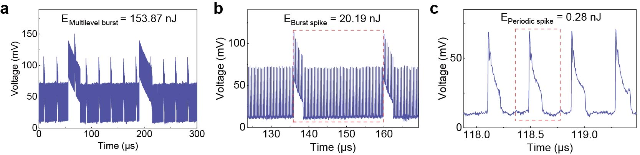
Supplementary Fig. 14. The first layer energy consumption of AMIN. The input voltage is 1.8 V, and the measured output spike energy consumption on a load resistance of 50 Ω are as follows: E_{Multilevel burst} = 153.87 nJ, E_{Burst spike} = 20.19 nJ, and E_{Periodic spike} = 0.28 nJ.

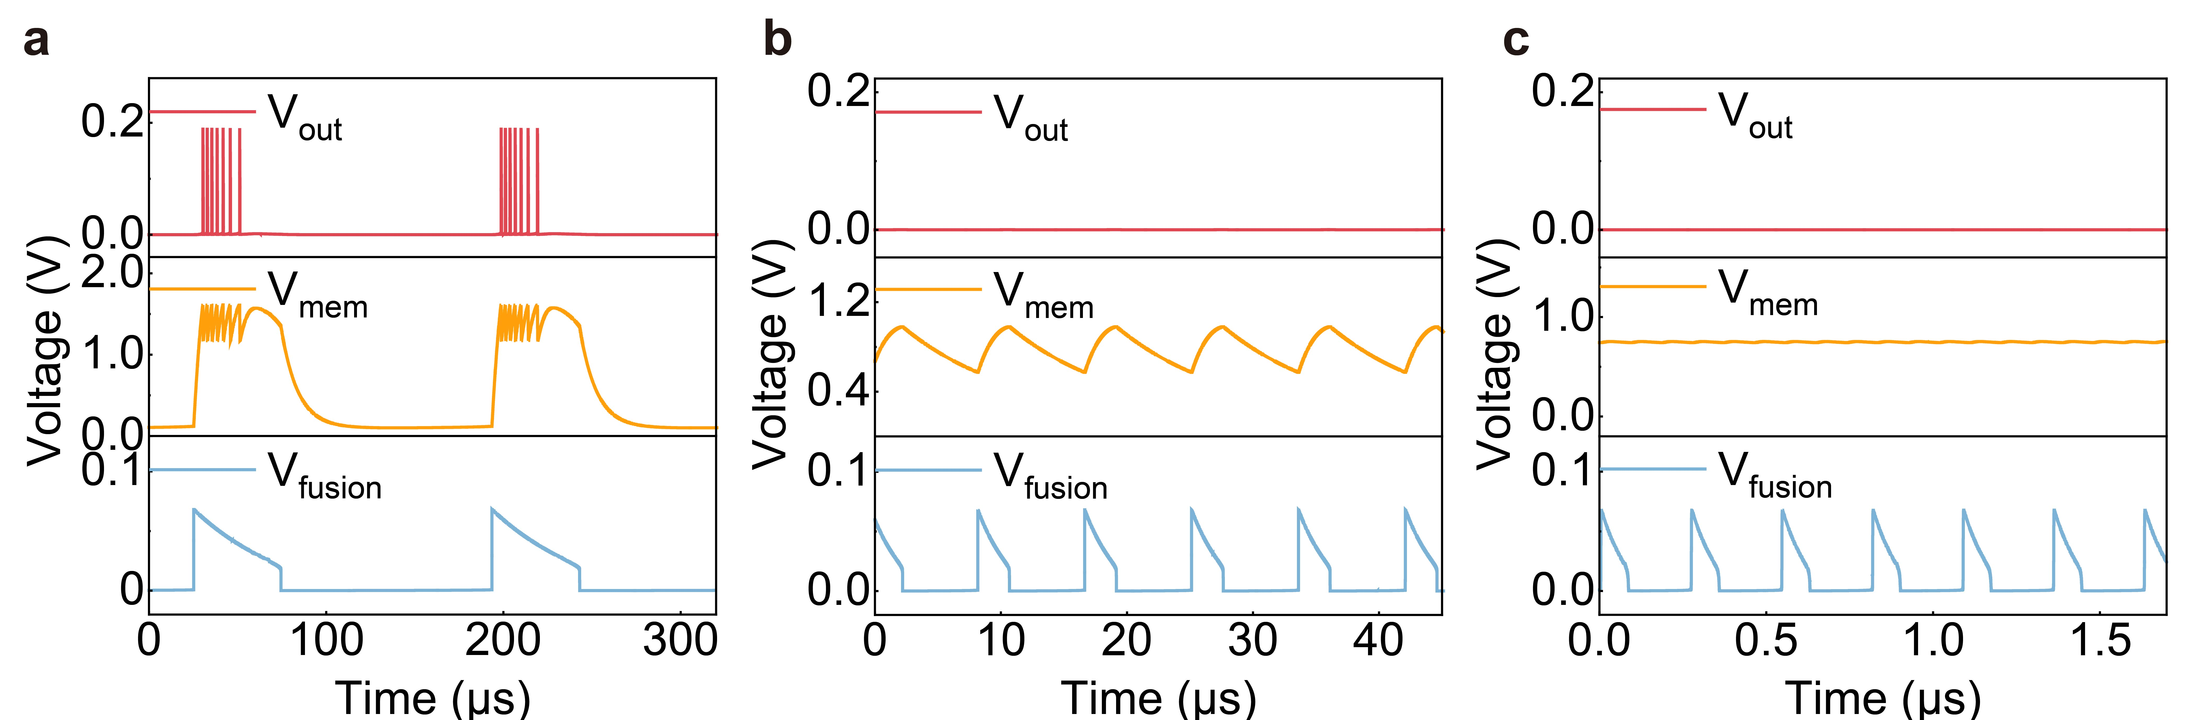
Supplementary Fig. 15. Spike behavior of the first‑layer AMIN memristor under single‑modality input. a, Low‑frequency activation drives the first‑layer AMIN memristor to its threshold, after which it switches and discharges slowly, generating spikes with a sharp rise and gradual decay. The amplified V_{fusion} surpasses the interneuron firing threshold, initiating a burst in which the spike intervals increase over time. b, Mid‑frequency activation produces the same spike waveform at the memristor output, but the amplified V_{fusion} does not reach the firing threshold. The V_{mem} shows a temporary voltage increase that relaxes without firing. c, High‑frequency activation raises the V_{mem}, but the amplified V_{fusion} remains below the firing threshold, resulting in no spike output.
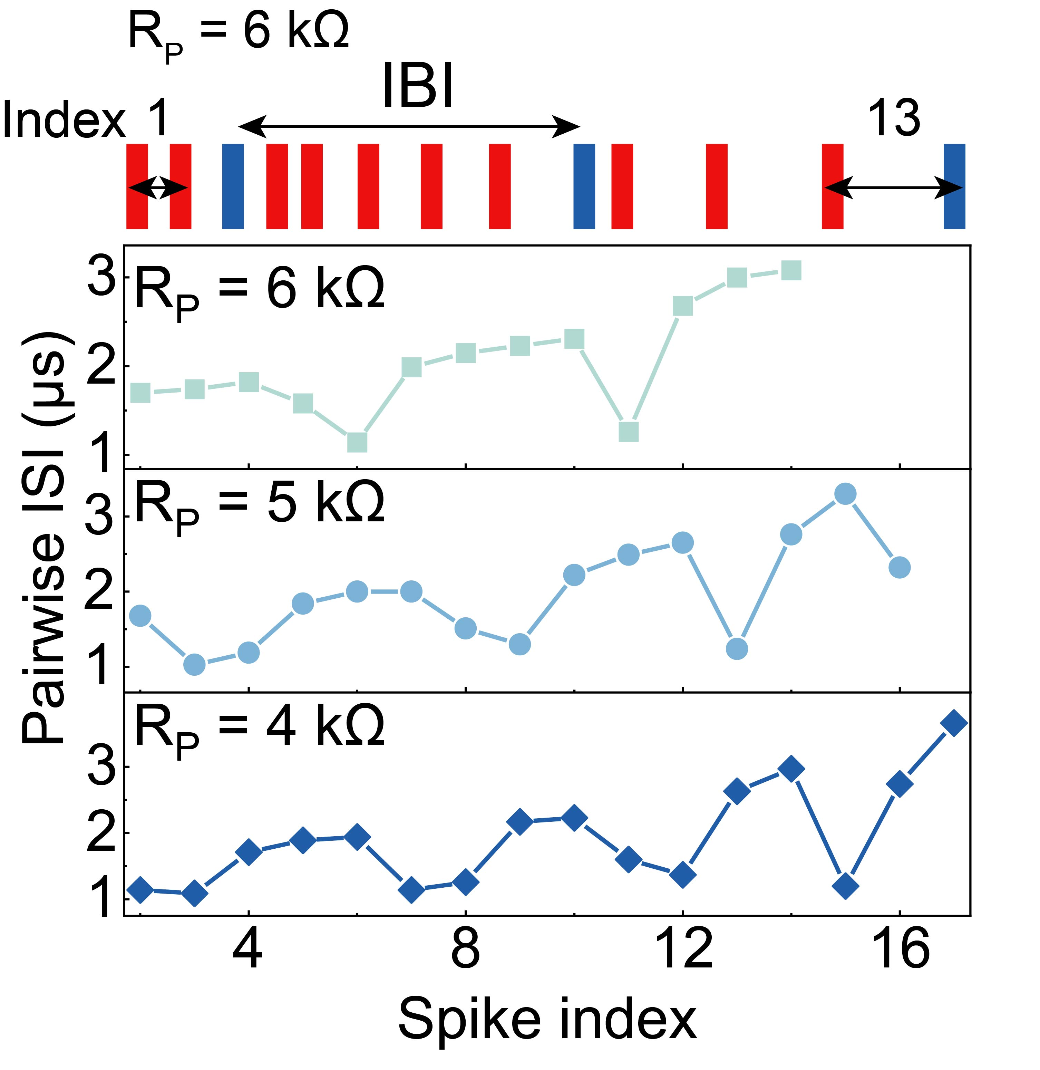
Supplementary Fig. 16. Modulation of intra-burst intervals (IBI). Low-frequency input drives the first-layer NbO_{x} memristor to generate a burst of spikes with gradually increasing pairwise inter-spike intervals (ISI). The IBI is defined as the interval between the densest clusters of spikes within a burst. As R_{P} decreases from 6 kΩ to 4 kΩ, the additional current path accelerates charging, inserting more spikes into the burst and creating multiple local spike clusters, which shortens the IBI.
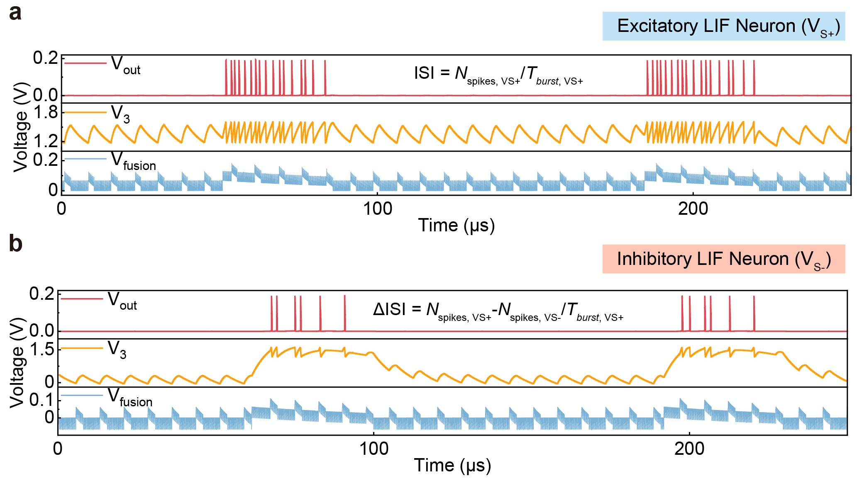
Supplementary Fig. 17. LTspice simulation of the input–output characteristics of the excitatory and inhibitory AMIN. The bottom, middle, and top traces show the fused input voltage (V_{fusion}), membrane potential (V_{mem}), and output spikes (V_{out}), respectively. As the input amplitude increases, the membrane potential accumulates and triggers burst firing once it exceeds the threshold. With a positive DC bias (V_{S+} = 3 V), the neuron operates in an excitatory mode. Under a negative DC bias (V_{S−} = −3 V), it switches to an inhibitory mode and produces fewer spikes than in the excitatory state. ΔISI is defined as the difference between the number of spikes under excitatory (N_{spikes, VS+}) and inhibitory bias (N_{spikes, VS−}), divided by the burst duration under excitatory conditions (T_{burst, VS+}).

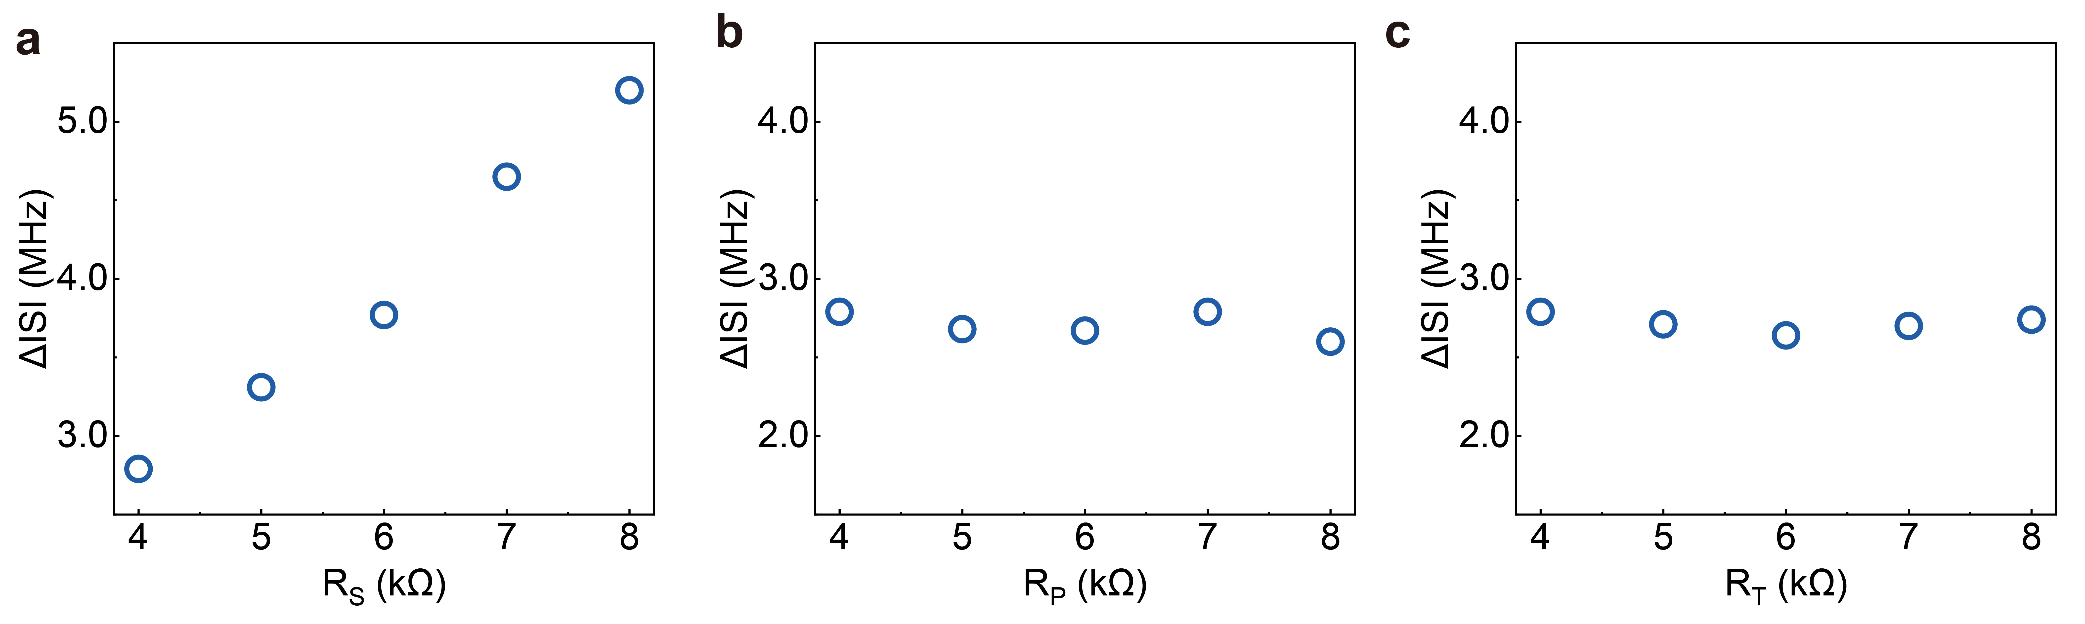
Supplementary Fig. 18. ΔISI modulation by RS enables modality decoupling. a, ΔISI varies strongly with R_{S}, indicating that the spike interval difference between excitatory and inhibitory states is predominantly regulated by the strain channel. b,c, ΔISI remains nearly constant when R_{P} (b) and R_{T} (c) are varied, confirming minimal contribution from the pressure and temperature channels. Both ISI and ΔISI are influenced by R_{S} due to membrane potential elevation in the excitatory state, which increases the N_{spikes}, while in the inhibitory state N_{spikes} decreases. The IBI and MBI remains nearly unchanged between the two states. Therefore, computing ΔISI between opposite bias polarities removes IBI and MBI contributions and extracts the ISI component solely controlled by RS, enabling effective decoupling of modality-specific features.

Supplementary Table 1. SPICE model parameters for NbO_{x} devices.
Physical quantity | Symbols | Values | Units
Thermal capacitance | C_{th} | 1.50E-16 | J/K
Thermal conductance | Γ_{th} | 5.70E-07 | W/K
Boltzmann’s constant | k | 1.38E-23 | J/K
Activation energy | Ea | 0.225 | eV
Electron charge | q | 1.60E-19 | C
Fitting constant | R₀ | 512 | Ω
Vacuum permittivity | ε₀ | 8.85E-12 | F/m
Relative permittivity | ε_{r} | 45
Oxide thickness | t_{ox} | 40 | nm
Ambient temperature | T_{amb} | 298 | K

Supplementary Table 2. Circuit parameters used for simulation in the AMINs-SNN.
Parameter | Value
R_{off} | 64.18 kΩ
R_{on} | 1.50 kΩ
V_{th} | 1.4 V
V_{hold} | 0.9 V
R_{0_fusion} | 40 Ω
R_{0_out} | 100 Ω
A_{v} | 45
C_{T} | 0.15 nF
C_{P} | 5.5 nF
C_{S} | 50 nF
R_{S} | 4–10 kΩ
R_{P} | 5-15 kΩ
R_{T} | 5 kΩ (45 °C) , 6 kΩ (25 °C) , 8 kΩ (10 °C)
V_{in} (V_{S}, V_{P}, V_{T}) | 3.0 V
Total time (T_{total}) | 2000 µs
Samples (N) | 50,000

