Supplementary Information to Soliton-Assisted Massive Signal Broadcasting via Exceptional Points
Zhuang Fan^{1†}, Yukun Huang^{1†}, Wenchan Dong^{1†}, Haodong Yang¹, Jiahao Hu², Yizheng Chen¹, Hanghang Li¹, Nuo Chen¹, Heng Zhou^{2,4}, Jing Xu^{1,3,5} and Xinliang Zhang^{1,3,6}
¹School of Optical and Electronic Information and Wuhan National Laboratory for Optoelectronics, Huazhong University of Science and Technology, Wuhan 430074, China
²Key Lab of Optical Fiber Sensing and Communication Networks, School of Information and Communication Engineering, University of Electronic Science and Technology of China, Chengdu 611731, China
³Optics Valley Laboratory, Hubei 430074, China
⁴Corresponding author: zhouheng@uestc.edu.cn
⁵Corresponding author: jing_xu@hust.edu.cn
⁶Corresponding author: xlzhang@hust.edu.cn
†These authors contributed equally
Context
S1. Theoretical frameworks of the coupled cavity system 2
S2. Extraction of cavity parameters 5
S3. Analytical description of the field enhancement 6
S4. Numerical simulation of soliton crystal generation and broadcasting 7
S5. Conversion efficiency of broadcast signals 13
S6. Extended experimental results of broadcast signals 15
S7. Measurement of broadcasting bandwidths 18
S8. Phase noises of comb lines and broadcast lights 20
Reference 23

S1. Theoretical frameworks of the coupled cavity system
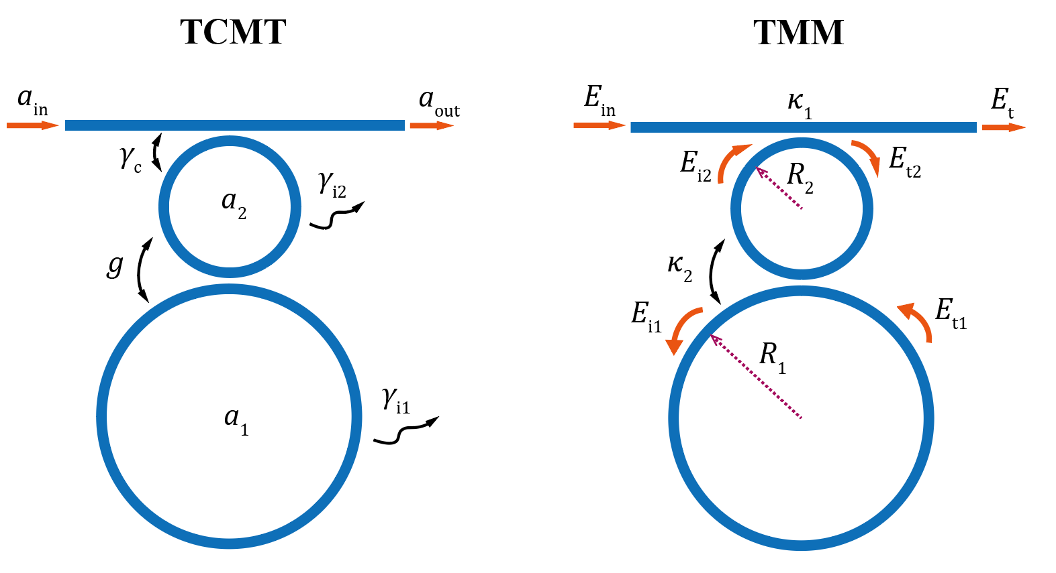
Fig. S1. Schematic diagrams of TMM and TCMT of the coupled cavity system
Two primary theoretical frameworks for describing coupled cavity are briefly described here, i.e., the Temporal Coupled-Mode Theory (TCMT) and the Transfer Matrix Method (TMM)^{1,2}. TCMT provides an intuitive physical description of the Hamiltonian of the system, whereas TMM allows for more precise extraction of cavity parameters (e.g., coupling strength, loss) from experimental data such as transmission spectra and is particularly suitable for estimating the field enhancement in coupled resonators.
Fig. S1 presents the schematic diagrams of the theoretical frameworks of the coupled cavity, with the meanings of different symbols annotated in the illustration. For the TCMT, we define the intracavity mode field of the main cavity as $a_{1}$, the intracavity mode field of the auxiliary cavity as $a_{2}$, the resonance frequency as $ω_{0}$, the energy coupling rate between the main cavity and the auxiliary cavity as $g$, the coupling rate between the auxiliary cavity and the bus waveguide as $γ_{c}$, the intrinsic decay rates of the main cavity and auxiliary cavity as $γ_{1}$ and $γ_{2}$, the input field as $a_{in}$, and the output field as $a_{out}$.
The coupled mode equations can be written as:
$$\begin{aligned}\begin{matrix}\frac{da_{1}}{dt}=-iω_{0}a_{1}-\frac{γ_{1}}{2}a_{1}-{iga}_{2}, \\ \begin{matrix}\frac{da_{2}}{dt}=-iω_{0}a_{2}-\frac{γ_{2}+γ_{c}}{2}a_{2}-{iga}_{1}-\sqrt{γ_{c}}a_{in}, \\ a_{out}=a_{in}+\sqrt{γ_{c}}a_{2}.\end{matrix}\end{matrix}\#(S1)\end{aligned}$$
When the two cavities possess identical intrinsic decay rates $γ_{1}=γ_{2}=γ_{0}$ and the system is operating in the vicinity of the EP, i.e., $γ_{c}≈4g$, the resulting non-Hermitian Hamiltonian is given by $\hat{H}=\left[\begin{matrix}ω_{0}-i\frac{γ_{1}}{2} & g \\ g & ω_{0}-i\frac{γ_{2}+γ_{c}}{2}\end{matrix}\right]$. The eigen-frequencies can be calculated as $ω_{+}=ω_{-}≈ω_{0}-{i\left(γ_{1}+γ_{2}\right)}/2-iγ_{c}/4$, with corresponding eigenvector $\left.|1,2\right\rangle =(1,-i)$, forming the broad resonances, i.e., low-Q modes, in the main text. Actually, the synthesized linewidth is maximized in the PT-symmetric regime but close to EP due to the merging effect of two splitting mode peaks, giving a linewidth of $γ_{c}$. Details can be found in the supplementary material of Ref. [3].
The Transfer Matrix Method (TMM) accounts for the phase change and loss introduced when light propagates one full round in the microresonators. Under the condition that the lossless approximation is applied in the coupling region—i.e., assuming the coupling process is an energy-conserving process—the following equation can be derived for the coupled double cavities described above³:
$\left[\begin{matrix}E_{t} \\ E_{t2}\end{matrix}\right]=\left[\begin{matrix}r_{1} & -iκ_{1} \\ -iκ_{1} & r_{1}\end{matrix}\right]\left[\begin{matrix}E_{in} \\ E_{i2}\end{matrix}\right]$, (S2)
$\left[\begin{matrix}E_{i1} \\ E_{i2}{a_{2}}^{-\frac{1}{2}}e^{-i\frac{φ_{2}}{2}}\end{matrix}\right]=\left[\begin{matrix}r_{2} & -iκ_{2} \\ -iκ_{2} & r_{2}\end{matrix}\right]\left[\begin{matrix}E_{i1}a_{1}e^{iφ_{1}} \\ E_{t2}{a_{2}}^{\frac{1}{2}}e^{i\frac{φ_{2}}{2}}\end{matrix}\right]$, (S3)
where $E_{in}$ is the input field, $E_{t}$ is the output field at the bus waveguide, $κ_{1}$is the field coupling coefficient between the auxiliary resonator and the waveguide, $κ_{2}$ is the field coupling coefficient between the resonators, $r_{j=1,2}$is the transmission coefficient, and ${r_{i}}^{2}+{κ_{i}}^{2}=1$. $E_{i1}, E_{t1}$ are the fields in the main resonator, $E_{i2}, E_{t2}$ are the fields in the auxiliary resonator. $a_{i=1,2}=e^{-α_{0}L_{i}/2}$ are the roundtrip field attenuation factor of the resonators, where $α_{0}$ is the transmission loss per unit length, $φ_{i=1,2}$ are the phase shift of input light traveling per roundtrip in the resonators, and indices 1 and 2 refers to the main and auxiliary resonator, respectively. The conversion relationship between parameters of the TMM and TCMT is listed in Tab. S1. More information about the comparison between two methods is given in Ref. [3].
Tab. S1: The relationships between the parameters of the TMM and TCMT *.
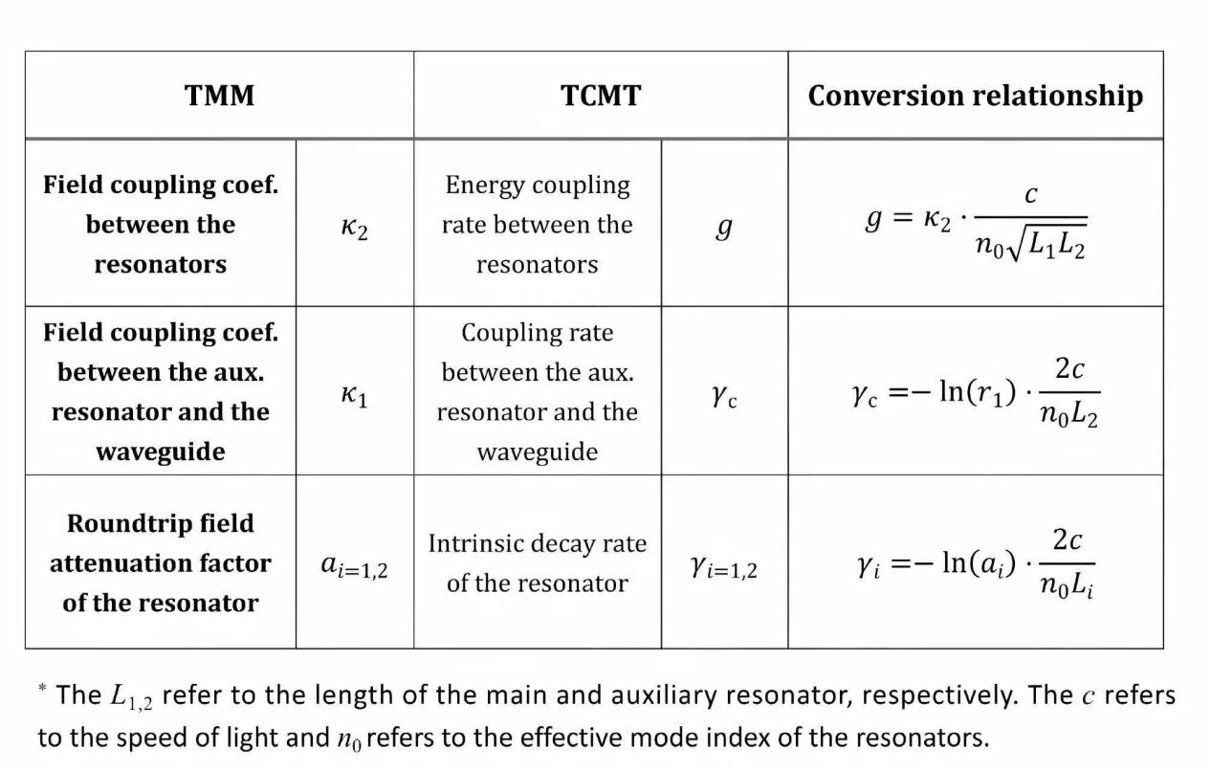
As shown in Fig. 2(a) and 2(b), the electric field distributions for the low-Q and high-Q modes (e.g. the broad and narrow resonances shown in Fig. 2(a)) are calculated through a finite-element analysis, respectively. Figure S2(a) shows field distributions of the low-Q modes that are used for input signal and broadcast signals, indicating equal strength of field enhancement in both cavities. Figure S2(b) illustrates the field distributions of the high-Q mode, where the pump energy is mostly confined in the main resonator. Therefore, the four-wave mixing among pump light, input signal as well as broadcast signals is expected to occur dominantly in the main cavity.
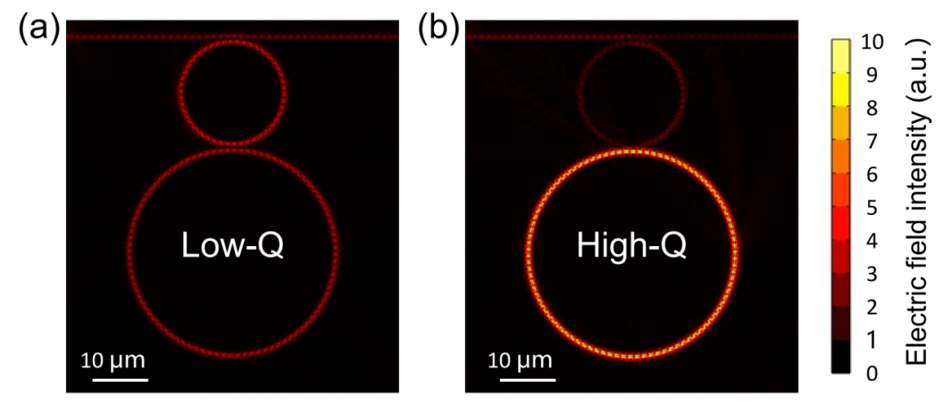
Fig. S2. Normalized intracavity field distribution simulated by finite-element method. (a) Intracavity field distribution of the low-Q mode. (b) Intracavity field distribution of the high-Q mode.

S2. Extraction of cavity parameters
From Eq.(S2) and Eq.(S3), the transmission spectrum of the coupled cavity can be derived as:
$$\begin{aligned}T={\left|\frac{E_{out}}{E_{in}}\right|}^{2}={\left|\frac{r_{2}-a_{1}τexp\left({iφ}_{1}\right)}{1-r_{2}a_{1}τexp\left({iφ}_{1}\right)}\right|}^{2},\#(S4)\end{aligned}$$
where $τ=\frac{r_{1}-a_{2}τexp\left({iφ}_{2}\right)}{1-r_{1}a_{2}τexp\left({iφ}_{2}\right)}.$
In order to extract the microcavity coupling parameters, the experimental transmission spectrum was fitted using Eq.(S4), as shown by the dashed line in Fig. S3. The fitting yields the following values: $r\text{₁ = 0.9}\text{84}$,$r\text{₂ = 0.9}\text{04}$, ${\text{a}}_{\text{1}}\text{ = 0.997}$, ${\text{a}}_{\text{2}}\text{ = 0.9985}$ and ${\text{L}}_{\text{1}}\text{ =}{\text{2}\text{L}}_{\text{2}}\text{= 1508 μm}$. The initial design parameters are$r\text{₁ = 0.9}\text{71}$, $r\text{₂ = 0.}\text{907}$, and ${\text{L}}_{\text{1}}\text{ =}{\text{2}\text{L}}_{\text{2}}\text{= 150}\text{2}\text{ μm}$, showing good agreement with the extracted parameters. Then, by applying the relationship outlined in Table 1, the parameters for the TCMT are derived as follows: ${\text{γ}}_{1}\text{=} {\text{γ}}_{2}\text{= 0.6 GHz}$, ${\text{γ}}_{\text{c}}\text{ = 98 GHz}$, $g\text{ = 25 GHz}$.
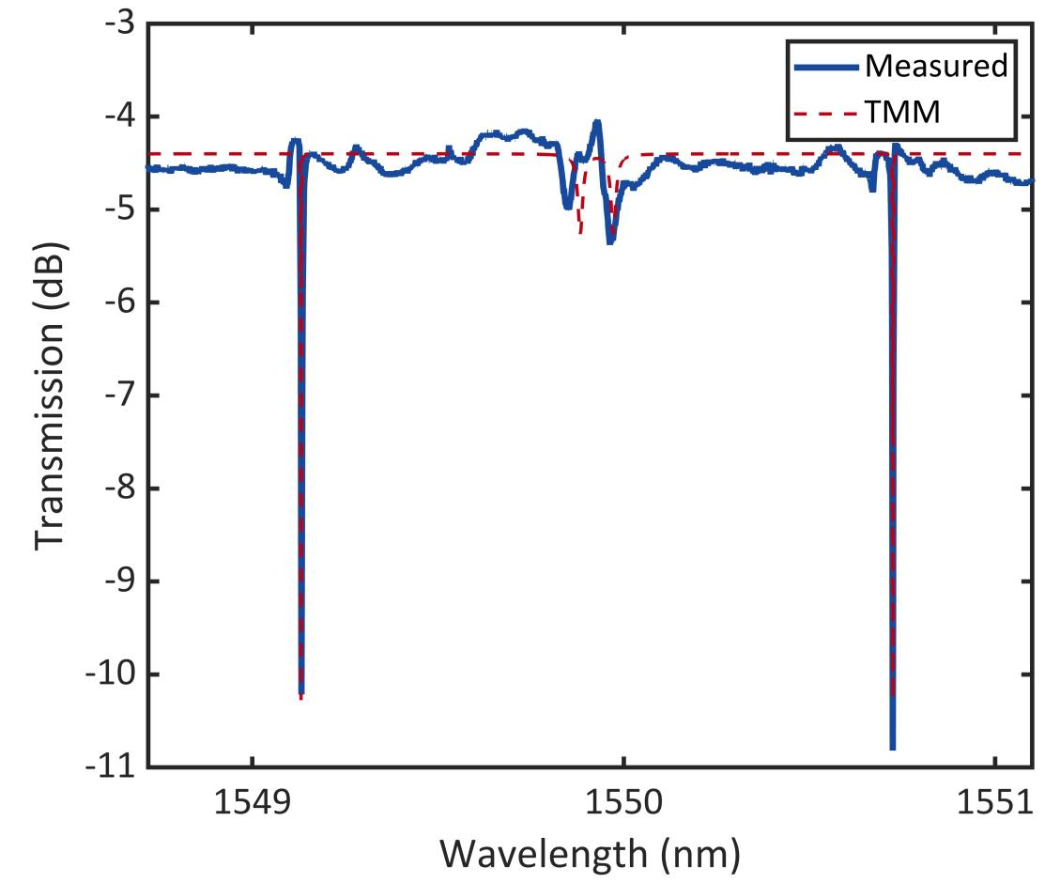
Fig. S3. Comparison of the measured transmission spectrum with the TMM analytical fit.

S3. Analytical description of the field enhancement
From Eq.(S2) and Eq.(S3), the field enhancement factor in the main cavity, which is defined as $\left|\frac{E_{i1}}{E_{in}}\right|$, can be derived as:
$FE=\left|\frac{-κ_{1}κ_{2}\sqrt{a_{2}}\exp{(}iφ_{2}/2)}{1-r_{2}a_{1}\exp{(}iφ_{1})-r_{1}r_{2}a_{2}\exp{(}iφ_{2})+r_{1}a_{1}a_{2}\exp{(}iφ_{1}{+iφ}_{2})}\right|$. (S5)
Based on the above expression, the field enhancement of the high-Q (narrow) and low-Q (broad) resonances can be calculated by substituting specific parameters extracted from experimental results, as shown in Fig. S4. For consistency, broad resonances are used instead of low-Q modes/resonances in the following text when describing signal broadcasting related information. Note that the field enhancements are functions of wavelength, where the enhancement at central wavelength of the narrow and broad resonances, i.e., ${FE}_{n}$ and ${FE}_{b}$, respectively, are frequently used in the following analysis.
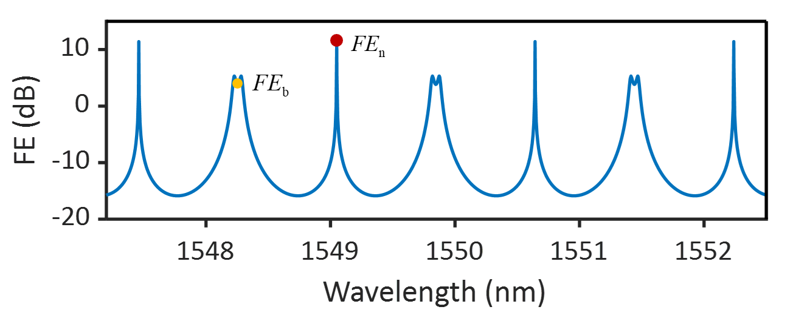
Fig. S4. The field enhancement of the main cavity in the coupled microcavity

S4. Numerical simulation of soliton crystal generation and broadcasting
Soliton crystal generation
To carry out simulations for DKS comb generation, an assumption is used by noting the fact that high-Q resonances are used for DKS generation where the pump and comb energy are most confined in the main resonator. Therefore, numerical simulations of the optical frequency comb generation are performed by applying the Lugiato-Lefever equation (LLE)⁴ in an all-pass single resonator. The size of the single resonator is set equal to that of the main resonator, while the intrinsic loss $α_{0}$ and the second-order dispersion term of the single resonator are taken the same as those of the main resonator. The Raman self-frequency shift, self-steepening effect, and thermal effect are neglected. The specific form of the LLE equation is given as follows⁵:
$i\frac{∂A}{∂ϕ}=-\frac{iα}{2}A-iΔA+\frac{β_{2}}{2}\frac{∂^{2}A}{∂T^{2}}-γ{\left|A\right|}^{2}A+κA_{\text{in}}$, (S6)
where $A=A(ϕ,T)$ is the complex field amplitude in the microresonators; $ϕ$ is the circular angle; $α$ is the intrinsic loss of the waveguide; $Δ$ is the detuning values between the pump and the cavity modes; $β_{2}$ is the group velocity dispersion; $T$ is the time; $γ$ is nonlinear coefficients; $κ$ is the field coupling strengths between the bus waveguide and the microresonator, which is set to ensure that the simulated Q-factor matches the Q-factor of the narrow resonance in the PT resonator; $A_{\text{in}}$ is the amplitude of the input pump light in the bus waveguide.
Simulations using continuous-wave pump light with frequency sweeping from blue detuning to red detuning show that the resulting soliton states are strongly correlated with noise, making it impossible to deterministically control the number of generated solitons and their distribution positions within the cavity. To obtain perfect soliton crystals (PSCs) on demand, the initial input field is composed of several equally spaced Gaussian pulses, which are switched to continuous light at a specific time. For the simulations presented in Fig. 3 of the main text, the corresponding parameters are given as follows: $α=12$dB/m, $L=1508$ $μm$, $n_{g}=1.991$, $κ = 0.0632$, $β_{2} = -100$ ps²/km, $γ = 1$ W⁻¹/m. The simulation results for 4-soliton crystal generation are presented in Fig. S5. Using the aforementioned method, we can also obtain PSCs for other soliton numbers. The numerical simulations of 2-, 4-, and 6-soliton crystal are shown in Fig. S6.

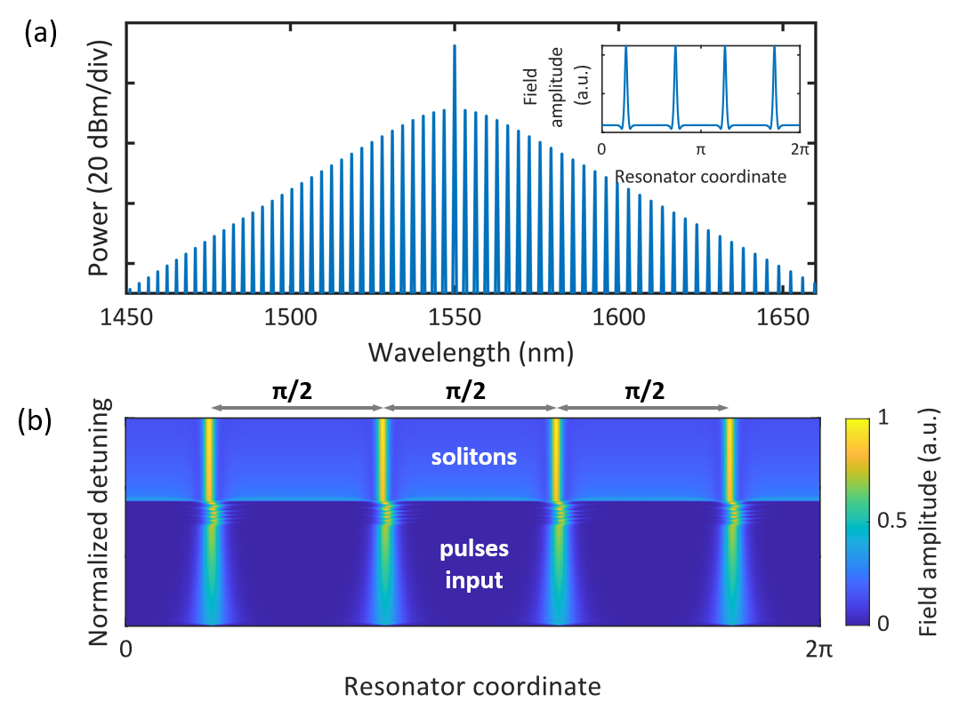
Fig. S5. Numerical simulation of soliton crystal generation (a) Output optical spectrum and temporal pulses of soliton crystal state (b) Temporal evolution from input pulses to 4-soliton crystal state.
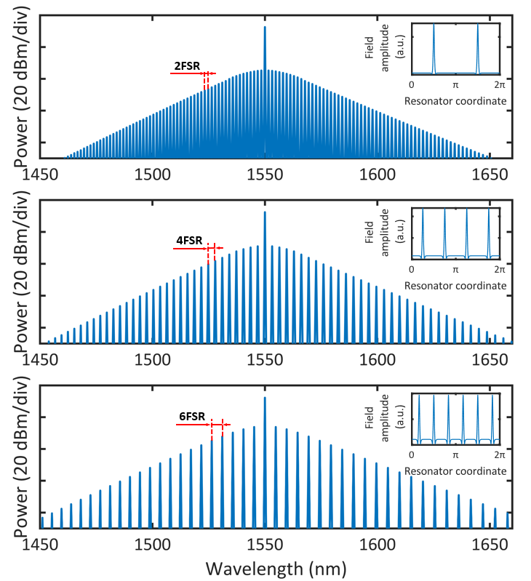
Fig. S6. Numerical simulation of 2-, 4-and 6-soliton crystal.
Signal broadcasting
Directly considering the FWM processes of solitons and signals within coupled cavity is complex; thus, we propose a simplified model for the simulation of signal broadcasting, termed the field-enhanced weighting model. Firstly, during the organization of the soliton crystal, the internal electric field of the main resonator is acquired via the aforementioned method. Secondly, the electric field of the soliton comb in the cavity, $E_{sol}$, and the signal light, $E_{sig}$, with a certain weighting factor are launched into a section of nonlinear waveguide for propagation (named “effective waveguide” in the following). The weighting factor applied to the signal is equal to the maximum field enhancement of the broad resonances (i.e., ${FE}_{b}$ as shown in Fig. S4). Therefore, the optical field at the input of the effective waveguide can be written as:
$A\left(0,t\right)=E_{sol}+E_{sig}⋅{FE}_{b}$. (S7)
The length of the effective nonlinear waveguide is equal to the circumference of the main cavity, i.e., $z_{end}=2πR_{1}$. The model used to describe light transmission in the waveguide is Nonlinear Schrödinger Equation (NLSE)⁶:
$i\frac{∂A}{∂z}+\frac{iα}{2}A-\frac{β_{2}}{2}\frac{∂^{2}A}{∂T^{2}}+γ{\left|A\right|}^{2}A=0$. (S8)
The optical field at the output of the effective waveguide can be written as
$A\left(z_{end}\right)=A_{sol}\left(z_{end}\right)+A_{sig}\left(z_{end}\right)+A_{bc}\left(z_{end}\right),$ (S9)
where the right terms of Eq. (S9) refers to the soliton field ($A_{sol}$), signal field ($A_{sig}$) and a third field generated by nonlinear processes ($A_{bc})$, which contains the broadcast lights.
Next, we consider the real output optical field, $E_{out}$, from the PT cavities, i.e., the output optical field from the bus waveguide. Due to field enhancement in the main resonator, the first two fields must be divided by ${FE}_{n}$ and ${FE}_{b}$, respectively, while the last field is derived by carrying out a convolution to give the total output field $E_{out}$:
$E_{out}=\frac{A_{sol}\left(z_{end}\right)}{{FE}_{n}}+\frac{A_{sig}\left(z_{end}\right)}{{FE}_{b}}$+$A_{bc}\left(z_{end}\right)*F^{-1}\left[τ(ω)\right]$. (S10)
In Eq.(S10), $τ\left(ω\right)=\frac{κ(ω)a_{1}e^{-iφ_{1}}}{1-a_{1}\sqrt{1-{κ\left(ω\right)}^{2}}e^{-iφ_{1}}}$is introduced to account for the multi-turn interference of the cavity-generated field before coupling out. $F^{-1}\left[τ\left(ω\right)\right]$ refers to the inverse Fourier transform of $τ\left(ω\right)$ and symbol $*$ represents convolution. Here, $κ\left(ω\right)=-\frac{κ_{1}κ_{2}\sqrt{a_{2}}e^{-iφ_{2}/2}}{1-a_{2}r_{1}r_{2}e^{-iφ_{2}}}$ denotes an effective field coupling coefficient when considering the auxiliary cavity and waveguide as a subsystem.
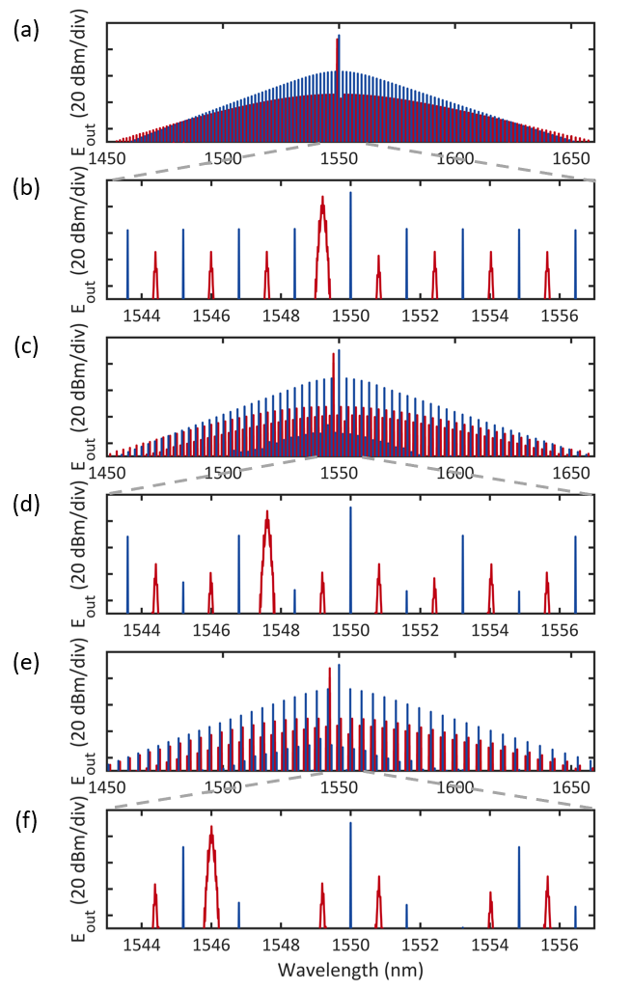
Fig. S7. Numerical simulation of signal broadcasting assisted by 2-, 4-and 6-soliton crystals

Figure S7 shows the simulated output spectra of the bus waveguide. Equation (S8) is solved with the fourth-order Runge-Kutta method. Figure S7(a), S7(c) and S7(e) are also presented in Fig. 3(d) of the main text. The corresponding parameters are given as follows: $α=12$dB/m, $z_{end}=1508$ $μ\text{m}$, $β_{2} = -100$ ps²/km, $γ = 1$ W⁻¹/m. It can be seen that the simulation results show perfect agreement with the experimental observations (Fig. 4(b) in the main text).
Based on this model, we investigate the two phenomena observed in the experiments. Before we proceed, it needs to be clarified that the broadcast channels can be classified into two groups, i.e., group one where all the broadcast channels lie on the right side of the nearest comb lines (named channel R), and group two where all the broadcast channels lie on the left side of the nearest comb lines (named channel L). The field $A$ can be decomposed into two components: the comb ($A_{c}$) and the signal ($A_{s}$), i.e.,
$A=A_{c}+A_{s}$, (S11)
and the nonlinear term can be expanded as
${\left|A\right|}^{2}A={\left|A_{c}\right|}^{2}A_{c}+{\left|A_{s}\right|}^{2}A_{s}+2({\left|A_{c}\right|}^{2}A_{s}+A_{c}{\left|A_{s}\right|}^{2})+{A_{c}}^{2}A_{s}+A_{c}{A_{s}}^{2}$ . (S12)
Equation (S12) is the key to understand the behavior of the broadcasting phenomena.
First, the optical power of the channel R is higher than that of the channel L. This is due to the fact that the nonlinear term contributes differently to the optical power of the two channel groups: the term $2{\left|A_{c}\right|}^{2}A_{s}$ contributes to the optical power of the multicast channels belonging to the same group as the signal light, while the term ${A_{c}}^{2}A_{s}$contributes to the other channels. It is evident that the amplitude of the former term is twice that of the latter, resulting in a fourfold difference in optical power.
Second, channel Ch19 positions symmetrically to the signal light with respect to the pump light exhibits lower optical power than its adjacent channels. This phenomenon arises because the comb phase undergoes an abrupt jump at the pump mode, which arises from the difference of self-phase modulation experienced by the pump mode and the cross-phase modulation experienced by other modes. As shown in Fig. S8, by manually adjusting the phase of pump mode in numerical simulation, the channel positioned symmetrically to the signal light will no longer exhibit such distinctive behavior.
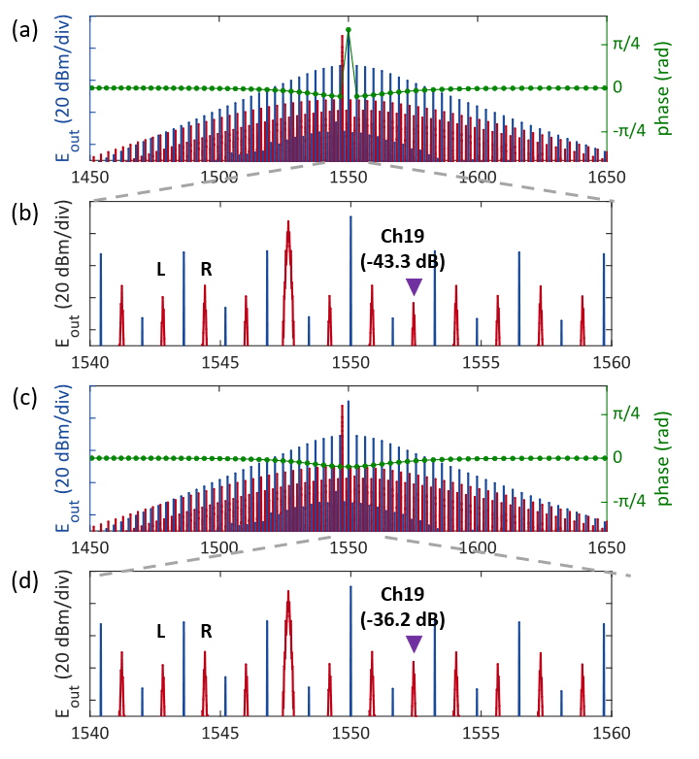
Fig. S8. Numerical simulation of massive signal broadcasting (a) Output optical spectrum of broadcast. The green dots indicate the related phase of soliton comb. (b) Zoomed-in Optical spectrum around 1550 nm. The purple triangle marks the location of Ch19. The spectra after deliberately adjusting the pump phase are shown in (c) and (d).

S5. Conversion efficiency of broadcast signals
In this section we give the derivation of Eq. (1) given in the main text. In this derivation, the pump light is assumed to work in the un-depletion regime since the broadcasting scenario does not enter into the amplification regime. First, we consider the case that the pump light is a continuous-wave (CW). The four-wave mixing conversion efficiency, ${CE}_{cw}$, in the main resonator is given by the following formula⁷
$$\begin{aligned}{CE}_{cw}={\left(γP_{p}L_{eff}\right)}^{2}{{PE}_{p}}^{2}{PE}_{s}{PE}_{i},\#(S13)\end{aligned}$$
where
$$\begin{aligned}{L_{eff}}^{2}=L^{2}e^{-αL}{\left|\frac{1-e^{-αL}}{αL}\right|}^{2}.\#(S14)\end{aligned}$$
The nonlinear coefficient is represented by $γ$, and the pump power is denoted by $P_{p}$. ${PE}_{p}$, ${PE}_{s}$, and ${PE}_{i}$ represent the power enhancement factors for the pump, signal, and idler waves, respectively. In our configuration, the pump is coupled into a narrow resonance, while the signal and idler light are located in the broad resonances. Consequently, ${PE}_{p}={PE}_{n}={\left|{FE}_{n}\right|}^{2}$ and ${PE}_{s}={PE}_{i}={PE}_{b}={\left|{FE}_{b}\right|}^{2}$, where $\left|{FE}_{n}\right|$ and $\left|{FE}_{b}\right|$ are described in SI-III and indicated in Fig. S4. $L$ is the circumference of the main resonator.
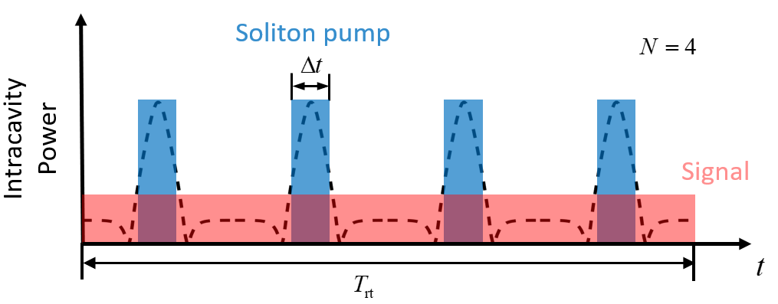
Fig. S9. Schematic diagram of the model used for the CE calculation of soliton-based signal broadcasting
When the soliton acts as the pump, as illustrated in Fig. S9, we treat it as a rectangular pulse with a constant power of ${\frac{π}{2}∙P}_{p}∙{PE}_{n}$ over its duration $Δt$, while neglecting the power of the background field⁸. Within this soliton duration, the power of the converted light can be calculated using the continuous-wave formula given by Eq. (S13). Since the signal-to-idler conversion occurs only during the soliton duration, the conversion efficiency when using the soliton as the pump must be multiplied by the soliton duty cycle $\frac{N∙∆t}{T_{rt}}$, where $N$ represents the number of solitons. Additionally, assuming the converted optical power is evenly distributed among all the comb lines within the spectrum, the final conversion efficiency must be divided by the number of soliton comb lines $\frac{∆f}{N∙FSR}$, where $∆f$ is the spectral width of the soliton and satisfies the relation $∆f=\frac{1}{Δt}$. Consequently, the broadcast conversion efficiency per individual broadcast light can be approximated as：
$$\begin{aligned}\begin{matrix}CE={{CE}_{cw}∙ \frac{N∙∆t}{T_{rt}}}/{\left(\frac{∆f}{N∙FSR}\right)} \\ ={\left(γP_{p}ηL_{eff}{PE}_{n}{PE}_{b}\right)}^{2}N^{2}\end{matrix}\#(S15)\end{aligned}$$
where $η=\frac{π∆t}{2T_{rt}}=\frac{πFSR}{2∆f}.$ Note that $η$ has the physical meaning of pump-to-soliton conversion efficiency, as mentioned in Ref. [8].

S6. Extended experimental results of broadcast signals
In the broadcasting experiment, we use an EDFA for amplification and a tunable filter to amplify and remove ASE noise of the broadcast channels, respectively. The power of the broadcast signal reaching the PD is maintained at -10 dBm. The electrical signal output from the PD is then fed into an oscilloscope to display the eye diagram of the signal. The eye diagrams of the OOK signals for Ch1-46 are shown in Fig. S10. Among them, Ch16 corresponds to the original signal. As mentioned in the main text, the signal quality of Ch15, 17, and 19 is degraded due to factors such as ASE noise, resulting in unopened eye diagrams. After characterizing the broadcast performance of the OOK signals, we test the constellation diagrams and EVM of QPSK signals, by using the same experimental setup but replacing the PD and oscilloscope with a modulation format analyzer. The constellation diagrams for Ch1-22 are shown in Fig. S11.
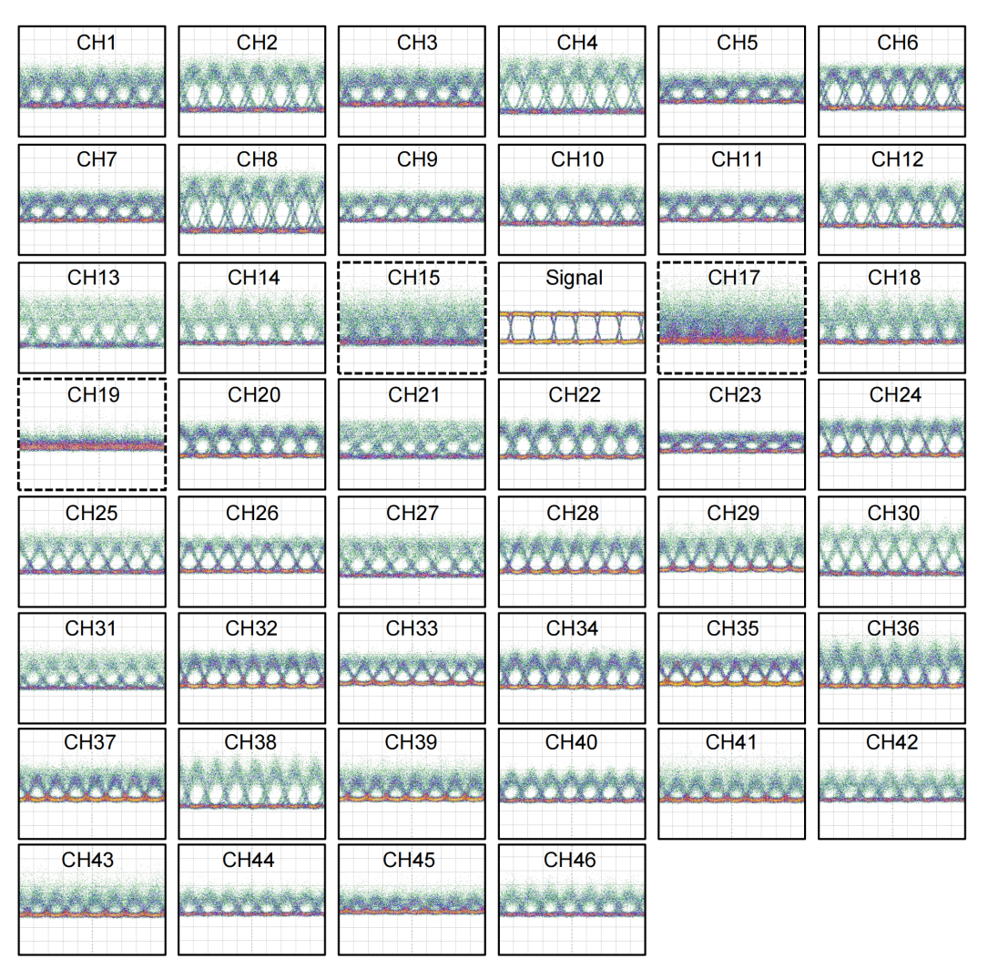
Fig. S10. Eye diagrams of Ch1-46 broadcast OOK signals
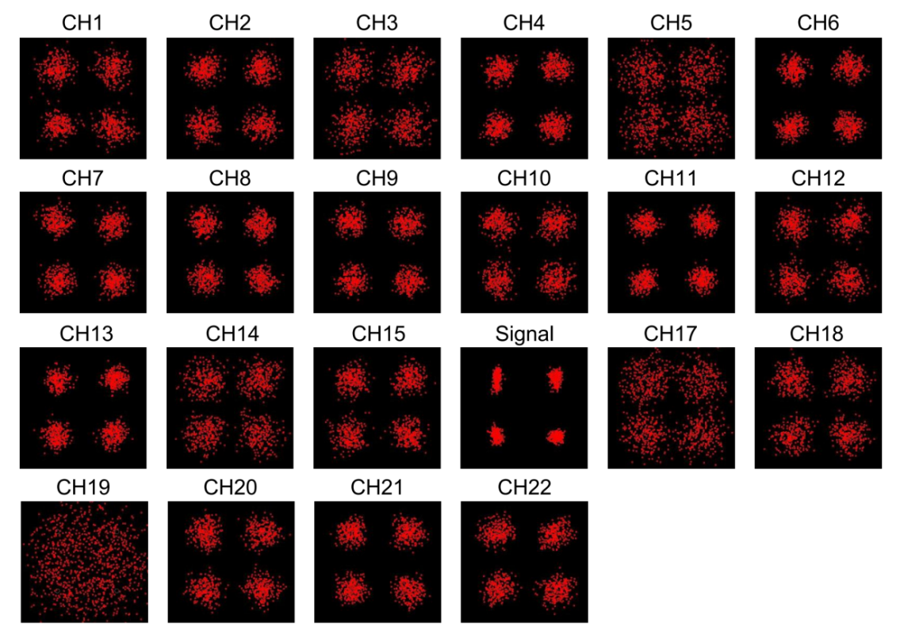
Fig. S11. Constellation diagrams of Ch1-22 broadcast QPSK signals
Subsequently, the bit error rates (BER) of Ch6, Ch26 and Ch36 under different received power levels are measured to characterize the power penalty of the broadcast process, as present in Fig. S12. The typical power penalty of the broadcast channel at BER of 3.8×10⁻³ in the C-band, as represented by Ch6, is approximately 1.9 dB. The power penalty of Ch26 and Ch36, located in the L-band, exhibits even negative power penalty at BER of 3.8×10⁻³. This is due to the utilization of an L-band optical receiver with lower noise compared to that of the C-band receiver.
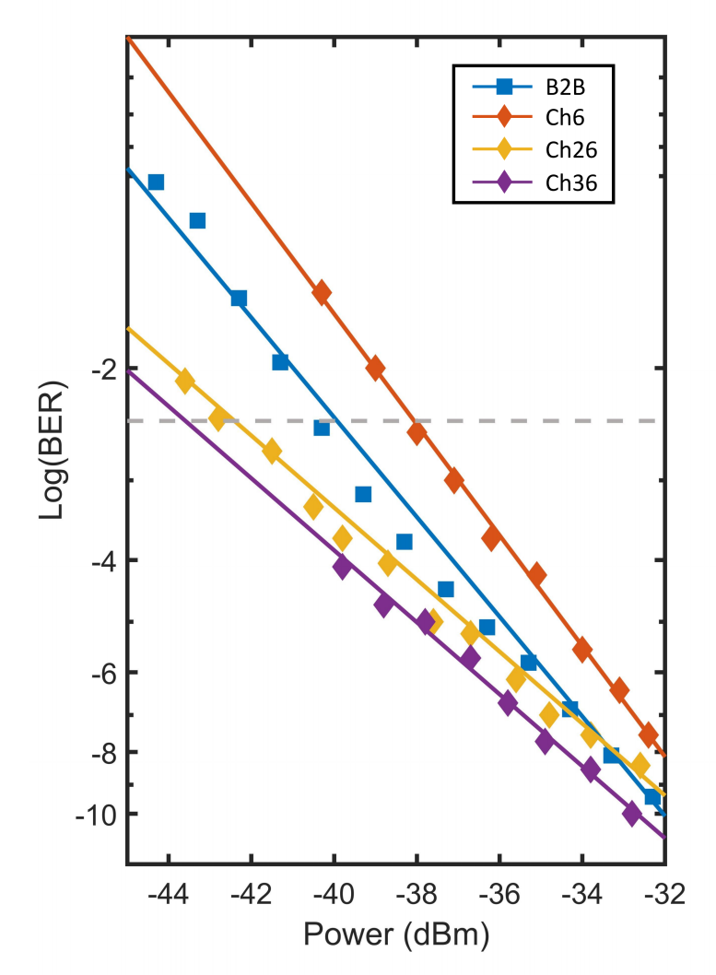
Fig. S12. BER curves of B2B and Ch6, Ch26, Ch36 broadcast OOK signals

S7. Measurement of broadcasting bandwidths
As mentioned in the main text, the transmission spectrum of broad resonance exhibits a very low extinction ratio. Consequently, direct measurement of the linewidth from this spectrum is not applicable. To address this issue, we develop the experimental characterization procedure described in the main text using the setup depicted in Fig. S13(a). This setup utilizes an oscilloscope, which synchronously acquires the wavelength of the probe laser and detects the output optical power from the TBPF.
It is important to note that prior to conducting the bandwidth measurements, the resonance peaks of the two cavities must be aligned. This alignment is achieved by varying the heater power to adjust the refractive index of the main cavity. We obtained conversion spectra at different heating levels, as shown in Fig. S13(b). It can be seen that a heater power of 80 mW was optimal for ensuring resonance alignment, which is used during subsequent bandwidth measurements and broadcast experiments. The conversion spectra for Ch1-46 are displayed in Fig. S14. It can be seen that the bandwidths of all channels are broadened to over 15 GHz. Nevertheless, the measured conversion spectra of Ch15-17 exhibit exceptionally high noise level due to un-filtered ASE noise from the pump, degrading their performances in the system-level testing experiments.
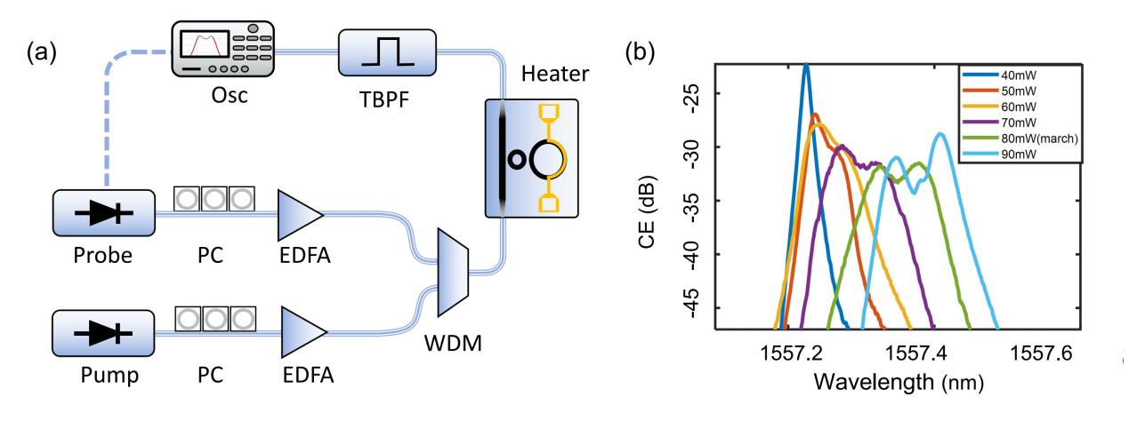
Fig. S13. Experimental setup for measuring the bandwidths of broad resonances.

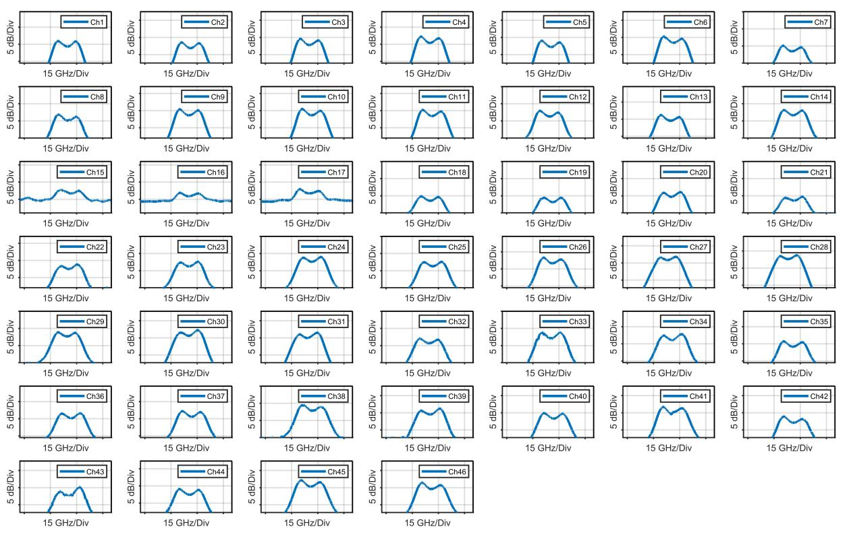
Fig. S14. Measured conversion efficiency spectra of C+L band channels (Ch1-46) used for broadcasting bandwidth characterization.

S8. Phase noises of comb lines and broadcast lights
High-order Quadrature Amplitude Modulation (QAM) formats are highly sensitive to phase noise. As a result, optical broadcasting schemes that could achieve low additional phase noise are highly desirable for optical communication and computing applications. To investigate the noise performance of our approach, we conducted experimental measurements of the phase noise in our broadcasting system. As shown in Fig. S15, a delayed self-heterodyne setup is employed to measure the linewidth of the comb lines and the broadcast lights. The fiber delay line used in this measurement is 2 km (corresponding to a time delay of ~10 µs), which enables linewidth resolution down to approximately 16 kHz. Both the pump and signal laser used in the experiments have characteristic linewidth of ~300kHz, indicating that this resolution is sufficient to characterize the pump laser, DKS comb, as well as broadcast lights. Here, the acousto-optic modulator (AOM) shifts the input optical frequency by 40 MHz, and the electrical spectrum analyzer (ESA) is used for RF spectrum analysis.
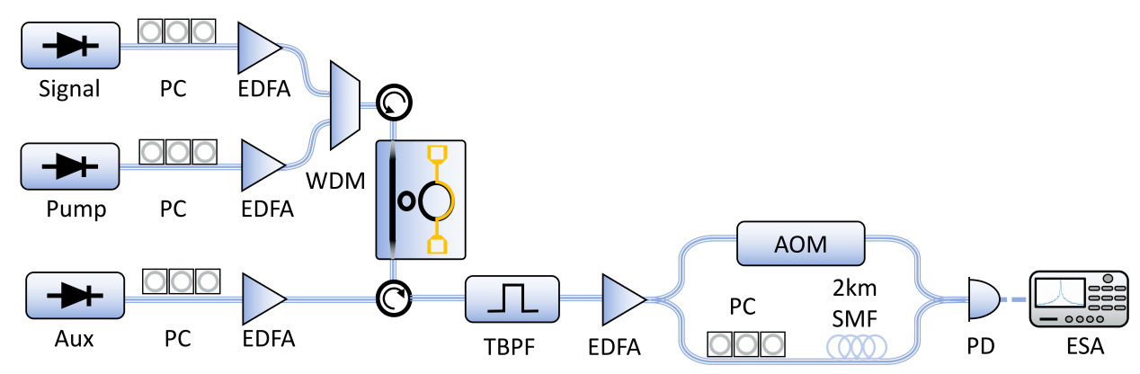
Fig. S15. Experimental setup for measuring the linewidths.
Our validations are carried out from two aspects. On the one hand, the presence of input signal light with data modulation may deteriorate the noise characteristics of the generated DKS comb lines. On top of this issue, it is unclear whether the phase noise of broadcast lights accumulate with increasing broadcasting order.
Phase noises of soliton comb lines
First, we analyze the impact of the presence of input signal light to the noise characteristics of the generated DKS comb lines. Note that in this measurement the signal light is modulated with data information. This analysis is necessary due to the fact that at the input the signal power is amplified to a level higher than that of the pump light. To evaluate this impact, we measured the RF spectrum of the pump light as well as the comb line at 1548 nm with and without the presence of the signal light, as shown in Fig. S16. The optical spectra of the comb lines in the two cases correspond to those shown in Fig. 3(c)(ii) and Fig. 4(b), respectively. The results demonstrate that the presence or absence of the signal light does not show observable effect on the comb linewidth, confirming that the presence of the signal light does not affect the noise characteristics of the soliton comb lines. We attributed this desirable feature to two main facts. First, although the input signal power is high, its field enhancement within the low-Q resonance cavity resonator is considerably lower than that of the comb lines. Second, the DKS comb locates in high-Q resonances, which apply strong filtering effects on the comb lines, leading to robust operation of the comb generation in the presence of data-modulated signal light as well as broadcast lights.
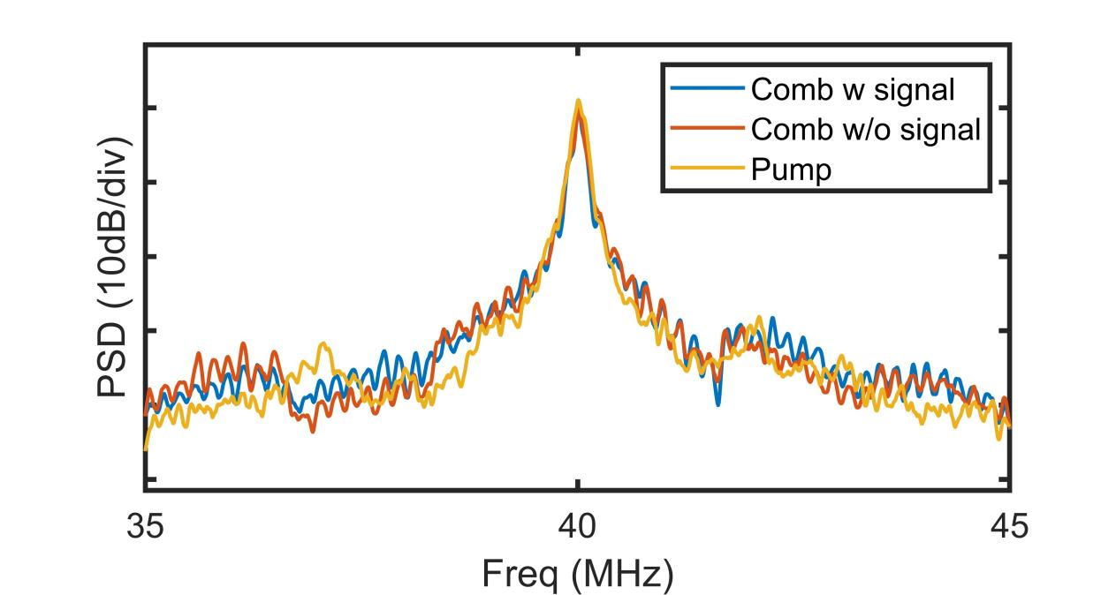
Fig. S16. RF spectra of the comb line near 1548 nm in the presence and absence of the signal light.
Phase noises of broadcast lights
In previous reported optical broadcasting based on cascaded FWM, the phase noises accumulate exponentially with the cascading order⁹, which poses severe challenges for their application in optical communications. With the use of coherent pump light, i.e., DKS comb, it has been shown that this phase noise accumulation effects can be eliminated¹⁰, as a result of soliton mode locking of the whole comb spectrum. To verify that the phase noise of the broadcast light does not accumulate with increasing broadcast order in our scheme, we turn off the modulation on the input signal light so that it is injected as a CW carrier to quantify the linewidths of different-order broadcast lights. Consequently, the broadcast lights are also CW lights. The optical spectrum of the output broadcast light is shown in Fig. S17(a), while the corresponding RF spectra are presented in Fig. S17(b). The results provide clear evidence that the linewidths of all broadcast orders remain comparable to that of the input CW signal carrier. This is because the pump light self-organizes into a stable temporal soliton pattern and the comb lines are mutually phase-locked which minimize phase noise accumulation among comb lines¹¹, ensuring that the phase noise of the broadcast signals does not accumulate with increasing broadcast order.
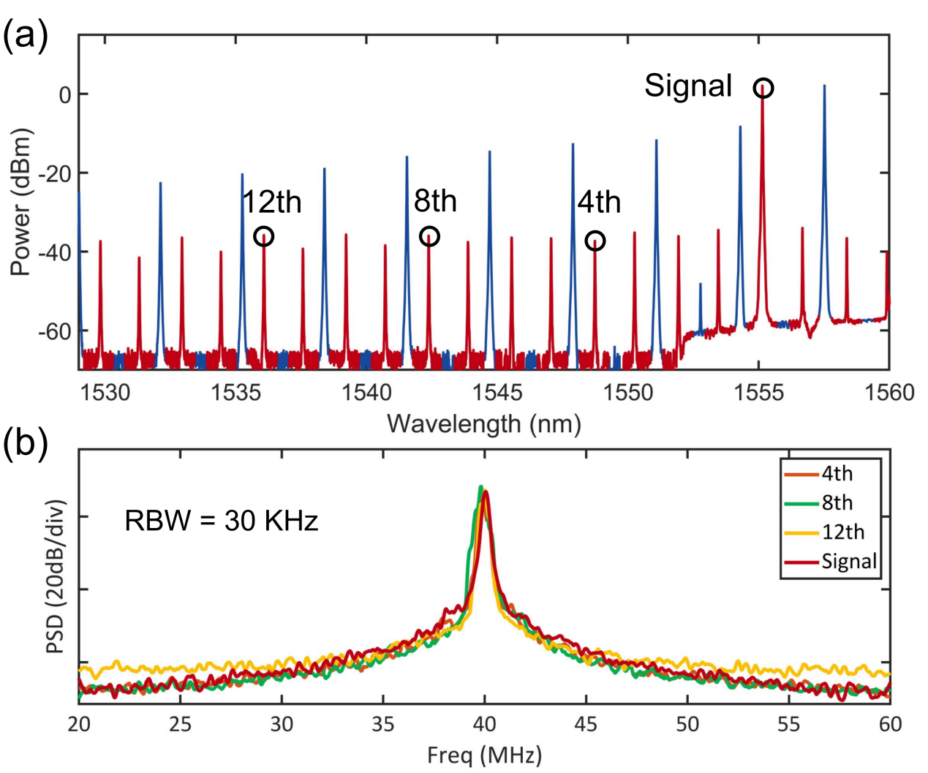
Fig. S17. Phase noises of the broadcast lights (a) Output optical spectrum of the broadcast lights (b) RF spectra of the broadcast lights measured using the delayed self-heterodyne system. In this case, the modulation on the signal laser has been turned off.

Reference
1. Van, V. Optical Microring Resonators: Theory, Techniques, and Applications. (CRC Press, Boca Raton, 2016).
2. Vahala, K. Optical Microcavities. (World Scientific, New Jersey Singapore, 2007).
3. Kim, C. et al. Parity-time symmetry enabled ultra-efficient nonlinear optical signal processing. eLight 4, 6 (2024).
4. Lugiato, L. A. & Lefever, R. Spatial dissipative structures in passive optical systems. Phys. Rev. Lett. 58, 2209-2211 (1987).
5. Coen, S., Randle, H. G., Sylvestre, T. & Erkintalo, M. Modeling of octave-spanning Kerr frequency combs using a generalized mean-field Lugiato-Lefever model. Opt. Lett. 38, 37 (2013).
6. Agrawal, G. P. Nonlinear Fiber Optics. (Elsevier/Academic Press, Amsterdam, 2013).
7. Turner, A. C., Foster, M. A., Gaeta, A. L. & Lipson, M. Ultra-low power parametric frequency conversion in a silicon microring resonator. Opt. Express 16, 4881 (2008).
8. Jang, J. K. et al. Conversion efficiency of soliton Kerr combs. Opt. Lett. 46, 3657 (2021).
9. Tong, Z. et al. Spectral linewidth preservation in parametric frequency combs seeded by dual pumps. Opt. Express 20, 17610 (2012).
10. Liao, P. et al. Pump-linewidth-tolerant wavelength multicasting using soliton Kerr frequency combs. Opt. Lett. 42, 3177 (2017).
11. Liao, P. et al. Dependence of a microresonator Kerr frequency comb on the pump linewidth. Opt. Lett. 42, 779 (2017).

