Additional file 1
Intensive greenhouse vegetable production decreases spatial turnover and increases stochasticity of soil bacterial communities
Xingang Zhou^{1,2}, Muhammad Khashi u Rahman², Jiayao Liu², Fengzhi Wu^{1,2}
Institutional addresses: ª Key Laboratory of Biology and Genetic Improvement of Horticultural Crops (Northeast Region), Ministry of Agriculture and Rural Affairs, Northeast Agricultural University, Harbin 150030, China. ^{b} Department of Horticulture, Northeast Agricultural University, Harbin 150030, China
Email addresses: Xingang Zhou, xgzhou@neau.edu.cn;
Muhammad Khashi u Rahman, khashiurahman@yahoo.com;
Jiayao Liu, jiayaoliu@cjaas.com;
Fengzhi Wu, wufz@neau.edu.cn.
Corresponding author: Fengzhi Wu

SUPPLEMENTARY METHODS
Edaphic variables analysis
Soil pH and electric conductivity were determined in water suspensions at a soil/water ratio of 1:2.5 with a EL20-K glass electrode and EL30-K conductivity meter (Mettler Toledo, Zurich, Switzerland), respectively. For soil Olsen phosphorus, nitrate- and ammonium-nitrogen, soil was extracted with 0.5 M sodium bicarbonate and 2 M potassium chloride, respectively; for soil total nitrogen, soil was digested with potassium permanganate and sulphuric acid; for total phosphorus, soil was digested with perchloric and sulphuric acids, and phosphorus, nitrate- and ammonium-nitrogen contents in these extracts were determined with a San++ continuous flow analyzer (SKALAR, Breda, Netherlands). For available potassium, soil was extracted with 1 M ammonium acetate and determined by a FP641 flame photometry (INASA, Tianjin, China). Soil organic matter was analyzed by digesting 0.5 g soil with potassium dichromate and sulphuric acid, and titrating the residual potassium dichromate with ammonia ferrous sulphate. For soil dissolved organic carbon, soil was extracted with 0.5 M potassium sulfate and determined with a TOC-1500 total organic carbon analyzer (METASH, Shanghai, China).
Quantitative PCR conditions
Quantitative PCR assays were performed in a 25 μl reaction mixture containing 12.5 μl of 2×Real SYBR Mixture (Tiangen Biotech, Beijing, China), 0.2 μM of each of the forward and reverse primers, 5 ng of soil DNA, and sterile deionized water was used to bring the total volume to 25 μl. The PCR protocol was 94°C for 5 min; followed by 94°C for 45 s, 56°C for 45 s, 72°C for 60 s, 30 cycles; and a final extension at 72°C for 10 min. Standard curves were created with 10-fold dilution series of plasmids containing the target gene. The threshold cycle values obtained for each sample were compared with the standard curve to calculate the copy number of the bacterial 16S rRNA gene. Sterile water was used as a negative control to replace the template.
PCR conditions and library preparation for Illumina MiSeq sequencing
PCR was performed in a reaction mixture of 25 μl consisting of 12.5 μl of 2×Taq PCR MasterMix (Tiangen Biotech, Beijing, China), 0.2 μM of each of the forward and reverse primers, 5 ng of soil DNA; sterile deionized water was used to bring the total volume to 25 μl. PCR was conducted in an ABI GeneAmp 9700 PCR System (ABI, MA, USA) and the PCR protocol was 95°C for 3 min; followed by 95°C for 30 s, 55°C for 30 s, 72°C for 30 s, 27 cycles; and an extension at 72°C for 10 min. To avoid DNA contaminations originating from kits and reagents, sterile water was used as a negative control. There were three technically replicated PCR reactions for each soil DNA sample. Then, PCR products of technical replicates were pooled and purified using a PCR Product Gel Purification Kit (Tiangen, Beijing, China). A second eight-cycle PCR step was performed to add dual index and Illumina sequencing adapters using a Nextera XT Index Kit (Illumina Inc., San Diego, USA). Then, PCR products were purified again and DNA concentrations were quantified by a TBS-380 micro-fluorometer with Picogreen reagent (Invitrogen, CA, USA). Samples were combined in equimolar concentration and paired-end sequenced (2×300) on an Illumina Miseq platform (Illumina Inc., San Diego, USA).

SUPPLEMENTARY RESULTS
Summary of sequencing data and taxonomic patterns of soil bacterial communities
After quality control and removing singletons and chloroplast and mitochondrial reads, a total of 9,417,461 amplicon sequences with an average read length of 438 bp from 288 soil samples was obtained. After rarefaction, the dataset was composed of 20,488 bacterial OTUs (97% similarity). Rarefaction curves of observed OTUs, Good’s coverage and truncated Preston log-normal model analyses indicated a large proportion of the bacterial diversity was covered by sequencing (Additional file 1: Figure S4 and S5).
In total, 46 bacterial phyla were observed across all samples with Proteobacteria (32.78%), Actinobacteria (17.88%), Chloroflexi (12.80%), Acidobacteria (11.99%) and Bacteroidetes (7.36%) having the highest relative abundances (Additional file 1: Figure S6a). The relative abundances of several main bacterial phyla and classes differed among land-use types (Additional file 1: Figure S6b, S7). For example, the relative abundances of bacterial classes Alphaproteobacteria, Gammaproteobacteria, Bacteroidia, Bacilli, Clostridia and Saccharimonadia were higher but Betaproteobacteria, Deltaproteobacteria and Blastocatellia were lower in the VG treatment than in CF and VF treatments (Tukey’s HSD, P < 0.05) (Additional file 1: Figure S7).
Taxonomic patterns of land-use type sensitive OTUs and keystone OTUs in co-occurrence networks
Land-use type sensitive OTUs were classified into 14 different phyla, with Proteobacteria, Acidobacteria, Bacteroidetes, Chloroflexi and Actinobacteria having the highest relative abundances (23.69%, 18.17%, 17.26%, 12.74% and 11.08% of the total relative abundances of sensitive OTUs, respectively) (Fig. 2b, Additional file 1: Figure S9). However, most of these sensitive OTUs could not be assigned at the genus level (Additional file 1: Figure S9, Additional file 2). CF-sensitive OTUs (six OTUs) were assigned to phyla Proteobacteria and Patescibacteria. A single OTU (OTU20306) from the Phylum Bacteroidetes was specific to the VF treatment. VG-sensitive OTUs (55 OTUs) were mainly belonged to bacterial phyla Bacteroidetes, Gemmatimonadetes and Chloroflexi. CF_VF-sensitive OTUs (174 OTUs) were mainly belonged to bacterial phyla Acidobacteria, Actinobacteria, Chloroflexi, Bacteroidetes, Gemmatimonadetes and Proteobacteria (classes Alphaproteobacteria and Betaproteobacteria). Five OTUs were detected as CF_VG-sensitive OTUs, belonging to bacterial phyla Actinobacteria, Firmicutes, Proteobacteria and Patescibacteria. VF_VG-sensitive OTUs (33 OTUs) were mainly belonged to bacterial phyla Proteobacteria, Bacteroidetes, Actinobacteria and Acidobacteria.
Two CF_VF-sensitive OTUs were identified as keystone OTUs in the meta co-occurrence network, which belonged to bacterial class Acidobacteria (OTU1328, family Acidobacteriales; OTU5971, family Pyrinomonadaceae) (Additional file 1: Table S6, Additional file 2). Three CF_VF-sensitive OTUs were found as keystone OTUs in the CF network, which belonged to classes Acidobacteria (OTU1328 and OTU1439, family Solibacteraceae) and Verrucomicrobia (OTU1376, family Chthoniobacteraceae). Two CF_VF-sensitive (OTU1328 and OTU15990, phylum Acidobacteria, family Pyrinomonadaceae), one VF_VG-sensitive (OTU19554, phylum Bacteroidetes, family Microscillaceae), and one VG-sensitive OTUs (OTU22241, unclassified members of the phylum Chloroflexi) were keystone OTUs in the VF network. The VG network contained one VF_VG-sensitive (OTU18620, phylum Actinobacteria, order Actinomarinales) as a keystone OTU.

SUPPLEMENTARY FIGURES
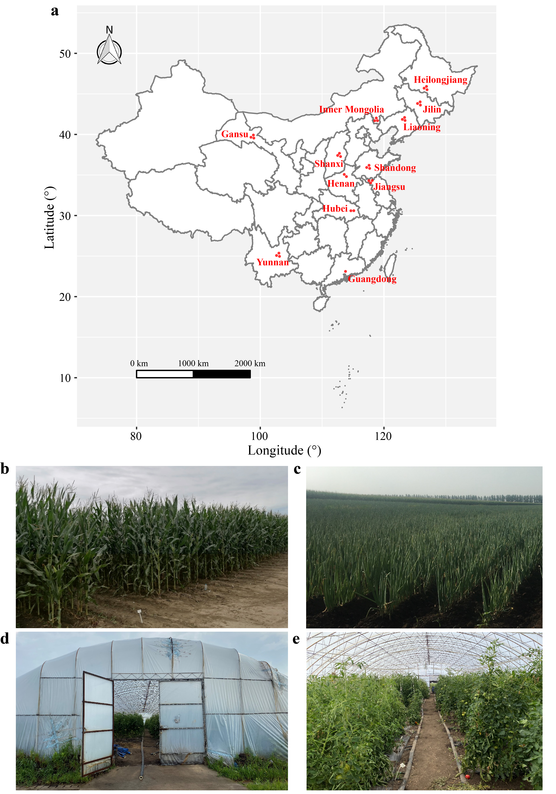
Figure S1. Geographical locations of sampling sites and represent photos for each land-use type in this study. a The map showing locations of sampling sites in each province. b-e Represent photos for each land-use type in site A of Heilongjiang province. Each site comprised adjacent triplets of (b) open field cultivated with main crop, (c) open field cultivated with vegetable and (d and e) greenhouse cultivated with vegetable. d and e are the outside and inside photos of the greenhouse, respectively.
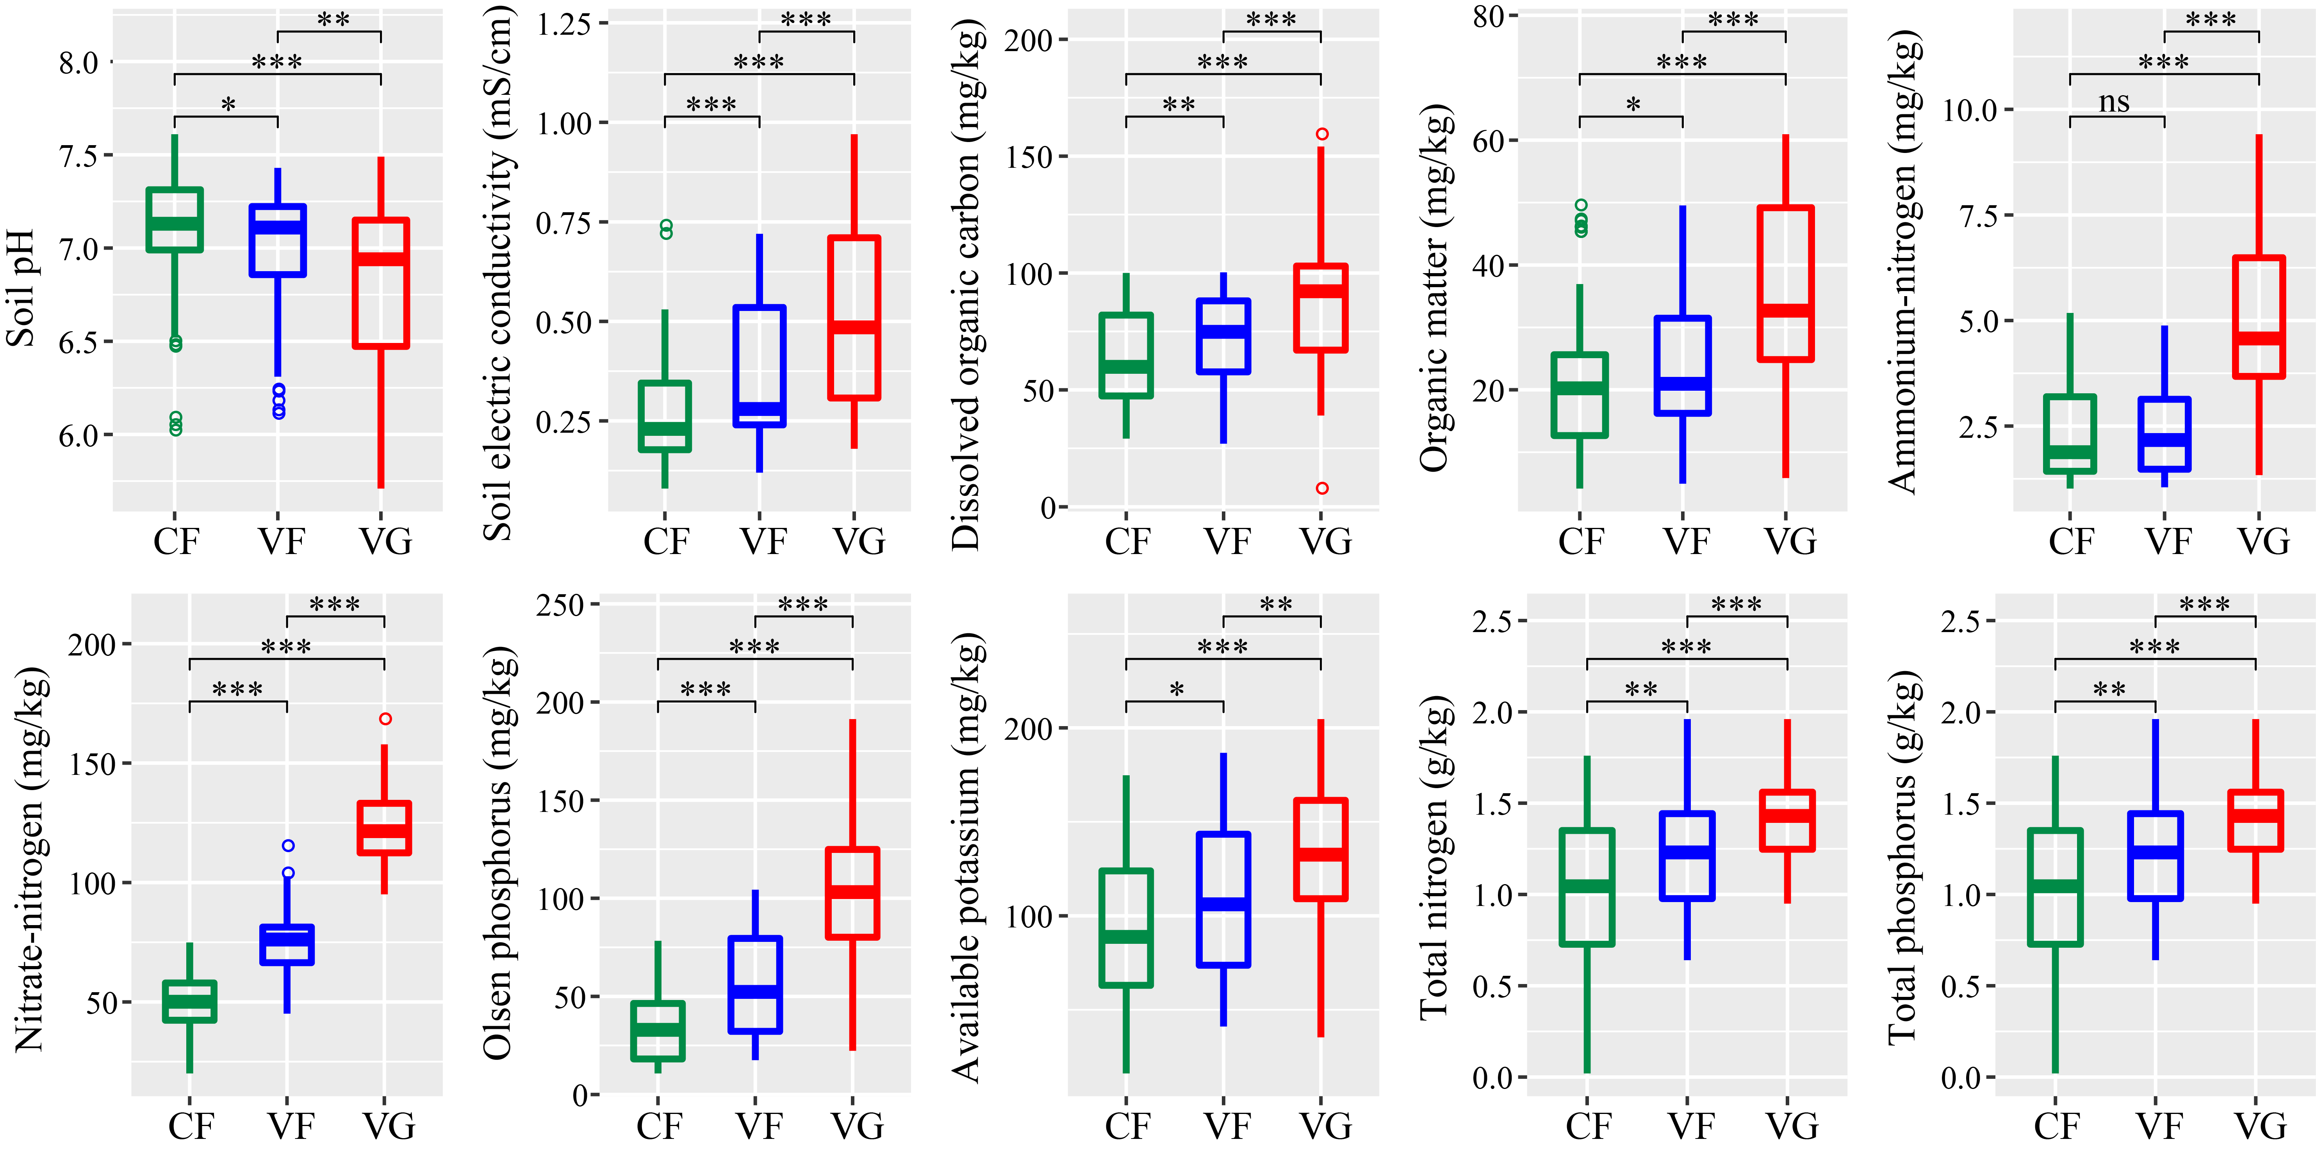
Figure S2. Effects of land-use types on edaphic variables. CF, open field cultivated with main crop; VF, open field cultivated with vegetable; VG, greenhouse cultivated with vegetable. ns indicates no significant effect (P > 0.05); *, **, *** indicate significant differences at P < 0.05, P < 0.01, P < 0.001 based on Tukey’s HSD test, respectively.
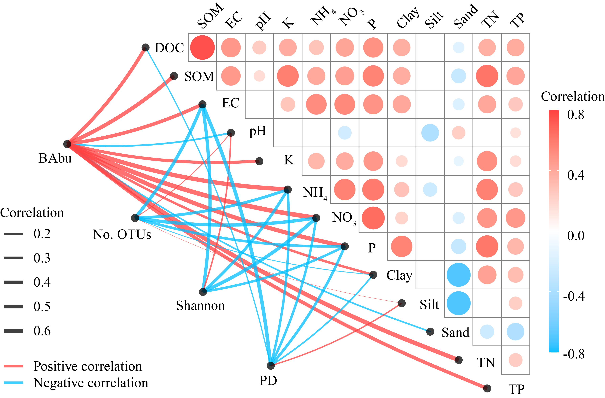
Figure S3. Spearman’s correlations between the abundance and α-diversity of bacterial communities and edaphic variables. Correlation matrix (the upper triangle of the graph) shows Spearman’s correlations among edaphic variables. Curved lines (the lower triangle of the graph) denotes Spearman’s correlations between the abundance and α-diversity of bacterial communities and edaphic variables. Only significant correlations (BH-corrected P < 0.05) are shown. No. OTUs, Number of OTUs; Shannon, Shannon index; PD, Faith's phylogenetic diversity; BAbu, bacterial abundance; DOC, dissolved organic carbon; SOM, soil organic matter; EC, electric conductivity; K, available potassium; NH₄, ammonium-nitrogen; NO₃, nitrate-nitrogen; P, Olsen phosphorus; TN, total nitrogen; TP, total phosphorus.
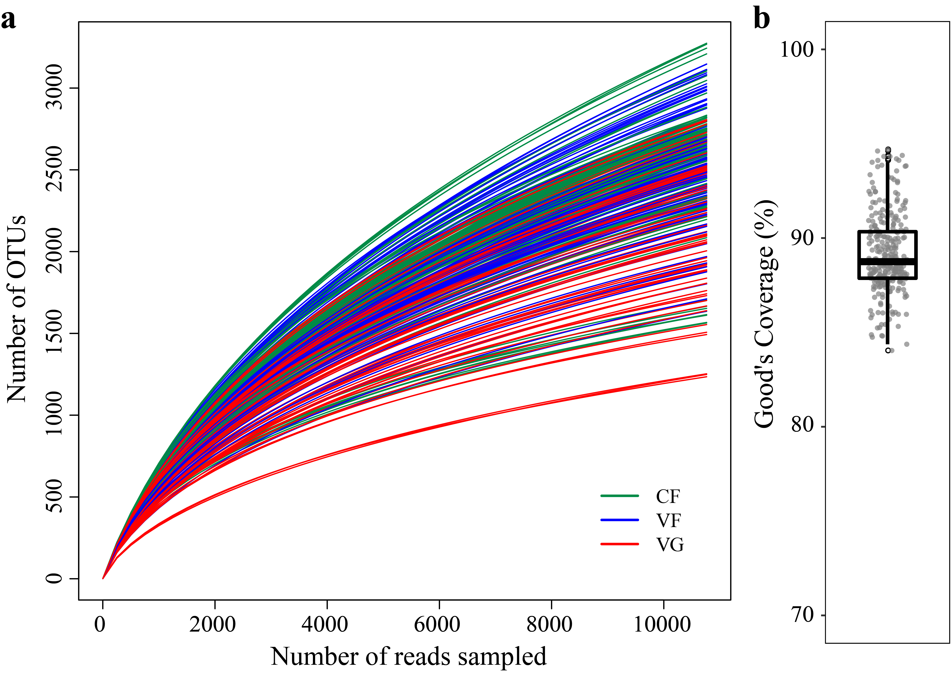
Figure S4. Rarefaction curves and Good's coverage of soil bacterial communities. a Rarefaction curves of the number OTUs (97% sequence similarity) were generated with random subsamples of 10,763 16S rRNA gene sequences per sample. b Box plot showing the Good's coverage. CF, open field cultivated with main crop; VF, open field cultivated with vegetable; VG, greenhouse cultivated with vegetable.
Figure S5. OTU abundance distribution and fitting to the Preston log-normal model. a OTU abundance distribution for the whole bacterial community of all samples with five models (Null, Preemption, Lognormal, Zipf and Zipf-Mandelbrot models). The model with the best fit was the Lognormal model according to the Akaike's Information Criterion. Criterion is indicated for each model with a plink colored curve. b Fit of the whole bacterial community to the Preston log-normal model using two approximations: Quasi-Poisson fit to octaves and Maximized likelihood to log₂ abundances. The table shows estimation of the “veiled” OTUs (i.e. OTUs not sampled) using both approximations.
Figure S6. Taxonomic profiles of soil bacterial community. a Relative abundances of main bacterial phyla/Proteobacteria classes (mean relative abundances > 1%) of each soil samples. Each bar represents the mean value of three replicates. b Effects of land-use types on main bacterial phyla (mean relative abundances > 1%). Values shown are the means of three replications. CF, open field cultivated with main crop; VF, open field cultivated with vegetable; VG, greenhouse cultivated with vegetable. ns indicates no significant effect (P > 0.05); *, **, *** indicate significant differences at P < 0.05, P < 0.01, P < 0.001 based on Tukey’s HSD test, respectively.
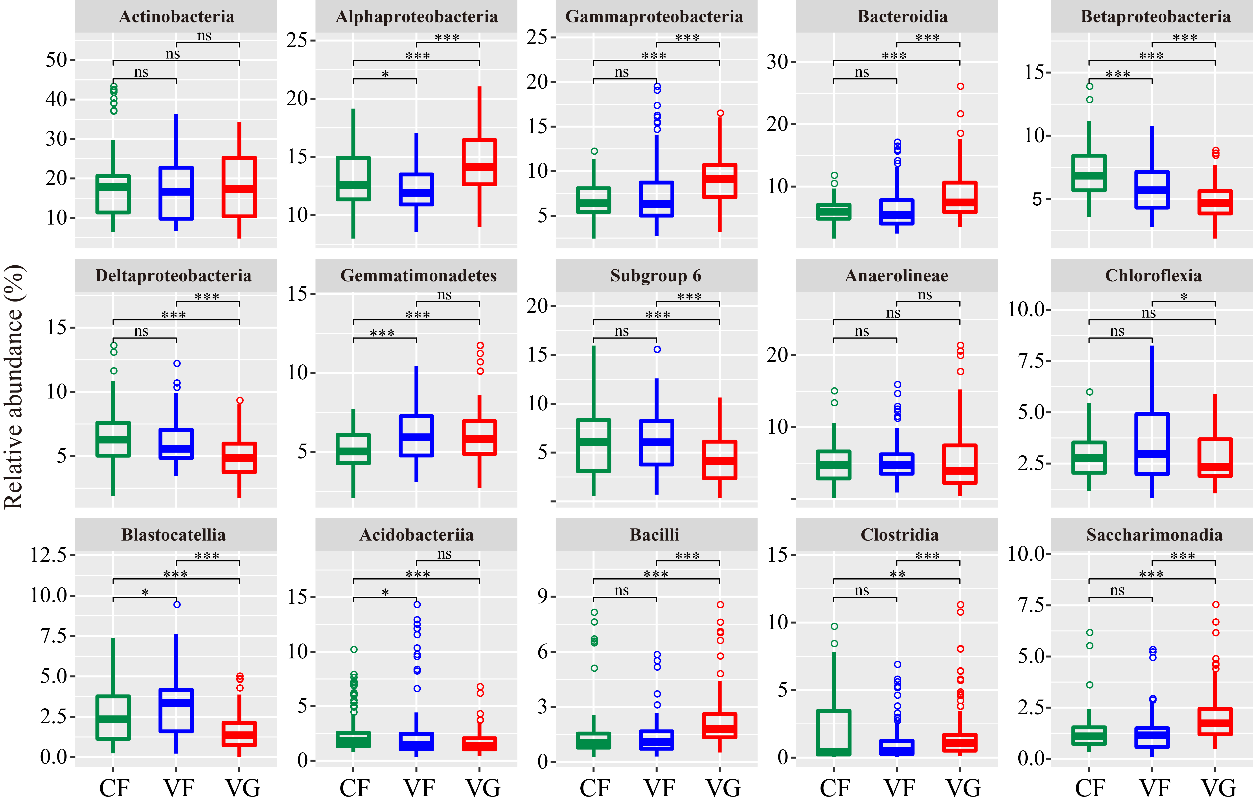
Figure S7. Effects of land-use types on main bacterial classes. Bacterial classes with mean relative abundances above 1.5% are shown. Values are the means of three replications. CF, open field cultivated with main crop; VF, open field cultivated with vegetable; VG, greenhouse cultivated with vegetable. ns indicates no significant effect (P > 0.05); *, **, *** indicate significant differences at P < 0.05, P < 0.01, P < 0.001 based on Tukey’s HSD test, respectively.
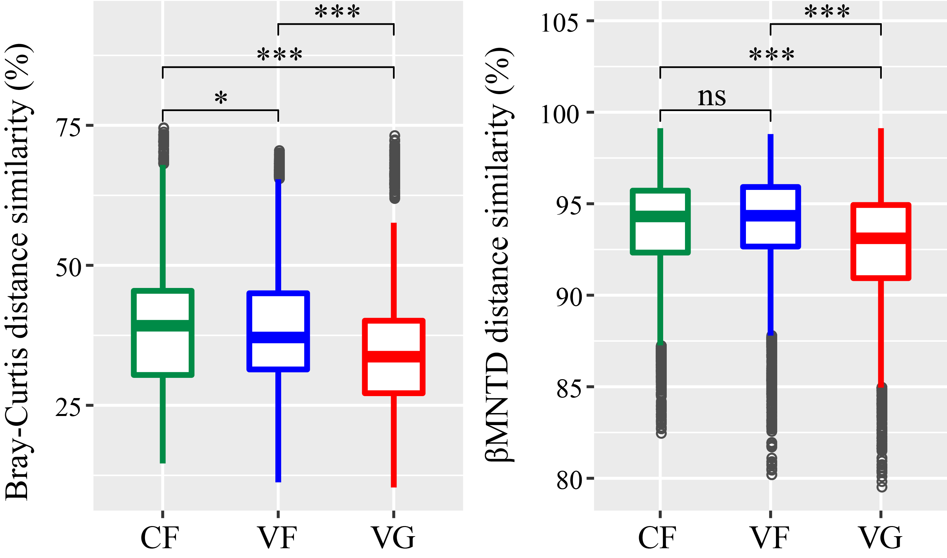
Figure S8. Effects of land-use types on soil bacterial community taxonomic and phylogenetic similarities. ns indicates no significant effect (P > 0.05); * and *** indicate significant differences at P < 0.05 and P < 0.001 based on Tukey’s HSD test, respectively. CF, open field cultivated with main crop; VF, open field cultivated with vegetable; VG, greenhouse cultivated with vegetable.
Figure S9. The maximum likelihood tree of the land-use type sensitive OTUs. The branches of the tree are colored according to the taxonomic affiliations of the sensitive OTUs at the phylum/Proteobacteria class level. The size of each circle represents the relative abundances of each OTU (log-transformed) in each land-use type. The strip indicates the associations between sensitive OTUs and different land-use types. Taxa that could be assigned to the genus level were shown as genus, otherwise were shown as OTU id. CF, open field cultivated with main crop; VF, open field cultivated with vegetable; VG, greenhouse cultivated with vegetable.
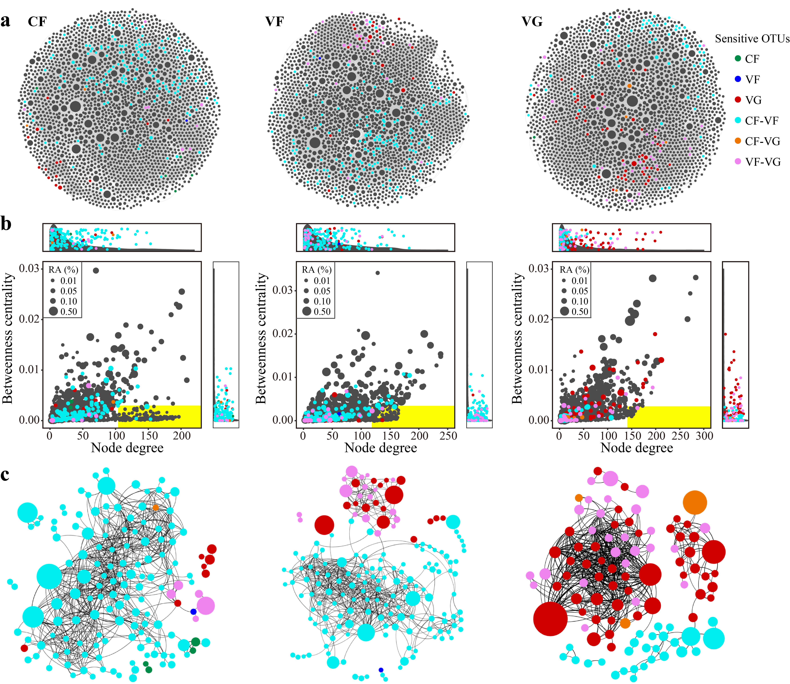
Figure S10. Co-occurrence patterns of soil bacterial communities of each land-use type. a Co-occurrence networks showing significant correlations (ρ > 0.6, BH-corrected P < 0.001) between OTUs. The size of each node is proportional to the relative abundance of the OTU; the edge thickness is proportional to the value of the Spearman’s correlation coefficient. b Degree-betweenness centrality plots of OTUs in the co-occurrence networks. Keystone OTUs (OTUs with low betweenness centrality and high degree values) have yellow background. Side panels recapitulate the distributions of node degrees and betweenness centrality for the land-use type sensitive OTUs compared to the density of all. c Co-occurrence networks of land-use type sensitive OTUs. OTUs are colored by their association to different land-use types and gray color is for insensitive OTUs. CF, open field cultivated with main crop; VF, open field cultivated with vegetable; VG, greenhouse cultivated with vegetable.
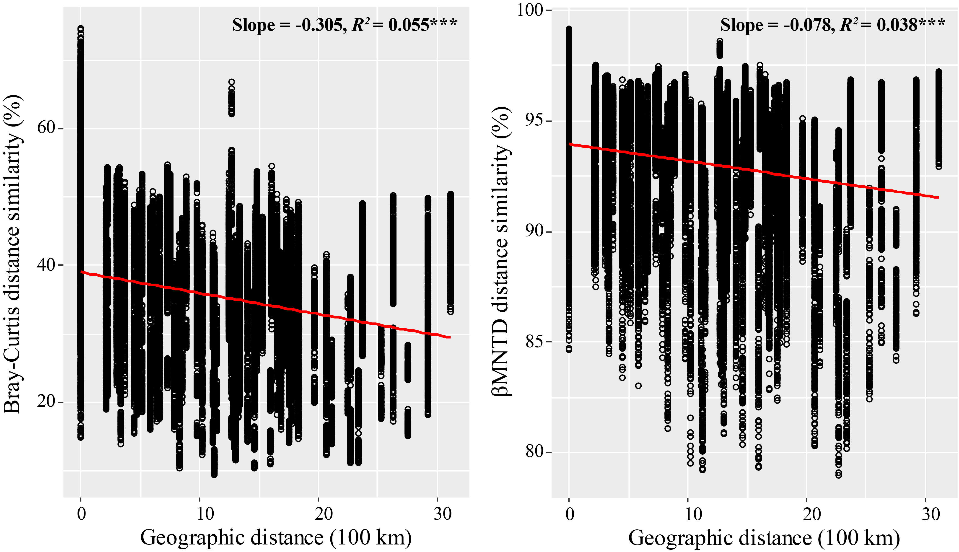
Figure S11. Taxonomic and phylogenetic spatial turnover of the bacterial community for all samples. Distance-decay curves show Bray-Curtis or βMNTD distance similarities against geographic distances for all samples. Solid red lines represent the linear regression models. *** indicates significant correlation at P < 0.001.
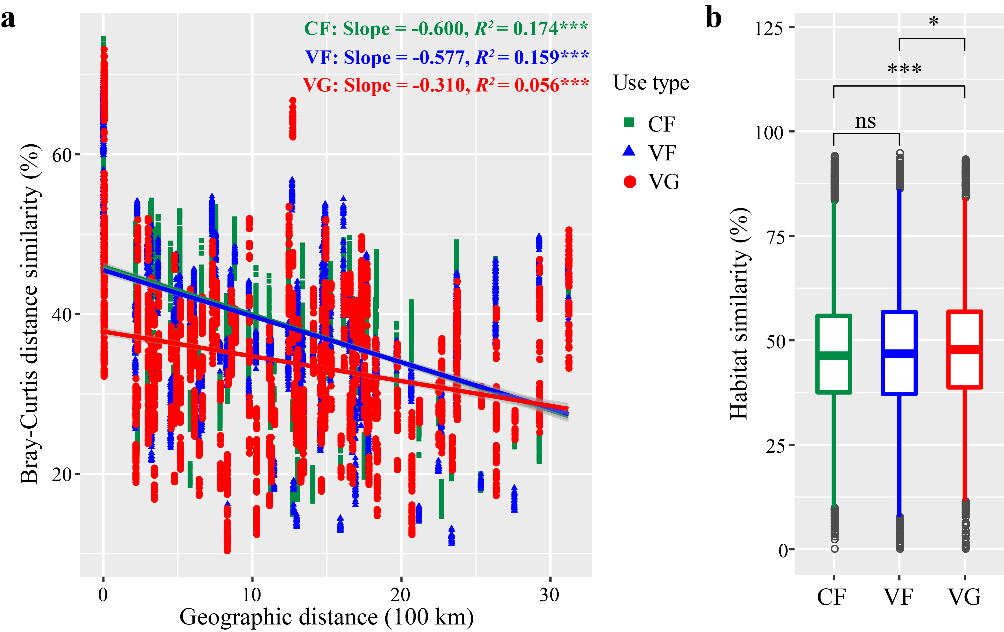
Figure S12. Bacterial community taxonomic spatial turnover and habitat similarity for each land-use type. a Distance-decay curves showing Bray-Curtis distance similarity against geographic distances for each land-use type. Solid lines represent the linear regression models. *** indicates significant correlation at P < 0.001. b Box plot showing differences in habitat similarity (based on based on Euclidean distance of edaphic variables) among land-use types. ns indicates no significant effect (P > 0.05); * and *** indicate significant differences at P < 0.05 and P < 0.001 based on Tukey’s HSD test, respectively. CF, open field cultivated with main crop; VF, open field cultivated with vegetable; VG, greenhouse cultivated with vegetable.
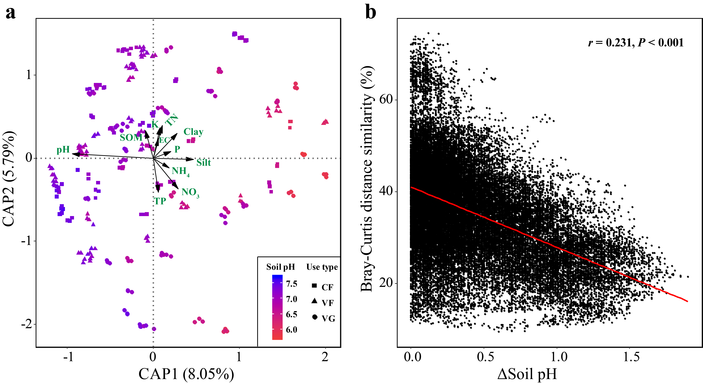
Figure S13. Drivers of soil bacterial community taxonomic β-diversity. a Constrained analysis of principal coordinates (CAP) revealing edaphic variables that influenced bacterial community β-diversity based on the Bray-Curtis distance dissimilarities. Samples are colored according to soil pH. CF, open field cultivated with main crop; VF, open field cultivated with vegetable; VG, greenhouse cultivated with vegetable. SOM, soil organic matter; K, available potassium; TN, total nitrogen; EC, Soil electric conductivity; P, Olsen phosphorus; NH₄, ammonium-nitrogen; NO₃, nitrate-nitrogen; TP, total phosphorus. b Relationships between the Bray-Curtis distance similarities and differences in soil pH. The solid red line represents the linear regression model.
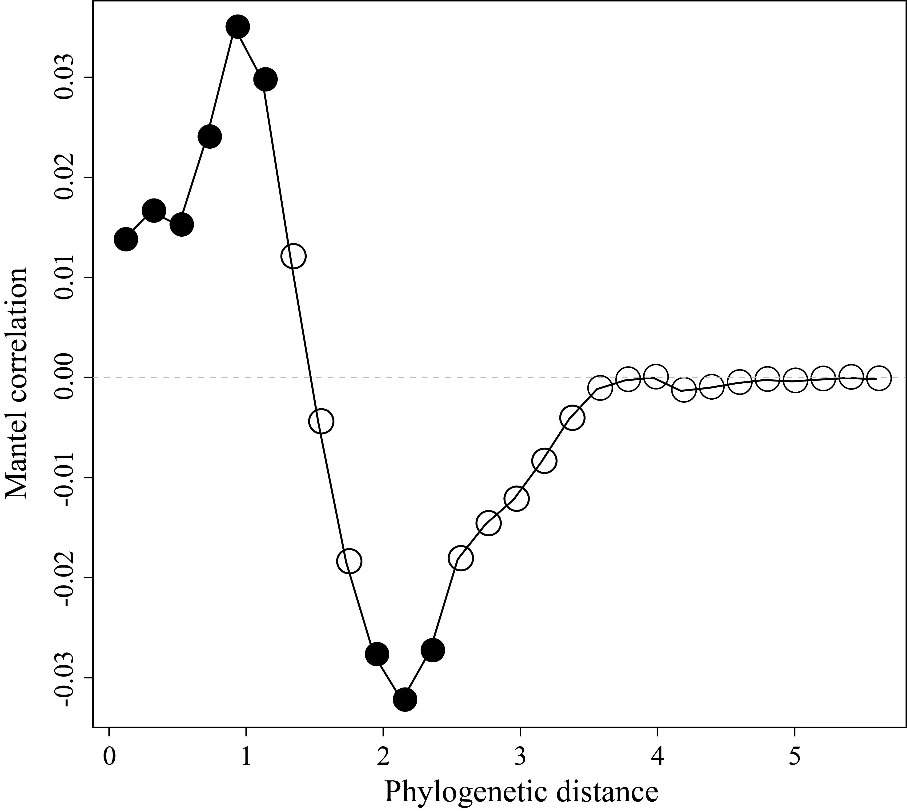
Figure S14. Mantel correlograms comparing the estimated habitat optima and phylogenetic distances. Solid points indicate significant correlations (P < 0.05).
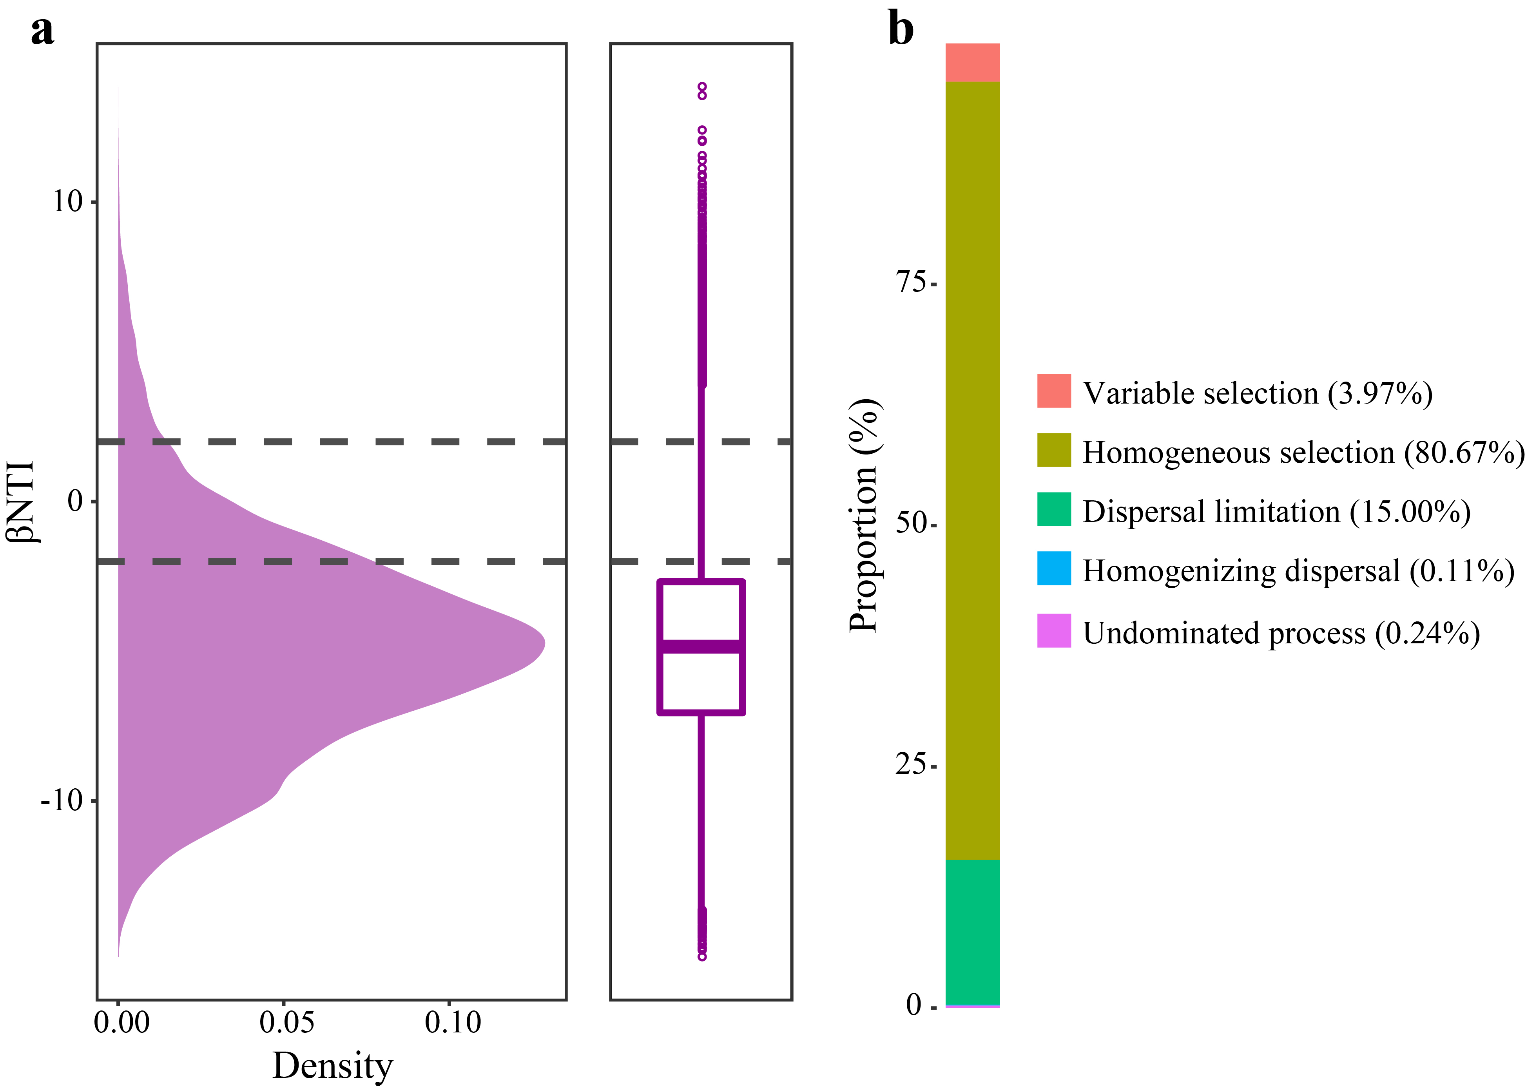
Figure S15. Ecological processes governing bacterial community assembly across all samples. a The density plot showing the distribution of βNTI for all samples. The side boxplot shows the βNTI value for all samples. Horizontal dashed grey lines indicate lower and upper significance thresholds at βNTI = -2 and +2, respectively. b Relative contributions of ecological processes governing bacterial community assembly across all samples.
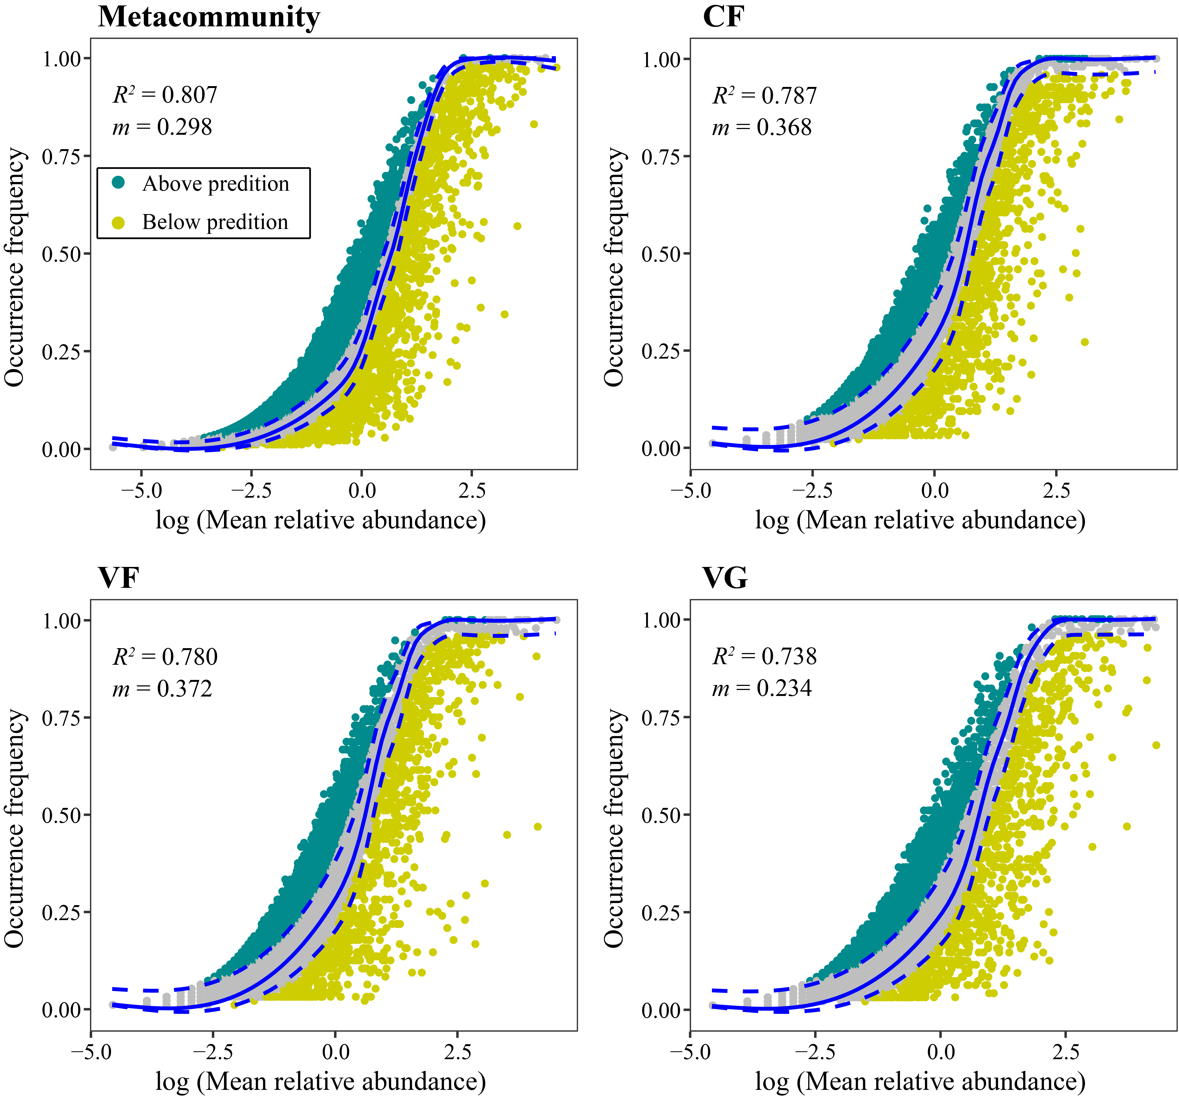
Figure S16. Fit of the Sloan neutral model. The predicted occurrence frequencies for the metacommunity of all samples, and communities of each land-use type were shown. Each point represents an OTU. The predicted occurrence frequency is shown as a solid blue line and dashed lines indicate the 95% confidence interval around the neutral model prediction. CF, open field cultivated with main crop; VF, open field cultivated with vegetable; VG, greenhouse cultivated with vegetable.

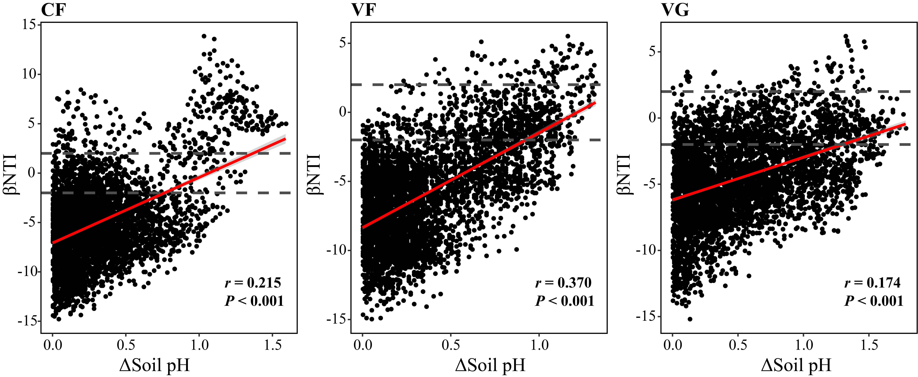
Figure S17. Relationships between βNTI and differences in soil pH within each land-use type. Solid red lines represent the linear regression models. Horizontal dashed grey lines indicate lower and upper significance thresholds at βNTI = -2 and +2, respectively. CF, open field cultivated with main crop; VF, open field cultivated with vegetable; VG, greenhouse cultivated with vegetable.
Figure S18. Relationships between SES.MNTD and soil pH within each land-use type. Solid red lines represent the linear regression models. Shaded areas represent the estimated 95% confidence intervals. CF, open field cultivated with main crop; VF, open field cultivated with vegetable; VG, greenhouse cultivated with vegetable.
Table S1. Information of soil texture, number of croppings per year and cultivated crops for each sampling site in this study
Province | Soil texture | Site | LUT ª | NC ^{b} | Crop ^{c} | Province | Soil texture | Site | LUT | NC | Crop
Heilongjiang | Clay loam | A | CF | 1 | Maize | Shanxi | Loam | A | CF | 2 | Maize
Heilongjiang | Clay loam | A | VF | 1 | Green-onion | Shanxi | Loam | A | VF | 2 | Cucumber
Heilongjiang | Clay loam | A | VG(3) ^{d} | 2 | Tomato | Shanxi | Loam | A | VG(3) | 3 | Eggplant
Heilongjiang | Clay loam | B | CF | 1 | Maize | Shanxi | Loam | B | CF | 2 | Maize
Heilongjiang | Clay loam | B | VF | 1 | Green-onion | Shanxi | Loam | B | VF | 2 | Pepper
Heilongjiang | Clay loam | B | VG(7) | 2 | Tomato | Shanxi | Loam | B | VG(7) | 3 | Tomato
Heilongjiang | Clay loam | C | CF | 1 | Maize | Shanxi | Loam | C | CF | 2 | Maize
Heilongjiang | Clay loam | C | VF | 1 | Green-onion | Shanxi | Loam | C | VF | 2 | Green-onion
Heilongjiang | Clay loam | C | VG(>15) | 2 | Cucumber | Shanxi | Loam | C | VG(>15) | 3 | Kidney-bean
Jilin | Clay loam | A | CF | 1 | Maize | Shandong | Loam | A | CF | 2 | Maize
Jilin | Clay loam | A | VF | 1 | Kidney-bean | Shandong | Loam | A | VF | 2 | Green-onion
Jilin | Clay loam | A | VG(3) | 2 | Tomato | Shandong | Loam | A | VG(3) | 3 | Cucumber
Jilin | Clay loam | B | CF | 1 | Maize | Shandong | Loam | B | CF | 2 | Maize
Jilin | Clay loam | B | VF | 1 | Kidney-bean | Shandong | Loam | B | VF | 2 | Green-onion
Jilin | Clay loam | B | VG(10) | 2 | Cucumber | Shandong | Loam | B | VG(8) | 3 | Cucumber
Jilin | Clay loam | C | CF | 1 | Maize | Shandong | Loam | C | CF | 2 | Maize
Jilin | Clay loam | C | VF | 1 | Kidney-bean | Shandong | Loam | C | VF | 2 | Green-onion
Jilin | Clay loam | C | VG(>15) | 2 | Tomato | Shandong | Loam | C | VG(>15) | 3 | Cucumber
Liaoning | Clay loam | A | CF | 1 | Maize | Henan | Loam | A | CF | 2 | Wheat
Liaoning | Clay loam | A | VF | 1 | Green-onion | Henan | Loam | A | VF | 2 | Cucumber
Liaoning | Clay loam | A | VG(3) | 2 | Tomato | Henan | Loam | A | VG(3) | 3 | Cucumber
Liaoning | Clay loam | B | CF | 1 | Maize | Henan | Loam | B | CF | 2 | Wheat
Liaoning | Clay loam | B | VF | 1 | Green-onion | Henan | Loam | B | VF | 2 | Cucumber
Liaoning | Clay loam | B | VG(7) | 2 | Tomato | Henan | Loam | B | VG(>15) | 3 | Tomato
Liaoning | Clay loam | C | CF | 1 | Maize | Jiangsu | Clay loam | A | CF | 2 | Soybean
Liaoning | Clay loam | C | VF | 1 | Green-onion | Jiangsu | Clay loam | A | VF | 2 | Garlic
Liaoning | Clay loam | C | VG(>15) | 2 | Cucumber | Jiangsu | Clay loam | A | VG(3) | 3 | Watermelon
Inner Mongolia | Loam | A | CF | 1 | Maize | Jiangsu | Clay loam | B | CF | 2 | Soybean
Inner Mongolia | Loam | A | VF | 1 | Eggplant | Jiangsu | Clay loam | B | VF | 2 | Garlic
Inner Mongolia | Loam | A | VG(4) | 2 | Tomato | Jiangsu | Clay loam | B | VG(10) | 3 | Eggplant
Inner Mongolia | Loam | B | CF | 1 | Maize | Jiangsu | Clay loam | C | CF | 2 | Soybean
Inner Mongolia | Loam | B | VF | 1 | Eggplant | Jiangsu | Clay loam | C | VF | 2 | Garlic
Inner Mongolia | Loam | B | VG(7) | 2 | Tomato | Jiangsu | Clay loam | C | VG(>15) | 3 | Cucumber
Inner Mongolia | Loam | C | CF | 1 | Maize | Hubei | Clay loam | A | CF | 2 | Peanut
Inner Mongolia | Loam | C | VF | 1 | Eggplant | Hubei | Clay loam | A | VF | 2 | Cowpea
Inner Mongolia | Loam | C | VG(>15) | 2 | Tomato | Hubei | Clay loam | A | VG(7) | 3 | Sponge-gourd
Gansu | Clay loam | A | CF | 1 | Maize | Hubei | Clay loam | B | CF | 2 | Peanut
Gansu | Clay loam | A | VF | 1 | Cabbage | Hubei | Clay loam | B | VF | 2 | Cowpea
Gansu | Clay loam | A | VG(3) | 2 | Cucumber | Hubei | Clay loam | B | VG(>15) | 3 | Amaranth
Gansu | Clay loam | B | CF | 1 | Maize | Yunnan | Clay loam | A | CF | 2 | Wheat
Gansu | Clay loam | B | VF | 1 | Cabbage | Yunnan | Clay loam | A | VF | 2 | Tomato
Gansu | Clay loam | B | VG(8) | 2 | Tomato | Yunnan | Clay loam | A | VG(3) | 3 | Eggplant
Gansu | Clay loam | C | CF | 1 | Maize | Yunnan | Clay loam | B | CF | 2 | Wheat
Gansu | Clay loam | C | VF | 1 | Cabbage | Yunnan | Clay loam | B | VF | 2 | Tomato
Gansu | Clay loam | C | VG(>15) | 2 | Cucumber | Yunnan | Clay loam | B | VG(7) | 3 | Pepper
Guangdong | Clay loam | A | CF | 2 | Sugarcane | Yunnan | Clay loam | C | CF | 2 | Wheat
Guangdong | Clay loam | A | VF | 2 | Water-spinach | Yunnan | Clay loam | C | VF | 2 | Tomato
Guangdong | Clay loam | A | VG(>15) | 3 | Amaranth | Yunnan | Clay loam | C | VG(>15) | 3 | Cucumber
ª Land-use type.
^{b} Numbers of croppings per year.
^{c} Type of crops cultivated in the soil when soil sampling was performed.
^{d} Numbers in the brackets indicate the number of year of the greenhouse had been established and cultivated with vegetables.

Table S2. Results of two way-ANOVA testing effects of sampling sites and land-use types on edaphic variables. F values were shown. *** indicate significant effect at P < 0.001. EC, electric conductivity; SOM, soil organic matter; DOC, dissolved organic carbon; NO₃, nitrate-nitrogen; NH₄, ammonium-nitrogen; P, Olsen phosphorus; K, available potassium; TN, total nitrogen; TP, total phosphorus.
 | pH | EC | SOM | DOC | NO₃
Type _{(2,192)} | 464.69*** | 990.33*** | 2045.57*** | 350.41*** | 4974.61***
Site _{(31,192)} | 221.97*** | 125.89*** | 607.60*** | 79.32*** | 24.57***
Type*Site _{(62,192)} | 20.91*** | 36.61*** | 31.48*** | 12.98*** | 15.24***
 | NH₄ | P | K | TN | TP
Type _{(2,192)} | 1296.09*** | 3676.29*** | 480.19*** | 260.73*** | 541.18***
Site _{(31,192)} | 57.12*** | 168.76*** | 194.56*** | 55.99*** | 85.25***
Type*Site _{(62,192)} | 24.98*** | 35.11*** | 19.83*** | 3.36*** | 5.77***

Table S3. Results of two way-ANOVA testing effects of sampling sites and land-use types on bacterial community α-diversity. F values were shown. *** indicate significant effect at P < 0.001.
 | Bacterial abundance | Number of OTUs | Shannon index | Faith's phylogenetic diversity
Type _{(2,192)} | 1821.69*** | 1009.01*** | 629.55*** | 246.69***
Site _{(31,192)} | 31.15*** | 131.43*** | 85.02*** | 84.22***
Type*Site _{(62,192)} | 15.28*** | 125.83*** | 93.65*** | 66.19***

Table S4. Results of PERMANOVA testing effects of sampling sites and land-use types on bacterial community β-diversity. *** indicate significant effect at P < 0.001. Different letters in the pairwise comparisons indicate significant differences at P < 0.05 (BH corrected).
 | Bray-Curtis distance similarity |  |  | βMNTD distance similarity
 | pseudo-F | R² |  | pseudo-F | R²
Type _{(2,192)} | 29.716*** | 0.054 |  | 265.751*** | 0.092
Site _{(31,192)} | 14.195*** | 0.400 |  | 108.529*** | 0.585
Type*Site _{(62,192)} | 6.587*** | 0.371 |  | 26.888*** | 0.290
Pairwise use type comparisons
 | CF ª |  |  | CF ª
 | VF ^{b} |  |  | VF ª
 | VG ^{c} |  |  | VG ^{b}

Table S5. Key topological features of the empirical and Erdös-Rényi random networks.
 | Empirical networks |  |  |  |  |  |  |  |  | Random networks
 | N ª | E ^{b} | PE ^{c} | NE ^{d} | AC e | APL ^{f} | ACC ^{g} | MD ^{h} |  | APL | ACC | MD
Meta network | 1490 | 10508 | 10320 | 188 (1.79) ^{i} | 14.10 | 4.54 | 0.555 | 0.569 |  | 3.03 | 0.009 | 0.226
CF network | 2281 | 38929 | 36302 | 2627 (6.75) | 34.13 | 3.76 | 0.520 | 0.562 |  | 2.58 | 0.015 | 0.139
VF network | 2334 | 49007 | 46069 | 2938 (6.00) | 41.99 | 3.51 | 0.551 | 0.626 |  | 2.44 | 0.018 | 0.124
VG network | 2187 | 32711 | 29866 | 2845 (8.70) | 29.91 | 3.73 | 0.494 | 0.488 |  | 2.64 | 0.014 | 0.150
ª N, number of nodes.
^{b} E, number of edges.
^{c} PE, number of positive edges.
^{d} NE, number of negative edges.
^{e} AC, Average connectivity. The average connections of each node with another unique node in the network. It indicates the complexity of a network, higher value indicates a more complex network ^{[1]}.
^{f} APL, Average path length. The average network distance between all pairs of nodes. Smaller average path length indicates all the nodes in the network are closer ^{[1]}.
^{g} ACC, Average clustering coefficient; The degree to which the nodes tend to cluster together. Higher clustering coefficient indicates nodes in a network were more connected ^{[1, 2]}.
^{h} MD, modularity. Tendency of a network to contain subclusters of nodes. High modularity indicates more structured communities within a network ^{[3, 4]}.
^{i} Numbers in the brackets indicate percentages of negative edges (%).

Table S6. Numbers and properties of land-use type sensitive OTUs in each co-occurrence network.
 |  | Land-use type sensitive OTUs ª
 |  | CF | VF | VG | CF-VF | CF-VG | VF-VG
Meta  network | Number of OTUs | 4 | 1 | 43 | 126 (2) ^{b} | 1 | 20
Meta  network | Number of edges | 5 | 1 | 394 | 1654 | 8 | 128
Meta  network | Number of positive edges | 5 | 1 | 377 | 1642 | 8 | 126
Meta  network | Number of negative edges | 0 [0] ^{c} | 0 [0] | 17 [4.31] | 12 [0.73] | 0 [0] | 2 [1.56]
Meta  network | Average degree | 1.75 | 1.00 | 11.44 | 15.78 | 8.00 | 6.85
Meta  network | Betweenness centrality (10⁻³) | 0.95 | 0.00 | 3.05 | 1.39 | 1.32 | 1.96
CF  network | Number of OTUs | 5 | 1 | 14 | 158 (3) | 2 | 8
CF  network | Number of edges | 79 | 49 | 332 | 5270 | 99 | 277
CF  network | Number of positive edges | 76 | 49 | 314 | 4917 | 96 | 263
CF  network | Number of negative edges | 3 [3.80] | 0 [0] | 18 [5.42] | 353 [6.70] | 3 [3.03] | 14 [5.05]
CF  network | Degree | 16.20 | 49.00 | 24.00 | 37.04 | 49.50 | 34.88
CF  network | Betweenness centrality (10⁻³) | 1.60 | 0.13 | 1.30 | 1.40 | 1.83 | 1.14
VF  network | Number of OTUs | 0 | 1 | 20 (1) | 162 (2) | 0 | 26 (1)
VF  network | Number of edges | 0 | 61 | 777 | 6089 | 0 | 784
VF  network | Number of positive edges | 0 | 57 | 764 | 5549 | 0 | 772
VF  network | Number of negative edges | 0 [0] | 4 [6.56] | 13 [1.67] | 540 [8.87] | 0 | 12 [1.53]
VF  network | Degree |  | 61.00 | 39.95 | 41.04 |  | 31.35
VF  network | Betweenness centrality (10⁻³) |  | 1.52 | 0.42 | 1.16 |  | 0.87
VG  network | Number of OTUs | 1 | 0 | 52 | 66 | 4 | 31 (1)
VG  network | Number of edges | 4 | 0 | 3426 | 648 | 95 | 1317
VG  network | Number of positive edges | 4 | 0 | 2903 | 641 | 49 | 1190
VG  network | Number of negative edges | 0 [0] | 0 [0] | 523 [15.27] | 7 [1.08] | 46 [48.42] | 127 [9.64]
VG  network | Degree | 4.00 |  | 71.04 | 10.27 | 23.75 | 43.58
VG  network | Betweenness centrality (10⁻³) | 0.01 |  | 3.85 | 0.31 | 0.41 | 1.57
ª Six kinds of sensitive OTUs which were enriched in one or a combination of land-use types were identified by indicator species analysis and likelihood ratio test. For example, CF-sensitive OTUs were OTUs that had higher relative abundances in the CF treatment than in VF and VG treatments. CF_VF-sensitive OTUs were OTUs that had higher relative abundances in CF and VF treatments than in the VG treatment.
^{b} Numbers in the brackets indicate the number of keystone OTUs.
^{c} Numbers in the square brackets indicate percentages of negative edges of land-use type sensitive OTUs in each co-occurrence network (%).

Table S7. Mantel test results showing the relationship between bacterial community or habitat dissimilarity and geographic distance. *** indicates significant correlation at P < 0.001. Whole, the whole community of all samples; CF, open field cultivated with main crop; VF, open field cultivated with vegetable; VG, greenhouse cultivated with vegetable.
 | Whole | CF | VF | VG
Bray-Curtis distance dissimilarity | 0.235*** | 0.418*** | 0.399*** | 0.237***
βMNTD distance dissimilarity | 0.196*** | 0.372*** | 0.286*** | 0.185***
Habitat dissimilarity | 0.159*** | 0.365*** | 0.237*** | 0.180***

Table S8. Partial Mantel test results showing the relationship between bacterial community dissimilarity and either geographic distance and edaphic variables. ** and *** indicate significant correlations at P < 0.01 and P < 0.001, respectively. Whole, the whole community of all samples; CF, open field cultivated with main crop; VF, open field cultivated with vegetable; VG, greenhouse cultivated with vegetable.
 | Variables | Controlling for | Whole | CF | VF | VG
Bray-Curtis distance  dissimilarity | Geographic distance | Edaphic variables | 0.206*** | 0.243*** | 0.325*** | 0.177***
Bray-Curtis distance  dissimilarity | Edaphic variables | Geographic distance | 0.449*** | 0.445*** | 0.534*** | 0.565***
βMNTD distance  dissimilarity | Geographic distance | Edaphic variables | 0.208*** | 0.187** | 0.279*** | 0.155***
βMNTD distance  dissimilarity | Edaphic variables | Geographic distance | 0.478*** | 0.461*** | 0.597*** | 0.544***

Table S9. Differences in the slopes of the distance decay relationship for bacterial community and habitat between land-use types. *** indicates significant difference at P < 0.001. CF, open field cultivated with main crop; VF, open field cultivated with vegetable; VG, greenhouse cultivated with vegetable.
 | CF vs. VF | CF vs. VG | VF vs. VG
Bray-Curtis distance similarity | -0.023 | -0.290*** | -0.266***
βMNTD distance similarity | -0.035*** | -0.074*** | -0.039***
Environmental similarity | -0.279*** | -0.421*** | -0.142***

Table S10. Results of the multiple regression on matrices analysis for the bacterial community β-diversities. *, ** and *** indicate significant correlations at P < 0.05, P < 0.01 and P < 0.001, respectively. ns indicates not significant, P > 0.05. LUT, land-use type; Geo, geographic distance; EC, electric conductivity; SOM, soil organic matter; DOC, dissolved organic carbon; NH₄, ammonium-nitrogen; NO₃, nitrate-nitrogen; P, Olsen phosphorus; K, available potassium; TN, total nitrogen; TP, total phosphorus. Whole, the whole community of all samples; CF, open field cultivated with main crop; VF, open field cultivated with vegetable; VG, greenhouse cultivated with vegetable.
 | Bray-Curtis distance dissimilarity |  |  |  |  | βMNTD distance dissimilarity
 | Whole  (R²=0.270, P<0.001) | CF  (R²=0.290, P<0.001) | VF  (R²=0.434, P<0.001) | VG  (R²=0.339, P<0.001) |  | Whole  (R²=0.285, P<0.001) | CF  (R²=0.298, P<0.001) | VF  (R²=0.466, P<0.001) | VG  (R²=0.338, P<0.001)
LUT | 0.050* |  |  |  |  | 0.013*
Geo | 0.178*** | 0.245*** | 0.287*** | 0.126*** |  | 0.171*** | 0.208*** | 0.233*** | 0.139***
pH | 0.413*** | 0.300*** | 0.351*** | 0.359*** |  | 0.435*** | 0.313*** | 0.381*** | 0.371***
EC | ns | 0.215*** | -0.087** | ns |  | ns | 0.215*** | -0.071* | ns
SOM | ns | -0.122** | 0.095* | 0.151*** |  | ns | -0.101* | 0.106** | 0.129***
DOC | ns | ns | ns | ns |  | ns | ns | ns | ns
NH₄ | ns | 0.158*** | -0.065* | ns |  | 0.038* | 0.169*** | -0.083** | ns
NO₃ | 0.122*** | ns | 0.142*** | 0.123*** |  | 0.161*** | ns | 0.193*** | 0.098**
P | ns | ns | 0.073** | ns |  | 0.037* | ns | 0.068* | ns
K | ns | ns | 0.081** | 0.153*** |  | ns | ns | ns | 0.127***
TN | -0.086*** | ns | -0.101** | ns |  | -0.061** | -0.086* | -0.080* | ns
TP | ns | ns | ns | ns |  | ns | ns | ns | 0.076*
Clay | ns | ns | ns | ns |  | ns | ns | ns | ns
Silt | 0.055** | ns | 0.150*** | ns |  | 0.057** | 0.113** | 0.199*** | ns
Sand | ns | ns | ns | 0.132*** |  | ns | ns | ns | 0.145***
Crop | ns |  |  |  |  | ns

Table S11. Results of ANOVA of edaphic variables correlated with soil bacterial β-diversities in CAP analysis for all soil samples. df, degree of freedom; SS, sum of squares. * and *** indicate significant effects at P < 0.05 and P < 0.001, respectively. ND, not determined (removed by the forward selection procedure). EC, electric conductivity; SOM, soil organic matter; NH₄, ammonium-nitrogen; NO₃, nitrate-nitrogen; P, Olsen phosphorus; K, available potassium; TN, total nitrogen; TP, total phosphorus. CF, open field cultivated with main crop; VF, open field cultivated with vegetable; VG, greenhouse cultivated with vegetable.
 | Bray-Curtis distance similarity |  |  |  | βMNTD distance similarity
 | df | SS | Pseudo-F |  | df | SS | Pseudo-F
pH | 1 | 4.552 | 28.217*** |  | 1 | 0.158 | 55.459***
EC | 1 | 0.845 | 5.241*** |  | 1 | 0.024 | 8.545***
SOM | 1 | 1.406 | 8.717*** |  | 1 | 0.079 | 27.838***
NH₄ | 1 | 0.692 | 4.289*** |  | 1 | 0.008 | 2.636*
NO₃ | 1 | 2.495 | 15.469*** |  | 1 | 0.087 | 30.366***
P | 1 | 0.565 | 3.501*** |  | 1 | 0.008 | 2.784*
K | 1 | 0.680 | 4.215*** |  | ND | ND | ND
TN | 1 | 2.243 | 13.904*** |  | 1 | 0.016 | 5.736***
TP | 1 | 0.987 | 6.119*** |  | 1 | 0.022 | 7.562***
Clay | 1 | 1.078 | 6.684*** |  | 1 | 0.024 | 8.576***
Silt | 1 | 1.459 | 9.047*** |  | ND | ND | ND
Residual | 276 | 44.525 |  |  | 278 | 0.793
Overall model | Pseudo-F = 9.358*** |  |  |  | Pseudo-F = 15.861***

Table S12. Results of ANOVA of edaphic variables correlated with soil bacterial taxonomic β-diversities in CAP analysis for each land-use type. df, degree of freedom; SS, sum of squares. *, ** and *** indicate significant effects at P < 0.05, P < 0.01 and P < 0.001, respectively. ND, not determined (removed by the forward selection procedure). EC, electric conductivity; SOM, soil organic matter; NH₄, ammonium-nitrogen; NO₃, nitrate-nitrogen; P, Olsen phosphorus; K, available potassium; TN, total nitrogen; TP, total phosphorus. CF, open field cultivated with main crop; VF, open field cultivated with vegetable; VG, greenhouse cultivated with vegetable.
 | CF |  |  |  | VF |  |  |  | VG
 | df | SS | Pseudo-F |  | df | SS | Pseudo-F |  | df | SS | Pseudo-F
pH | 1 | 1.671 | 14.337*** |  | 1 | 2.199 | 18.054*** |  | 1 | 2.162 | 14.638***
EC | ND | ND | ND |  | 1 | 0.932 | 7.6478*** |  | 1 | 0.505 | 3.419***
SOM | 1 | 0.493 | 4.226*** |  | 1 | 0.514 | 4.217*** |  | 1 | 2.022 | 13.690***
NH₄ | 1 | 1.482 | 12.710*** |  | 1 | 0.286 | 2.350* |  | 1 | 0.456 | 3.088**
NO₃ | 1 | 1.131 | 9.703*** |  | 1 | 0.292 | 2.398** |  | 1 | 0.492 | 3.332***
P | 1 | 0.487 | 4.175*** |  | 1 | 1.270 | 10.427*** |  | ND | ND | ND
K | 1 | 0.608 | 5.214*** |  | 1 | 0.770 | 6.321*** |  | 1 | 0.385 | 2.608**
TN | 1 | 0.732 | 6.275*** |  | 1 | 0.514 | 4.218*** |  | 1 | 0.462 | 3.131***
TP | 1 | 0.629 | 5.395*** |  | 1 | 0.474 | 3.888*** |  | 1 | 0.641 | 4.340***
Clay | 1 | 0.699 | 5.997*** |  | ND | ND | ND |  | 1 | 0.717 | 4.855***
Silt | 1 | 0.630 | 5.407*** |  | 1 | 0.975 | 8.000*** |  | 1 | 0.757 | 5.128***
Residual | 85 | 9.908 |  |  | 85 | 10.354 |  |  | 85 | 12.556
Overall model | Pseudo-F = 7.344*** |  |  |  | Pseudo-F = 6.752*** |  |  |  | Pseudo-F = 5.823***

Table S13. Results of ANOVA of edaphic variables correlated with soil bacterial phylogenetic β-diversities in CAP analysis for each land-use type. df, degree of freedom; SS, sum of squares. *, ** and *** indicate significant effects at P < 0.05, P < 0.01 and P < 0.001, respectively. ND, not determined (removed by the forward selection procedure). EC, electric conductivity; SOM, soil organic matter; NH₄, ammonium-nitrogen; NO₃, nitrate-nitrogen; P, Olsen phosphorus; K, available potassium; TN, total nitrogen; TP, total phosphorus. CF, open field cultivated with main crop; VF, open field cultivated with vegetable; VG, greenhouse cultivated with vegetable.
 | CF |  |  |  | VF |  |  |  | VG
 | df | SS | Pseudo-F |  | df | SS | Pseudo-F |  | df | SS | Pseudo-F
pH | 1 | 0.072 | 2.778*** |  | 1 | 0.093 | 5.491*** |  | 1 | 0.115 | 3.832***
EC | ND | ND | ND |  | 1 | 0.029 | 1.718** |  | 1 | 0.037 | 1.243*
SOM | ND | ND | ND |  | ND | ND | ND |  | 1 | 0.096 | 3.212***
NH₄ | 1 | 0.060 | 2.291*** |  | ND | ND | ND |  | ND | ND | ND
NO₃ | 1 | 0.066 | 2.541*** |  | ND | ND | ND |  | ND | ND | ND
P | ND | ND | ND |  | 1 | 0.034 | 2.044*** |  | ND | ND | ND
K | 1 | 0.031 | 1.184* |  | 1 | 0.026 | 1.556** |  | ND | ND | ND
TN | ND | ND | ND |  | 1 | 0.022 | 1.315* |  | ND | ND | ND
TP | ND | ND | ND |  | ND | ND | ND |  | 1 | 0.039 | 1.306*
Clay | 1 | 0.036 | 1.380** |  | ND | ND | ND |  | 1 | 0.039 | 1.315*
Silt | 1 | 0.033 | 1.276** |  | 1 | 0.026 | 1.548** |  | 1 | 0.036 | 1.200*
Residual | 88 | 2.292 |  |  | 88 | 1.488 |  |  | 88 | 2.636
Overall model | Pseudo-F = 1.801*** |  |  |  | Pseudo-F = 2.129*** |  |  |  | Pseudo-F = 1.888***

Table S14. Results of the multiple regression on matrices analysis for the β-nearest taxon index of bacterial community. *, ** and *** indicate significant correlations at P < 0.05, P < 0.01 and P < 0.001, respectively. ns indicates not significant, P > 0.05. Geo, geographic distance; EC, electric conductivity; SOM, soil organic matter; DOC, dissolved organic carbon; NH₄, ammonium-nitrogen; NO₃, nitrate-nitrogen; P, Olsen phosphorus; K, available potassium; TN, total nitrogen; TP, total phosphorus. Whole, the whole community of all samples; CF, open field cultivated with main crop; VF, open field cultivated with vegetable; VG, greenhouse cultivated with vegetable.
 | Whole  (R² = 0.194, P < 0.001) | CF  (R² = 0.237, P < 0.001) | VF  (R² = 0.402, P < 0.001) | VG  (R² = 0.210, P < 0.001)
Geo | 0.092*** | ns | ns | ns
pH | 0.372*** | 0.237*** | 0.401*** | 0.341***
EC | ns | 0.143** | ns | 0.088**
SOM | ns | ns | ns | 0.108**
DOC | ns | 0.063* | ns | ns
NH₄ | 0.051** | 0.232*** | -0.098** | ns
NO₃ | 0.153*** | 0.145*** | 0.266*** | ns
P | -0.084*** | ns | ns | -0.101*
K | ns | ns | ns | 0.092*
TN | ns | -0.182*** | ns | ns
TP | ns | ns | ns | 0.100**
Clay | ns | ns | ns | ns
Silt | ns | 0.128*** | 0.250*** | ns
Sand | ns | ns | ns | 0.090**

Table S15. Partial Mantel test results showing the relationship between the β-nearest taxon index of bacterial community and either soil pH, edaphic variables (excluding pH) and geographic distance. ** and *** indicate significant correlations at P < 0.01 and P < 0.001, respectively. Whole, the whole community of all samples; CF, open field cultivated with main crop; VF, open field cultivated with vegetable; VG, greenhouse cultivated with vegetable.
Variables | Controlling for | Whole | CF | VF | VG
Soil pH | Geographic distance +  Edaphic variables (excluding pH) | 0.381*** | 0.180*** | 0.428*** | 0.363***
Edaphic variables (excluding pH) | Geographic distance +  Soil pH | 0.048 | 0.127** | 0.164*** | 0.155**
Geographic distance | Edaphic variables (excluding pH) +  Soil pH | 0.090** | 0.157** | 0.142** | 0.091*

SUPPLEMENTARY REFERENCES
1. Deng Y, Jiang YH, Yang YF, He ZL, Luo F, Zhou JZ. Molecular ecological network analyses. BMC Bioinformatics. 2012;13:113.
2. Zhou JZ, Deng Y, Luo F, He ZL, Yang YF. Phylogenetic molecular ecological network of soil microbial communities in response to elevated CO₂. Mbio. 2011;2:e00122-00111.
3. Newman MEJ. Modularity and community structure in networks. Proc Natl Acad Sci U S A. 2006;103:8577-8582.
4. Faust K, Raes J. Microbial interactions: from networks to models. Nat Rev Microbiol. 2012;10:538-550.

