A nanoscale intertwined architecture within chloroplast of live Chlorella
Xiaomin Zheng^{1,2}, Bofei Gong¹, Yifeng Deng¹, Ying Long¹, Jiajie Chen¹, Junle Qu¹, Gaixia Xu², Yuye Wang^{1, *}, Xiao Peng^{1, *}, and Yonghong Shao^{1, *}
1College of Physics and Optoelectronic Engineering, Key Laboratory of Optoelectronic Devices and Systems of Ministry of Education and Guangdong Province, Shenzhen University, Shenzhen 518060, China.
2Guangdong Key Laboratory for Biomedical Measurements and Ultrasound Imaging, National-Regional Key Technology Engineering Laboratory for Medical Ultrasound, School of Biomedical Engineering, Shenzhen University Medical School, Shenzhen 518060, China
* corresponding author: pengxiao_px@szu.edu.cn, yuyewang@szu.edu.cn, shaoyh@szu.edu.cn

Supplementary Note 1
Fluorescence microscopy, while widely used for live-cell imaging, has a spatial resolution limited to ~200 nm by optical diffraction. This is insufficient for resolving fine intracellular structures. To break the diffraction barrier, super-resolution techniques like stimulated emission depletion microscopy (STED)¹, stochastic optical reconstruction microscopy (STORM)², and structured illumination microscopy (SIM)³, were developed.
STED offers high resolution (tens of nm) but its high-power lasers induce significant phototoxicity, making it unsuitable for live-cell dynamics. Furthermore, specific fluorescence dyes are required for STED, making it incompatible for autofluorescence super-resolution imaging. STORM provides excellent resolution (<20 nm) but requires reconstructing tens of thousands of frames, limiting its speed, and relies on specific photoswitchable probes. SIM (~100 nm resolution) is ideal for live-cell imaging due to its high speed, low phototoxicity, and compatibility with standard fluorophores, including autofluorescent molecules. However, conventional SIM only doubles the resolution and, as a wide-field technique, suffers from low contrast and signal-to-noise ratio (SNR) due to out-of-focus light.
Researchers have long sought to enhance SIM's capabilities. Gustafsson's group developed nonlinear (NL-SIM) and saturated (SSIM) techniques, reaching ~50 nm resolution but at the cost of high phototoxicity or the need for specialized proteins^{4, 5}. Other approaches used near-field surface plasmon interference (Wei et al.) ^{6, 7}or photonic chips (Helle's group)⁸ to achieve higher-frequency patterns, but these methods suffer from limited practical application in biology due to complex sample preparation or specialized hardware.
A key drawback of traditional SIM is that it is a wide-field technique, resulting in low contrast and poor SNR, restricting it to the application on thin samples. Point-scanning techniques (like confocal microscopy) excel in this regard, offering superior contrast and optical sectioning. Combining SIM with point-scanning has been a promising direction. Based on this, our team proposed a confocal-based SIM, termed laser scanning structured illumination microscopy (LSSIM), and demonstrated a 3-fold resolution enhancement (79 nm)⁹. LSSIM is compatible for autofluorescence super-resolution imaging with a resolution of ~80 nm, while it can improve the SNR of the raw data due to the optical sectioning brought by the confocal microscopy design.
In conclusion, our LSSIM is one of the most suitable techniques for the live cell super-resolution imaging for microalgae. LSSIM enables the dual-color autofluorescence super-resolution observation of live microalgae or higher plants, and therefore providing a precise view to observe the nanoscale spatial relationship of different pigment or other complex.

Supplementary Note 2
We constructed our LSSIM setup based on the optical path design illustrated in Figure S1. Light from a 488 nm semiconductor laser was first coupled into an approximately 3.5 µm diameter single-mode fiber. This light was then collimated into a parallel beam using a collimating lens. The beam subsequently passed through a half-wave plate and an electro-optic modulator (EOM), where its intensity was modulated point-by-point in a time series according to our designed nonlinear cosine function. Following modulation, the light was reflected by a dichroic mirror (DM1, ZT405/488/561/647rpc, Chroma) onto a two-dimensional galvo scanner. It was then converged by a 60 mm focal length scanning lens, whose back focal plane coincided with the front focal plane of the tube lens within an inverted microscope. The laser was subsequently focused onto the sample, mounted on an electrical control XY stage, by a 100$×$oil-immersion objective lens (NA, 1.45) mounted on a piezoelectric ceramic axial displacer. Autofluorescent molecules excited by the laser emitted autofluorescence, which passed through the DM1 and was converged by a 100 mm focal length lens onto an electrically controlled pin-hole, effectively blocking most out-of-focus fluorescence originating from outside the objective's focal plane. Subsequently, the autofluorescence was separated into two beams by the DM2 (T570lpxr, Chroma). The separated fluorescence was filtered by filter 1 (519/26, Chroma) and filter 2 (650/40, Thorlabs), respectively. Finally, the two beams of autofluorescence signal were collected and recorded by a photomultiplier tube (PMT) at the same time, enabling point-by-point image reconstruction on a personal computer (PC).
Figure S1 The setup of LSSIM
In the LSSIM system, a PC controls three key devices—the EOM, 2D galvo scanner, and PMT—all interfaced through a single National Instruments PCIe-6363 data acquisition (DAQ) card. Synchronous operation of these devices is managed by a custom LabVIEW program. Prior to digitization by the DAQ card, the PMT output signal was amplified using a Stanford Research Systems SR570 low-noise preamplifier. The EOM's modulation was precisely synchronized with the galvo scanner motion using a line trigger signal. During experiments, the image acquisition rate was set to 1.6fps (800$×$800 pixels).

Supplementary Note 3
We assessed the resolving power of our LSSIM using 70±5 nm fluorescent nanorulers (GATTA-SIM, 70B) as the test sample. As demonstrated in the right region of Figure S2, LSSIM achieved a resolution of 76 nm, where it successfully distinguished two dots spaced 76 nm apart.
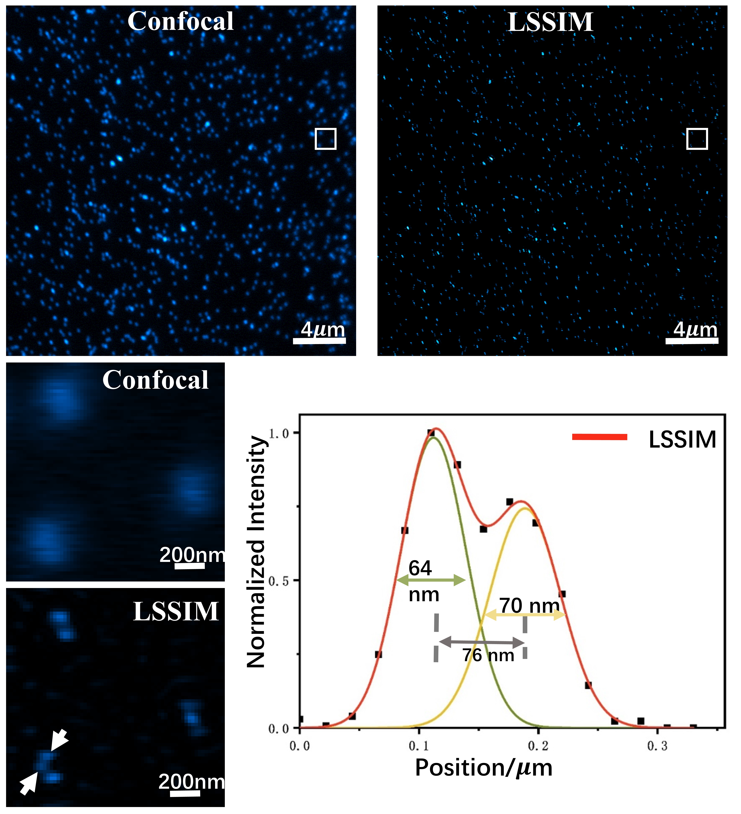
Figure S2 Comparison between the confocal microscopy and LSSIM in the imaging of the 70±5 nm fluorescent nanorulers.

Supplementary Note 4
Figure S3 The autofluorescence images of live Chlorella captured by SP8 in different detection band under 488nm excitation

Supplementary Note 5
Super-resolution image reconstruction process
Super-resolution image reconstruction was performed using the LSSIM algorithm, implemented in a custom MATLAB program. The process began with background subtraction from the raw data. The LSSIM algorithm then extracted low- and high-frequency components⁹. Following Gaussian filtering, these components were shifted back to their original positions in the frequency domain. Subsequently, each component was multiplied by a calculated phase value to correct for initial phase shifts. Then, the processed components were linearly combined using adjustable weights to generate the super-resolution image. Finally, the reconstructed images were processed by the BM3D algorithm (an image denoising algorithm) to remove the noise to a certain extent.
Supplementary Note 6
Comparison between the resolve capability of the commercial SIM and LSSIM
We selected the powerful commercial SIM (Multi-SIM X, Beijing NAXI) to image the live Chlorella and therefore to compare the resolving power between Multi-SIM X and our home-built LSSIM. As is shown in Figure S4, our LSSIM depicted a more detailed nanoscale intertwined architecture than Multi-SIM X did.
Figure S4 Comparison between the commercial Multi-SIM X and our LSSIM in the imaging of the live Chlorella.

Supplementary Note 7
Figure S5 The 3D projection of the live Chlorella 3D super-resolution images in different angles of view. The field of view is 6.51×4.68μm²

Supplementary Note 8
Cell culture
The Chlorella dynamic super-resolution record experiment was conducted over four days (Day 0 to Day 3), dividing the culture conditions into four distinct groups: control, salinity, dark, and dark+salinity.
The concentration for the salinity groups was 0.63 g of NaCl added to 10 mL of BG-11 medium. This level was chosen to create a "7x salt" condition, using 0.9% (w/v) NaCl (physiological saline) as the "1x" reference standard. The resulting 6.3% (w/v) concentration corresponds to approximately 1.08 M NaCl, creating a strong salinity environment (approx. 2.16 Osm) sufficient to induce a clear salt-stress effect. This "7x salt" designation is relative to physiological saline, not the components of the base BG-11 medium.
For the light groups, the average light intensity yields a mean of 66.41 (x10 Lux), with daily light, temperature (~24.18 °C), and humidity (~55.5%) also recorded.
Sample preparation process:
Turn on the UV sterilization lamp in the biosafety cabinet and wipe down the work surface with 75% ethanol. Wearing latex gloves, transfer the prepared cultivation flask(s) into the cabinet. Open the flask and aspirate 1.0 mL of algal suspension using a sterile pipette tip. Dispense the aspirated algal suspension dropwise into a 1.5 mL microcentrifuge tube. Centrifuge the prepared sample at 2000 × g for 2 minutes. After centrifugation, carefully remove the supernatant using a pipette, leaving approximately 50 μL of cell pellet. Using a bulb pipette, add approximately 1 mL of phosphate buffered saline buffer to the microcentrifuge tube. Vortex the tube vigorously for approximately 40 seconds to ensure thorough mixing and homogeneous dispersion of the Chlorella cells. Centrifuge the tube again at 2000 × g for 2 minutes. After centrifugation, carefully remove the supernatant. Repeat this washing step 2-3 times to ensure complete removal of residual culture medium. Using a pipette, transfer approximately 10 μL of the final cell suspension onto the center of a glass-bottom dish suitable for confocal microscopy. Allow the cells to settle naturally for 3 minutes at room temperature. Carefully cover the sample with a coverslip. The prepared sample is now ready for observation and analysis using a fluorescence microscope system.

Supplementary Note 9
The principle calculating the chlorophyll area and the Pearson’s correlation coefficient (PCC)
We calculated the area of the cell structures, which exhibit a toroidal (donut-like) topology.
1. Chlorophyll area calculation
The chlorophyll area calculation begins by binarizing the image with an optimal grayscale threshold, which separates the bright cellular foreground from the dark background. A morphological 'Open' operation is then applied to remove small noise artifacts, or 'debris,' from the binary image. Critically, when contours are found, their 'parent-child' relationships are rebuilt; this identifies 'parent' contours (the outer edge of the cell) and their corresponding 'child' contours (the inner edge of the hole). The final 'ring area' is then determined by iterating through these hierarchies: for each 'parent' contour, the area of all its 'child' (hole) contours is subtracted from it.
2. PCC calculation
To precisely calculate the PCC while excluding background interference, the analysis is subsequently focused exclusively on pixels within these identified 'cell rings.' A 'total mask' is generated by combining the individual ring masks (which contain holes) from both the red fluorescence (Image 1) and green fluorescence (Image 2) images. This combined mask serves as a filter to extract the corresponding pixel values from the original images. Finally, the PCC is computed using only these two extracted sets of 'ring' pixel data.

Supplementary Note 10
Figure S6 The dual-color super-resolution images of different microalgae.

References
1. Hell, S.W. & Wichmann, J. Opt. Lett. 19, 780-782 (1994).
2. Rust, M.J., Bates, M. & Zhuang, X. Nat. Methods 3, 793-795 (2006).
3. Cogswell, C.J. Proceedings of SPIE - The International Society for Optical Engineering 3919, 141-150 (2000).
4. Gustafsson, M.G.L. Proc. Natl. Acad. Sci. U.S.A. 102, 13081-13086 (2005).
5. Rego, E.H. et al. Proc. Natl. Acad. Sci. U.S.A. 109, E135-E143 (2012).
6. Wei, F.F. et al. Nano Lett. 14, 4634-4639 (2014).
7. Wei, F. & Liu, Z. Nano Lett. 10, 2531-2536 (2010).
8. Helle, O.I. et al. Nat. Photonics 14, 431-438 (2020).
9. Zheng, X. et al. Laser Photon. Rev. 17, 2200796 (2023).

