Supplementary Information:
Physics Informed Activation Functions and Loss Functions for Signal Reconstruction and Digital Twinning
Brent Cook^{1*}, Adryel Gainza¹, Bryan Portocarrero¹, Mubarak Mujawar¹, Vivek Kamat¹, Dan Ewing², Himanshu Upadhyay^{1*} and Shekhar Bhansali^{3*}
¹ Florida International University, Department of Electrical and Computer Engineering, Miami, Florida 33174, United States
² Department of Energy’s National Security Campus, Kansas City, Missouri 64147, United States
³ Vanderbilt University, Department of Electrical and Computer Engineering, Nashville, Tennessee 37235, United States
The setup used to generate our data is shown in Figure 1. The orientation of the printer is in a typical right-handed coordinate system as shown in Figure 1a, while the sensors are attached on top of the moving head as seen in Figure 1b and the camera on the nozzle is shown in Figure 1c and the connection of the sensors is given in Figure 1d.
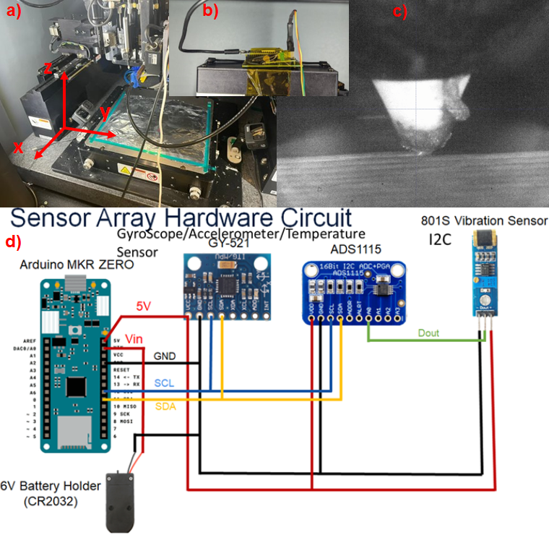
Figure S1. In (a) is the whole printer and the orientation of the printer, while in (b) is the mounted sensors on top of the printer head, and the tip camera is shown in (c). The sensor setup is shown and how the Arduino sensors are connected are shown in (d).
The results for the RK4 at different coupling constants is shown in Fig. S2, and the spectrogram of the G-Code, Data, and for the 4th order Runga-Kutta (RK4) for c = 1 is shown in Fig. S3, where c is the coupling constant shown below in equation S1.
${\ddot{Q}}_{i}+2γ\sqrt{c}{\dot{Q}}_{i}+cω_{ij}^{2}Q_{j}=-\frac{l}{L}{\ddot{x}}_{i}$ (S1)
Here equation S1 is from equation (2) in the main manuscript, and it is the non-dimensional version of the equation for solving the RK4 with the following substitutions:
$$t= \frac{τ}{T}, x_{i}= \frac{X_{i}}{L}, q_{i}= \frac{Q_{i}}{l}, c=\frac{1}{T^{2}}, \frac{Ml}{µL}=a=1, 2γ\sqrt{c}= 2ζω$$
$$2γ=\frac{β}{m}, ω_{ij}^{2}=\frac{k_{ij}}{m}$$
Here the damping ratio to the critical damping ratio coefficient is used to approximate the dynamics of the system to test the dynamical equations. The critical damping ratio, $ζ$, is related to the coefficient of the second term of equation (4), and is set to a value of ~0.04. The fourth order Runga Kutta (RK4) is used to solve equations (4), and equation (3) is the constraints to convert between the accelerations of the two masses. The next step is to put the equations in a form that is solvable for an RK4 here we go into matrix and vector notation we have the following set of equations.
${\vec{y}}_{1}=\vec{Q}$ (S2)
${\vec{y}}_{2}=\dot{\vec{Q}}$ (S3)
${\dot{\vec{y}}}_{1}= {\vec{y}}_{2}$ (S4)
${\dot{\vec{y}}}_{2}=-\vec{f}-2γ\sqrt{c}{\vec{y}}_{2}-c\overset{⃡}{ω}{\vec{y}}_{1}$ (S5)

The driver of vibrations here is the acceleration of the larger mass M, which we will denote as $\vec{f}$, and is just the acceleration force derived from each step of the G-code shown in (7). In (7) ‘n’ is the step number, and ‘n+1’ is the acceleration at the next step, and here ‘h’ is the step size that divides step ‘n’ to ‘n+1’ into ‘N’ segments, and each slice is incremented by an ‘s’ index, such that we have a linear function between accelerations of each step given below in equation (S7). To calculate the spectrogram from the G-Code alone, the positions and velocities are used to calculate the time between steps. The time is then used to find the acceleration, and the spectrogram is calculated (Figure S3). This is done using a spline that is spliced to the same size as our sensors of about ~175 Hz.
$\vec{f}=\left( {\ddot{\vec{x}}}_{n+1}-{\ddot{\vec{x}}}_{n}\right)\left(\frac{sh}{ t_{n+1}-t_{n}}\right)+{\ddot{\vec{x}}}_{n}$ (S7)

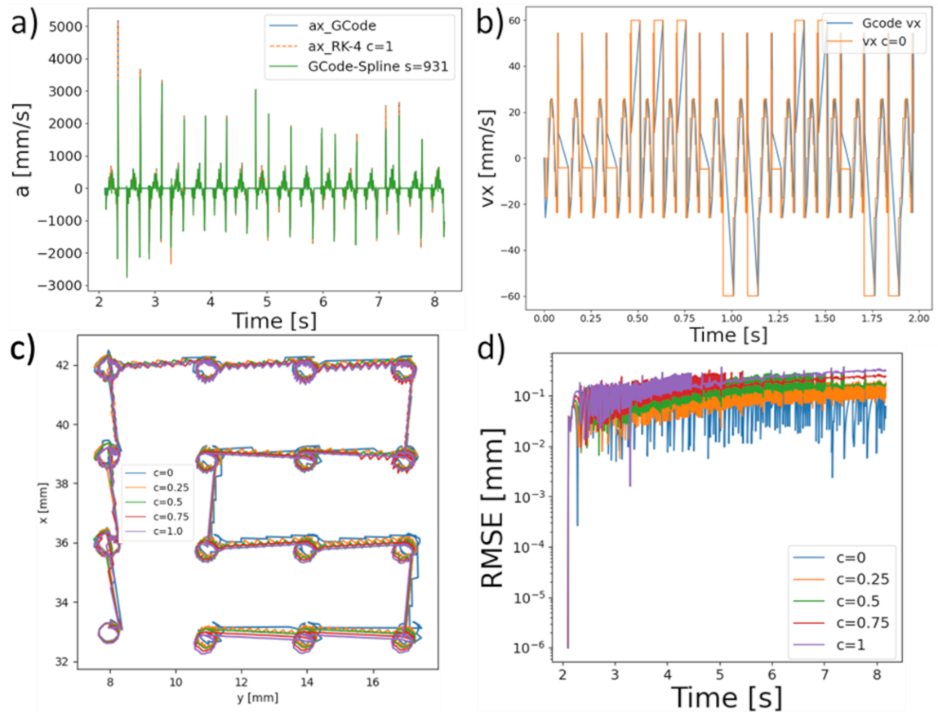
Figure S2. (a) The x component of acceleration compared to the G-Code, RK4, and Spline of GCode. The velocities used to calculate (a) are in (b) and the positions in (c). The error in position as a function of the parameter c= 0.25, 0.5, 1 and is shown in (d).
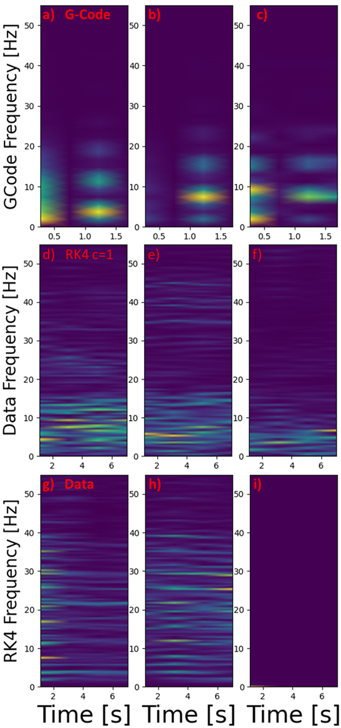
Figure S3. (a), (b), (c) are the spectrograms of the G-Code spline for the x, y, z components of acceleration respectively and for the sensor data it is shown underneath for (d), (e), and (f), and at the bottom is the RK4 for a parameter of c = 1 shown in (g), (h), and (i) respectively.

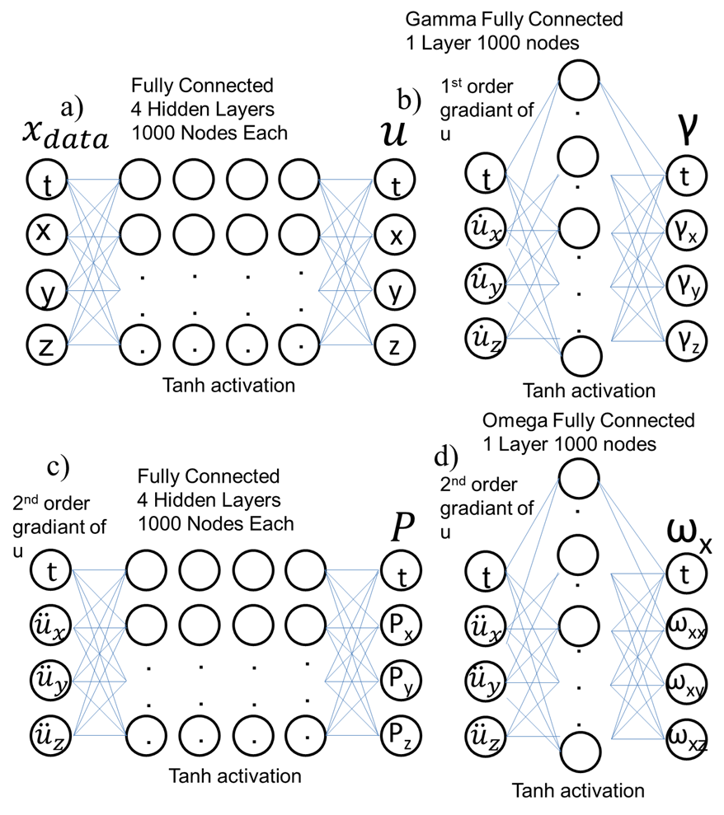
Figure S4. In a) is the structure for u modeling position, b) is the damping constant, c) the driving force model and lastly the model for frequency in d) is only shown for ω_{x}, but is the same for ω_{y} and ω_{z}.
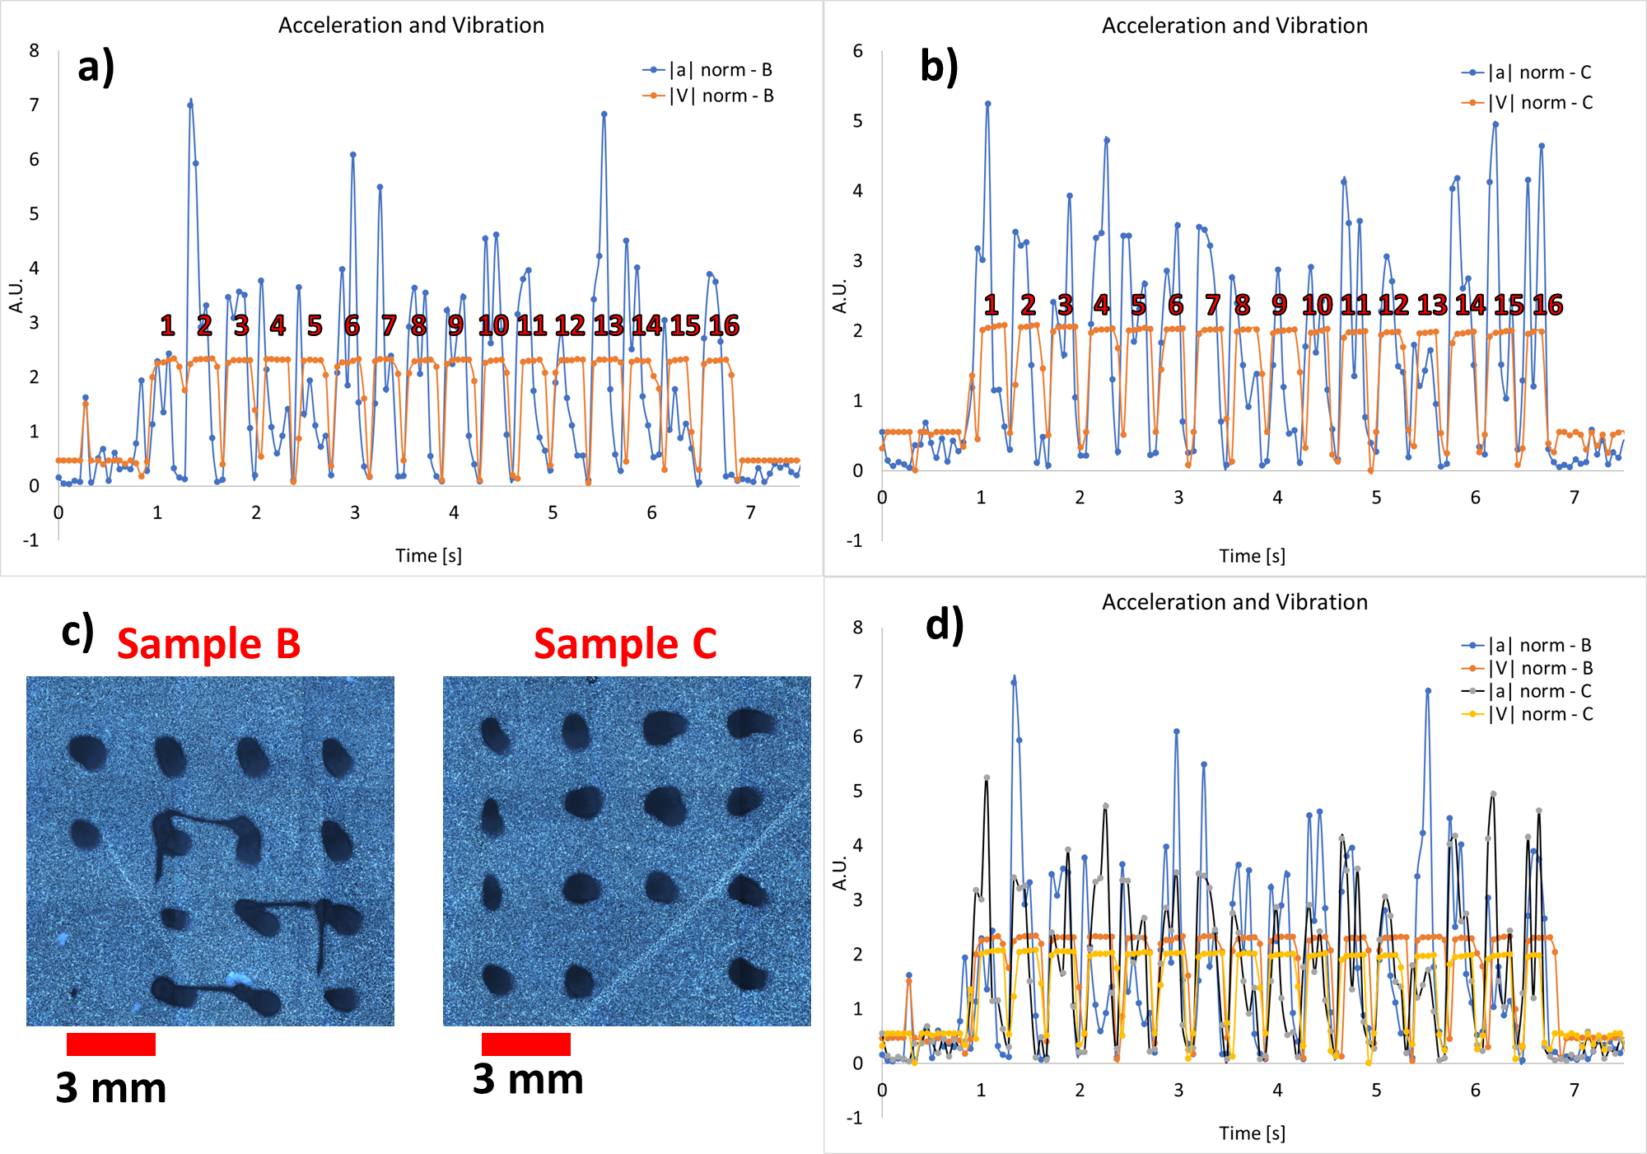
Figure S5. (a) Two samples printed Sample B and Sample C, with B in (a) and C in (b) respectively, and acceleration and vibration plotted, and they both indicated 16 peaks. In (d) both plots overlayed

