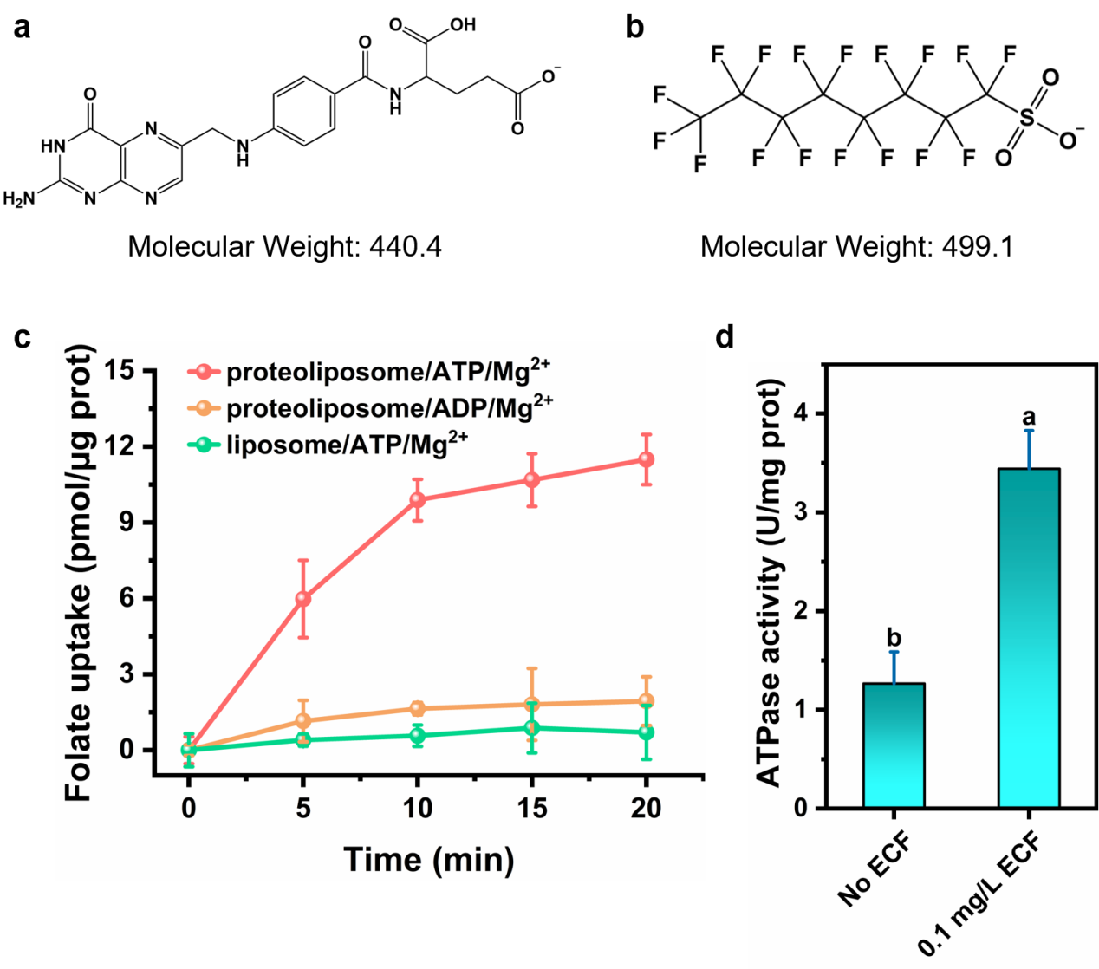

Extended Data Fig. 1. Verification experiment of ECF-FolT2 functions. (a) Chemical structure of folate. (b) Chemical structure of PFOS. Folate and PFOS have similar molecular weights and exist in anionic form under neutral conditions. Their sulfonic acid groups carry negative charges and act as the hydrophilic headgroup of the molecules. (c) Folate uptake assay with proteoliposomes. The coexistence of ATP and ECF-FolT2s is necessary for folate uptake by proteoliposomes. The folate uptake of the groups, proteoliposome/ATP/Mg²⁺, proteoliposome/ADP/Mg²⁺, and liposome/ATP/Mg²⁺ at 25 ℃ in 20 min were 11.49, 1.94, and 0.70 pmol/g protein. (d) ATPase activity of ECF-FolT2. We ompared the decomposition of ATP with and without ECF-FolT2. a and b indicates the significant difference between each sets of data. Without ECF, ATP occurred a little hydrolysis equivalent to 1.27 U/mg protein of ATPase activity, due to the instability of ATP. The measure of ATPase activity by 0.1 mg/L ECF could reach 3.44 U/mg protein at 25 ℃.

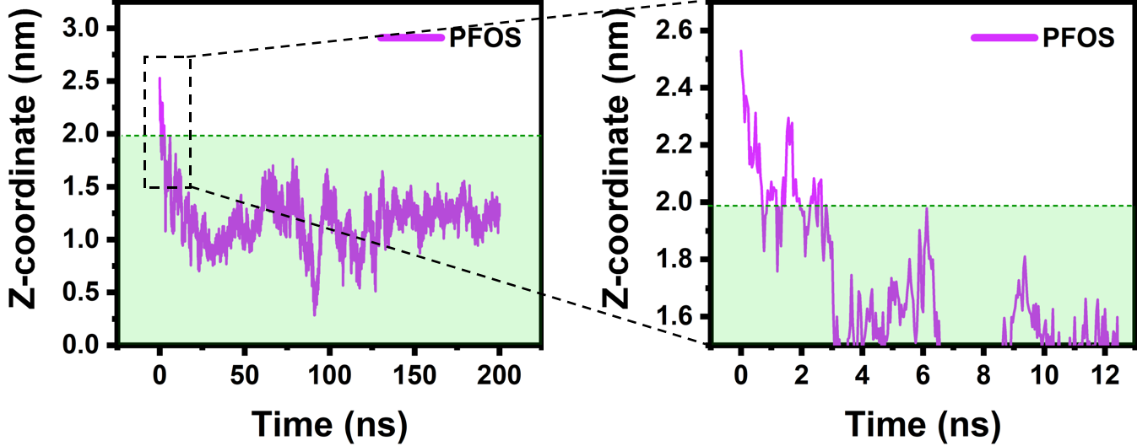

Extended Data Fig. 2. Time evolutions of the Z-coordinate of PFOS during 200-ns MD simulation.

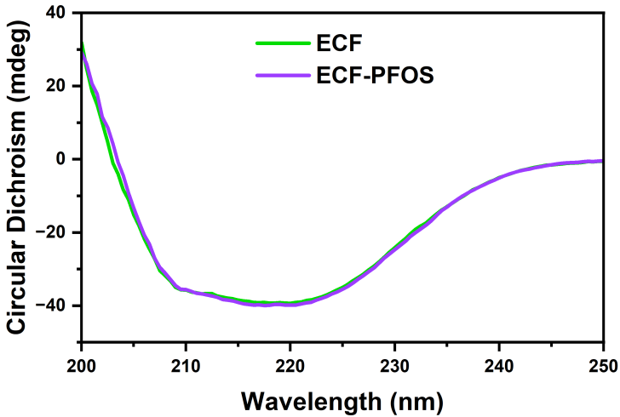

Extended Data Fig. 3. Circular dichroism spectrum of ECF-FolT2 binding with PFOS. The binding of PFOS to the ECF-FolT2 did not significantly affect the secondary structure of the protein.

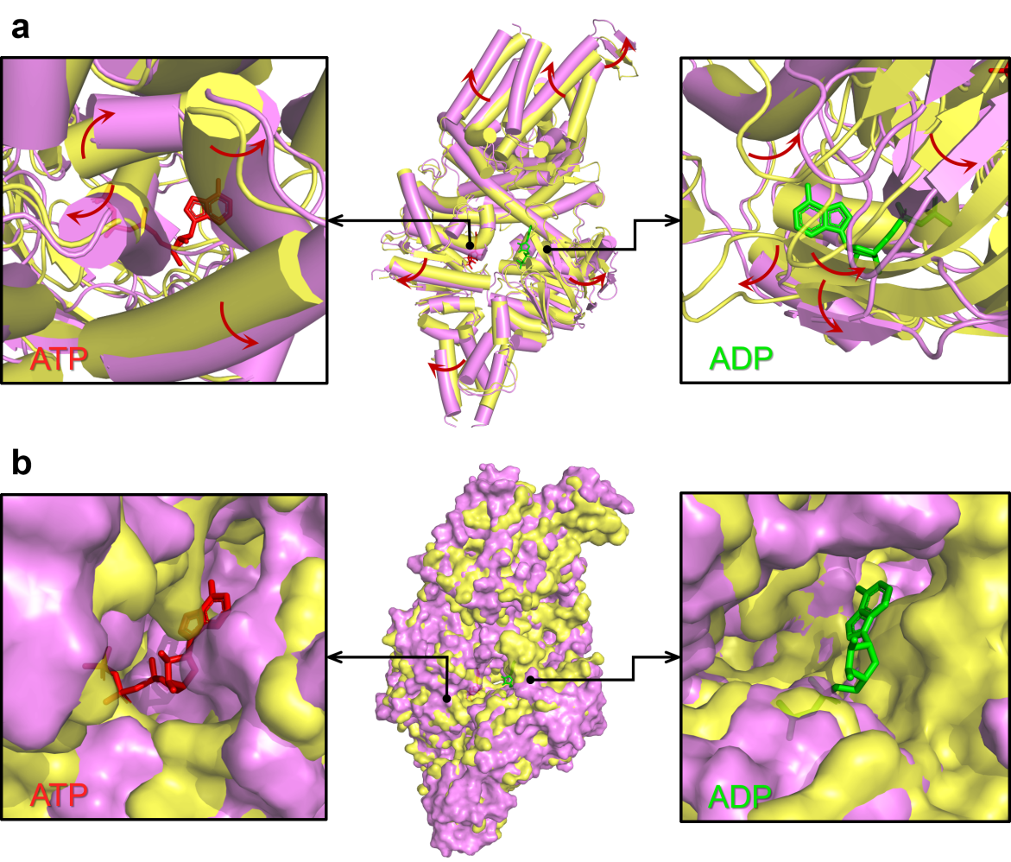

Extended Data Fig. 4. Structure alignment of ECF-FolT2 from Lactobacillus brevis (this work, violet) affected by PFOS and ECF-FolT2 from Lactobacillus delbrueckii (PDB ID: 8BMP, yellow) bound to ATP (red) and ADP (green). (a) ECF-FolT2s are shown as sticks, and the conformational changes are indicated with red arrows. (b) ECF-FolT2s are shown as surface. The PFOS-affected folate ECF transporter presented an “eversion” state. The protein sticks at sites for ATP and ADP occurred misalignment in different degrees. If the ECFs were shown as surface form, we could found that the surfaces of the binding pocket for ATP and ADP changed so much. The influence of PFOS on ECF-FolT2 transporter had greatly transformed the protein tertiary structure including the binding sites of ATP and ADP.

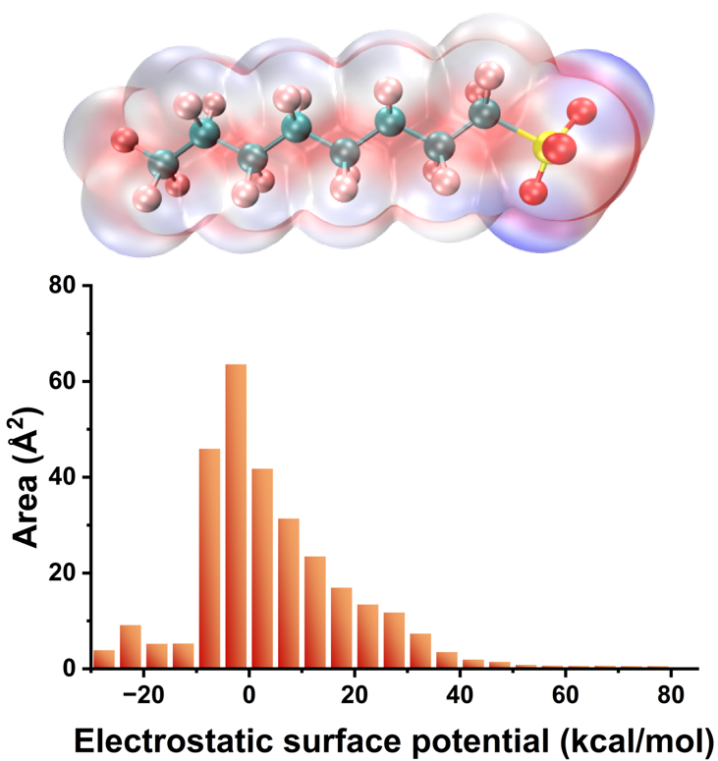

Extended Data Fig. 5. Electrostatic surface potential (ESP) distribution of PFOS. In the upper figures, red part means negative ESP, blue part indicates positive ESP, and white part represents zero region. The bottom bar charts show the potential distribution. Some specific results in quantitative analysis of molecular surface are listed as following:

Volume: 279.73561 Angstrom³
Estimated density according to mass and volume (M/V): 2.9628 g/cm³
Minimal value: -26.79573 kcal/mol
Maximal value: 82.30824 kcal/mol
Overall surface area: 289.68681 Angstrom²
Positive surface area: 156.77207 Angstrom²
Negative surface area: 132.91474 Angstrom²
Overall average value: 4.74014 kcal/mol
Positive average value: 14.73513 kcal/mol
Negative average value: -7.04889 kcal/mol
Overall variance (sigma²_tot): 225.38401 (kcal/mol)²
Positive variance: 181.80554 (kcal/mol)²
Negative variance: 43.57847 (kcal/mol)²
Balance of charges (nu): 0.15596706
Product of sigma²_tot and nu: 35.15248 (kcal/mol)²
Internal charge separation (Pi): 11.49808 kcal/mol
Molecular polarity index (MPI): 11.20851 kcal/mol
Nonpolar surface area (|ESP| ≤ 10 kcal/mol): 182.57 Angstrom² (63.02 %)
Polar surface area (|ESP| > 10 kcal/mol): 107.12 Angstrom² (36.98 %)

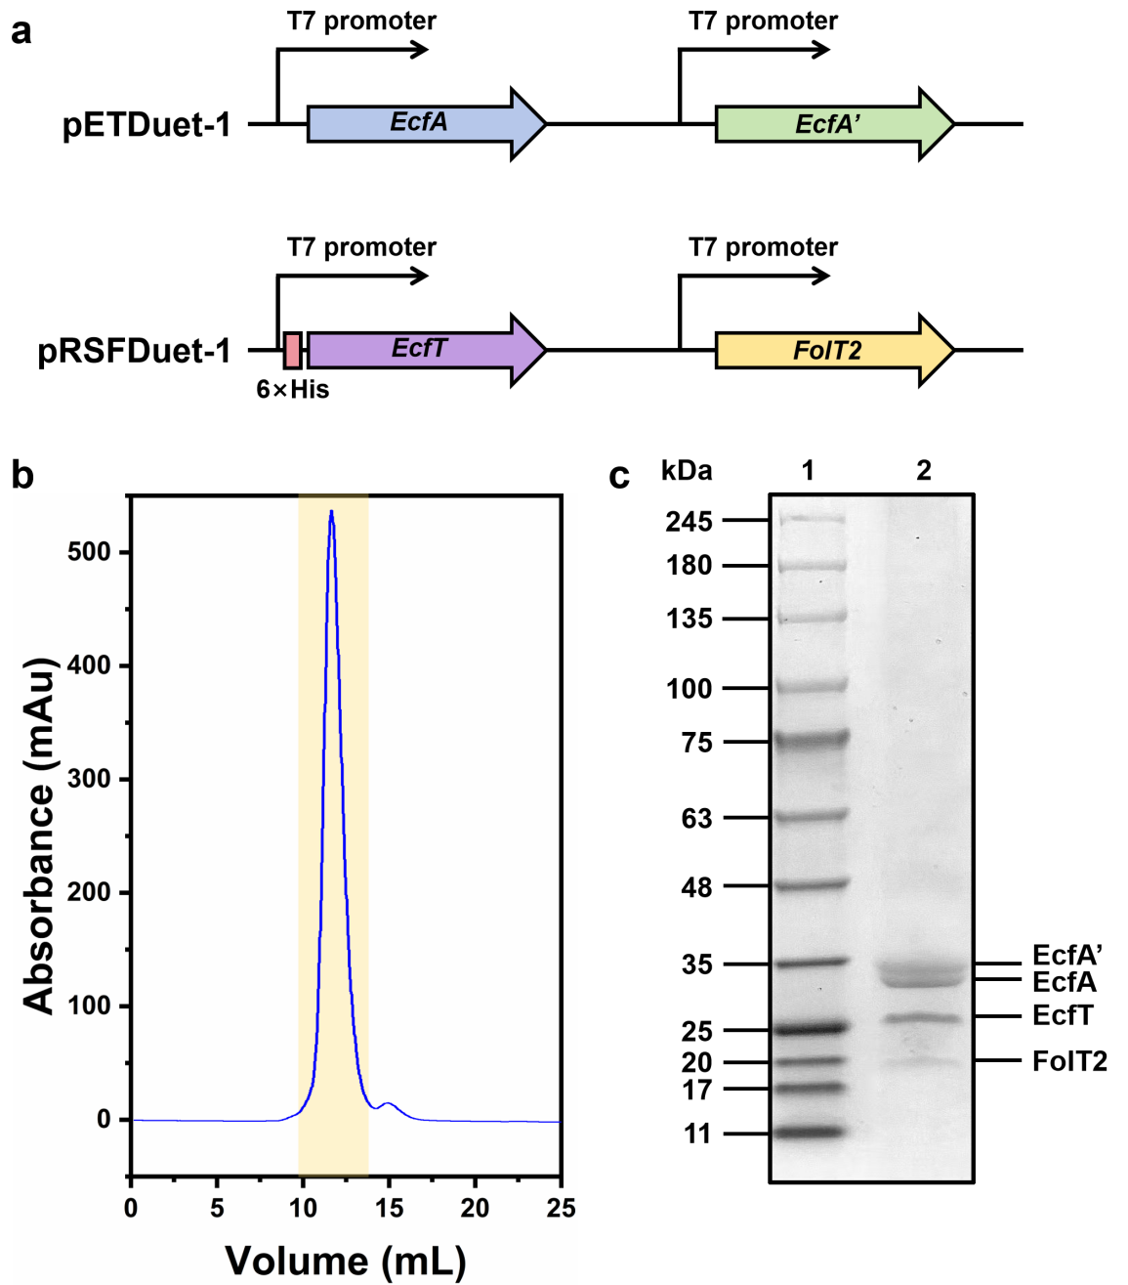

Extended Data Fig. 6. Gene expression and purification of ECF-FolT2. a. Schematic representation of the gene expression for ECF-FolT2. Genes of EcfA and EcfA’ were subcloned separately after two T7 promoters into pETDuet-1 plasmids. While genes of EcfT and FolT were subcloned into pRSFDuet-1 plasmids. A tag of six histidine residues was added at the N terminus of EcfT. b. Representative elution profiles from a Superdex 200 Increase 10/300 GL size-exclusion chromatography column. c. Validation of ECF-FolT2 in peak fraction from size-exclusion chromatography by using SDS-PAGE.

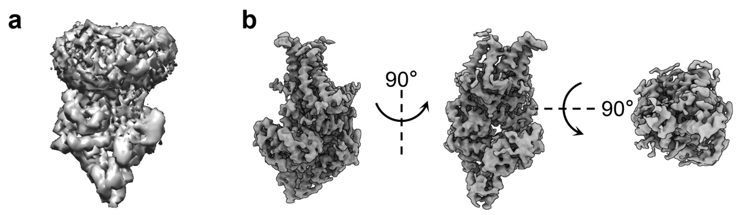

Extended Data Fig. 7. 3D models of a ECF-FolT2. a, 3D initial model of a ECF-FolT2 in detergent micelles after 3D reconstruction. b, Density maps of the final structure of ECF-FolT2 (after extraction from detergent micelles) from different angles.

