Supplementary material

Reconstructing the effects of anthropogenic activities and climate change in three lakes of the Fildes Peninsula, Maritime Antarctic

Table S.1. Samples analyzed in Mondsee Lake. The right-hand column indicates which proxy was analyzed in each sample. M: metals; D: diatoms; B: bacteria.

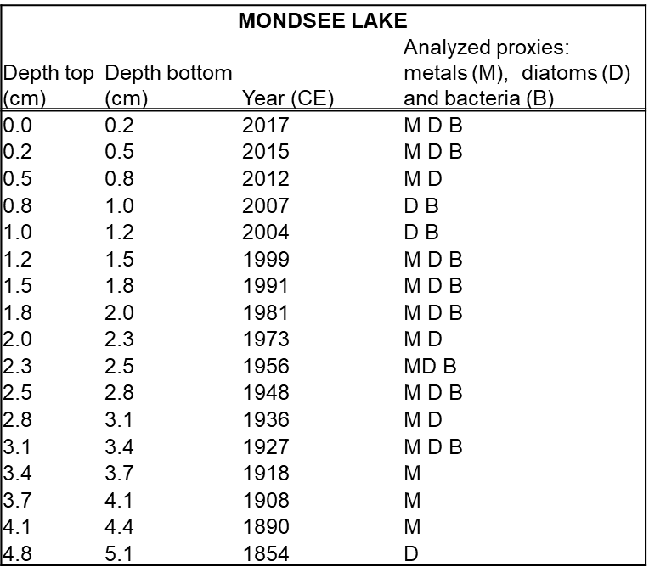

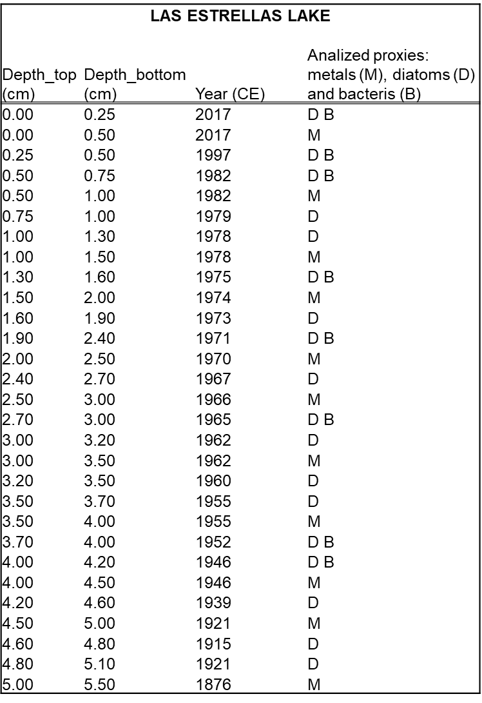
Table S.1 cont’d. Samples analyzed in Las Estrellas Lake. The right-hand column indicates which proxy was analyzed in each sample. M: metals; D: diatoms; B: bacteria.

Table S.1 cont’d. Samples analyzed in Hotel Lake. The right-hand column indicates which proxy was analyzed in each sample. M: metals; D: diatoms; B: bacteria.

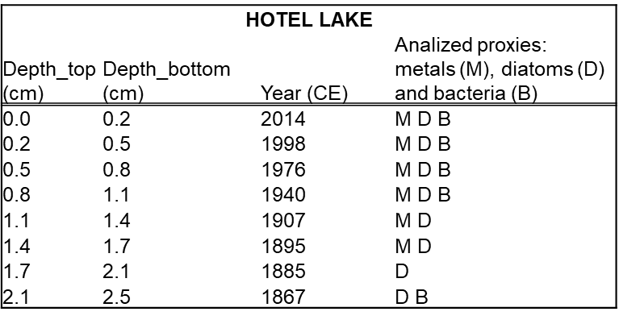

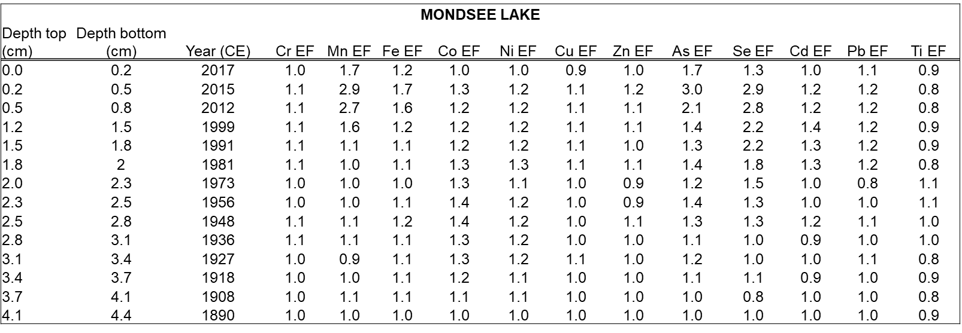
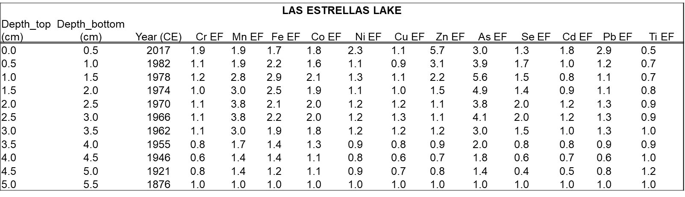
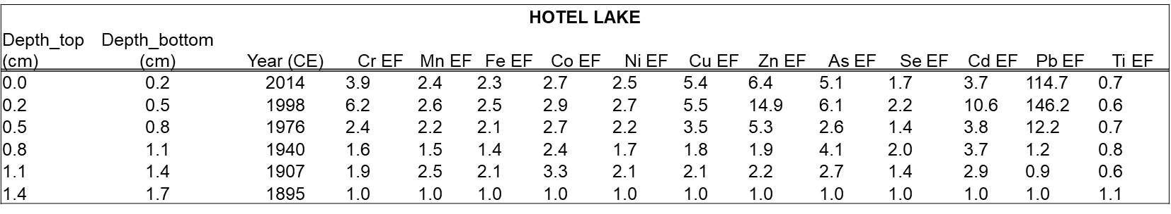
Table S.2. Metal enrichment factors (EFs) in the three evaluated lakes
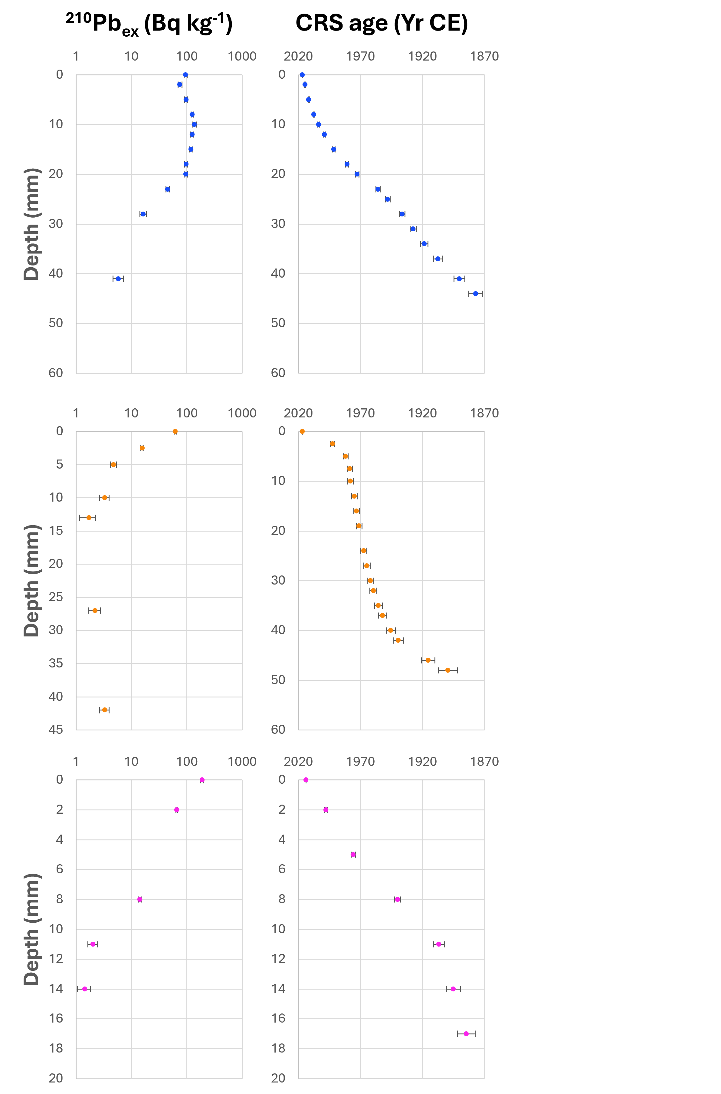
Figure S.1. Unsupported ²¹⁰Pb activities (²¹⁰Pb_{ex}) and age-depth relationships established with the constant rate of supply (CRS) model for the three study lakes. Top: Mondsee Lake; middle: Las Estrellas Lake; bottom: Hotel Lake.

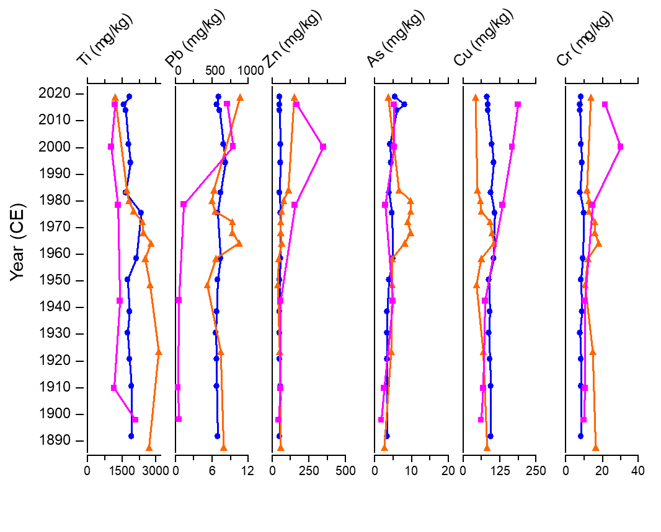
Figure S.2. Metal concentrations (mg kg⁻¹) in the three study lakes. Blue lines: Mondsee Lake, orange lines: Las Estrellas Lake and pink lines Hotel lake. Note the different x-axis for Pb in Hotel Lake (top).

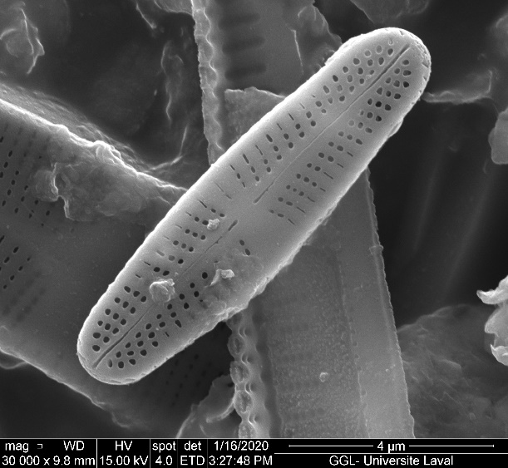
Figure S.3. Selected diatom species by scanning electron microscope (SEM). A) Achnanthidium indistinctum, B) Achnanthidium maritimo-antarcticum, C) Sellaphora nigri, D) Cavinula pseudoscutiformis.

A
B
C
D

Table S3. Diatom species identified in the three study lakes.

Achnanthidium australexiguum | Microcostatus naumanii
Achnanthidium indistinctum | Muelleria spuldingiana
Achnanthidium maritimo-antarcticum | Navicula cremeri
Adlafia submuscora | Navicula gregaria
Aulacoseira lirata | Navicula sp.5
Caloneis australis | Nitzschia annewillemsiana
Cavinula pseudoscutiformis | Nitzschia archibaldii
Chamaepinnularia antarctica | Nitzschia gracilis
Chamaepinnularia australomediocris | Nitzschia homburgiensis
Chamaepinnularia elliptica | Nitzschia kleinteichiana
Chamaepinnularia evanida | Nitzschia perminuta
Chamaepinnularia gerlachei | Nitzschia soratensis
Chamaepinnularia krookiformis | Nitzschia sp.1
Chamaepinnularia krookii | Nitzschia velazqueziana
Craticula subpompeana | Orthoseira roseana
Diatomella balfouriana | Pinnularia borealis
Fragilaria capucina var. Vaucheriae | Pinnularia gemella
Fragilaria parva | Pinnularia livingstonensis
Gomphonema cf. angustatum | Pinnularia microstauroides
Gomphonema jamesrossense | Pinnularia sergiplaiana
Gomphonema maritimo-antarcticum | Pinnularia sp.11
Gomphonema sp.1 | Pinnularia sp.9
Halamphora ausloosiana | Pinnularia subantarctica
Halamphora oligotraphenta | Placoneis australis
Hippodonta hungarica | Planothidium australe
Humidophila keiliorum | Planothidium capitatum
Humidophila komarekiana | Planothidium cf. densistriatum
Humidophila sceppacuerciae | Planothidium frequentissimum
Humidophila tabellariaeformis | Planothidium lanceolatum
Humidophila vojtajarosikii | Planothidium renei
Luticola muticopsis | Planothidium rostrolanceolatum
Luticola truncata | Planothidium sp.2

Table S3 cont'd. Diatom species identified in the three study lakes.
Planothidium wetzelectorianum
Psammothidium abundans
Psammothidium aretasii
Psammothidium confusoneglectum
Psammothidium incognitum
Psammothidium manguinii
Psammothidium papilio
Psammothidium rostrogermainii
Psammothidium sp.1
Psammothidium subatomoides
Psammothidium superpapilio
Sellaphora antarctica
Sellaphora cf. seminulum
Sellaphora nana
Sellaphora nigri
Sellaphora sp
Stauroforma inermis
Stauroneis bryocola
Stauroneis delicata
Stauroneis latistauros
Stauroneis sofia
Stauroneis subgracilis
Staurosira pottiezii
Staurosira sp.1
Staurosirella antarctica
Staurosirella sp.2
Surirella sp.1
Tryblionella debilis

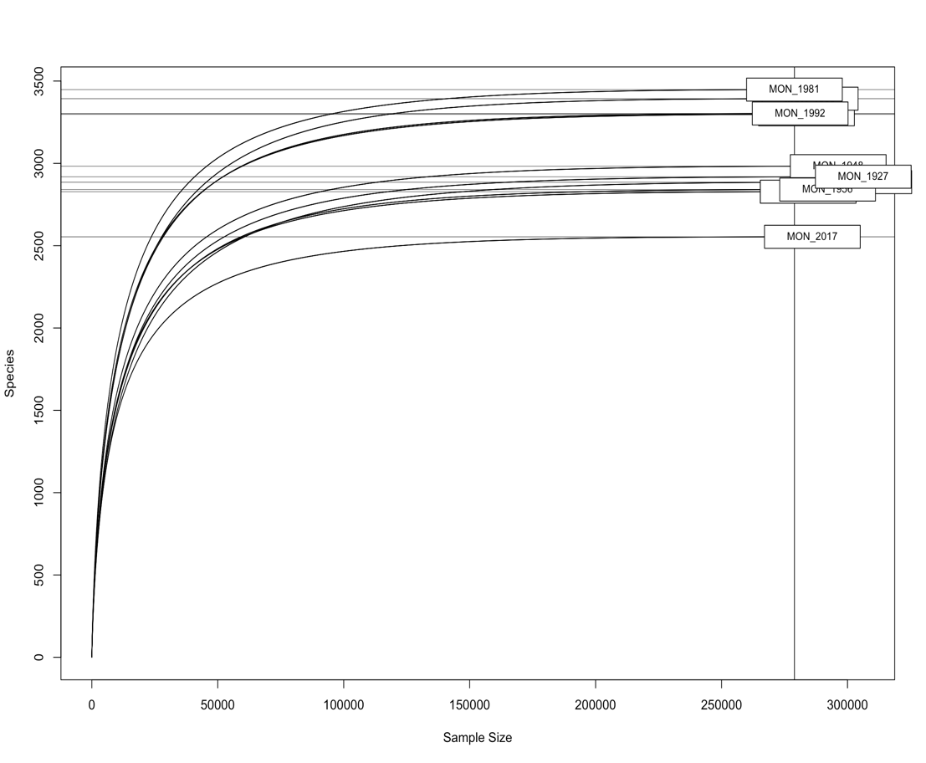
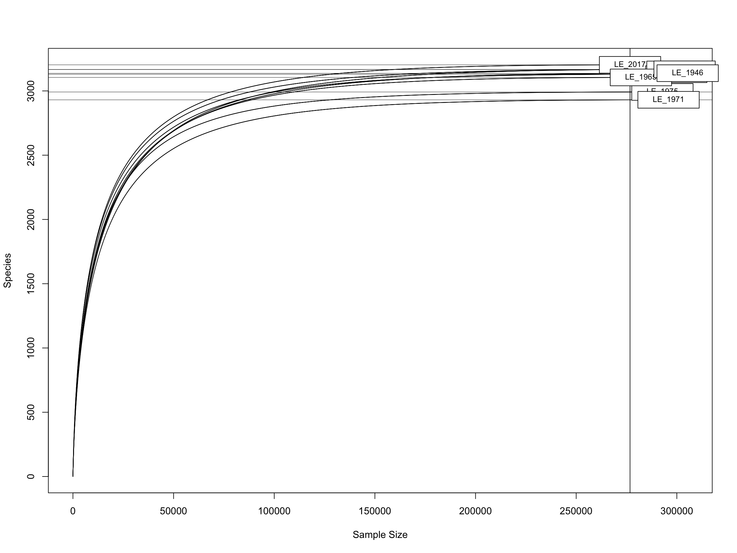
Figure S.4. Rarefaction curves. Top: Mondsee Lake; Bottom: Las Estrellas Lake.

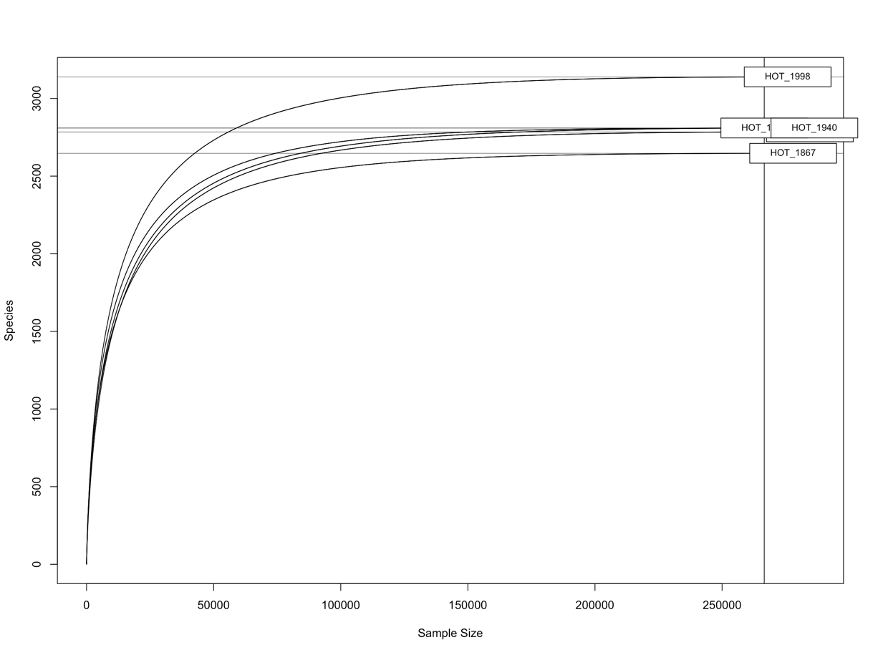
Figure S.4 cont’d. Rarefaction curve for Hotel Lake.

