Supplementary File
PBMA Panel terms of reference
Cardiff and Vale University Health Board
Maximising Health Outcomes in Type 2 Diabetes Panel
Terms of Reference

Date: 20/06/2024 | Version: 1
Background:

In 2022, a recommendation was made in the annual report of the Director of Public Health for Cardiff and Vale UHB to ‘Consider the use of Programme Budgeting and Marginal Analysis (PBMA) as a tool to help shift funding from low-value to high-value interventions and move funding upstream towards prevention’. PBMA is a transparent, consultative decision-making framework that can be used by those planning services to maximise health outcomes by reallocating resources. It is not a new method; it has been used successfully at both national and local level in Wales and around the UK,. By implementing PBMA, organisations can make consultative, informed and evidence-based decisions about resource allocation, ensuring that limited resources are effectively and efficiently utilised to achieve desired outcomes. Type 2 diabetes has been identified by Cardiff and Vale UHB as a suitable programme to trial the use of PBMA in the Health Board. This group constitutes an expert panel for working through the PBMA process, facilitated by the Centre for Health Economics and Medicines Evaluation (CHEME), Bangor University.

Aim:
To maximise health outcomes in type 2 diabetes by producing recommendations for shifting funding from low-value to high-value interventions and to move funding upstream towards prevention.

Purpose of the series of three panel meetings is to:

- Identify what is currently working well and not working well in the diabetes pathway
- Request candidate interventions for resource reallocation
- Determine decision-making criteria for resource allocation (e.g. clinical effectiveness, cost-effectiveness, reducing health inequalities, alignment with government policy, etc)
- Discuss and decide on candidate interventions for resource allocation
- Produce an evidence booklet for suggested candidate interventions
- Complete a priority ranking exercise to provide CaV UHB with a direction of travel via a set of recommendations as a result of the process
Membership:

Voting members:
- Executive Director of Public Health (Chair)
- GP and Clinical Director for Diabetes, PCIC
- Consultant Physician and Diabetologist
- Costing and Value Senior Business Partner, Finance
- Independent Member (Vice-Chair)
- Pharmacist Prescribing Advisor
- All Wales Dietetic Lead for Diabetes (Adult) / Dietetic Lead for AWDPP
- Public Health Consultant/Registrar
- Head of Nutrition and Dietetics
- Director of Integrated Health and Social Care
- Children’s Specialist Nurse for Diabetes
- Consultant Physician Diabetes / National Strategic Clinical Network for Diabetes Chair
- Podiatry Professional Lead / Lead for Diabetic Foot Services / National Rep.
- Consultant Paediatrician / Clinical Lead for Paediatric Diabetes
- Patient Representative
- Health Systems Engagement Manager, Diabetes UK Cymru
- Nurse Lead Diabetes

Non-voting members:
- Administrative support
- Senior Communication and Engagement Officer
- Co-Director, Centre for Health Economics and Medicines Evaluation, Bangor University
- Research Fellow, Centre for Health Economics and Medicines Evaluation, Bangor University
- Research Project Support Officer, Centre for Health Economics and Medicines Evaluation, Bangor University

Frequency of meetings:

- Meetings will be held three times between July to October 2024.
Reporting to:

- Cardiff and Vale University Health Board Diabetes Programme Board

Governance Structure:

The group is a workstream under the new Diabetes Strategic Programme Board.

Figure 1. Governance structure of the PBMA Panel

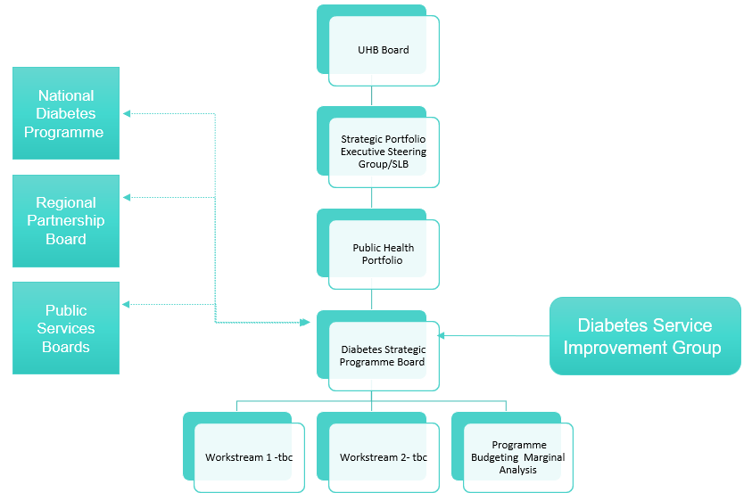

Summary of candidate costs, benefits and evidence of cost savings
Table 1. Summary of candidate costs, benefits and evidence of cost savings
Candidates | Costs | Benefits | Potential cost savings
T2D Structured Education for CYP and their families | £249,043/year  - design of workbooks, resources and curriculum | - prevent progression and aggressive complications  - helps to prevent the type 2 diabetes progression | - long term cost-saving due to prevention/reversal of diabetes and comorbidities
Additional community DSNs to conduct medication reviews | £504,543 per year  - salary of band 7 Diabetic Specialist Nurses | - ensuring safety by avoiding drug related adverse effects  - supporting patients to consider the most appropriate medication at the right dose with regular review | - reducing medicine wastage  - reducing variation in prescription  - avoiding frequent GP consultations  - improved medicine optimisation
Additional clinical space for the Community Diabetes Hub in Central Cardiff | £122,138/year  - staff salary of a receptionist, healthcare worker, rent, utilities, cleaning | - integrated pathway between primary and secondary care  - providing a one-stop-shop for patients  - central hub for multi-disciplinary team | - reduced referrals to secondary care, number of adverse health events avoided such as long-term vascular events.
Extension of AWDPP to three additional clusters | £191,136/year  - staff salaries, Hba1c tests, Phlebotomy tests, etc | - reducing weight, increasing physical activity and improving the diet of those at high risk  - reduce the incidence of type 2 diabetes | - Research shows that AWDPP is more effective and less costly than usual care (Harris et al., 2019)
Additional DSNs in perioperative care | £466,419 per year  - staffing cost of 8.8 DSNs | - reduce length of stay.  - reduce cancellations  - improve patient safety through staff and patient education | - reduce length of stay and bed days to range of 1.2 – 4.2 days resulting in a savings from £612,000-£2,142,000.
National Exercise Referral Scheme (NERS) pathway for people with prediabetes | £133,800 per year  - salaries of two exercise professionals  - room hire costs | - increased physical activity and healthy lifestyle changes  - prevent or delay the onset of type 2 diabetes | - prevention/reversal of type 2 diabetes and related comorbidities

Indicative costs of 6 evidence-based options
Figure 2. Benefits and cost saving of T2D Structured Education for CYP and families
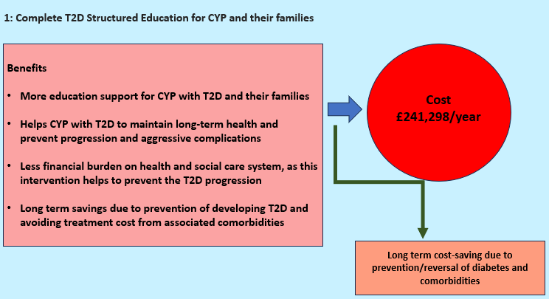
Table 2. Indicative costs of T2D Structured Education for CYP and families
Indicative cost of T2D Structured Education for CYP and families (plus case finding)
Children population in Cardiff and Vale University Health Board (Wales stats 2023) | £92,049
Number of children aged 10-15 | £37,195
Assuming 10% of the children need to do screening | 3720
Cost of Hba1c test | £33
Total cost for Screening | £122,760
Salary of 2 Band 5 nurse | £92,650
Administrator cost | £10,000
Management support | £8,000
Structured Diabetes Education | £5,600
Evaluation cost | £10,000
Annual Total cost | £249,043

Figure 3. Benefits and cost saving of Medicines Optimisation
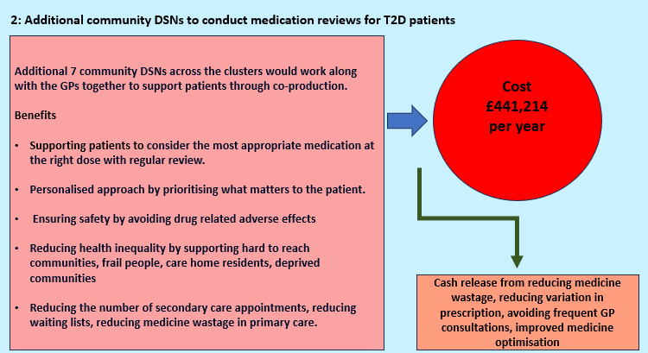
Table 3. Indicative costs Medicines Optimisation
Indicative cost for Medicines Optimisation
Salary of Band 7 DSN - | £67,649
Travel cost | £2,000
Training | £1,000
Total cost for 1 DSN | £70,649
Total cost for 7 DSNS | £49,4543
Monitoring | £10,000
Total Annual cost | £504,543

Figure 4. Benefits and cost saving of Community Clinic space
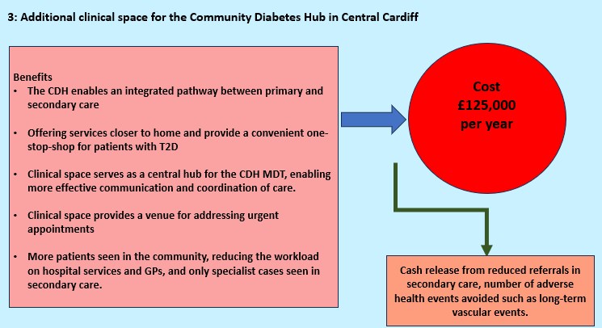
Table 4. Indicative costs for Community Clinic space
Indicative cost for Community Clinic space
Staff Salaries (Receptionist, plus administrator) | £64,138
Rent and Utilities | £10,000
Medical Equipment and Supplies | £10,000
Pharmacy services | £10,000
Facility Maintenance and Cleaning | £10,000
Laptop cost | £3,000
IT support | £5,000
Evaluation Costs | £10,000
Total Annual Cost | £122,138

Figure 5. Benefits and cost saving of extension of AWDPP to 3 new Clusters
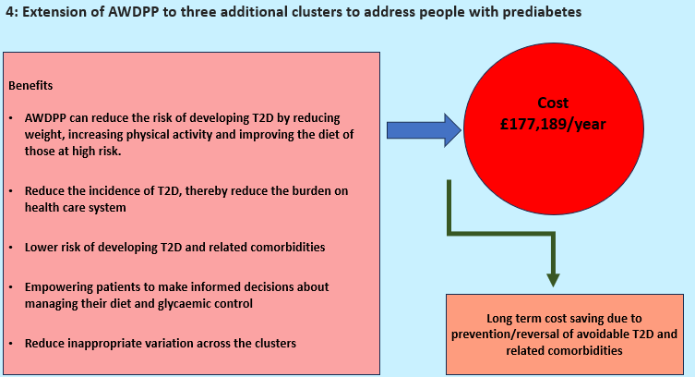
Table 5. Indicative costs for extension of AWDPP to 3 new Clusters
Indicative cost for extension of AWDPP to 3 new Clusters
Staff costs 0.25 wte Dietitian (Band 7) | £16,912
1 Health Care Support Worker (Band 3) | £30,813
Staff total | £47,725
Accommodation/ contingency | £7,143
HbA1c lab test | £2,662
HbA1c phlebotomy | £3,300
Stationary/postage | £2,882
Delivery total | £15,987
Cost per cluster | £63,712
Grand total per annum for additional 3 clusters | £191,136

Figure 6. Benefits and cost saving of additional 8.8 DSNs perioperative care
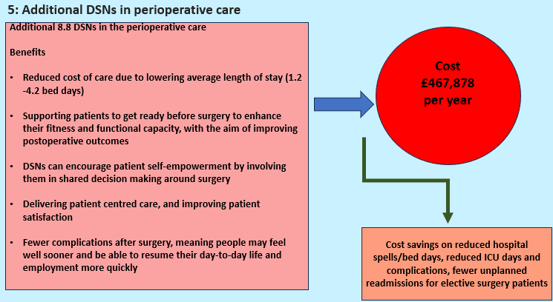
Table 6. Indicative cost for additional 8.8 DSNs perioperative care
Indicative cost for additional 8.8 DSNs perioperative care
Salary of 1 Band 6 DSN | £67,649
Salary of 3.5 DSNs at UHL | £200,896
Salary of 5.3 DSNs at UHW | £245,522
Evaluation | £10,000
Training | £10,000
Annual Total Cost | £466,419

Figure 7. Benefits and cost saving of funding a prediabetes NERS pathway
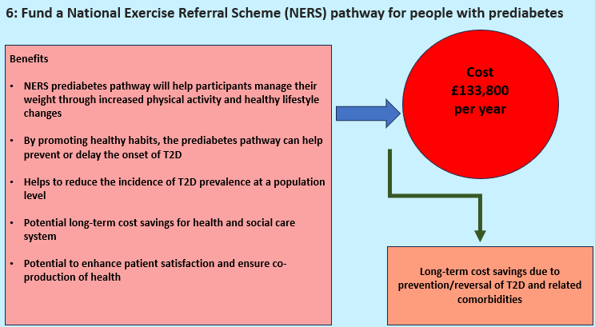
Table 7. Indicative cost for funding a prediabetes NERS pathway
Indicative cost for funding a prediabetes NERS pathway
Exercise Referral Professional (ERP) x 1: Salary and oncosts (grade 5 - £24,702 - £26,421 – based on top of scale) | £38,000
Recruitment | £1,500
Office space | £1,500
Administration support | £4,000
Management support | £3,000
Laptop, mobile phone, dongle, internet access, licences etc. | £2,000
Extra classes (£25 per hour: 2 classes per centre per week = £200/week) | £10,400
Pool car/Mileage | £2,000
Training | £1,000
Miscellaneous/Contingency | £1,000
Annual Cost for 1 ERP | £64,400
Annual Cost for 2 ERP | £128,800
Marketing cost | £5,000
Annual Total Cost | £133,800

