Table S1: Replication-phase Linear Regression Analysis of K170R Variant.
Trait | Confounders Adjustment | Unstandardized Coefficients |  | Standardized Coefficients | t | Significance | 95.0% Confidence Interval for B
Trait | Confounders Adjustment | B | Std Error | Beta | t | Significance | Lower Bound | Upper Bound
HbA1c | Not adjusted | 0 | 0.006 | 0.001 | 0.023 | 0.982 | -0.011 | 0.011
HbA1c | Adjusted for Age, sex | -0.002 | 0.006 | -0.012 | -0.302 | 0.763 | -0.014 | 0.010
HbA1c | Adjusted for Age, sex,BMI | -0.002 | 0.006 | -0.013 | -0.328 | 0.743 | -0.014 | 0.010
HbA1c | Ethnicity | 0 | 0.006 | -0.001 | -0.026 | 0.979 | -0.011 | 0.011
LDL | Not adjusted | 0.004 | 0.010 | 0.014 | 0.379 | 0.705 | -0.015 | 0.023
LDL | Adjusted for Age, sex | 0.003 | 0.010 | 0.011 | 0.286 | 0.775 | -0.016 | 0.022
LDL | Adjusted for Age, sex,BMI | 0.002 | 0.010 | 0.006 | 0.156 | 0.876 | -0.018 | 0.021
LDL | Ethnicity | 0.003 | 0.010 | 0.012 | 0.319 | 0.750 | -0.016 | 0.022
TC | Not adjusted | 0.003 | 0.009 | 0.012 | 0.323 | 0.747 | -0.014 | 0.020
TC | Adjusted for Age, sex | 0.002 | 0.009 | 0.007 | 0.179 | 0.858 | -0.016 | 0.019
TC | Adjusted for Age, sex,BMI | 0.001 | 0.009 | 0.002 | 0.065 | 0.948 | -0.017 | 0.018
TC | Ethnicity | 0.003 | 0.009 | 0.012 | 0.316 | 0.752 | -0.014 | 0.020
DBP | Not adjusted | 0 | 0.001 | -0.018 | -0.491 | 0.623 | -0.002 | 0.001
DBP | Adjusted for Age, sex | 0 | 0.001 | -0.023 | -0.598 | 0.550 | -0.002 | 0.001
DBP | Adjusted for Age, sex,BMI | -0.001 | 0.001 | -0.031 | -0.796 | 0.426 | -0.002 | 0.001
DBP | Ethnicity | 0 | 0.001 | -0.015 | -0.411 | 0.681 | -0.002 | 0.001
SBP | Not adjusted | 9.787x10⁻⁵ | 0 | 0.008 | 0.215 | 0.830 | -0.001 | 0.001
SBP | Adjusted for Age, sex | -7.384x10⁻⁵ | 0.001 | -0.006 | -0.147 | 0.883 | -0.001 | 0.001
SBP | Adjusted for Age, sex,BMI | 0 | 0.001 | -0.011 | -0.254 | 0.800 | -0.001 | 0.001
SBP | Ethnicity | 0 | 0 | 0.010 | 0.258 | 0.797 | -0.001 | 0.001
WC | Not adjusted | 0.001 | 0.001 | 0.049 | 1.293 | 0.196 | 0 | 0.002
WC | Adjusted for Age, sex | 0.001 | 0.001 | 0.037 | 0.929 | 0.353 | -0.001 | 0.002
WC | Adjusted for Age, sex,BMI | 0 | 0.001 | 0.018 | 0.273 | 0.785 | -0.002 | 0.003
WC | Ethnicity | 0.001 | 0.001 | 0.037 | 0.898 | 0.369 | -0.001 | 0.002
BMI | Not adjusted | 0.003 | 0.001 | 0.065 | 1.893 | 0.059 | 0 | 0.005
BMI | Adjusted for Age, sex | 0.002 | 0.001 | 0.049 | 1.361 | 0.174 | -0.001 | 0.005
BMI | Ethnicity | 0.002 | 0.001 | 0.058 | 1.613 | 0.107 | -0.001 | 0.005
Waist:Hip Ratio | Not adjusted | 0.099 | 0.120 | 0.031 | 0.823 | 0.411 | -0.137 | 0.335
Waist:Hip Ratio | Adjusted for Age, sex | 0.075 | 0.124 | 0.026 | 0.602 | 0.548 | -0.169 | 0.318
Waist:Hip Ratio | Adjusted for Age, sex,BMI | 0.038 | 0.128 | 0.013 | 0.296 | 0.767 | -0.213 | 0.288
Waist:Hip Ratio | Ethnicity | 0.093 | 0.120 | 0.029 | 0.769 | 0.442 | -0.144 | 0.329
FBG | Not adjusted | -0.002 | 0.004 | -0.022 | -0.577 | 0.564 | -0.009 | 0.005
FBG | Adjusted for Age, sex | -0.004 | 0.004 | -0.039 | -0.992 | 0.321 | -0.011 | 0.004
FBG | Adjusted for Age, sex,BMI | -0.004 | 0.004 | -0.045 | -1.121 | 0.263 | -0.012 | 0.003
FBG | Ethnicity | -0.003 | 0.004 | -0.027 | -0.718 | 0.473 | -0.010 | 0.005
TGL | Not adjusted | 0.001 | 0.010 | 0.004 | 0.103 | 0.918 | -0.018 | 0.020
TGL | Adjusted for Age, sex | 0 | 0.010 | 0.002 | 0.044 | 0.965 | -0.019 | 0.020
TGL | Adjusted for Age, sex,BMI | -0.002 | 0.010 | -0.006 | -0.164 | 0.870 | -0.021 | 0.018
TGL | Ethnicity | 0 | 0.010 | 0.001 | 0.014 | 0.989 | -0.019 | 0.019
HDL | Not adjusted | -0.007 | 0.026 | -0.011 | -0.280 | 0.780 | -0.058 | 0.043
HDL | Adjusted for Age, sex | -0.013 | 0.028 | -0.019 | -0.473 | 0.636 | -0.067 | 0.041
HDL | Adjusted for Age, sex,BMI | -0.007 | 0.029 | -0.010 | -0.251 | 0.802 | -0.063 | 0.049
HDL | Ethnicity | 0 | 0.026 | -0.001 | -0.018 | 0.986 | -0.052 | 0.051

Table S2: Replication-phase Linear Regression Analysis of M662V Variant. Significant associations are shown in bold font (P< 0.05).
Trait | Confounders Adjustment | Unstandardized Coefficients |  | Standardized Coefficients | t | Significance | 95.0% Confidence Interval for B
Trait | Confounders Adjustment | B | Std Error | Beta | t | Significance | Lower Bound | Upper Bound
DBP | Not adjusted | -0.001 | 0.001 | -0.047 | -1.263 | 0.207 | -0.003 | 0.001
DBP | Adjusted for Age, sex | -0.001 | 0.001 | -0.026 | -0.686 | 0.493 | -0.003 | 0.001
DBP | Adjusted for Age, sex,BMI | 0 | 0.001 | -0.016 | -0.416 | 0.682 | -0.002 | 0.002
DBP | Ethnicity | -0.002 | 0.001 | -0.068 | -1.898 | 0.058 | -0.004 | 0
SBP | Not adjusted | 0 | 0.001 | -0.022 | -0.578 | 0.563 | -0.002 | 0.001
SBP | Adjusted for Age, sex | 0 | 0.001 | 0.031 | 0.748 | 0.455 | -0.001 | 0.002
SBP | Adjusted for Age, sex,BMI | 0.001 | 0.001 | 0.038 | 0.920 | 0.358 | -0.001 | 0.002
SBP | Ethnicity | -0.001 | 0.001 | -0.032 | -0.902 | 0.367 | -0.002 | 0.001
HbA1c | Not adjusted | -0.004 | 0.007 | -0.021 | -0.570 | 0.569 | -0.019 | 0.010
HbA1c | Adjusted for Age, sex | 0.004 | 0.008 | 0.019 | 0.484 | 0.628 | -0.012 | 0.019
HbA1c | Adjusted for Age, sex,BMI | 0.004 | 0.008 | 0.022 | 0.547 | 0.585 | -0.011 | 0.020
HbA1c | Ethnicity | -0.002 | 0.007 | -0.009 | -0.247 | 0.805 | -0.016 | 0.012
BMI | Not adjusted | -0.003 | 0.002 | -0.055 | -1.600 | 0.110 | -0.006 | 0.001
BMI | Adjusted for Age, sex | -0.004 | 0.002 | -0.073 | -2.058 | 0.040 | -0.007 | 0
BMI | Ethnicity | 0.002 | 0.002 | 0.041 | 1.184 | 0.237 | -0.001 | 0.005
Waist:Hip Ratio | Not adjusted | 0.001 | 0.159 | 0 | 0.006 | 0.995 | -0.312 | 0.314
Waist:Hip Ratio | Adjusted for Age, sex | 0.352 | 0.162 | 0.092 | 2.166 | 0.031 | 0.033 | 0.670
Waist:Hip Ratio | Adjusted for Age, sex,BMI | 0.447 | 0.167 | 0.117 | 2.684 | 0.007 | 0.120 | 0.774
Waist:Hip Ratio | Ethnicity | 0.067 | 0.152 | 0.016 | 0.440 | 0.660 | -0.232 | 0.366
FBG | Not adjusted | 0.001 | 0.005 | 0.010 | 0.257 | 0.797 | -0.008 | 0.011
FBG | Adjusted for Age, sex | 0.006 | 0.005 | 0.045 | 1.152 | 0.250 | -0.004 | 0.016
FBG | Adjusted for Age, sex,BMI | 0.007 | 0.005 | 0.052 | 1.317 | 0.188 | -0.003 | 0.017
FBG | Ethnicity | 0.006 | 0.005 | 0.045 | 1.240 | 0.215 | -0.003 | 0.015
TC | Not adjusted | -0.003 | 0.012 | -0.011 | -0.300 | 0.765 | -0.026 | 0.019
TC | Adjusted for Age, sex | -0.002 | 0.012 | -0.006 | -0.164 | 0.870 | -0.025 | 0.021
TC | Adjusted for Age, sex,BMI | 0 | 0.012 | 0.001 | 0.029 | 0.977 | -0.023 | 0.023
TC | Ethnicity | -0.003 | 0.011 | -0.010 | -0.265 | 0.791 | -0.025 | 0.019
TGL | Not adjusted | -0.014 | 0.013 | -0.043 | -1.136 | 0.256 | -0.039 | 0.010
TGL | Adjusted for Age, sex | -0.005 | 0.013 | -0.016 | -0.416 | 0.678 | -0.030 | 0.020
TGL | Adjusted for Age, sex,BMI | 0 | 0.013 | -0.001 | -0.025 | 0.980 | -0.026 | 0.025
TGL | Ethnicity | -0.007 | 0.012 | -0.020 | -0.554 | 0.580 | -0.030 | 0.017
HDL | Not adjusted | 0.134 | 0.034 | 0.146 | 3.933 | 0 | 0.067 | 0.200
HDL | Adjusted for Age, sex | 0.108 | 0.036 | 0.118 | 2.953 | 0.003 | 0.036 | 0.179
HDL | Adjusted for Age, sex,BMI | 0.098 | 0.038 | 0.107 | 2.601 | 0.009 | 0.024 | 0.172
HDL | Ethnicity | 0.080 | 0.034 | 0.087 | 2.369 | 0.018 | 0.014 | 0.145
LDL | Not adjusted | -0.021 | 0.013 | -0.063 | -1.679 | 0.094 | -0.046 | 0.004
LDL | Adjusted for Age, sex | -0.018 | 0.013 | -0.053 | -1.400 | 0.162 | -0.042 | 0.007
LDL | Adjusted for Age, sex,BMI | -0.015 | 0.013 | -0.046 | -1.208 | 0.227 | -0.040 | 0.010
LDL | Ethnicity | -0.016 | 0.012 | -0.048 | -1.341 | 0.180 | -0.040 | 0.008
TC:HDL | Not adjusted | -0.026 | 0.007 | -0.133 | -3.580 | 0 | -0.040 | -0.012
TC:HDL | Adjusted for Age, sex | -0.015 | 0.013 | -0.046 | -1.208 | 0.227 | -0.040 | 0.010
TC:HDL | Adjusted for Age, sex,BMI | -0.015 | 0.013 | -0.046 | -1.208 | 0.227 | -0.040 | 0.010
TC:HDL | Ethnicity | -0.015 | 0.007 | -0.080 | -2.183 | 0.029 | -0.029 | -0.002

Table S3: Replication-phase Linear Regression Analysis of I908V Variant. Significant associations are shown in bold font (P< 0.05).
Trait | Confounders Adjustment | Unstandardized Coefficients |  | Standardized Coefficients | t | Significance | 95.0% Confidence Interval for B
Trait | Confounders Adjustment | B | Std Error | Beta | t | Significance | Lower Bound | Upper Bound
HbA1c | Not adjusted | -0.010 | 0.005 | -0.077 | -2.057 | 0.040 | -0.019 | 0
HbA1c | Adjusted for Age, sex | -0.009 | 0.005 | -0.071 | -1.781 | 0.075 | -0.019 | 0.001
HbA1c | Adjusted for Age, sex,BMI | -0.009 | 0.005 | -0.072 | -1.794 | 0.073 | -0.019 | 0.001
HbA1c | Ethnicity | -0.010 | 0.005 | -0.083 | -2.236 | 0.026 | -0.020 | -0.001
DBP | Not adjusted | -0.001 | 0.001 | -0.032 | -0.847 | 0.397 | -0.002 | 0.001
DBP | Adjusted for Age, sex | 0 | 0.001 | -0.022 | -0.583 | 0.560 | -0.002 | 0.001
DBP | Adjusted for Age, sex,BMI | 0 | 0.001 | -0.027 | -0.698 | 0.485 | -0.002 | 0.001
DBP | Ethnicity | 0 | 0.001 | -0.022 | -0.597 | 0.551 | -0.002 | 0.001
SBP | Not adjusted | 0 | 0 | -0.041 | -1.084 | 0.279 | -0.001 | 0
SBP | Adjusted for Age, sex | 0 | 0 | -0.026 | -0.636 | 0.525 | -0.001 | 0.001
SBP | Adjusted for Age, sex,BMI | 0 | 0 | -0.029 | -0.698 | 0.485 | -0.001 | 0.001
SBP | Ethnicity | 0 | 0 | -0.036 | -0.960 | 0.338 | -0.001 | 0
WC | Not adjusted | 0 | 0.001 | 0.032 | 0.857 | 0.392 | -0.001 | 0.002
WC | Adjusted for Age, sex | 0.001 | 0.001 | 0.041 | 1.026 | 0.305 | -0.001 | 0.002
WC | Adjusted for Age, sex,BMI | 0.001 | 0.001 | 0.052 | 0.795 | 0.427 | -0.001 | 0.003
WC | Ethnicity | 0 | 0.001 | -0.025 | -0.609 | 0.543 | -0.002 | 0.001
BMI | Not adjusted | 0.001 | 0.001 | 0.035 | 1.027 | 0.305 | -0.001 | 0.003
BMI | Adjusted for Age, sex | 0.001 | 0.001 | 0.024 | 0.677 | 0.499 | -0.001 | 0.003
BMI | Ethnicity | 0 | 0.001 | 0.015 | 0.416 | 0.678 | -0.002 | 0.003
Waist:Hip Ratio | Not adjusted | -0.016 | 0.100 | -0.006 | -0.165 | 0.869 | -0.212 | 0.179
Waist:Hip Ratio | Adjusted for Age, sex | -0.176 | 0.104 | -0.072 | -1.689 | 0.092 | -0.381 | 0.029
Waist:Hip Ratio | Adjusted for Age, sex,BMI | -0.200 | 0.107 | -0.082 | -1.862 | 0.063 | -0.411 | 0.011
Waist:Hip Ratio | Ethnicity | -0.035 | 0.099 | -0.013 | -0.355 | 0.723 | -0.230 | 0.159
FBG | Not adjusted | -0.007 | 0.003 | -0.089 | -2.383 | 0.017 | -0.013 | -0.001
FBG | Adjusted for Age, sex | -0.007 | 0.003 | -0.089 | -2.251 | 0.025 | -0.013 | -0.001
FBG | Adjusted for Age, sex,BMI | -0.007 | 0.003 | -0.093 | -2.330 | 0.020 | -0.014 | -0.001
FBG | Ethnicity | -0.009 | 0.003 | -0.107 | -2.864 | 0.004 | -0.015 | -0.003
TC | Not adjusted | 0.006 | 0.007 | 0.033 | 0.886 | 0.376 | -0.008 | 0.021
TC | Adjusted for Age, sex | 0.006 | 0.007 | 0.033 | 0.886 | 0.376 | -0.008 | 0.021
TC | Adjusted for Age, sex,BMI | 0.006 | 0.007 | 0.032 | 0.835 | 0.404 | -0.008 | 0.021
TC | Ethnicity | 0.006 | 0.007 | 0.032 | 0.872 | 0.384 | -0.008 | 0.021
TGL | Not adjusted | -0.004 | 0.008 | -0.020 | -0.543 | 0.588 | -0.020 | 0.011
TGL | Adjusted for Age, sex | -0.002 | 0.008 | -0.007 | -0.187 | 0.852 | -0.018 | 0.015
TGL | Adjusted for Age, sex,BMI | -0.002 | 0.008 | -0.012 | -0.296 | 0.768 | -0.019 | 0.014
TGL | Ethnicity | -0.007 | 0.008 | -0.031 | -0.836 | 0.404 | -0.022 | 0.009
HDL | Not adjusted | 0.016 | 0.022 | 0.028 | 0.755 | 0.451 | -0.026 | 0.059
HDL | Adjusted for Age, sex | 0.001 | 0.023 | 0.001 | 0.031 | 0.975 | -0.045 | 0.047
HDL | Adjusted for Age, sex,BMI | 0.004 | 0.024 | 0.007 | 0.169 | 0.866 | -0.043 | 0.051
HDL | Ethnicity | 0.035 | 0.022 | 0.061 | 1.594 | 0.111 | -0.008 | 0.078
LDL | Not adjusted | 0.008 | 0.008 | 0.037 | 0.972 | 0.331 | -0.008 | 0.024
LDL | Adjusted for Age, sex | 0.009 | 0.008 | 0.041 | 1.091 | 0.275 | -0.007 | 0.025
LDL | Adjusted for Age, sex,BMI | 0.008 | 0.008 | 0.039 | 1.032 | 0.303 | -0.008 | 0.024
LDL | Ethnicity | 0.006 | 0.008 | 0.030 | 0.793 | 0.428 | -0.009 | 0.022
TC:HDL | Not adjusted | 0.002 | 0.005 | 0.019 | 0.493 | 0.622 | -0.007 | 0.011
TC:HDL | Adjusted for Age, sex | 0.005 | 0.005 | 0.042 | 1.060 | 0.290 | -0.004 | 0.014
TC:HDL | Adjusted for Age, sex,BMI | 0.005 | 0.005 | 0.038 | 0.945 | 0.345 | -0.005 | 0.014
TC:HDL | Ethnicity | -0.001 | 0.005 | -0.008 | -0.215 | 0.830 | -0.010 | 0.008
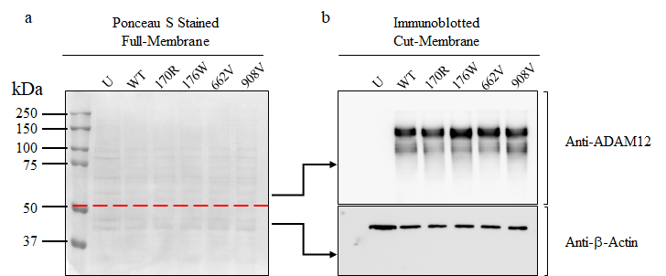

Supplementary Figure S1: The effect of ADAM12 variants on enzyme kinetic parameters.
Western blot analysis of ADAM12 variants (170R, 176W, 662V, 908V) using anti-ADAM12 and b-actin as a loading control. ADAM12-GFP tagged constructs of WT and variants were transfected in HEK293 cells. Control cells were transfected with empty vectors. Before blotting with antibodies, the nitrocellulose membrane was stained with Ponceau S stain to verify proteins transfer (a), then it was cut into two pieces according to the molecular weight marker (at the red dashed line) to enable blotting with anti-ADAM12 and anti-Actin antibodies separately (b).

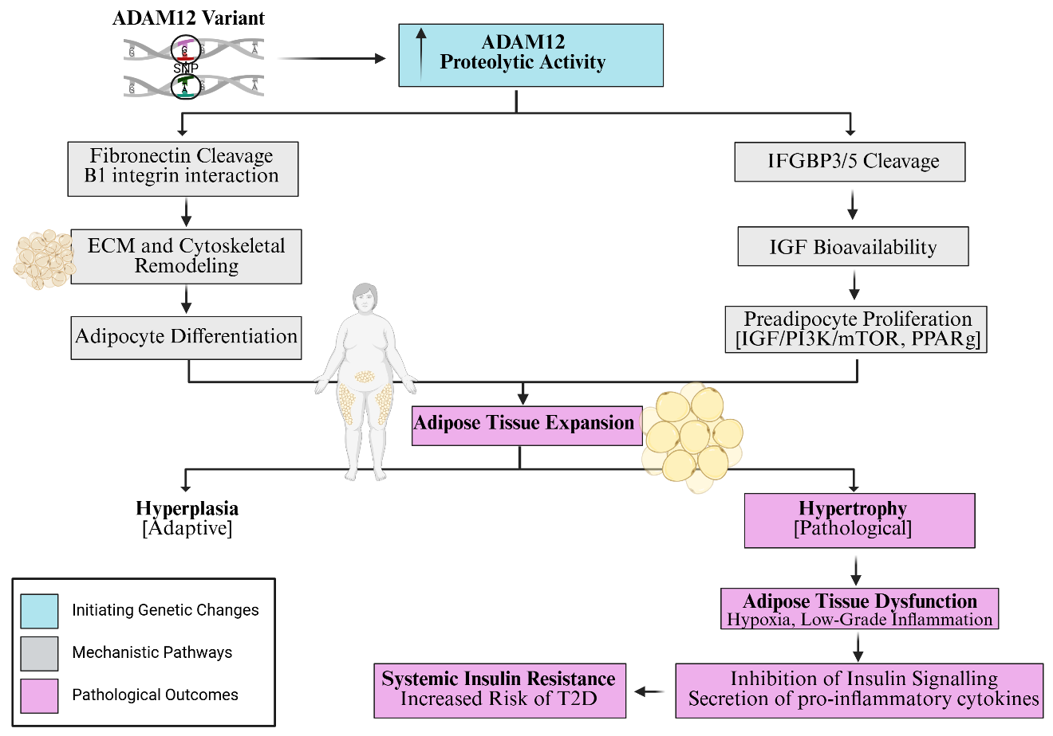
Figure S2:Proposed mechanism linking increased ADAM12 proteolytic activity to adipose tissue expansion and insulin resistance.
This diagram illustrates the proposed mechanism of metabolic dysregulation caused by increased ADAM12 variant proteolytic activity. Increased ADAM12 proteolytic activity elevates IGF-binding proteins (IGFBP3, IGFBP5) cleavage, thus increasing the bioavailability of insulin-like growth factors (IGF-1/2). These in turn promote preadipocyte proliferation and adipose tissue hyperplasia through the activation of IGF/IGF1R/mTOR and PPARγ pathways. At the same time, increased ADAM12 proteolytic activity promotes cytoskeletal remodelling and extracellular matrix reorganization by ADAM12-mediated cleavage of fibronectin and its interaction with b1 integrins, aiding adipocyte differentiation. Although initially beneficial, the progressive expansion of white adipose tissue, results in adipocyte hypertrophy, tissue hypoxia, and localized chronic inflammation. Such a proinflammatory environment inhibits insulin signalling pathways, eventually causing systemic insulin resistance and elevated risk of T2D development.

