Supplementary Material: The fingerprint of Gegen Qinlian Decoction for this study

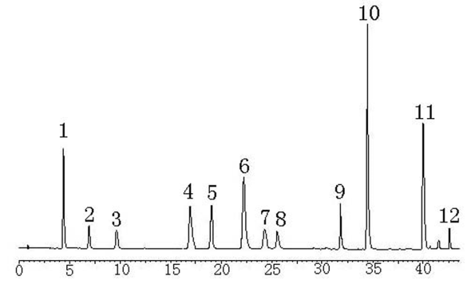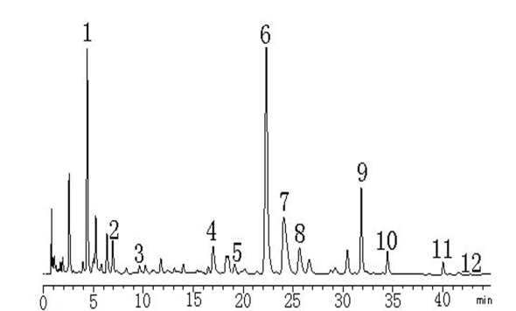
A B
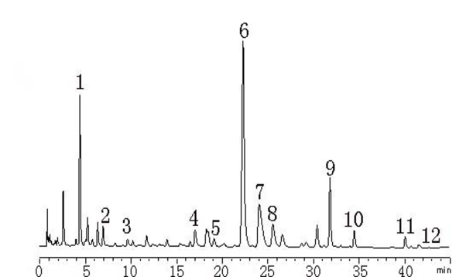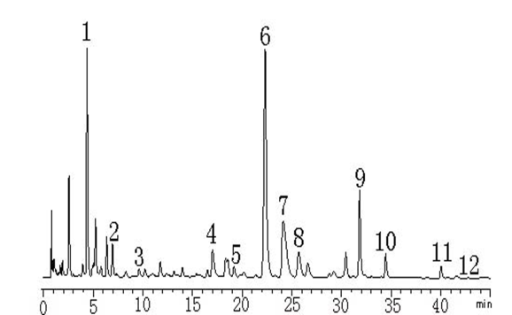
C D
SFig.1. HPLC fingerprint analysis of three batches of GGQLD aqueous preparation. Contents of chemical markers of GGQLD aqueous preparation (Batch A is the sample used in the experiment). (A) HPLC-UV chromatogram of standard reference; (B) HPLC-UV chromatogram of Batch A; (C) HPLC-UV chromatogram of Batch B; (D) HPLC-UV chromatogram of Batch C. Peaks were detected at 275 nm (1, puerarin; 2, daidzin; 3, liquiritin; 4, coptisine; 5, atrorrhizine; 6, baicalin; 7, berberine; 8, palmatine; 9, wogonoside; 10, baicalein; 11, wogonin; 12, ammonium glycyrrhizinate; GGQLD, Gegen Qinlian Decoction.).

