Table S1. ACEI/ARB use and other outcomes

 | Model 1 |  | Model 2
 | OR (95%CI) | P | OR (95%CI) | P
AKI | 1.32 (1.24–1.4) | <0.001 | 1.09 (1.01–1.17) | 0.026
CRRT | 0.63 (0.56–0.71) | <0.001 | 0.77 (0.66–0.9) | 0.001
Vasopressors | 1.04 (0.98–1.09) | 0.174 | 1.11 (1.04–1.19) | 0.002
Mechanical ventilation | 0.88 (0.84–0.93) | <0.001 | 0.89 (0.83–0.96) | 0.002
ACEIs, angiotensin-converting enzyme inhibitors; ARBs, angiotensin II receptor blockers; OR, odds ratio; CI, confidence interval; AKI, acute kidney injury; CRRT, continuous renal replacement therapy.
Model 1: Not adjusted.
Model 2: Age, sex, BMI, race, WBC, HB, PLT, BUN, Cr, glucose, PT, APPT, PO₂, lactate, heart rate, MAP, respiration rate, temperature, SpO₂, myocardial infarct, congestive heart failure, cerebrovascular disease, chronic pulmonary disease, renal disease, severe liver disease, diabetes, Charlson Comorbidity Index, SOFA, ICU stay.

Table S2. ACEI/ARB use and ventilation time (h)

 |  | Model 1 |  | Model 2 |  | PSM
Variable | n. total | β (95%CI) | P | β (95%CI) | P | β (95%CI) | P
No ACEIs/ARBs | 13374 | 0(Ref) |  | 0(Ref) |  | 0(Ref)
ACEIs/ARBs | 9409 | −7.41 (−9.57 to −5.26) | <0.001 | −2.53 (−4.12 to −0.93) | 0.002 | −2.77 (−4.5 to −1.03) | 0.002

ACEIs, angiotensin-converting enzyme inhibitors; ARBs, angiotensin II receptor blockers; CI, confidence interval; PSM, propensity-score matching.
Model 1: Not adjusted.
Model 2: Age, sex, BMI, race, WBC, HB, PLT, BUN, Cr, glucose, PT, APPT, PO₂, lactate, heart rate, MAP, respiration rate, temperature, SpO₂, myocardial infarct, congestive heart failure, cerebrovascular disease, chronic pulmonary disease, renal disease, severe liver disease, diabetes, Charlson Comorbidity Index, SOFA, ICU stay, CRRT, vasopressors.

Table S1. ACEI/ARB use and vasopressor duration time (h)
 |  | Model 1 |  | Model 2 |  | PSM
Variable | n. total | β (95%CI) | P | β (95%CI) | P | β (95%CI) | P
No ACEIs/ARBs | 13374 | 0(Ref) |  | 0(Ref) |  | 0(Ref)
ACEIs/ARBs | 9409 | −6.61 (−9.15 to −4.07) | <0.001 | −3.2 (−5.22 to −1.18) | 0.002 | −3.05 (−5.24 to −0.86) | 0.006

ACEIs, angiotensin-converting enzyme inhibitors; ARBs, angiotensin II receptor blockers; CI, confidence interval; PSM, propensity-score matching.
Model 1: Not adjusted.
Model 2: Age, sex, BMI, race, WBC, HB, PLT, BUN, Cr, glucose, PT, APPT, PO₂, lactate, heart rate, MAP, respiration rate, temperature, SpO₂, myocardial infarct, congestive heart failure, cerebrovascular disease, chronic pulmonary disease, renal disease, severe liver disease, diabetes, Charlson Comorbidity Index, SOFA, ICU stay, CRRT, mechanical ventilation.
Table S2. Baseline characteristics of participants after PSM.
Variable | Total  (n = 15,440) | No use of ACEIs/ARBs  (n = 7,720) | ACEI/ARB use  (n = 7,720) | P
Age, years | 68.0 ± 14.4 | 68.4 ± 15.1 | 67.5 ± 13.7 | < 0.001
Sex, male, n (%) | 9,128 (59.1) | 4,555 (59) | 4,573 (59.2) | 0.768
BMI, kg/m² | 28.9 ± 6.6 | 28.9 ± 6.6 | 28.9 ± 6.5 | 0.905
Race, n (%) |  |  |  | 0.345
White | 10842 (70.2) | 5460 (70.7) | 5382 (69.7)
Black | 1344 ( 8.7) | 653 (8.5) | 691 (9)
Other | 3254 (21.1) | 1607 (20.8) | 1647 (21.3)
WBC (×10⁹ ) | 12.9 ± 7.9 | 12.9 ± 7.1 | 12.9 ± 8.6 | 0.973
HB (g/L) | 10.6 ± 2.0 | 10.6 ± 2.0 | 10.6 ± 2.0 | 0.17
PLT (×10⁹ ) | 209.0 ± 110.2 | 208.9 ± 111.2 | 209.1 ± 109.2 | 0.92
Respiration rate (bpm) | 19.5 ± 3.9 | 19.5 ± 3.9 | 19.5 ± 3.9 | 0.504
Temperature (°C) | 36.9 ± 0.6 | 36.8 ± 0.6 | 36.9 ± 0.5 | 0.735
SpO₂ (%) | 97.0 ± 2.2 | 97.0 ± 2.2 | 97.0 ± 2.1 | 0.366
Heart rate (bpm) | 85.2 ± 15.3 | 85.1 ± 15.4 | 85.3 ± 15.2 | 0.411
MAP, mean ± SD | 76.9 ± 10.3 | 77.0 ± 10.1 | 76.9 ± 10.5 | 0.381
PT, mean ± SD | 16.2 ± 8.1 | 16.0 ± 7.6 | 16.3 ± 8.6 | 0.022
APPT, mean ± SD | 37.5 ± 17.8 | 37.3 ± 18.0 | 37.6 ± 17.6 | 0.206
PaO₂, mean ± SD | 164.2 ± 86.9 | 164.5 ± 86.7 | 163.9 ± 87.1 | 0.667
LAC (mmol/L) | 1.9 (1.4, 2.4) | 1.9 (1.4, 2.4) | 1.9 (1.5, 2.5) | 0.033
BUN, median (IQR) | 21.0 (14.5, 34.5) | 20.0 (14.0, 34.0) | 21.5 (15.0, 35.0) | < 0.001
Cr, median (IQR) | 1.0 (0.8, 1.6) | 1.0 (0.8, 1.5) | 1.0 (0.8, 1.6) | < 0.001
Glucose (mmol/L) | 146.5 ± 63.3 | 145.8 ± 62.3 | 147.1 ± 64.3 | 0.188
Charlson Comorbidity Index | 5.9 ± 2.7 | 5.9 ± 2.8 | 5.9 ± 2.5 | 0.848
SOFA score | 5.7 ± 3.1 | 5.6 ± 3.1 | 5.7 ± 3.0 | 0.082
Myocardial infarct, n (%) | 2,726 (17.7) | 1,325 (17.2) | 1,401 (18.1) | 0.109
Congestive heart failure, n (%) | 4,794 (31.0) | 2,327 (30.1) | 2,467 (32) | 0.015
Cerebrovascular disease, n (%) | 2,330 (15.1) | 1,185 (15.3) | 1,145 (14.8) | 0.368
Severe liver disease, n (%) | 323 ( 2.1) | 141 (1.8) | 182 (2.4) | 0.021
Diabetes, n (%) |  |  |  | 0.02
No | 10,240 (66.3) | 5,187 (67.2) | 5,053 (65.5)
complications | 4,073 (26.4) | 2,008 (26) | 2,065 (26.7)
With complications | 1,127 ( 7.3) | 525 (6.8) | 602 (7.8)
ICU stay, days | 3.0 (1.8, 5.9) | 3.0 (1.7, 6.0) | 3.0 (1.8, 5.9) | 0.58
30-day mortality, n (%) | 1,565 (10.1) | 1,140 (14.8) | 425 (5.5) | < 0.001
90-day mortality, n (%) | 1,674 (10.8) | 1,208 (15.6) | 466 (6) | < 0.001
CRRT, n (%) | 773 ( 5.0) | 388 (5) | 385 (5) | 0.912
Vasopressors, n (%) | 7,774 (50.3) | 3,910 (50.6) | 3,864 (50.1) | 0.459
Ventilation, n (%) | 7,638 (49.5) | 3,828 (49.6) | 3,810 (49.4) | 0.772
AKI in 7 days, n (%) | 11,623 (75.3) | 5,740 (74.4) | 5,883 (76.2) | 0.008
For each variable, mean ± standard deviation, median (interquartile range), or number (percentage) are reported (as appropriate).
ACEIs, angiotensin-converting enzyme inhibitors; ARBs, angiotensin II receptor blockers; BMI, body mass index; WBC, white blood cells; HB, hemoglobin; PLT, platelets; SpO₂, pulse oxygen saturation; MAP, mean arterial pressure; PT, prothrombin time; APTT, activated partial thromboplastin time; PaO₂, arterial partial pressure of oxygen; LAC, lactate; BUN, blood urea nitrogen; Scr, serum creatinine; SOFA, Sequential Organ Failure Assessment; ICU, intensive care unit; CRRT, continuous renal replacement therapy; AKI, acute kidney injury.

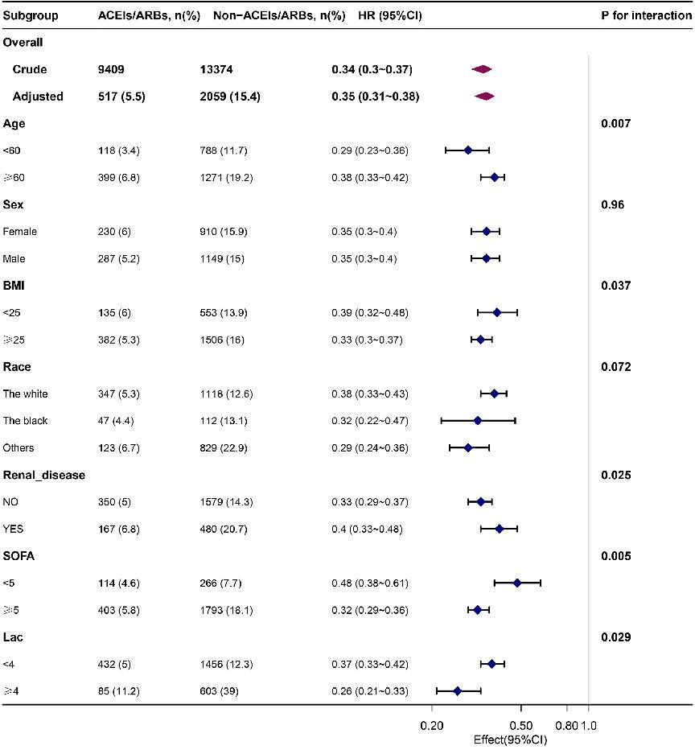
Figure S1 Association between ACEIs/ARBs use and 30-day mortality according to baseline characteristics.

