Annex
Annex 2: Sankey diagram, Reorientation cluster
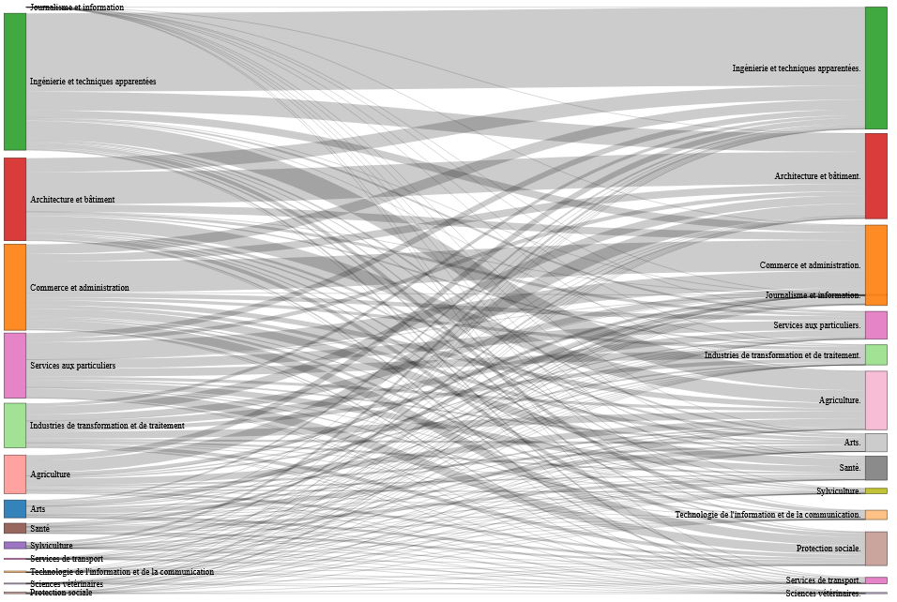

This Sankey diagram emphasise the flow of apprentices transitioning between their initial vocational field of training and the subsequent field they move into. It highlights that nearly 80% of apprentices who experienced the Reorientation type change their vocational field after completing their initial training.

Annex 3: Gender disparities in SWT – Results from a multinomial regression model without accounting for FVETD occupations as level 2

 | NEET | Unstable pattern | Re-orientation | Late vocational tertiary | Early vocational tertiary | General Tertiairy
(Intercept) | -2.47*** | -0.65*** | -1.87*** | -1.34*** | -1.08*** | -1.33***
21 - 25 | 0.38*** | -0.21*** | -1.36*** | -0.48*** | -0.33*** | -0.90***
> 25 | 0.24*** | -0.84*** | -3.28*** | -1.27*** | -1.35*** | -2.71***
Swiss-French | 0.28*** | 0.10** | 0.37*** | -1.24*** | -0.87*** | -0.08
Swiss-Italian | 0.86*** | 0.52*** | 0.58*** | -1.89*** | -0.54*** | -0.70***
Swiss born abroad | 0.55*** | 0.20*** | -0.54*** | 0.08 | 0.03 | 0.03
Foreigners born in Switzerland | -0.15 | -0.08 | -0.68*** | -0.41*** | -0.34*** | -0.61***
Foreigners born abroad | 0.14* | -0.13** | -0.82*** | -0.52*** | -0.35*** | -0.74***
Women | 0.12** | -0.13*** | -0.62*** | -0.53*** | -0.38*** | -0.38***
BIC | 16679.38 | 40730.88 | 13258.03 | 18693.18 | 24609.12 | 20209.90
Deviance | 16588.15 | 40637.24 | 13167.02 | 18601.73 | 24517.15 | 20118.31
Num. obs. | 25235 | 32985 | 24667 | 25890 | 27426 | 26272
***p < 0.001; **p < 0.01; *p < 0.05

Annex 4: Missing data
To show that the introduction of missing data in our sample did not bias our results, in this appendix we present the same regression models presented in chapter 6, estimated without accounting for the number of lessons in training programmes. It should be remembered that this variable was extracted from the database produced by Grønning (et.al., 2020) and merged with LABB database, which resulted in the loss of about 6% of the sample.

Gender disparities in post-VET trajectories and the influence of specific FVETD programmes

 | NEET | Unstable pattern | Re-orientation | Late vocational tertiary | Early vocational tertiary | General Tertiairy
(Intercept) | -2.40*** | -0.59*** | -2.21*** | -1.50*** | -1.36*** | -1.84***
21 - 25 | 0.35*** | -0.21*** | -1.20*** | -0.54*** | -0.49*** | -1.05***
> 25 | 0.28*** | -0.85*** | -2.92*** | -1.46*** | -1.92*** | -2.88***
Swiss-French | 0.29*** | 0.09** | 0.44*** | -1.29*** | -0.90*** | -0.21***
Swiss-Italian | 0.85*** | 0.52*** | 0.57*** | -1.73*** | -0.20 | -0.68***
Swiss born abroad | 0.53*** | 0.18*** | -0.51*** | 0.09 | 0.02 | 0.15
Foreigners born in Switzerland | -0.18* | -0.10* | -0.65*** | -0.36*** | -0.26*** | -0.46***
Foreigners born abroad | 0.18** | -0.13** | -0.89*** | -0.41*** | -0.25** | -0.44***
Women | -0.10 | -0.38*** | -0.16* | -0.66*** | -0.52*** | -0.83***
BIC | 17430.05 | 42543.69 | 13098.16 | 19000.28 | 23790.74 | 18243.92
Num. obs. | 26605 | 34874 | 25982 | 27190 | 28883 | 27926
Num. FVETD Prog | 187 | 197 | 189 | 185 | 184 | 185
Random Intercept Variance | 0.34 | 0.17 | 0.63 | 0.19 | 0.79 | 2.26
***p < 0.001; **p < 0.01; *p < 0.05

The influence of FVETD programmes’ characteristics on post-VET trajectories

 | NEET | Unstable pattern | Reorientation | Late vocational tertiary | Early vocational tertiary | General Tertiairy
(Intercept) | -2.37*** | -0.57*** | -2.04*** | -1.65*** | -1.63*** | -2.29***
21 - 25 | 0.36*** | -0.21*** | -1.20*** | -0.55*** | -0.50*** | -1.08***
> 25 | 0.29*** | -0.85*** | -2.92*** | -1.46*** | -1.92*** | -2.89***
Swiss-French | 0.21*** | 0.02 | 0.41*** | -1.36*** | -1.08*** | -0.42***
Swiss-Italian | 0.81*** | 0.46*** | 0.58*** | -1.77*** | -0.39** | -0.91***
Swiss born abroad | 0.54*** | 0.18*** | -0.51*** | 0.09 | 0.03 | 0.15
Foreigners born in Switzerland | -0.17* | -0.10* | -0.65*** | -0.36*** | -0.26*** | -0.45***
Foreigners born abroad | 0.18* | -0.13** | -0.90*** | -0.40*** | -0.25** | -0.44***
Women | -0.10 | -0.37*** | -0.18** | -0.64*** | -0.51*** | -0.82***
Full-time | 0.87*** | 0.86*** | 0.60*** | 0.70*** | 1.15*** | 1.70***
Length >3 years | -0.18 | -0.15* | -0.50** | 0.35*** | 0.58*** | 0.92***
BIC | 17380.95 | 42403.75 | 13097.60 | 18981.14 | 23642.58 | 17892.49
Num. obs. | 26605 | 34874 | 25982 | 27190 | 28883 | 27926
Num. FVETD Prog | 187 | 197 | 189 | 185 | 184 | 185
Random Intercept Variance | 0.24 | 0.11 | 0.59 | 0.15 | 0.62 | 1.61
***p < 0.001; **p < 0.01; *p < 0.05

The impact of horizontal gender segregation on post-VET trajectories

 | NEET | Unstable pattern | Re-orientation | Late vocational tertiary | Early vocational tertiary | General Tertiairy
(Intercept) | -2.07*** | -0.35*** | -1.90*** | -1.66*** | -1.86*** | -1.81***
21 - 25 | 0.35*** | -0.21*** | -1.20*** | -0.55*** | -0.50*** | -1.09***
> 25 | 0.27*** | -0.85*** | -2.91*** | -1.46*** | -1.92*** | -2.89***
Swiss-French | 0.21*** | 0.02 | 0.41*** | -1.36*** | -1.08*** | -0.42***
Swiss-Italian | 0.80*** | 0.45*** | 0.58*** | -1.77*** | -0.39** | -0.91***
Swiss born abroad | 0.54*** | 0.18*** | -0.51*** | 0.09 | 0.03 | 0.15
Foreigners born in Switzerland | -0.17* | -0.10* | -0.65*** | -0.36*** | -0.26*** | -0.46***
Foreigners born abroad | 0.19** | -0.13** | -0.90*** | -0.40*** | -0.25** | -0.44***
Full-time | 0.84*** | 0.84*** | 0.60*** | 0.70*** | 1.16*** | 1.69***
Length >3 years | -0.09 | -0.10 | -0.61*** | 0.40*** | 0.69*** | 1.15***
Women | -0.18** | -0.42*** | -0.14 | -0.67*** | -0.53*** | -0.85***
Female-dominated | -0.01 | -0.03 | -0.55* | 0.16 | 0.60* | 0.33
Male-dominated | -0.54*** | -0.39*** | 0.00 | -0.05 | 0.13 | -1.05***
BIC | 17378.76 | 42397.83 | 13110.86 | 18999.12 | 23656.07 | 17884.29
Num. obs. | 26605 | 34874 | 25982 | 27190 | 28883 | 27926
Num. FVETD Prog | 187 | 197 | 189 | 185 | 184 | 185
Random Intercept Variance | 0.18 | 0.08 | 0.55 | 0.14 | 0.57 | 1.24
***p < 0.001; **p < 0.01; *p < 0.05

The consequences of undertaking gender-atypical trainings on post-VET trajectories

 | NEET | Unstable pattern | Reorientation | Late Vocational Tertiary | Early Vocational Tertiary | General Tertiairy
(Intercept) | -1.99*** | -0.30*** | -1.90*** | -1.65*** | -1.82*** | -1.78***
21 - 25 | 0.34*** | -0.22*** | -1.21*** | -0.55*** | -0.50*** | -1.09***
> 25 | 0.26*** | -0.86*** | -2.93*** | -1.46*** | -1.92*** | -2.89***
Swiss-French | 0.21*** | 0.02 | 0.41*** | -1.36*** | -1.08*** | -0.42***
Swiss-Italian | 0.81*** | 0.46*** | 0.59*** | -1.77*** | -0.39** | -0.91***
Swiss born abroad | 0.55*** | 0.19*** | -0.51*** | 0.09 | 0.03 | 0.16
Foreigners born in Switzerland | -0.17* | -0.10* | -0.66*** | -0.36*** | -0.26*** | -0.45***
Foreigners born abroad | 0.19** | -0.13** | -0.90*** | -0.40*** | -0.25** | -0.44***
Full-time | 0.85*** | 0.84*** | 0.60*** | 0.70*** | 1.16*** | 1.69***
Length >3 years | -0.10 | -0.11 | -0.61*** | 0.40*** | 0.70*** | 1.15***
Women | -0.32*** | -0.49*** | -0.13 | -0.69*** | -0.62*** | -0.91***
Female-dominated | 0.12 | 0.00 | -0.12 | 0.08 | 0.47 | 0.28
Male-dominated | -0.68*** | -0.46*** | -0.01 | -0.06 | 0.08 | -1.09***
Women : female-dominated | -0.09 | -0.00 | -0.47* | 0.10 | 0.18 | 0.09
Women : Male-dominated | 0.82*** | 0.42*** | 0.17 | 0.03 | 0.22 | 0.33*
BIC | 17358.08 | 42393.31 | 13124.62 | 19019.08 | 23672.78 | 17900.22
Num. obs. | 26605 | 34874 | 25982 | 27190 | 28883 | 27926
Num. FVETD Prog | 187 | 197 | 189 | 185 | 184 | 185
Random Intercept Variance | 0.17 | 0.07 | 0.55 | 0.14 | 0.56 | 1.23
***p < 0.001; **p < 0.01; *p < 0.05

