Supplementary material 1:
Interview and Focus Group Guide
Open Questions:
- Introduction/Rapport Building
  - Could you tell me a bit about your role in this unit and how long you’ve been working here? What kind of training have you received in evidence-based practice or research?
- Process
  - How did you learn about the project, and why did you decide to join it?
  - How has the implementation of the recommendations evolved? What strategies have you developed?
- Internal/External Context
  - What factors or elements have helped to implement the recommendations? Which ones have hindered the process?
Prompts:
- Characteristics of the Recommendations
  - What do you think about the recommendations we provided for implementation? How do you perceive the complexity of the recommendations? What changes have been necessary to implement the recommendations? Which ones have been the most significant?
- External Context
  - In what ways has the organization (hospital/unit) influenced the implementation of the recommendations? Which factors have been the most relevant? What changes in your organisation would make it easier to implement the recommendations?
  - What types of incentives or support do you receive from your organization to carry out the project? How do you expect your participation in the project to be acknowledged?
- Internal Context
  - In what ways do you believe the recommendations affect patient pain management? Have you observed any specific improvements? What challenges or facilitators have you encountered when adapting the recommendations to the unit's workflow? How have you managed these challenges? What resources did you need for implementation, and which were available? How did you manage any resource shortages, if applicable? What were you able to secure?
- Individuals
  - How has the unit’s staff received the recommendations? What was the staff's level of familiarity with the recommendations before implementation? How has the staff's receptiveness to changes impacted the implementation process?
  - How has staff participation influenced the implementation of strategies? Who have been the key stakeholders in the implementation? Was anyone's involvement limited or particularly influential? Was there any role or person whose involvement could have benefited the implementation process? How would their involvement have changed the outcome?
  - Have you encountered any staff members, not part of the implementation team, who actively supported or contributed to the project? How did you collaborate with them?
- Process
  - What strategies have you implemented? Have you had to modify these strategies over time? Why?
  - How have you engaged the staff in the implementation process?
  - How do you share audit results with the involved professionals? How do they respond to this feedback? How do you assess the support received from the coordinating team? Were there areas where you needed more assistance? Is there anything more that could have been done to assist you? What would you change for future editions?
  - What are your expectations regarding the long-term use of the recommendations? What factors will influence their sustainability or discontinuation? Could you tell me about the most important barriers and facilitators you encountered during the project?

Supplementary material 2: Different heat maps with factors organized according to unit audits results, type of unit, the role of LIT leader and the size of the institution. Factors selected are those identified by half or more of the units, or highlighted as highly important by the units.

According to audits results: Organised by the difference between baseline and six-month audit results, ordered by the percentage of increase in adherence over the first six months, from highest to lowest.
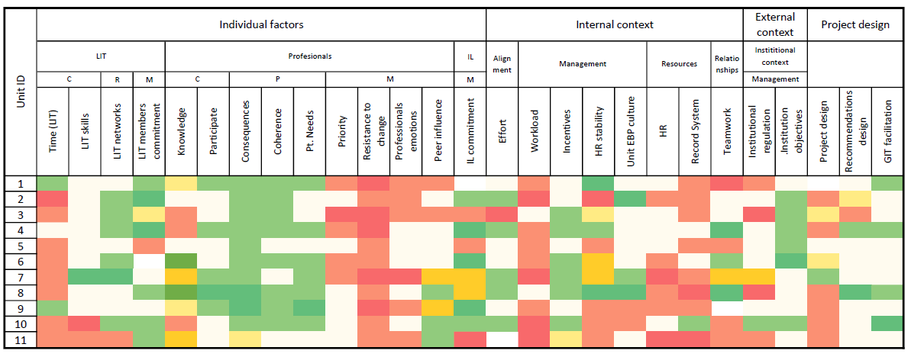

According to type of unit
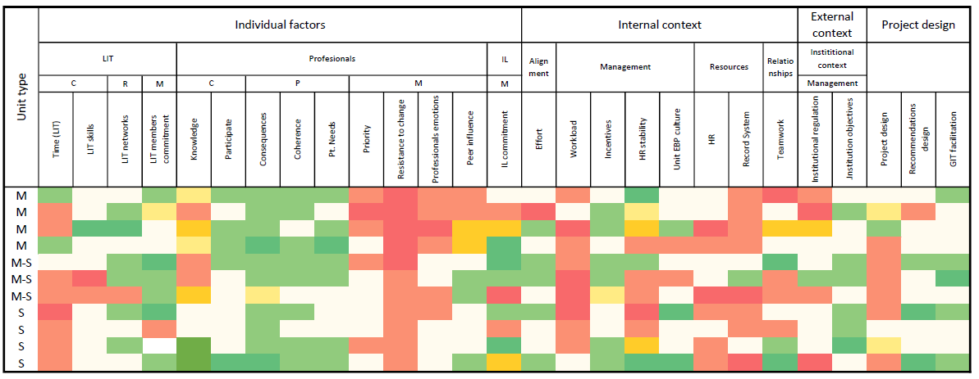
M: Medical unit; M-S. Medical-surgical unit; S: Surgical unit

According to the role of LIT leader
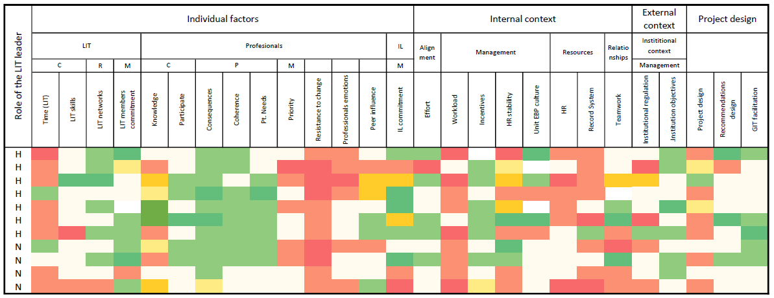
H: Unit Head Nurse; N: Clinical Nurse

According to institution size (by numbers of beds)
