Supplementary material: Divergent effects of economic and behavioural policy coupling on electric vehicle adoption at individual and system levels

Anne Günther¹, Mart van der Kam¹, Amir Hosein Hadian Rasanan¹, Sebastian Gluth², & Ulf J.J. Hahnel^{3,1}

¹University of Basel, Switzerland, ² University of Hamburg, Germany, ³ Leuphana University Lüneburg, Germany

This file contains:
Supplementary Figures S1 to S6
Supplementary Tables S1 to S20

Supplementary Figures

Figure S1. Attention allocation as a function of political orientation and intervention condition
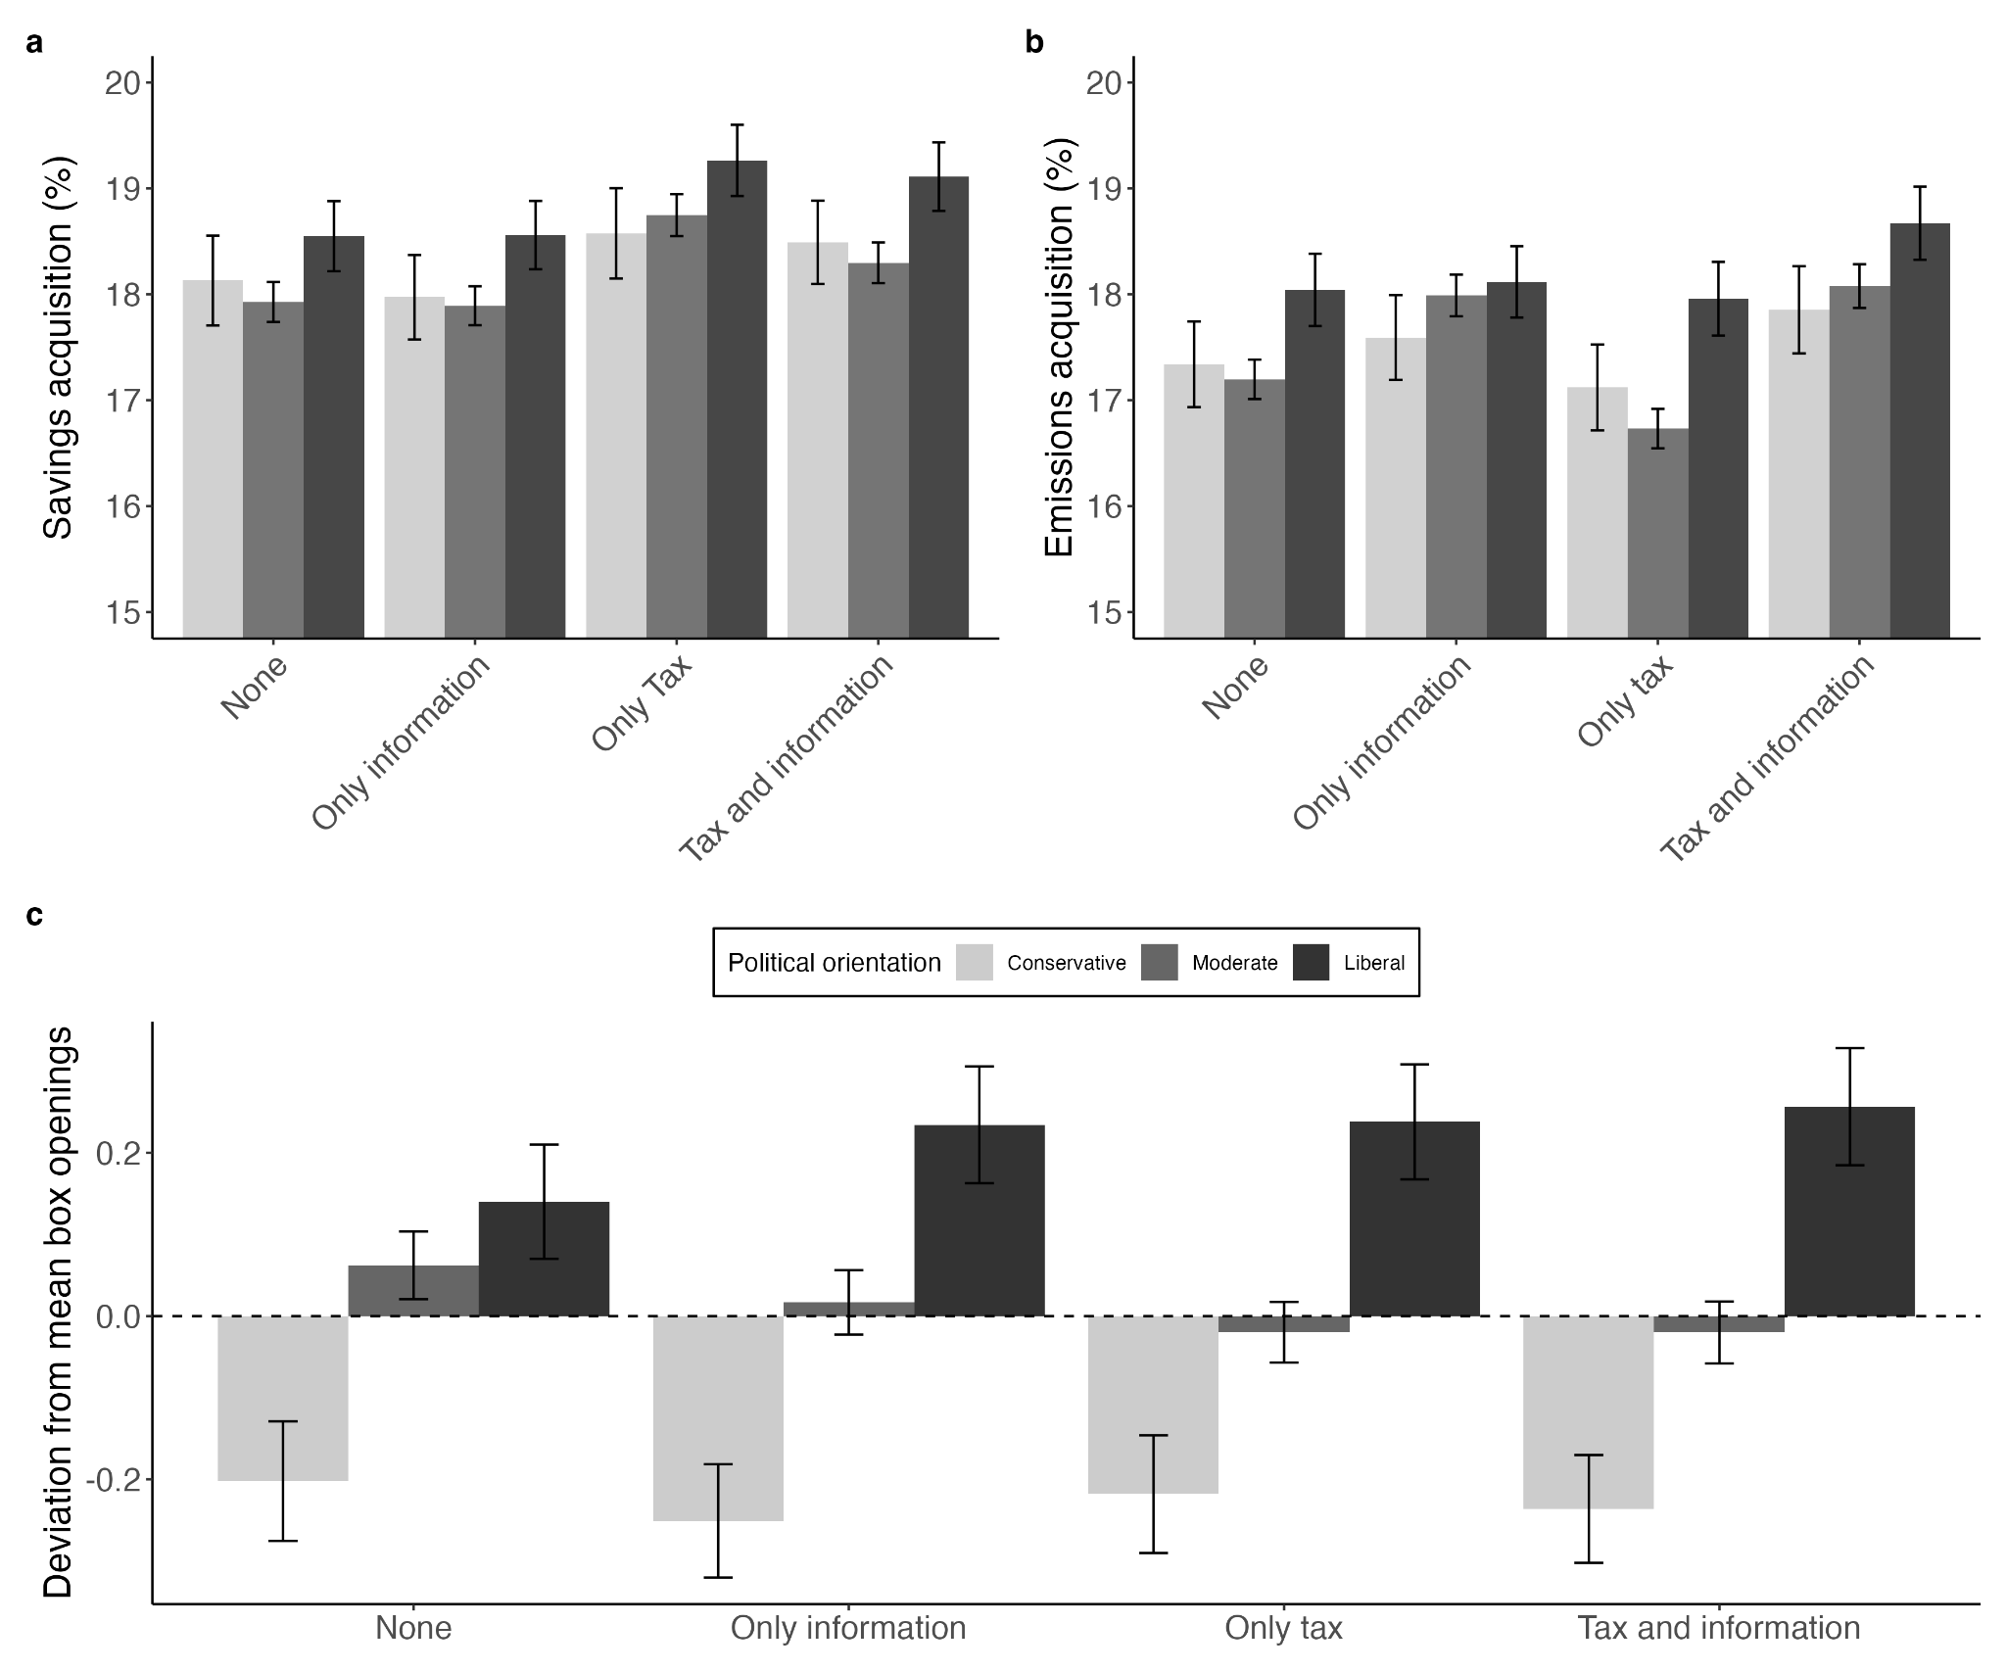
Note. The figure shows descriptive results of attention allocated during decision-making. Error bars represent 95% confidence intervals. a No significant interaction observed between the carbon tax and political orientation on attention to savings (b=-0.02, 95% CI [-0.15, 0.12], p=0.806). b More liberal participants did not seek out significantly more information regarding GHG emissions than conservatives (main effect political orientation: b=-0.23, 95% CI [-0.57,0.11], p=0.184; evidence against preregistered H9b). No significant interaction observed between information intervention and political orientation on attention to GHG emissions (b=0.12, 95% CI [-0.01, 0.26], p=0.081). c Deviation from mean absolute box openings by condition and political orientation. More conservative participants acquired significantly less information overall than liberals before making a decision (b=-0.12, 95% CI [-0.19, -0.04], p=0.002; evidence for preregistered H9a). For the figure, political orientation was categorised as liberal (-1SD), conservative (+1SD), and moderate (between -1SD and +1SD).

Figure S2. Agent-based model simulation results under a 2°C policy scenario
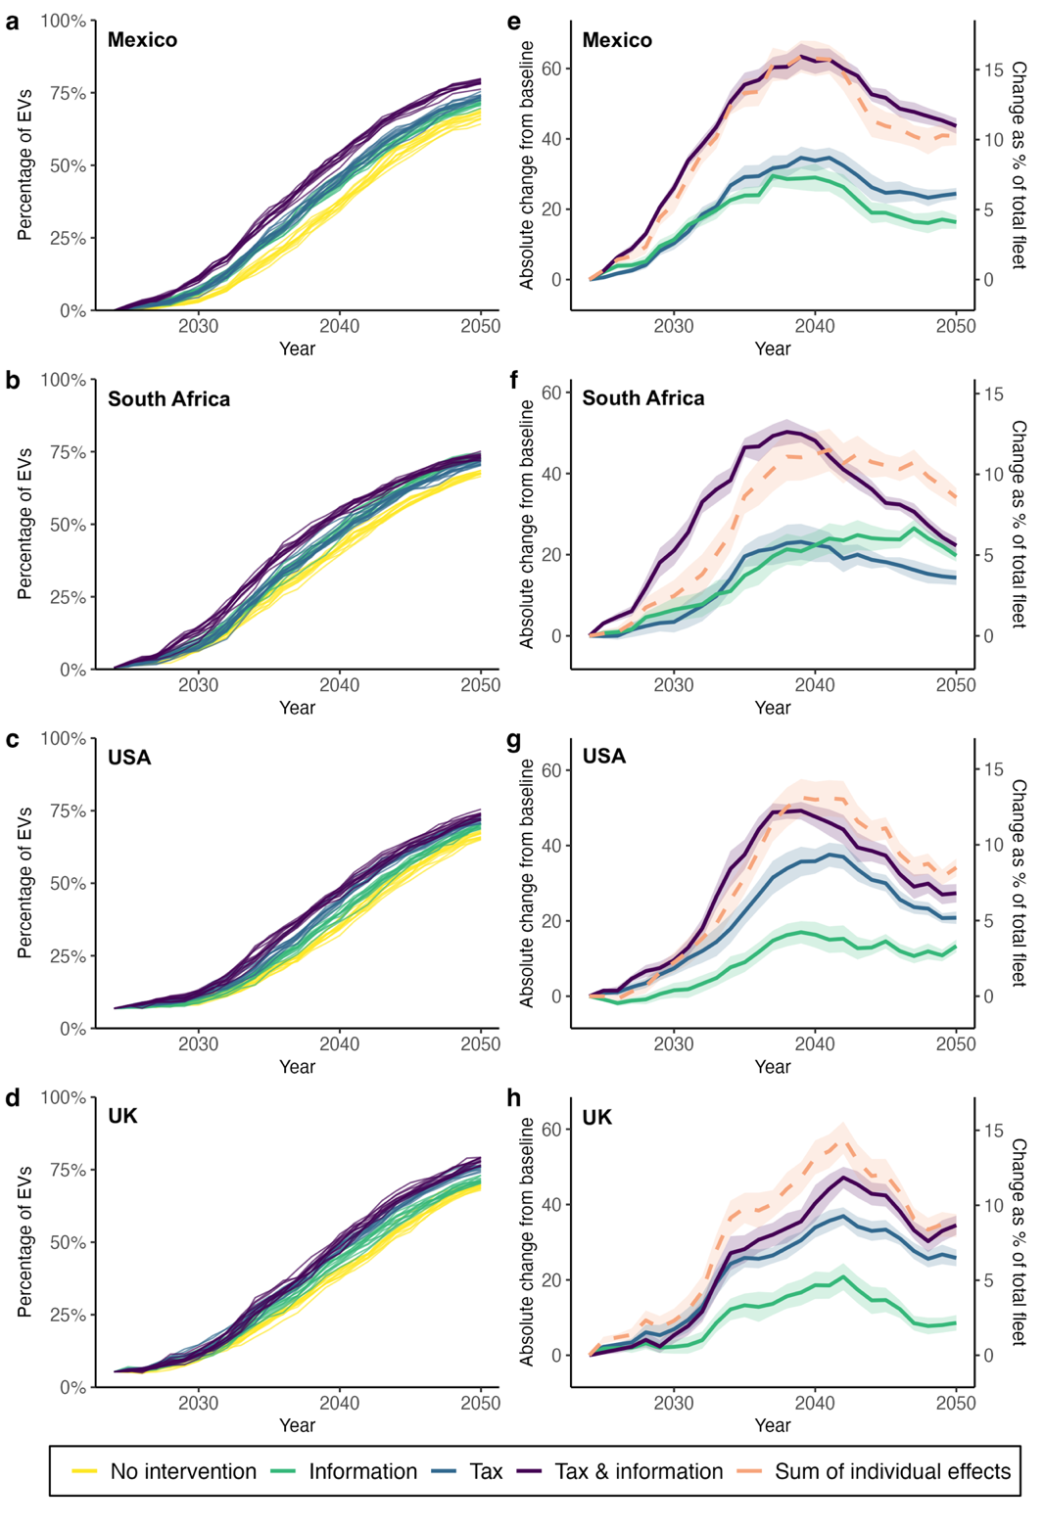
Note. a-d Mean diffusion curves of EV adoption under different intervention scenarios: no intervention, carbon tax only, information intervention only, and both interventions combined. Each line represents one simulation, capturing stochastic variation (e.g., agent interactions). Initial share of EVs in the simulations were based on participants’ reported EV ownership in each country: Mexico=0%, South Africa=0.51%, USA=6%, UK=4.36%. These values represent realistic EV market shares. Lifecycle GHG emissions in the simulations were based on projections from ref.¹ under a 2 °C climate policy scenario consistent with the Paris Agreement. Underlying policies include stronger renewable energy policies, which lead to reduced lifecycle GHG emissions from EVs. e-h Absolute change in EV adoption over time relative to the baseline (neither tax nor information intervention, corresponding to yellow line in left panels). Lines depict adoption under different policy scenarios: combined interventions, individual interventions (carbon tax or information intervention), and their sum (additive expectation). Deviations between observed (purple line) and additive effects (orange dashed line) highlight synergistic, additive, or subadditive dynamics when interventions are combined. The left y-axis shows the absolute change in number of EVs; the right y-axis translates this into the equivalent change as a percentage of the total vehicle fleet in the agent population. Shaded areas represent the 95% range of simulated outcomes.

Figure S3. Policy support as a function of national context
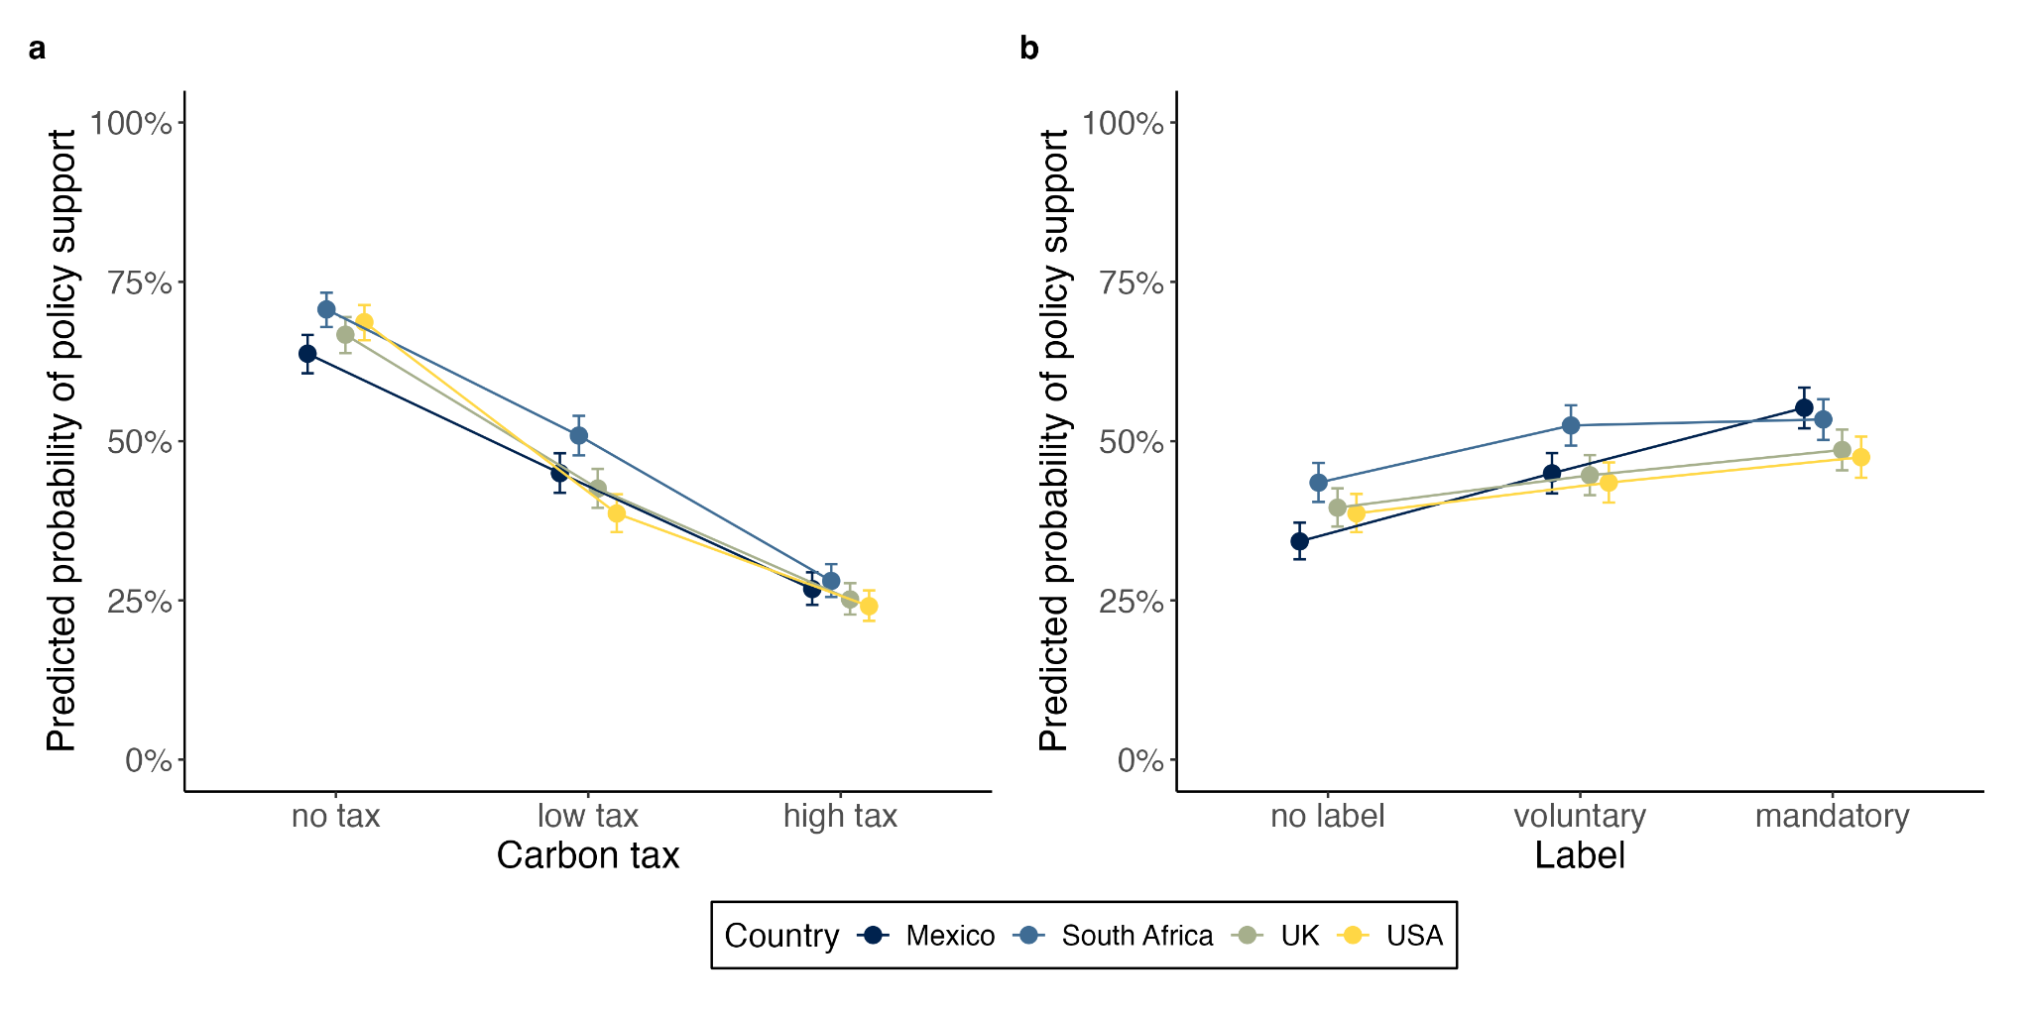
Note. a Predicted probability of support for policy packages as a function of the carbon tax and country estimated from mixed-effects logistic regression models. Country significantly moderated the effect of the carbon tax on policy support. b Predicted probability of support for policy packages as a function of the climate information label and country estimated from mixed-effects logistic regression models. Country significantly moderated the effect of the label on policy support. Error bars represent 95% CIs based on predicted probabilities, accounting for repeated measures. N=1,589 participants, N=28,602 observations.

Figure S4. Sensitivity analysis results for country-specific agent-based models
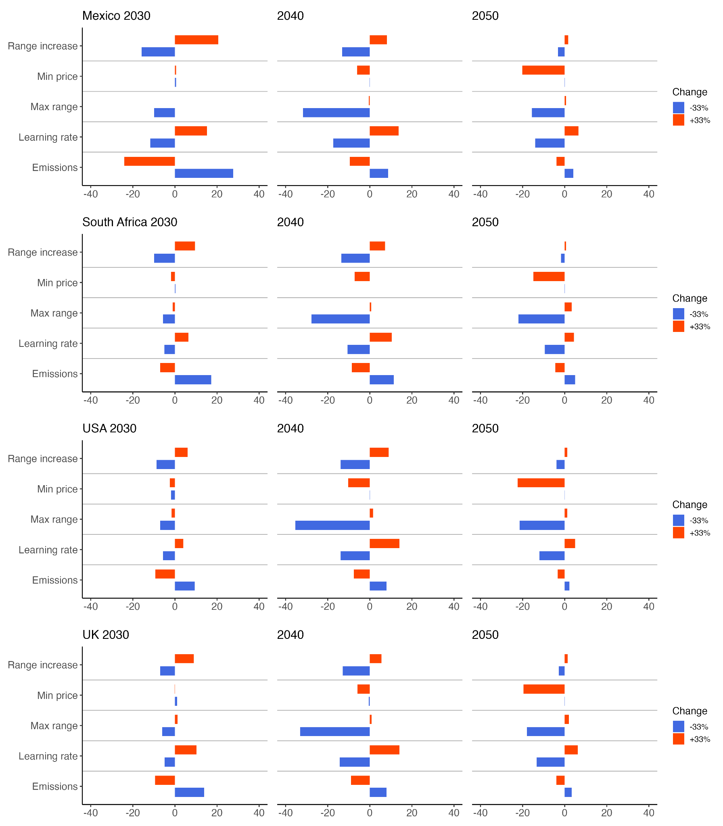
Note. The figure shows the percentage difference (x-axis) in mean EV adoption outcomes in 2030, 2040, and 2050 between the baseline simulation and scenarios from a one-at-a-time sensitivity analysis. In each scenario, one model parameter was varied by ±33% while all others were held constant.

Figure S5. Stability analysis results for country-specific agent-based models
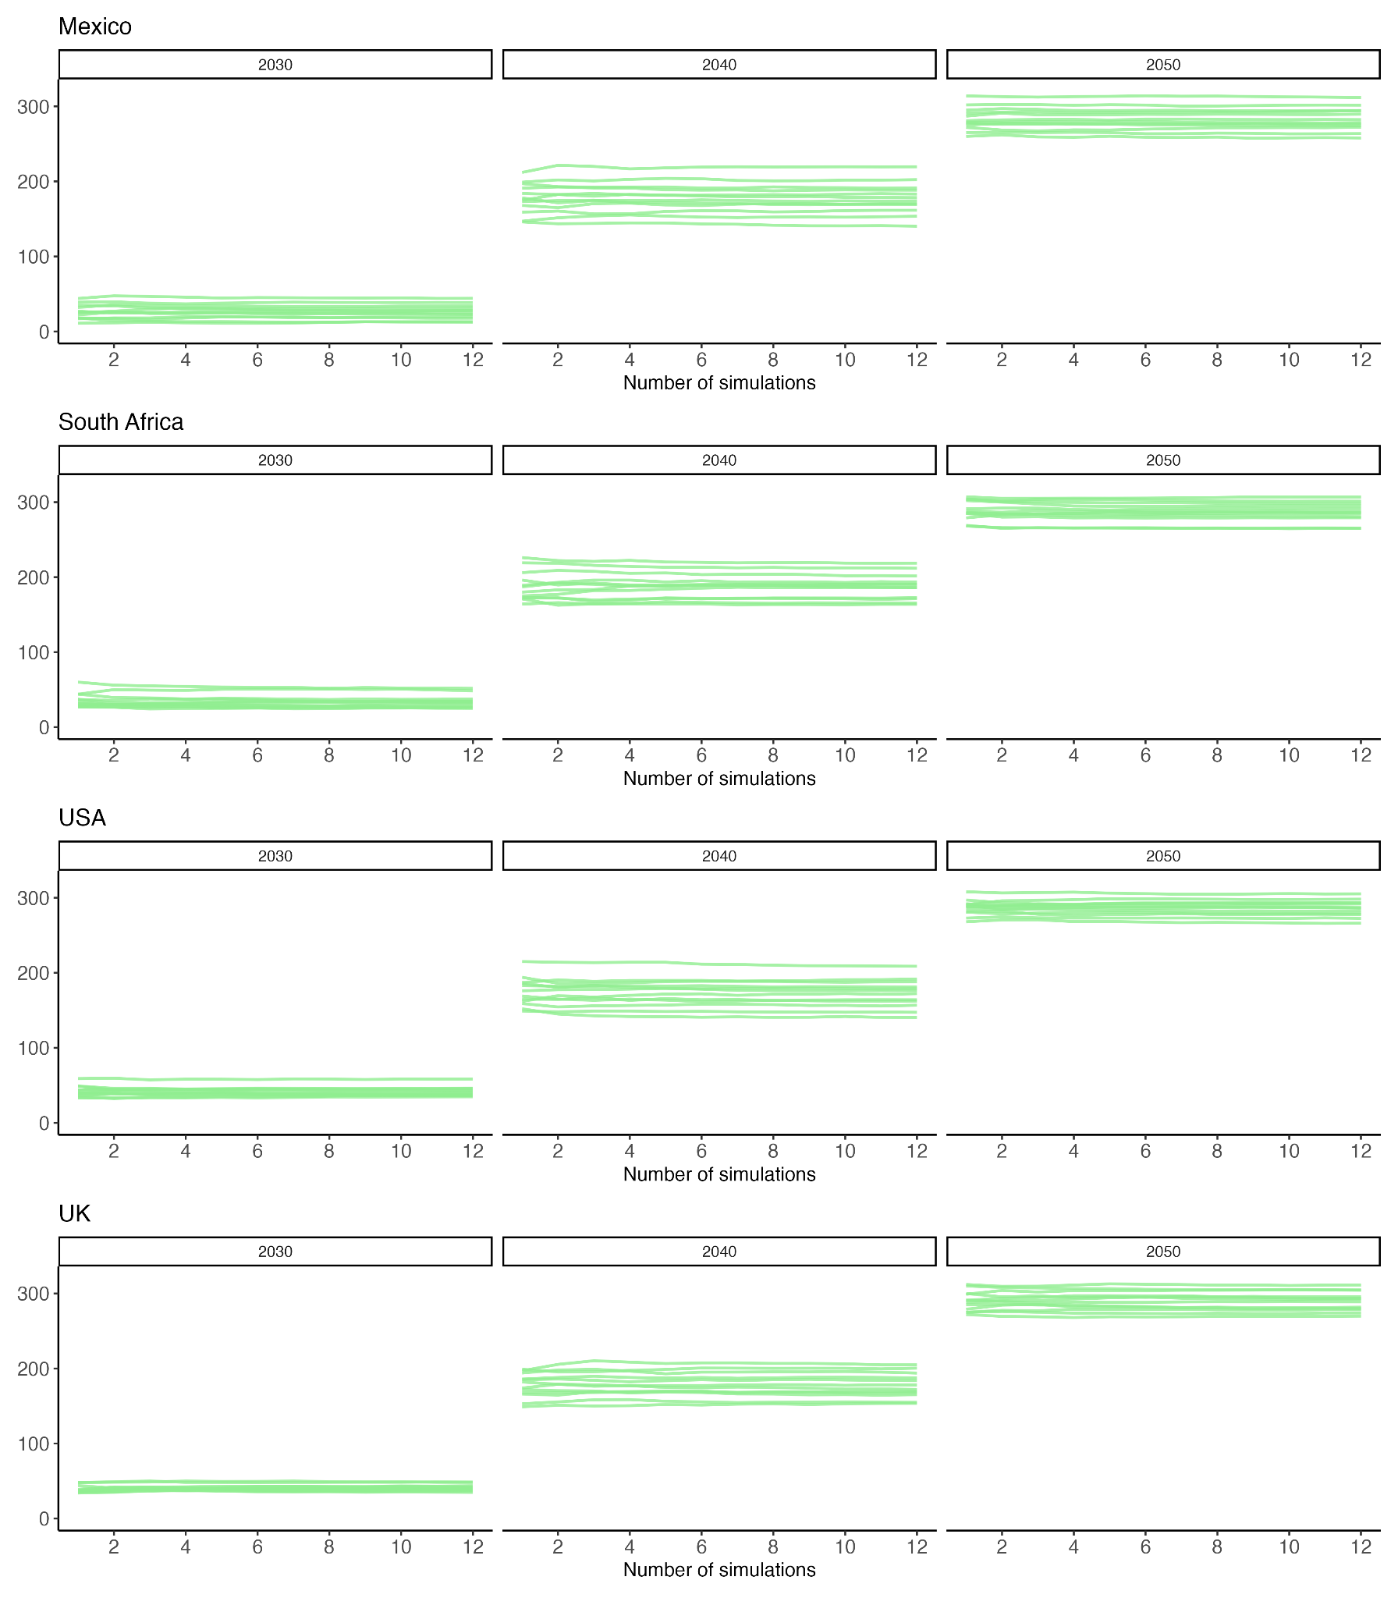
Note. The figure shows the mean EV adoption outcomes across increasing numbers of simulation repetitions (1–12) for each scenario. Stability analysis results indicate that using 12 repetitions was sufficient to ensure consistency in outcomes across scenarios.

Figure S6. Uncertainty analysis results for country-specific agent-based models
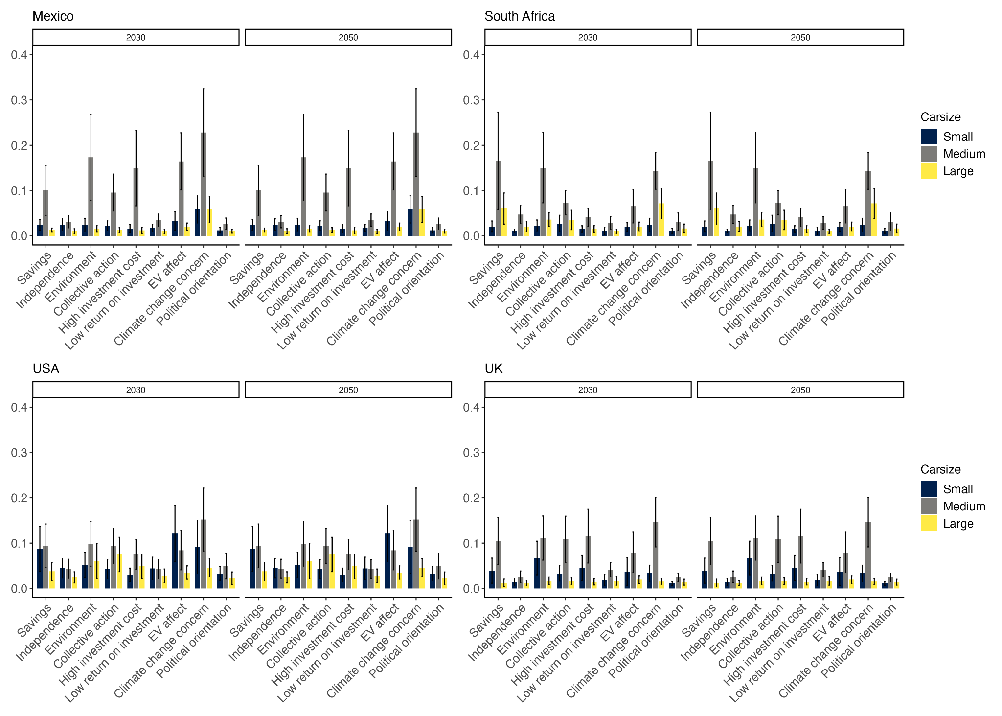
Note. The figure presents Sobol total sensitivity indices for EV adoption in 2030 and 2050. Each bar indicates the influence of a behavioural parameter on EV adoption, disaggregated by car size. Behavioural parameters include the subjective probabilities for benefits and risks from adopting EVs, affect toward EVs, and political orientation. Error bars represent CIs derived from the Sobol sensitivity analysis. Input parameter distributions were specified as normal distributions using regression coefficient estimates and standard errors from the regression models.

Supplementary Tables

Table S1. Multilevel logistic regression results for EV adoption decisions including attention to GHG emissions and savings information, additional vehicle attributes and covariates as fixed effects
 | EV adoption decision
Fixed effects | OR |  | CI |  | p
(Intercept) | 0.38 |  | 0.28, 0.51 |  | <0.001
Car size [medium] | 1.75 |  | 1.40, 2.19 |  | <0.001
Car size [small] | 2.06 |  | 1.62, 2.64 |  | <0.001
Price [medium] | 0.28 |  | 0.21, 0.36 |  | <0.001
Price [high] | 0.08 |  | 0.05, 0.13 |  | <0.001
Savings [medium] | 1.11 |  | 0.98, 1.25 |  | 0.093
Savings [high] | 1.18 |  | 1.04, 1.33 |  | 0.009
Battery range [medium] | 5.48 |  | 4.85, 6.19 |  | <0.001
Battery range [high] | 13.72 |  | 12.13, 15.51 |  | <0.001
Emissions [medium] | 0.80 |  | 0.71, 0.91 |  | <0.001
Emissions [high] | 0.54 |  | 0.48, 0.61 |  | <0.001
Neighbourhood [medium] | 1.24 |  | 1.09, 1.39 |  | 0.001
Neighbourhood [high] | 1.60 |  | 1.41, 1.80 |  | <0.001
Attention to GHG emissions (z-scaled) | 1.03 |  | 1.01, 1.05 |  | 0.001
Attention to savings (z-scaled) | 1.09 |  | 1.08, 1.12 |  | <0.001
Carbon tax [low] | 1.04 |  | 1.00, 1.09 |  | 0.046
Carbon tax [high] | 1.40 |  | 1.34, 1.46 |  | <0.001
Information intervention [yes] | 1.26 |  | 1.22, 1.30 |  | <0.001
Age | 0.76 |  | 0.70, 0.83 |  | <0.001
Income | 1.19 |  | 1.09, 1.29 |  | <0.001
Political orientation | 0.84 |  | 0.78, 0.91 |  | <0.001
Random effects
$$σ^{2}$$ | 3.29
$τ_{00 }$participant_id | 2.49
$τ_{00 }$current_task | 0.01
$τ_{00 }$country | 0.02
$τ_{11 }$country.price medium | 0.05
$τ_{11 }$country.price_high | 0.21
$ρ_{01 }$country.price_medium | -0.21
$ρ_{01 }$country.price_high | -0.00
ICC | 0.44
N participant_id | 1589
N current_task | 18
N country | 4
Observations | 110978
Marginal R² / Conditional R² | 0.305 / 0.612

Table S2. Multilevel regression results for attention allocation as a function of interventions and national context
 | Frequency of savings |  | Likelihood of savings first |  | Frequency emissions |  | Likelihood of emissions first
 | b [CI] | p | OR [CI] | p | b [CI] | p | OR [CI] | p
Fixed effects
Intercept | 16.97 [15.94, 17.99] |  | 0.19 [0.18, 0.21] |  | 17.96 [16.87, 19.05] |  | 0.19 [0.17, 0.21]
Carbon tax [Yes] | 0.38 [0.11, 0.65] | 0.006 | 1.04 [0.98, 1.10] | 0.219 | -0.06 [-0.20, 0.07] | 0.361 | 1.02 [0.99, 1.05] | 0.309
Country [South Africa] | 0.96 [0.05, 1.87] | 0.040 | 1.08 [0.99, 1.17] | 0.089 | 0.42 [-0.55, 1.39] | 0.394 | 1.09 [1.00, 1.20] | 0.055
Country [UK] | -0.58 [-1.53, 0.36] | 0.226 | 0.94 [0.86, 1.03] | 0.173 | -2.88 [-3.88, -1.87] | <0.001 | 0.85 [0.77, 0.93] | 0.001
Country [USA] | -0.18 [-1.14, 0.77] | 0.711 | 0.96 [0.88, 1.05] | 0.369 | -1.98 [-2.99, -0.96] | <0.001 | 0.89 [0.81, 0.98] | 0.018
Information intervention [Yes] | -0.19 [-0.32, -0.05] | 0.007 | 0.99 [0.96, 1.03] | 0.743 | 0.09 [-0.19, 0.36] | 0.530 | 1.04 [0.98, 1.10] | 0.231
Car [medium] | 0.71 [-0.15, 1.57] | 0.106 | 1.05 [0.97, 1.12] | 0.225 | 0.18 [-0.74, 1.10] | 0.706 | 1.04 [0.96, 1.13] | 0.311
Car [small] | 1.51 [0.56, 2.45] | 0.002 | 1.14 [1.06, 1.24] | 0.001 | 0.83 [-0.18, 1.84] | 0.107 | 1.10 [1.00, 1.20] | 0.038
Price [medium] | -0.15 [-0.31, 0.02] | 0.084 | 0.99 [0.95, 1.02] | 0.465 | -0.17 [-0.34, -0.00] | 0.049 | 0.99 [0.95, 1.03] | 0.545
Price [high] | -0.28 [-0.44, -0.11] | 0.001 | 0.98 [0.94, 1.02] | 0.250 | -0.22 [-0.39, -0.06] | 0.008 | 0.97 [0.93, 1.01] | 0.121
Savings [medium] | 0.05 [-0.12, 0.21] | 0.584 | 0.98 [0.95, 1.02] | 0.351 | -0.08 [-0.25, 0.09] | 0.347 | 1.03 [1.00, 1.07] | 0.086
Savings [high] | -0.02 [-0.18, 0.15] | 0.845 | 0.99 [0.96, 1.03] | 0.683 | 0.00 [-0.16, 0.17] | 0.974 | 1.02 [0.98, 1.06] | 0.355
Range [medium] | 0.55 [0.38, 0.72] | <0.001 | 1.02 [0.99, 1.06] | 0.231 | 0.25 [0.09, 0.42] | 0.003 | 1.01 [0.97, 1.05] | 0.567
Range [high] | 0.68 [0.52, 0.85] | <0.001 | 1.05 [1.01, 1.09] | 0.015 | 0.36 [0.19, 0.53] | <0.001 | 1.04 [1.00, 1.08] | 0.049
Emissions [medium] | -0.03 [-0.20, 0.14] | 0.706 | 1.02 [0.98, 1.05] | 0.417 | 0.06 [-0.11, 0.22] | 0.506 | 1.01 [0.98, 1.05] | 0.463
Emissions [high] | 0.04 [-0.13, 0.21] | 0.630 | 1.01 [0.97, 1.05] | 0.539 | 0.06 [-0.10, 0.23] | 0.466 | 1.00 [0.96, 1.04] | 0.979
Neighbourhood [medium] | 0.02 [-0.15, 0.19 | 0.806 | 1.01 [0.97, 1.05] | 0.590 | -0.14 [-0.31, 0.02] | 0.090 | 0.99 [0.96, 1.03] | 0.690
Neighbourhood [high] | -0.01 [-0.18, 0.16] | 0.914 | 0.98 [0.95, 1.02] | 0.364 | 0.02 [-0.15, 0.19] | 0.831 | 1.01 [0.97, 1.05] | 0.761
Age | -0.09 [-0.41, 0.24] | 0.610 | 1.00 [0.98, 1.03] | 0.797 | 0.44 [0.09, 0.79] | 0.014 | 1.03 [1.00, 1.06] | 0.043
Income | 0.09 [-0.24, 0.41] | 0.592 | 1.00 [0.97, 1.03] | 0.904 | -0.00 [-0.35, 0.35] | 0.998 | 1.00 [0.97, 1.03] | 0.817
Political orientation | -0.12 [-0.43, 0.19] | 0.464 | 0.99 [0.97, 1.02] | 0.468 | -0.17 [-0.50, 0.16] | 0.319 | 0.99 [0.96, 1.01] | 0.304
Tax [Yes] × country  [South Africa] | 0.26 [-0.13, 0.65] | 0.192 | 1.02 [0.93, 1.11] | 0.696
Tax [Yes] × country  [UK] | 0.33 [-0.06, 0.71] | 0.095 | 1.01 [0.93, 1.11] | 0.750
Tax [Yes] × country  [USA] | 0.32 [-0.07, 0.70] | 0.109 | 1.00 [0.92, 1.09] | 0.996
Information [Yes] × country  [South Africa] |  |  |  |  | 1.08 [0.69, 1.46] | <0.001 | 1.04 [0.95, 1.13] | 0.433
Information [Yes] × country  [UK] |  |  |  |  | 1.30 [0.91, 1.68] | <0.001 | 1.03 [0.94, 1.12] | 0.529
Information [Yes] × country  [USA] |  |  |  |  | 0.65 [0.26, 1.03] | 0.001 | 1.01 [0.93, 1.11] | 0.780
Random effects
$$σ^{2}$$ | 134.61 |  | 3.29 |  | 134.28 |  | 3.29
$τ_{00 }$ _{participant_id} | 37.28 |  | 0.17 |  | 42.81 |  | 0.22
ICC | 0.22 |  | 0.05 |  | 0.24 |  | 0.06
N _{participant_id} | 1589 |  | 1589 |  | 1589 |  | 1589
Observations | 110978 |  | 110978 |  | 110978 |  | 110978
Marginal R² / Conditional R² | 0.004 / 0.220 |  | 0.002 / 0.051 |  | 0.011 / 0.250 |  | 0.003 / 0.067

Table S3. Multilevel logistic regression results for EV adoption decisions including additional vehicle attributes and covariates
 | EV adoption decision
Fixed effects | OR | CI | p
(Intercept) | 0.36 | 0.27, 0.49 | <0.001
Car size [medium] | 1.80 | 1.44, 2.26 | <0.001
Car size [small] | 2.20 | 1.72, 2.82 | <0.001
Price [medium] | 0.28 | 0.22, 0.36 | <0.001
Price [high] | 0.08 | 0.05, 0.13 | <0.001
Savings [medium] | 1.11 | 0.98, 1.26 | 0.089
Savings [high] | 1.17 | 1.04, 1.33 | 0.011
Battery range [medium] | 5.40 | 4.77, 6.10 | <0.001
Battery range [high] | 13.39 | 11.83, 15.16 | <0.001
Neighbourhood [medium] | 1.23 | 1.09, 1.39 | 0.001
Neighbourhood [high] | 1.60 | 1.41, 1.81 | <0.001
Emissions [medium] | 0.80 | 0.71, 0.91 | <0.001
Emissions [high] | 0.54 | 0.48, 0.61 | <0.001
Information intervention [yes] | 1.26 | 1.22, 1.29 | <0.001
Carbon tax [low] | 1.05 | 1.00, 1.09 | 0.029
Carbon tax [high] | 1.40 | 1.34, 1.46 | <0.001
Age | 0.75 | 0.69, 0.82 | <0.001
Income | 1.17 | 1.08, 1.28 | <0.001
Random effects
$$σ^{2}$$ | 3.29
$τ_{00 }$participant_id | 2.52
$τ_{00 }$current_task | 0.01
$τ_{00 }$country | 0.02
$τ_{11 }$country.price_medium | 0.05
$τ_{11 }$country.price_high | 0.21
$ρ_{01 }$country.price_medium | -0.12
$ρ_{01 }$country.price_high | 0.07
ICC | 0.45
N participant_id | 1589
N current_task | 18
N country | 4
Observations | 114408
Marginal R² / Conditional R² | 0.296 / 0.610

Table S4. Multilevel logistic regression results for EV adoption decisions by national context
 | USA |  | UK |  | South Africa |  | Mexico
 | OR | p | OR | p | OR | p | OR | p
Fixed effects
(Intercept) | 0.19  [0.12, 0.29] |  | 0.12  [0.06, 0.24] |  | 0.92  [0.71, 1.20] |  | 0.70  [0.45, 1.07]
Car size [medium] | 2.58  [1.60, 4.17] | <0.001 | 4.28  [2.18, 8.40] | <0.001 | 0.95  [0.70, 1.27] | 0.716 | 1.37  [0.90, 2.07] | 0.141
Car size [small] | 4.98  [2.85, 8.71] | <0.001 | 3.79  [1.90, 7.54] | <0.001 | 1.11  [0.79, 1.56] | 0.559 | 1.52  [0.98, 2.34] | 0.061
Price [medium] | 0.25  [0.21, 0.29] | <0.001 | 0.22  [0.17, 0.27] | <0.001 | 0.46  [0.43, 0.50] | <0.001 | 0.22  [0.20, 0.25] | <0.001
Price  [high] | 0.07  [0.06, 0.08] | <0.001 | 0.04  [0.04, 0.06] | <0.001 | 0.21  [0.19, 0.22] | <0.001 | 0.06  [0.05, 0.06] | <0.001
Savings [medium] | 1.10  [0.95, 1.27] | 0.217 | 1.23  [0.99, 1.53] | 0.060 | 1.04  [0.97, 1.12] | 0.244 | 1.11  [0.98, 1.26] | 0.102
Savings [high] | 1.04  [0.90, 1.20] | 0.607 | 1.19  [0.96, 1.47] | 0.113 | 1.19  [1.11, 1.28] | <0.001 | 1.34  [1.18, 1.51] | <0.001
Range [medium] | 6.52  [5.61, 7.56] | <0.001 | 11.25  [9.07, 13.95] | <0.001 | 3.36  [3.14, 3.59] | <0.001 | 4.61  [4.08, 5.20] | <0.001
Range  [high] | 14.74  [12.65, 17.16] | <0.001 | 30.70  [24.63, 38.26] | <0.001 | 7.65  [7.10, 8.24] | <0.001 | 12.86  [11.33, 14.60] | <0.001
Neighbourhood [medium] | 1.20  [1.04, 1.39] | 0.015 | 1.12  [0.91, 1.39] | 0.286 | 1.35  [1.26, 1.44] | <0.001 | 1.22  [1.08, 1.37] | 0.001
Neighbourhood [high] | 1.72  [1.48, 2.00] | <0.001 | 1.35  [1.09, 1.68] | 0.006 | 1.63  [1.52, 1.75] | <0.001 | 1.60  [1.41, 1.81] | <0.001
Emissions [medium] | 0.92  [0.80, 1.07] | 0.302 | 0.97  [0.79, 1.21] | 0.813 | 0.68  [0.63, 0.73] | <0.001 | 0.70  [0.62, 0.80] | <0.001
Emissions [high] | 0.62  [0.54, 0.72] | <0.001 | 0.62  [0.50, 0.77] | <0.001 | 0.51  [0.48, 0.55] | <0.001 | 0.46  [0.41, 0.52] | <0.001
Information [yes] | 1.26  [1.18, 1.35] | <0.001 | 1.16  [1.08, 1.23] | <0.001 | 1.24  [1.17, 1.31] | <0.001 | 1.37  [1.29, 1.45] | <0.001
Carbon tax [low] | 1.07  [0.98, 1.16] | 0.138 | 1.00  [0.92, 1.10] | 0.966 | 1.03  [0.96, 1.10] | 0.456 | 1.09  [1.01, 1.18] | 0.030
Carbon tax [high] | 1.48  [1.36, 1.62] | <0.001 | 1.51  [1.38, 1.66] | <0.001 | 1.24  [1.16, 1.33] | <0.001 | 1.45  [1.34, 1.57] | <0.001
Age | 0.62  [0.52, 0.75] | <0.001 | 0.81  [0.68, 0.97] | 0.024 | 0.89  [0.78, 1.02] | 0.103 | 0.89  [0.75, 1.07] | 0.212
Income | 1.62  [1.31, 2.00] | <0.001 | 1.27  [1.01, 1.61] | 0.043 | 1.00  [0.90, 1.12] | 0.940 | 1.03  [0.90, 1.18] | 0.639
Political orientation | 0.61  [0.50, 0.75] | <0.001 | 0.84  [0.69, 1.02] | 0.079 | 0.96  [0.85, 1.09] | 0.557 | 0.94  [0.83, 1.07] | 0.379
Random effects
$$σ^{2}$$ | 3.29 |  | 3.29 |  | 3.29 |  | 3.29
$$τ_{00 }$$ | 3.74 _{participant_id} |  | 3.82 _{participant_id} |  | 1.36 _{participant_id} |  | 1.51 _{participant_id}
 | 0.01 _{current_task} |  | 0.03 _{current_task} |  |  |  | 0.01 _{current_task}
ICC | 0.53 |  | 0.54 |  | 0.29 |  | 0.32
N | 402 _{participant_id} |  | 398 _{participant_id} |  | 392 _{participant_id} |  | 397 _{participant_id}
 | 18 _{current_task} |  | 18 _{current_task} |  | * |  | 18 _{current_task}
Observations | 28944 |  | 28656 |  | 28224 |  | 28584
Marginal R²/ Conditional R² | 0.338 / 0.691 |  | 0.364 / 0.707 |  | 0.213 / 0.444 |  | 0.360 / 0.562
Note. * Random intercept for choice task was removed from the logistic regression model in South Africa due to a singular fit. The model converged after removing this random effect.

Table S5. Multilevel logistic regression results for EV adoption decisions including intervention x political orientation interaction by national context
 | USA |  |  | UK |  |  | South Africa |  |  | Mexico
 | OR | CI | p | OR | CI | p | OR | CI | p | OR | CI | p
Fixed effects
(Intercept) | 0.19 | 0.12, 0.29 | <0.001 | 0.12 | 0.06, 0.24 | <0.001 | 0.92 | 0.71, 1.20 | 0.539 | 0.70 | 0.45, 1.07 | 0.100
Car size [medium] | 2.58 | 1.60, 4.17 | <0.001 | 4.29 | 2.18, 8.41 | <0.001 | 0.95 | 0.70, 1.27 | 0.717 | 1.37 | 0.90, 2.08 | 0.142
Car size [small] | 4.98 | 2.85, 8.71 | <0.001 | 3.79 | 1.90, 7.55 | <0.001 | 1.11 | 0.79, 1.56 | 0.559 | 1.52 | 0.98, 2.34 | 0.061
Price [medium] | 0.25 | 0.21, 0.29 | <0.001 | 0.22 | 0.17, 0.27 | <0.001 | 0.46 | 0.43, 0.50 | <0.001 | 0.22 | 0.20, 0.25 | <0.001
Price  [high] | 0.07 | 0.06, 0.08 | <0.001 | 0.04 | 0.04, 0.06 | <0.001 | 0.21 | 0.19, 0.22 | <0.001 | 0.06 | 0.05, 0.06 | <0.001
Savings [medium] | 1.10 | 0.95, 1.27 | 0.216 | 1.23 | 0.99, 1.53 | 0.060 | 1.04 | 0.97, 1.12 | 0.243 | 1.11 | 0.98, 1.26 | 0.102
Savings [high] | 1.04 | 0.90, 1.20 | 0.605 | 1.19 | 0.96, 1.47 | 0.113 | 1.19 | 1.11, 1.28 | <0.001 | 1.34 | 1.18, 1.51 | <0.001
Range [medium] | 6.52 | 5.62, 7.57 | <0.001 | 11.25 | 9.07, 13.96 | <0.001 | 3.36 | 3.14, 3.59 | <0.001 | 4.61 | 4.09, 5.21 | <0.001
Range  [high] | 14.75 | 12.66, 17.18 | <0.001 | 30.71 | 24.64, 38.27 | <0.001 | 7.65 | 7.11, 8.24 | <0.001 | 12.88 | 11.34, 14.62 | <0.001
Neighbourhood [medium] | 1.20 | 1.04, 1.39 | 0.015 | 1.12 | 0.91, 1.39 | 0.286 | 1.35 | 1.26, 1.44 | <0.001 | 1.22 | 1.08, 1.37 | 0.001
Neighbourhood [high] | 1.72 | 1.48, 2.00 | <0.001 | 1.35 | 1.09, 1.68 | 0.006 | 1.63 | 1.52, 1.75 | <0.001 | 1.60 | 1.41, 1.81 | <0.001
Emissions [medium] | 0.92 | 0.80, 1.07 | 0.300 | 0.97 | 0.79, 1.21 | 0.813 | 0.68 | 0.63, 0.73 | <0.001 | 0.70 | 0.62, 0.80 | <0.001
Emissions [high] | 0.62 | 0.54, 0.72 | <0.001 | 0.62 | 0.50, 0.77 | <0.001 | 0.51 | 0.48, 0.55 | <0.001 | 0.46 | 0.41, 0.52 | <0.001
Information [yes] | 1.26 | 1.18, 1.34 | <0.001 | 1.15 | 1.08, 1.23 | <0.001 | 1.24 | 1.17, 1.31 | <0.001 | 1.37 | 1.29, 1.45 | <0.001
Political orientation | 0.64 | 0.52, 0.78 | <0.001 | 0.86 | 0.70, 1.06 | 0.162 | 1.00 | 0.88, 1.13 | 0.944 | 1.00 | 0.87, 1.14 | 0.990
Carbon tax [low] | 1.07 | 0.98, 1.16 | 0.127 | 1.00 | 0.92, 1.10 | 0.970 | 1.03 | 0.96, 1.10 | 0.462 | 1.09 | 1.01, 1.18 | 0.030
Carbon tax [high] | 1.48 | 1.36, 1.61 | <0.001 | 1.51 | 1.38, 1.66 | <0.001 | 1.24 | 1.16, 1.33 | <0.001 | 1.45 | 1.34, 1.57 | <0.001
Age | 0.62 | 0.52, 0.75 | <0.001 | 0.81 | 0.68, 0.97 | 0.024 | 0.89 | 0.78, 1.02 | 0.103 | 0.89 | 0.75, 1.07 | 0.213
Income | 1.62 | 1.31, 1.99 | <0.001 | 1.27 | 1.01, 1.61 | 0.043 | 1.00 | 0.90, 1.12 | 0.941 | 1.03 | 0.90, 1.18 | 0.638
Information [yes] x Political orientation | 0.93 | 0.87, 0.99 | 0.024 | 0.96 | 0.90, 1.03 | 0.274 | 0.96 | 0.90, 1.01 | 0.128 | 0.89 | 0.84, 0.95 | <0.001
Carbon tax [low] x Political orientation | 1.03 | 0.95, 1.11 | 0.500 | 0.98 | 0.90, 1.06 | 0.650 | 0.98 | 0.92, 1.05 | 0.647 | 0.99 | 0.92, 1.06 | 0.726
Carbon tax [high] x Political orientation | 0.97 | 0.89, 1.05 | 0.422 | 0.96 | 0.89, 1.05 | 0.370 | 0.98 | 0.91, 1.05 | 0.518 | 1.01 | 0.94, 1.09 | 0.756
Random effects
$$σ^{2}$$ | 3.29 |  |  | 3.29 |  |  | 3.29 |  |  | 3.29
$$τ_{00 }$$ | 3.74 _{participant_id} |  |  | 3.82 _{participant_id} |  |  | 1.36 _{participant_id} |  |  | 1.51 _{participant_id}
 | 0.01 _{current_task} |  |  | 0.03 _{current_task} |  |  |  |  |  | 0.01 _{current_task}
ICC | 0.53 |  |  | 0.54 |  |  | 0.29 |  |  | 0.32
N | 402 _{participant_id} |  |  | 398 _{participant_id} |  |  | 392 _{participant_id} |  |  | 397 _{participant_id}
 | 18 _{current_task} |  |  | 18 _{current_task} |  |  | * |  |  | 18 _{current_task}
Observations | 28944 |  |  | 28656 |  |  | 28224 |  |  | 28584
Marginal R²/ Conditional R² | 0.338 / 0.691 |  |  | 0.364 / 0.707 |  |  | 0.213 / 0.444 |  |  | 0.360 / 0.562
Note. * Random intercept for choice task was removed from the regression model in South Africa due to a singular fit. The model converged after removing this random effect.

Table S6. Linear regression results on simulated EV adoption (from ABM) in 2030, 2040, 2050, by national context, showing the effects of a high carbon tax, information intervention and interaction of policies
 | 2030 |  |  | 2040 |  |  | 2050
 | Estimate | CI |  | Estimate | CI |  | Estimate | CI
Mexico
(Intercept) | 17.75 | 15.48, 20.02 |  | 161.50 | 157.83, 165.17 |  | 272.33 | 269.88, 274.79
Information [yes] | 13.75 | 10.54, 16.96 |  | 21.58 | 16.40, 26.77 |  | 17.33 | 13.86, 20.80
Tax [high] | 9.83 | 6.63, 13.04 |  | 26.83 | 21.65, 32.02 |  | 22.08 | 18.61, 25.55
Information [yes] × tax [high] | 2.83 | -1.70, 7.37 |  | 9.58 | 2.25, 16.92 |  | 0.08 | -4.82, 4.99
South Africa
(Intercept) | 26.17 | 23.81, 28.52 |  | 172.67 | 169.09, 176.24 |  | 291.25 | 289.37, 293.13
Information [yes] | 8.33 | 5.00, 11.66 |  | 20.67 | 15.61, 25.73 |  | 9.92 | 7.26, 12.57
Tax [high] | 5.83 | 2.50, 9.16 |  | 17.58 | 12.52, 22.64 |  | 7.00 | 4.35, 9.65
Information [yes] × tax [high] | 11.33 | 6.62, 16.04 |  | 7.75 | 0.59, 14.91 |  | -1.58 | -5.33, 2.17
USA
(Intercept) | 36.25 | 34.28, 38.22 |  | 164.08 | 160.88, 167.28 |  | 282.83 | 280.99, 284.68
Information [yes] | 4.17 | 1.39, 6.95 |  | 14.67 | 10.14, 19.19 |  | 10.17 | 7.56, 12.77
Tax [high] | 10.00 | 7.22, 12.78 |  | 27.75 | 23.22, 32.28 |  | 15.33 | 12.73, 17.94
Information [yes] × tax [high] | 7.92 | 3.99, 11.85 |  | 2.17 | -4.23, 8.57 |  | -3.08 | -6.77, 0.60
UK
(Intercept) | 37.75 | 35.57, 39.93 |  | 169.92 | 166.35, 173.48 |  | 281.67 | 279.21, 284.12
Information [yes] | 3.83 | 0.75, 6.92 |  | 14.00 | 8.96, 19.04 |  | 11.92 | 8.45, 15.39
Tax [high] | 10.92 | 7.83, 14.00 |  | 30.50 | 25.46, 35.54 |  | 23.08 | 19.61, 26.55
Information [yes] × tax [high] | -4.25 | -8.61, 0.11 |  | -9.50 | -16.63, -2.37 |  | -5.25 | -10.16, -0.34
Note. The intercept reflects the baseline level of absolute EV adoption in the absence of any policy. Main effects represent the change in EV adoption when the respective policy is implemented alone, relative to the baseline. The interaction effect reflects the additional change in EV adoption when the two policies are implemented together, beyond the sum of their individual main effects.

Table S7. Linear regression results on simulated EV adoption (from ABM) in 2030, 2040, 2050, by national context, showing the effects of a low carbon tax, information intervention and interaction of policies
 | 2030 |  |  | 2040 |  |  | 2050
 | Estimate | CI |  | Estimate | CI |  | Estimate | CI
Mexico
(Intercept) | 17.75 | 15.44, 20.06 |  | 161.50 | 157.79, 165.21 |  | 272.33 | 270.17, 274.50
Information [yes] | 13.75 | 10.49, 17.01 |  | 21.58 | 16.34, 26.82 |  | 17.33 | 14.27, 20.40
Tax [low] | 1.92 | -1.35, 5.18 |  | 8.92 | 3.68, 14.16 |  | 5.92 | 2.85, 8.98
Information [yes] × tax [low] | 0.75 | -3.86, 5.36 |  | -0.75 | -8.16, 6.66 |  | -1.25 | -5.58, 3.08
South Africa
(Intercept) | 26.17 | 24.01, 28.32 |  | 172.67 | 168.83, 176.50 |  | 291.25 | 288.94, 293.56
Information [yes] | 8.33 | 5.29, 11.38 |  | 20.67 | 15.24, 26.09 |  | 9.92 | 6.66, 13.18
Tax [low] | 1.17 | -1.88, 4.21 |  | -1.50 | -6.93, 3.93 |  | -5.08 | -8.34, -1.82
Information [yes] × tax [low] | -0.92 | -5.23, 3.39 |  | 9.75 | 2.08, 17.42 |  | -1.25 | -5.86, 3.36
USA
(Intercept) | 36.25 | 34.23, 38.27 |  | 164.08 | 160.66, 167.51 |  | 282.83 | 281.07, 284.60
Information [yes] | 4.17 | 1.32, 7.02 |  | 14.67 | 9.82, 19.51 |  | 10.17 | 7.67, 12.66
Tax [low] | 0.08 | -2.77, 2.93 |  | 8.08 | 3.24, 12.93 |  | 3.75 | 1.26, 6.24
Information [yes] × tax [low] | 2.75 | -1.28, 6.78 |  | -5.67 | -12.52, 1.19 |  | -4.92 | -8.44, -1.39
UK
(Intercept) | 37.75 | 35.54, 39.96 |  | 169.92 | 166.73, 173.10 |  | 281.67 | 278.71, 284.62
Information [yes] | 3.83 | 0.71, 6.96 |  | 14.00 | 9.49, 18.51 |  | 11.92 | 7.74, 16.10
Tax [low] | 1.67 | -1.46, 4.79 |  | -2.17 | -6.67, 2.34 |  | 7.17 | 2.99, 11.35
Information [yes] × tax [low] | -3.08 | -7.50, 1.33 |  | -3.83 | -10.21, 2.54 |  | -8.25 | -14.16, -2.34
Note. The intercept reflects the baseline level of EV adoption in the absence of any policy. Main effects represent the change in EV adoption when the respective policy is implemented alone, relative to the baseline. The interaction effect reflects the additional change in EV adoption when the two policies are implemented together, beyond the sum of their individual main effects.

Table S8. Multilevel logistic regression results for policy support including additional policy attributes and covariates
 | Policy support
 | OR | CI | p
Fixed effects
(Intercept) | 0.52 | 0.46, 0.59
Carbon tax [low] | 0.38 | 0.36, 0.41 | <0.001
Carbon tax [high] | 0.17 | 0.16, 0.18 | <0.001
Climate label [voluntary] | 1.36 | 1.27, 1.45 | <0.001
Climate label [mandatory] | 1.65 | 1.54, 1.76 | <0.001
Subsidy [medium] | 3.12 | 2.91, 3.34 | <0.001
Subsidy [high] | 4.53 | 4.23, 4.86 | <0.001
Neighbourhood [medium] | 1.34 | 1.26, 1.44 | <0.001
Neighbourhood [high] | 1.49 | 1.39, 1.59 | <0.001
Age | 0.86 | 0.82, 0.91 | <0.001
Income | 1.06 | 1.01, 1.12 | 0.019
Random effects
$$σ^{2}$$ | 3.29
$τ_{00 }$ _{participant_id} | 0.72
$τ_{00 }$ _{country} | 0.01
ICC | 0.18
N _{participant_id} | 1589
N _{country} | 4
Observations | 28602
Marginal R² / Conditional R² | 0.205 / 0.349

Table S9. Multilevel logistic regression results for policy support by national context
 | USA |  |  | UK |  |  | Mexico |  |  | South Africa
 | OR | CI | p | OR | CI | p | OR | CI | p | OR | CI | p
Fixed effects
(Intercept) | 0.67 | 0.55, 0.81 |  | 0.44 | 0.36, 0.53 |  | 0.45 | 0.37, 0.54 |  | 0.62 | 0.52, 0.74
Carbon tax [low] | 0.28 | 0.25, 0.32 | <0.001 | 0.35 | 0.30, 0.40 | <0.001 | 0.49 | 0.43, 0.55 | <0.001 | 0.43 | 0.38, 0.49 | <0.001
Carbon tax [high] | 0.14 | 0.12, 0.16 | <0.001 | 0.15 | 0.13, 0.18 | <0.001 | 0.22 | 0.20, 0.26 | <0.001 | 0.16 | 0.14, 0.19 | <0.001
Climate label [voluntary] | 1.22 | 1.07, 1.40 | 0.003 | 1.24 | 1.08, 1.42 | 0.002 | 1.55 | 1.36, 1.76 | <0.001 | 1.44 | 1.26, 1.64 | <0.001
Climate label [mandatory] | 1.47 | 1.28, 1.68 | <0.001 | 1.45 | 1.26, 1.66 | <0.001 | 2.29 | 2.01, 2.61 | <0.001 | 1.48 | 1.30, 1.69 | <0.001
Subsidy [low] | 2.99 | 2.60, 3.43 | <0.001 | 3.98 | 3.45, 4.58 | <0.001 | 2.73 | 2.40, 3.10 | <0.001 | 3.09 | 2.71, 3.53 | <0.001
Subsidy [high] | 4.14 | 3.59, 4.77 | <0.001 | 7.39 | 6.38, 8.57 | <0.001 | 3.16 | 2.77, 3.60 | <0.001 | 4.71 | 4.11, 5.41 | <0.001
Neighbourhood [medium] | 1.33 | 1.16, 1.52 | <0.001 | 1.38 | 1.21, 1.58 | <0.001 | 1.39 | 1.22, 1.58 | <0.001 | 1.29 | 1.13, 1.47 | <0.001
Neighbourhood [high] | 1.36 | 1.19, 1.56 | <0.001 | 1.52 | 1.33, 1.75 | <0.001 | 1.59 | 1.40, 1.81 | <0.001 | 1.51 | 1.32, 1.72 | <0.001
Age | 0.79 | 0.71, 0.88 | <0.001 | 0.87 | 0.79, 0.96 | 0.005 | 0.99 | 0.87, 1.11 | 0.817 | 0.87 | 0.78, 0.98 | 0.016
Income | 1.12 | 0.99, 1.26 | 0.072 | 1.13 | 1.00, 1.28 | 0.051 | 1.02 | 0.94, 1.12 | 0.606 | 1.00 | 0.92, 1.09 | 0.996
Random Effects
$$σ^{2}$$ | 3.29 |  |  | 3.29 |  |  | 3.29 |  |  | 3.29
$$τ_{00 }$$ | 1.04 _{participant_id} |  |  | 0.81 _{participant_id} |  |  | 0.47 _{participant_id} |  |  | 0.62 _{participant_id}
ICC | 0.24 |  |  | 0.20 |  |  | 0.12 |  |  | 0.16
N | 402 _{participant_id} |  |  | 398 _{participant_id} |  |  | 397 _{participant_id} |  |  | 392 _{participant_id}
Observations | 7236 |  |  | 7164 |  |  | 7146 |  |  | 7056
Marginal R² / Conditional R² | 0.210 / 0.400 |  |  | 0.252 / 0.400 |  |  | 0.173 / 0.277 |  |  | 0.212 / 0.337

Table S10. Multilevel logistic regression results for policy support including the three-way-interaction between tax x climate impact label x political orientation by national context
 | USA |  |  | UK |  |  | Mexico |  |  | South Africa
 | OR | CI | p | OR | CI | p | OR | CI | p | OR | CI | p
Fixed effects
(Intercept) | 0.64 | 0.52, 0.79 |  | 0.45 | 0.37, 0.56 |  | 0.43 | 0.35, 0.53 |  | 0.62 | 0.51, 0.75
Carbon tax [low] | 0.29 | 0.22, 0.38 | <0.001 | 0.33 | 0.25, 0.44 | <0.001 | 0.46 | 0.35, 0.59 | <0.001 | 0.45 | 0.34, 0.58 | <0.001
Carbon tax [high] | 0.16 | 0.12, 0.21 | <0.001 | 0.12 | 0.09, 0.16 | <0.001 | 0.25 | 0.19, 0.32 | <0.001 | 0.17 | 0.13, 0.22 | <0.001
Climate label [voluntary] | 1.26 | 0.96, 1.65 | 0.094 | 1.05 | 0.80, 1.38 | 0.733 | 1.37 | 1.06, 1.78 | 0.017 | 1.44 | 1.09, 1.89 | 0.009
Climate label [mandatory] | 1.77 | 1.34, 2.32 | <0.001 | 1.40 | 1.07, 1.85 | 0.015 | 2.84 | 2.18, 3.70 | <0.001 | 1.64 | 1.25, 2.15 | <0.001
Political orientation | 1.23 | 1.01, 1.49 | 0.035 | 1.20 | 0.99, 1.44 | 0.057 | 1.26 | 1.06, 1.49 | 0.009 | 1.04 | 0.87, 1.24 | 0.690
Subsidy [low] | 2.80 | 2.35, 3.34 | <0.001 | 4.05 | 3.38, 4.85 | <0.001 | 2.41 | 2.05, 2.84 | <0.001 | 3.02 | 2.56, 3.57 | <0.001
Subsidy [high] | 3.91 | 3.30, 4.64 | <0.001 | 7.90 | 6.61, 9.44 | <0.001 | 3.02 | 2.58, 3.54 | <0.001 | 4.52 | 3.83, 5.33 | <0.001
Neighbourhood [medium] | 1.34 | 1.13, 1.59 | 0.001 | 1.46 | 1.23, 1.74 | <0.001 | 1.50 | 1.28, 1.78 | <0.001 | 1.27 | 1.07, 1.51 | 0.005
Neighbourhood [high] | 1.47 | 1.24, 1.76 | <0.001 | 1.52 | 1.27, 1.82 | <0.001 | 1.82 | 1.54, 2.13 | <0.001 | 1.54 | 1.30, 1.82 | <0.001
Age | 0.80 | 0.72, 0.89 | <0.001 | 0.88 | 0.80, 0.97 | 0.013 | 0.99 | 0.88, 1.12 | 0.881 | 0.87 | 0.78, 0.97 | 0.014
Income | 1.14 | 1.01, 1.29 | 0.034 | 1.17 | 1.03, 1.32 | 0.013 | 1.03 | 0.94, 1.12 | 0.596 | 1.00 | 0.92, 1.09 | 0.999
Tax [low] × label  [voluntary] | 1.05 | 0.69, 1.58 | 0.828 | 1.10 | 0.72, 1.67 | 0.658 | 1.33 | 0.90, 1.96 | 0.155 | 1.04 | 0.69, 1.56 | 0.846
Tax [high] × label [voluntary] | 0.88 | 0.58, 1.33 | 0.533 | 1.55 | 1.02, 2.37 | 0.042 | 1.08 | 0.73, 1.61 | 0.697 | 0.96 | 0.64, 1.44 | 0.830
Tax [low] × Label  [mandatory] | 0.81 | 0.54, 1.22 | 0.313 | 0.96 | 0.64, 1.46 | 0.855 | 0.87 | 0.59, 1.29 | 0.487 | 0.84 | 0.56, 1.24 | 0.380
Tax [high] × label  [mandatory] | 0.70 | 0.46, 1.07 | 0.097 | 1.16 | 0.76, 1.77 | 0.497 | 0.63 | 0.43, 0.94 | 0.023 | 0.90 | 0.60, 1.35 | 0.604
Tax [low] × political orientation | 0.61 | 0.48, 0.77 | <0.001 | 0.56 | 0.44, 0.71 | <0.001 | 0.73 | 0.59, 0.91 | 0.005 | 1.04 | 0.84, 1.30 | 0.708
Tax [high] × political orientation | 0.59 | 0.47, 0.75 | <0.001 | 0.66 | 0.52, 0.83 | <0.001 | 0.65 | 0.51, 0.81 | <0.001 | 0.93 | 0.75, 1.17 | 0.540
Label [voluntary] × political orientation | 0.97 | 0.77, 1.22 | 0.798 | 1.06 | 0.84, 1.34 | 0.640 | 0.92 | 0.74, 1.15 | 0.472 | 0.95 | 0.75, 1.20 | 0.684
Label [mandatory] × political orientation | 0.63 | 0.49, 0.80 | <0.001 | 0.72 | 0.56, 0.92 | 0.008 | 1.00 | 0.79, 1.27 | 0.990 | 0.71 | 0.56, 0.91 | 0.006
(Tax [low] × label  [voluntary]) × political orientation | 0.86 | 0.62, 1.20 | 0.378 | 1.07 | 0.77, 1.49 | 0.691 | 1.04 | 0.76, 1.41 | 0.805 | 0.90 | 0.65, 1.23 | 0.500
(Tax [high] × label [voluntary]) × Political orientation | 1.18 | 0.84, 1.66 | 0.335 | 0.87 | 0.62, 1.22 | 0.415 | 1.10 | 0.79, 1.52 | 0.568 | 1.17 | 0.84, 1.62 | 0.346
(Tax [low] × label  [mandatory]) × political orientation | 1.40 | 1.00, 1.97 | 0.050 | 1.40 | 1.00, 1.97 | 0.053 | 0.90 | 0.65, 1.24 | 0.517 | 1.29 | 0.93, 1.79 | 0.131
(Tax [high] × label  [mandatory]) × political orientation | 1.74 | 1.23, 2.44 | 0.002 | 1.31 | 0.93, 1.85 | 0.119 | 1.08 | 0.78, 1.51 | 0.641 | 1.42 | 1.01, 1.98 | 0.041
Random effects
$$σ^{2}$$ | 3.29 |  |  | 3.29 |  |  | 3.29 |  |  | 3.29
$$τ_{00 }$$ | 1.05 _{participant_id} |  |  | 0.81 _{participant_id} |  |  | 0.48 _{participant_id} |  |  | 0.62 _{participant_id}
ICC | 0.24 |  |  | 0.20 |  |  | 0.13 |  |  | 0.16
N | 402 _{participant_id} |  |  | 398 _{participant_id} |  |  | 397 _{participant_id} |  |  | 392 _{participant_id}
Observations | 7236 |  |  | 7164 |  |  | 7146 |  |  | 7056
Marginal R² / Conditional R² | 0.227 / 0.413 |  |  | 0.267 / 0.411 |  |  | 0.183 / 0.287 |  |  | 0.215 / 0.340

Table S11. Sample characteristics compared to national benchmarks
Variable | Our sample | National distribution | Source
Mexico (N=397)
Age (median) | 34 | 29 | ref. ²
Gender (female in %) | 44.8 | 51.2 | ref. ²
Median disposable household income in $MXN | 120,001 to 400,000 | 171,330 (per capita household income) | ref. ³
Education (low / medium / high education in %) | 1.62 / 21.02 / 77.36 | 56.22 / 23.15 / 20.64 | ref. ⁴
South Africa (N=392)
Age (median) | 37 | 28 | ref. ⁵
Gender (female in %) | 51.0 | 51.1 | ref. ⁶
Median disposable household income in R | 60,001 to 130,000 | 95,770 | ref. ³
Education (low / medium / high education in %) | 2.48 / 27.33 / 70.19 | 54.73 / 31.35 / 13.91 | ref. ⁴
United States (N=402)
Age (median) | 45 | 39.2 | ref. ⁷
Gender (female in %) | 48.5 | 50.5 | ref. ⁸
Median disposable household income in $ | 55,001 to 90,000 | 74,580 | ref. ⁹
Education (low / medium / high education in %) | 0.6 / 30.24 / 69.16 | 8.16 / 41.82 / 50.32 | ref. ⁴
United Kingdom (N=398)
Age (median) | 44 | 40.7 | ref. ¹⁰
Gender (female in %) | 49.0 | 51.0 | ref. ¹¹
Median disposable household income in £ | 15,001 to 30,000 | 36,663 | ref. ¹²
Education (low / medium / high education in %) | 18.02 / 16.22 / 65.77 | 18.56 / 30.12 / 51.32 | ref. ⁴

Table S12. Attributes and levels of the EV choice experiment by country
Country | Car size | Attribute | Attribute levels | Reference
Mexico | Small | Investment costs | 155; 223; 291 k MXN | ref. ¹³
Mexico | Small | Savings on driving | 155; 170; 185 $MXN / 100km | Own calculation (see table note)
Mexico | Small | Lifecycle GHG emissions | 15; 25; 35 tCO₂e | ref. ¹
Mexico | Small | Battery range | 240; 420; 600 km | refs.^{14–16}
Mexico | Small | EV adopters in neighbourhood | 8; 40; 72 % | Own scenario
Mexico | Medium | Investment costs | 261; 350; 436 k $MXN | ref. ¹³
Mexico | Medium | Savings on driving | 175; 195; 215 $MXN / 100km | Own calculation (see table note)
Mexico | Medium | Lifecycle GHG emissions | 15; 25; 35 tCO₂e | ref. ¹
Mexico | Medium | Battery range | 300; 480; 660 km | refs.^{14–16}
Mexico | Medium | EV adopters in neighbourhood | 8; 40; 72 % | Own scenario
Mexico | Large | Investment costs | 688; 805; 950 k $MXN | ref. ¹³
Mexico | Large | Savings on driving | 205; 225; 245 $MXN / 100km | Own calculation (see table note)
Mexico | Large | Lifecycle GHG emissions | 15; 25; 35 tCO₂e | ref. ¹
Mexico | Large | Battery range | 370; 550; 730 km | refs.^{14–16}
Mexico | Large | EV adopters in neighbourhood | 8; 40; 72 % | Own scenario
South Africa | Small | Investment costs | 112; 161; 210 k R | ref. ¹⁷
South Africa | Small | Savings on driving | 130; 145; 160 R / 100km | Own calculation (see table note)
South Africa | Small | Lifecycle GHG emissions | 15; 40; 50 tCO₂e | ref. ¹
South Africa | Small | Battery range | 240; 420; 600 km | refs.^{14–16}
South Africa | Small | EV adopters in neighbourhood | 8; 40; 72 % | Own scenario
South Africa | Medium | Investment costs | 189; 252; 315 k R | ref. ¹⁷
South Africa | Medium | Savings on driving | 150; 165; 180 R / 100km | Own calculation (see table note)
South Africa | Medium | Lifecycle GHG emissions | 15; 40; 50 tCO₂e | ref. ¹
South Africa | Medium | Battery range | 300; 480; 660 km | refs.^{14–16}
South Africa | Medium | EV adopters in neighbourhood | 8; 40; 72 % | Own scenario
South Africa | Large | Investment costs | 497; 581; 686 k R | ref. ¹⁷
South Africa | Large | Savings on driving | 175; 195; 215 R / 100km | Own calculation (see table note)
South Africa | Large | Lifecycle GHG emissions | 15; 40; 50 tCO₂e | ref. ¹
South Africa | Large | Battery range | 370; 550; 730 km | refs.^{14–16}
South Africa | Large | EV adopters in neighbourhood | 8; 40; 72 % | Own scenario
USA | Small | Investment costs | 16; 23; 30 k $ | ref. ¹⁸
USA | Small | Savings on driving | 6.7; 7.4; 8.1 $ / 100 miles | Own calculation (see table note)
USA | Small | Lifecycle GHG emissions | 11; 19; 30 tCO₂e | ref. ¹
USA | Small | Battery range | 150; 260; 370 miles | refs.^{14–16}
USA | Small | EV adopters in neighbourhood | 8; 40; 72 % | Own scenario
USA | Medium | Investment costs | 27; 36; 45 k $ | ref. ¹⁸
USA | Medium | Savings on driving | 7.2; 8; 8.8 $ / 100 miles | Own calculation (see table note)
USA | Medium | Lifecycle GHG emissions | 11; 19; 30 tCO₂e | ref. ¹
USA | Medium | Battery range | 190; 300; 410 miles | refs.^{14–16}
USA | Medium | EV adopters in neighbourhood | 8; 40; 72 % | Own scenario
USA | Large | Investment costs | 71; 83; 98 k $ | ref. ¹⁸
USA | Large | Savings on driving | 8.7; 9.6; 10.5 $ / 100 miles | Own calculation (see table note)
USA | Large | Lifecycle GHG emissions | 11; 19; 30 tCO₂e | ref. ¹
USA | Large | Battery range | 230; 340; 450 miles | refs.^{14–16}
USA | Large | EV adopters in neighbourhood | 8; 40; 72 % | Own scenario
UK | Small | Investment costs | 11.2; 16; 21 k £ | ref. ¹⁹
UK | Small | Savings on driving | 9.9; 10.8; 11.7 £ / 100 miles | Own calculation (see table note)
UK | Small | Lifecycle GHG emissions | 13; 19; 30 tCO₂e | ref. ¹
UK | Small | Battery range | 150; 260; 370 miles | refs.^{14–16}
UK | Small | EV adopters in neighbourhood | 8; 40; 72 % | Own scenario
UK | Medium | Investment costs | 18.9; 25.2; 31.5 k £ | ref. ¹⁹
UK | Medium | Savings on driving | 11.5; 12.8; 14.1 £ / 100 miles | Own calculation (see table note)
UK | Medium | Lifecycle GHG emissions | 13; 19; 30 tCO₂e | ref. ¹
UK | Medium | Battery range | 190; 300; 410 miles | refs.^{14–16}
UK | Medium | EV adopters in neighbourhood | 8; 40; 72 % | Own scenario
UK | Large | Investment costs | 49.7; 58; 68 k £ | ref. ¹⁹
UK | Large | Savings on driving | 13.8; 15.4; 17 £ / 100 miles | Own calculation (see table note)
UK | Large | Lifecycle GHG emissions | 13; 19; 30 tCO₂e | ref. ¹
UK | Large | Battery range | 230; 340; 450 miles | refs.^{14–16}
UK | Large | EV adopters in neighbourhood | 8; 40; 72 % | Own scenario
Note. *Savings of driving an EV compared to an ICEV for 100 km (miles) were calculated as follows: (ICEV fuel consumption [litre/100 km (miles)] * price of gasoline [local currency/litre]) - (EV fuel consumption [kWh/100 km (miles)] * price of electricity [local currency/kWh]). Local gasoline and electricity prices at the time of data collection were used as baseline values. Energy consumption depended on car size and type: small car (7.35 litre or 16 kWh), medium (8.4 litre or 19 kWh), large (9.8 litre or 22 kWh) ^{20,21}.

Table S13. Attributes and levels of the policy support experiment by country
Country | Attribute | Attribute levels | Reference
Mexico | Carbon tax on gasoline | no tax; 550; 2200 $MXN | ref. ²²
Mexico | Climate impact label | no label; voluntary; mandatory | Own scenario
Mexico | Subsidy on investment cost | no subsidy; 24.25; 48.5 k $MXN | ref. ¹⁶
Mexico | Adopters in neighbourhood | 11; 47; 83 % | Own scenario
South Africa | Carbon tax on gasoline | no tax; 400; 1600 R | ref. ²²
South Africa | Climate impact label | no label; voluntary; mandatory | Own scenario
South Africa | Subsidy on investment cost | no subsidy; 17.5; 35 k R | ref. ¹⁶
South Africa | Adopters in neighbourhood | 11; 47; 83 % | Own scenario
USA | Carbon tax on gasoline | no tax; 60; 240 $ | ref. ²²
USA | Climate impact label | no label; voluntary; mandatory | Own scenario
USA | Subsidy on investment cost | no subsidy; 2.5; 5 k $ | ref. ¹⁶
USA | Adopters in neighbourhood | 11; 47; 83 % | Own scenario
UK | Carbon tax on gasoline | no tax; 40; 160 £ | ref. ²²
UK | Climate impact label | no label; voluntary; mandatory | Own scenario
UK | Subsidy on investment cost | no subsidy; 1.75; 3.5 k £ | ref. ¹⁶
UK | Adopters in neighbourhood | 11; 47; 83 % | Own scenario

Table S14. Preregistered hypotheses and corresponding manuscript hypotheses numbering
Manuscript numbering | Preregistered hypothesis | Expected effect | Deviation from preregistration
Hypothesis 1 | Hypothesis 5 | Main effect of tax on attention to savings | -
Hypothesis 2 | Hypothesis 6 | Main effect of information intervention on attention to emissions | -
Hypothesis 3 | Hypothesis 7 | Negative interaction effect between tax and information on attention to savings | -
Hypothesis 4 | Hypothesis 8 | Negative interaction effect between tax and label on attention to emissions | -
Hypothesis 5 | Hypothesis 1 | Main effect of tax on EV choice | -
Hypothesis 6 | Hypothesis 2 | Main effect of attribute translation on EV choice | -
Hypothesis 7a  Hypothesis 7b | Hypothesis 3a  Hypothesis 3b | a) Main effect of political orientation  b) interaction of political orientation with tax on EV choice | Additionally tested interaction of political orientation and information intervention
Hypothesis 8a  Hypothesis 8b | Hypothesis 4a  Hypothesis 4b | a) Main effect of country on EV choice b) interaction of country with tax and information intervention | -
Hypothesis 9 | Hypothesis 12 | Main effect of tax on policy support | -
Hypothesis 10 | Hypothesis 11 | Main effect of climate information label on policy support | -
Hypothesis 11a  Hypothesis 11b | Hypothesis 13a  Hypothesis 13b | a) Main effect political orientation  b) interaction political orientation and carbon tax on policy support | Additionally tested interaction of political orientation and climate information label
Hypothesis 12a  Hypothesis 12b | Hypothesis 14a  Hypothesis 14b | a) Interaction tax and climate information label on policy support  b) three-way-interaction with political orientation | -
Hypothesis 13a  Hypothesis 13b | Hypothesis 15a  Hypothesis 15b | a) Main effect of country and b) interaction of country with interventions on policy support | -
- | Hypothesis 9a  Hypothesis 9b | a) Main effect of political orientation on total attribute acquisitions and  b) main effect on attention to emissions | Reported in the supplementary material, not in the main text (Figure S1)
- | Hypothesis 10a  Hypothesis 10b | a) Higher decision threshold for yes-decisions in information intervention conditions compared to without the intervention and  b) interaction with political orientation on decision threshold. | Not reported here

Table S15. Sensitivity analysis: Multilevel regression results for attention allocation excluding trials with a response time above a cut-off value of three median absolute deviations above the median, as preregistered
 | Frequency of savings |  |  | Likelihood of viewing savings first |  | Frequency emissions |  | Likelihood of viewing emissions first
 | b [CI] | p |  | OR [CI] | p | b [CI] | p | OR [CI] | p
Fixed effects
Intercept | 17.00 [16.02, 17.97] |  |  | 0.19 [0.18, 0.21] |  | 16.87 [15.22, 18.52] |  | 0.18 [0.16, 0.20]
Car size [medium] | 0.70 [-0.18, 1.58] | 0.118 |  | 1.05 [0.97, 1.13] | 0.230 | 0.10 [-0.84, 1.04] | 0.832 | 1.04 [0.96, 1.13] | 0.317
Car size [large] | 1.45 [0.49, 2.41] | 0.003 |  | 1.14 [1.05, 1.23] | 0.002 | 0.81 [-0.22, 1.83] | 0.124 | 1.10 [1.00, 1.20] | 0.043
Price [medium] | -0.13 [-0.31, 0.04] | 0.141 |  | 0.99 [0.95, 1.03] | 0.515 | -0.19 [-0.37, -0.02] | 0.032 | 0.99 [0.95, 1.03] | 0.488
Price [high] | -0.26 [-0.44, -0.09] | 0.004 |  | 0.98 [0.94, 1.02] | 0.365 | -0.24 [-0.42, -0.06] | 0.008 | 0.96 [0.92, 1.00] | 0.055
Savings [medium] | 0.07 [-0.11, 0.24] | 0.472 |  | 0.98 [0.94, 1.02] | 0.327 | -0.09 [-0.27, 0.09] | 0.310 | 1.03 [0.99, 1.08] | 0.091
Savings [high] | -0.03 [-0.21, 0.14] | 0.709 |  | 1.00 [0.96, 1.04] | 0.901 | 0.02 [-0.15, 0.20] | 0.784 | 1.01 [0.97, 1.05] | 0.511
Range [medium] | 0.58 [0.40, 0.76] | <0.001 |  | 1.02 [0.98, 1.06] | 0.365 | 0.28 [0.10, 0.46] | 0.002 | 1.02 [0.98, 1.06] | 0.353
Range [high] | 0.67 [0.50, 0.85] | <0.001 |  | 1.04 [1.00, 1.08] | 0.069 | 0.37 [0.19, 0.54] | <0.001 | 1.05 [1.01, 1.09] | 0.019
Emissions [medium] | -0.03 [-0.20, 0.15] | 0.765 |  | 1.00 [0.96, 1.04] | 0.953 | 0.08 [-0.09, 0.26] | 0.350 | 1.02 [0.98, 1.06] | 0.366
Emissions [high] | 0.03 [-0.14, 0.21] | 0.704 |  | 1.00 [0.96, 1.04] | 0.982 | 0.06 [-0.12, 0.23] | 0.537 | 1.00 [0.97, 1.05] | 0.821
Neighbourhood [medium] | 0.02 [-0.16, 0.20] | 0.818 |  | 1.01 [0.97, 1.05] | 0.693 | -0.16 [-0.34, 0.01] | 0.072 | 0.98 [0.94, 1.02] | 0.332
Neighbourhood [high] | -0.02 [-0.20, 0.16] | 0.831 |  | 0.98 [0.94, 1.02] | 0.357 | -0.01 [-0.19, 0.17] | 0.932 | 1.00 [0.96, 1.04] | 0.929
Carbon tax [Yes] | 0.60 [0.46, 0.75] | <0.001 |  | 1.05 [1.02, 1.09] | 0.002 | -0.08 [-0.23, 0.06] | 0.266 | 1.01 [0.98, 1.04] | 0.571
Information intervention [Yes] | -0.23 [-0.37, -0.08] | 0.002 |  | 0.99 [0.96, 1.02] | 0.497 | 0.89 [0.75, 1.04] | <0.001 | 1.06 [1.03, 1.10] | <0.001
Age | -0.12 [-0.45, 0.20] | 0.457 |  | 1.00 [0.97, 1.03] | 0.990 | 0.39 [0.04, 0.75] | 0.030 | 1.03 [1.00, 1.06] | 0.098
Income | 0.11 [-0.22, 0.44] | 0.519 |  | 1.00 [0.98, 1.03] | 0.804 | 0.01 [-0.34, 0.37] | 0.944 | 1.00 [0.97, 1.03] | 0.931
Political orientation | -0.13 [-0.45, 0.19] | 0.432 |  | 0.99 [0.96, 1.02] | 0.506 | -0.15 [-0.49, 0.19] | 0.389 | 0.99 [0.96, 1.02] | 0.471
Random effects
$$σ^{2}$$ | 139.47 |  |  | 3.29 |  | 75.09 |  | 3.29
$τ_{00 }$ _{participant_id} | 38.91 |  |  | 0.19 |  | 39.73 |  | 0.24
$τ_{00 }$ _{country} | 0.32 |  |  | 0.00 |  | 0.12 |  | 0.01
ICC | 0.22 |  |  | 0.05 |  | 0.35 |  | 0.07
N _{participant_id} | 1589 |  |  | 1589 |  | 1589 |  | 1589
N _{country} | 4 |  |  | 4 |  | 4 |  | 4
Observations | 101982 |  |  | 101982 |  | 101982 |  | 101982
Marginal R² / Conditional R² | 0.003 / 0.222 |  | 0.001 / 0.055 |  |  | 0.003 / 0.252 |  | 0.001 / 0.07 | 1

Table S16. Sensitivity analysis: Multilevel regression results for attention allocation with excluding trials with a response time above a cut-off value of three median absolute deviations above the median, as preregistered, including the interaction between interventions
 | Frequency of savings |  | Likelihood of viewing savings first |  | Frequency emissions |  | Likelihood of viewing emissions first
 | b [CI] | p | OR [CI] | p | b [CI] | p | OR [CI] | p
Fixed effects
Intercept | 16.92 [15.95, 17.90] |  | 0.19 [0.17, 0.21] |  | 17.01 [15.37, 18.66] |  | 0.18 [0.16, 0.21]
Car size [medium] | 0.70 [-0.18, 1.58] | 0.118 | 1.05 [0.97, 1.13] | 0.229 | 0.10 [-0.84, 1.04] | 0.832 | 1.04 [0.96, 1.13] | 0.317
Car size [large] | 1.45 [0.49, 2.41] | 0.003 | 1.14 [1.05, 1.23] | 0.002 | 0.81 [-0.22, 1.83] | 0.124 | 1.10 [1.00, 1.20] | 0.043
Price [medium] | -0.13 [-0.31, 0.04] | 0.142 | 0.99 [0.95, 1.03] | 0.516 | -0.19 [-0.37, -0.02] | 0.032 | 0.99 [0.95, 1.03] | 0.486
Price [high] | -0.26 [-0.44, -0.09] | 0.004 | 0.98 [0.94, 1.02] | 0.365 | -0.24 [-0.42, -0.06] | 0.008 | 0.96 [0.92, 1.00] | 0.055
Savings [medium] | 0.07 [-0.11, 0.24] | 0.473 | 0.98 [0.94, 1.02] | 0.326 | -0.09 [-0.27, 0.09] | 0.312 | 1.04 [0.99, 1.08] | 0.090
Savings [high] | -0.03 [-0.21, 0.14] | 0.708 | 1.00 [0.96, 1.04] | 0.900 | 0.03 [-0.15, 0.20] | 0.782 | 1.01 [0.97, 1.05] | 0.509
Range [medium] | 0.58 [0.40, 0.76] | <0.001 | 1.02 [0.98, 1.06] | 0.367 | 0.28 [0.10, 0.46] | 0.002 | 1.02 [0.98, 1.06] | 0.349
Range [high] | 0.67 [0.50, 0.85] | <0.001 | 1.04 [1.00, 1.08] | 0.069 | 0.37 [0.19, 0.54] | <0.001 | 1.05 [1.01, 1.09] | 0.019
Emissions [medium] | -0.03 [-0.21, 0.15] | 0.761 | 1.00 [0.96, 1.04] | 0.956 | 0.09 [-0.09, 0.26] | 0.346 | 1.02 [0.98, 1.06] | 0.361
Emissions [high] | 0.03 [-0.14, 0.21] | 0.704 | 1.00 [0.96, 1.04] | 0.982 | 0.06 [-0.12, 0.23] | 0.537 | 1.00 [0.97, 1.05] | 0.820
Neighbourhood [medium] | 0.02 [-0.16, 0.20] | 0.816 | 1.01 [0.97, 1.05] | 0.692 | -0.16 [-0.34, 0.01] | 0.072 | 0.98 [0.94, 1.02] | 0.330
Neighbourhood [high] | -0.02 [-0.20, 0.16] | 0.830 | 0.98 [0.94, 1.02] | 0.356 | -0.01 [-0.18, 0.17] | 0.935 | 1.00 [0.96, 1.04] | 0.931
Carbon tax [Yes] | 0.75 [0.55, 0.96] | <0.001 | 1.08 [1.03, 1.13] | 0.001 | -0.37 [-0.57, -0.16] | <0.001 | 0.95 [0.90, 0.99] | 0.021
Information intervention [Yes] | -0.08 [-0.29, 0.12] | 0.441 | 1.02 [0.97, 1.06] | 0.480 | 0.61 [0.40, 0.81] | <0.001 | 1.00 [0.95, 1.05] | 0.939
Age | -0.12 [-0.45, 0.20] | 0.457 | 1.00 [0.97, 1.03] | 0.990 | 0.39 [0.04, 0.75] | 0.030 | 1.03 [1.00, 1.06] | 0.098
Income | 0.11 [-0.22, 0.44] | 0.520 | 1.00 [0.98, 1.03] | 0.806 | 0.01 [-0.34, 0.37] | 0.942 | 1.00 [0.97, 1.03] | 0.936
Political orientation | -0.13 [-0.45, 0.19] | 0.432 | 0.99 [0.96, 1.02] | 0.506 | -0.15 [-0.49, 0.19] | 0.389 | 0.99 [0.96, 1.02] | 0.471
Carbon tax [Yes] × Information intervention  [Yes] | -0.29 [-0.58, -0.00] | 0.049 | 0.95 [0.89, 1.01] | 0.096 | 0.58 [0.29, 0.87] | <0.001 | 1.13 [1.06, 1.21] | <0.001
Random effects
$$σ^{2}$$ | 139.47 |  | 3.29 |  | 139.28 |  | 3.29
$τ_{00 }$ _{participant_id} | 38.91 |  | 0.19 |  | 44.37 |  | 0.24
$τ_{00 }$ _{country} | 2.08 |  | 0.01 |  | 0.12 |  | 0.01
ICC | 0.22 |  | 0.05 |  | 0.25 |  | 0.07
N _{participant_id} | 1598 |  | 1598 |  | 1598 |  | 1598
N _{country} | 4 |  | 4 |  | 4 |  | 4
Observations | 101982 |  | 101982 |  | 101982 |  | 101982
Marginal R² / Conditional R² | 0.003 / 0.222 |  | 0.001 / 0.055 |  | 0.003 / 0.252 |  | 0.001 / 0.071

Table S17. Adoption thresholds for EV adoption in ABM simulations based on Matthews Correlation Coefficient (MCC)
 | Threshold | Small EV | Medium EV | Large EV
Mexico | 0.05 | 0.47567866 | 0.43875093 | 0.56678438
Mexico | 0.1 | 0.5648422 | 0.53295209 | 0.64968551
Mexico | 0.15 | 0.62070837 | 0.59374456 | 0.69967399
Mexico | 0.2 | 0.66082575 | 0.64095843 | 0.73916518
Mexico | 0.25 | 0.69508298 | 0.67846265 | 0.77454744
Mexico | 0.3 | 0.72587821 | 0.70400995 | 0.79235492
Mexico | 0.35 | 0.74305651 | 0.72349457 | 0.79452467
Mexico | 0.4 | 0.75721786 | 0.73306422 | 0.81170732
Mexico | 0.45 | 0.76865893 | 0.74289365 | 0.81331915
Mexico | 0.5 | 0.77696061 | 0.74857129 | 0.81930663
Mexico | 0.55 | 0.76987475 | 0.74649088 | 0.81412754
Mexico | 0.6 | 0.7669583 | 0.73825378 | 0.80702052
Mexico | 0.65 | 0.75496686 | 0.72313551 | 0.79658968
Mexico | 0.7 | 0.74021297 | 0.70417223 | 0.78266502
Mexico | 0.75 | 0.71491783 | 0.67905498 | 0.76678095
Mexico | 0.8 | 0.68631987 | 0.64609415 | 0.73609905
Mexico | 0.85 | 0.65174069 | 0.6040703 | 0.69840469
Mexico | 0.9 | 0.59773049 | 0.54204377 | 0.66081908
Mexico | 0.95 | 0.50911657 | 0.44483082 | 0.57718263
Mexico | 1 | 0 | 0 | 0
South Africa | 0.05 | 0.38879624 | 0.40120483 | 0.3584761
South Africa | 0.1 | 0.48950369 | 0.49990976 | 0.4610751
South Africa | 0.15 | 0.55444263 | 0.55984481 | 0.53243295
South Africa | 0.2 | 0.60532447 | 0.6098948 | 0.5706388
South Africa | 0.25 | 0.6465513 | 0.64140061 | 0.60178198
South Africa | 0.3 | 0.67727657 | 0.66928424 | 0.6386677
South Africa | 0.35 | 0.69913906 | 0.69214806 | 0.66013338
South Africa | 0.4 | 0.71087168 | 0.70500715 | 0.67277017
South Africa | 0.45 | 0.71904016 | 0.71709103 | 0.67928782
South Africa | 0.5 | 0.72139414 | 0.7214309 | 0.68387725
South Africa | 0.55 | 0.7224669 | 0.7233394 | 0.69373363
South Africa | 0.6 | 0.71846014 | 0.71992668 | 0.68773568
South Africa | 0.65 | 0.70941916 | 0.70802977 | 0.6772074
South Africa | 0.7 | 0.68390597 | 0.68946273 | 0.65851262
South Africa | 0.75 | 0.6668481 | 0.6642268 | 0.63763607
South Africa | 0.8 | 0.63854098 | 0.62852808 | 0.59452617
South Africa | 0.85 | 0.59606413 | 0.58267425 | 0.54949447
South Africa | 0.9 | 0.52588893 | 0.51876043 | 0.48799149
South Africa | 0.95 | 0.42837165 | 0.43022575 | 0.39798969
South Africa | 1 | 0 | 0 | 0
USA | 0.05 | 0.55460343 | 0.57945057 | 0.61343626
USA | 0.1 | 0.62697642 | 0.64581391 | 0.68352051
USA | 0.15 | 0.67046848 | 0.68712438 | 0.73242232
USA | 0.2 | 0.70838706 | 0.72299471 | 0.76180624
USA | 0.25 | 0.73504721 | 0.74660398 | 0.78408462
USA | 0.3 | 0.76061421 | 0.76706248 | 0.79678171
USA | 0.35 | 0.77606226 | 0.77921651 | 0.81062427
USA | 0.4 | 0.78764054 | 0.79222763 | 0.81583766
USA | 0.45 | 0.79590034 | 0.79583958 | 0.81669057
USA | 0.5 | 0.79730212 | 0.79492529 | 0.81872465
USA | 0.55 | 0.79233213 | 0.79212102 | 0.81481377
USA | 0.6 | 0.78646969 | 0.7864248 | 0.80321809
USA | 0.65 | 0.77715431 | 0.77185337 | 0.78742852
USA | 0.7 | 0.76369067 | 0.75216938 | 0.76365388
USA | 0.75 | 0.74614329 | 0.72648083 | 0.74060351
USA | 0.8 | 0.71720597 | 0.69098026 | 0.70397319
USA | 0.85 | 0.68462228 | 0.64677254 | 0.65917957
USA | 0.9 | 0.63288442 | 0.59432304 | 0.58887414
USA | 0.95 | 0.55799056 | 0.50135042 | 0.49085536
USA | 1 | 0 | 0 | 0
UK | 0.05 | 0.62320844 | 0.61572794 | 0.64515784
UK | 0.1 | 0.7024404 | 0.696631 | 0.7255681
UK | 0.15 | 0.74762113 | 0.7444894 | 0.77192039
UK | 0.2 | 0.77917982 | 0.77905882 | 0.8026893
UK | 0.25 | 0.80059787 | 0.80154085 | 0.81832201
UK | 0.3 | 0.81702424 | 0.81760165 | 0.83263736
UK | 0.35 | 0.82885721 | 0.8265217 | 0.84258824
UK | 0.4 | 0.83893928 | 0.83403107 | 0.84349237
UK | 0.45 | 0.84735386 | 0.84061966 | 0.84355094
UK | 0.5 | 0.84749874 | 0.84235024 | 0.84851609
UK | 0.55 | 0.84795189 | 0.83997959 | 0.8453183
UK | 0.6 | 0.84330429 | 0.83752957 | 0.83714381
UK | 0.65 | 0.83310563 | 0.83181661 | 0.82470228
UK | 0.7 | 0.82100676 | 0.8216776 | 0.80934147
UK | 0.75 | 0.80107834 | 0.80384873 | 0.78226806
UK | 0.8 | 0.77216056 | 0.78054366 | 0.7501613
UK | 0.85 | 0.73769078 | 0.75237928 | 0.70618452
UK | 0.9 | 0.695018 | 0.70368485 | 0.64715655
UK | 0.95 | 0.60241514 | 0.62688248 | 0.56810984
UK | 1 | 0 | 0 | 0
Note. For each country and car size, the threshold that maximizes the MCC is selected. An MCC of 1.0 indicates perfect classification, 0.0 indicates performance no better than chance. MCC for binary classification of electric vehicle choices, based on model-predicted probabilities across varying thresholds.

Table S18. Agent-based model: Agent-level variables
Name | Description | Domain
General
Survey profile | One row of the survey data corresponding to one respondent | survey data row (list)
ID number | ID number of the agent, correspond to survey respondent number | integer ≥ 0
Region | In which type of region the agent lives | {0=urban, 0.5=suburban, 1=rural}
Education level | Education level (coded from obligatory school to doctorate) | [0, 1]
Income level | Income level (coded from lowest to highest income category) | [0, 1]
Car
Car ownership | Whether the agent owns a car | {true, false}
Current car | Link to the agent’s current car (ICE, EV, or HEV) | agent reference
Car size | Size of the car the agent is interested in buying | {“small”, “medium”, “large”}
Car replacement time | After how many years the car will be replaced | {1, 4, 8, 12, random (12–20)}
Car age | Age of the car | integer ≥ 0 years
Adoption status | Whether an agent without a car will adopt in the future | {“current-adopter”, “future-adopter”, “never-adopter”}
Future adoption year | Year (relative to simulation start) when future adopters evaluate EVs | integer (0–9)
Opinion EV | Opinion on EVs after adoption | {“positive”, “neutral”, “negative”}
Social network
Number of peers | Number of links to peers an agent has | integer (0–10)
Homophily preference: region | Degree to which the agent prefers connecting with others from the same region type | [0, 1]
Homophily preference: education | Degree to which the agent prefers connecting with others with similar education | [0, 1]
Homophily preference: income | Degree to which the agent prefers connecting with others with similar income | [0, 1]
Homophily preference: political orientation | Degree to which the agent prefers connecting with others with similar political orientation | [0, 1]
Psychological characteristics
Affect EV | How the agent feels about EVs from very negative to very positive | [0, 1]
Political orientation | Political orientation of agent from left to right | [0, 1]
Climate change concern | Climate change concern from low to high | [0, 1]
Adoption model
Subjective probabilities (SP)
SP: savings | Reported perceived probability that EV adoption reduces agents’ expenses | [0, 1]
SP: collective action | Reported perceived probability that EV adoption contributes to collective action | [0, 1]
SP: independence | Reported perceived probability that EV adoption increases the agents’ independence | [0, 1]
SP: investment costs | Reported perceived probability that the investment cost for an EV is too high | [0, 1]
SP: return on investment | Reported perceived probability that the return on investment for an EV is too low | [0, 1]
Regression model: intercept and coefficients
Intercept | Value of choice function when all other variables are set to zero | Dimensionless
Betas: investment costs | Change in choice function associated with the importance the agent attributes to investment cost | $10,000 (USA); £10,000 (UK); R10,000 (ZA); MXN$10,000 (MX)
Betas: savings | Change in choice function associated with the importance the agent attributes to operating cost savings after adoption | $ / 100 miles (USA); £10 / 100 miles (UK); R10 / 100km (ZA); MXN$10 / 100 km (MX)
Betas: life cycle greenhouse gas emissions | Change in choice function associated with the importance the agent attributes to lifecycle GHG emissions | 10t GHG lifetime emissions (USA, UK)  1t GHG lifetime emissions (ZA, MX)
Betas: battery range | Change in choice function based on importance the agent attributes to independence | 100 miles
Betas: Indirect peer effect | Change in choice function based on importance the agent attributes to the percentage of other agents that have adopted EVs | 10% of other adopters (USA, UK)  1% of other adopters (MX, ZA)
Betas: subjective probabilities | Change in choice function based on subjective probability values | Dimensionless
Betas: Affect towards EVs | Change in choice function based on agents’ affect toward EVs | Dimensionless
Betas: Political orientation | Change in choice function based on agents’ political orientation | Dimensionless
Betas: Climate change concern | Change in choice function based on agents’ climate change concern | Dimensionless
Betas: Carbon tax [low tax] | Change in choice function based on the importance the agent attributes to the implementation of a low carbon tax | Dimensionless
Betas: Carbon tax [high tax] | Change in choice function based on the importance the agent attributes to the implementation of a high carbon tax | Dimensionless
Betas: Climate impact information | Change in choice function based on the importance the agent attributes to the implementation of a climate impact information intervention | Dimensionless
Betas: Carbon tax [low tax] x Climate impact information | Change in choice function based on the importance the agent attributes to the joint implementation of low carbon tax and climate impact information intervention | Dimensionless
Betas: Carbon tax [high tax] x Climate impact information | Change in choice function based on the importance the agent attributes to the joint implementation of high carbon tax and climate impact information intervention | Dimensionless

Table S19. Agent-based model: State variables of the environment
Name | Description | Unit
General
Year | Year in the simulation, starts in 2024 | Years
Adoption thresholds | Threshold values to adopt EV (for each car size) | [0, 1]
EV attributes
Price | Price of EVs before subsidy (for each car size) | Local currency
Learning rate | Yearly decrease in EV price before subsidy | %
Minimum price | Minimum price for EVs (for each EV car size) | Local currency
Life cycle GHG emissions | Life cycle greenhouse gas emissions of EVs | tCO₂-eq / lifetime
EV range | Range of EVs (for each car size) | Miles or km
Range increase | Yearly increase in EV range (linear increase) | Miles or km / year
Policies
Gasoline tax | Tax imposed on gasoline | {none, low, high}
Climate label on cars | Manufacturer label on cars | {true, false}

Table S20. Agent-based model: Technology-related variables fixed at initialization
Variable |  | Initial value | Source
Adoption threshold | Mexico | Small EV: 0.50  Medium EV: 0.50  Large EV: 0.50 | Own calculation (see Table S17)
Adoption threshold | South Africa | Small EV: 0.55  Medium EV: 0.55  Large EV: 0.55 | Own calculation (see Table S17)
Adoption threshold | USA | Small EV: 0.5  Medium EV: 0.45  Large EV: 0.5 | Own calculation (see Table S17)
Adoption threshold | UK | Small EV: 0.55  Medium EV: 0.50  Large EV: 0.50 | Own calculation (see Table S17)
Price | Mexico | Small EV: $MXN291,000  Medium EV: $MXN436,000  Large EV: $MXN950,000 | Same as EV choice experiment (see Table S12)
Price | South Africa | Small EV: R210,000  Medium EV: R315,000  Large EV: R686,000 | Same as EV choice experiment (see Table S12)
Price | USA | Small EV: $30,000  Medium EV: $45,000  Large EV: $98,000 | Same as EV choice experiment (see Table S12)
Price | UK | Small EV: £21,000  Medium EV: £31,500  Large EV: £68,000 | Same as EV choice experiment (see Table S12)
Learning rate price | All countries | Small EV: 0.976  Medium EV: 0.981  Large EV: 0.988 | Calculated based on price data (see Table S12) using learning curve function (see Note ª)
Life cycle greenhouse  gas emissions | Mexico | Current trajectory: 29.6 tCO₂e  2°C policy scenario: 25.0 tCO₂e | Calculation based on ref. ¹
Life cycle greenhouse  gas emissions | South Africa | Current trajectory: 45.1 tCO₂e  2°C policy scenario: 47.1 tCO₂e | Calculation based on ref. ¹
Life cycle greenhouse  gas emissions | USA | Current trajectory: 30.2 tCO₂e  2°C policy scenario: 23.7 tCO₂e | Calculation based on ref. ¹
Life cycle greenhouse  gas emissions | UK | Current trajectory: 26.4 tCO₂e  2°C policy scenario: 22.3 tCO₂e | Calculation based on ref. ¹
EV range | Mexico | Small EV: 156 km  Medium EV: 352 km  Large EV: 392 km | ref. ¹⁵
EV range | South Africa | Small EV: 156 km  Medium EV: 352 km  Large EV: 392 km | ref. ¹⁵
EV range | USA | Small EV: 97 miles  Medium EV: 219 miles  Large EV: 244 miles | ref. ¹⁵
EV range | UK | Small EV: 97 miles  Medium EV: 219 miles  Large EV: 244 miles | ref. ¹⁵
Range increase | Mexico | Small EV: 1.41 km / year  Medium EV: 23.6 km / year  Large EV: 13.8 km / year | Calculation based on ref. ¹⁵ (see Note ^{b})
Range increase | South Africa | Small EV: 1.41 km / year  Medium EV: 23.6 km / year  Large EV: 13.8 km / year | Calculation based on ref. ¹⁵ (see Note ^{b})
Range increase | USA | Small EV: 0.9 miles / year  Medium EV: 14.7 miles / year  Large EV: 8.5 miles / year | Calculation based on ref. ¹⁵ (see Note ^{b})
Range increase | UK | Small EV: 0.9 miles / year  Medium EV: 14.7 miles / year  Large EV: 8.5 miles / year | Calculation based on ref. ¹⁵ (see Note ^{b})
Note. ª The annual price reduction factor was calculated as ${(\frac{P_{final}}{P_{initial}})}^{\frac{1}{t}}$, where $P_{initial}$ is the starting EV price, $P_{final}$ is the assumed minimum price (equal to the current price of an equivalent ICEV), and $t$ is the number of years until the minimum price is reached. EV prices were multiplied by this factor each year, producing a stronger decline in the beginning that slows as prices approach the minimum. ^{b} EV range increases were projected using a linear trend based on sales-weighted average range data for battery electric vehicles from 2015 to 2024 ¹⁵. Linear regressions were fitted to these data, and resulting coefficients were used as estimated annual increase in battery range.

References Supplementary Material

1. Knobloch, F. et al. Net emission reductions from electric cars and heat pumps in 59 world regions over time. Nat. Sustain. 3, 437–447 (2020).
2. INEGI. Perfil sociodemográfico de la población afrodescendiente en México, Censo de Población y Vivienda 2020. https://en.www.inegi.org.mx/contenidos/productos/prod_serv/contenidos/espanol/bvinegi/productos/nueva_estruc/889463921431.pdf (2024).
3. OECD. Household disposable income. https://www.oecd.org/en/data/indicators/household-disposable-income.html (2024).
4. OECD. Education at a Glance 2023: OECD Indicators. (OECD Publishing, Paris, 2023). doi:10.1787/e13bef63-en.
5. Stats SA. South African Age-Sex Structure, 1996-2022: Is the Population Ageing? https://www.statssa.gov.za/publications/Report-03-00-23/Report-03-00-232022.pdf (2025).
6. Stats SA. Mid-Year Population Estimates. https://www.statssa.gov.za/publications/P0302/P03022025.pdf (2025).
7. U.S. Census Bureau. Median Age by Sex. American Community Survey, ACS 1-Year Estimates Detailed Tables, Table B01002 https://data.census.gov/table/ACSDT1Y2023.B01002.
8. U.S. Census Bureau. ACS DEMOGRAPHIC AND HOUSING ESTIMATES. American Community Survey, ACS 1-Year Estimates Data Profiles, Table DP05. https://data.census.gov/table/ACSDP1Y2017.DP05?q=United+States&g=010XX00US.
9. Guzman, G. & Kollar, M. Income in the United States: 2022. https://www.census.gov/content/dam/Census/library/publications/2023/demo/p60-279.pdf (2023).
10. Office for National Statistics. Population estimates for the UK, England, Wales, Scotland, and Northern Ireland: mid-2022. https://www.ons.gov.uk/peoplepopulationandcommunity/populationandmigration/populationestimates/bulletins/annualmidyearpopulationestimates/mid2022 (2024).
11. Office for National Statistics. Estimates of the population for the UK, England, Wales, Scotland, and Northern Ireland. (2024).
12. Office for National Statistics. Average household income, UK: Financial Year Ending 2024. https://www.ons.gov.uk/peoplepopulationandcommunity/personalandhouseholdfinances/incomeandwealth/bulletins/householddisposableincomeandinequality/financialyearending2024 (2025).
13. Autocosmos. Autos nuevos. https://www.autocosmos.com.mx/catalogo.
14. IEA. Evolution of Average Range of Electric Vehicles by Powertrain, 2010-2021. https://www.iea.org/data-and-statistics/charts/evolution-of-average-range-of-electric-vehicles-by-powertrain-2010-2021 (2022).
15. IEA. Sales-Weighted Average Range of Battery Electric Cars by Segment, 2015-2024. https://www.iea.org/data-and-statistics/charts/sales-weighted-average-range-of-battery-electric-cars-by-segment-2015-2024 (2024).
16. IEA. Global EV Outlook 2024. https://iea.blob.core.windows.net/assets/a9e3544b-0b12-4e15-b407-65f5c8ce1b5f/GlobalEVOutlook2024.pdf (2024).
17. Carmag. Car Price Guide. https://www.carmag.co.za/car-price-guide/.
18. U.S. News. Cars and Trucks. https://cars.usnews.com/cars-trucks/browse.
19. Autotrader. New cars. https://www.autotrader.co.uk/cars/new.
20. EV Database. Energy consumption of full electric vehicles. Electric vehicle database https://ev-database.org/cheatsheet/energy-consumption-electric-car.
21. U.S. Department of Energy. Fuel Economy Guide 2024. https://www.fueleconomy.gov/feg/pdfs/guides/feg2024.pdf (2024).
22. Worldbank. State and Trends of Carbon Pricing Dashboard. Carbon Pricing Dashboard https://carbonpricingdashboard.worldbank.org.

