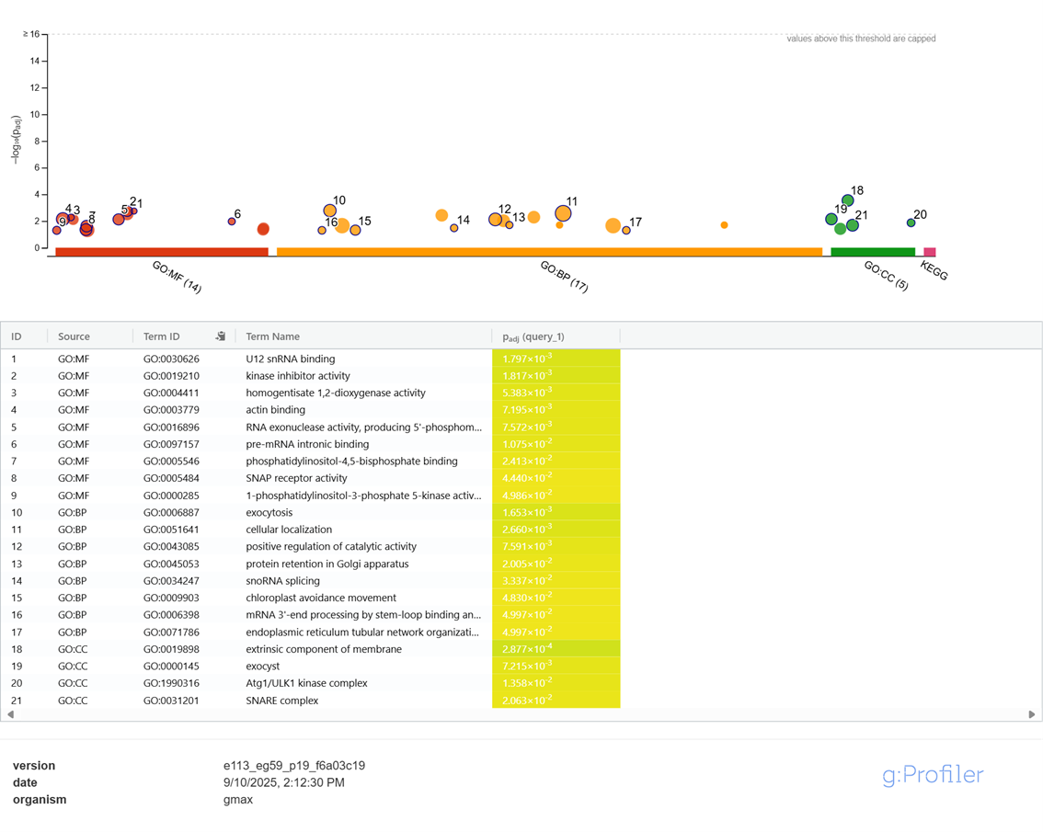
Figure S1 | Functional enrichment analysis of candidate substrates phosphorylated by SymRK identified in the KiC assay.
Results from g:Profiler analysis are shown as a Manhattan-style plot displaying significantly enriched terms across multiple annotation sources, including Gene Ontology Molecular Function (GO:MF), Biological Process (GO:BP), and Cellular Component (GO:CC), as well as KEGG pathways. Each dot represents a single enriched term, with the x-axis grouping terms by source and the y-axis showing the –log10 adjusted p-value. The size of each dot corresponds to the number of overlapping genes in the query set, and colors indicate the significance level.

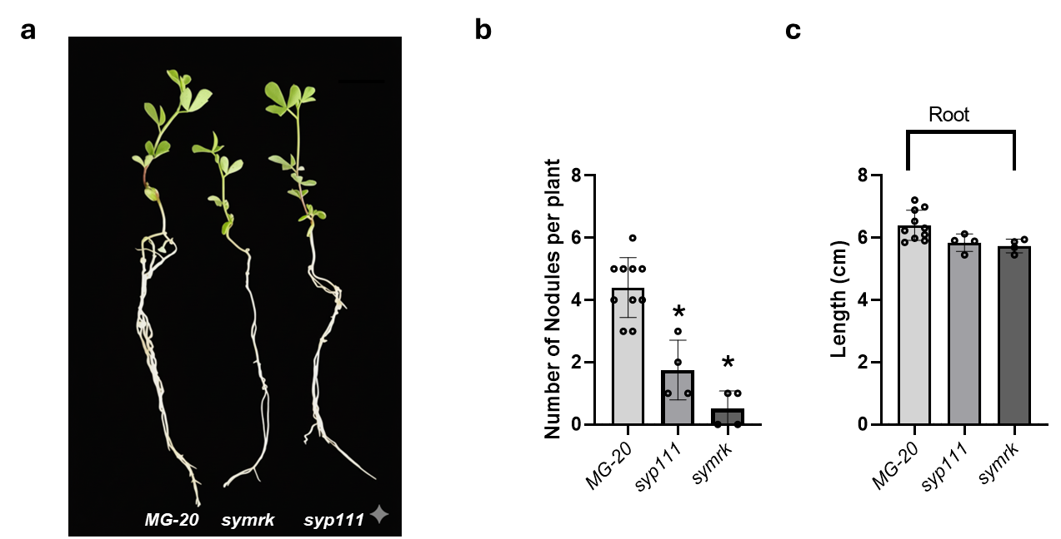
Figure S2 | Defective nodulation and growth phenotype of syp111 mutant.
(a) Representative images of 14-day-old Lotus japonicus wild-type (Gifu), symrk, and syp111 mutant plants inoculated with Mesorhizobium loti MAFF303099. Scale bar, 1 cm. (b) Quantification of nodule numbers per plant. (c) Quantification of shoot and root lengths.
Data are presented as mean ± s.d. (n = 6–8). Statistical significance was determined by unpaired two-tailed t-test; P < 0.05 was considered significant.

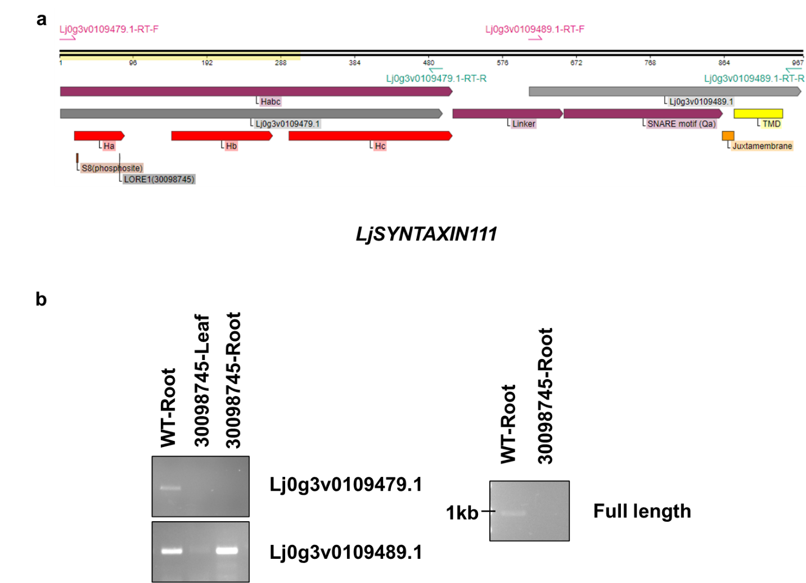
Figure S3 | Characterization of LjSYP111 transcript structure and validation of LORE1 insertion mutant.
(a) Diagram of the LjSYP111 gene models Lj0g3v0109479.1 and Lj0g3v0109489.1. Predicted functional domains, and the site of the LORE1 insertion within Lj0g3v0109479.1 are shown. (b) RT-PCR analysis of LjSYP111 transcripts in wild-type and LORE1(30098745) mutant plants. The amplification regions targeted in each assay are indicated, illustrating the segments of the transcript evaluated for structural integrity.

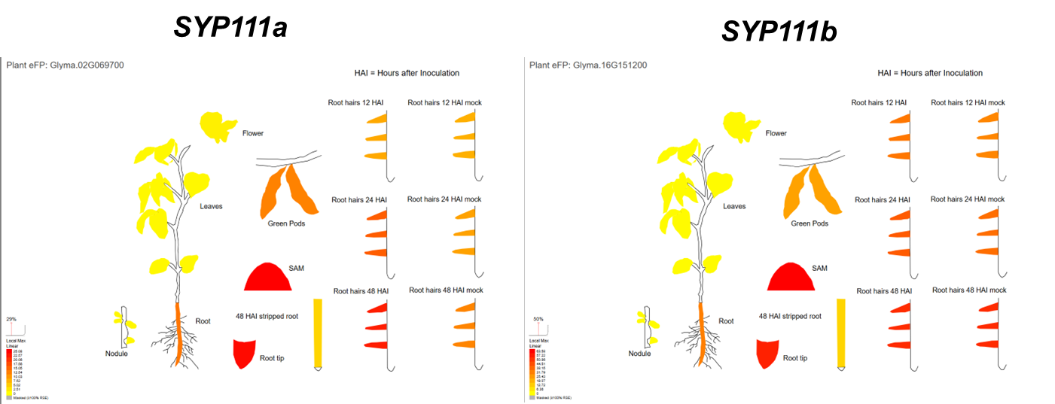
Figure S4 | Expression profiles of SYP111a (Glyma.02G069700) and SYP111b (Glyma.16G151200) in soybean tissues and root hairs following inoculation with Bradyrhizobium diazoefficiens and mock treatment.
Plant eFP Browser–generated illustration of transcript abundance for SYP111a (left) and SYP111b (right) across soybean organs—flower, leaves, green pods, root, shoot apical meristem (SAM), root tip, and nodules—as well as in root hairs at 12, 24, and 48 hours after inoculation (HAI) with B. diazoefficiens and corresponding mock treatments. Color intensity depicts normalized expression relative to the local maximum within each gene’s dataset.

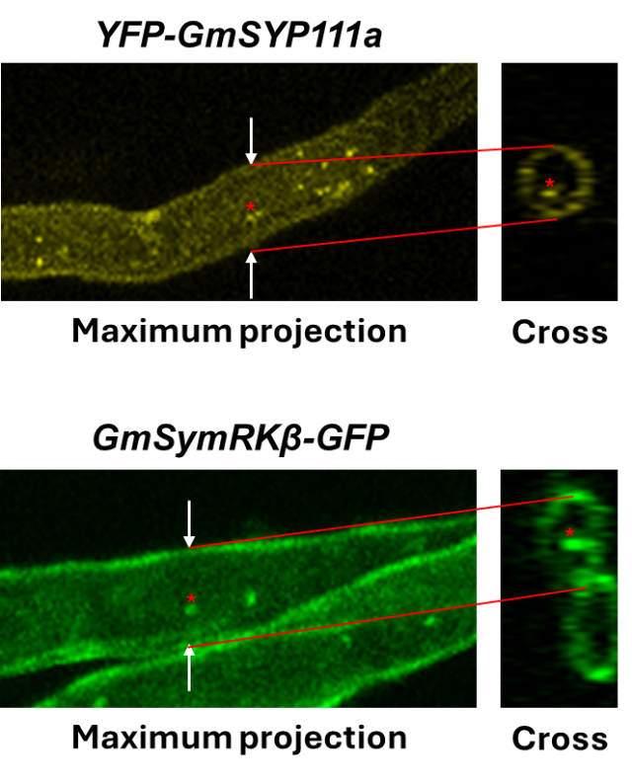
Figure S5 | Cross-sectional imaging of internalized YFP–GmSYP111a and GmSymRKβ–GFP in soybean root hairs.
Confocal images of root hairs expressing YFP–GmSYP111a (top) and GmSymRKβ–GFP (bottom). White arrows indicate the positions used for cross-sectional analysis, and the corresponding orthogonal views are displayed on the right. Red asterisks mark intracellular puncta localized inside the plasma membrane, representing internalized vesicles.

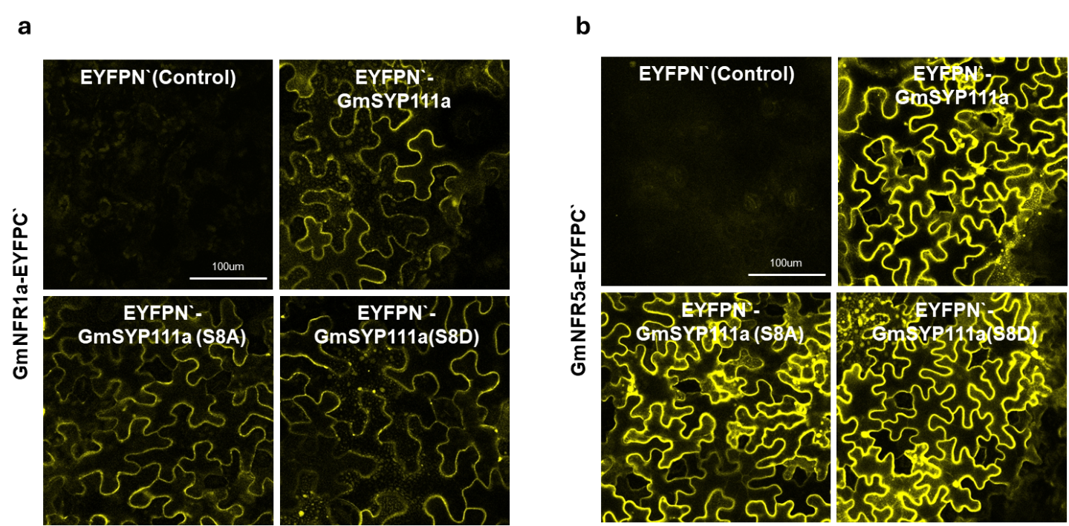

Figure S6. Bimolecular fluorescence complementation (BiFC) between GmSYP111a variants and Nod-factor receptors in Nicotiana benthamiana epidermal cells.
(a) BiFC analysis of EYFPN′–GmSYP111a (wild type, S8A, or S8D) co-expressed with GmNFR1a–EYFPC′. EYFPN′ alone was used as a negative control. Fluorescence at the plasma membrane reflects reconstitution of YFP upon interaction with GmNFR1a. Scale bars: 100 μm. (b) BiFC analysis of EYFPN′–GmSYP111a (wild type, S8A, or S8D) co-expressed with GmNFR5a–EYFPC′ under the same imaging conditions. EYFPN′ alone served as a negative control. Scale bars: 100 μm.

