Supporting documents for
“Probing the lubrication of shear-induced self-assembled layer on amorphous carbon films in methane atmosphere”
Fig. S1 displays the optical photographs for wear track of a-C film under a load of 3 N. It illustrates that the film begins to wear off.
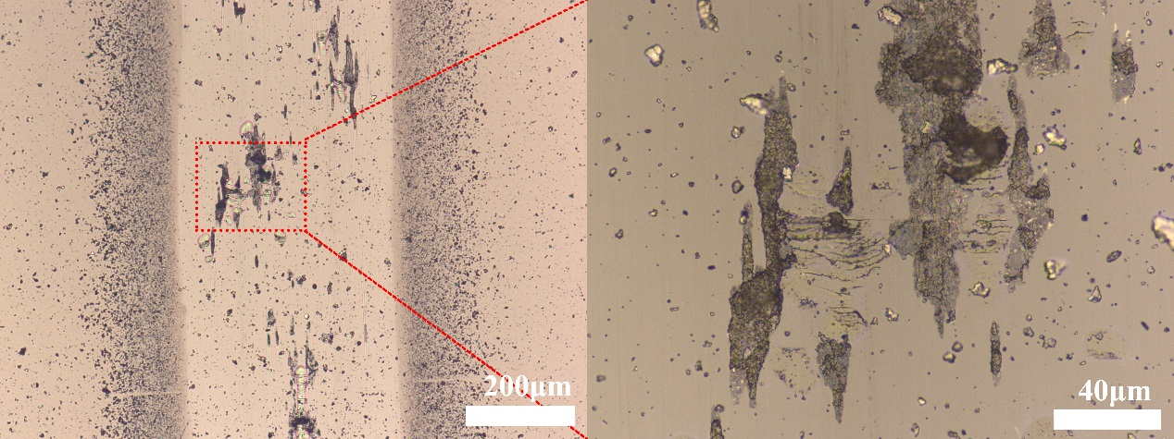
Fig. S1 Optical photographs for worn surfaces of film with a load of 3 N under methane.
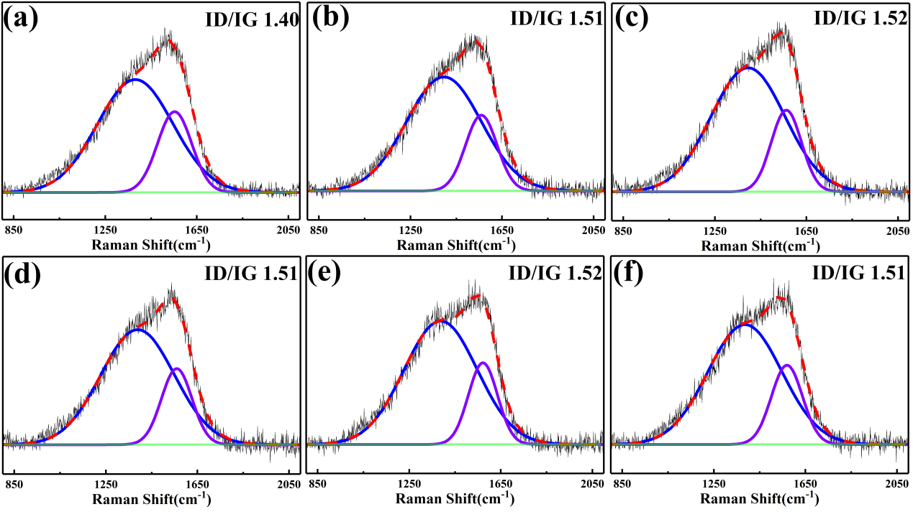
Fig. S2 Raman spectra of pristine a-C film and the wear tracks as well as the corresponding ID/IG. Select regions of local enlarged images are marked in Fig. 3: (a) pristine film, (b) - ①, (c) - ②, (d) - ③, (e) - ④, (f) - ⑤.
Fig. S3 gives the other configurations of diamond (1 1 1) / diamond (111) under methane. The energy of configuration given in main article is -41065.37 eV. Therefore, the configuration given in main article possesses the lowest energy.
Fig. S3 The microstructures of various configurations for diamond (1 1 1) / diamond (111) under methane and the corresponding energy.

