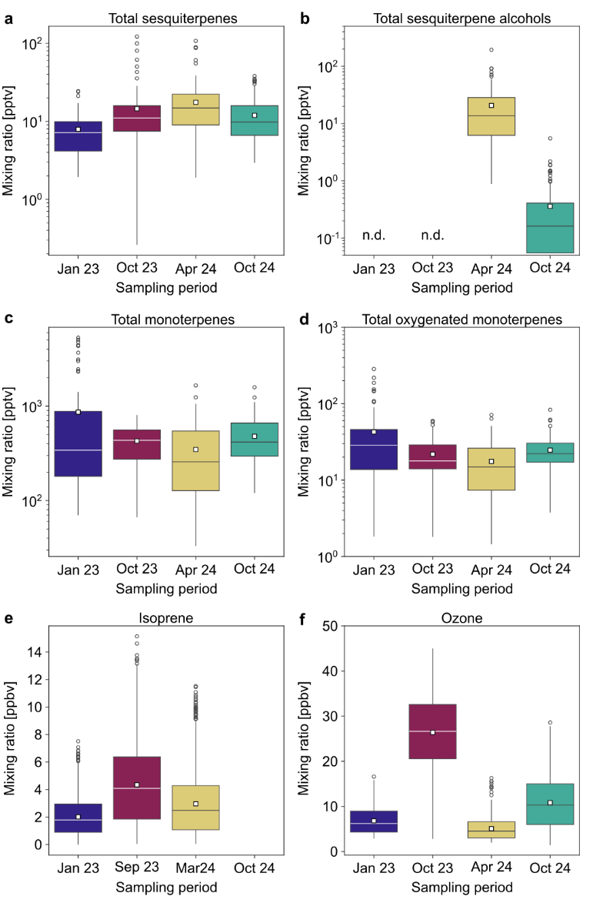
Supplementary Fig. 1 | Changes in the isoprenoid and ozone mixing ratios throughout the development of the El Niño–Southern Oscillation during 2023-24. a. Total sesquiterpenes. b. Total sesquiterpene alcohols. c. Total monoterpenes. d. Total oxygenated monoterpenes. e. Isoprene from 80 m on the nearby 320 m tall tower. f. Ozone. The box plots give the median and 25th and 75th percentiles, the squares show the mean, the whiskers show the maximum and minimum acquired data points that are not considered outliers, and the circles represent outliers. n.d. stands for not detected. For isoprene, data is given for the whole of January and September 2023, and March 2024 from 80 m on the 320 m tall tower as data was not available from the 23 m on the 80 m walk-up tower during the same periods as the other isoprenoids.

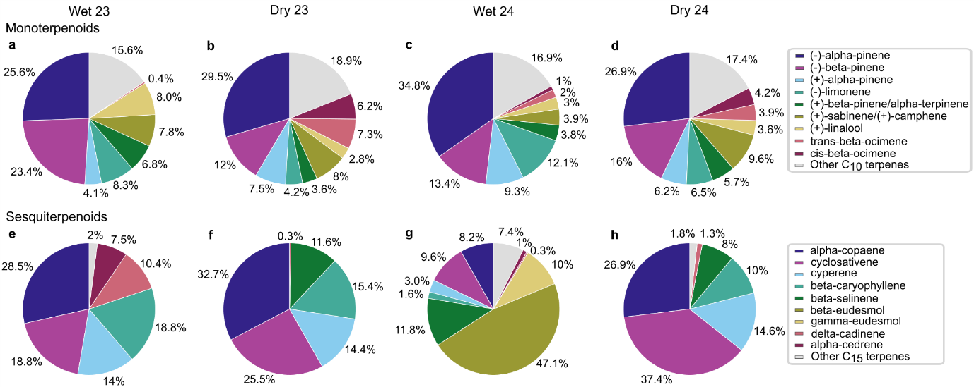
Supplementary Fig. 2 | Pie charts showing relative speciation based on median mixing ratios during each sampling period for Monoterpenoids. a. Wet 23. b. Dry 23. c. Wet 24. d. Dry 24. and Sesquiterpenoids. e. Wet 23. f. Dry 23. g. Wet 24. h. Dry 24.

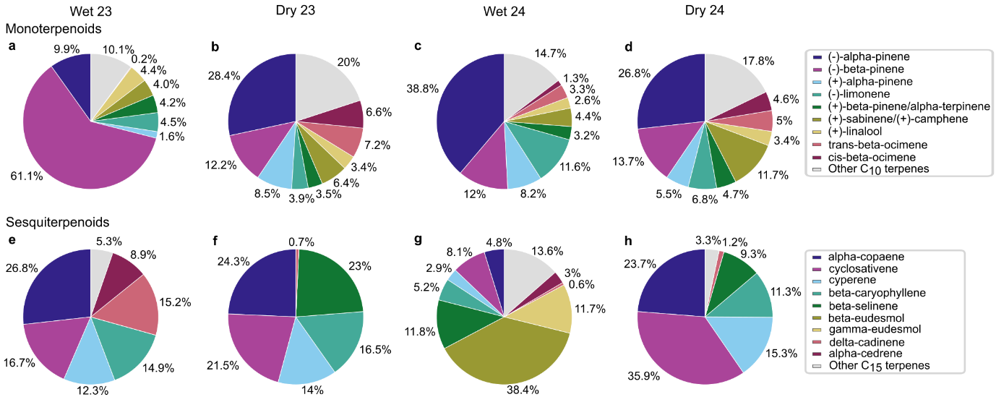
Supplementary Fig. 3 | Pie charts showing relative speciation based on mean mixing ratios during each sampling period for Monoterpenoids. a. Wet 23. b. Dry 23. c. Wet 24. d. Dry 24. and Sesquiterpenoids. e. Wet 23. f. Dry 23. g. Wet 24. h. Dry 24.

