Indigenous Coffee Leaf Brew and Engere Brewing Practices, and Consumption Patterns in South Ethiopia

Supplementary materials
Supplementary-I. Data collection tool
Part 1. Socio-demographic characteristics of the study population who produce coffee leaf brew and Engere in the south Ethiopia region
- Participants' gender: a. Male b. Female
- Participants age range: a. <30 b. 31-45 c. 46-60 d. >60.
- Participants educational background: a. No reading and writing b. Elementary and High School c. Certificate and above
- Marital status of participants: a. Married b. Single c. Widowed
- Participants family size: a. <3 b. 3 – 6 c. >7
- Participants occupations: a. Farmer b. Business c. Employed d. Unemployed
- Monthly income of participants: a. >3000 ETB b. 1000 - 3000 ETB c. <1000 ETB
- Participants religious background: a. Orthodox Christian b. Protestant Christian c. Muslim d. Catholic Christian
- Ethnic background of participants: a. Gamo b. Gofa c. Male d. Wolaita e. Amhara

Part II: Practice of Brewing of Coffee Leaf Brew and Engere in study area
- Coffee leaf brew preparation - Coffee leaf as a major ingredients, and spices, herbs and sweeteners are used as minor ingredients: a. Coffee leaf b. Coffee leaf + Sweeteners c. Coffee leaf + Spices + Sweeteners d. Coffee leaf + Herbs + Sweeteners e. Coffee leaf + Spices + Herbs + Sweeteners
- Engere preparation - Coffee leaf brew and milk as a major ingredients, and spices, herbs, and sweeteners are used as minor ingredients: a. Coffee leaf brew + Milk b. Coffee leaf brew + Milk + Sweeteners c. Coffee leaf brew + Spices + Milk + Sweeteners d. Coffee leaf brew + Herbs + Milk + Sweeteners e. Coffee leaf brew + Spices + Herbs + Milk + Sweeteners f. Coffee leaf brew + honey + Sweeteners g. Coffee leaf brew + butter + Sweeteners
- The fresh or raw coffee leaf biomass was harvested based on maturity: a. Handpicked or manually by hand b. Mechanically methods c. Other
- The maturity level of the coffee leaf: a. Large sized green and yellow colored coffee leaf b. Matured leaf from the bottom part of coffee plant tree c. Matured enough leaf fall down near the coffee tree
- Collection of the coffee leaf: a. Coffee plant around homestead b. Local market c. Other
- Commonly applied pretreatment for the coffee leaf: a. Drying b. Roasting c. Heat (griddle) d. Other
- Cleaning of the coffee leaf: a. Manually brushed by bare hand b. Washed with clean water c. Brushed and washed with clean water
- Size reduction of the coffee leaf in to small pieces: a. Traditional wooden grinder b. A mortar and pestle c. Mechanically chopped d. Other
- Milling of the spices and herbs that used in coffee leaf brew: a. Traditional wooden grinder b. A mortar and pestle c. Mechanically chopped d. Other
- Boiling of the coffee leaf chop: a. Boiling with hot water (85ºC-100ºC) in coffee pot or Jabena (7-15 min) b. Boiling with hot water in metal pot (5-10 min)
- Filtration of the coffee leaf infusion: a. Locally available traditional sieve and materials b. Tea sieve or tea strainer
- Mixing the coffee leaf brew with minor ingredients: a. Herbs b. Spices c. Spices and herbs d. Others
- Mixing the coffee leaf brew with cow milk: a. Fresh cow milk b. Fresh cow milk + Spices c. Fresh cow milk + herbs d. Fresh cow milk + Spices + herbs
- Serving the products: a. Served with sweeteners b. Served without sweeteners
- Brewing practices frequency: a. 1 times per-day b. 2 times per-day c. 3 times per-day d. >3 times per-day
- Brewing experience: a. Short term b. Long term
- Purpose of preparing the coffee leaf brew product: a. Staple and stimulating drink b. Brew and medicine c. Brew, medicine and cultural ceremonies d. Staple brew and marketing
- Purpose of preparing Engere product: a. Consumption at home as staple drink b. Body strength brew and medicine c. Marketing d. Consumption and marketing
- Sensory acceptability of the final products: a. Acceptability of the type 1 brew b. Acceptability of the type 2 brew c. Acceptability of the type 3 brew
- Utilization trends of the final products: a. As staple hot drink or Energy boosting brew b. As stew for the different cultural foods c. As staple brew and traditional medicine
- The volume of the product that can be consumed per-day: a. Known b. Unknown
- The consumption were increases the breast milk production of the lactating mothers: a. Yes b. No
- The consumption was increases body strength and rapid recovery of the lactating mothers: a. Yes b. No
- Do you known the health related problems associated with the consumption of the product: a. Yes b. No
- Types of health related problems associated with consumption of the product: a. Gastritis b. Heart disease c. Others (No problems)
- Do you known the product have a therapeutic value? a. Yes b. No
- Types of diseases that the product treat it: a. Common cold, cough and headache b. Gastritis c. Eye vision, Appetizer and stimulatory effect d. Bleeding after child birth e. Stunting and childhood diseases f. Joint and backbone pain g. Typhoid fever and malaria diseases h. Respiratory diseases, abdominal pain and constipation i. Blood pressure, anemia, heart diseases
- Dose of the product for adult, children, male and female: a. Known b. Unknown

Supplementary material-II. Data collection of various traditional processing of coffee leaf brew and Engere
Various figures illustrating traditional Indigenous brewing practices as well as the preparation and serving of coffee leaf brew and Engere were documented across the research areas.
- Collection and preparation of coffee leaves, followed by blending with fresh cow milk for the production of Engere
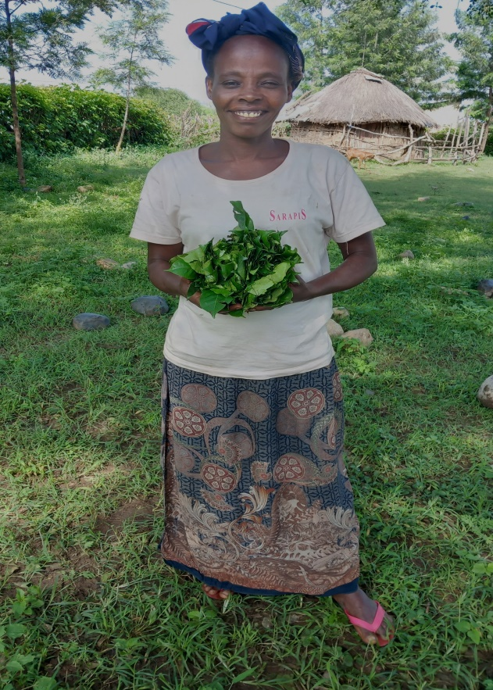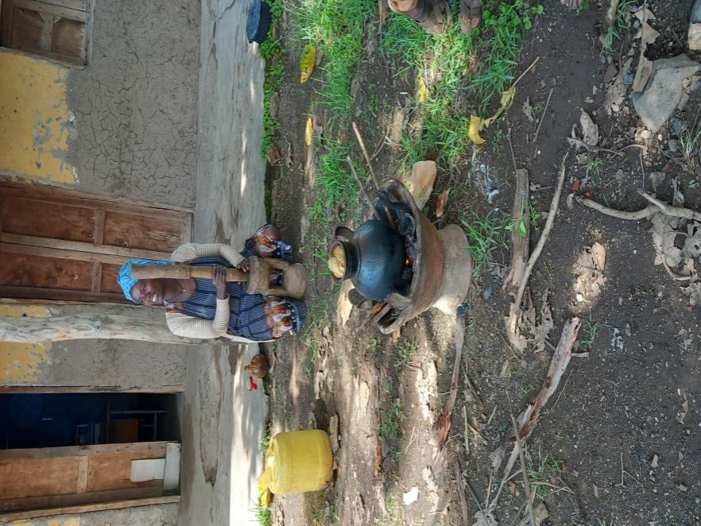
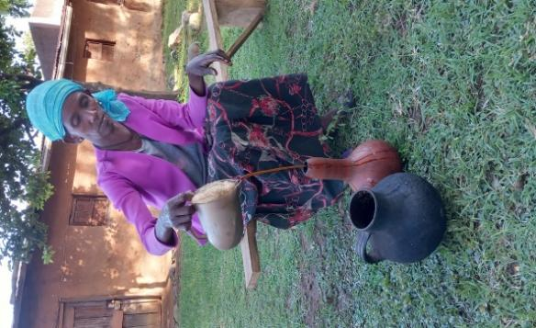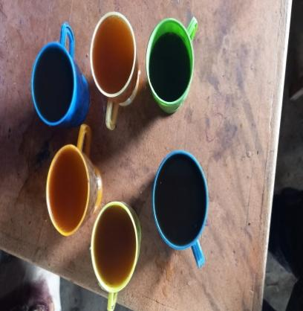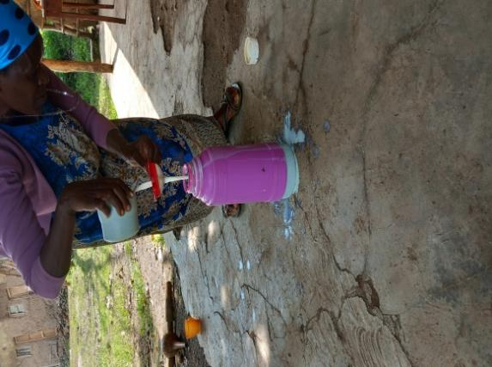

- The final forms of the coffee leaf and Engere products, as well as the ways in which they are traditionally served, were recorded.
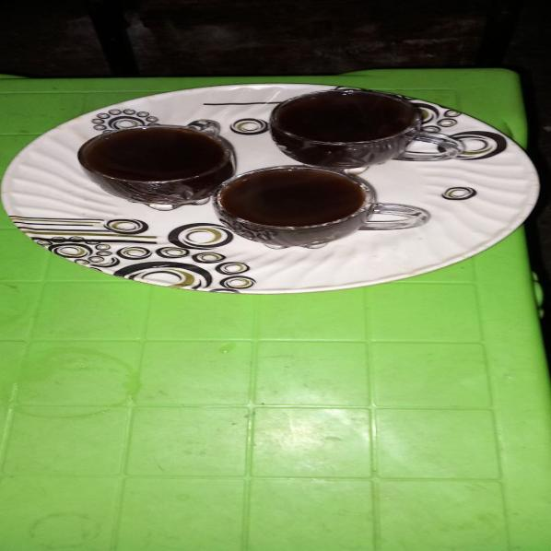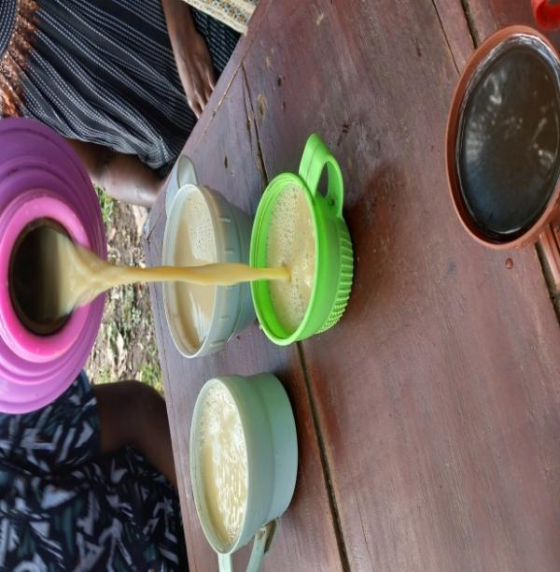
Coffee Leaf Brew Engere

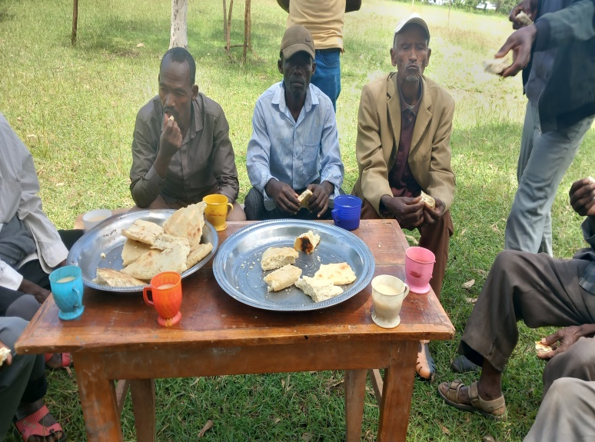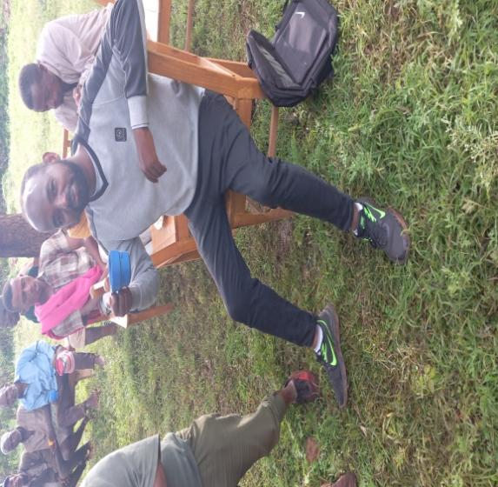
Figure: Coffee Leaf Brew and Engere traditionally served

Supplementary material-III. Group discussions
Several group discussions focused on the preparation, utilization, traditional medicinal value, and broader significance of coffee leaf brew and Engere products.
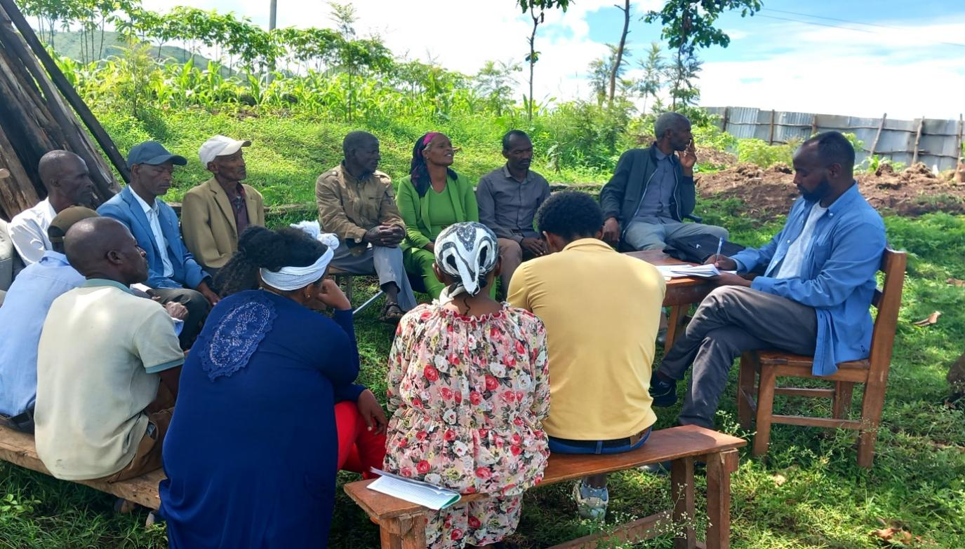

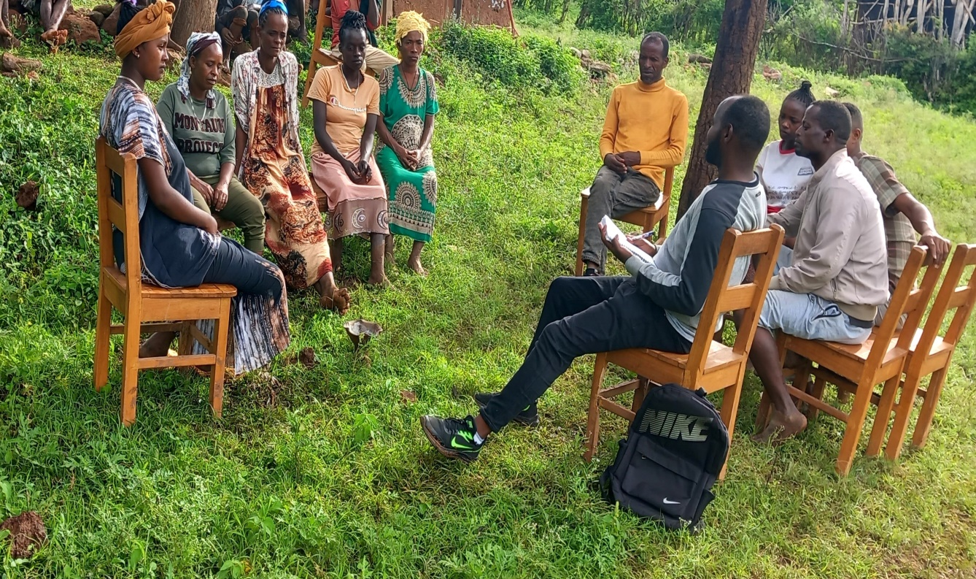

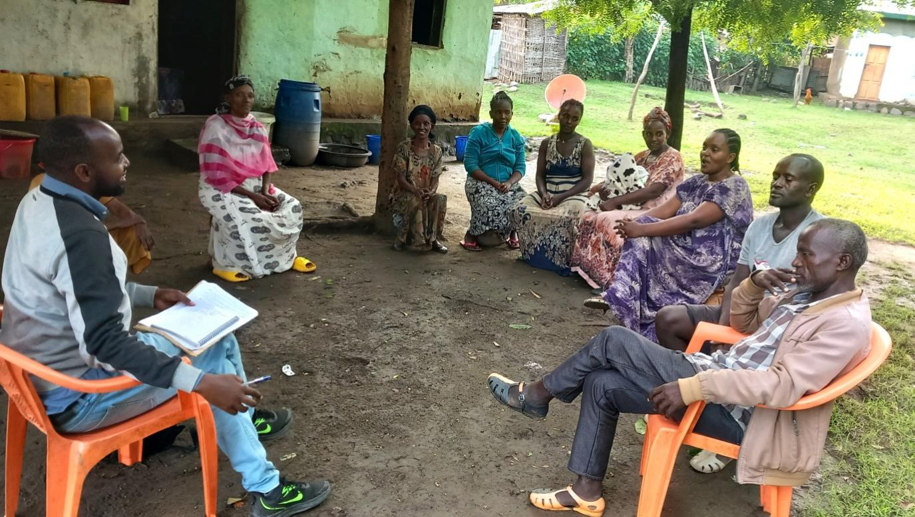

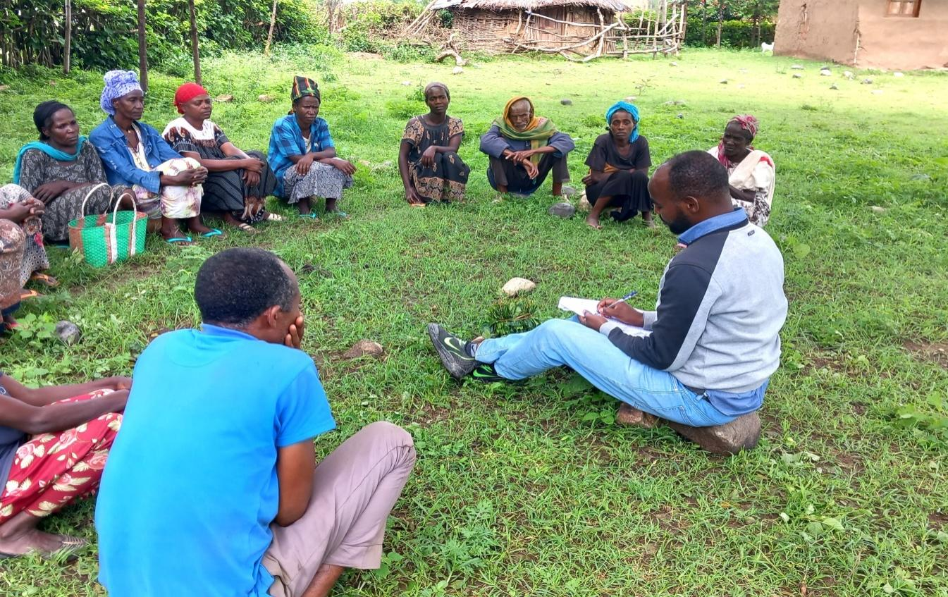
Figure: Group discussions

