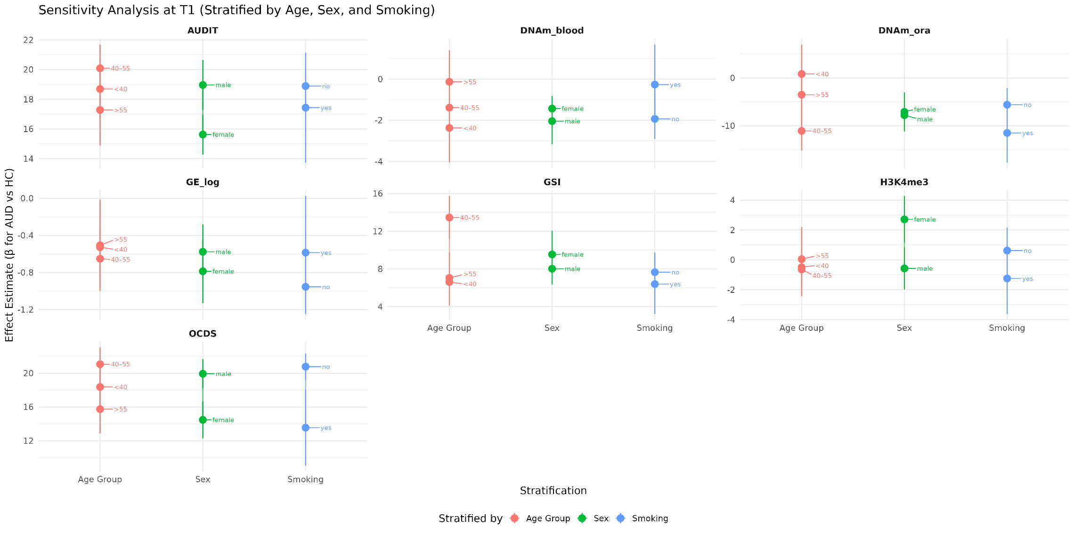
Figure S1. Sensitivity analysis of AUD-associated questionnaire scores and molecular variables at baseline (T1), stratified by age group (<40, 40–55, >55), sex (male, female), and smoking status (yes, no). Points represent β estimates for the AUD versus HC comparison from linear models, with error bars showing ±1 standard error. Lines connect points within each stratification type, and labels indicate the specific stratum level.

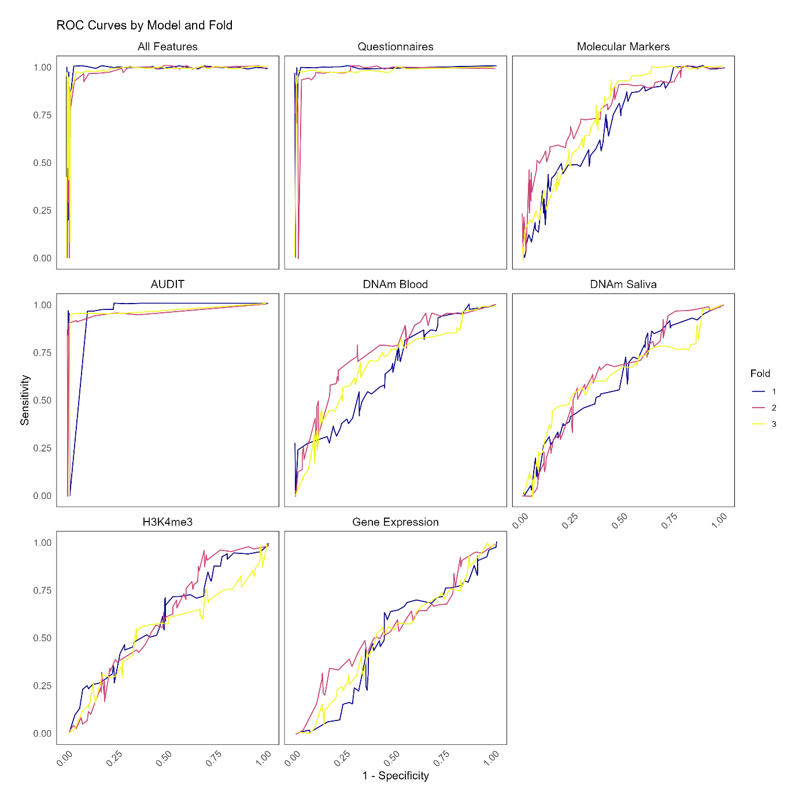
Fig. S2: ROC curves of the different models. Color codes corresponding to outer fold are displayed. Receiver-operating characteristic curve = ROC curve.

