Scalabe Synthesis of the Azaperone Drug by Using Flow Chemistry
Ali Ghobadian, Mohammad Javad Taghizadeh
Department of Chemistry, Faculty of Science, University of Imam Hossein, Tehran, Iran

S1: General schematic of the preparation of Azaperone

Bise (2-chloroethyl) amine
GC–MS: retention time: /338 min; (m/z) (%), 2 (100), 4 (33), 8 (24), 3 (22), 2 (21), 6(14). ¹H NMR (400 MHz, DMSO-d₆) (ppm): .61 (s, H), .83 (t, J = .4 Hz, H), .25 (t, J = .3 Hz, H). ¹³C NMR (100 MHz, DMSO-d₆) (ppm): 8.64, 7.89

4-Chloro-1-(4-fluorophenyl) butan-1-one

FT-IR (KBr): 966, 684, 598 cm⁻¹.GC–MS: retention time: 2/481 min; (m/z) (%), 23 (100), 38 (36), 5 (33), 5 (10), 24 (8), 64(7), 33(5). 1H NMR (400 MHz, Chloroform-d) (ppm): .97-8.01(m, H), .10 (t, J = .5 Hz, H), .55 (t, J = .1 Hz, H), .33 (t, J = .9 Hz, H), .27-2.37 (m,1H).
¹³C NMR (100 MHz, Chloroform-d) (ppm): 97.3, 30.9 (d, J = .3 Hz), 17.3 (d, J =21.9 Hz), 2.7, 3.7, 4, .72.

1-(pyridin-2-yl) piperazine
FT-IR (KBr): 282, 005, 843, 595, 484, 436 cm⁻¹.GC–MS: retention time: 3/301 min; (m/z) (%), 21 (100), 5 (85), 07 (81), 63 (46), 9 (37), 8(35), 33(23), 08(20), 19(14), 0(13).¹H NMR (400 MHz, Chloroform-d) (ppm): .96 (d, J = .6 Hz, H), .33 (t, J = .8 Hz, H), .08-7.13 (m, H), .54-3.56 (m, H), .94-2.98 (m, H), .77 (s, H). ¹³C NMR (100 MHz, Chloroform-d) (ppm): 60.58, 47.64, 32.59, 14.56, 03.75, 5.93, 5.6.

1-(4-fluorophenyl)-4-(4-(pyridin-2-yl) piperazin-1-yl) butan-1-one
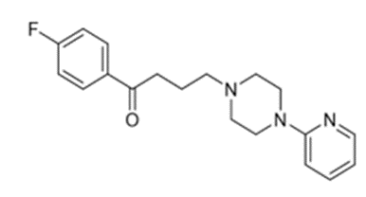
FT-IR (KBr): 950, 806, 680, 591, 478, 435, 158, 006 cm⁻¹. ¹H NMR (400MHz, CDCl3): δ .04 (2H, m, CH2, Hd), .50 (2H, t, CH2, Hc), .55 (4H, s, CH2, Hf), .05 (2H, t, CH2, He), .50 (4H, s, CH2, Hg), .65 (2H, d, CH, Hk and Hi) .16 (2H, t, CH, Ha), .48 (1H, t, CH, Hj), .03 (2H, d, CH, Hb), .22 (1H, s, CH, Hh) ppm. ¹³C NMR (100MHz, CDCl₃): δ 2.0, 6.7, 5.7, 4.0, 7.8, 07.4, 13.3, 14.9, 15.1, 30.4, 30.7, 33.5, 36.8 46.7(C=N), 59.7, 64.4, 66.4, 98.3(C=O) ppm.

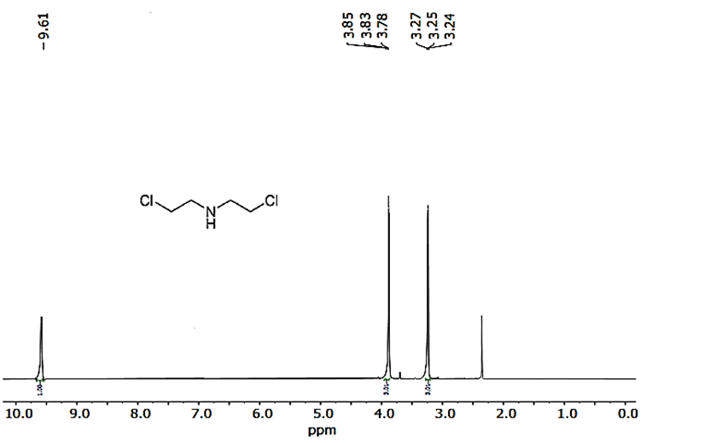
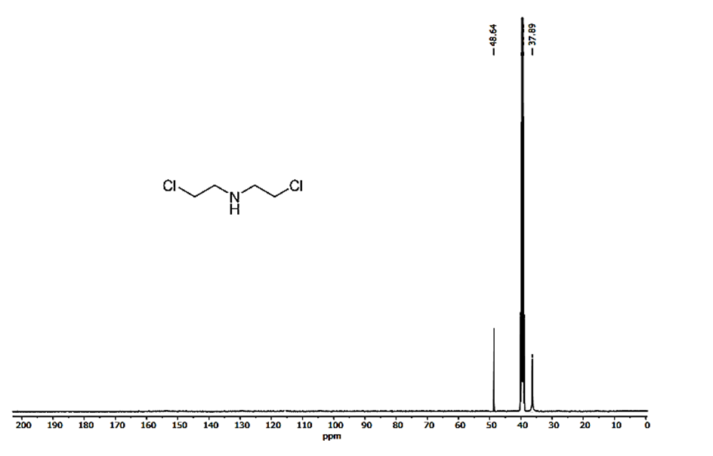
S2: ¹H NMR and ¹³C NMR spectra of bis(2-chloroethyl) amine
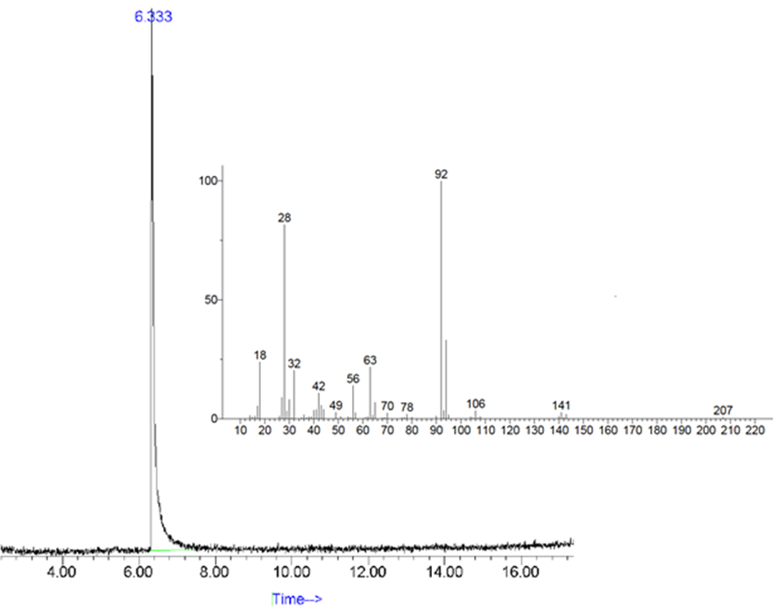
S3: GC-MS chromatogram of bis(2-chloroethyl) amine

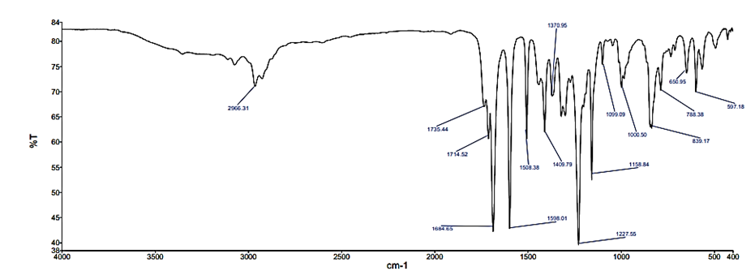
S4: FT-IR spectrum of the compound -chloro-1-(4-fluorophenyl) butan-1-one.

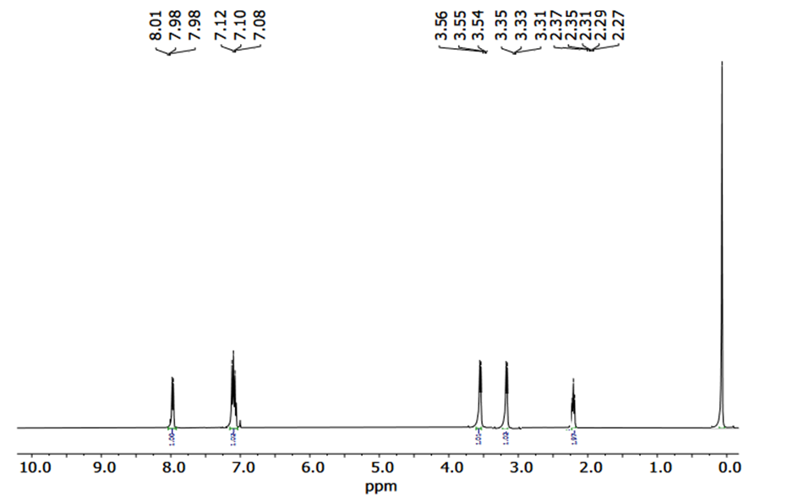
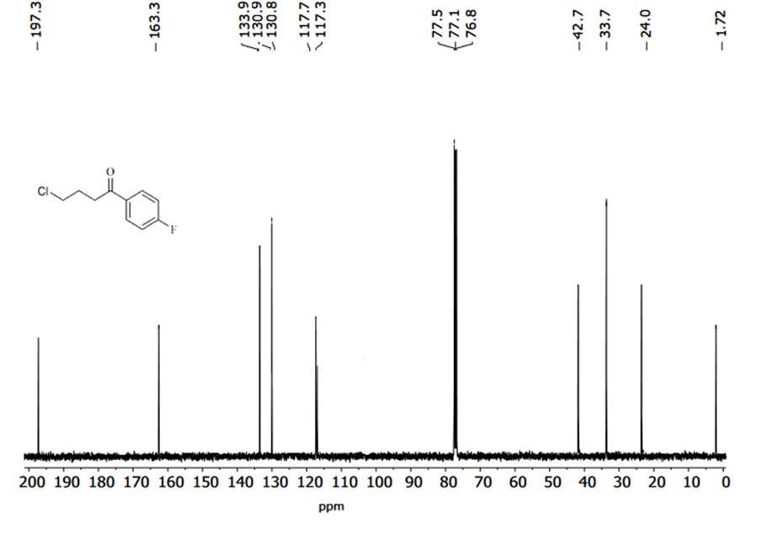
S5: ¹H NMR and ¹³C NMR spectra of the compound 4-chloro-1-(4-fluorophenyl) butan-1-one.
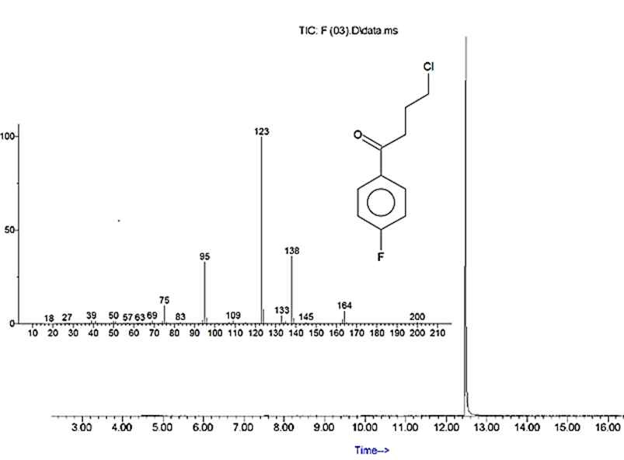
S6: GC-MS chromatogram of -chloro-1-(4-fluorophenyl) butan-1-one.
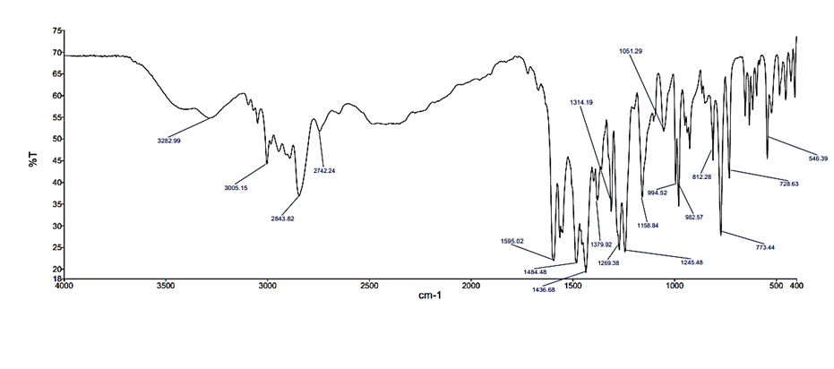
S7: FT-IR spectrum of -(pyridin-2-yl) piperazine compound

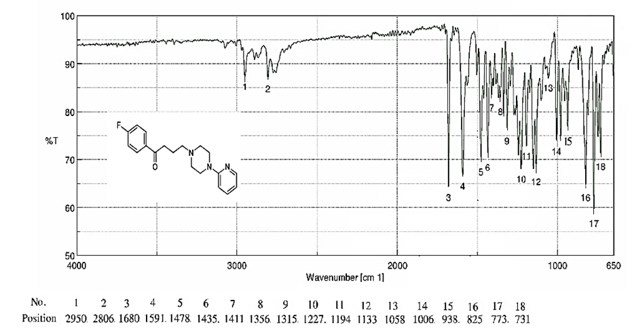
S8: FT-IR spectrum of Azaperone compound.

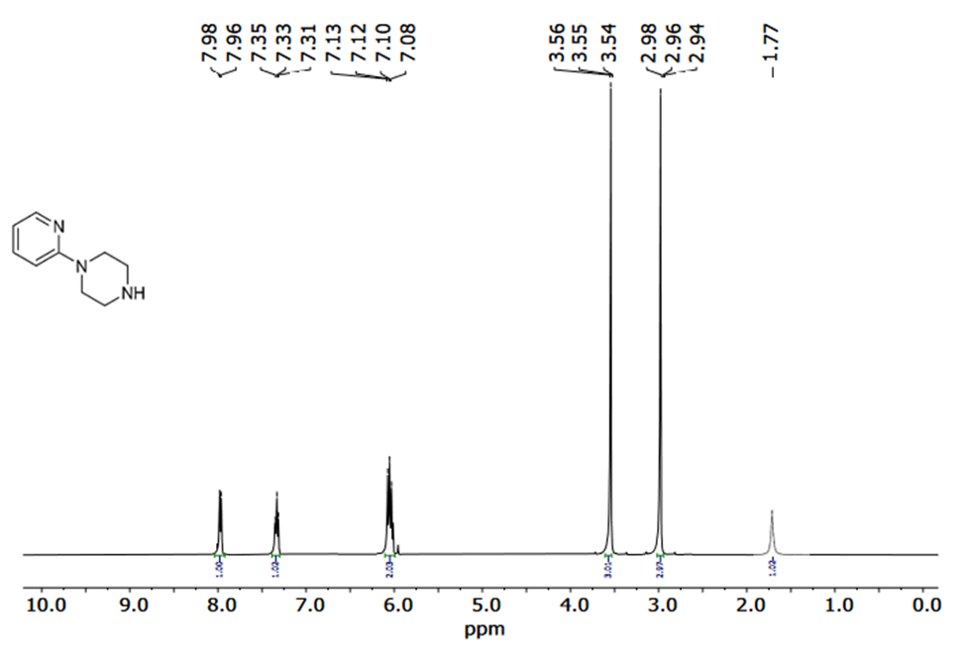
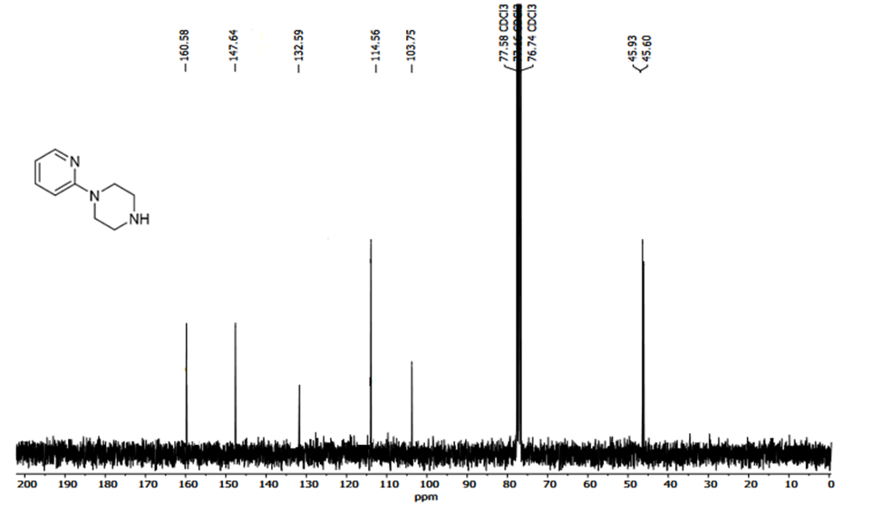
S9. ¹H NMR and 3C NMR spectra of the compound -(pyridin-2-yl) piperazine.
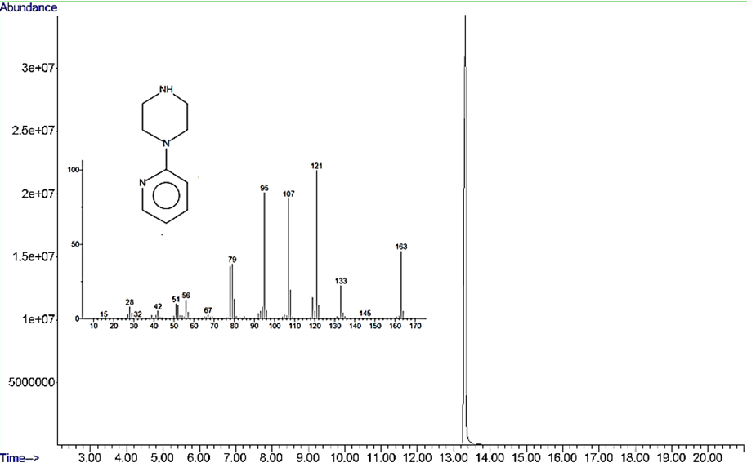
S10: GC-MS chromatogram of -(pyridin-2-yl) piperazine compound.

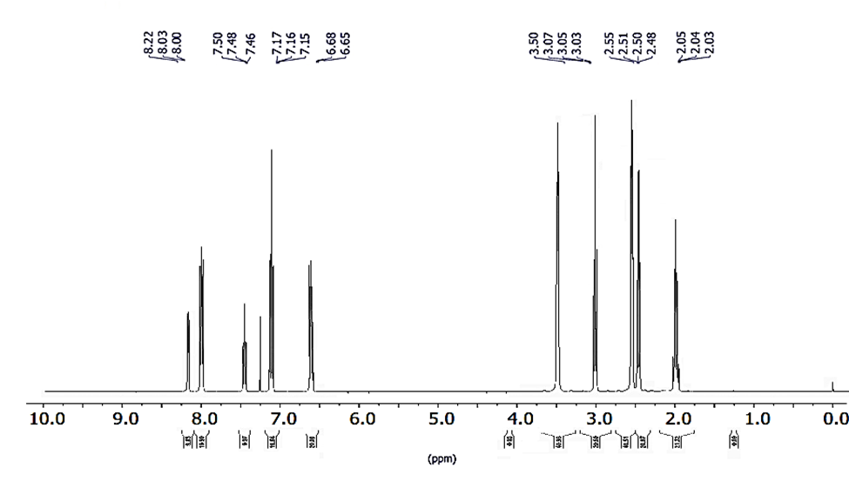

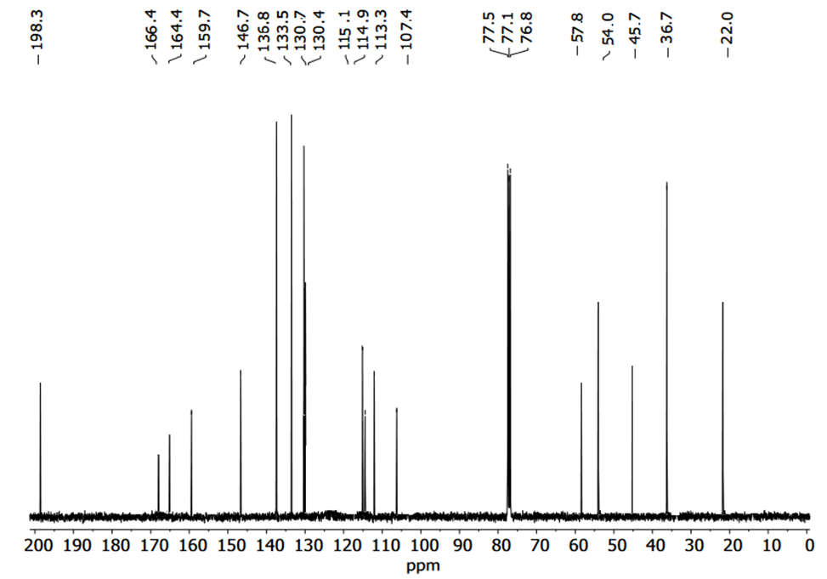
S11: ¹H NMR and ¹³C NMR spectra of Azaproone
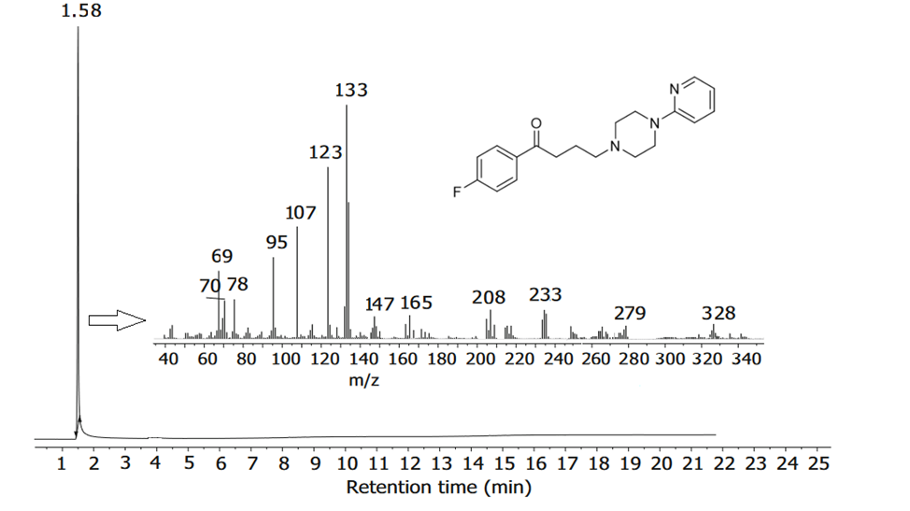
S12: GC-MS chromatogram of Azaperone compound

