Supplementary material

Online monitoring of the hygromechanical properties of spruce tracheid cell walls at the nanoscale

Raphaël Coste¹ · Véronique Aguié–Béghin¹ · Hugues Clivot¹ · Dominique Derome³ · Michaël Molinari² · Brigitte Chabbert¹*

¹ Université de Reims Champagne Ardenne, INRAE, FARE, UMR A 614, Reims, France
² CBMN UMR CNRS 5248, University of Bordeaux, IPB, Pessac, France
³ Department of Civil and Building Engineering, Université de Sherbrooke, Sherbrooke, J1K 2R1, Québec, Canada

*e-mail: brigitte.chabbert@inrae.fr

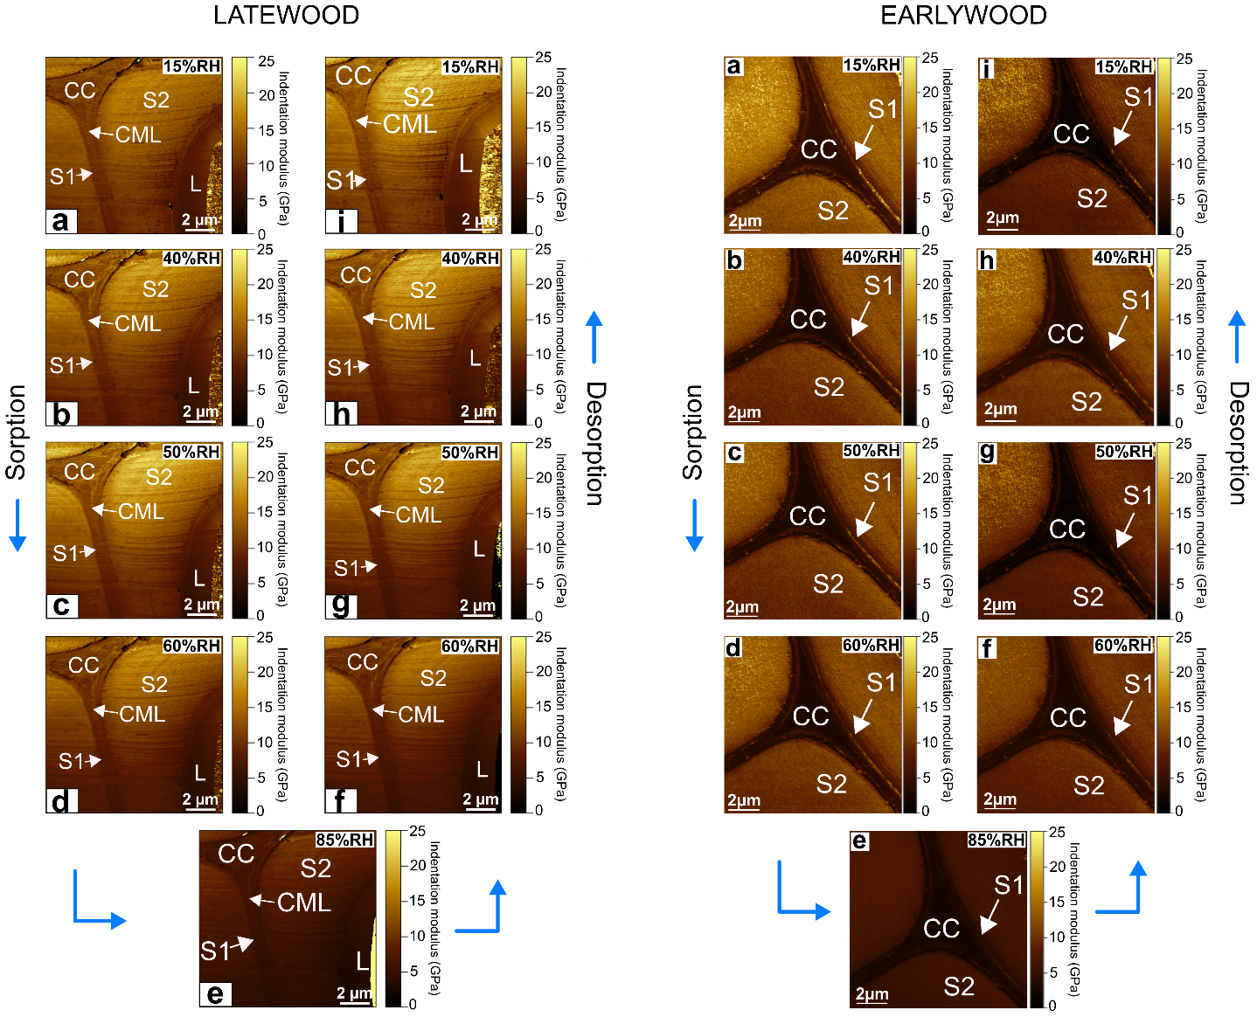

Supplementary figure 1 : AFM indentation moduli maps of latewood and earlywood obtained at each of the RH during cycle 3 (sorption and desorption)

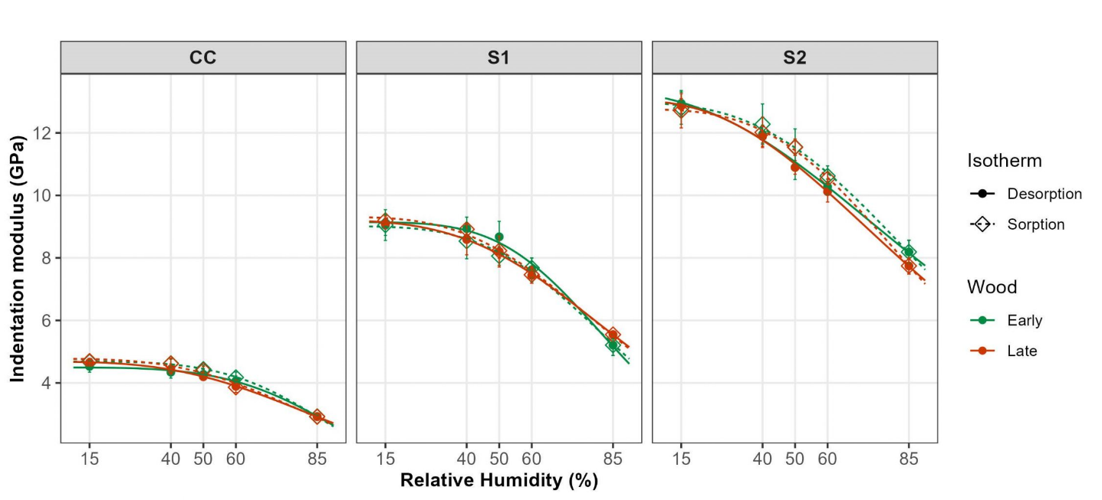

Supplementary figure 2: Fitting of the responses of the indentation moduli to relative humidity according to a three parameter logistic function

