Table S1 Combined ANOVA for all traits evaluated across different ABA concentrations and time
SOV | DF | RWC | MSI | PRO | Fv/Fm | SMC
Time | 2 | 10670.4** | 569.20** | 127.30** | 0.39** | 907.81**
Treatment | 3 | 7740.5** | 1733.83** | 59.06** | 0.1** | 388.88**
Variety | 3 | 903.5** | 513.44** | 0.86** | 0.01* | 11.29
Time*Treatment | 6 | 3376.4** | 1070.26** | 43.44** | 0.08** | 99.17**
Time*Variety | 6 | 151.1** | 306.66** | 2.97** | 0.01** | 9.44
Treatment*Variety | 9 | 75.7** | 143.90** | 2.26** | 0.01** | 5.64
Time*Treatment*Variety | 18 | 43.90 | 106.14** | 2.57** | 0.004** | 3.40
Error | 96 | 27.80 | 46.61 | 0.001 | 0.001 | 10.30
GM |  | 63.51 | 17.64 | 1.16 | 0.62 | 20.49
CV |  | 8.29 | 38.71 | 4.63 | 6.78 | 15.67
SEm (Time) |  | 0.76 | 0.99 | 0.01 | 0.01 | 0.46
SEm (Treatment) |  | 0.88 | 1.14 | 0.01 | 0.01 | 0.54
SEm (Variety) |  | 0.88 | 1.14 | 0.01 | 0.01 | 0.54
SEm (Time*Treatment) |  | 1.52 | 1.97 | 0.02 | 0.01 | 0.93
SEm (Time*Variety) |  | 1.52 | 1.97 | 0.02 | 0.01 | 0.93
SEm (Treatment*Variety) |  | 1.76 | 2.28 | 0.02 | 0.01 | 1.07
SEm (Time*Treatment*Variety) |  | 3.04 | 3.94 | 0.03 | 0.02 | 1.85
*, ** = significant at the 5% and 1% level of significance respectively, (Where df= degrees of freedom, RWC= relative water content (%), MSI = membrane stability index (%), PRO = proline (µg/g FW). Fv/Fm = ratio of variable and maximum fluorescence/maximum quantum efficiency, SMC = Soil moisture content, GM= grand mean, CV= coefficient of variation)

Table S2 Interaction mean of morpho-physiological effects under WS and ABA treatments.
Treatments | Variety | LA | SLA | PH | RWC | MSI | PRO | SPAD | g_{s} | IL | PL | SMC
A100NW | Asha | 29.82 | 10.11 | 0.23 | 76.37 | 12.08 | 0.22 | 35.33 | 38.22 | 0.93 | 2.56 | 25.32
A100W | Asha | 28.92 | 16.13 | 0.29 | 71.85 | 28.68 | 0.27 | 37.34 | 38.11 | 0.89 | 2.22 | 24.68
CON | Asha | 30.42 | 16.03 | 0.26 | 73.24 | 12.80 | 0.18 | 35.03 | 37.70 | 0.86 | 2.22 | 24.10
WS | Asha | 28.65 | 11.02 | 0.19 | 71.78 | 21.75 | 0.23 | 31.67 | 37.67 | 0.85 | 2.17 | 24.05
A100NW | Bahar | 30.32 | 12.00 | 0.18 | 69.10 | 14.03 | 0.12 | 35.47 | 37.33 | 0.81 | 2.17 | 23.71
A100W | Bahar | 31.17 | 16.61 | 0.22 | 77.78 | 15.70 | 0.11 | 37.33 | 34.67 | 0.73 | 2.13 | 23.60
CON | Bahar | 29.97 | 23.51 | 0.26 | 76.80 | 11.82 | 0.15 | 40.23 | 34.11 | 0.72 | 2.13 | 23.12
WS | Bahar | 29.28 | 17.70 | 0.44 | 75.86 | 12.51 | 0.13 | 32.03 | 31.56 | 0.69 | 2.09 | 23.10
A100NW | PAU881 | 30.47 | 7.72 | 0.20 | 76.17 | 8.89 | 0.21 | 36.78 | 26.67 | 0.69 | 2.08 | 21.65
A100W | PAU881 | 30.12 | 14.69 | 0.23 | 75.82 | 12.85 | 0.21 | 39.24 | 26.44 | 0.68 | 2.03 | 21.20
CON | PAU881 | 30.50 | 17.83 | 0.26 | 77.81 | 9.97 | 0.33 | 38.09 | 26.44 | 0.65 | 2.02 | 19.76
WS | PAU881 | 30.85 | 14.38 | 0.31 | 73.39 | 12.14 | 0.30 | 34.30 | 25.50 | 0.65 | 1.79 | 19.71
A100NW | PRG158 | 30.23 | 6.58 | 0.25 | 81.99 | 8.05 | 0.24 | 34.40 | 24.89 | 0.62 | 1.63 | 16.90
A100W | PRG158 | 30.67 | 13.78 | 0.23 | 73.32 | 13.86 | 1.32 | 36.06 | 24.11 | 0.62 | 1.60 | 15.50
CON | PRG158 | 30.92 | 21.93 | 0.45 | 82.65 | 9.98 | 0.30 | 37.29 | 23.22 | 0.60 | 1.58 | 14.87
WS | PRG158 | 31.00 | 8.35 | 0.23 | 67.60 | 32.09 | 0.32 | 32.61 | 23.11 | 0.54 | 1.25 | 14.50
GM |  | 30.21 | 14.27 | 0.26 | 75.10 | 14.82 | 0.29 | 35.83 | 30.61 | 0.72 | 1.98 | 20.99
CV |  | 2.78 | 35.22 | 52.67 | 6.90 | 33.92 | 31.95 | 5.62 | 9.19 | 8.66 | 29.65 | 0.41
LSD |  | 1.40 | 8.36 | 0.23 | 8.61 | 8.36 | 0.15 | 3.35 | 4.68 | 0.10 | 0.98 | 0.14
(Where, A100NW = ABA without water, A100W = ABA and water, CON = Control, WS = Water stress, SLA = specific leaf area, LA = leaf area, RWC= relative water content (%), MSI = membrane stability index (%), PRO = proline (µg/g FW), SPAD=chlorophyll meter reading (SCMR), PH=plant height (cm), g_{s} = stomatal conductance (cm/s), IL = internode length (cm), PL = petiole length (cm), and SMC = soil moisture content, GM= grand mean, CV= coefficient of variation, LSD = Least significant difference)
Table S3 Interaction mean of root parameters under WS and ABA treatments
Treatment | Variety | RL | RSA | AvDia | L/Vol | RV | Nodules | Tips | Forks | Crossings
A100NW | Bahar | 376.28 | 84.88 | 0.73 | 417971.30 | 1.58 | 18.33 | 289.00 | 1223.00 | 135.67
A100W | Bahar | 303.73 | 84.48 | 0.96 | 325366.20 | 2.25 | 8.67 | 289.67 | 1017.67 | 130.00
CON | Bahar | 311.33 | 132.30 | 1.16 | 346850.00 | 3.71 | 14.33 | 338.33 | 1279.67 | 147.00
WS | Bahar | 391.03 | 100.35 | 0.87 | 423763.00 | 2.18 | 13.00 | 288.67 | 1297.67 | 146.00
A100NW | PRG158 | 306.87 | 79.05 | 0.78 | 342136.20 | 1.66 | 17.33 | 312.33 | 1134.00 | 115.00
A100W | PRG158 | 573.68 | 155.22 | 0.82 | 638783.80 | 3.08 | 20.33 | 355.33 | 1603.00 | 187.67
CON | PRG158 | 566.86 | 132.09 | 0.76 | 640890.70 | 2.54 | 19.33 | 386.33 | 596.00 | 801.33
WS | PRG158 | 406.54 | 111.88 | 0.81 | 455704.90 | 2.29 | 14.00 | 309.00 | 1147.67 | 117.00
GM |  | 404.54 | 110.03 | 0.86 | 448933.30 | 2.41 | 15.67 | 321.08 | 1162.33 | 222.46
CV |  | 10.84 | 10.13 | 13.29 | 10.94 | 11.89 | 20.44 | 44.36 | 33.66 | 133.72
LSD |  | 75.92 | 19.29 | 0.20 | 84996.78 | 0.50 | 5.54 | 246.53 | 677.14 | 514.90
(Where, A100NW = ABA without water, A100W = ABA and water, CON = Control, WS = Water stress, RL = root length, RSA = root surface area, AvDia = average diameter, L/Vol = root length/volume ratio, RV = root volume, number of nodules, number of root tips, forks, and crossings, GM= grand mean, CV= coefficient of variation, LSD = Least significant difference)

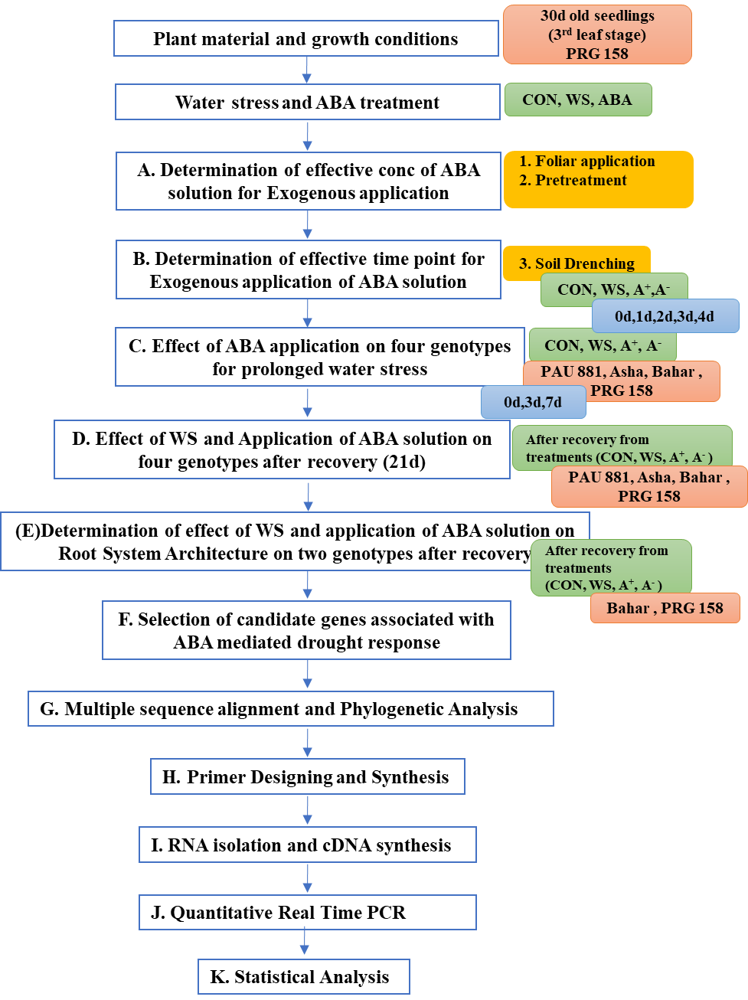
Fig. S1 Schematic representation of an experimental design that outlines the key steps involved during the present study.

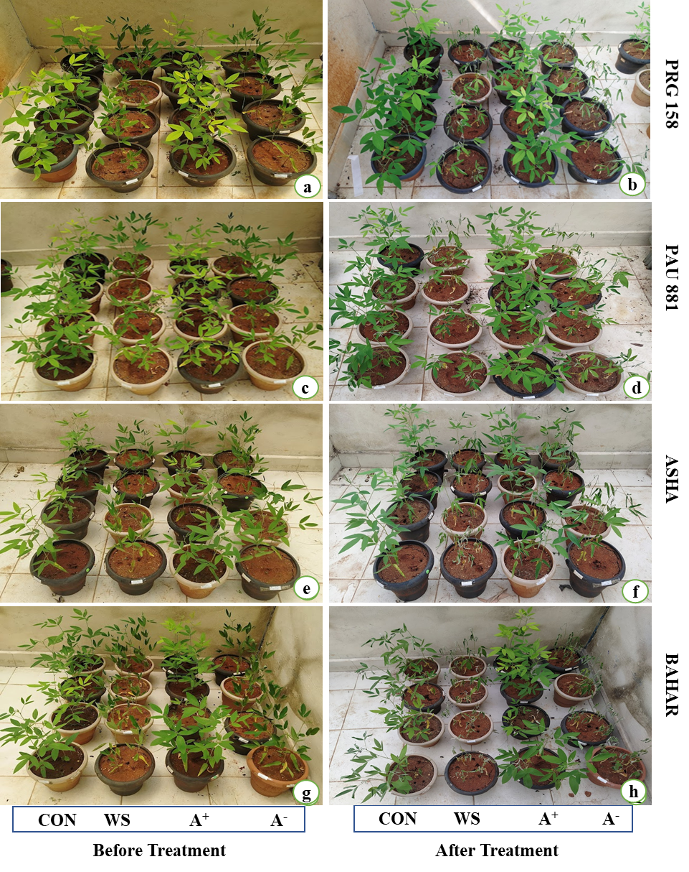
Fig. S2 Effect of WS and soil drench of ABA solution (100μm) at different time points (0d, 3d, 7d) on physiological and biochemical responses of four genotypes.

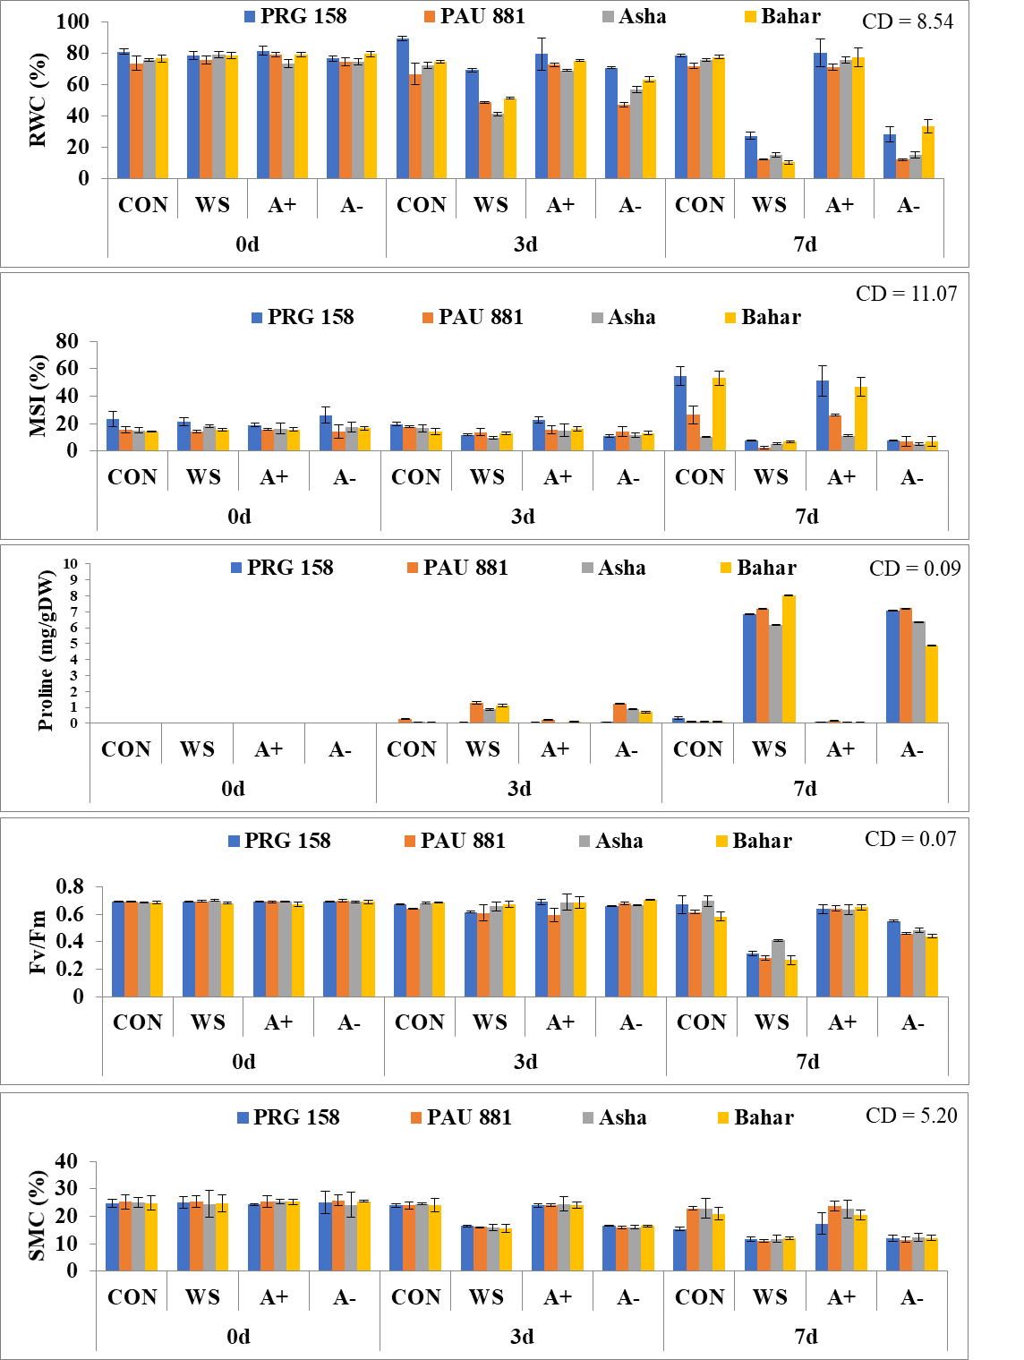
Fig. S3 Physiological effect of ABA application on four genotypes after prolonged water stress.

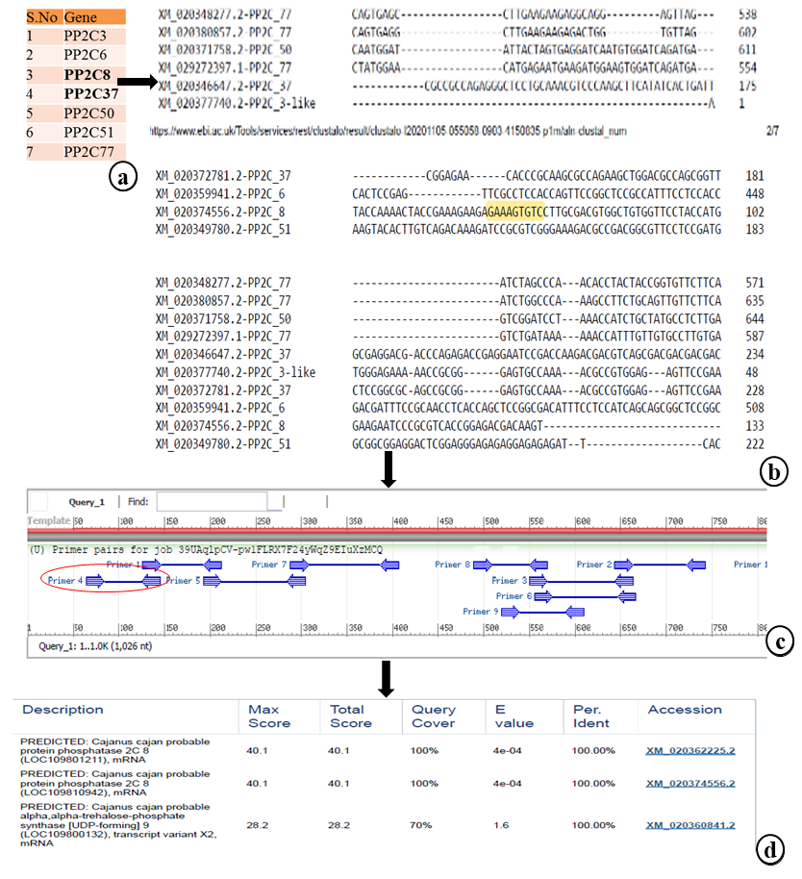
Fig. S4 Schematic representation of methodology for primer designing of PP2C8 gene for qRT PCR.

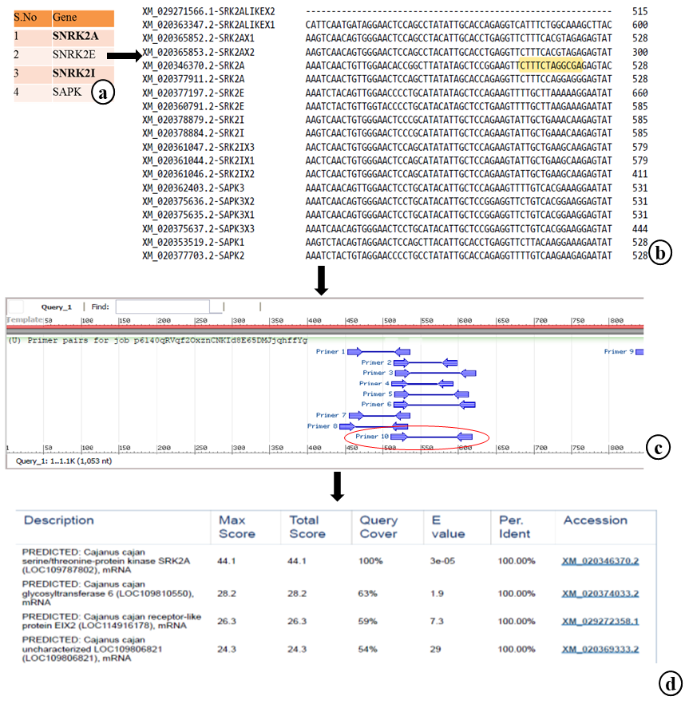
Fig. S5 Schematic representation of methodology for primer designing of SNRK2A gene for qRT PCR.

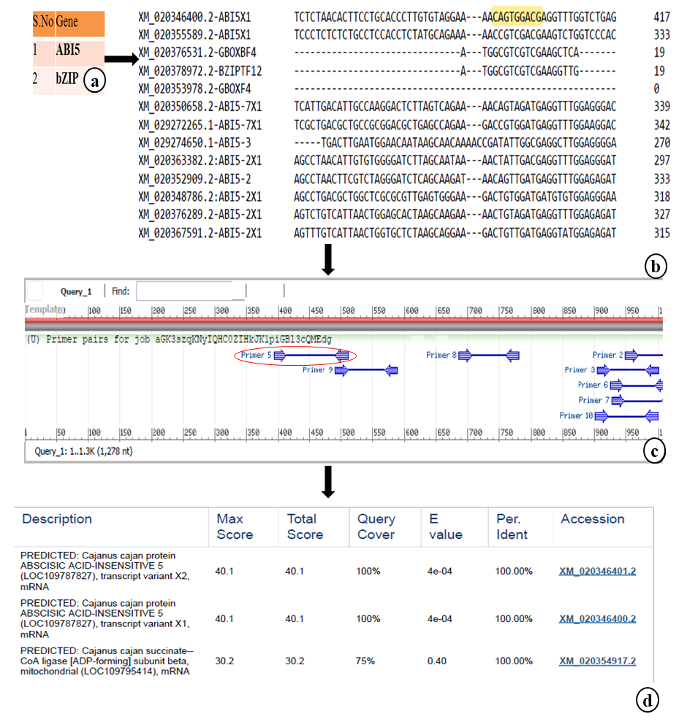
Fig. S6 Schematic representation of methodology for primer designing of ABI5 gene for qRT PCR.

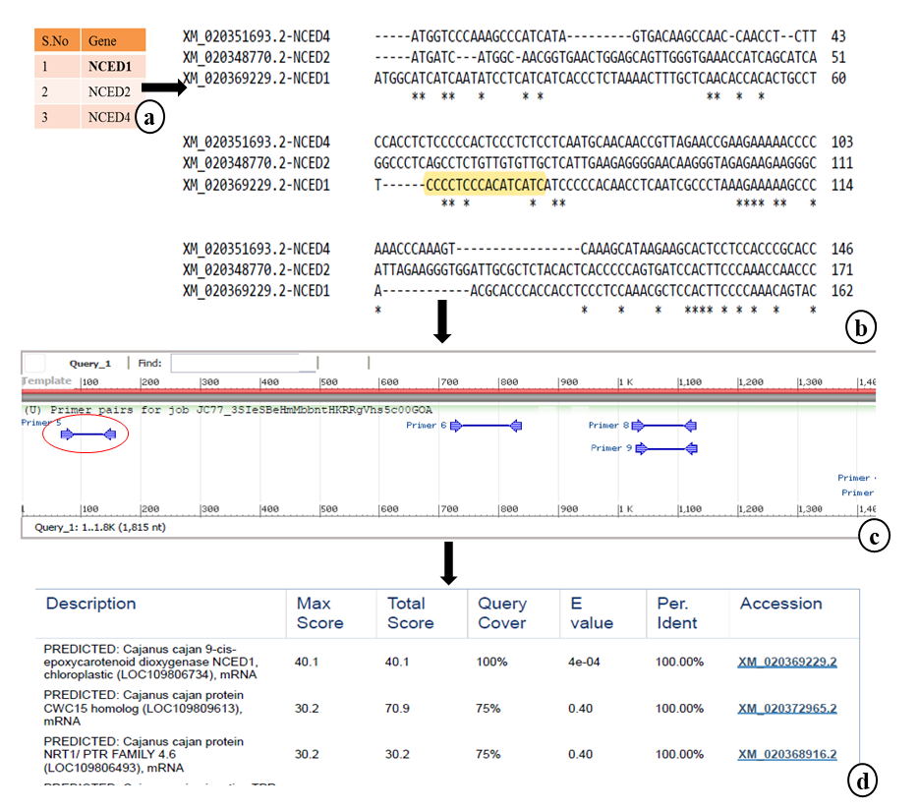
Fig. S7 Schematic representation of methodology for primer designing of NCED gene for qRT PCR.

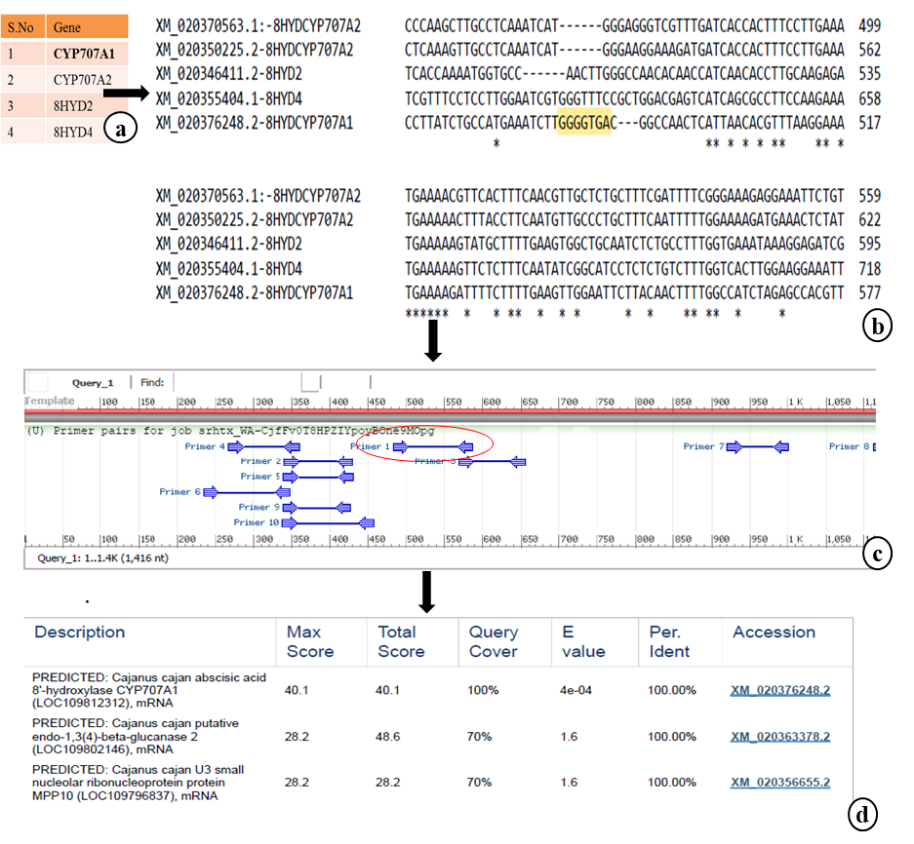
Fig. S8 Schematic representation of methodology for primer designing of CYP gene for qRT PCR.

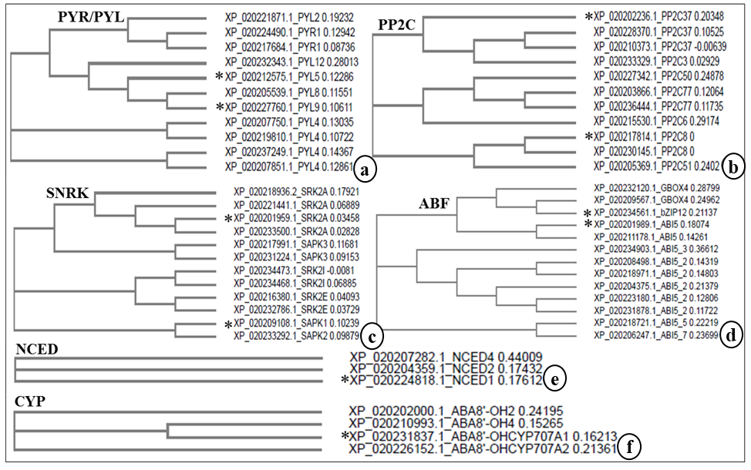
Fig. S9 Phylogenetic analysis of the genes selected from the specific gene families involved in ABA mediated drought response using the protein sequences obtained from KEGG/NCBI databases for pigeon pea a) Genes from PYR/PYL gene family b) Genes from PP2C gene family c) Genes from SnRK gene family d) Genes from ABF gene family e) Genes from NCED f) Genes from CYP gene family. *Asterisk indicates the genes selected for primer designing.

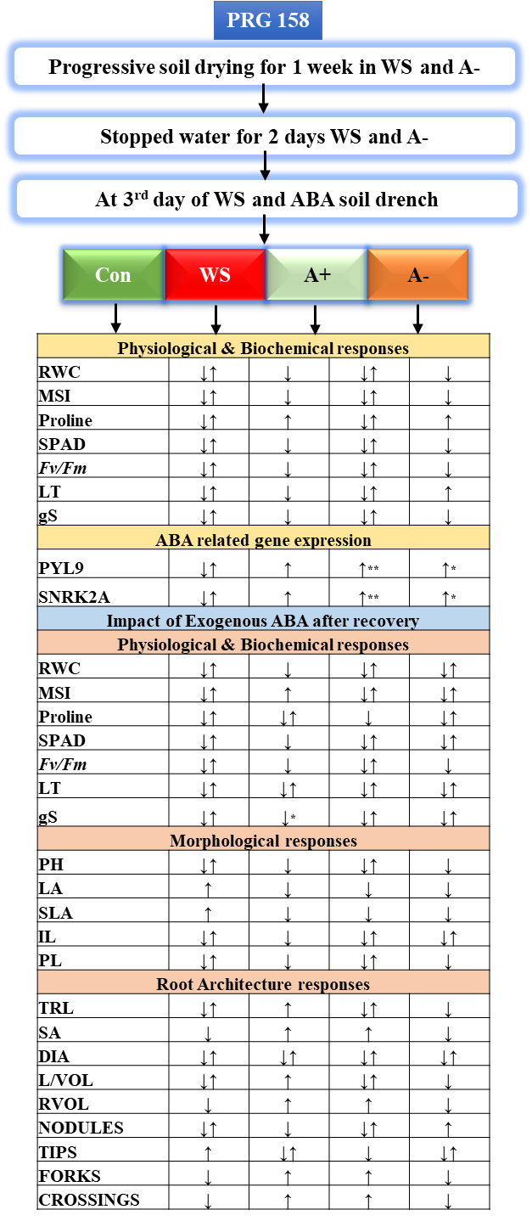
Fig. S10 Schematic Representation of the physiological, biochemical and morphological responses during CON, WS, A+ and A- treatments after the recovery in PRG 158.
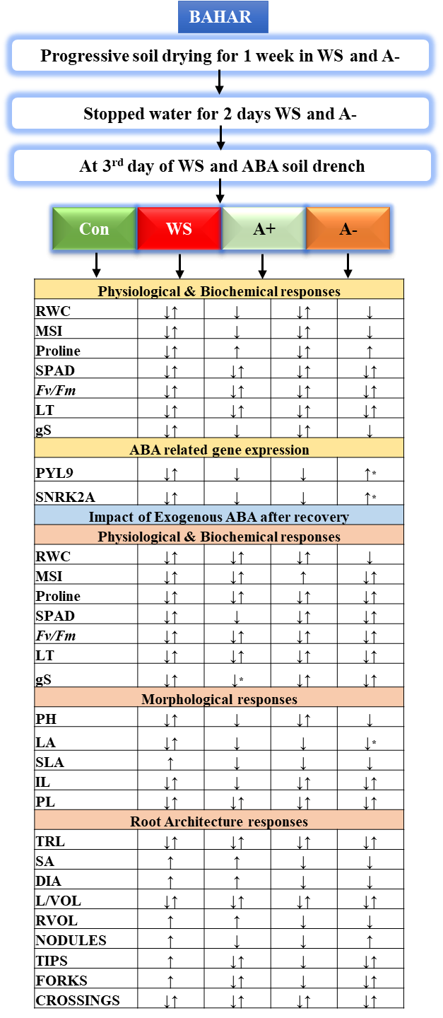
Fig. S11 Schematic Representation of the physiological, biochemical and morphological responses during CON, WS, A+ and A- treatments after the recovery in BAHAR.

