Supporting information:

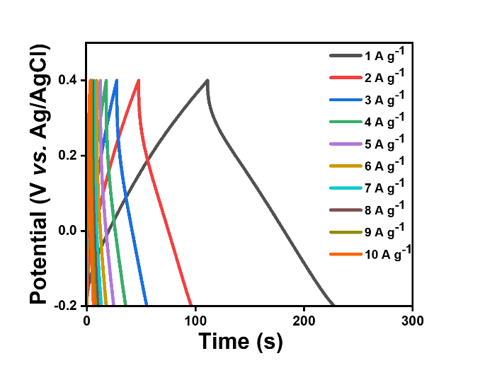
Figure S1. The GCD curves of GMC yarn electrode at the current density of 1-10 A g⁻¹.

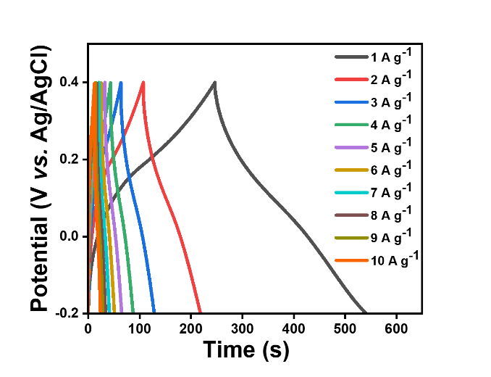
Figure S2. The GCD curves of GMPC yarn electrode at the current density of 1-10 A g⁻¹.

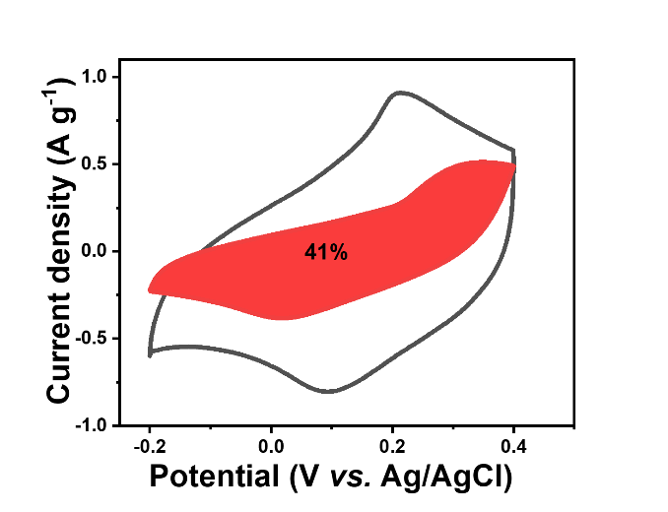
Figure S3. Differentiation of the capacity contributions from the surface capacity effect and the diffusion-controlled process for GMPC yarn at a CV scan rate of 1 mV s⁻¹.

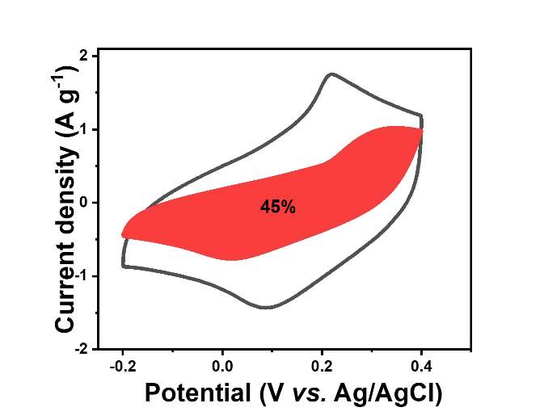
Figure S4. Differentiation of the capacity contributions from the surface capacity effect and the diffusion-controlled process for GMPC yarn at a CV scan rate of 2 mV s⁻¹.

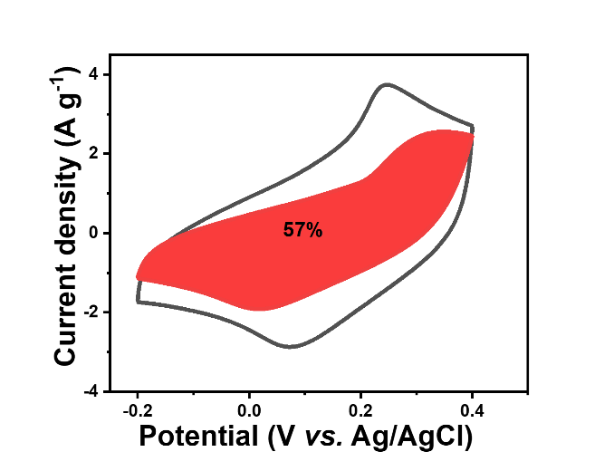
Figure S5. Differentiation of the capacity contributions from the surface capacity effect and the diffusion-controlled process for GMPC yarn at a CV scan rate of 5 mV s⁻¹.

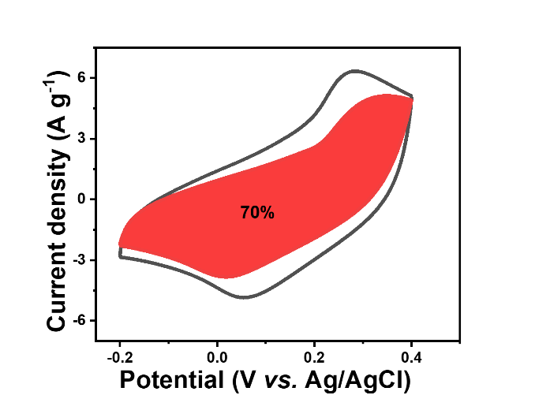
Figure S6. Differentiation of the capacity contributions from the surface capacity effect and the diffusion-controlled process for GMPC yarn at a CV scan rate of 10 mV s⁻¹.

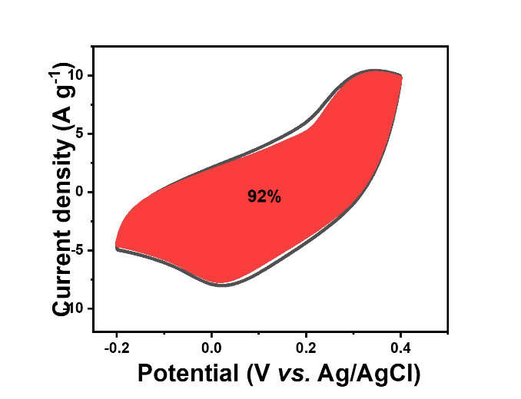
Figure S7. Differentiation of the capacity contributions from the surface capacity effect and the diffusion-controlled process for GMPC yarn at a CV scan rate of 20 mV s⁻¹.

Table S1. The comparison of the capacitance of' PTG electrode with previous reported literatures.
Electrode | Electrolyte | Capacitance (F g⁻¹) | Cycling stability |  |  | Reference
Electrode | Electrolyte | Capacitance (F g⁻¹) | Cycles | Capacitance  retention(%) |  | Reference
PTG fiber | 1 M H₂SO₄ | 406.7  (1 A g⁻¹) | 5000 |  | 87.8% | This work
MoS₂/PANI-10/FCC | 1 M H₂SO₄ | 393.8  (1 A g⁻¹) | 1000 |  | 87 % | [1]
N-doped carbonized cotton | 1 M H₂SO₄ | 207  (1 A g⁻¹) | 10,000 |  | 134 % | [2]
PANI@MWCNT | 1 M KOH | 296  (1.6 A g⁻¹) | 2000 |  | 95 % | [3]
rGO/MXene hybrid  fiber | 1 M H₂SO₄ | 195  (0.1 A g⁻¹) | 7500 |  | 125 % | [4]
PANI/N-CNT@CNT fiber | 1 M H₂SO₄ | 323.8  (1 A g⁻¹) | 10000 |  | 92.1 % | [5]
MoS₂/activated carbon | 1 M Na₂SO₄ | 333.5  (1 A g⁻¹) | 7000 |  | 81.8 % | [6]
MoS₂/PANI | 1 M H₂SO₄ | 390  (0.8 A g⁻¹) | 1000 |  | 86 % | [7]
C-Fe/PANI/Ni-GF | 1 M NaNO₃ | 139.9  (1 A g⁻¹) | 10000 |  | 91 % | [8]
MoS₂-rGO/ PEDOTNP/NF | 3 M KOH | 298  (1 A g⁻¹) | 10000 |  | 93.17 % | [9]
PANI/AgNWs/cotton | HCl | 154  (0.5 A g⁻¹) | 5000 |  | 96 % | [10]
PANI/MoS₂ | 1 M H₂SO₄ | 400  (0.8 A g⁻¹) | 500 |  | 84 % | [11]

References
[1] Y. Wang, X. Lv, S. Zou, X. Lin, Y. Ni, (2021) MoS2/polyaniline/functionalized carbon cloth electrode materials for excellent supercapacitor performance, RSC Adv. 11: 10941-10950, doi:10.1039/d0ra09126j.
[2] L. Li, Q. Zhong, N.D. Kim, G. Ruan, Y. Yang, C. Gao, H. Fei, Y. Li, Y. Ji, J.M. Tour, (2016) Nitrogen-doped carbonized cotton for highly flexible supercapacitors, Carbon 105: 260-267, doi:10.1016/j.carbon.2016.04.031.
[3] R. Wang, Q. Wu, X. Zhang, Z. Yang, L. Gao, J. Ni, O.K.C. Tsui, (2016) Flexible supercapacitors based on a polyaniline nanowire-infilled 10 nm-diameter carbon nanotube porous membrane by in situ electrochemical polymerization, J. Mater. Chem. A 4: 12602-12608, doi:10.1039/c6ta03957j.
[4] Z. Wang, Y. Chen, M. Yao, J. Dong, Q. Zhang, L. Zhang, X. Zhao, (2020) Facile fabrication of flexible rGO/MXene hybrid fiber-like electrode with high volumetric capacitance, J. Power Sources 448: 227398, doi:10.1016/j.jpowsour.2019.227398.
[5] J. Tian, N. Cui, P. Chen, K. Guo, X. Chen, (2021) High-performance wearable supercapacitors based on PANI/N-CNT@CNT fiber with a designed hierarchical core-sheath structure, J. Mater. Chem. A 9: 20635-20644, doi:10.1039/d1ta03663g.
[6] F. Wang, J. Ma, K. Zhou, X. Li, (2020) MoS2/corncob-derived activated carbon for supercapacitor application, Mater. Chem. Phys. 244: 122215, doi:10.1016/j.matchemphys.2019.122215.
[7] J. Wang, Z. Wu, K. Hu, X. Chen, H. Yin, (2015) High conductivity graphene-like MoS₂/polyaniline nanocomposites and its application in supercapacitor, J. Alloy. Compd. 619: 38-43, doi:10.1016/j.jallcom.2014.09.008.
[8] M.N. Rantho, M.J. Madito, N. Manyala, (2020) High-performance symmetric supercapacitor device based on carbonized iron-polyaniline/nickel graphene foam, J. Alloy. Compd. 819: 152993, doi:10.1016/j.jallcom.2019.152993.
[9] D. Sarmah, A. Kumar, (2021) Symmetric Supercapacitors with layer-by-layer Molybdenum disulfide - reduced graphene oxide structures and poly(3,4-ethylenedioxythiophene) nanoparticles nanohybrid electrode, J. Energy Storage 35: 102289, doi:10.1016/j.est.2021.102289.
[10] D. Gao, P. Zhao, J. Liu, Y. Zhou, B. Lyu, J. Ma, L. Shao, (2021) Polyaniline/silver nanowire cotton fiber: A flexible electrode material for supercapacitor, Adv. Powder Technol. 32: 3954-3963, doi:10.1016/j.apt.2021.08.019.
[11] M. Kim, Y.K. Kim, J. Kim, S. Cho, G. Lee, J. Jang, (2016) Fabrication of a polyaniline/MoS₂ nanocomposite using self-stabilized dispersion polymerization for supercapacitors with high energy density, RSC Adv. 6: 27460-27465, doi:10.1039/c6ra00797j.

