Supplementary Information

Text S1 Supplementary Method
We download the source code of package “interactions” version 1.2.0 from the website (https://cran.r-project.org/web/packages/interactions/index.html). And we modified the R script “johnson_neyman.R”. Specifically, we inserted Code 1 after original line 192, Code 2 after original line 280, and Code 3 after original line 326.

Code 1:
if(class(mod) == ‘glmmTMB’){
return(lme4::fixef(model)$cond)
}

Code 2:
if(class(model) == ‘glmmTMB’){
vcovs <- vcov(model)$cond
}

Code 3:
if(class(model) == ‘glmmTMB’){
vmat <- vcov(model)$cond
}
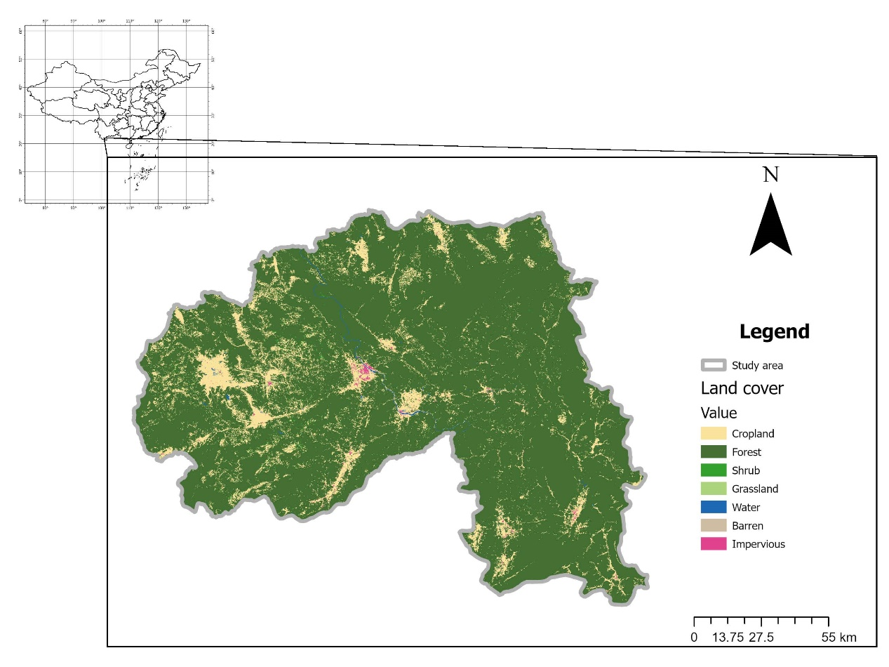
Figure S1. Study area.

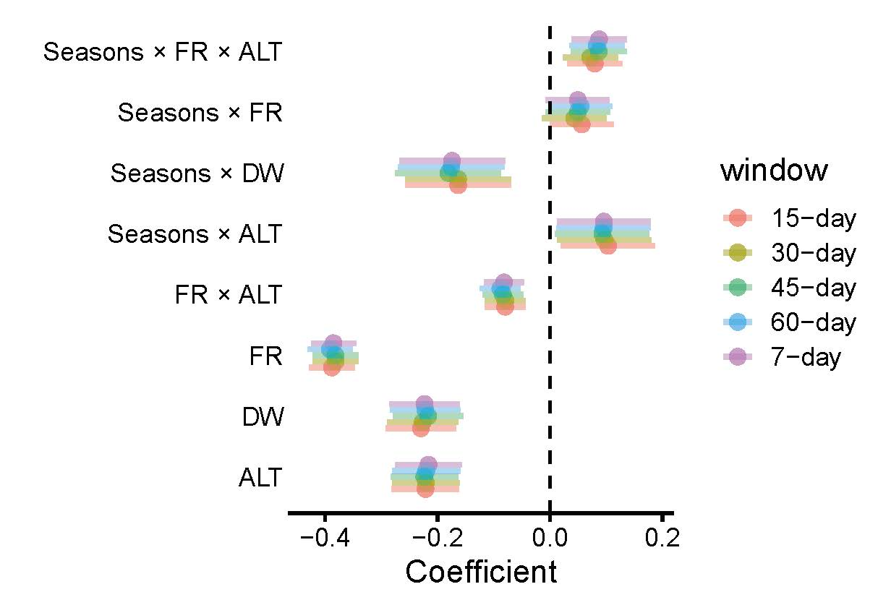
Figure S2. Resource selection function results of different time length windows.
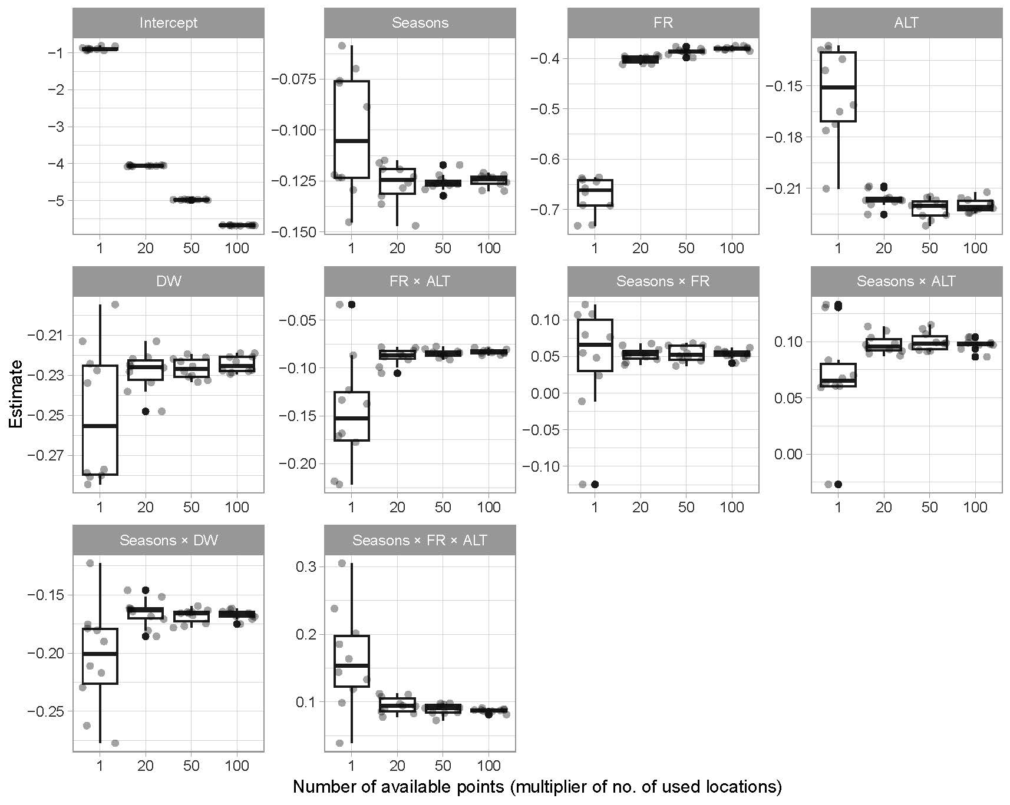
Figure S3. The estimate of resource selection function with different number of available points.

Table S1. Correlation between variables. FR, forest ratio; DW, distance to water; ALT, altitude; TMP, temperature; PRE, precipitation.
 | FR | ALT | DW | TMP | PRE
FR | 1 | 0.274233 | 0.23004 | -0.15984 | -0.04022
ALT | 0.274233 | 1 | 0.153783 | -0.2756 | -0.05794
DW | 0.23004 | 0.153783 | 1 | -0.13367 | -0.08301
TMP | -0.15984 | -0.2756 | -0.13367 | 1 | 0.703683
PRE | -0.04022 | -0.05794 | -0.08301 | 0.703683 | 1

Table S2. Model 1: Asian elephants’ habitat selection differences between seasons estimated by resource selection function (n = 162792). FR, forest ratio; DW, distance to water; ALT, altitude. Significant terms (P < 0.05) are bolded.
Variable | Estimate | Std. Error | z value | Pr(>|z|)
Intercept | -4.2108 | 0.33485 | -12.575 | <2.00E-16
Wet | -0.1292 | 0.04165 | -3.102 | 0.001921
FR | -0.37765 | 0.02048 | -18.438 | <2.00E-16
ALT | -0.22164 | 0.03056 | -7.254 | 4.06E-13
DW | -0.23475 | 0.03203 | -7.329 | 2.33E-13
FR : ALT | -0.08288 | 0.01827 | -4.537 | 5.72E-06
Wet : FR | 0.03946 | 0.0291 | 1.356 | 0.175108
Wet : ALT | 0.103 | 0.04262 | 2.417 | 0.015648
Wet : DW | -0.16089 | 0.04829 | -3.332 | 0.000862
Wet : FR : ALT | 0.07326 | 0.02492 | 2.94 | 0.003287

Table S3. The variance inflation factor (VIF) of the Model 1.
Term | VIF | VIF_CI |  | Increased SE | Tolerance | Tolerance CI
Seasons | 1.33 | 1.32 | 1.33 | 1.15 | 0.75 | 0.75 | 0.76
ALT | 2.81 | 2.79 | 2.83 | 1.68 | 0.36 | 0.35 | 0.36
DW | 2.24 | 2.22 | 2.26 | 1.50 | 0.45 | 0.44 | 0.45
FR : ALT | 3.46 | 3.43 | 3.49 | 1.86 | 0.29 | 0.29 | 0.29
Wet : ALT | 2.95 | 2.93 | 2.97 | 1.72 | 0.34 | 0.34 | 0.34
Wet : DW | 2.65 | 2.63 | 2.67 | 1.63 | 0.38 | 0.37 | 0.38
Wet : FR : ALT | 3.70 | 3.67 | 3.73 | 1.92 | 0.27 | 0.27 | 0.27
FR | 2.90 | 2.87 | 2.92 | 1.70 | 0.35 | 0.34 | 0.35
Wet : FR | 3.31 | 3.28 | 3.34 | 1.82 | 0.30 | 0.30 | 0.30
Table S4. Model 2: Habitat differences between seasons estimated by the generalized linear mixed models with binomial family. FR, forest ratio; DW, distance to water; ALT, altitude. Significant terms (P < 0.05) are bolded.
Variables | Estimate | Std.Error | z value | Pr(>|z|)
Intercept | 0.15111 | 0.23338 | 0.647 | 0.51732
FR | 0.13461 | 0.04349 | 3.095 | 0.00197
ALT | -0.04637 | 0.04007 | -1.157 | 0.24722
DW | -0.18001 | 0.03799 | -4.739 | 2.15E-06
FR : ALT | 0.16843 | 0.03582 | 4.702 | 2.58E-06

Table S5. The variance inflation factor (VIF) of the generalized linear mixed models with binomial family. FR, forest ratio; DW, distance to water; ALT, altitude.
Term | VIF | VIF CI |  | Increased SE | Tolerance | Tolerance CI
FR | 1.25 | 1.20 | 1.31 | 1.12 | 0.80 | 0.76 | 0.83
ALT | 1.11 | 1.07 | 1.16 | 1.05 | 0.90 | 0.86 | 0.93
DW | 1.07 | 1.04 | 1.12 | 1.03 | 0.94 | 0.89 | 0.96
FR : ALT | 1.09 | 1.06 | 1.15 | 1.05 | 0.91 | 0.87 | 0.94

Table S6. Model 3: The bootstrap coefficient of GLMM on the mixed dataset (n = 6296).
Variables | mean | 95% CI
Intercept | 0.022545 | -0.00941 | 0.053943
FR | -0.02677 | -0.11427 | 0.063813
ALT | 0.006901 | -0.06008 | 0.069767
DW | 0.00769 | -0.0522 | 0.07138
Ocuur | 0.039676 | 0.004126 | 0.078913
FR : ALT | 0.009443 | -0.06012 | 0.079363
FR : ocuur | 0.121823 | 0.030384 | 0.213038
ALT : ocuur | 0.027176 | -0.03859 | 0.094809
DW : ocuur | -0.22411 | -0.28886 | -0.16185
FR : ALT : ocuur | 0.175977 | 0.104986 | 0.245698

Table S7. The model rank of ordered beta regressions.
Intercept | ALT | DW | TMP | ALT : DW | ALT : TMP | DW : TMP | ALT : DW: TMP | df | logLik | AICc | delta | weight
0.842031 | 0.219318 | 0.193921 | -0.102775 | NA | 0.102452 | NA | NA | 8 | -58.9961701 | 134.0382147 | 0 | 0.381106521
0.843532 | 0.218247 | 0.194486 | -0.103072 | NA | 0.097078 | 0.024020 | NA | 9 | -58.29570958 | 134.6487805 | 0.610565853 | 0.280843056
0.841788 | 0.219528 | 0.194427 | -0.102862 | 0.003163 | 0.103245 | NA | NA | 9 | -58.98671123 | 136.0307838 | 1.992569166 | 0.140723129
0.842865 | 0.218862 | 0.196298 | -0.103406 | 0.011048 | 0.099340 | 0.026542 | NA | 10 | -58.18860612 | 136.4473429 | 2.40912826 | 0.114264369
0.843684 | 0.213586 | 0.190606 | -0.099322 | 0.013243 | 0.097932 | 0.023087 | -0.024574 | 11 | -57.50062695 | 137.0854376 | 3.047222891 | 0.083052046
FR, forest ratio; DW, distance to water; ALT, altitude; TMP, temperature. The final model was highlighted in red.

Variables | Estimate | Std.Error | z value | Pr(>|z|)
Intercept | 0.84203 | 0.02256 | 37.32 | < 2e-16
DW | 0.19392 | 0.02063 | 9.4 | < 2e-16
ALT | 0.21932 | 0.02064 | 10.63 | < 2e-16
TMP | -0.10278 | 0.02003 | -5.13 | 2.87E-07
ALT : TMP | 0.10245 | 0.01939 | 5.28 | 1.26E-07
Table S8. Model 4: The final ordered beta regressions.

DW, distance to water; ALT, altitude; TMP, temperature. Significant terms (P < 0.05) are bolded.

Table S9. The variance inflation factor (VIF) of the ordered beta regressions.
Term | VIF | VIF CI |  | Increased SE | Tolerance | Tolerance CI
DW | 1.03 | 1.01 | 1.10 | 1.01 | 0.97 | 0.91 | 0.99
ALT | 1.12 | 1.08 | 1.17 | 1.06 | 0.90 | 0.86 | 0.92
TMP | 1.07 | 1.04 | 1.13 | 1.04 | 0.93 | 0.89 | 0.96
ALT : TMP | 1.04 | 1.02 | 1.10 | 1.02 | 0.96 | 0.91 | 0.98
DW, distance to water; ALT, altitude; TMP, temperature.

