Supplementary Materials
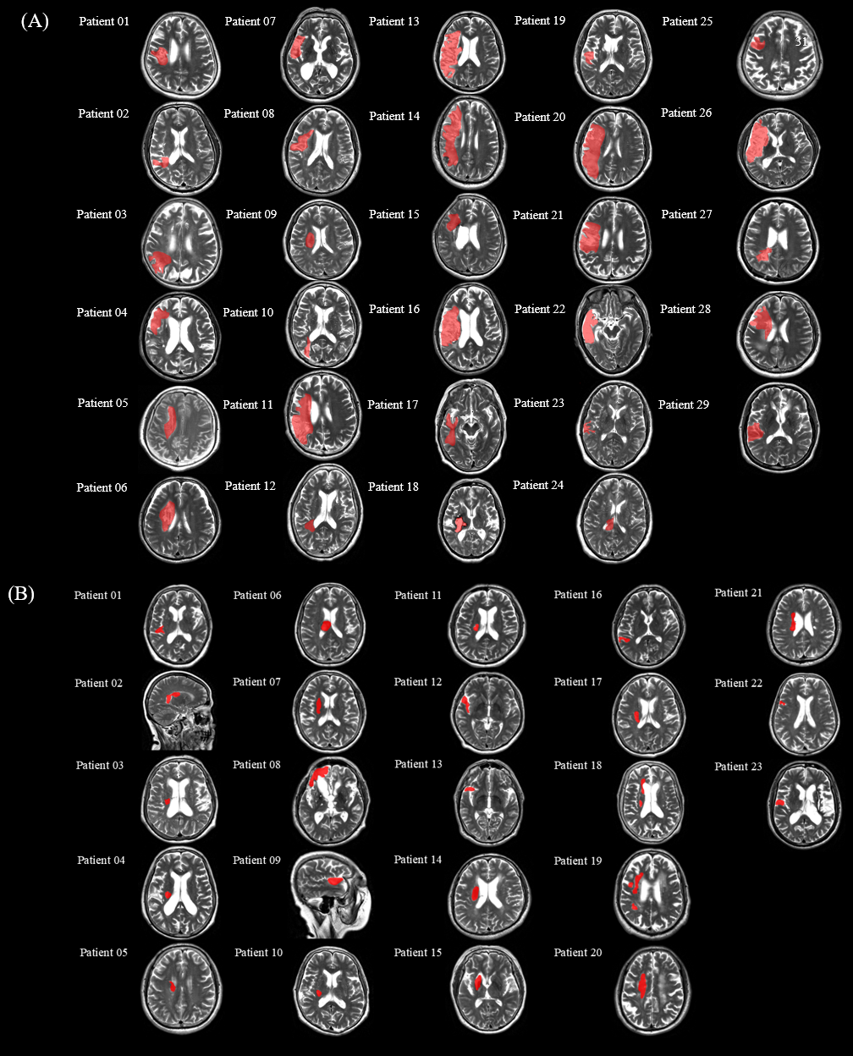

Figure. S1. The display of stroke lesion for each PSA (A) and nonPSA (B) patient.
Table S2: Language assessment results for the patients.
 |  | Western Aphasia Battery
 |  | WAB-0 |  |  |  | WAB-1
Number | AQ-0 | Auditory Comprehension-0 | Spontaneous speech-0 | Naming-0 | repetition-0 | AQ-1 | Auditory Comprehension-1 | Spontaneous speech-1 | Naming-1 | Repetition-1 | ΔAQ | rΔAQ
Patient01 | 46.40 | 7.30 | 9.00 | 4.00 | 2.90 | 47.10 | 8.65 | 9.00 | 4.30 | 1.60 | 0.70 | 1.00
Patient02 | 96.20 | 10.00 | 19.00 | 9.90 | 9.20 | 97.20 | 10.00 | 19.00 | 10.00 | 9.60 | 1.00 | 0.32
Patient03 | 39.30 | 7.35 | 8.00 | 0.80 | 3.50 | 26.60 | 5.80 | 4.00 | 2.10 | 1.40 | -12.70 | 0.60
Patient04 | 0.00 | 0.00 | 0.00 | 0.00 | 0.00 | 0.00 | 0.00 | 0.00 | 0.00 | 0.00 | 0.00 | 0.00
Patient05 | 10.00 | 3.80 | 1.00 | 0.20 | 0.00 | 54.00 | 6.00 | 10.00 | 8.00 | 3.00 | 44.00 | 0.73
Patient06 | 21.00 | 3.30 | 4.00 | 1.30 | 1.90 | 55.90 | 3.45 | 13.00 | 3.00 | 8.50 | 34.90 | -2.40
Patient07 | 6.80 | 1.40 | 2.00 | 0.00 | 0.00 | 6.90 | 1.45 | 2.00 | 0.00 | 0.00 | 0.10 | -0.35
Patient08 | 11.10 | 5.25 | 0.00 | 0.00 | 0.30 | 69.70 | 7.95 | 13.00 | 6.50 | 7.40 | 58.60 | 0.28
Patient09 | 52.60 | 8.20 | 6.00 | 5.60 | 6.50 | 78.60 | 8.30 | 16.00 | 6.90 | 8.10 | 26.00 | 1.45
Patient10 | 73.20 | 7.10 | 14.00 | 6.30 | 9.20 | 78.20 | 7.90 | 17.00 | 8.00 | 6.20 | 5.00 | 0.62
Patient11 | 20.50 | 4.85 | 3.00 | 1.60 | 0.80 | 24.50 | 4.75 | 3.00 | 1.50 | 3.00 | 4.00 | -1.91
Patient12 | 78.10 | 9.15 | 14.00 | 7.70 | 8.20 | 80.70 | 8.95 | 15.00 | 7.50 | 8.90 | 2.60 | 0.24
Patient13 | 4.90 | 2.45 | 0.00 | 0.00 | 0.00 | 5.60 | 2.80 | 0.00 | 0.00 | 0.00 | 0.70 | -0.08
Patient14 | 6.40 | 2.20 | 1.00 | 0.00 | 0.00 | 0.00 | 0.00 | 0.00 | 0.00 | 0.00 | 0.00 | 0.57
Patient15 | 25.10 | 5.75 | 6.00 | 0.10 | 0.70 | 28.00 | 7.30 | 4.00 | 1.70 | 1.00 | 2.90 | -0.71
Patient16 | 14.30 | 1.75 | 1.00 | 0.00 | 4.40 | 5.50 | 0.75 | 2.00 | 0.00 | 0.00 | -8.80 | -4.98
Patient17 | 21.30 | 1.65 | 9.00 | 0.00 | 0.00 | 16.30 | 0.15 | 8.00 | 0.00 | 0.00 | -5.00 | 0.38
Patient18 | 64.20 | 5.80 | 12.00 | 6.70 | 7.60 | 73.30 | 8.05 | 14.00 | 7.20 | 7.40 | 9.10 | 1.23
Patient19 | 71.90 | 6.85 | 14.00 | 6.30 | 8.80 | 75.60 | 8.00 | 16.00 | 7.60 | 6.20 | 3.70 | -0.08
Patient20 | 1.80 | 0.90 | 0.00 | 0.00 | 0.00 | 2.00 | 1.00 | 0.00 | 0.00 | 0.00 | 0.20 | -5.65
Patient21 | 9.10 | 4.35 | 0.00 | 0.00 | 0.20 | 16.00 | 4.50 | 3.00 | 0.00 | 0.50 | 6.90 | -6.64
Patient22 | 6.00 | 3.00 | 0.00 | 0.00 | 0.00 | 9.80 | 4.90 | 0.00 | 0.00 | 0.00 | 3.80 | 0.12
Patient23 | 79.50 | 7.95 | 15.00 | 8.50 | 8.30 | 90.40 | 9.20 | 18.00 | 9.20 | 8.80 | 10.90 | 1.73
Patient24 | 4.60 | 2.30 | 0.00 | 0.00 | 0.00 | 0.00 | 0.00 | 0.00 | 0.00 | 0.00 | 0.00 | -0.08
Patient25 | 41.40 | 5.40 | 9.00 | 3.30 | 3.00 | 69.00 | 8.10 | 12.00 | 7.00 | 7.40 | 27.60 | 0.24
Patient26 | 12.40 | 2.50 | 3.00 | 0.70 | 0.00 | 11.70 | 1.65 | 3.00 | 0.00 | 1.20 | -0.70 | 0.97
Patient27 | 85.00 | 9.00 | 17.00 | 8.90 | 7.60 | 90.10 | 9.05 | 18.00 | 9.00 | 9.00 | 5.10 | 1.90
Patient28 | 40.90 | 5.55 | 7.00 | 4.60 | 3.30 | 0.00 | 0.00 | 0.00 | 0.00 | 0.00 | 0.00 | 3.29
Patient29 | 88.20 | 17.00 | 9.10 | 9.60 | 8.40 | 87.10 | 9.45 | 17.00 | 9.40 | 7.70 | -1.10 | 2.19
All patients underwent WAB-R testing twice at the baseline (~28 days post-stroke, WAB0) and at three months post-stroke (WAB1). ΔAQ = AQ₁ – AQ_{0,} r ΔAQ= (AQ₁ – AQ₀)/ AQ₀

Table S2. Aphasic stroke features in the 29 patients.
N | Age | Sex | Lesion side | Lesion site | Lesion Volume (cm³) | Types of Aphasia
Patient01 | 64 | F | Left | Frontal | 16.77 | Fluent
Patient02 | 47 | M | Left | Frontal ,Temporal | 28.67 | Fluent
Patient03 | 86 | M | Left | Frontal, Parietal, Temporal | 62.97 | Fluent
Patient04 | 79 | M | Left | Frontal, Parietal | 107.49 | Non-fluent
Patient05 | 39 | M | Left | Frontal | 19.06 | Fluent
Patient06 | 69 | M | Left | Frontal | 32.81 | Fluent
Patient07 | 76 | M | Left | Frontal | 8.59 | Fluent
Patient08 | 54 | M | Left | Frontal | 30.40 | Non-fluent
Patient09 | 54 | F | Left | Insula | 10.75 | Fluent
Patient10 | 81 | F | Left | Frontal | 5.27 | Fluent
Patient11 | 67 | M | Left | Frontal, Parietal, Temporal | 150.38 | Fluent
Patient12 | 53 | F | Left | Frontal, Parietal | 8.46 | Fluent
Patient13 | 47 | M | Left | Frontal, Parietal | 139.55 | Non-fluent
Patient14 | 58 | M | Left | Frontal | 59.87 | Fluent
Patient15 | 56 | F | Left | Frontal | 28.04 | Fluent
Patient16 | 71 | M | Left | Frontal, Parietal | 171.91 | Fluent
Patient17 | 71 | M | Left | Frontal, Parietal, Temporal | 31.38 | Fluent
Patient18 | 55 | F | Left | Frontal | 13.69 | Fluent
Patient19 | 70 | F | Left | Frontal | 7.69 | Fluent
Patient20 | 54 | M | Left | Frontal, Parietal, Temporal | 119.83 | Non-fluent
Patient21 | 73 | M | Left | Frontal, Parietal | 128.14 | Non-fluent
Patient22 | 49 | M | Left | Frontal, Parietal, | 84.83 | Non-fluent
Patient23 | 61 | F | Left | Frontal | 3.90 | Fluent
Patient24 | 36 | F | Left | Frontal, Parietal, Temporal | 23.99 | Non-fluent
Patient25 | 79 | F | Left | Frontal | 4.75 | Fluent
Patient26 | 52 | M | Left | Frontal, Parietal | 176.78 | Fluent
Patient27 | 49 | F | Left | Parietal | 27.98 | Fluent
Patient28 | 32 | M | Left | Frontal, Parietal | 77.42 | Fluent
Patient29 | 54 | M | Left | Frontal, Parietal | 13.26 | Fluent

Table S3: Regions showing significant differences between groups in the SFC

Category | Region Name | F | Adjusted p | p_HC_vs_PSA | T_HC_vs_PSA | p_HC_vs_nonPSA | T_HC_vs_nonPSA | p_PSA_vs_nonPSA | T_PSA_vs_nonPSA
Language-specific | Putamen_R | 15.52 | 2.53 × 10⁻⁵ | 1.39 × 10⁻³ | 3.41 | 0.88 | 0.16 | 5.08 × 10⁻⁷ | -5.80
Language-specific | Temporal_Pole_Mid_R | 10.94 | 3.53 × 10⁻⁴ | 2.16 × 10⁻² | 2.38 | 0.71 | -0.38 | 3.12 × 10⁻⁵ | -4.60
Language-specific | Cerebelum_9_R | 8.63 | 1.40 × 10⁻³ | 6.78 × 10⁻³ | 2.84 | 0.86 | 0.17 | 6.71 × 10⁻⁴ | -3.64
Language-specific | Cerebelum_10_L | 7.97 | 2.24 × 10⁻³ | 3.78 × 10⁻³ | 3.06 | 1.00 | 0.00 | 7.57 × 10⁻⁴ | -3.60
Language-specific | Cerebelum_10_R | 6.26 | 6.93 × 10⁻³ | 3.45 × 10⁻³ | 3.09 | 0.59 | -0.54 | 1.36 × 10⁻² | -2.56
Motor-specific | Frontal_Sup_Orb_R | 17.40 | 8.26 × 10⁻⁶ | 5.64 × 10⁻⁶ | 5.16 | 4.98 × 10⁻⁴ | 3.81 | 0.21 | -1.27
Motor-specific | Frontal_Mid_R | 4.63 | 2.42 × 10⁻² | 4.52 × 10⁻³ | 2.99 | 1.95 × 10⁻² | 2.44 | 0.95 | 0.06
Motor-specific | Rolandic_Oper_R | 7.08 | 3.96 × 10⁻³ | 4.28 × 10⁻² | -2.09 | 1.26 × 10⁻⁴ | -4.27 | 0.16 | -1.41
Motor-specific | Insula_R | 7.35 | 3.46 × 10⁻³ | 4.93 × 10⁻³ | 2.96 | 4.51 × 10⁻² | 2.07 | 0.36 | 0.92
Motor-specific | Parietal_Sup_R | 9.57 | 8.14 × 10⁻⁴ | 4.05 × 10⁻⁵ | 4.56 | 2.57 × 10⁻³ | 3.23 | 0.86 | 0.18
Motor-specific | Precuneus_R | 15.38 | 2.54 × 10⁻⁵ | 2.08 × 10⁻⁵ | 4.77 | 2.33 × 10⁻⁴ | 4.07 | 0.73 | -0.35
Motor-specific | Caudate_R | 9.32 | 9.27 × 10⁻⁴ | 4.11 × 10⁻⁴ | 3.82 | 1.19 × 10⁻² | 2.64 | 0.89 | 0.13
Motor-specific | Temporal_Pole_Sup_R | 10.79 | 3.78 × 10⁻⁴ | 3.99 × 10⁻⁴ | 3.83 | 1.61 × 10⁻³ | 3.40 | 0.16 | -1.42
Motor-specific | Temporal_Inf_R | 5.91 | 9.06 × 10⁻³ | 2.34 × 10⁻³ | 3.23 | 9.30 × 10⁻³ | 2.74 | 0.78 | -0.28
Motor-specific | Cerebelum_Crus1_R | 28.38 | 2.96 × 10⁻⁸ | 9.40 × 10⁻⁸ | 6.38 | 3.50 × 10⁻⁷ | 6.15 | 0.87 | 0.16
Motor-specific | Cerebelum_Crus2_R | 6.71 | 5.16 × 10⁻³ | 8.82 × 10⁻³ | 2.74 | 1.19 × 10⁻³ | 3.50 | 0.56 | 0.59
Motor-specific | Cerebelum_4_5_R | 5.39 | 1.32 × 10⁻² | 1.82 × 10⁻² | 2.45 | 2.67 × 10⁻² | 2.31 | 0.54 | 0.62
Motor-specific | Cerebelum_6_R | 14.33 | 4.38 × 10⁻⁵ | 1.10 × 10⁻⁴ | 4.25 | 1.75 × 10⁻⁵ | 4.91 | 0.45 | 0.77
Motor-specific | Vermis_8 | 9.17 | 9.88 × 10⁻⁴ | 3.24 × 10⁻³ | 3.11 | 8.41 × 10⁻⁴ | 3.63 | 0.23 | 1.20
Shared | Cerebelum_9_L | 10.52 | 4.33 × 10⁻⁴ | 3.45 × 10⁻² | 2.18 | 1.19 × 10⁻⁵ | 5.04 | 2.60 × 10⁻³ | 3.18

Table S4 Significant differences between PSA and nonPSA in the lesion-driven transmitter-informed metrics.
Variable | T | p | Adjusted p
Lesion load A4B2 | 3.24 | 2.15 × 10⁻³ | 7.94 × 10⁻³
Lesion load M1 | 3.24 | 2.15 × 10⁻³ | 7.94 × 10⁻³
Lesion load VAChT | 3.44 | 1.22 × 10⁻³ | 7.94 × 10⁻³
Lesion load D1 | 3.49 | 1.04 × 10⁻³ | 7.94 × 10⁻³
Lesion load D2 | 3.45 | 1.18 × 10⁻³ | 7.94 × 10⁻³
Lesion load DAT | 3.37 | 1.49 × 10⁻³ | 7.94 × 10⁻³
Lesion load NAT | 3.16 | 2.70 × 10⁻³ | 7.94 × 10⁻³
Lesion load 5HT1a | 3.21 | 2.40 × 10⁻³ | 7.94 × 10⁻³
Lesion load 5HT1b | 3.00 | 4.31 × 10⁻³ | 1.02 × 10⁻²
Lesion load 5HT2a | 3.16 | 2.76 × 10⁻³ | 7.94 × 10⁻³
Lesion load 5HT4 | 3.43 | 1.25 × 10⁻³ | 7.94 × 10⁻³
Lesion load 5HT6 | 3.28 | 1.93 × 10⁻³ | 7.94 × 10⁻³
Lesion load 5HTT | 3.65 | 6.52 × 10⁻⁴ | 7.94 × 10⁻³
Disconnection A4B2 | 3.04 | 3.83 × 10⁻³ | 9.70 × 10⁻³
Disconnection M1 | 3.21 | 2.34 × 10⁻³ | 7.94 × 10⁻³
Disconnection VAChT | 3.14 | 2.93 × 10⁻³ | 7.94 × 10⁻³
Disconnection D1 | 2.86 | 6.28 × 10⁻³ | 1.15 × 10⁻²
Disconnection D2 | 2.85 | 6.48 × 10⁻³ | 1.15 × 10⁻²
Disconnection DAT | 2.87 | 6.09 × 10⁻³ | 1.15 × 10⁻²
Disconnection NAT | 2.90 | 5.63 × 10⁻³ | 1.15 × 10⁻²
Disconnection 5HT1a | 2.96 | 4.79 × 10⁻³ | 1.07 × 10⁻²
Disconnection 5HT1b | 2.69 | 9.80 × 10⁻³ | 1.49 × 10⁻²
Disconnection 5HT2a | 2.84 | 6.63 × 10⁻³ | 1.15 × 10⁻²
Disconnection 5HT4 | 2.67 | 1.04 × 10⁻² | 1.52 × 10⁻²
Disconnection 5HT6 | 2.77 | 8.00 × 10⁻³ | 1.32 × 10⁻²
Disconnection 5HTT | 2.71 | 9.23 × 10⁻³ | 1.46 × 10⁻²
D2 presynaptic ratio | 2.21 | 3.19 × 10⁻² | 4.18 × 10⁻²
5HT1a presynaptic ratio | -2.50 | 1.61 × 10⁻² | 2.26 × 10⁻²
5HT2a presynaptic ratio | -2.48 | 1.67 × 10⁻² | 2.27 × 10⁻²
A4B2 presynaptic ratio | 0.24 | 8.10 × 10⁻¹ | 8.32 × 10⁻¹
M1 presynaptic ratio | -1.44 | 1.56 × 10⁻¹ | 1.91 × 10⁻¹
5HT1b presynaptic ratio | -1.11 | 2.73 × 10⁻¹ | 3.05 × 10⁻¹
D1 presynaptic ratio | 0.27 | 7.91 × 10⁻¹ | 8.32 × 10⁻¹
5HT4 presynaptic ratio | 0.10 | 9.21 × 10⁻¹ | 9.21 × 10⁻¹
5HT6 presynaptic ratio | -1.30 | 1.99 × 10⁻¹ | 2.36 × 10⁻¹
VAChT postsynaptic ratio | 0.45 | 6.56 × 10⁻¹ | 7.13 × 10⁻¹
DAT postsynaptic ratio | -1.28 | 2.08 × 10⁻¹ | 2.40 × 10⁻¹
5HTT postsynaptic ratio | 1.65 | 1.05 × 10⁻¹ | 1.34 × 10⁻¹
β: standardized regression coefficient; p: p-value; Cohen’s f²: local effect size for each predictor.

Table S5. Associations between neurotransmitter-informed lesion load and changes in aphasia severity (ΔAQ).
Neurotransmitter | WAB Scores | β | p | Cohen’s f²
M1 | ΔAQ | -4.675 | 0.046 | 0.185
NAT | ΔAQ | -4.212 | 0.049 | 0.179
5HT1a | ΔAQ | -4.177 | 0.031 | 0.220
5HT1b | ΔAQ | -3.933 | 0.048 | 0.181
5HT2a | ΔAQ | -4.201 | 0.035 | 0.207
β: standardized regression coefficient; p: p-value; Cohen’s f²: local effect size for each predictor.
Table S5. Relationship between SFC and lesion-derived transmitter-informed metrics.

SFC | Transmitter-informed metrics | β | p | Cohen_f²
Temporal_Pole_Mid_R | Lesion load M1 | 2.89 | 0.05 | 0.18
Temporal_Pole_Mid_R | Lesion load NAT | 3.28 | 0.04 | 0.20
Temporal_Pole_Mid_R | Lesion load 5HT1b | 3.65 | 0.03 | 0.21
Temporal_Pole_Mid_R | Disconnection A4B2 | 2.94 | 0.04 | 0.20
Temporal_Pole_Mid_R | Disconnection M1 | 2.70 | 0.05 | 0.18
Temporal_Pole_Mid_R | Disconnection VAChT | 2.93 | 0.04 | 0.20
Temporal_Pole_Mid_R | Disconnection D1 | 3.15 | 0.04 | 0.19
Temporal_Pole_Mid_R | Disconnection D2 | 3.17 | 0.04 | 0.20
Temporal_Pole_Mid_R | Disconnection DAT | 3.09 | 0.04 | 0.20
Temporal_Pole_Mid_R | Disconnection NAT | 3.01 | 0.03 | 0.21
Temporal_Pole_Mid_R | Disconnection 5HT1a | 3.19 | 0.03 | 0.23
Temporal_Pole_Mid_R | Disconnection 5HT1b | 3.01 | 0.04 | 0.21
Temporal_Pole_Mid_R | Disconnection 5HT2a | 3.07 | 0.04 | 0.21
Temporal_Pole_Mid_R | Disconnection 5HT4 | 3.20 | 0.04 | 0.20
Temporal_Pole_Mid_R | Disconnection 5HT6 | 3.31 | 0.03 | 0.22
Temporal_Pole_Mid_R | Disconnection 5HTT | 2.50 | 0.04 | 0.19
Cerebelum_9_R | D1 presynaptic ratio | 0.24 | 0.04 | 0.19
β: standardized regression coefficient; p: p-value; Cohen’s f²: local effect size for each predictor.

