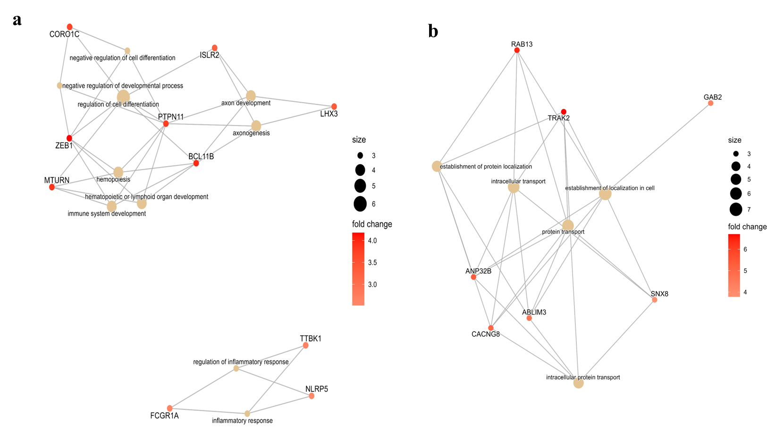

Additional Fig. 1: Pathway analysis of clusters identified through hierarchical clustering revealed the enrichment of GO processes. a) GO processes related to organ development and inflammation, which are all key to wound healing and b) GO processes related to intracellular protein transport and localization

