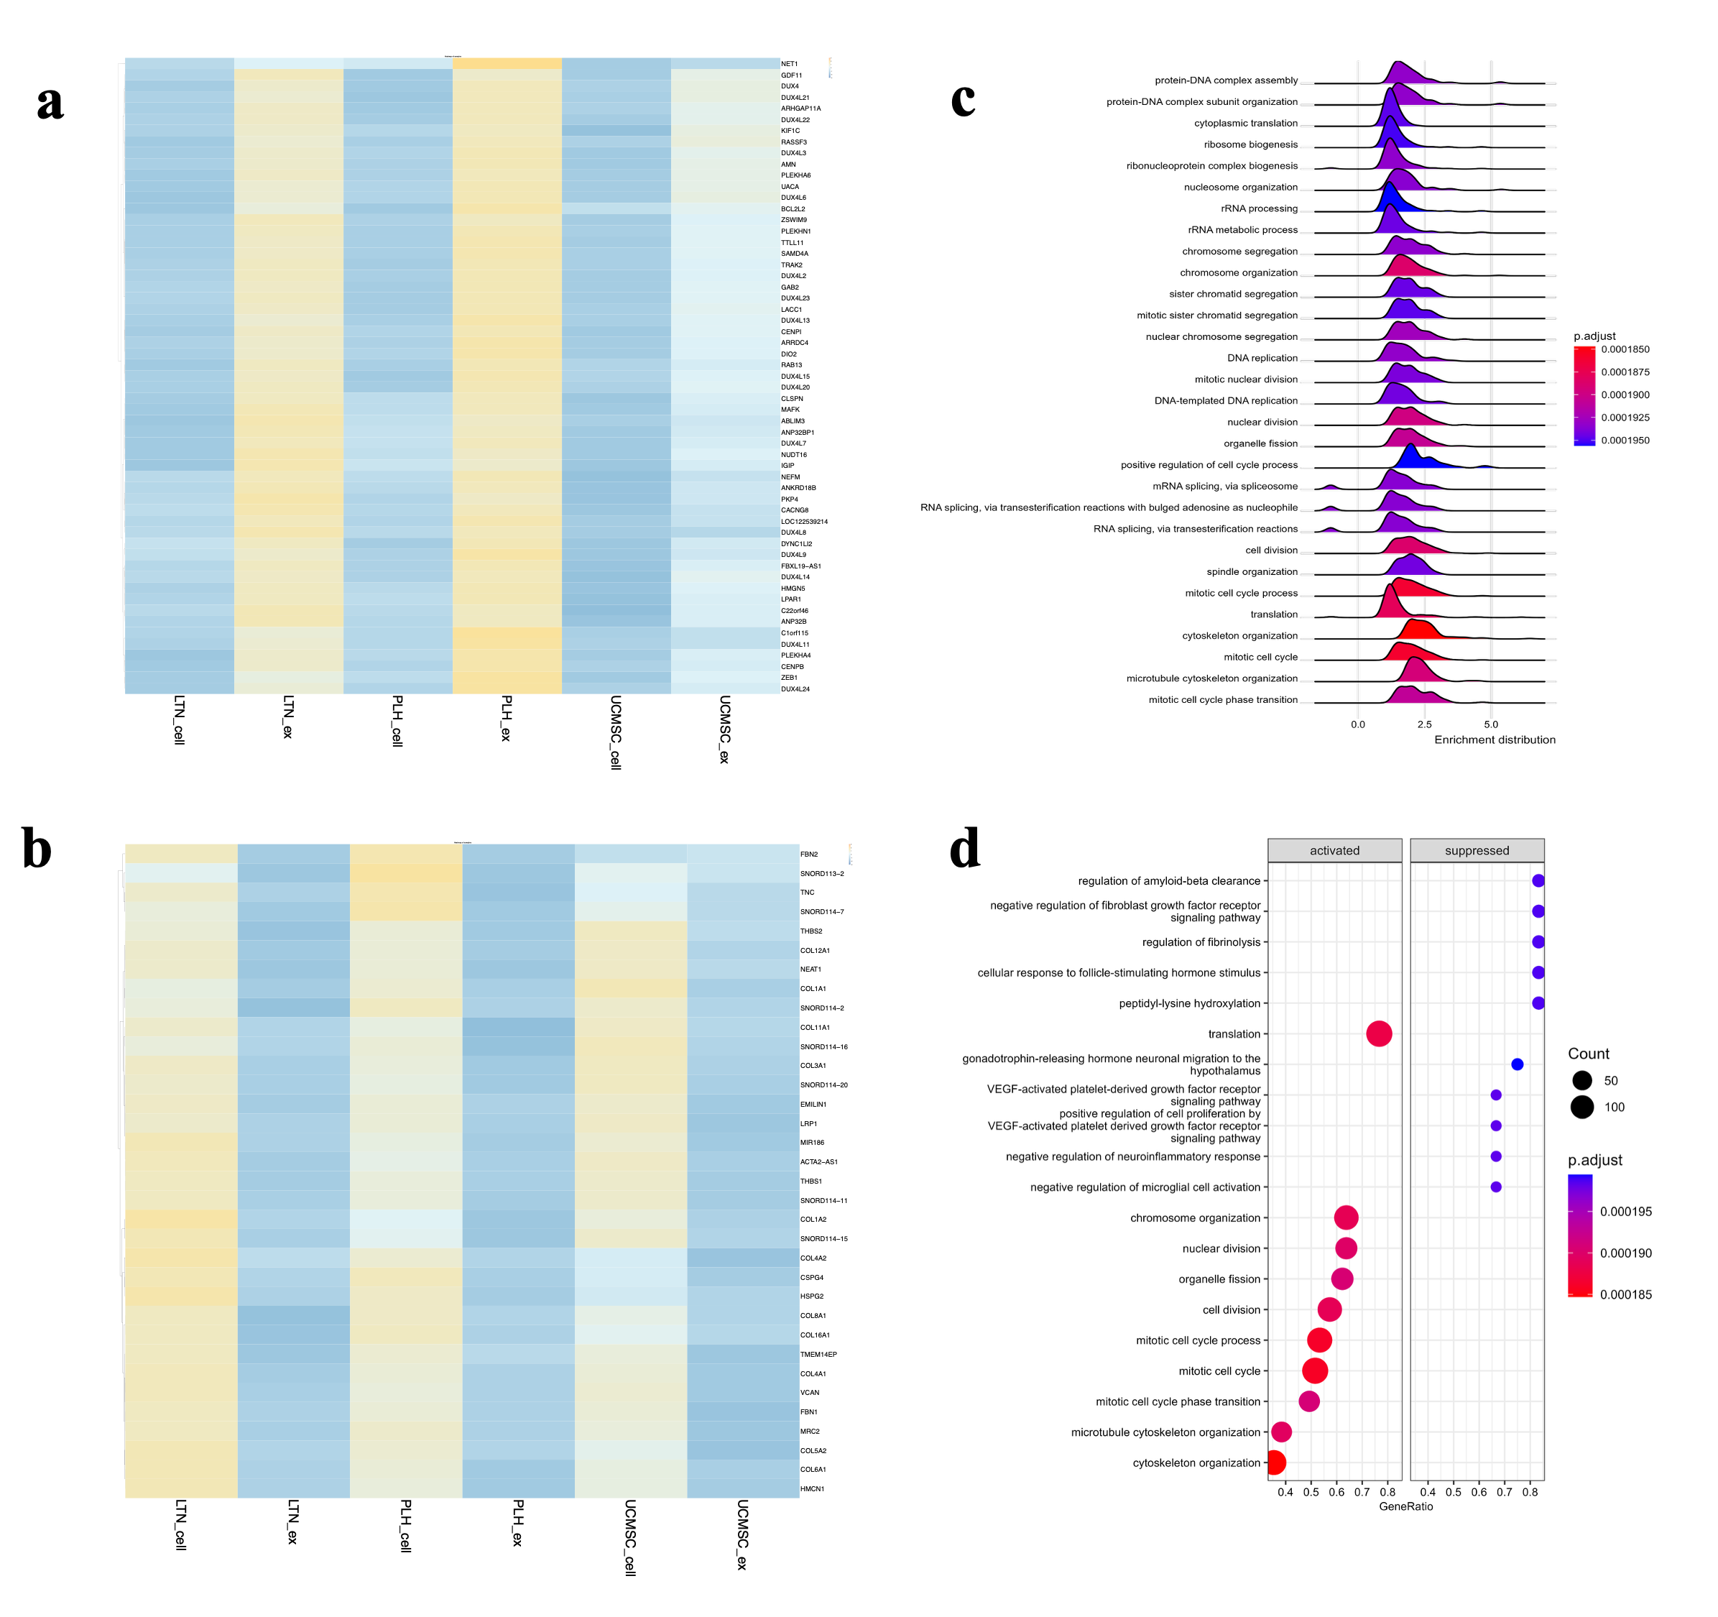

Additional Fig. 1: Top coding genes that enriched in exosomes. a) Top coding genes that enriched in exosomes with fold change greater than 4 and b) smaller than -4 (b). c) A ridge plot and d) dot plot indicated differentially enriched pathways generated using the Gene Ontology Biological Process database for the differential genes.

