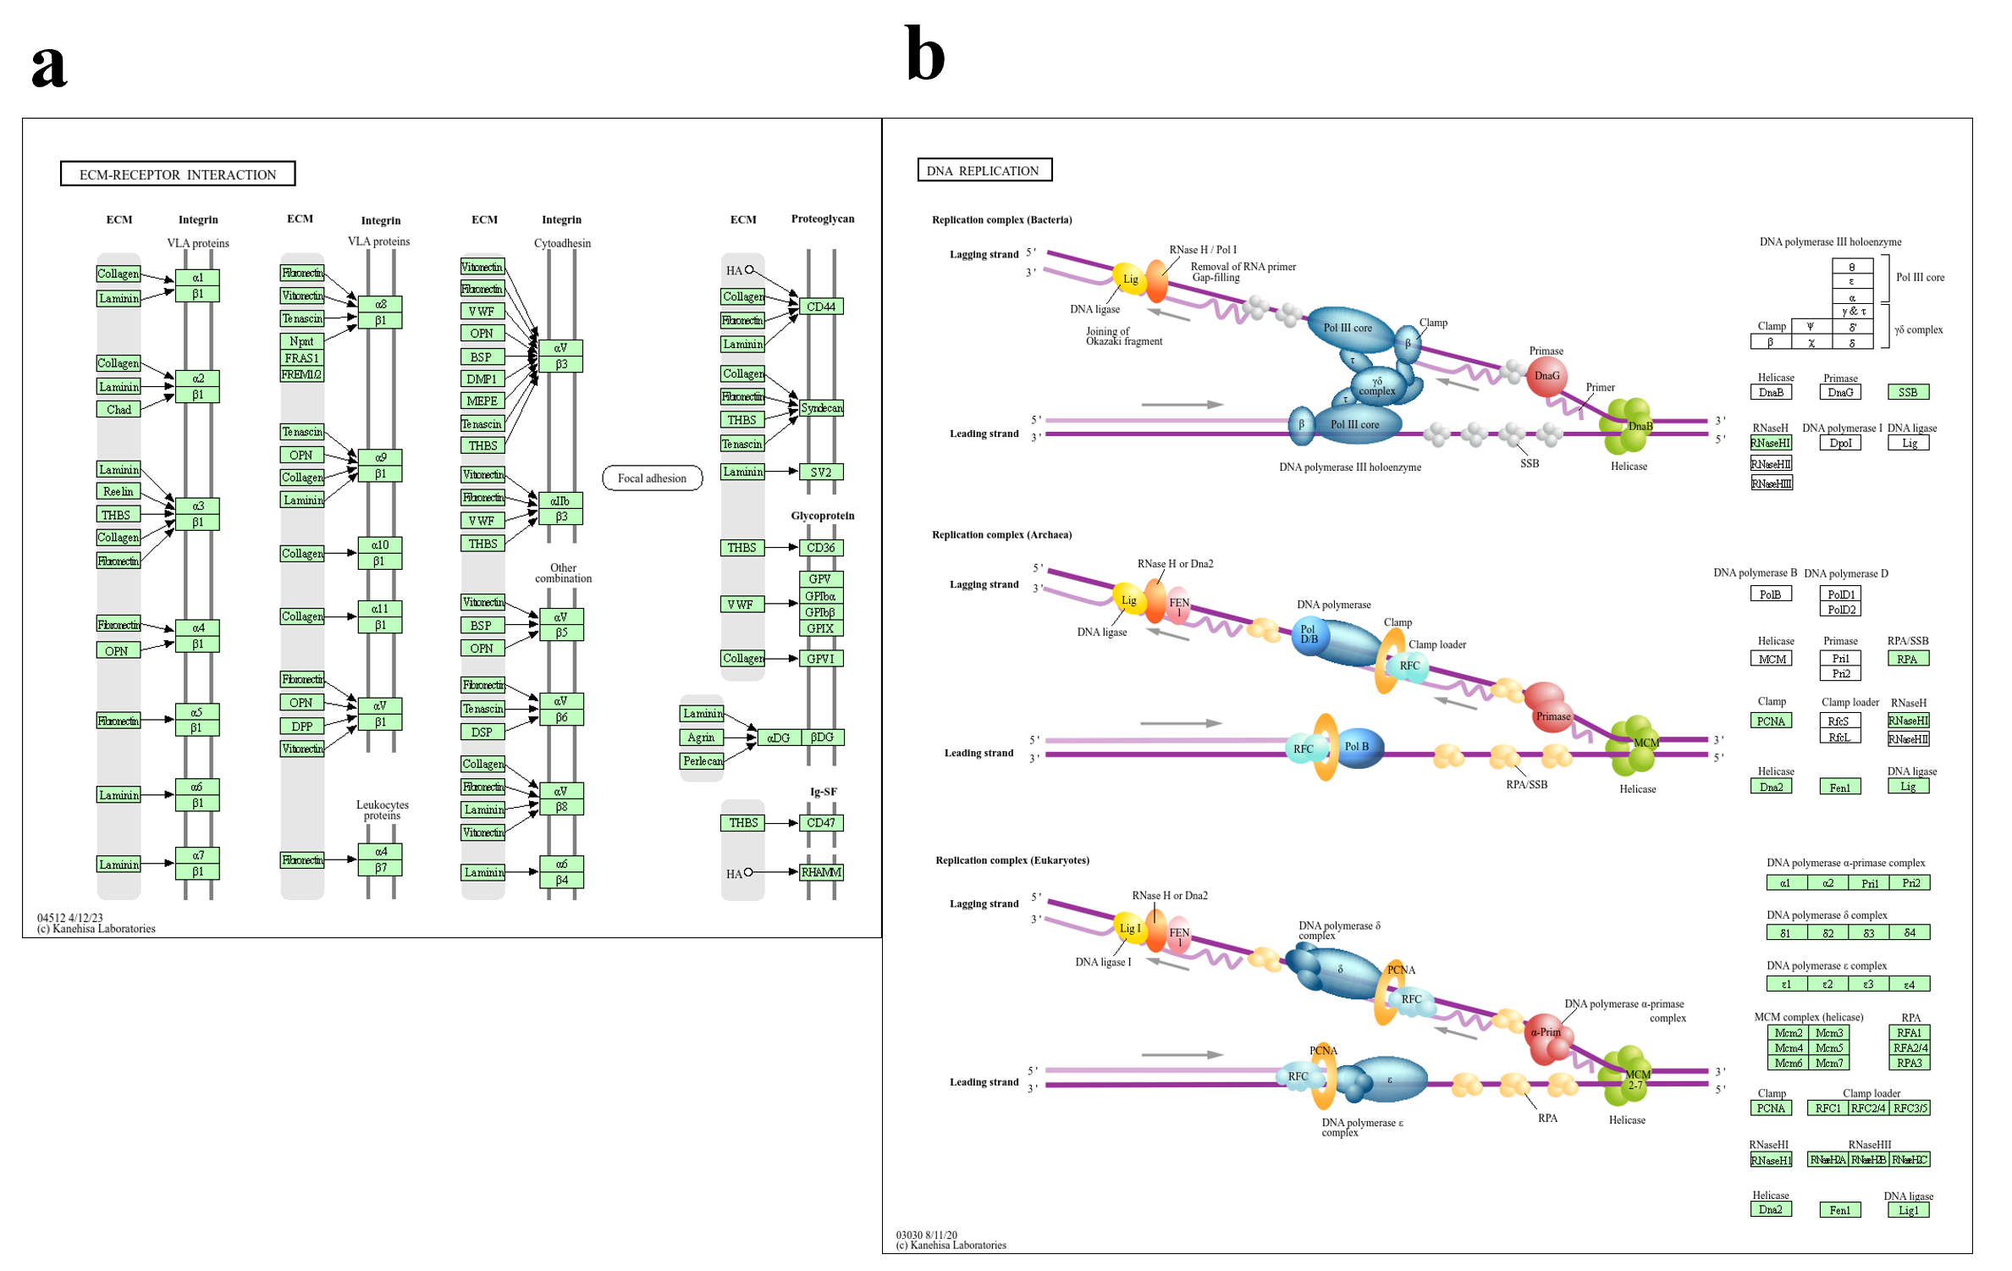
Additional Fig. 3: KEGG Mapper’s visualisation of a) the KEGG DNA replication pathway and b) the KEGG ECM-receptor interaction pathway. Differential genes (Entrez IDs) were mapped to KEGG pathways using KEGG Mapper’s “Search & Color Pathway” tool. Significant genes were submitted as a list to KEGG Mapper, which returned pathway diagrams with the corresponding gene boxes highlighted. These KEGG-provided images were then saved and used for pathway visualization.

