Supplemental Table 1. Community change points from TITAN for decreasing (z-) and increasing (z-) taxa for each environmental variable with the 5-95% quartile range.

 |  |  | Quartile
Variables | Inc./Dec. | Change Pt. | 0.05 | 0.1 | 0.5 | 0.9 | 0.95
Elevation  m | z- | 0.3 | 0 | 0 | 0.3 | 0.5 | 0.5
Elevation  m | z+ | 1.6 | 1.4 | 1.5 | 1.6 | 2.2 | 3.2
Na⁺  μg/g | z- | 265 | 264 | 265 | 303.5 | 342 | 733.5
Na⁺  μg/g | z+ | 3843 | 899.6 | 990.5 | 3843 | 4388 | 4459
Ca⁺ Mg⁺ μeq/g | z- | 44.5 | 6 | 6.1 | 44.5 | 78.8 | 81.3
Ca⁺ Mg⁺ μeq/g | z+ | 235.5 | 134.6 | 141.5 | 235.5 | 255 | 257.5

Supplemental Fig. 1 Log transformed soil Cl⁻ and Na⁺ ion concentrations (µg per gram of soil) from peninsula-wide survey are highly correlated. Regression line is generated using a linear model function.

Supplemental Fig. 2 Sodium, and calcium and magnesium are the primarily predictors of understory community composition. Non-metric multidimensional scaling (NMS) ordination analysis of Transect Survey plots only. Sodium, calcium and magnesium explains 69.9% herbaceous plant community composition. Open circles indicate each plot, and taxa names are weighted average abundance based on species presence. Significant environmental variables are fit as vectors (p < 0.05). The length of the arrow indicates a large degree of statistical significance. See Table 1 for statistics of NMS1 and NMS2, and see Table 3 for taxa full names.

Supplemental Fig. 3 Non-metric multidimensional scaling ordination analysis of Peninsula-wide Survey plots only. Salinity (Cl⁻, Na⁺, Ca⁺, Mg⁺ and SO₄⁻), nitrogen (NH₄⁺ and NO₃⁻) and elevation explain 56.1% of herbaceous plant community composition. Circles indicate each plot and taxa names are weighted average abundance based on species presence. Significant environmental variables are fit as vectors (p < 0.05). The length of the arrow indicates a large degree of statistical significance. See Table 1 for statistics of NMS1 and NMS2, and Table 3 for taxa full names.

Supplemental Fig. 4 Negative (gray) and positive (black) responding taxa from TITAN along the Σ Ca⁺ and Mg⁺ gradient. Grey dotted line denotes the summed z-scores for negative responding (z-) community change point, and the black dotted line denotes the summed z-scores for positive responding (z+) community change point. Points indicate the change-point for each species, which is sized by its indicator value (IndVal). Horizontal lines for each species indicate the 5-95% quartile range of that taxa.

Supplemental Fig. 5 Negative (black) and positive (gray) responding taxa from TITAN along the elevation gradient. Grey dotted line denotes the summed z-scores for negative responding (z-) community change point, and the black dotted line denotes the summed z-scores for positive responding (z+) community change point. In comparison to the other two gradients (Na⁺, Ca⁺ and Mg⁺), elevation is in reverse arrangement with decreasing taxa at lower elevations on the left, and increasing/sensitive taxa at higher elevations on the right. Points indicate the change-point for each species, which is sized by its indicator value (IndVal). Horizontal lines for each species indicate the 5-95% quartile range of that taxa.
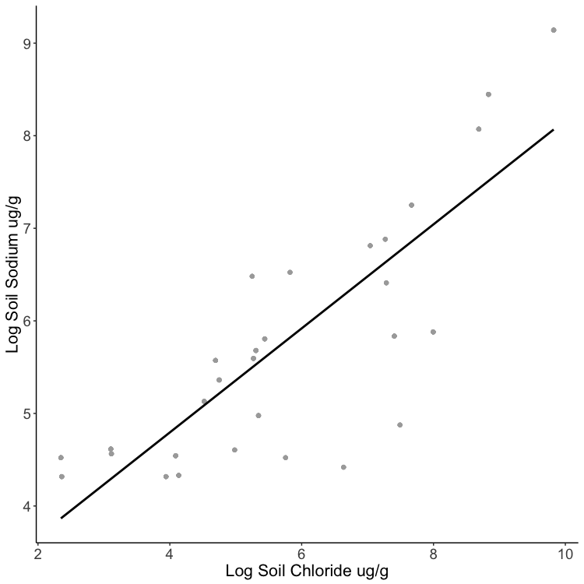
r² = 0.953

Supplemental Fig. 1
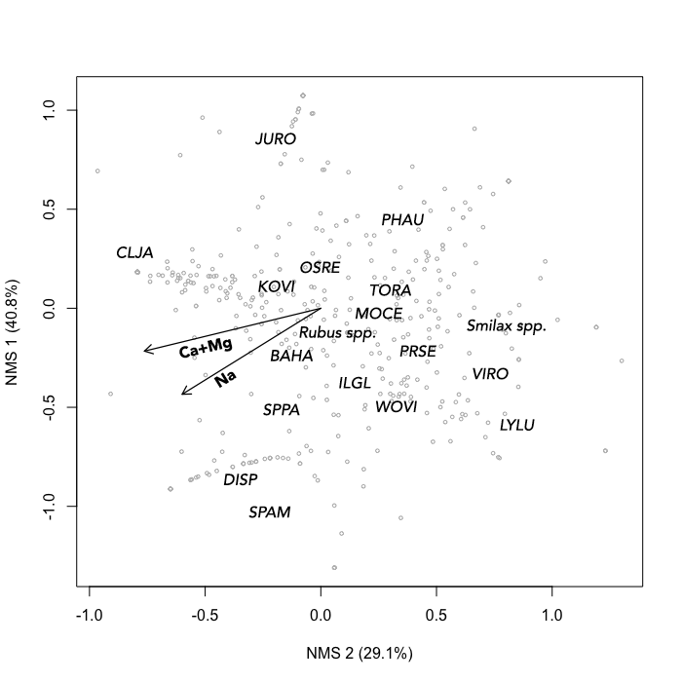
Supplemental Fig. 2
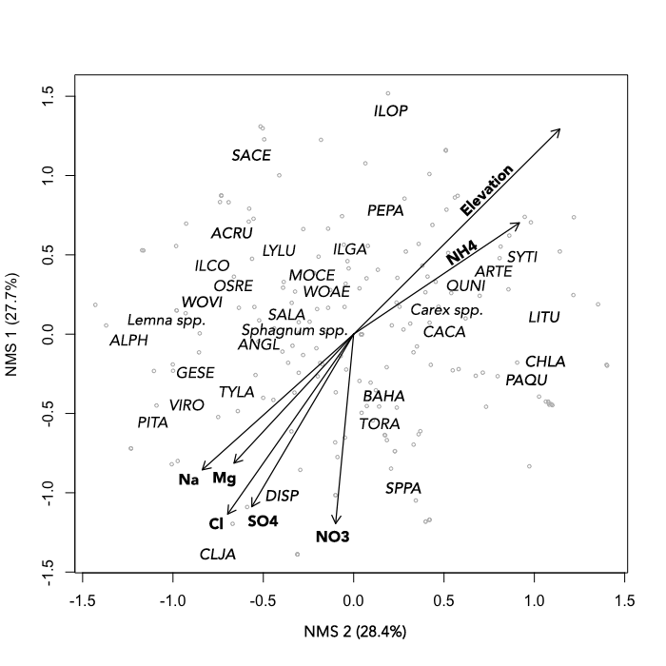
Supplemental Fig. 3
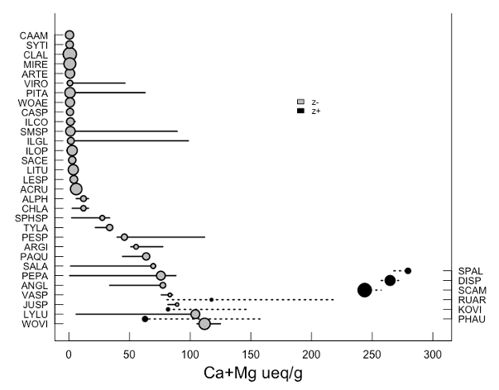

Supplemental Fig. 4
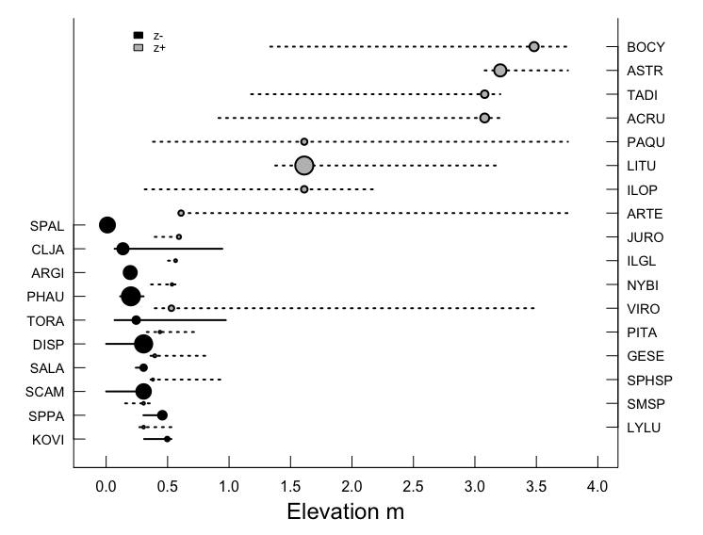
Supplemental Fig. 5

