Supplementary Materials

Supplementary Table S1: Summary of the nine volatile organic compounds (VOCs) emitted by herbivore damaged plants under no salt and salt conditions. Values represent the mean ± SEM of compound emissions (ng) for No Salt Herbivory and Salt Herbivory treatments. Chi square were derived from Anova (Type 2) of quasiPoisson generalized linear models (GLMs) comparing emission rates between treatments. Positive estimates indicate higher emissions under salt herbivory, while negative estimates indicate suppression. Significance was assessed using P-values from the GLMs (P < 0.05 considered significant, indicated with asterisks).
No. | Compound | Chi-square | P-value | No Salt Herbivory (ng, mean ± SE) | Salt Herbivory (ng, mean ± SE)
1 | Copaene Alpha | 160.8063 | <0.0001* | 2.436 ± 0.349 | 0.000 ± 0.000
2 | Oxime , Methoxy Phenyl | 17.0256 | 0.0008* | 1.517 ± 0.668 | 0.000 ± 0.000
3 | TMTT | 16.8385 | 0.0008* | 65.628 ± 16.225 | 16.087 ± 2.389
4 | Hexenol 3e | 16.5822 | 0.0008* | 0.848 ± 0.415 | 8.362 ± 2.194
5 | Eucarvone | 7.8582 | 0.0681 | 0.000 ± 0.000 | 0.678 ± 0.369
6 | Geranyl Acetone | 7.5728 | 0.0681 | 0.000 ± 0.000 | 0.618 ± 0.343
7 | Muurolene Alpha | 7.0451 | 0.0686 | 0.000 ± 0.000 | 0.229 ± 0.132
8 | Elemene Gamma | 6.5604 | 0.0758 | 0.238 ± 0.169 | 0.000 ± 0.000
9 | Hexenal 3z | 6.4674 | 0.0758 | 0.000 ± 0.000 | 1.489 ± 0.894
10 | Indole | 5.412 | 0.1254 | 3.043 ± 1.107 | 0.820 ± 0.338
11 | Linalool | 5.1157 | 0.1266 | 0.000 ± 0.000 | 0.626 ± 0.423
12 | Nonane N | 4.8834 | 0.1266 | 0.000 ± 0.000 | 1.216 ± 0.840
13 | P Cumenol | 4.8728 | 0.1266 | 0.000 ± 0.000 | 0.114 ± 0.079
14 | Nerolidol Z | 4.8573 | 0.1266 | 0.000 ± 0.000 | 0.207 ± 0.143
15 | 4 Oxohex 2 Enal | 4.7199 | 0.1286 | 0.000 ± 0.000 | 0.735 ± 0.517
16 | D Elemene | 4.5234 | 0.1357 | 0.000 ± 0.000 | 0.210 ± 0.151
17 | Hexenol 3z | 4.3828 | 0.1392 | 0.000 ± 0.000 | 0.953 ± 0.695
18 | Viridiflorene | 4.221 | 0.1427 | 0.386 ± 0.166 | 0.073 ± 0.057
19 | Selina 3,7(11) Diene | 4.1616 | 0.1427 | 0.000 ± 0.000 | 0.137 ± 0.103
20 | 4,8,12 Trimethyl 1,3(Z),7(E),11 Tridecatetraene (Ej Ren) | 3.3036 | 0.1823 | 0.092 ± 0.092 | 0.000 ± 0.000
21 | Nonanal | 3.3036 | 0.1823 | 0.594 ± 0.594 | 0.000 ± 0.000
22 | Cumenol O | 3.3036 | 0.1823 | 0.075 ± 0.075 | 0.000 ± 0.000
23 | Gurjunene Gamma | 3.3036 | 0.1823 | 0.025 ± 0.025 | 0.000 ± 0.000
24 | Cumenol M | 3.3036 | 0.1823 | 0.059 ± 0.059 | 0.000 ± 0.000
25 | P Cymene | 3.3036 | 0.1823 | 0.151 ± 0.151 | 0.000 ± 0.000
26 | O Cymene | 3.2519 | 0.1823 | 6.182 ± 2.729 | 1.702 ± 0.973
27 | Caryophyllene | 2.9566 | 0.2108 | 7.782 ± 6.463 | 0.631 ± 0.419
28 | Nonanoic Acid | 2.8477 | 0.2146 | 2.979 ± 0.914 | 1.229 ± 0.555
29 | Guaiadiene 6,9 | 2.8027 | 0.2146 | 2.364 ± 0.511 | 1.146 ± 0.462
30 | Caryophyllene Oxide | 2.764 | 0.2146 | 1.799 ± 0.614 | 0.749 ± 0.306
31 | Ocimene (E) Beta | 2.5844 | 0.2327 | 15.361 ± 2.063 | 21.238 ± 3.006
32 | Pinene Beta | 2.4817 | 0.2408 | 2.191 ± 0.509 | 1.083 ± 0.442
33 | Thujene Alpha | 2.3322 | 0.2498 | 0.000 ± 0.000 | 0.186 ± 0.186
34 | Phellandrene Beta | 2.3322 | 0.2498 | 0.000 ± 0.000 | 11.574 ± 11.574
35 | Jasmone Z | 2.267 | 0.2523 | 0.310 ± 0.156 | 0.069 ± 0.069
36 | Humulene Alpha | 1.8153 | 0.323 | 7.335 ± 1.664 | 4.895 ± 0.956
37 | Cymene Ortho | 1.5303 | 0.3823 | 22.926 ± 5.637 | 43.197 ± 16.184
38 | Elemene Beta | 1.3586 | 0.4205 | 1.098 ± 0.300 | 0.626 ± 0.259
39 | Terpinolene | 1.2752 | 0.4355 | 5.389 ± 1.048 | 8.020 ± 2.100
40 | Germacrene B | 0.6665 | 0.6622 | 0.232 ± 0.098 | 0.122 ± 0.086
41 | Sylvestrene Iso | 0.6612 | 0.6622 | 0.087 ± 0.087 | 0.211 ± 0.124
42 | Beta Myrcene | 0.644 | 0.6622 | 19.069 ± 4.746 | 14.408 ± 3.542
43 | Decanal N | 0.5334 | 0.7133 | 6.412 ± 1.171 | 7.596 ± 1.118
44 | B Elemene | 0.4814 | 0.7317 | 25.001 ± 5.817 | 20.348 ± 3.802
45 | Nonanal N | 0.4146 | 0.7602 | 10.261 ± 1.858 | 11.838 ± 1.604
46 | Decanal | 0.392 | 0.7602 | 0.730 ± 0.300 | 0.446 ± 0.311
47 | Cymene Para | 0.3758 | 0.7602 | 8.130 ± 4.464 | 5.289 ± 2.266
48 | P Cymene | 0.3029 | 0.8032 | 7.719 ± 4.276 | 4.922 ± 2.986
49 | Pinene Alpha | 0.2521 | 0.8329 | 47.453 ± 7.343 | 41.467 ± 8.934
50 | Dodecanal | 0.1923 | 0.8559 | 0.347 ± 0.240 | 0.511 ± 0.286
51 | Isoledene | 0.1818 | 0.8559 | 0.137 ± 0.080 | 0.090 ± 0.073
52 | Terpinene Gamma | 0.1511 | 0.875 | 6.149 ± 2.032 | 7.480 ± 2.714
53 | Methyl Salicylate | 0.1214 | 0.8795 | 1.361 ± 0.510 | 1.168 ± 0.278
54 | Germacrene D | 0.1183 | 0.8795 | 1.843 ± 0.526 | 1.600 ± 0.473
55 | Cumene | 0.0983 | 0.8795 | 7.162 ± 3.015 | 5.959 ± 2.438
56 | Sabinene | 0.0786 | 0.8795 | 687.928 ± 91.762 | 734.342 ± 133.336
57 | Elemene Delta | 0.0738 | 0.8795 | 6.086 ± 1.518 | 5.407 ± 1.891
58 | Isospathulenol | 0.0707 | 0.8795 | 3.536 ± 0.592 | 3.763 ± 0.608
59 | Geranyl Linalool E,E | 0.0481 | 0.9051 | 1.076 ± 0.576 | 0.920 ± 0.440
60 | Jasmone E | 0.0252 | 0.9423 | 0.536 ± 0.379 | 0.471 ± 0.202
61 | 1,7,7 Trimethyl 2 Vinylbicyclo[2 2 1]Hept 2 Ene | 0.0123 | 0.9509 | 0.332 ± 0.239 | 0.303 ± 0.142
62 | Phellandrene Alpha | 0.0109 | 0.9509 | 43.921 ± 9.999 | 41.818 ± 16.460
63 | Terpinene Alpha | 0.0093 | 0.9509 | 0.883 ± 0.484 | 0.816 ± 0.487
64 | Premnaspirodiene | 0.0023 | 0.9758 | 0.078 ± 0.078 | 0.083 ± 0.083
65 | Myrcene | 0.0001 | 0.9921 | 7.123 ± 2.483 | 7.091 ± 2.037

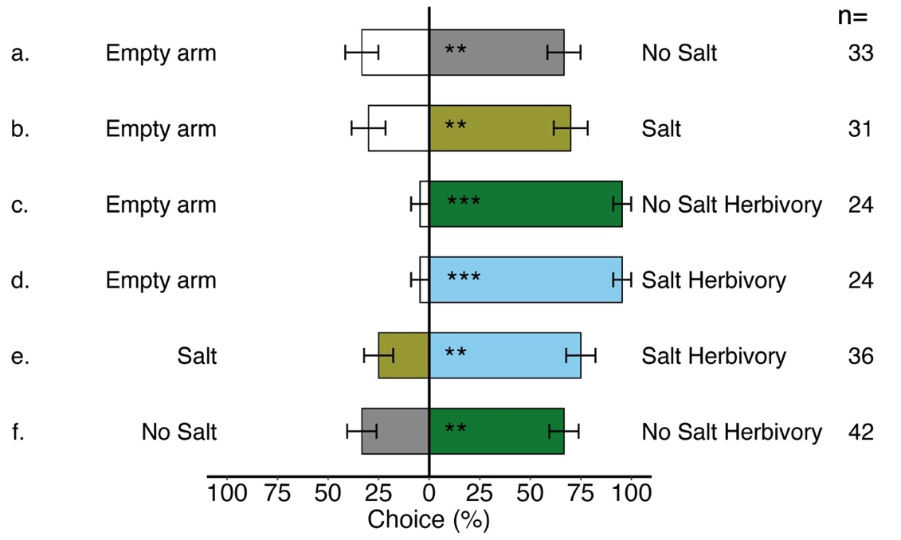
Supplementary Fig. S1 The percentage of M. croicepes wasps choices in a Y-tube olfactometer experimental setup, with error bars representing the standard error of the mean. Significance levels: asterisks (** P < 0.001, *** P < 0.0001).

