Supplementary Appendix

Table S1: Detailed search strings for all databases and registers
Database | Search string | Articles retrieved
PubMed/MEDLINE | ("Percutaneous Coronary Intervention"[MeSH Terms] OR "Drug-Eluting Stents"[MeSH Terms] OR "Percutaneous Coronary Intervention"[Title/Abstract] OR "PCI"[Title/Abstract] OR "coronary angioplasty"[Title/Abstract] OR "stent*"[Title/Abstract] OR "drug eluting stent*"[Title/Abstract]) AND ("Clopidogrel"[MeSH Terms] OR "Prasugrel Hydrochloride"[MeSH Terms] OR "Ticagrelor"[MeSH Terms] OR "Platelet Aggregation Inhibitors"[MeSH Terms] OR "Clopidogrel"[Title/Abstract] OR "prasugrel"[Title/Abstract] OR "Ticagrelor"[Title/Abstract] OR "p2y12 inhibitor*"[Title/Abstract] OR "adenosine diphosphate receptor antagonist*"[Title/Abstract]) AND ("Aspirin"[MeSH Terms] OR "Aspirin"[Title/Abstract] OR "acetylsalicylic acid"[Title/Abstract]) AND ("Monotherapy"[Title/Abstract] OR "single antiplatelet therapy"[Title/Abstract] OR "SAPT"[Title/Abstract]) AND ("randomized controlled trial"[Publication Type] OR "randomized"[Title/Abstract] OR "randomised"[Title/Abstract] OR "randomly"[Title/Abstract] OR "trial"[Title/Abstract]) | 298
Embase | ('percutaneous coronary intervention'/exp OR 'coronary angioplasty'/exp OR 'drug eluting stent'/exp  OR (PCI OR "percutaneous coronary intervention" OR "coronary angioplasty" OR stent* OR "drug-eluting stent*"):ti,ab)  AND  ('clopidogrel'/exp OR 'prasugrel'/exp OR 'ticagrelor'/exp OR 'platelet aggregation inhibitor'/exp  OR (clopidogrel OR prasugrel OR ticagrelor OR "P2Y12 inhibitor*" OR "adenosine diphosphate receptor antagonist*"):ti,ab)  AND  ('aspirin'/exp OR 'acetylsalicylic acid'/exp OR (aspirin OR "acetylsalicylic acid"):ti,ab)  AND  (monotherapy:ti,ab OR "single antiplatelet therapy":ti,ab OR SAPT:ti,ab)  AND  ('randomized controlled trial'/exp OR random*:ti,ab OR trial:ti,ab) | 648
Cochrane Central Register of RCTs | (percutaneous coronary intervention OR PCI OR coronary angioplasty OR stent OR "drug-eluting stent")  AND  (clopidogrel OR prasugrel OR ticagrelor OR "P2Y12 inhibitor")  AND  (aspirin OR "acetylsalicylic acid")  AND  (monotherapy OR "single antiplatelet therapy" OR SAPT) | 345
Clinicaltrials.gov | (percutaneous coronary intervention OR PCI OR coronary angioplasty OR stent OR "drug-eluting stent") AND  (clopidogrel OR prasugrel OR ticagrelor OR "P2Y12 inhibitor")  AND (aspirin OR "acetylsalicylic acid") AND (monotherapy OR "single antiplatelet therapy" OR SAPT) | 7

Figure S1. Effect of P2Y12 inhibitor monotherapy versus aspirin monotherapy on all-cause mortality

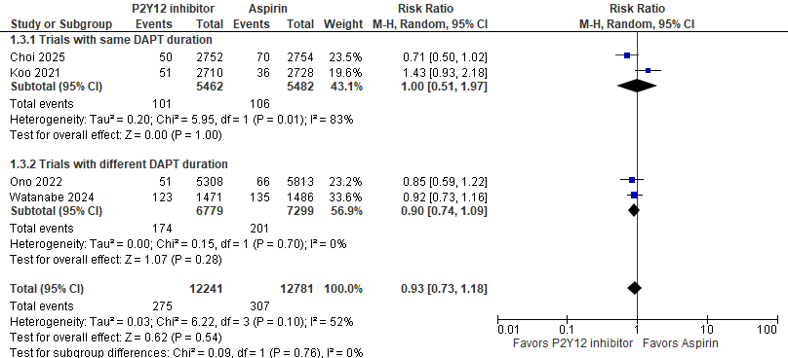

Figure S2. Effect of P2Y12 inhibitor monotherapy versus aspirin monotherapy on cardiovascular mortality
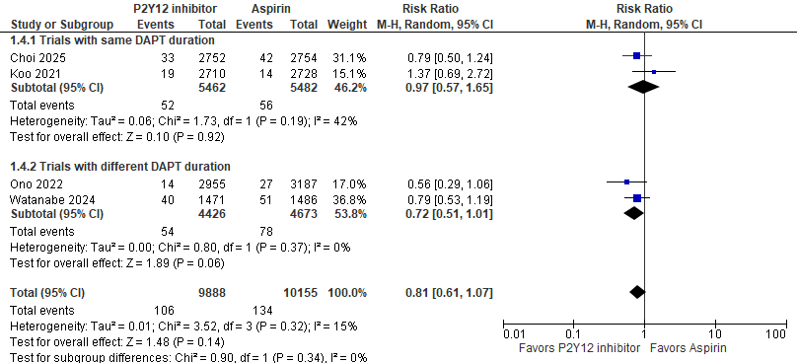

Figure S3. Effect of P2Y12 inhibitor monotherapy versus aspirin monotherapy on myocardial infarction
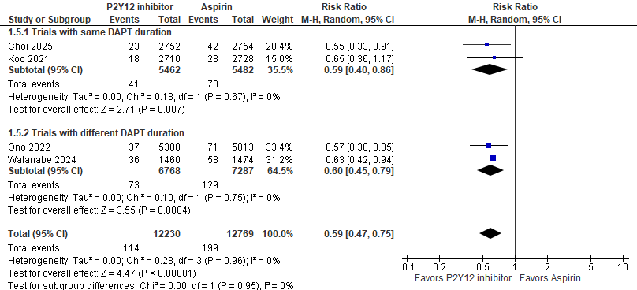

Figure S4. Effect of P2Y12 inhibitor monotherapy versus aspirin monotherapy for any stroke

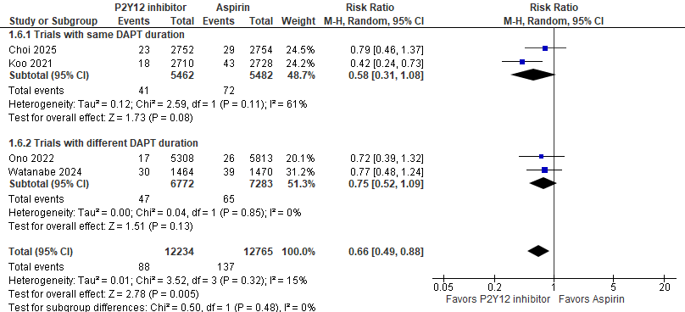

Figure S5. Effect of P2Y12 inhibitor monotherapy versus aspirin monotherapy for ischemic stroke

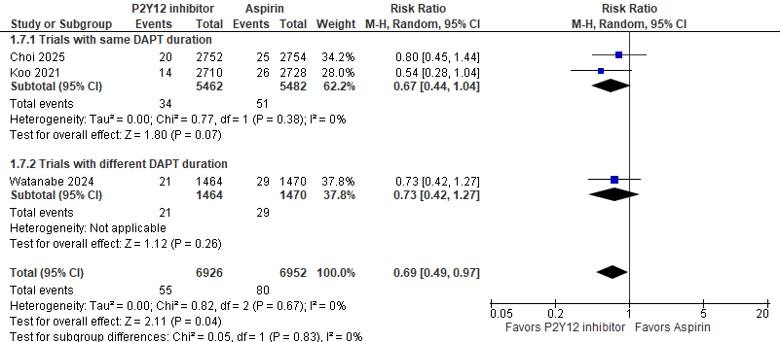

Figure S6. Effect of P2Y12 inhibitor monotherapy versus aspirin monotherapy for hemorrhagic stroke
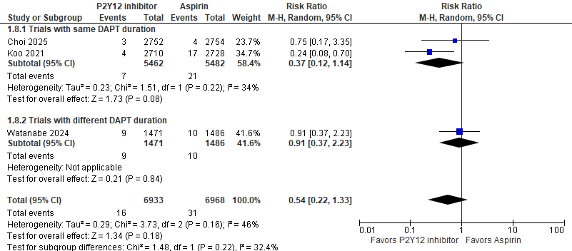

Figure S7. Effect of P2Y12 inhibitor monotherapy versus aspirin monotherapy for stent thrombosis

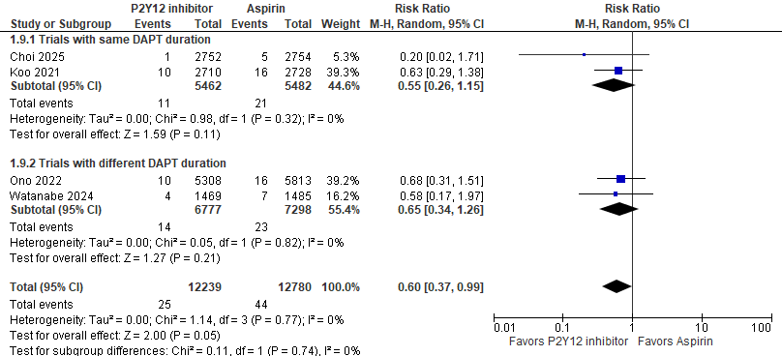

Figure S8. Effect of P2Y12 inhibitor monotherapy versus aspirin monotherapy for any revascularization
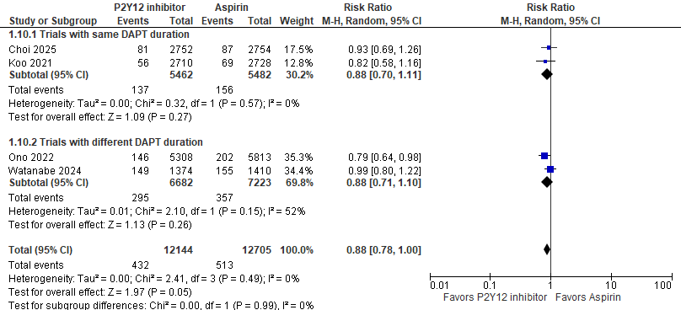

Figure S9. Effect of P2Y12 inhibitor monotherapy versus aspirin monotherapy for target lesion revascularization

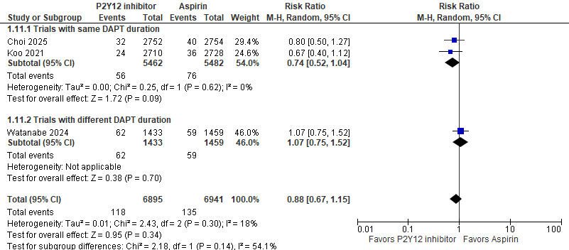

Figure S10. Effect of P2Y12 inhibitor monotherapy versus aspirin monotherapy for target vessel revascularization

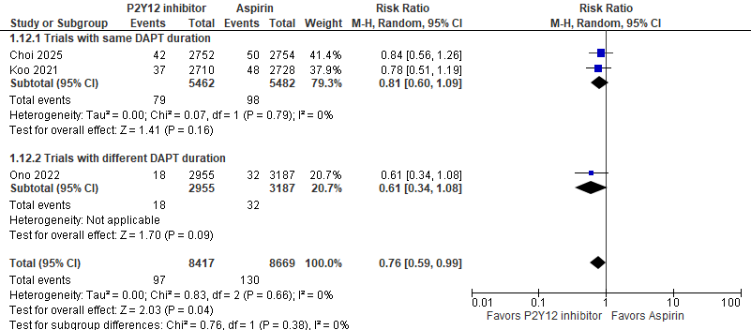

Figure S11. Effect of P2Y12 inhibitor monotherapy versus aspirin monotherapy for any bleeding
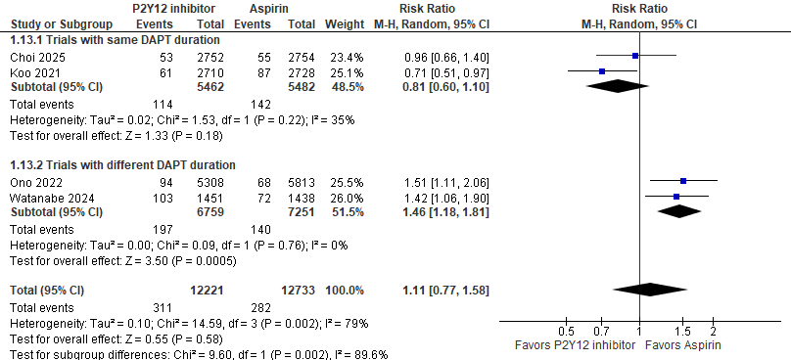

Figure S12. Effect of P2Y12 inhibitor monotherapy versus aspirin monotherapy for major bleeding
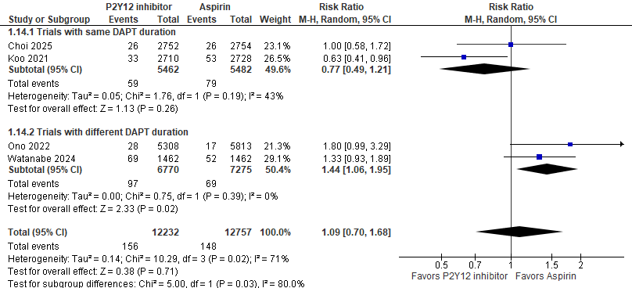

Figure S13. Effect of P2Y12 inhibitor monotherapy versus aspirin monotherapy for gastrointestinal bleeding
