Table S1. Strength of edges in the AIR, LM and AIA network
Edge | Partial correlation coefficient
Ability-Extrinsic Motivation | 0.15
Ability- Learning | -0.15
Intrinsic Motivation-learning | -0.14
Intrinsic Motivation- Job Replacement | -0.13
Cognition- Learning | -0.12
Intrinsic Motivation-Sociotechnical Blind | -0.11
Cognition- Intrinsic Motivation | 0.11
Extrinsic Motivation- Learning | -0.11
Ability- Sociotechnical Blind | -0.09
Ability- AI Configuration | -0.08
Intrinsic Motivation- AI Configuration | -0.08
Cognition- AI Configuration | -0.08
Vision- Sociotechnical Blind | -0.07
Extrinsic Motivation- Sociotechnical Blind | -0.07
Ethics- Job Replacement | -0.07
Cognition- Sociotechnical Blind | -0.07
Extrinsic Motivation- Sociotechnical Blind | -0.06
Ability- Intrinsic Motivation | 0.06
Vision- Extrinsic Motivation | 0.06
Vision- Job Replacement | -0.06
Vision- Intrinsic Motivation | 0.06
Ability- Job Replacement | -0.06
Vision- AI Configuration | -0.05
Cognition- Extrinsic Motivation | 0.05
Cognition- Job Replacement | -0.05
Ethics- AI Configuration | -0.05
Ethics- Learning | -0.04
Vision- Learning | -0.04
Ethics- Extrinsic Motivation | 0.01
Ethics- Sociotechnical Blind | -0.00

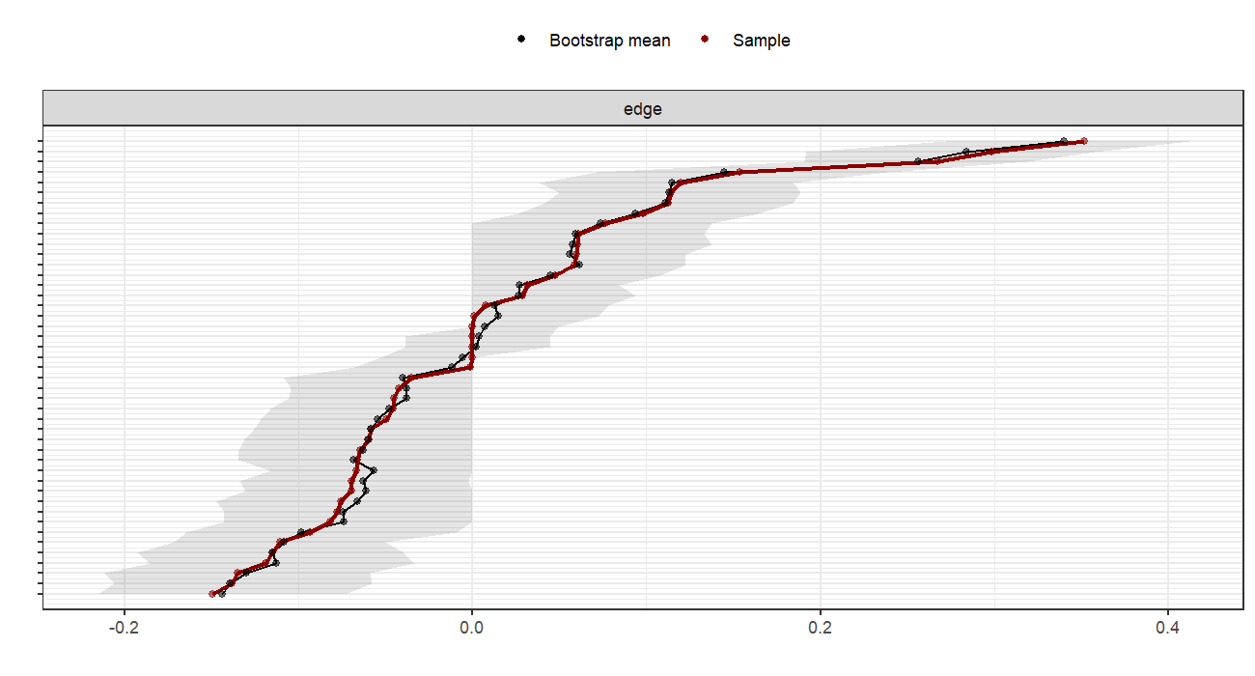Fig. S1 Accuracy of edge weight in the AIR-LM-AIA network.

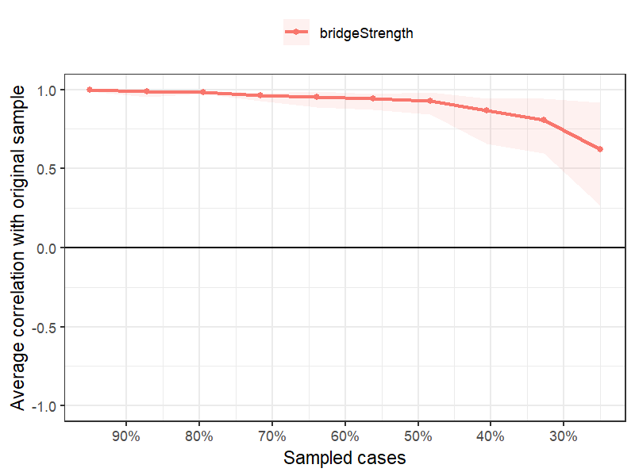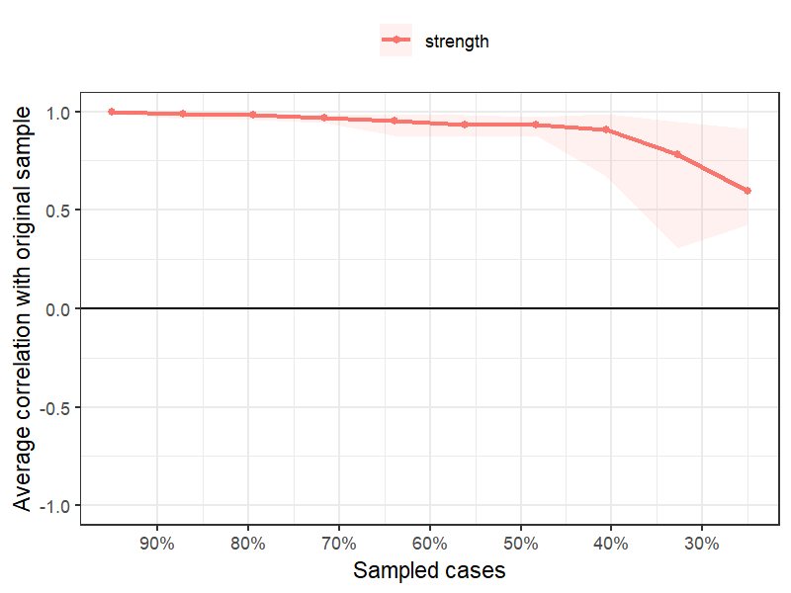
Fig. S2 Stability in the AIR-LM-AIA network

