SUPPLEMANTARY INFORMATION
Theoretical Information
Reactivities of molecules can be determined global reactivity parameters. According to Koopman’s Theorem, the energies of highest occupied molecular orbital (E_{HOMO}) and lowest unoccupied molecular orbital (E_{LUMO}) are used to calculate the chemical potential and hardness reactivity parameters. The electrophilicity index, ω introduced by Parr and it was calculated by using the chemical potential and hardness [1,2]. Softness has a inverse relationship with hardness value. Using the following relations the properties such as Chemical potential (μ), Electrophilicity index (ω), Global hardness (η), and Softness (S) are calculated [1,2]
$µ=\frac{E_{LUMO}+E_{HOMO}}{2}$$=\frac{E_{LUMO}-E_{HOMO}}{2}$ (1)

$ƞ=\frac{E_{LUMO}-E_{HOMO}}{2}$ (2)

$s=\frac{1}{2.η}$ (3)

$ω=\frac{µ^{2}}{2.}$ (4)

Light harvesting efficiency (LHE) is used parameter in order to discuss suitability of a compound use as a DSSC [3, 4]. The optical stability of a compound is determined by using the excited state lifetime (τ) factor [5]. LHE and the excited lifetime can be calculated as follows:
$LHE=1-{10}^{-f}$ (5)
$τ= \frac{1.499}{fE_{ex}^{2}}$ (6)
In these equations $f$ is the oscillator strength and E_{ex} is excitation energy. Power conversion efficiency of a compound rlies on injection driving force (ΔG_{inj}) which is the injection of electrons into the semiconductor’s conduction bond from the excited state of dye. Moreover driving force of dye regeneration (ΔG_{reg}) is meaning of the ability of an oxidized compound to recover electrons from electrolyte after photoexcitation In order to get high efficiency from a compound as a DSSC both ΔG_{inj} and ΔG_{reg} should be negative value. ΔG_{inj} and ΔG_{reg} can be calculated as follows:
$ΔG_{inj}= E_{dye}^{*}-E_{CB}$ (7)
$ΔG_{reg}= E_{I^{-}/I_{3}^{-}}{-E}_{dye}$ (8)
where $E_{dye}^{*}$ is the oxidation potential of a compound as a dye in the exicited state, $E_{CB}$ is the experimentally determined conduction bond energy of TiO₂ (usually -4.00 eV) and $E_{I^{-}/I_{3}^{-}}$ redox potential of electrolyte. $E_{dye}^{*}$ can be determined as [4, 6, 7]:
$E_{dye}^{*}=E_{dye}- E_{ex}$ (9)
where $E_{dye}$is the oxidation potential of a compound that equals the negative value of HOMO and $E_{ex}$ is the excitation energy [4, 7].
Scheme SI.1 Synthesis scheme of A1-Br₂ and A1 compound

Scheme SI. 2 Synthesis scheme of compound A3

Scheme SI. 3 Synthesis scheme of compound B1

Scheme SI.4 Synthesis scheme of compound B3

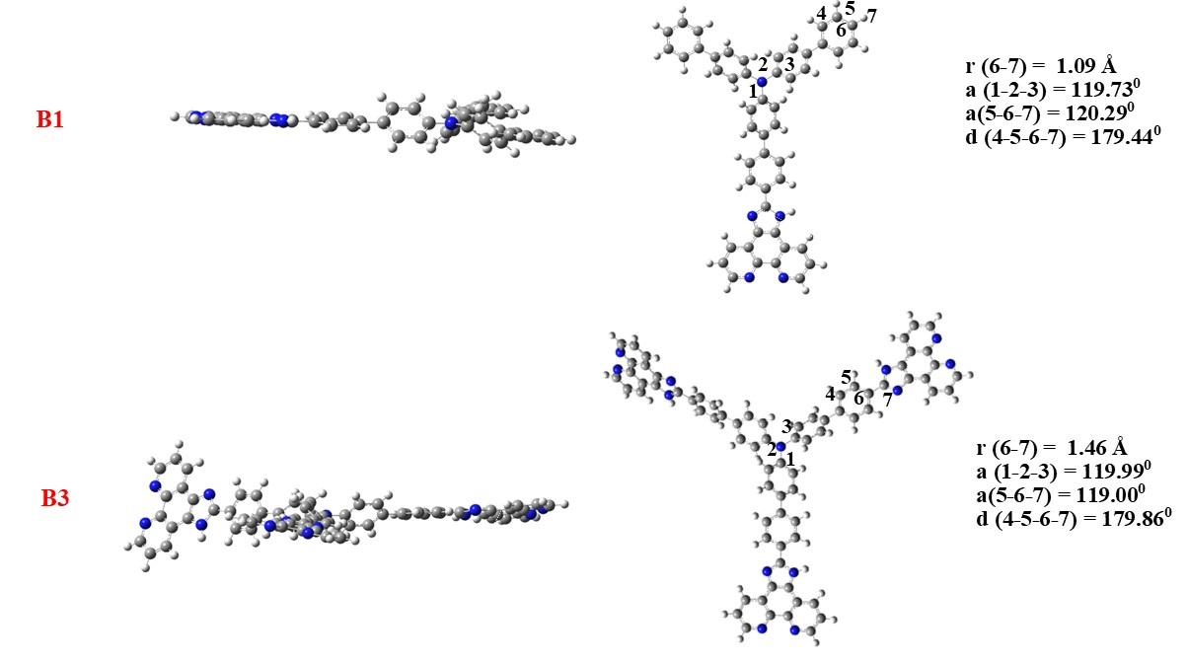
Figure SI.1 Optimized Geometries of B1 and B3

Figure SI.2 Changing of Dipole Moments of B1 and B3 for different phases

Figure SI.3 Molecular orbitals of B1 from HOMO-1 to LUMO+4
Figure SI.4 Molecular orbitals of B3 from HOMO-3 to LUMO+11
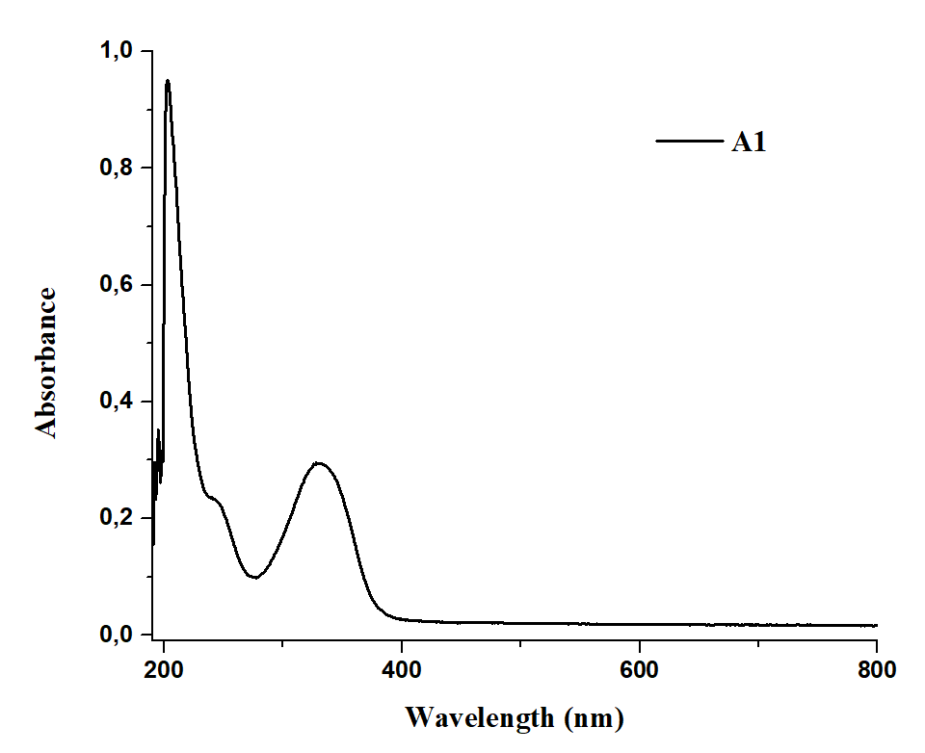
Figure SI.5 UV-Visible spectrum of compound A1

Figure SI.6 UV-Visible spectrum of compound A3

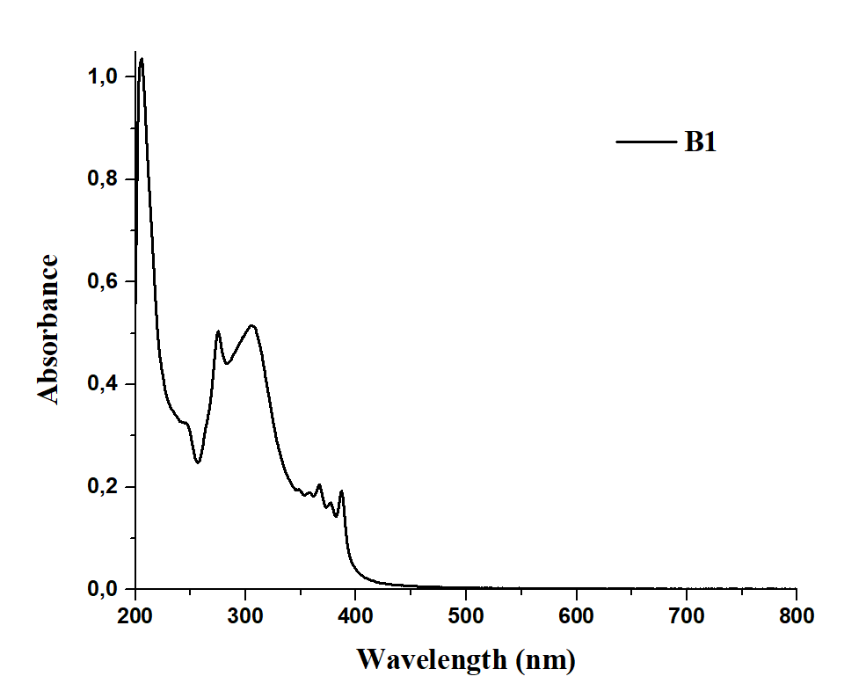
Figure SI.7 UV-Visible spectrum of compound B1

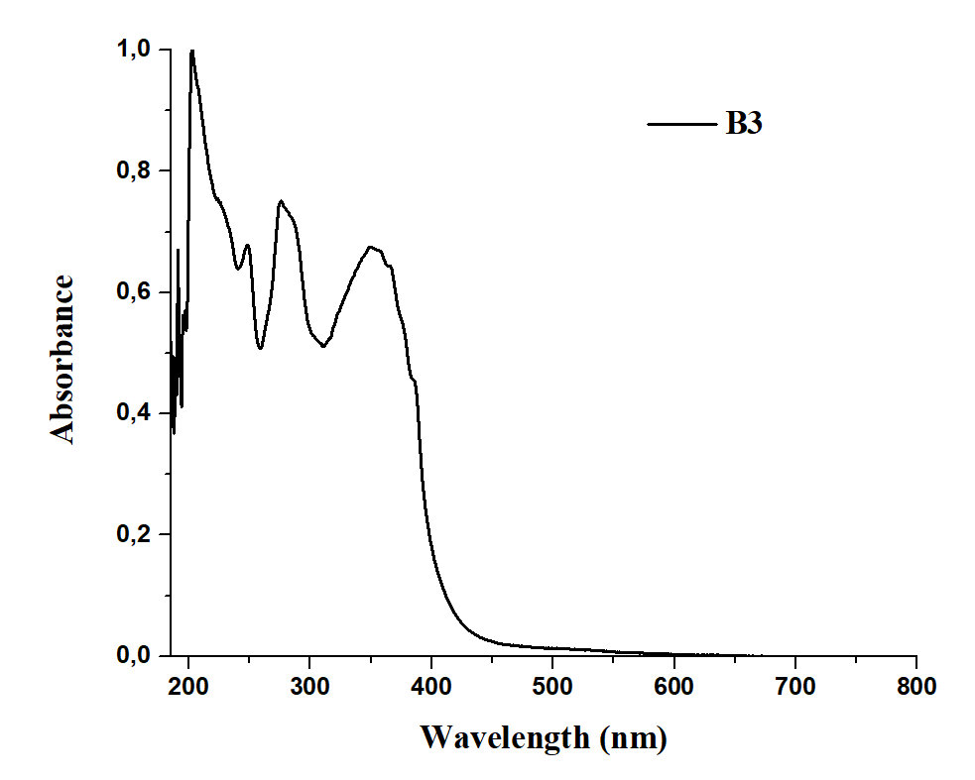
Figure SI.8 UV-Visible spectrum of compound B3

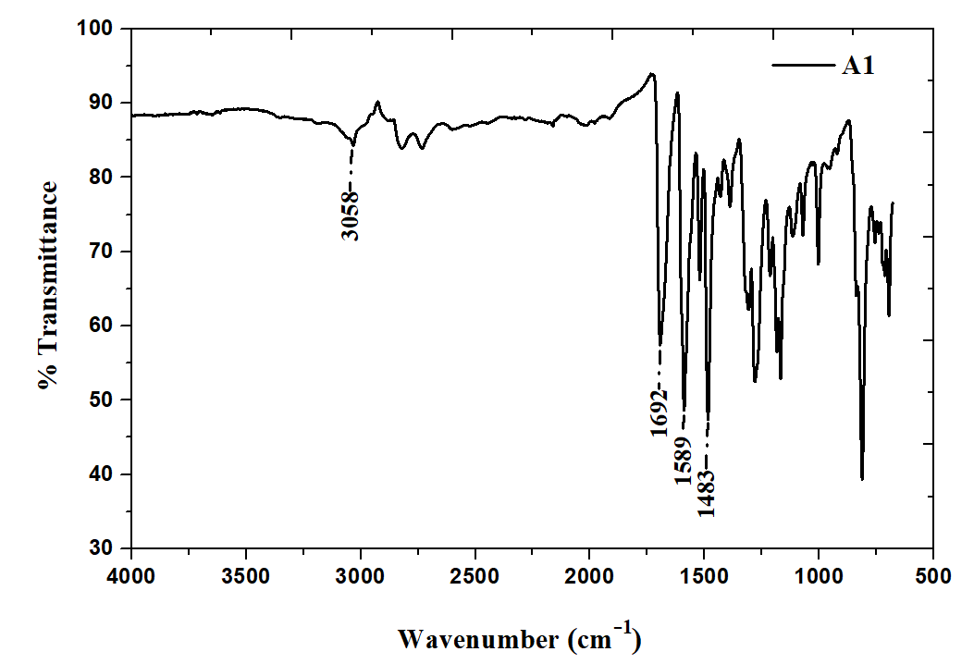
Figure SI.9 FTIR spectrum of compound A1

Figure SI.10 FTIR spectrum of compound A3

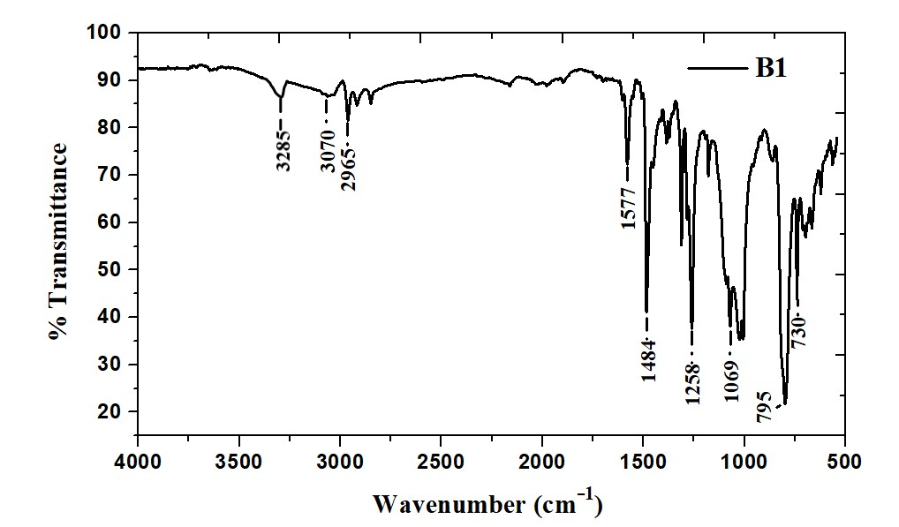
Figure SI.11 FTIR spectrum of compound B1
Figure SI.12 FTIR spectrum of compound B3

Table SI.1 Calculated IR Results of Compounds
 | B1 |  | B3
 | Calculated  (cm⁻¹) | Experimental  (cm⁻¹) | Calculated  (cm⁻¹) | Experimental  (cm⁻¹)
γ_{C-H (benzene)} | 3059.30 | 3070 | 3079.73 | 3080
γ_{N-H (imidazole)} | 3526.45 | 3285 | 3526.99 | 3290
γ_{C=N} | 1492.80 | 1577 | 1493.47 | 1595
γ_{C=C} | 1508.91 | 1484 | 1518.75 | 1470

Table SI.2 Calculated NMR Results of Compounds
 | B1 |  | B3
 | Calculated  (ppm) | Experimental  (ppm) | Calculated  (ppm) | Experimental  (ppm)
H_{imidazole} | 9.41 | 8.95 | 9.49- 9.46 | 9.67

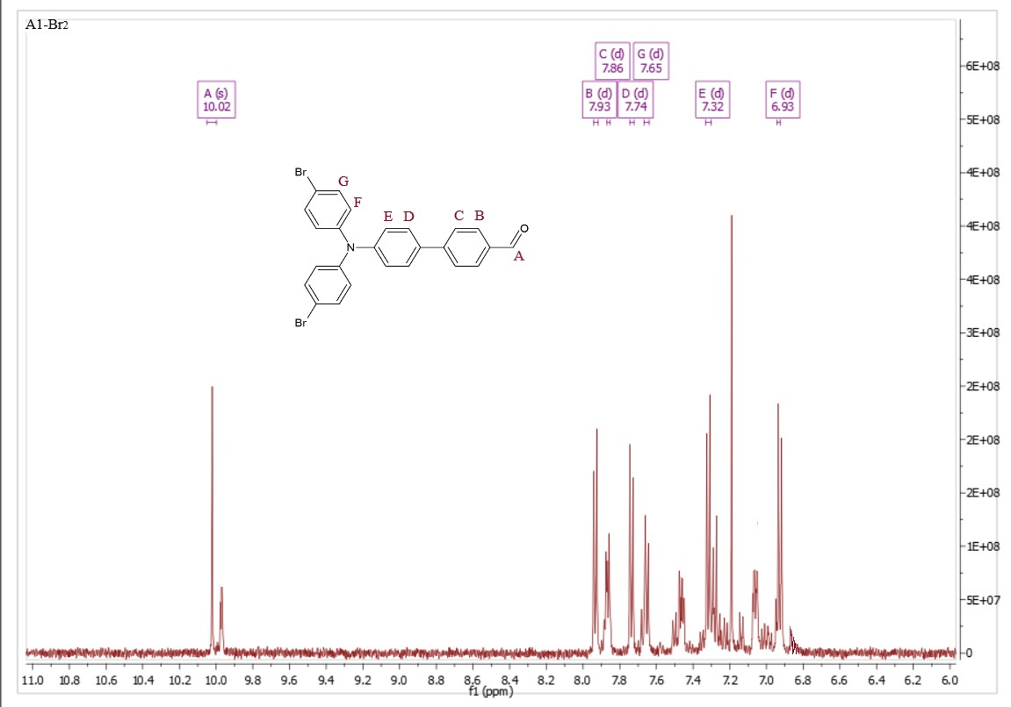
Figure SI.13 ¹H-NMR spectrum of A1-Br₂ compound

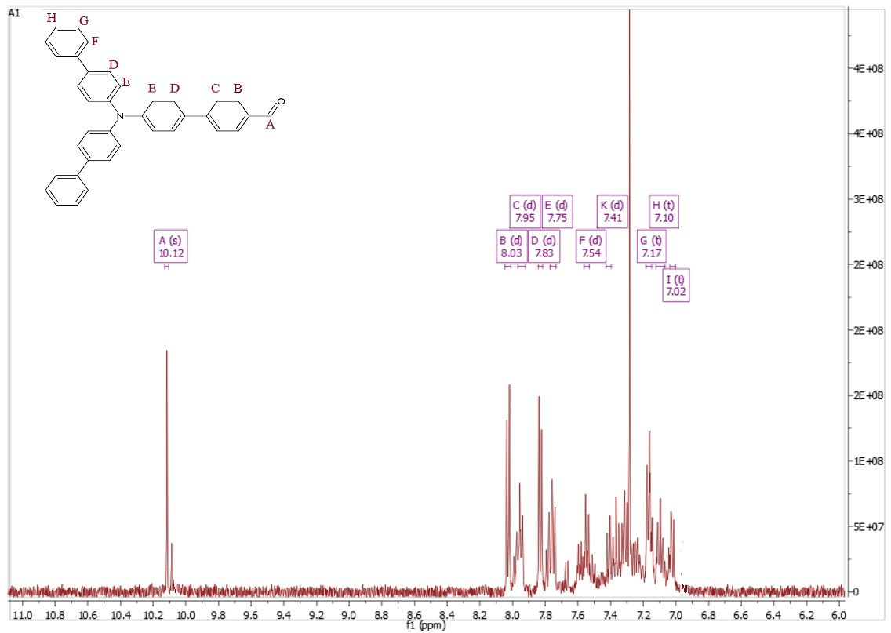
Figure SI.14 ¹H-NMR spectrum of A1 compound
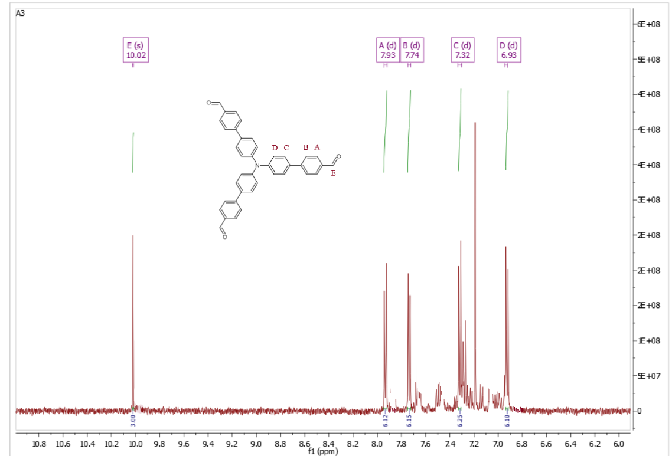
Figure SI.15 ¹H-NMR spectrum of A3 compound

Figure SI.16 ¹H-NMR spectrum of B1 compound
Figure SI.17 ¹H-NMR spectrum of B3 compound

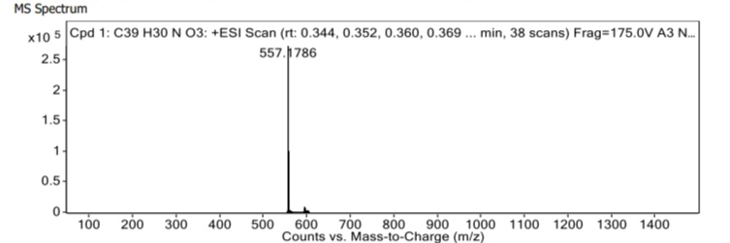
Figure SI.18 Q-Tof result of compound A3, Q-TOF ESI MS m/z [M+]: 557.18 g/mol

Figure SI.19 MALDI TOF spectrum of compound B1, MALDI-TOF [M⁺¹]+5H 697

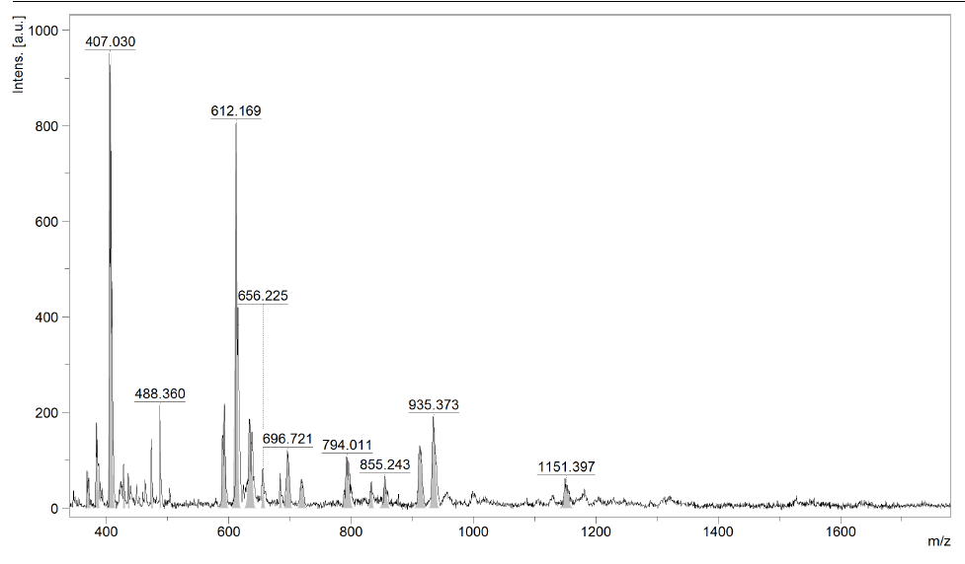
Figure SI.20 MALDI TOF spectrum of compound B3, MALDI-TOF [M⁺¹]Na⁺ 1151

REFERENCES
[1] Domingo LR, Pérez P (2011) Org. Biomol. Chem. 9:7168.
[2] Geerlings P, De Proft F, Langenaeker W (2003) Chem. Rev. 103:1793–1874.
[3] Samiee S, Hossienpour P (2019) Inorg. Chim. Acta 494:13–20.
[4] Britel O, Fitri A, Benjelloun AT, Benzakour M, Mcharfi M (2023) Struct. Chem. 34:1827–1842.
[5] Yüzer AC, Kurtay G, Ince T, Yurtdaş S, Harputlu E, Ocakoğlu K, Güllü M, Tozlu C, Ince M (2021) Mater. Sci. Semicond. Process. 129:105777.
[6] Sekkat Y, Fitri A, Britel O, Benjelloun AT, Mcharfi M, Benzakour M (2024) ChemistrySelect 9, e202403042.
[7] Wang S, Yu Z, Li L, Qiao J (2023) J. Mol. Graph. Model. 108677.

