SUPPLEMENTARY INFORMATION
Aerobic Exercise on Functional Capacity and Quality of Life in COPD Patients: a meta-analysis of randomized controlled trials

CONTENTS

Appendix 1: Search strategies 3
1.1 PubMed 3
1.2 Cochrane Central Register of Controlled Trials 3
1.3 Embase 3
1.4 Web of science 4
1.5 EBSCO 4
1.6 Clinical trials 4
1.7 China National Knowledge Information Database (CNKI), China Science and Technology Journal Database (CSTJ), WanFang Database 5
Appendix 2: Subgroup analysis 6
2.1 Subgroup analysis based on average age 6
2.1.1 6MWT 6
2.1.2 CAT 6
2.1.3 SGRQ 7
2.1.4 FEV1% pred 7
2.1.5 FEV1/FVC% 8
2.2 Subgroup analysis based on different interventions of the aerobic group 9
2.2.1 6MWT 9
2.2.2 CAT 9
2.2.3 SGRQ 10
2.2.4 FEV1% pred 10
2.2.5 FEV1/FVC% 11
Appendix 3: Meta Regression 12
Appendix 4: Sensitivity analysis 13
4.1 6MWT 13
4.2 CAT 13
4.3 SGRQ 14
4.4 FEV1% pred 14
4.5 FEV1/FVC% 15
Appendix 5: Publication bias 16
5.1 the Egger's test result of 6MWT 16
5.2 the funnel plot of 6MWT 16
5.3 6MWT's shear compensation funnel chart 17

Appendix 1: Search strategies
  - PubMed
#1 ((exercise[MeSH Terms]) OR (aerobic exercise[Title/Abstract])) OR (pulmonary rehabilitation[Title/Abstract])
#2 ((Pulmonary Disease, Chronic Obstructive[MeSH Terms]) OR (COPD[Title/Abstract])) OR (Chronic Obstructive Pulmonary Disease[Title/Abstract])
#1 AND #2

  - Cochrane Central Register of Controlled Trials
#1 MeSH descriptor: [Exercise] explode all trees
#2 ("aerobic exercise" OR "pulmonary rehabilitation"):ti,ab,kw
#3 #1 OR #2
#4 MeSH descriptor: [Pulmonary Disease, Chronic Obstructive] explode all trees
#5 (COPD OR "Chronic Obstructive Pulmonary Disease"):ti,ab,kw
#6 #4 OR #5
#7 #3 AND #6

  - Embase
#1 copd:ti,ab,kw OR 'chronic obstructive pulmonary disease':ti,ab,kw
#2 'chronic obstructive lung disease'/exp
#3 #1 OR #2
#4 'pulmonary rehabilitation'/exp
#5 'aerobic exercise'/exp
#6 #4 OR #5
#7 #3 AND #6

  - Web of science
#1 “aerobic exercise” OR “pulmonary rehabilitation”
#2 “Pulmonary Disease, Chronic Obstructive” OR COPD OR “Chronic Obstructive Pulmonary Disease”
#3 “Randomized Controlled Trial”
#1 AND #2 AND #3

  - EBSCO
#1 aerobic exercise OR pulmonary rehabilitation
#2 Pulmonary Disease, Chronic Obstructive OR COPD OR Chronic Obstructive Pulmonary Disease
#3 Randomized Controlled Trial
#1 AND #2 AND #3

  - Clinical trials
Condition or disease: Chronic Obstructive Pulmonary Disease
Intervention/treatment: aerobic exercise

  - China National Knowledge Information Database (CNKI), China Science and Technology Journal Database (CSTJ), WanFang Database
#1 aerobic exercise OR pulmonary rehabilitation
#2 Pulmonary Disease, Chronic Obstructive OR COPD OR Chronic Obstructive Pulmonary Disease
#3 Randomized Controlled Trial
#1 AND #2 AND #3

Appendix 2: Subgroup analysis

2.1 Subgroup analysis based on average age

2.1.1 6MWT
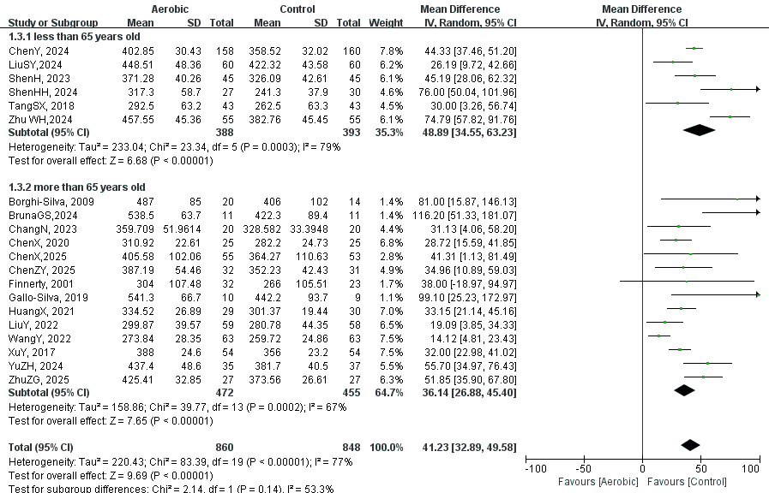
Figure. S1 Subgroup analysis based on average age of 6WMT

2.1.2 CAT
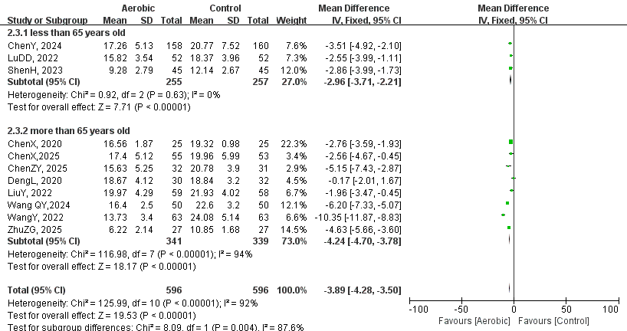
Figure. S2 Subgroup analysis based on average age of CAT

2.1.3 SGRQ
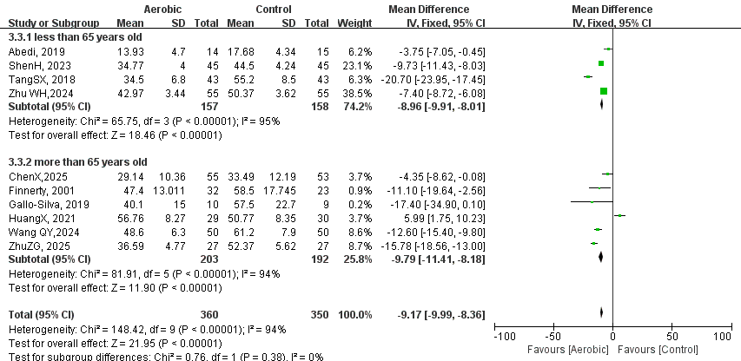
Figure. S3 Subgroup analysis based on average age of SGRQ

2.1.4 FEV1% pred
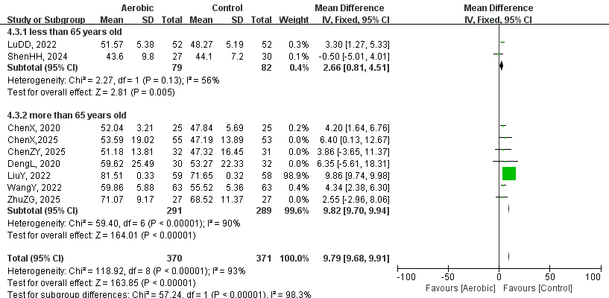
Figure. S4 Subgroup analysis based on average age of FEV1% pred

2.1.5 FEV1/FVC%
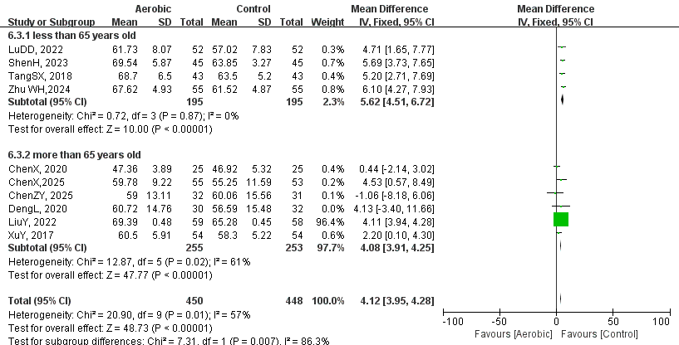
Figure. S5 Subgroup analysis based on average age of FEV1/FVC%.

2.2 Subgroup analysis based on different interventions of the aerobic group

2.2.1 6MWT
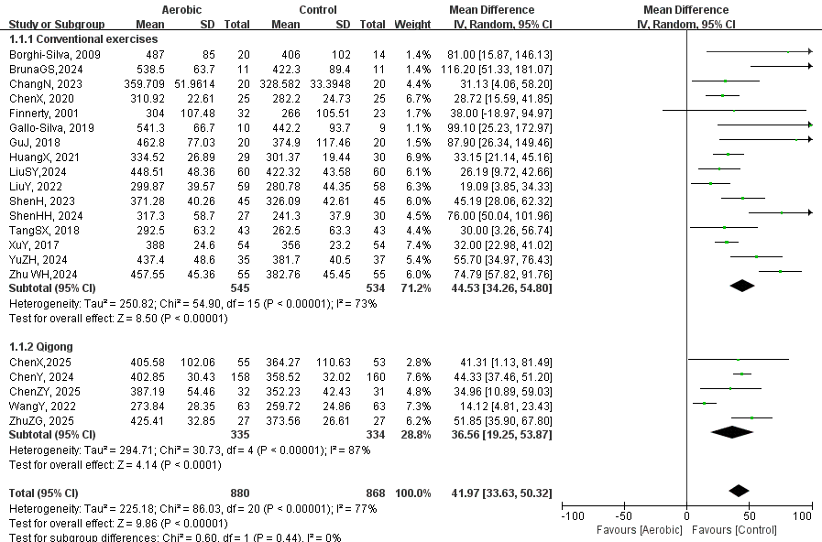
Figure. S6 Subgroup analysis based on different interventions of the aerobic group of 6MWT.

2.2.2 CAT
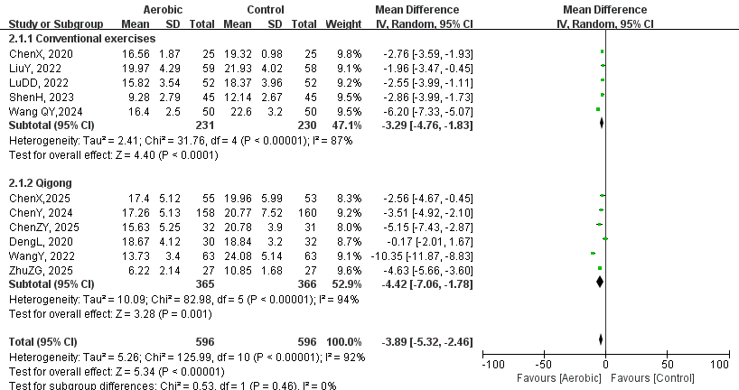
Figure. S7 Subgroup analysis based on different interventions of the aerobic group of CAT.

2.2.3 SGRQ
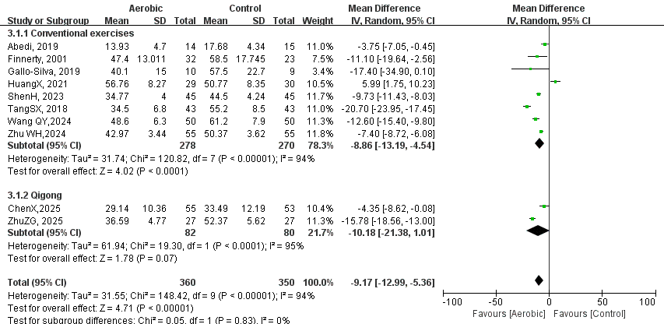
Figure. S8 Subgroup analysis based on different interventions of the aerobic group of SGRQ.

2.2.4 FEV1% pred
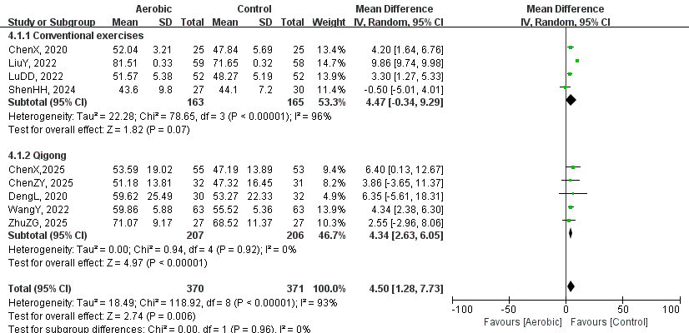
Figure. S9 Subgroup analysis based on different interventions of the aerobic group of FEV1% pred.

2.2.5 FEV1/FVC%
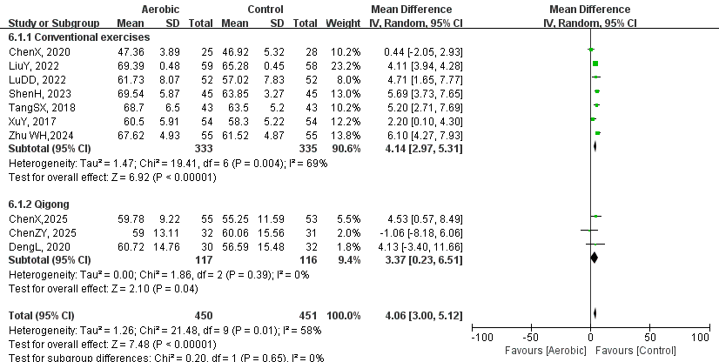
Figure. S10 Subgroup analysis based on different interventions of the aerobic group of FEV1/FVC%.

Appendix 3: Meta Regression
Outcomes | Characteristics (covariates)  (n = 21) | Coefficient | 95% CI | p value
- min walk test  (6MWT) | Nation | 40.57 | [4.25, 76.90] | 0.029
- min walk test  (6MWT) | Intervention time | -12.15 | [-39.14, 14.83] | 0.377
- min walk test  (6MWT) | Sample size | -14.84 | [-33.80, 4.11] | 0.125
Table. S1 Meta-regression analysis for 6-min walk test (6MWT)

Outcomes | Characteristics (covariates)  (n = 10) | Coefficient | 95% CI | p value
St. George’s Respiratory Questionnaire  (SGRQ) | Nation | 0.22 | [-11.41, 11.85] | 0.970
St. George’s Respiratory Questionnaire  (SGRQ) | Intervention Time | -0.32 | [-12.70, 12.06] | 0.960
St. George’s Respiratory Questionnaire  (SGRQ) | Sample size | -3.75 | [-13.53, 6.03] | 0.452
Table. S2 Meta-regression analysis for St. George’s Respiratory Questionnaire (SGRQ)

Appendix 4: Sensitivity analysis

4.1 6MWT

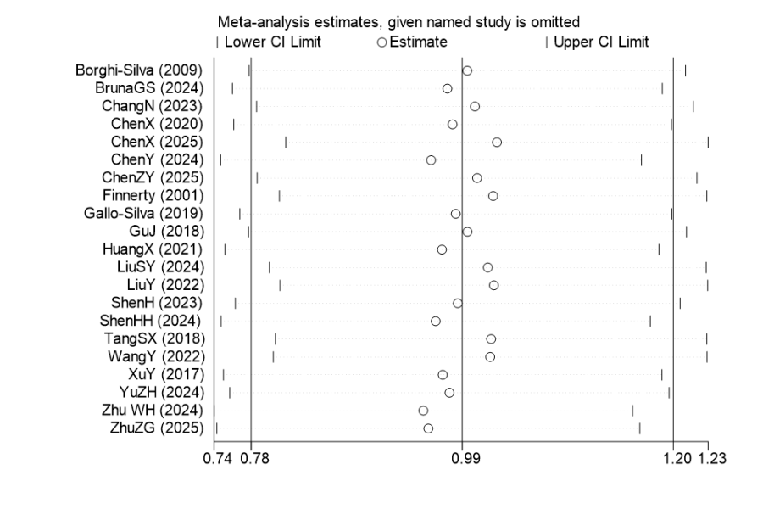
Figure. S11 Sensitivity analysis of 6MWT

4.2 CAT
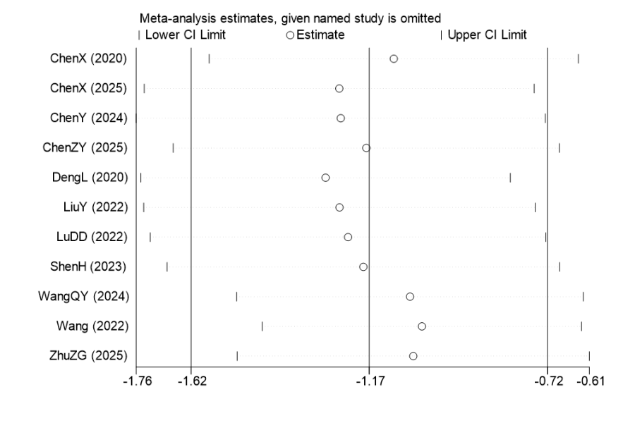
Figure. S12 Sensitivity analysis of CAT

4.3 SGRQ
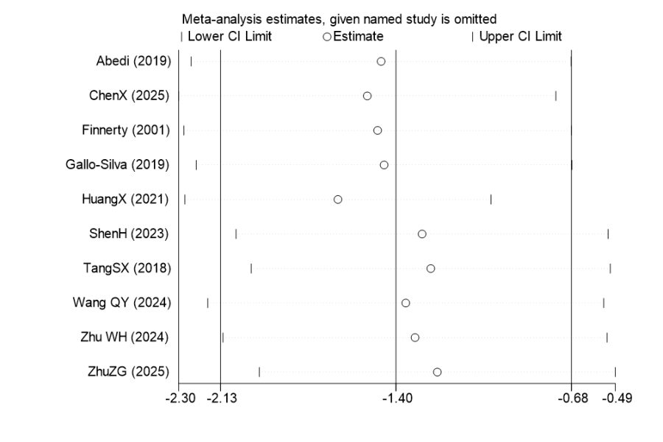
Figure. S13 Sensitivity analysis of SGRQ

4.4 FEV1% pred
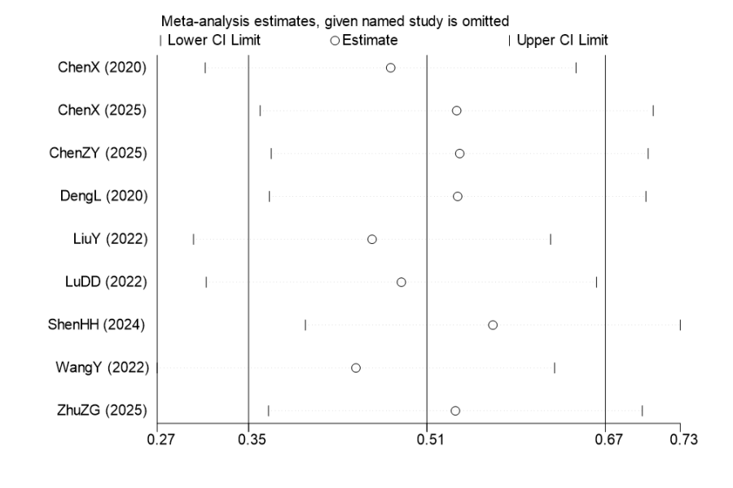
Figure. S14 Sensitivity analysis of FEV1% pred

4.5 FEV1/FVC%
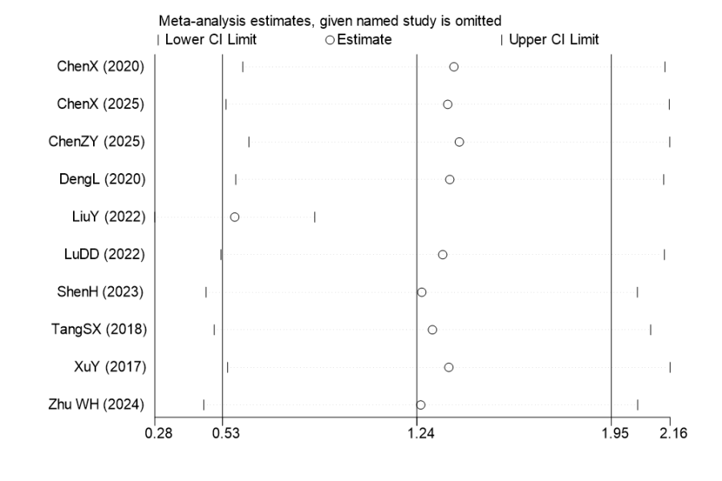
Figure. S15 Sensitivity analysis of FEV1/FVC%

Appendix 5: Publication bias

5.1 the Egger's test result of 6MWT
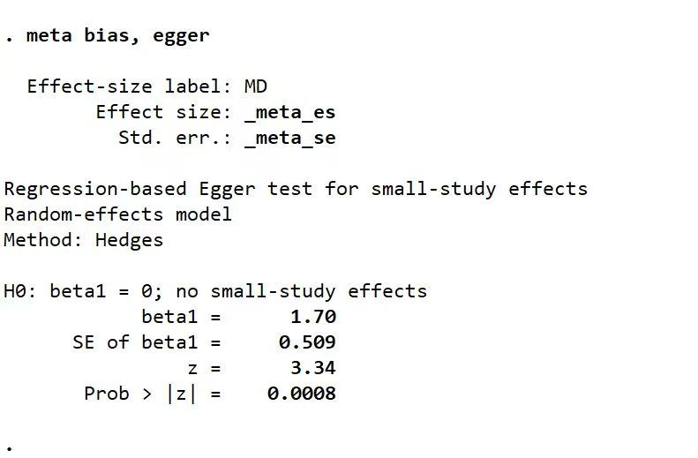
Figure. S16 the Egger's test result of 6MWT

5.2 the funnel plot of 6MWT
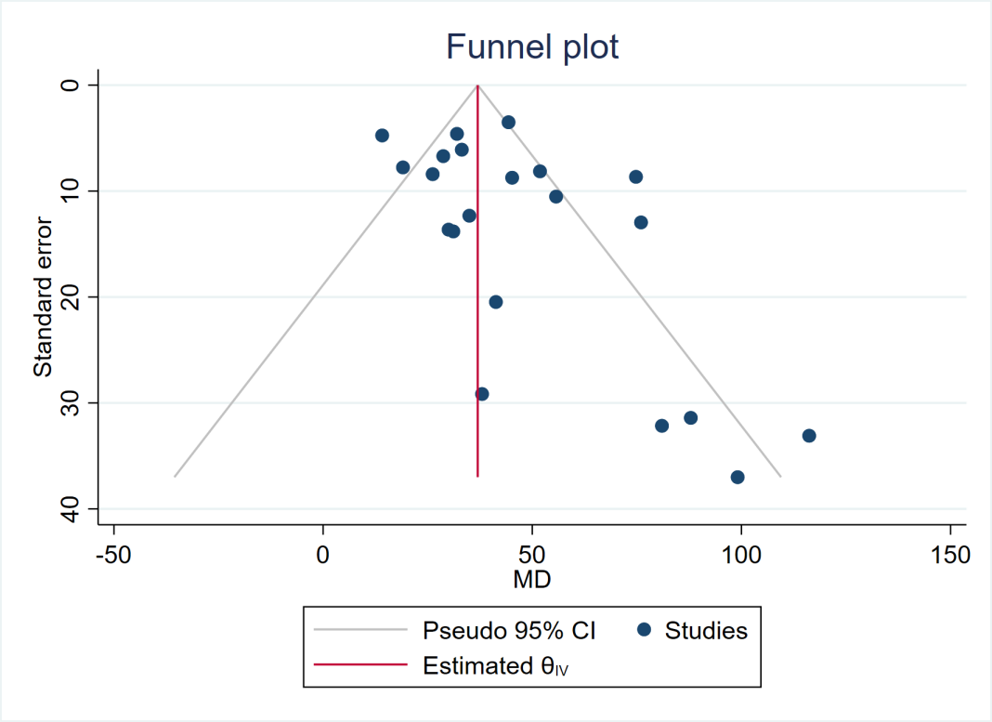
Figure. S17 the funnel plot of 6MWT

5.3 6MWT's the trim-and-fill method funnel chart
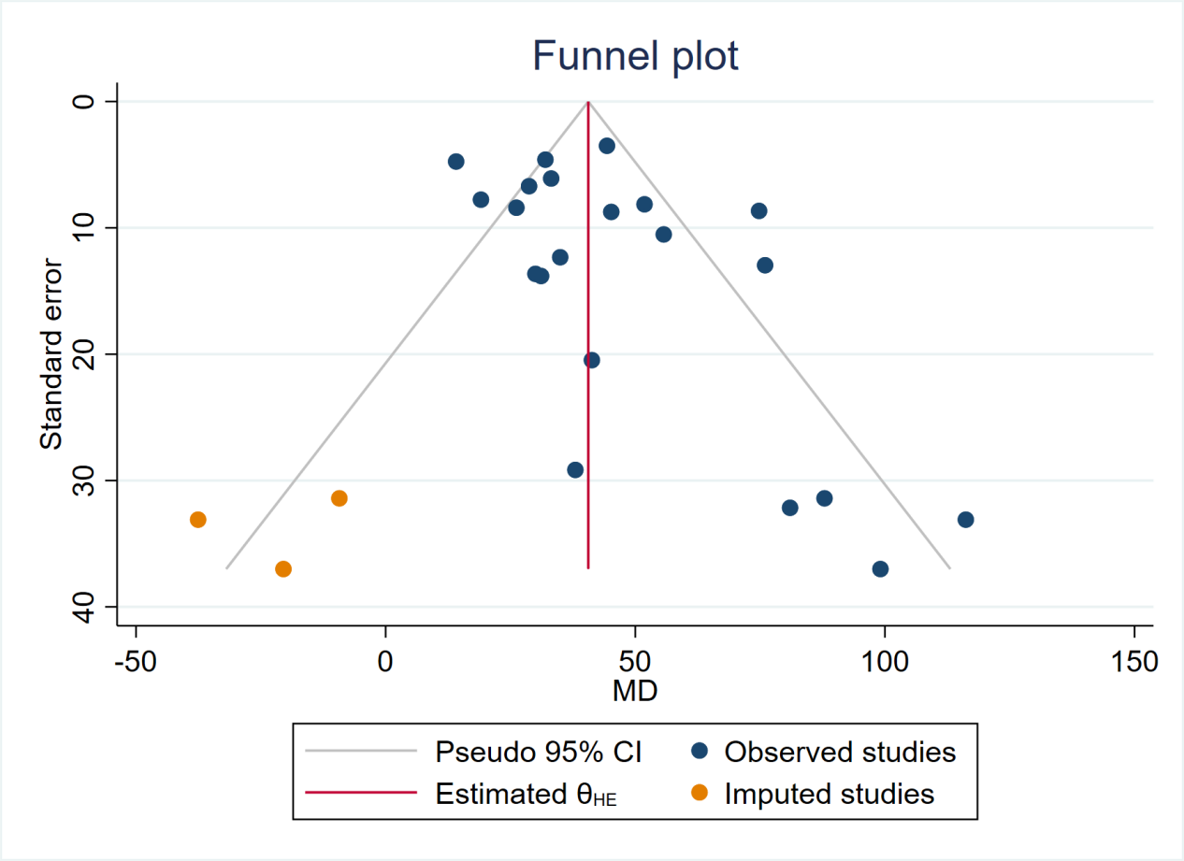
Figure. S18 6MWT's the trim-and-fill method funnel chart

