Supporting Information
Title: 4D printed hydrogel scaffolds with shape morphing by near-infrared to promote bone regeneration through immune and vascular coupling

Authors: Chuqiao Wei^{ab#}, Jingjie Zhai^{ab#}, Yidi Zhang^{ab}，Yuemeng Zhu^{ab}, Yuzhu Han^{ab}, Yangyang Li^{ab}, Sicong Ren^{ab}, Quan Lin^{c*}, Hanchi Wang^{ab}*, Yanmin Zhou^{ab}*
Figure S1 PDA NPs exhibited dose-dependent antioxidant capacity with >90% ABTS scavenging at concentrations >1 mg/mL.
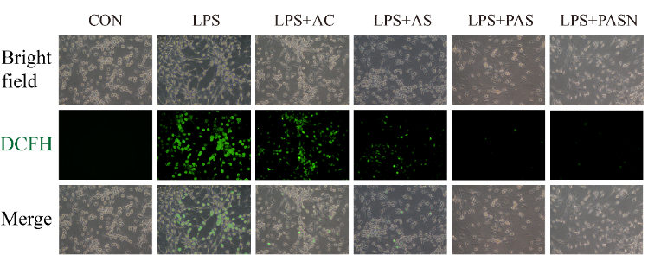
Figure S2. DCFH-DA staining analyses after co-culture with different scaffolds for 1 day
Figure S3 Fluorescence microscope images of JC-1 assay demonstrating activated (labeled red) and abnormal (labeled green) mitochondrial membrane potential.
Figure S4 Fluorescence intensities in BMSCs subjected to JC-1 staining. n = 3 per group.
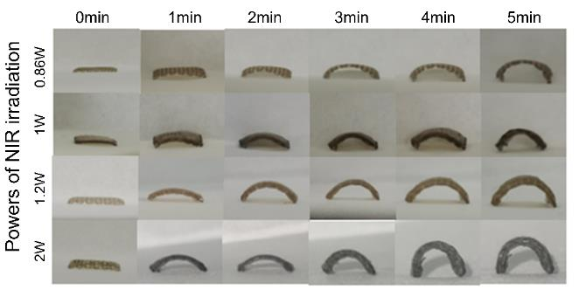
Figure S5 The photographs of the shape changes of 3D printed PDA/Alg/Sr²⁺ scaffolds under laser irradiation with different power in different time.
Figure S6 Young's modulus of different scaffolds.

Figure S7 The scaffold maintained its shape even after being placed in ddH₂O for 14 days.
Figure S8 The deformation effect remains unchanged when the printing length is extended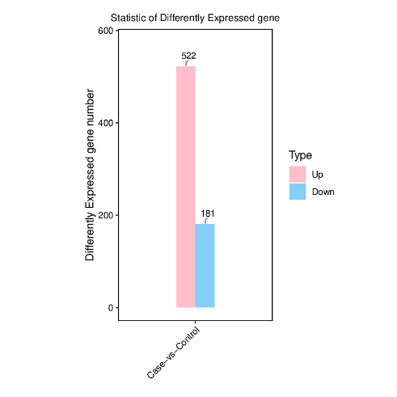
Figure S9 The differential BMSC genes expression of PAS group (control) and PASN group(case).
Figure S10 The corresponding quantitative result of western blot analysis of BMSCs. 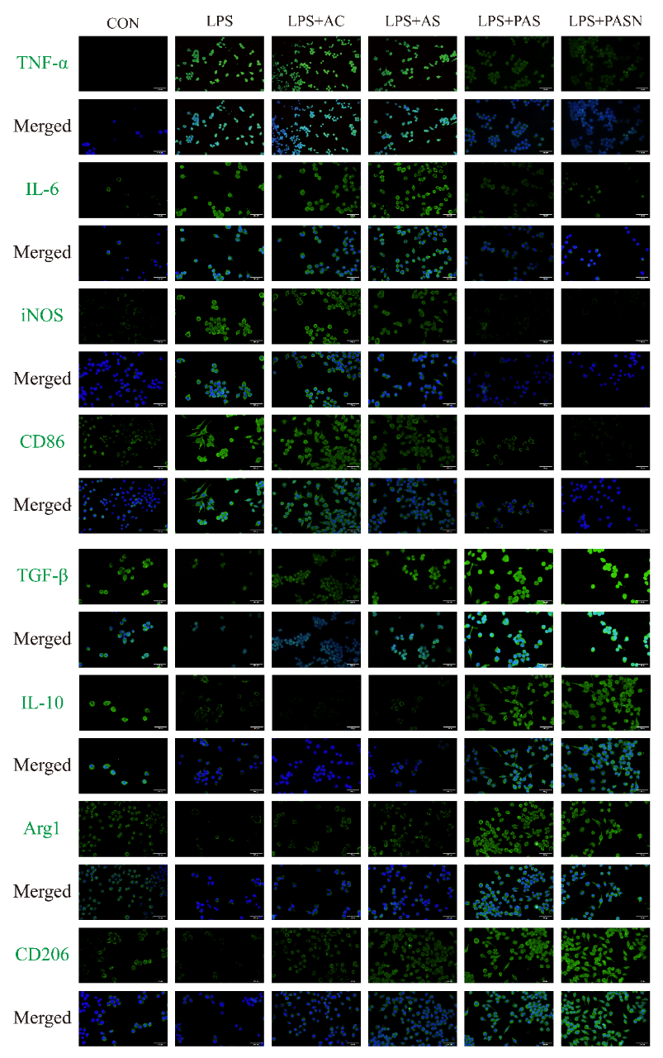
Figure S11 Immunofluorescent staining of macrophages co-cultured with different hydrogel scaffolds for 3 days, green for TNF-α, IL-6, iNOS, CD86, Tgf-β, IL-10, Arg-1,and CD206, and blue (DAPI) for nuclei.
Figure S12 Quantitative analysis of macrophages co-cultured with different hydrogel scaffolds for 3 days.

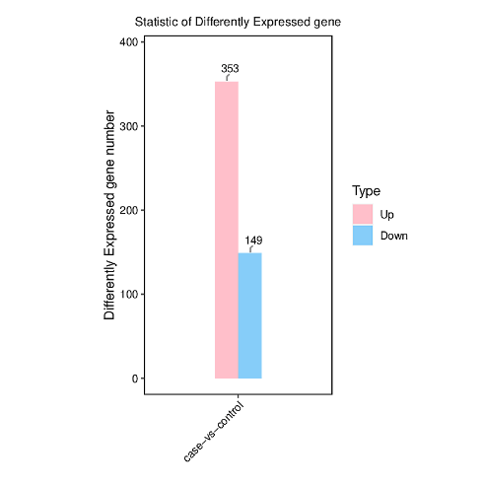
Figure S13 The differential RAW 264.7 genes expression of PAS group (control) and PASN group(case)
Figure S14 The CCK-8 assay of Control, AC, AS, PAS, PASN scaffolds for HUVECs.

Figure S15 After 5 minutes of NIR treatment (1.5W/cm²), the body temperature of the rats in the PASN group increased up to about 42 °C.
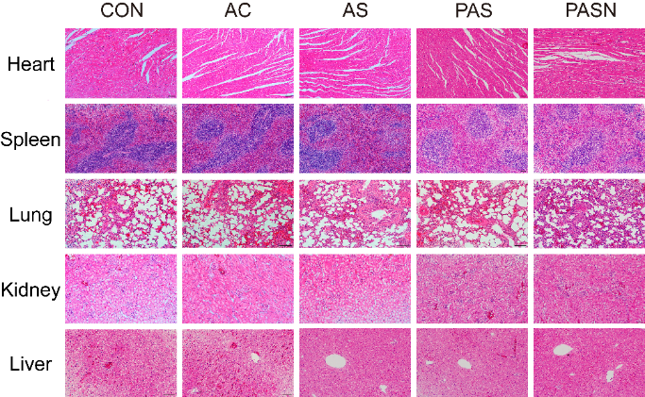
Figure S16 The H&E staining of hearts, livers, spleens, lungs, and kidneys of rats at 8 weeks post-surgery.
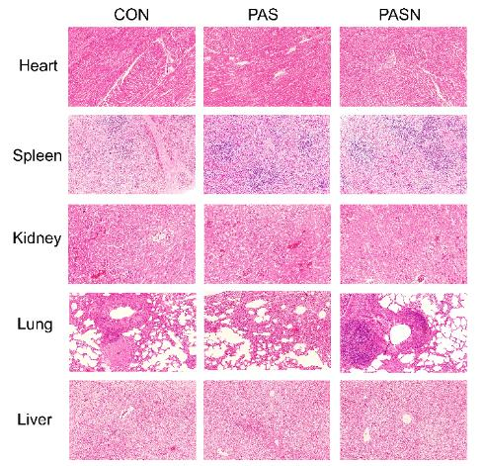
Figure S17 The H&E staining of hearts, livers, spleens, lungs, and kidneys of rabbits at 6 weeks post-surgery.
Figure S18 The deformation effect after cross-linking with strontium ions at different concentrations for 5 minutes, followed by 5-minute near-infrared irradiation at 1.5 W.

Table 1 The usage of RT-qRCT primers for osteogenesis-related genes.
Genes | Forward sequence（5’-3’） | Reverse sequence（5’-3’）
β-actin | GGAGATTACTGCCCTGGCTCCTA | GACTCATCGTACTCCTGCTTGCTG
COL-1 | GACATGTTCAGCTTTGTGGACCTC | AGGGACCCTTAGGCCATTGTGTA
OCN | AAGCAGGAGGGCAATAAGGT | CCGTAGATGCGTTTGTAGGC
RUNX2 | CATGGCCGGGAATGATGAG | TGTGAAGACCGTTATGGTCAAAGTG
ALP | CATCGCCTATCAGCTAATGCACA | ATGAGGTCCAGGCCATCCAG

Table 2 The usage of RT-qRCT primers for angiogenesis-related genes
Genes | Forward sequence（5’-3’） | Reverse sequence（5’-3’）
GAPDH | AGAAGGCTGGGGCTCATTTG | AGGGGCCATCAGTCTTC
VEGF | CAGAAGGAGGAGGGCAGAA | GTCTCGATTGGATGGCAGTAG
PDGFA | GCAGGAAGCAGGAATGTC | ATACTACAGCGAGGAGGTGTG
HIF-α | AGAAACCACCTATGACCTGCT | CGACTGAGGAAAGTCTTGCTA

Table 3 The usage of RT-qRCT primers for immunomodulation-related genes
Genes | Forward sequence（5’-3’） | Reverse sequence（5’-3’）
GAPDH | AGAAGGCTGGGGCTCATTTG | AGGGGCCATCAGTCTTC
IL-6 | GGCGGATCGGATGTTGTGAT | GGACCCCAGACAATCGGTTG
IL-10  TNF-α | GGTTGTCGTCTCATTCTGAAAGA  CCTGTAGCCCACGTCGTAGC | GGTAGAGGACCCAAGTTCGTTAAGA  TTGAGATCCATGCCGTTG
TGF-β  Arg-1 | GGACTACTACGCCAAAGAAG  CATTGGCTTGCGAGACGTAGAC | TCAAAAGACAGCCACTCAGG  GCTGAAGGTCTCTTCCATCACC

Table 4 The usage of RT-qRCT primers for adhesion-related genes
Genes | Forward sequence（5’-3’） | Reverse sequence（5’-3’）
RhoA | CTCATAGTCTTCAGCAAGGACC | GGCGGTCATAATCTTCCTGTC
ROCK- 1 | GACTGGGGACAGTTTTGAGAC | GGGCATCCAATCCATCCAGC
ROCK- 2 | TTGGTTCGTCATAAGGCATCAC | TGTTGGCAAAGGCCATAATATCT
VCL  Lamc1 | GAGGCTGAACTGCTTCAATCA  TGCCGGAGTTTGTTAATGCC | CCAGATTTGACGAGGTGCCTA  CTGGTTGTTGTAGTCGGTCAG
Video S1 Place the PASN scaffolds into the floor of the maxillary sinus for the operation of maxillary sinus augmentation surgery. 2x

