Supplementary Materials

- Histogram of the metal component of VR-12 and the physical component of VR-12.

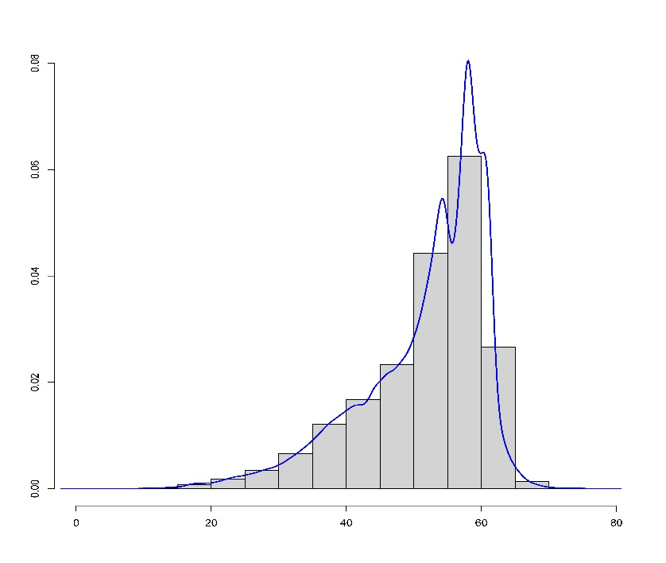
Figure 2: Histogram of the metal component of VR-12

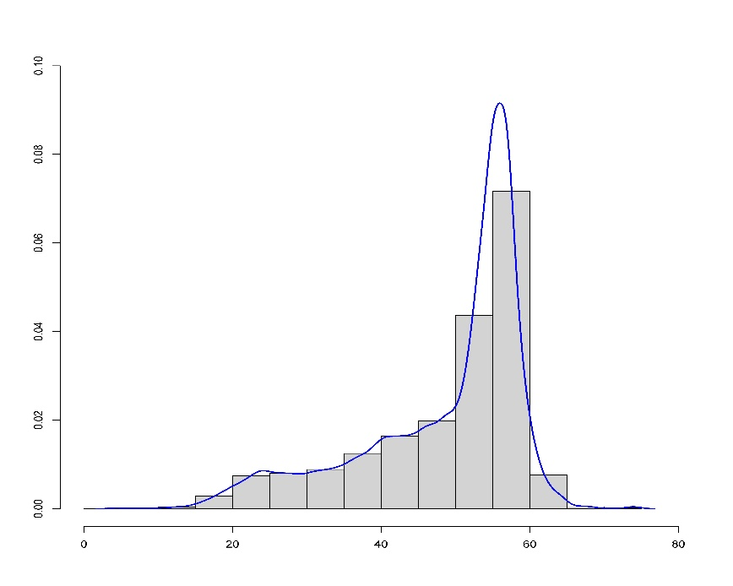
Figure 3: Histogram of the physical component of VR-12
- Estimation results of the metal component of VR-12 and the physical component of VR-12.

Table 4: Parameter estimation of mental component scores of VR-12 with all methods.
 | BQL($θ$=0.25) | BQL($θ$=0.5) | BQL($θ$=0.75) | BL | GLM (Gaussian)
 | coefficient (credible interval) | coefficient (credible interval) | coefficient (credible interval) | coefficient (credible interval) | coefficient (confidence interval) | p-value
intercept | 42.37(42.14,42.58) | 50.71(50.55,50.89) | 57.22(57.11,57.31) | 47.95(47.79,48.15) | 49.47(49.12,49.82) | 0
MS | -4.26(-5.46,-3.12) | -3.16(-4.31,-2.07) | -0.99(-1.72,-0.14) | -2.58(-3.55,-1.62) | -2.68(-3.66,-1.70) | 0
Age | 0.13(0.13,0.13) | 0.10(0.09,0.10) | 0.05(0.05,0.05) | 0.11(0.10,0.11) | 0.10(0.09,0.10) | 0
Sex | -1.50(-1.64,-1.38) | -1.11(-1.21,-1.00) | -0.56(-0.62,-0.50) | -1.04(-1.15,-0.93) | -1.14(-1.25,-1.03) | 0
Race (Ref. Hispanic)
non-Hispanic white | -2.41(-2.57,-2.24) | -2.01(-2.15,-1.87) | -1.52(-1.62,-1.43) | -1.98(-2.13,-1.81) | -2.09(-2.25,-1.93) | 0
non-Hispanic black | -0.77(-1.00,-0.55) | -0.88(-1.06,-0.68) | -0.72(-0.84,-0.60) | -0.55(-0.75,-0.35) | -0.68(-0.88,-0.48) | 0
others | -1.78(-2.02,-1.56) | -1.47(-1.66,-1.28) | -0.97(-1.11,-0.84) | -1.38(-1.61,-1.15) | -1.54(-1.78,-1.31) | 0
Region (Ref. northeast)
midwest | 0.43(0.22,0.64) | 0.04(-0.11,0.17) | -0.04(-0.14,0.07) | 0.22(0.04,0.40) | -0.03(-0.22,0.15) | 0.74
south | 0.79(0.61,0.98) | 0.55(0.41,0.68) | 0.39(0.30,0.48) | 0.57(0.41,0.73) | 0.29(0.12,0.46) | 0
west | -0.08(-0.27,0.10) | -0.21(-0.36,-0.07) | -0.09(-0.19,0.01) | -0.06(-0.23,0.11) | -0.34(-0.52,-0.16) | 0
Education (Ref.no degree)
high school diploma or ged | 1.01(0.80,1.21) | 0.44(0.27,0.60) | -0.05(-0.14,0.04) | 0.56(0.39,0.74) | 0.35(0.17,0.52) | 0
bachelor's degree | 0.82(0.57,1.08) | -0.05(-0.26,0.13) | -0.48(-0.59,-0.36) | 0.21(-0.00,0.42) | -0.01(-0.22,0.21) | 0.95
master's degree and soctorate degree | 1.13(0.86,1.41) | -0.00(-0.24,0.18) | -0.45(-0.58,-0.33) | 0.55(0.31,0.79) | 0.35(0.11,0.59) | 0
other degree | 0.90(0.63,1.19) | 0.20(-0.03,0.41) | -0.27(-0.40,-0.12) | 0.31(0.07,0.56) | 0.11(-0.13,0.35) | 0.37
Marital (Ref.marrried)
unknown | 0.01(-4.25,3.48) | -0.15(-3.79,2.61) | -0.03(-2.00,1.72) | -0.26(-8.13,5.91) | -3.32(-20.46,13.82) | 0.7
other situations | -1.90(-2.07,-1.71) | -1.29(-1.42,-1.16) | -0.56(-0.65,-0.47) | -1.27(-1.41,-1.13) | -1.29(-1.43,-1.14) | 0
never married | -0.69(-0.85,-0.53) | -0.11(-0.24,0.01) | 0.29(0.20,0.38) | -0.08(-0.22,0.06) | -0.36(-0.51,-0.20) | 0
Poverty (Ref. Porr/negative)
near poor | 1.30(0.96,1.69) | 1.20(0.91,1.50) | 0.28(0.08,0.47) | 0.97(0.69,1.25) | 0.73(0.45,1.02) | 0
low income | 2.35(2.10,2.61) | 1.88(1.68,2.08) | 0.49(0.36,0.61) | 1.64(1.44,1.83) | 1.38(1.17,1.58) | 0
middle income | 3.99(3.79,4.25) | 2.67(2.49,2.85) | 0.70(0.59,0.80) | 2.50(2.31,2.68) | 2.21(2.02,2.40) | 0
high income | 5.33(5.13,5.58) | 3.12(2.94,3.30) | 0.81(0.71,0.91) | 3.26(3.06,3.44) | 2.95(2.75,3.15) | 0
Insurance (Ref.any private)
public only | -1.82(-2.00,-1.61) | -0.74(-0.87,-0.60) | 0.02(-0.07,0.10) | -0.99(-1.13,-0.85) | -1.10(-1.24,-0.95) | 0
uninsured | 1.42(1.16,1.69) | 1.22(1.02,1.41) | 0.68(0.57,0.81) | 1.15(0.94,1.37) | 0.91(0.69,1.13) | 0
Exhauster comorbidity index | -1.65(-1.69,-1.61) | -1.04(-1.07,-1.01) | -0.40(-0.42,-0.38) | -1.08(-1.11,-1.04) | -1.07(-1.10,-1.03) | 0
Year (Ref.2017)
2018 | -0.18(-0.38,0.01) | -0.03(-0.19,0.11) | -0.05(-0.14,0.05) | -0.09(-0.26,0.09) | -0.25(-0.43,-0.08) | 0
2019 | -0.40(-0.62,-0.18) | -0.21(-0.37,-0.06) | -0.08(-0.18,0.02) | -0.19(-0.37,-0.03) | -0.35(-0.53,-0.18) | 0
2020 | -1.35(-1.58,-1.13) | -0.84(-1.00,-0.67) | -0.41(-0.53,-0.30) | -0.79(-0.98,-0.61) | -0.93(-1.12,-0.74) | 0
2021 | -2.40(-2.63,-2.18) | -1.36(-1.54,-1.19) | -0.50(-0.60,-0.39) | -1.52(-1.71,-1.34) | -1.65(-1.83,-1.46) | 0
2022 | -2.12(-2.34,-1.88) | -1.33(-1.50,-1.15) | -0.65(-0.77,-0.54) | -1.34(-1.55,-1.15) | -1.47(-1.67,-1.26) | 0

Table 5: Parameter estimation of physical component scores of VR-12 with all methods.
 | BQL($θ$=0.25) | BQL($θ$=0.5) | BQL($θ$=0.75) | BL | GLM (Gaussian)
 | coefficient (credible interval) | coefficient (credible interval) | coefficient (credible interval) | coefficient (credible interval) | coefficient (confidence interval) | p-value
intercept | 55.80(55.60,56.14) | 57.15(56.97,57.32) | 57.84(57.74,57.93) | 56.22(56.05,56.39) | 58.01(57.66,58.36) | 0
MS | -13.87(-15.01,-12.82) | -13.40(-14.56,-12.19) | -7.95(-9.22,-6.84) | -11.05(-12.06,-10.02) | -11.14(-12.12,-10.16) | 0
AGE | -0.19(-0.20,-0.19) | -0.10(-0.10,-0.10) | -0.05(-0.05,-0.05) | -0.13(-0.14,-0.13) | -0.14(-0.15,-0.14) | 0
SEX | -0.72(-0.83,-0.62) | -0.19(-0.27,-0.11) | -0.00(-0.06,0.05) | -0.43(-0.54,-0.32) | -0.55(-0.67,-0.44) | 0
Race (Ref. Hispanic)
non-Hispanic white | -0.68(-0.84,-0.52) | -0.10(-0.22,0.01) | 0.18(0.11,0.27) | -0.69(-0.85,-0.52) | -0.83(-0.99,-0.67) | 0
non-Hispanic black | -0.65(-0.85,-0.46) | -0.24(-0.39,-0.09) | -0.11(-0.21,0.01) | -0.54(-0.74,-0.34) | -0.69(-0.89,-0.49) | 0
others | -0.89(-1.11,-0.66) | -0.52(-0.68,-0.35) | -0.21(-0.32,-0.07) | -0.83(-1.07,-0.60) | -1.03(-1.26,-0.79) | 0
Region (Ref. northeast)
midwest | -0.38(-0.54,-0.19) | -0.39(-0.52,-0.24) | -0.28(-0.39,-0.18) | -0.42(-0.61,-0.24) | -0.73(-0.92,-0.55) | 0
south | -0.54(-0.69,-0.38) | -0.44(-0.56,-0.30) | -0.32(-0.42,-0.24) | -0.62(-0.79,-0.46) | -0.97(-1.14,-0.80) | 0
west | -0.06(-0.23,0.10) | -0.11(-0.25,0.02) | -0.09(-0.19,0.01) | -0.07(-0.24,0.11) | -0.41(-0.59,-0.23) | 0
Education (Ref. no degree)
high school diploma or ged | 1.01(0.82,1.24) | 0.84(0.71,0.96) | 0.44(0.33,0.54) | 1.04(0.88,1.20) | 0.78(0.60,0.96) | 0
bachelor's degree | 3.16(2.92,3.46) | 2.07(1.92,2.24) | 1.28(1.16,1.40) | 2.96(2.75,3.16) | 2.69(2.48,2.90) | 0
master's degree and soctorate degree | 3.93(3.67,4.21) | 2.57(2.40,2.73) | 1.59(1.47,1.74) | 3.48(3.24,3.71) | 3.24(3.00,3.48) | 0
other degree | 1.70(1.43,1.98) | 1.31(1.13,1.49) | 0.82(0.68,0.96) | 1.60(1.37,1.84) | 1.36(1.12,1.60) | 0
Marital (Ref. married)
unknown | 0.35(-4.34,6.96) | 0.26(-2.71,5.07) | 0.26(-1.60,3.46) | 2.05(-4.26,13.27) | 14.20(-3.01,31.41) | 0.11
other situations | -1.42(-1.59,-1.26) | -0.77(-0.90,-0.64) | -0.12(-0.21,-0.04) | -0.63(-0.77,-0.49) | -0.65(-0.80,-0.51) | 0
never married | -0.33(-0.46,-0.19) | -0.09(-0.19,0.00) | 0.20(0.12,0.27) | 0.12(-0.02,0.26) | -0.20(-0.36,-0.05) | 0.01
Povcat (Ref. Porr/negative)
near poor | 1.42(1.06,1.75) | 0.50(0.26,0.75) | 0.24(0.06,0.42) | 0.86(0.58,1.13) | 0.58(0.29,0.87) | 0
low income | 2.17(1.92,2.43) | 1.09(0.92,1.26) | 0.42(0.31,0.54) | 1.54(1.35,1.74) | 1.24(1.03,1.44) | 0
middle income | 3.30(3.09,3.51) | 1.71(1.53,1.87) | 0.82(0.71,0.94) | 2.60(2.42,2.79) | 2.26(2.07,2.46) | 0
high income | 4.55(4.31,4.77) | 2.45(2.28,2.61) | 1.35(1.25,1.47) | 3.90(3.71,4.09) | 3.54(3.34,3.74) | 0
Inscov (Ref. any private)
public only | -3.92(-4.10,-3.73) | -2.17(-2.31,-2.02) | -0.85(-0.94,-0.77) | -2.31(-2.45,-2.17) | -2.43(-2.58,-2.29) | 0
uninsured | 0.92(0.73,1.12) | 0.31(0.17,0.46) | 0.12(0.01,0.23) | 0.76(0.55,0.98) | 0.48(0.25,0.70) | 0
Exhauster comorbidity index | -2.48(-2.52,-2.44) | -2.12(-2.15,-2.08) | -1.06(-1.09,-1.04) | -1.83(-1.86,-1.80) | -1.82(-1.85,-1.79) | 0
Year (Ref. 2017)
2018 | 0.11(-0.06,0.27) | 0.01(-0.12,0.13) | 0.02(-0.06,0.11) | 0.13(-0.04,0.30) | -0.06(-0.23,0.12) | 0.52
2019 | 0.09(-0.05,0.25) | 0.05(-0.08,0.18) | 0.06(-0.04,0.15) | 0.09(-0.09,0.26) | -0.09(-0.27,0.09) | 0.33
2020 | 0.24(0.07,0.42) | 0.24(0.10,0.39) | 0.29(0.19,0.39) | 0.21(0.02,0.40) | 0.06(-0.13,0.25) | 0.53
2021 | -0.81(-0.98,-0.63) | -0.55(-0.68,-0.40) | -0.17(-0.27,-0.07) | -0.77(-0.95,-0.59) | -0.91(-1.10,-0.72) | 0
2022 | -0.84(-1.05,-0.63) | -0.48(-0.63,-0.32) | -0.17(-0.28,-0.07) | -0.73(-0.93,-0.52) | -0.86(-1.06,-0.65) | 0

- Posterior distribution of the coefficients of all covariates in Table 1 with BQL

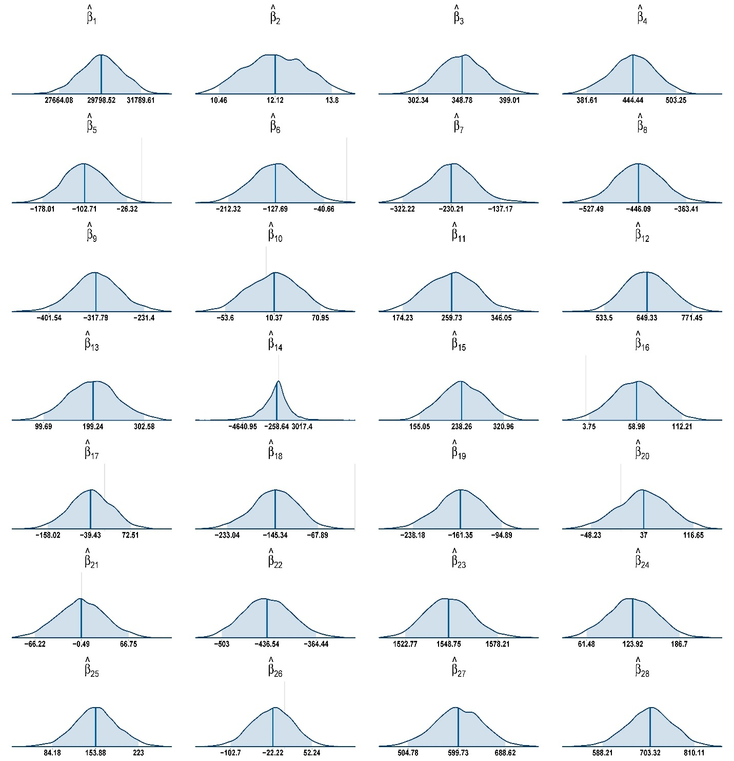

Figure 4: Posterior distribution of the coefficients of all covariates with healthcare expenditure with BQL when the quantile level is 0.5. The shaded region represents the 95% credible interval, defined by its lower and upper bounds, while the solid vertical line denotes the posterior median.

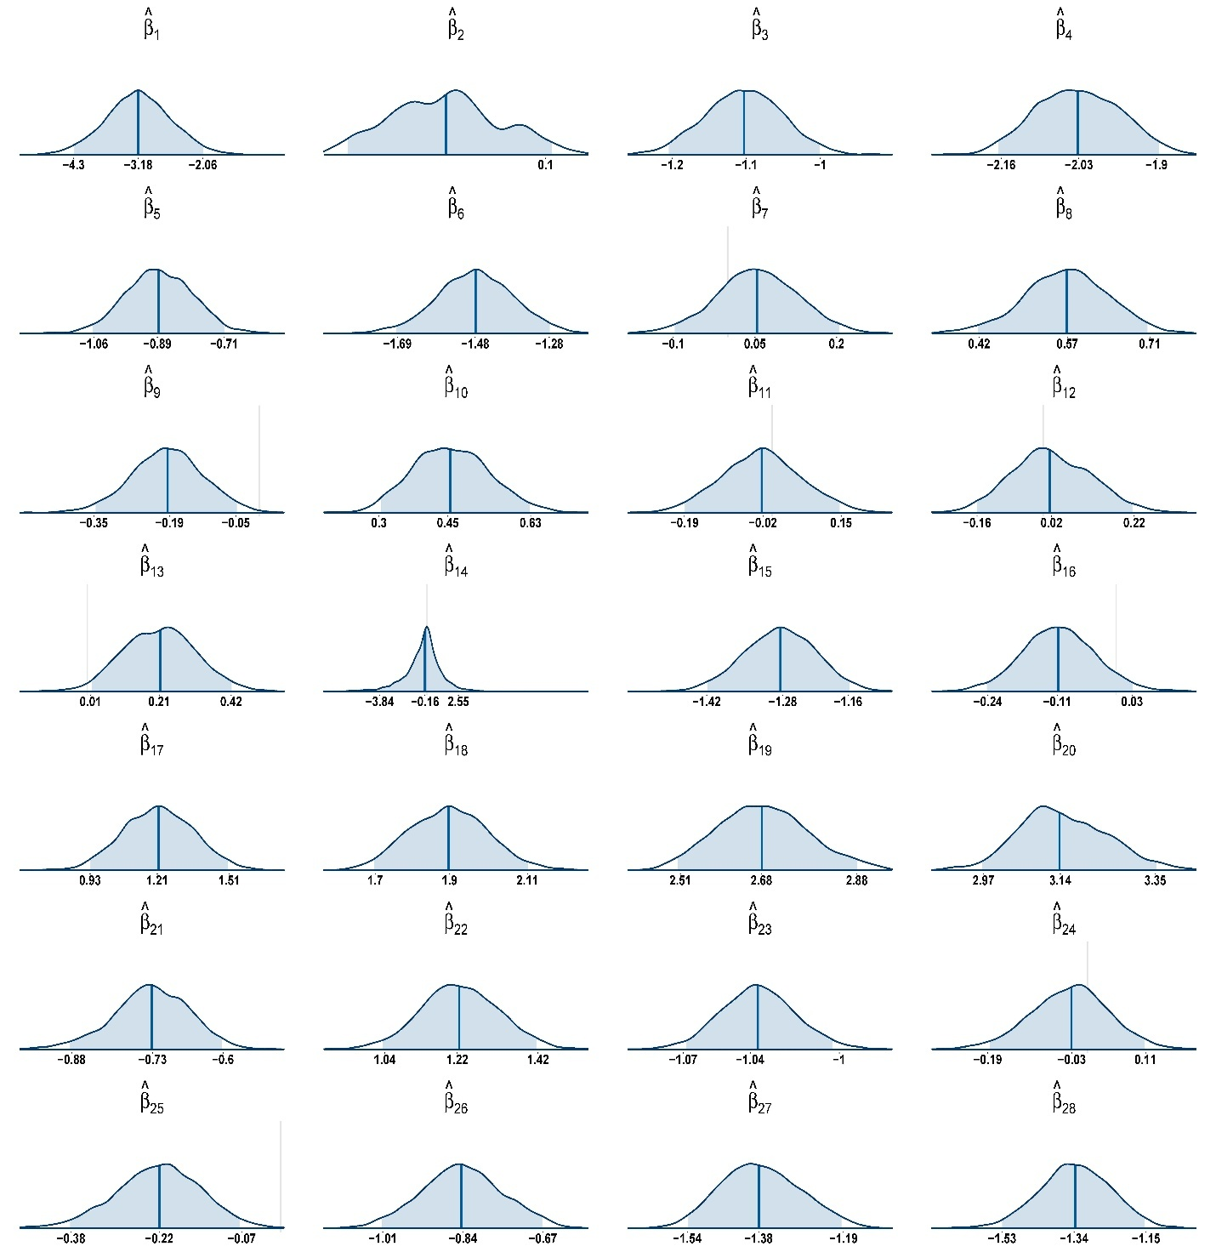

Figure 5: Posterior distribution of the coefficients of all covariates with mental component scores of VR-12 with BQL when the quantile level is 0.5. The shaded region represents the 95% credible interval, defined by its lower and upper bounds, while the solid vertical line denotes the posterior median.
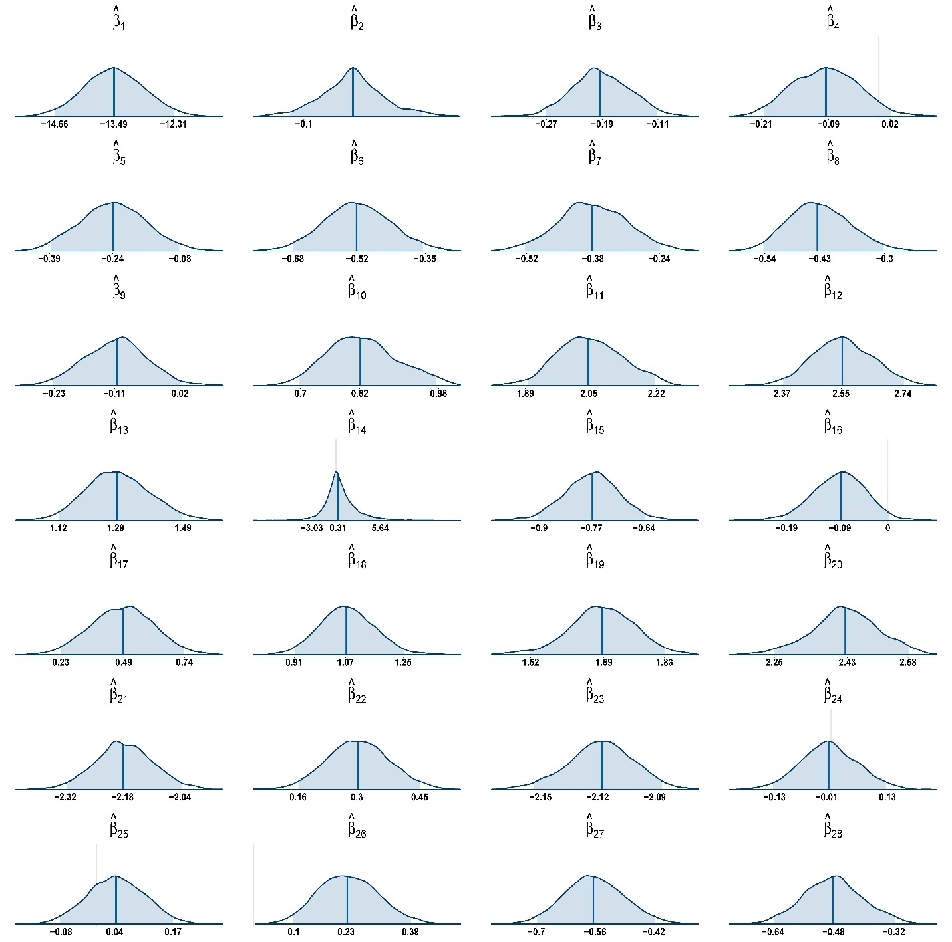
Figure 6: Posterior distribution of the coefficients of all covariates with physical component scores of VR-12 with BQL when the quantile level is 0.5. The shaded region represents the 95% credible interval, defined by its lower and upper bounds, while the solid vertical line denotes the posterior median.

- Convergence plot
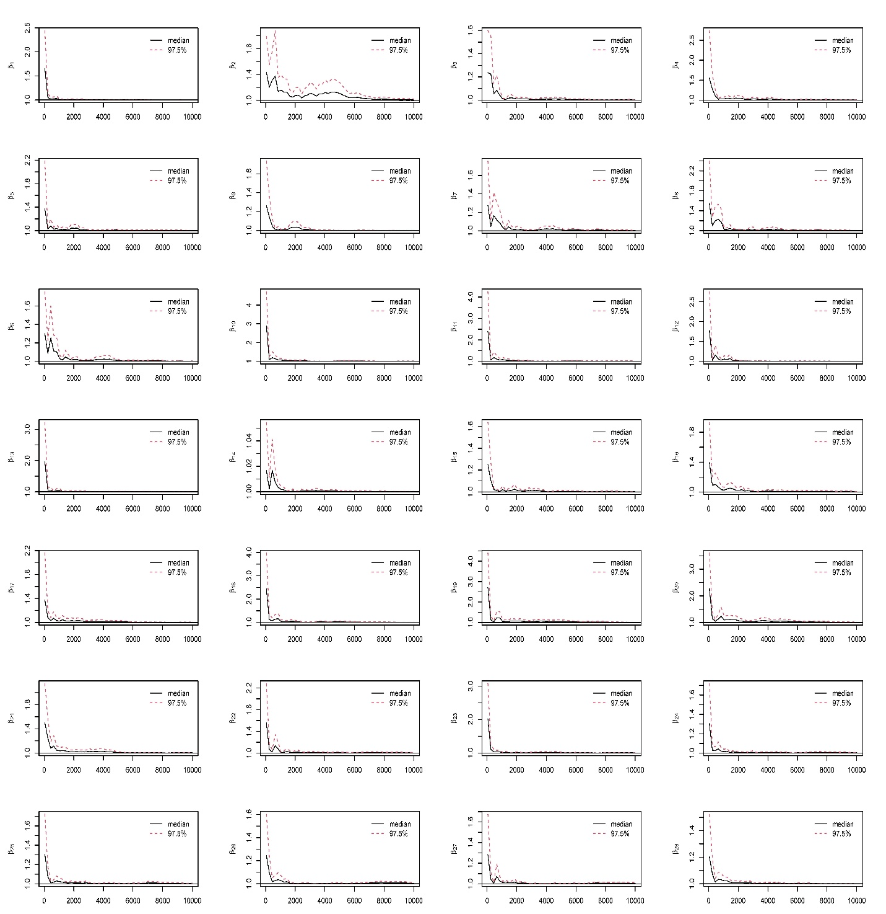

Figure 7: Potential scale reduction factor (PSRF) against iterations for the coefficients of all covariates with healthcare expenditure with BQL when the quantile level is 0.5.

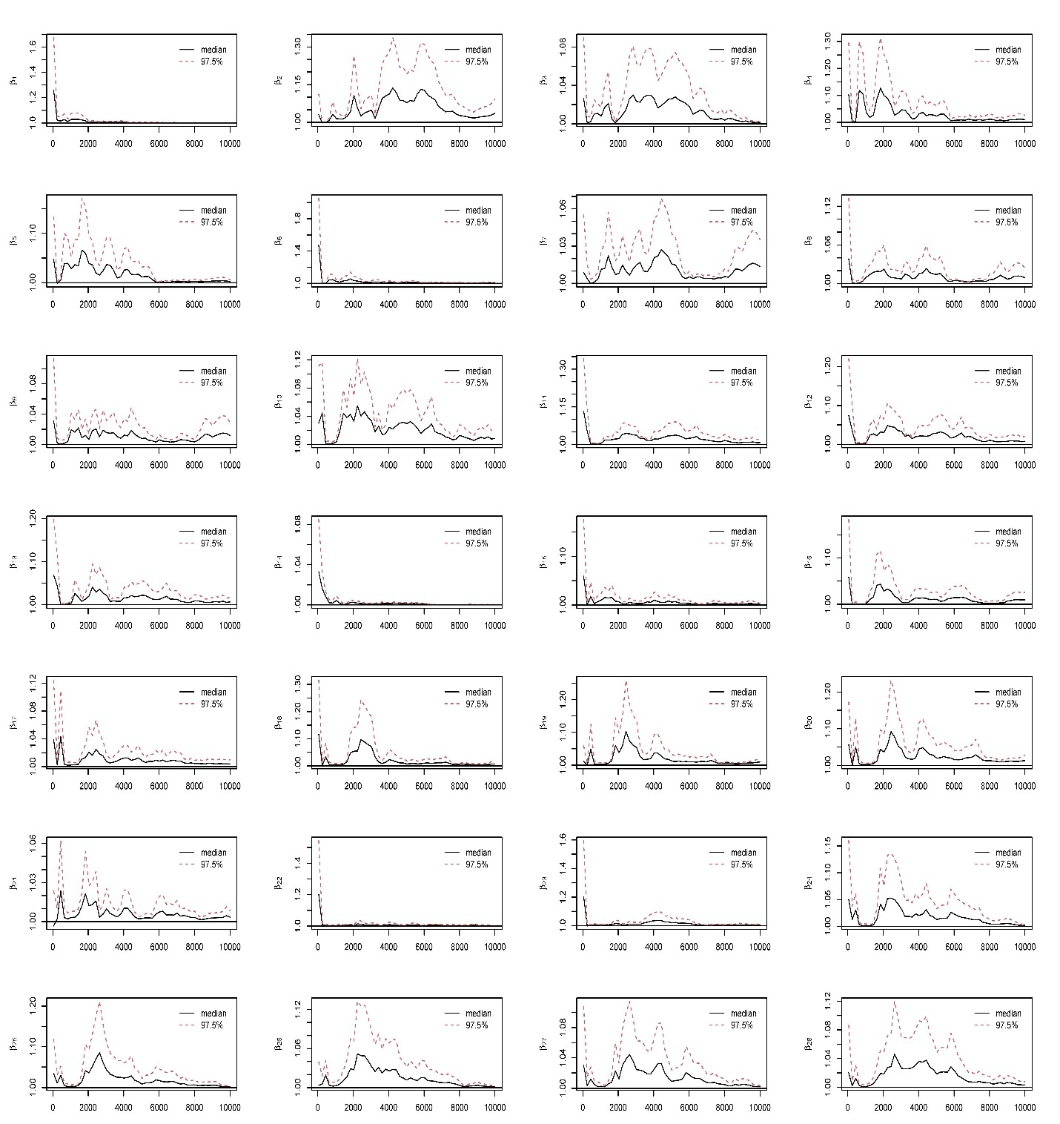
Figure 8: Potential scale reduction factor (PSRF) against iterations for the coefficients of all covariates with mental component scores of VR-12 with BQL when the quantile level is 0.5.
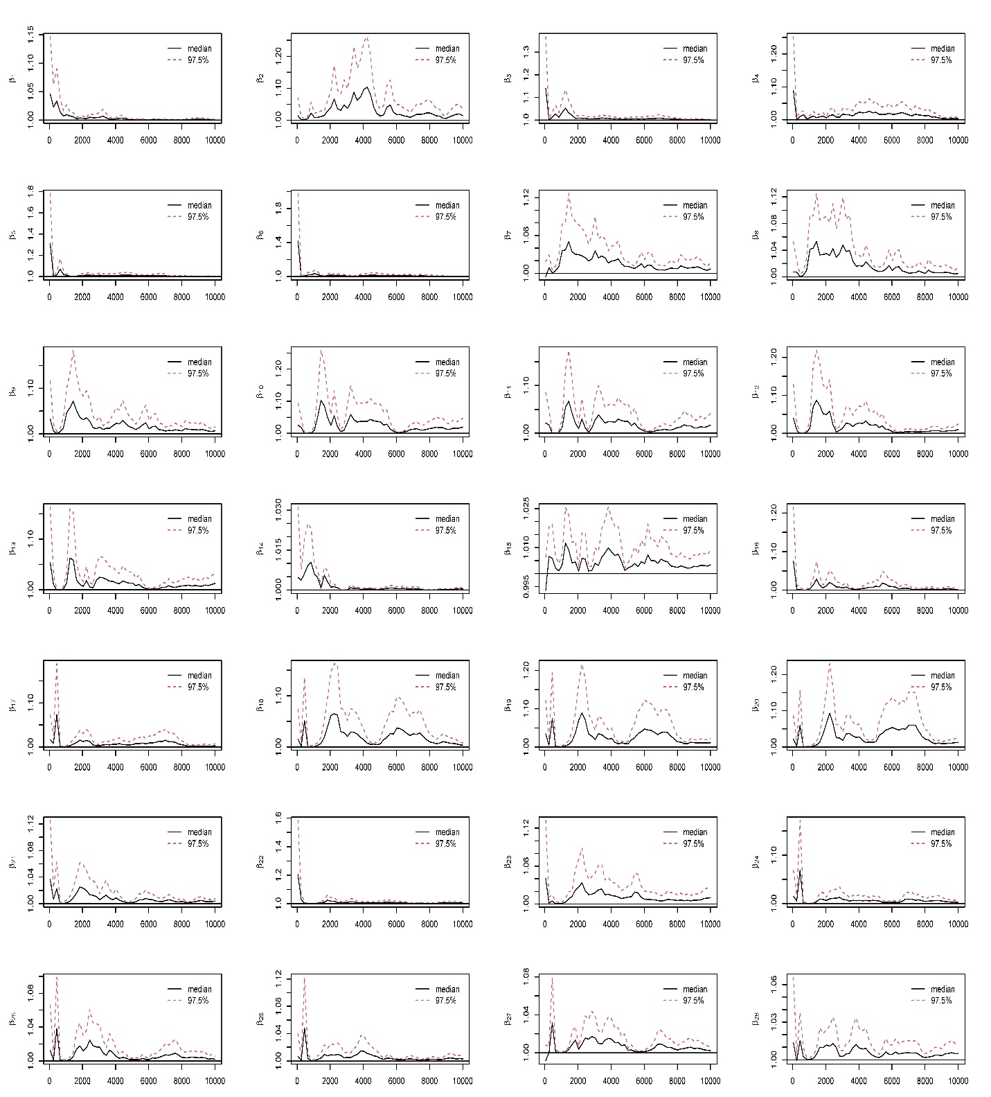

Figure 9: Potential scale reduction factor (PSRF) against iterations for the coefficients of all covariates with physical component scores of VR-12 with BQL when the quantile level is 0.5.
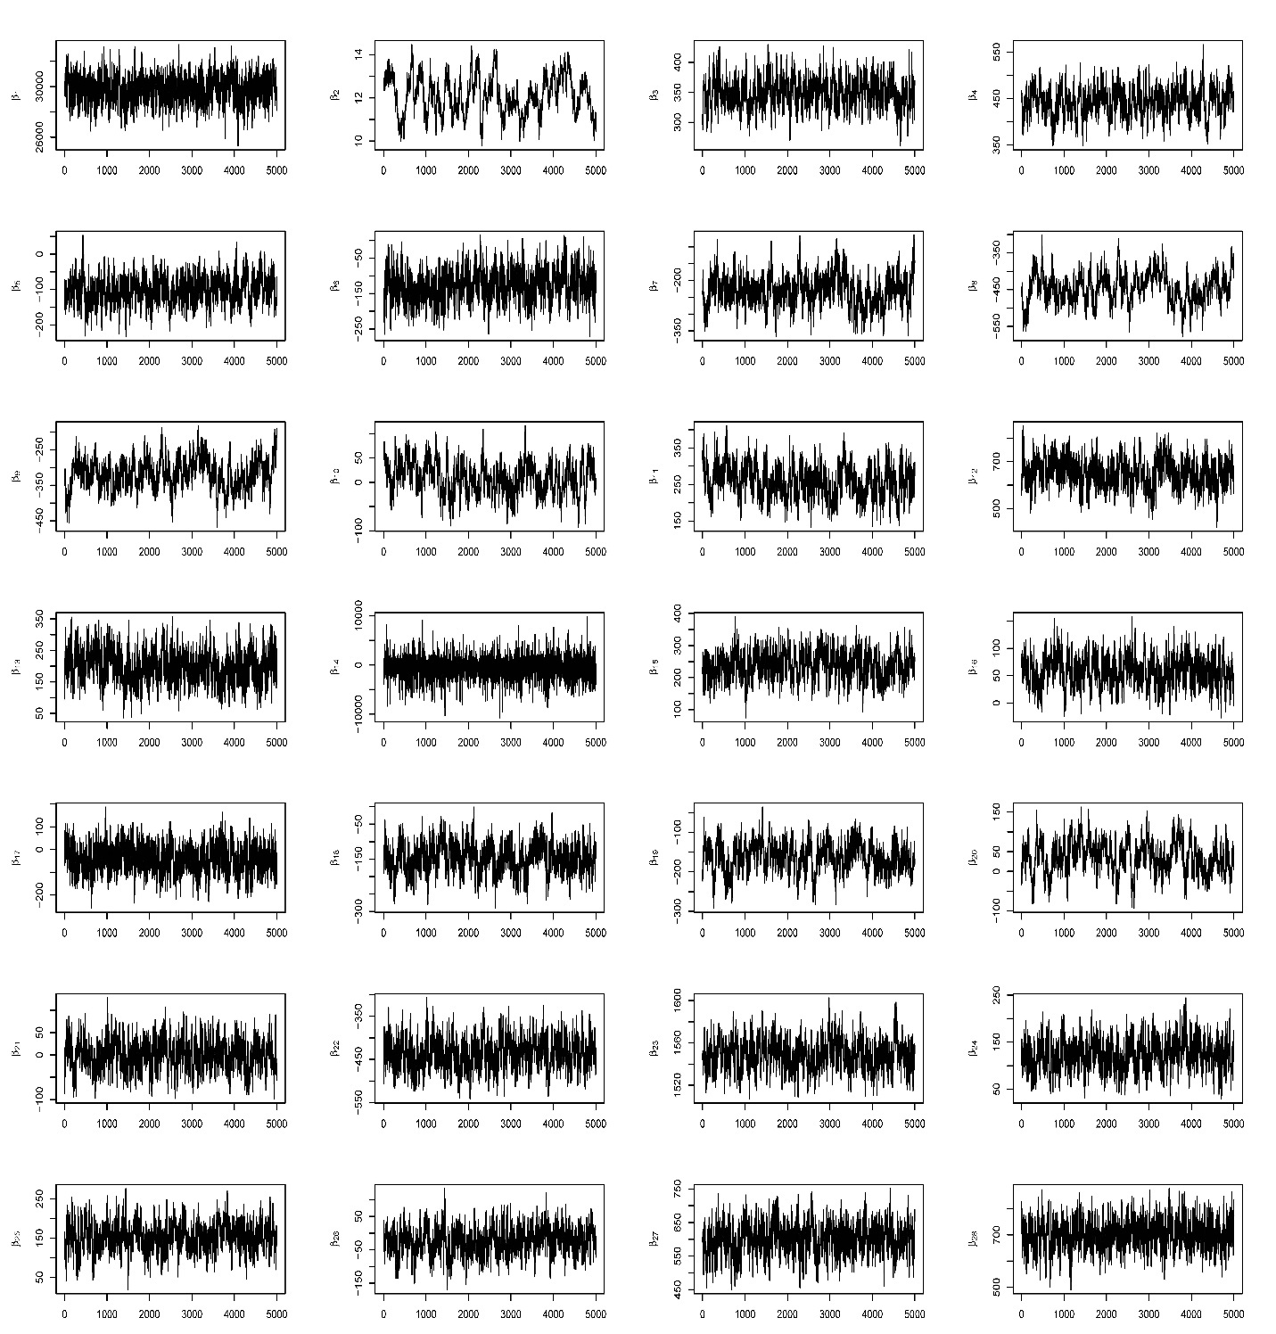

Figure 10: Trace plot of the coefficients of all covariates with healthcare expenditure with BQL when the quantile level is 0.5.

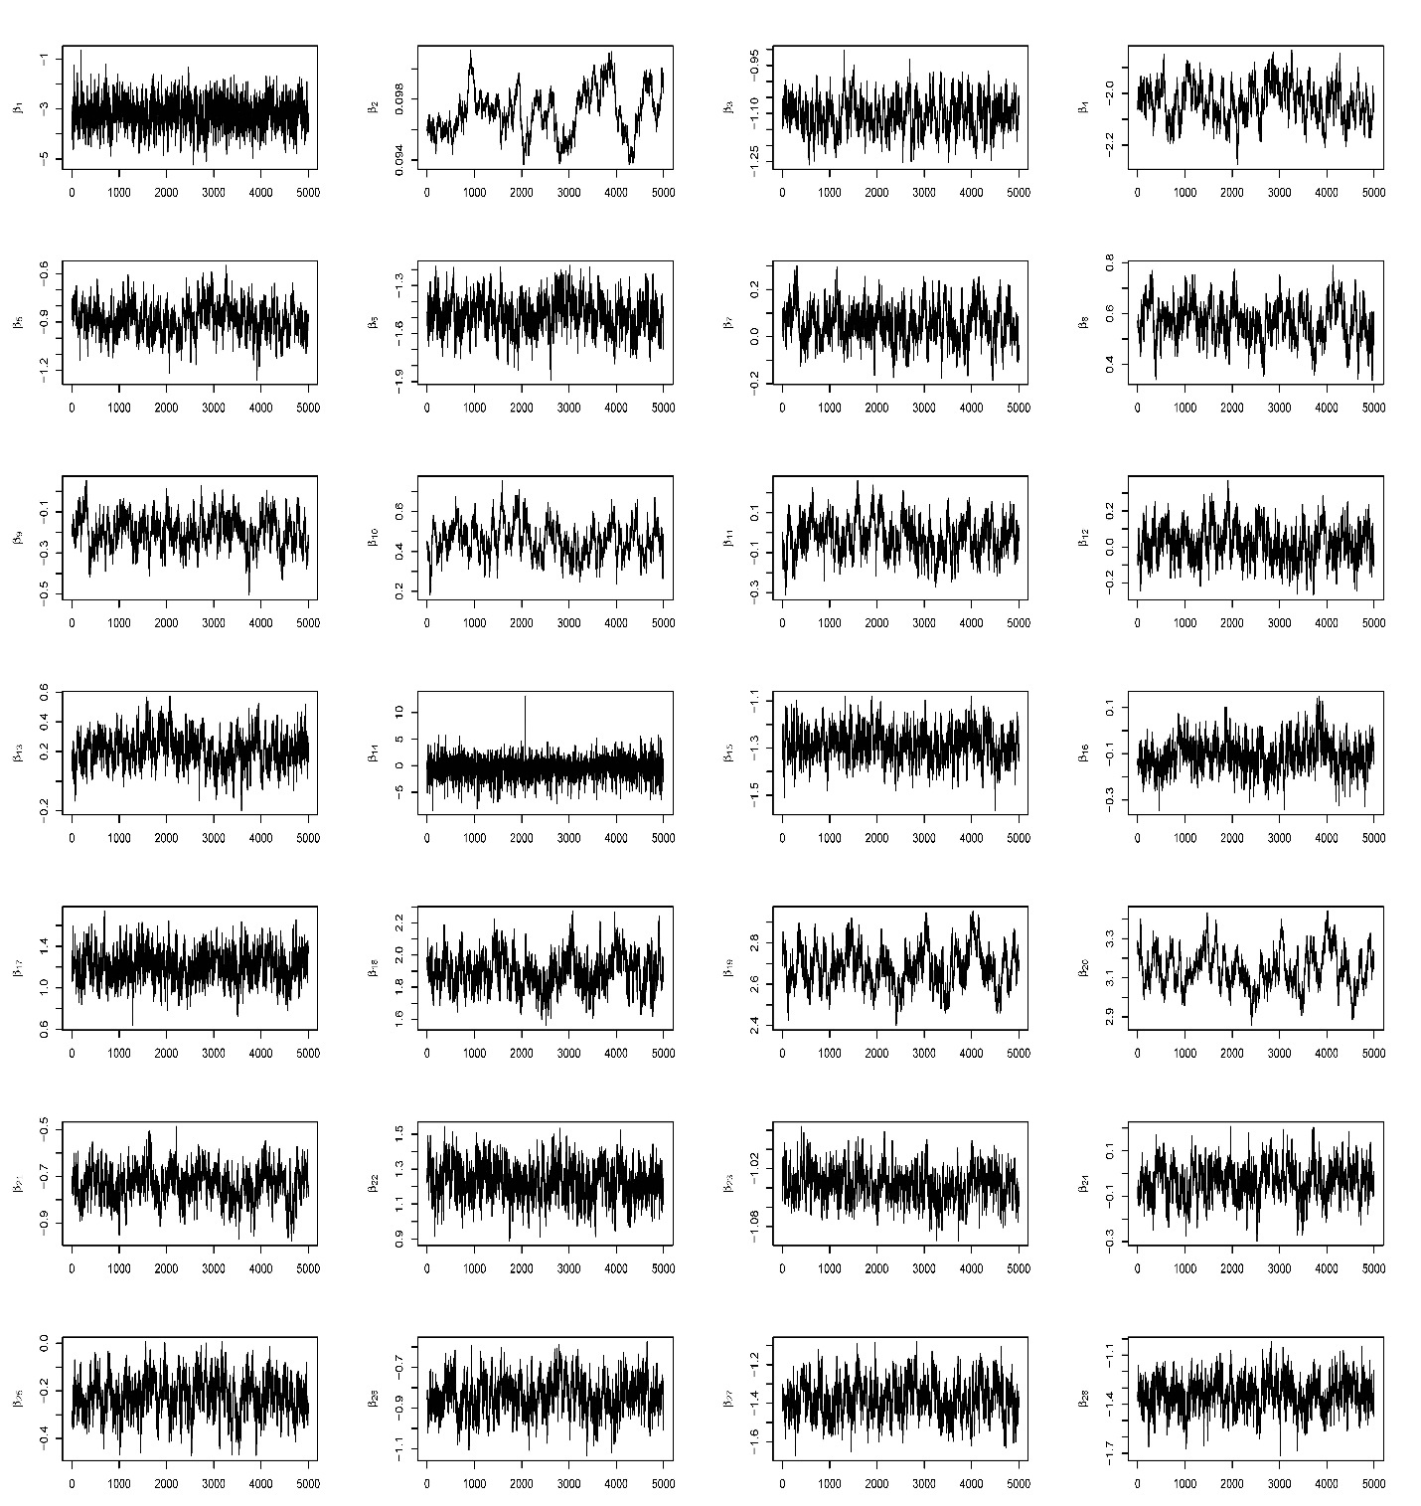
Figure 11: Trace plot of the coefficients of all covariates with mental component scores of VR-12 with BQL when the quantile level is 0.5.

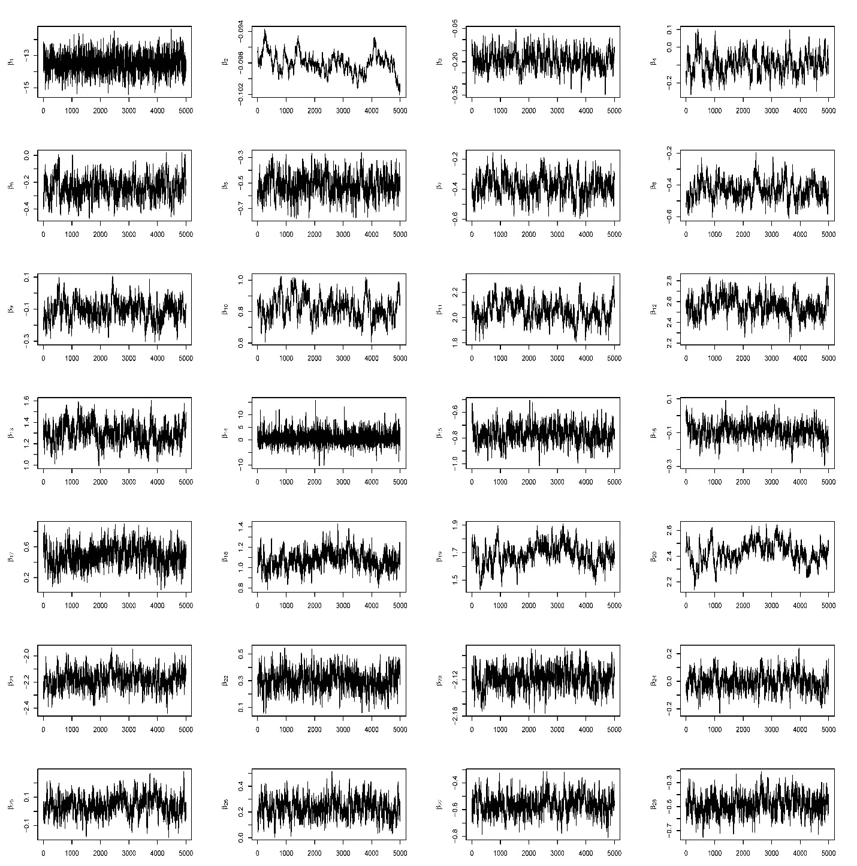
Figure 12: Trace plot of the coefficients of all covariates with physical component scores of VR-12 with BQL when the quantile level is 0.5.

