Supplementary Material

MEVALONATE KINASE represses anthocyanin biosynthesis via sucrose transporters and gibberellin synthesis pathways in Arabidopsis

Jinku Kang, Sua Cho, Kiyoon Kang, Daewon Kim, Sang-Il Bae, Eunji Shin, So-Yon Park, Gary Stacey, Nam-Chon Paek, and Sung-Hwan Cho

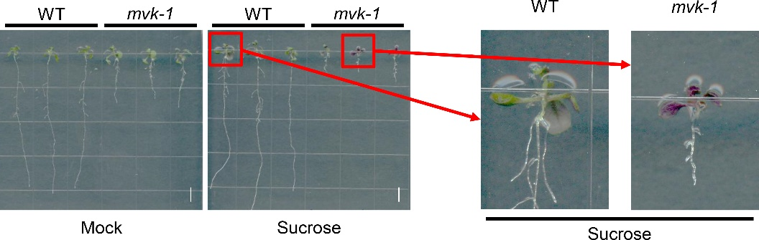

Supplementary Fig. S1 MVK is involved in sucrose-induced anthocyanin biosynthesis.
The mvk-1 mutants accumulate more anthocyanins in response to exogenous sucrose. 10-day-old seedlings of WT and mvk-1 mutants grown in half strength Murashige and Skoog (MS) medium were treated with or without 5% (v/w) exogenous sucrose for 3 days. Scale bar represents 1 mm. Red boxes and arrows indicate representative samples of WT (left panel), and the mvk-1 mutant (right panel).

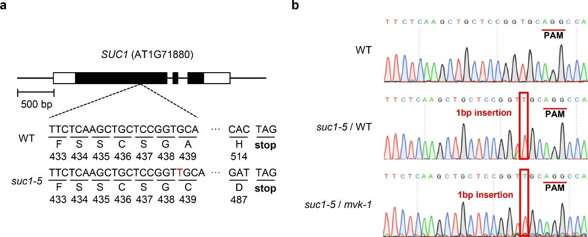

Supplementary Fig. S2 Gene editing information of suc1-5 and mvk-1 suc1-5 mutants.
a The schematic diagram indicates the position of the CRISPR/Cas9 cleavage site, which includes the target sequence and PAM, in SUC1 gene (AT1G71880). Black and white boxes represent exons and untranslated regions, respectively. Black lines represent introns. The nucleotides of the CRISPR/Cas9 edited site are compared below the diagram in WT, suc1-5, mvk-1 suc1-5 mutants. The insertion of a single adenosine nucleotide (lined-red alphabet) leads to the introduction of a premature stop codon.
b Sanger sequencing results showing a 1-bp insertion in the genomic DNA of suc1-5 compared to WT. The horizontal red lines indicate the PAM sequence, and the red box indicates the predicted double-strand break site.

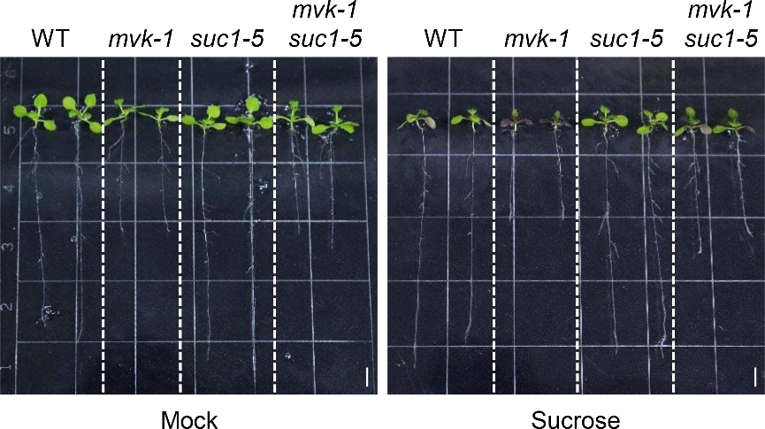

Supplementary Fig. S3 Phenotype of WT, mvk-1, suc1-5, and mvk-1 suc1-5 mutants with or without sucrose treatment.
10-day-old seedlings of WT, mvk-1, suc1-5, and mvk-1 suc1-5 grown in half strength Murashige and Skoog (MS) medium were treated with or without 3% (v/w) exogenous sucrose for 3 days. Scale bar represents 0.5 cm.

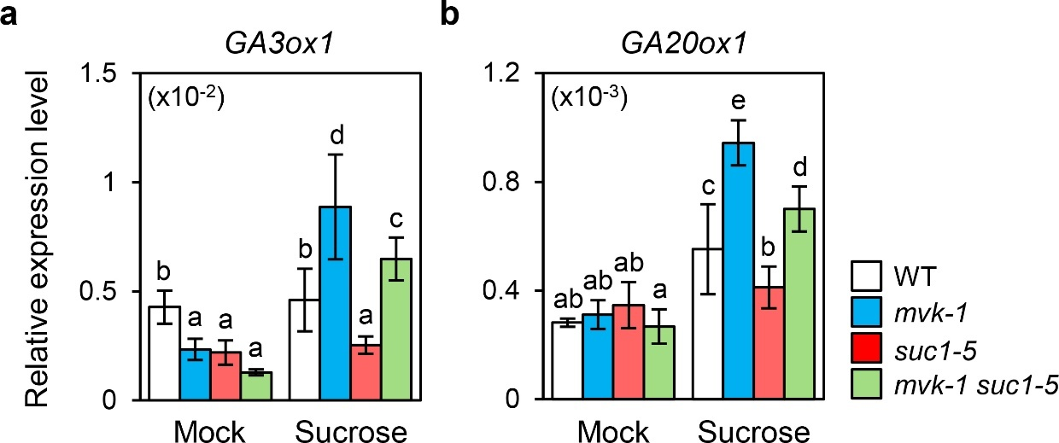

Supplementary Fig. S4 The relative expression levels of GA biosynthesis genes in WT and mvk-1 seedlings.
The relative expression levels of (a) GA3ox1, and (b) GA20ox1 in WT, mvk-1, suc1-5, and mvk-1 suc1-5 whole seedlings. 10-day-old seedlings grown in half-strength MS medium were treated with or without 3% (v/w) exogenous sucrose for 3 days. The white, blue, red, and green bars represent WT, mvk-1, suc1-5, and mvk-1 suc1-5, normalized to the UBQ5 reference gene. The mean and SD were obtained from four biological replicates. Different letters indicate significantly different values according to a one-way ANOVA followed by Duncan’s least significant range test (P<0.05).

Supplementary Table 1. Primer information in this study.
A. Primers used for plant transformation
Primer name | Forward primer (5’→3’) | Reverse primer (5’→3’)
pRGEB32-SUC1 | TAGGTCTCCCTGCTCCGGTGCGTTTTAGAGCTAGAA | ATGGTCTCAGCAGCTTGAGAATGCACCAGCCGGGAA
B. Primers used for RT-qPCR
Primer name | Forward primer (5’→3’) | Reverse primer (5’→3’)
qRT-CHS | GGCAAAGAAGCGGCAGTGAAG | CGGAAGGACGGAGACCAAGAAG
qRT-CHI | CCGGTTCATCGATCCTCTTC | ATCCCGGTTTCAGGGATACTATC
qRT-F3H | CAGATCGTTGAGGCTTGTGAGA | GACGAGTCATATCCGCCACTAAGT
qRT-F3’H | GCTCTCGCCGGAGTATTCAA | CCAGCGACGCCTTGTAAATC
qRT-DFR | CTTTGTTCGTGCCACCGTTCG | TCCTTCCTCAGATAAATCAGCCTTCC
qRT-LDOX | TATCAATTTGGCCTAAGACACCAAG | ACCAACTTCTTTCTCTAGACGGTCA
qRT-UF3GT | ATCGAATGAATCGTCAAGCATGAG | TGAGGGATAGAGATGGTGTGGAAAG
qRT-MYB75 | AGATAAGAAGAAAGACCAACTAGTG | CCAAGGTGTCCCCCTTTTC
qRT-SUC1 | TATTCTCAAGCTGCTCCGGT | TTGCTGCAACGATAAACGCC
qRT-SUC2 | GCAGACGGGTGAGTTAGA | GGAGATTGGACCACAGAG
qRT-SUC3 | CGGTGGCGGTCAAGGTTTGGC | AGCAGCGAAAGCAGCAACAGACG
qRT-SUC4 | CTCTACGCCACGACGACT | ACAACGGGACGAGATGAA
qRT-SWEET11 | TCCTTCTCCTAACAACTTATATACCATG | TCCTATAGAACGTTGGCACAGGA
qRT-SWEET12 | AAAGCTGATATCTTTCTTACTACTTCGAA | CTTACAAATCCTATAGAACGTTGGCAC
qRT-SWEET13 | CGCGTTCTTAGGAGCTGTTC | CCGGGTATGACGGTCGTTAG
qRT-SWEET14 | AAACGCTGTGGGATGCTTCA | TTCAAGAGCCCAAGAACCTTCA
qRT-GA3ox1 | TCCGAAGGTTTCACCATCACT | TCGCAGTAGTTGAGGTGATGTTG
qRT-GA20ox1 | GCCTGTAAGAAGCACGGTTTCT | CTCGTGTATTCATGAGCGTCTGA

