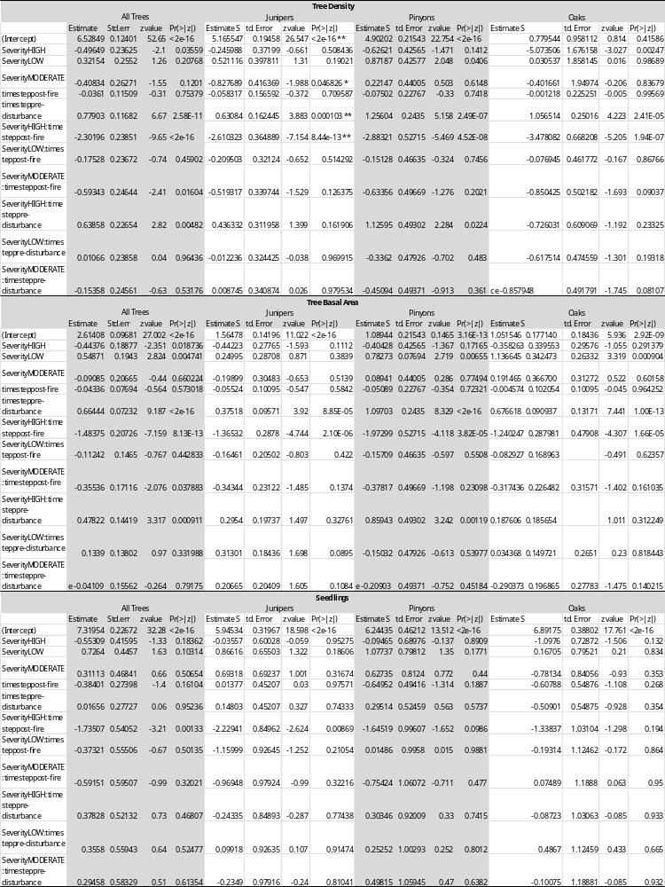
Appendix A: Zero-inflated linear mixed effects model results for stand structural changes in the Chisos Mountains, Big Bend National Park, USA
Appendix B: Estimated marginal means effects plots for tree density, basal area, and seedlings in the Chisos Mountains of Big Bend National Park.
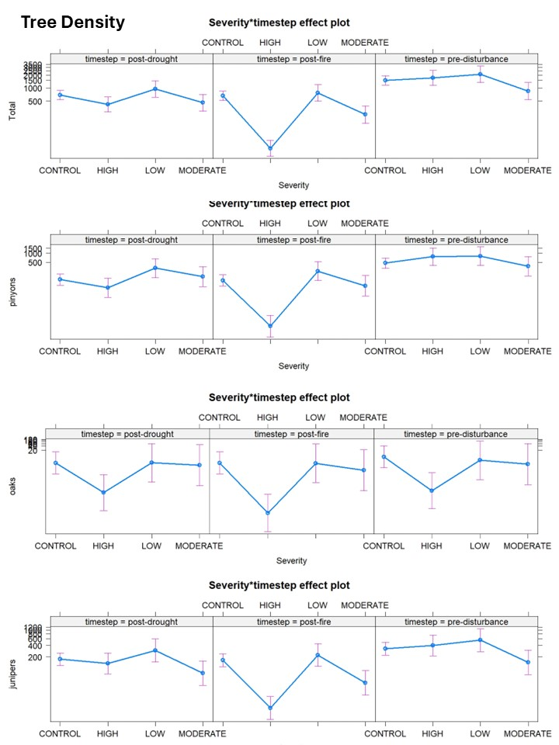
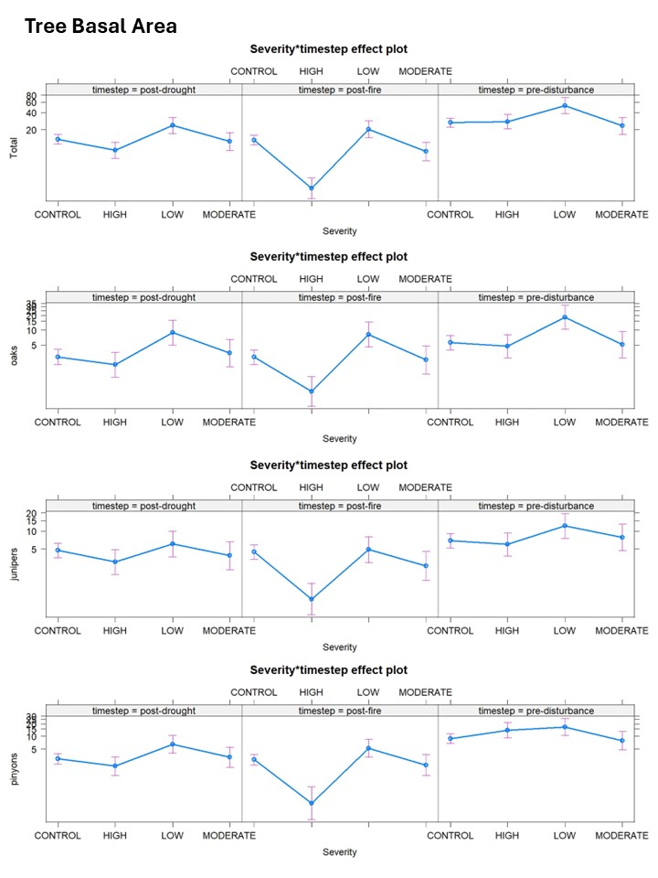

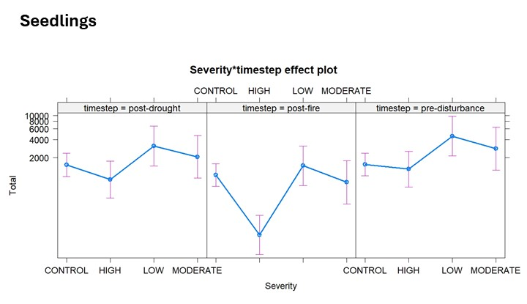

Appendix C: Estimated marginal means post-hoc tests for zero-inflated linear mixed effects models of tree mortality groups.