Supplementary Materials: The Use of Phosphodiesterase 5 Inhibitors Improves Survival in Men after Treatment for Rectal Cancer
Myroslav Lutsyk, Jonathan Green, Igor Albitskiy and Gil Bar-Sela
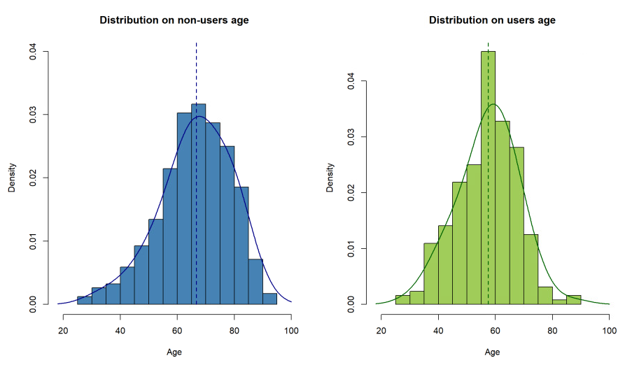
Figure S1: Age distribution at diagnosis of PDE5I users and non-users. Age distribution at diagnosis of PDE5I users (displayed in green on the right) and non-users (displayed in blue on the left). The graphical representations were created using histograms and Kernel Density Estimation. Mean ages at diagnosis are represented by the dashed lines (non-users clearly have higher mean diagnosis age). As displayed in the graphs (and verified in the Shapiro-Wilks tests), while PDE5I users’ distribution seems to be approximately normal, non-users’ distribution seems to be more skewed.
Table S1. Top 6 Variables/coefficients for Standardized Cox PH Model and Random Survival Forest.
Standardized Cox PH |  | Random Survival Forest
Variable: Level | Relative Importance | Variable | Importance
Ethnicity: Other | 0.261 | Recurrence | 0.0564
Solid Tumor: Metastatic | 0.090 | Age at diagnosis | 0.0318
Recurrence | 0.089 | CCI score | 0.030
Liver disease: Moderate-Severe | 0.065 | Ethnicity | 0.025
Age at diagnosis | 0.056 | Drug use | 0.016
Comorbidity count | 0.045 | Comorbidity count | 0.007

