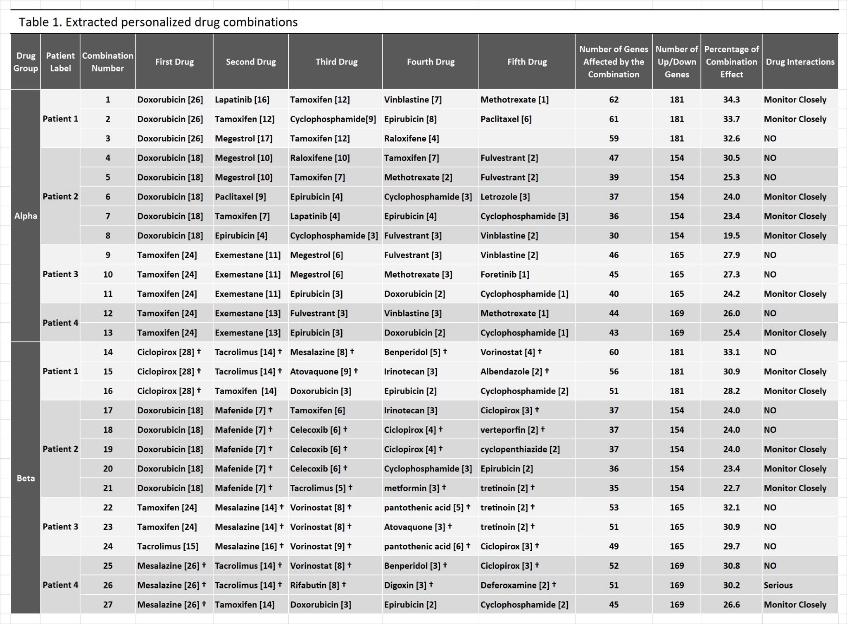

Table 1.
Extracted personalized drug combinations.
Only specialized cancer drugs were included in the Alpha group and, thus, in all drug combinations extracted from this group, while the Beta group contained both specialized and nonspecialized drugs. Nonspecialized drugs are marked with †.
The numbers within the Bracket display the number of perturbed genes for each patient that were influenced by the drug.

