Comparison of macroeconomic developments in ten scenarios of energy system transformation in Germany – National and regional results
Supplementary Material
Philip Ulrich, Tobias Naegler, Lisa Becker, Ulrike Lehr, Sonja Simon, Claudia Sutardhio, Anke Weidlich

- Short description of the model PANTA RHEI
PANTA RHEI is an environmentally extended version of macroeconometric simulation and forecasting model INFORGE (Ahlert et al. 2009), developed for the macroeconomic evaluation of environmental protection measures and energy economic policy. To quantify these macroeconomic effects, the long-term structural change in economic development and environmental-economic interdependencies are modeled.
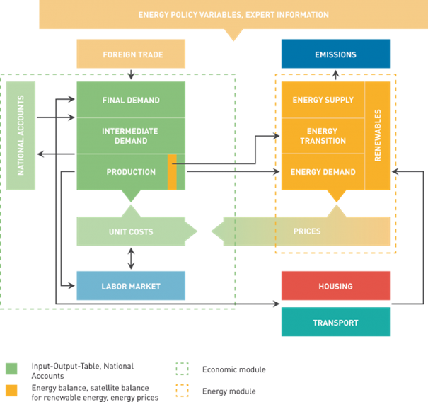
Figure 1: Overview of the PANTA RHEI model
The flow chart shown in Figure 1 provides an overview of the structure of the PANTA RHEI model. In addition to the comprehensive economic modelling, the sections of energy consumption and emissions as well as transport and housing are covered in detail. All model parts are consistently linked to each other. For example, the transport sector models fuel consumption in litres, which, multiplied by the price per litre, feeds into input demand from the manufacturing sector and demand for consumer goods. Changes to fuel tax rates result in changes to tax receipts and a broad range of economic adaptation processes. However, changes in fuel prices also lead to changes in behaviour, which are also considered in PANTA RHEI. The model is solved with full interdependence, i.e., the impacts between all model variables are captured simultaneously.
The model contains a multitude of macroeconomic variables drawn from official statistics and provides disaggregated information on 63 economic sectors. Energy balances (including satellite balances for renewable energy) are fully integrated into the model. The behavioral parameters are econometrically estimated based on time series data.
The economic core model INFORGE is regularly used, among others, for long-term employment projections and simulations by the Institute for Employment Research and the Federal Institute for Vocational Education and Training (Zika et al. 2019, Wolter et al. 2019. The model linkages are described in detail in (Maier et al. 2015). The PANTA RHEI model has been used extensively in recent years, e.g., to evaluate the macroeconomic effects of the energy transition (Lutz et al. 2018, Lehr et al. 2019) and to develop socio-economic scenarios (Lutz et al. 2019).

References for Supplement
Lehr, U., Edler, D., Ulrich, P., Blazejczak, J. & Lutz, C. (2019): Beschäftigungschancen auf dem Weg zu einer Green Economy – szenarienbasierte Analyse von (Netto-) Beschäftigungswirkungen. Umwelt, Innovation, Beschäftigung 03/2019, Dessau-Roßlau.
Lutz, C., Becker, L., Ulrich, P. & Distelkamp, M. (2019): Sozioökonomische Szenarien als Grundlage der Vulnerabilitätsanalysen für Deutschland – Teilbericht des Vorhabens „Politikinstrumente zur Klimaanpassung“. Climate Change 25/2019, Dessau-Roßlau.
Lutz, C., Flaute, M., Lehr, U., Kemmler, A., Kirchner, A., auf der Maur, A., Ziegenhagen, I., Wünsch, M., Koziel, S., Piégsa, A. & Straßburg, S. (2018): Gesamtwirtschaftliche Effekte der Energiewende. GWS Research Report 2018/4, Osnabrück, Basel.
Ahlert, G., Distelkamp, M., Lutz, C., Meyer, B., Mönnig, A. & Wolter, M. I. (2009): Das IAB/INFORGE-Modell. In: Schnur, P. & Zika, G. [Hrsg]: Das IAB/INFORGE-Modell. Ein sektorales makroökonometrisches Projektions- und Simulationsmodell zur Vorausschätzung des längerfristigen Arbeitskräftebedarfs. IAB-Bibliothek 318, Nürnberg, S. 15–175.
Zika, G., Schneemann, Ch., Kalinowski, M., Maier, T., Winnige, S., Groẞmann, A., Mönnig, A., Parton, F. & Wolter, M. I. (2019): BMAS-Prognose „Digitalisierte Arbeitswelt“ – Kurzbericht. Forschungsbericht 526/1K, Institut für Arbeitsmarkt- und Berufsforschung (IAB), Bundesinstitut für Berufsbildung (BIBB) & Gesellschaft für Wirtschaftliche Strukturforschung (GWS) mbH im Auftrag des Bundesministeriums für Arbeit und Soziales (BMAS), Berlin.
Wolter, M. I., Mönnig, A., Schneemann, Ch., Weber, E., Zika, G., Helmrich, R., Maier, T. & Winnige, S. (2019): Wirtschaft 4.0 und die Folgen für Arbeitsmarkt und Ökonomie. Szenario-Rechnungen im Rahmen der fünften Welle der BIBB-IAB-Qualifikations- und Berufsprojektionen; Heft-Nr.: 200, Bundesinstitut für Berufsbildung (BIBB), Bonn.
Maier, T., Mönnig, A. & Zika, G. (2015): Labour demand in Germany by industrial sector, occupational field and qualification until 2025 – model calculations using the IAB/INFORGE model. In: Economic Systems Research 27(1), pp. 19–42. DOI: 10.1080/09535314.2014.997678.

