Supplementary Figure S1. Escape Room to Understand Illness Nazopital Vol. 1: Phantom Thief Moriwarl and the Secret Vaccine Chapter 1A (front/back)
Annotation: Though the original version used in the study was in Japanese, an English translation of the relevant components is presented here for publication.
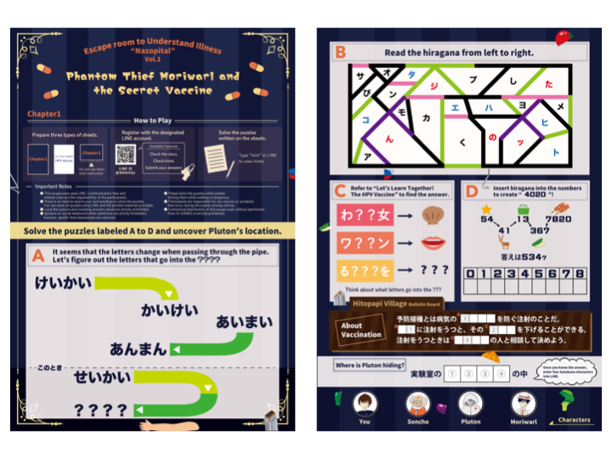

Supplementary Figure S2 . Escape Room to Understand Illness Nazopital Vol. 1: Phantom Thief Moriwarl and the Secret Vaccine, Chapter 1B - educational material on HPV vaccine knowledge

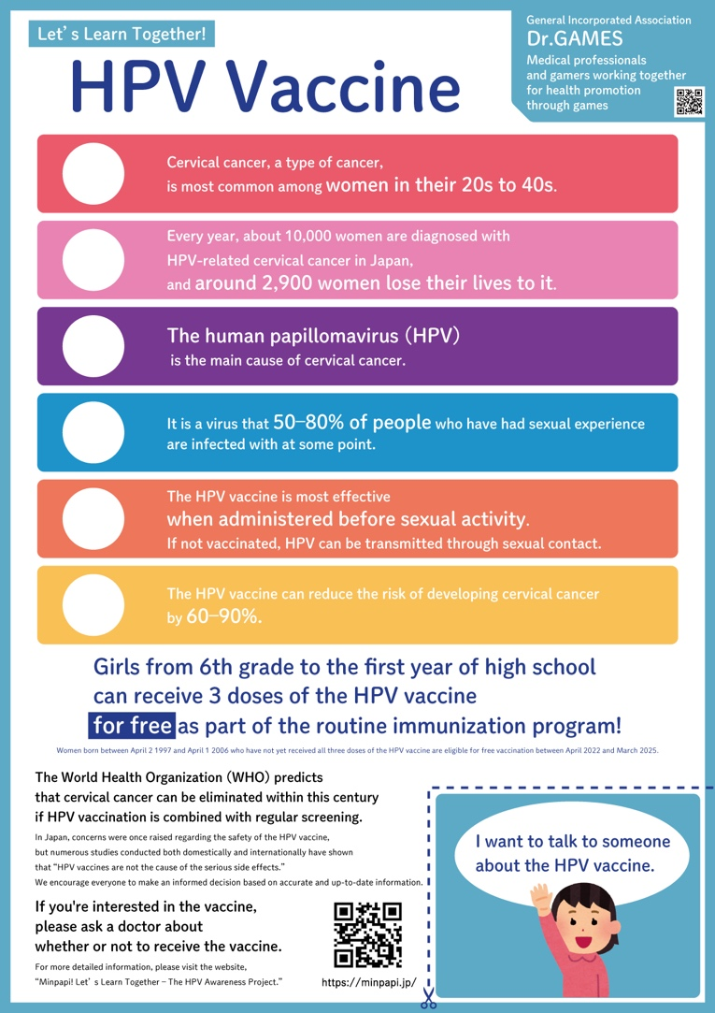

Supplementary Figure S3. Escape Room to Understand Illness Nazopital Vol. 1: Phantom Thief Moriwarl and the Secret Vaccine, LINE chatbot game interface (story section)

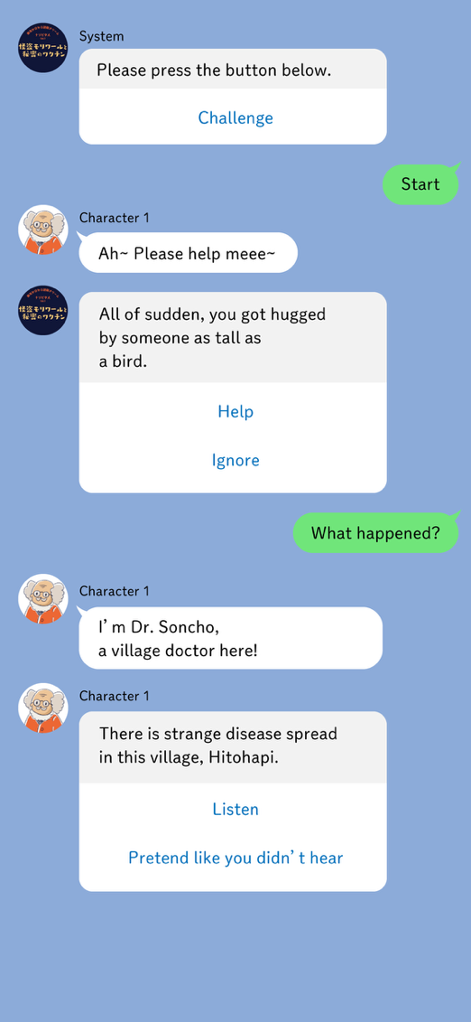

Supplementary Figure S4. Escape Room to Understand Illness Nazopital Vol. 1: Phantom Thief Moriwarl and the Secret Vaccine, LINE chatbot game interface (quiz section)
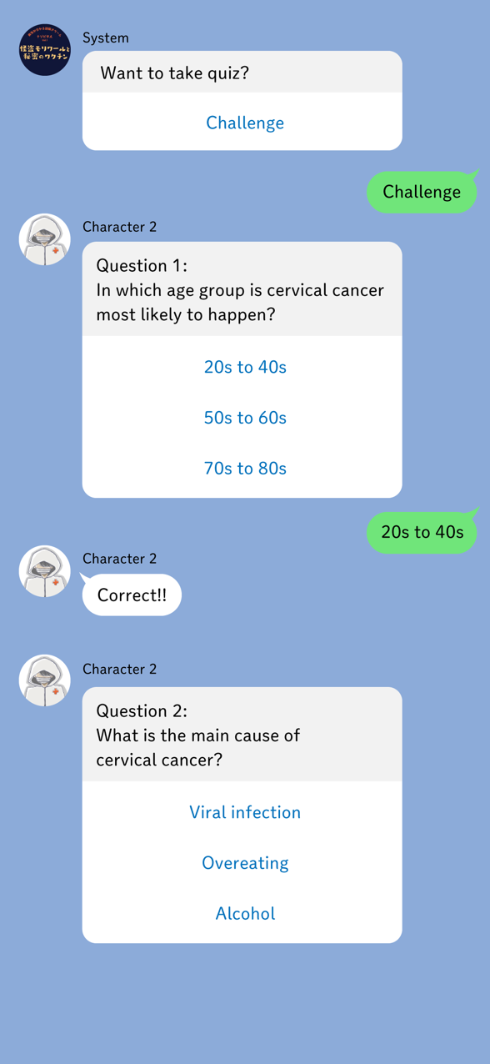

Supplementary Figure S5. Escape Room to Understand Illness Nazopital Vol. 1: Phantom Thief Moriwarl and the Secret Vaccine, Chapter 2 (front/back)

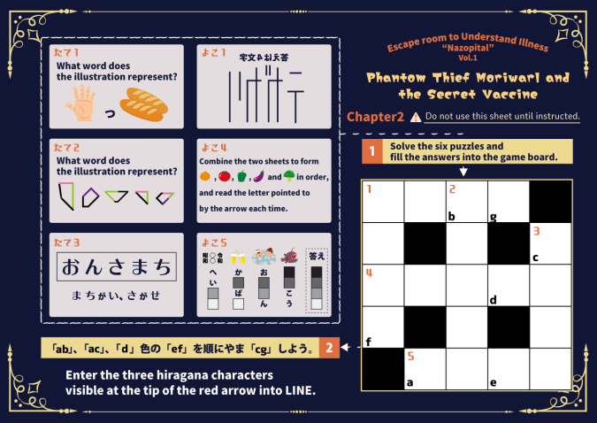
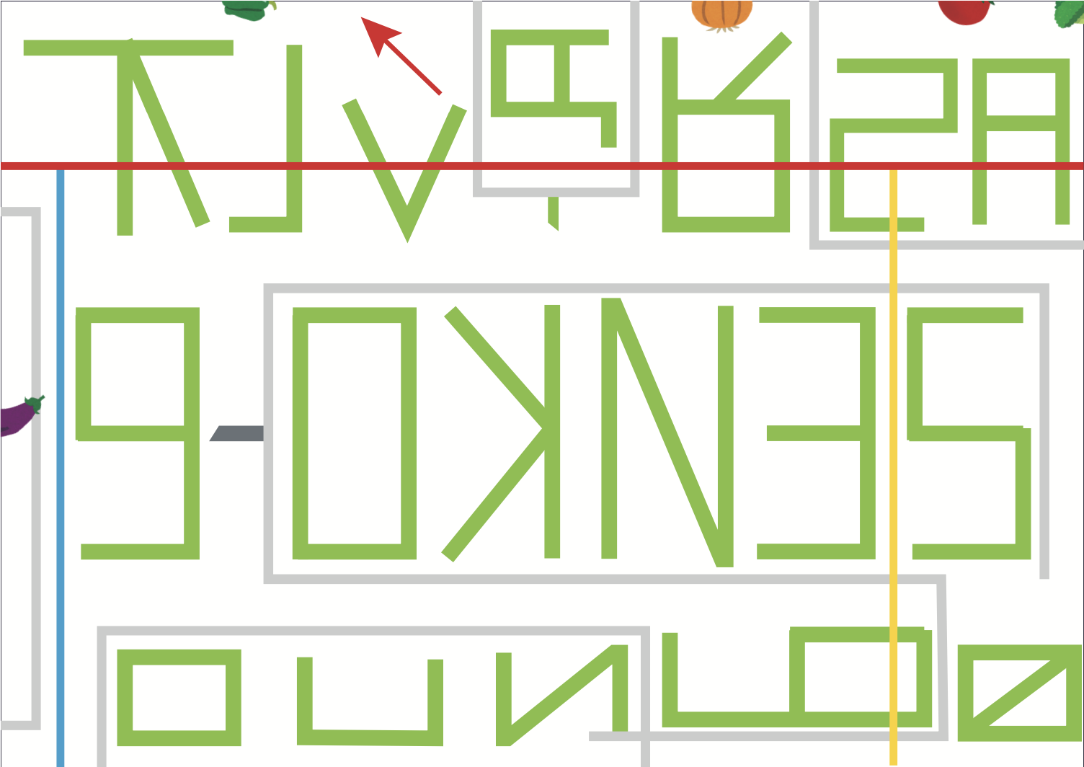

Supplementary Figure S6. Students participating in the escape room.


Supplementary Figure S7. Classroom scene from the lecture group.
