Supplementary Table 1: Optimization conditions for ADCP and ADCC assays
Assay type | E:T ratio | Serum dilution | Incubation time (hr)
ADCP | 1:2 | 1:100 | 4
ADCC | 1:1 | 1:100 | 4
Assay parameters were optimized for human ADCP and ADCC assays, using VZV-seropositive and VZV-seronegative sera. Optimal conditions were defined as those yielding the highest signal-to-noise (maximized signal from VZV-positive serum and minimized background from VZV-negative sera), along with good reproducibility. ADCP, antibody-dependent cellular phagocytosis; ADCC, antibody-dependent cellular cytotoxicity; VZV, varicella-zoster virus.

Supplementary Table 2: Antibody titers of varicella-zoster virus plasma panel and sera used for validation
Sample | ELISA titer^{b} (mIU/mL) | Remark
Panel 1 (P1) | < min | Negative control
Panel 12 (P12) | 229.7 | Low titer
Panel 14 (P14) | 367.6 | Low titer
Panel 15 (P15) | 540.3 | Medium titer
Panel 16 (P16) | 750.6 | Medium titer
Panel 22 (P22) | 2,896.2 | High titer
Panel 23 (P23) | 1,767.6 | High titer
Pre-01 | 482.2 | SHINGRIX
Post-03 | 6,549.5 | SHINGRIX
No.28(Pre)/No.28-1(Post) | 3.0/46.7 | BARYCELA
No.35(Pre)/No.35-1(Post) | < min/427.5 | VARIVAX
No.39(Pre)/No.39-1(Post) | 1.7/338.3 | VARIVAX
No.41-1(Post) | 282.3 | VARIVAX
ªAnti-VZV IgG ELISA antibody titer was measured using VZV IgG Serion ELISA classic kit.
^{b}Panel is varicella-zoster virus panel of the Korea Ministry of Food and Drug Safety prepared from healthy adult plasma. ELISA, enzyme-linked immunosorbent assay; VZV, varicella-zoster virus; IgG, immunoglobulin.
Supplementary Table 3: Lot-to-lot variation of VZV-infected MRC-5 target cell stocks in ADCP assay
Target cell stock | ADCP activities (%)
Target cell stock | P12 (low) | P15 (medium) | P22 (high)
Lot No.1 | 9.4 | 20.7 | 31.2
Lot No.2 | 10.2 | 21.0 | 32.4
Mean ± SD | 9.8 ± 0.4 | 20.8 ± 0.1 | 31.8 ± 0.6
%CV | 4.3 | 0.6 | 1.9
ADCP activities were measured in VZV panel samples with different antibody levels using two stocks of VZV-infected MRC-5 target cells, and background signals were subtracted using values obtained from the negative panel (P1). Results are presented as mean ADCP activity (%) ± standard deviation (SD) for each sample, together with the coefficient of variation (%CV) to assess assay variability. ADCP, antibody-dependent cellular phagocytosis; VZV, varicella-zoster virus; MRC-5, Medical Research Council cell strain 5.

Supplementary Table 4: Lot-to-lot variation of VZV-infected MRC-5 target cell stocks in ADCC assay
Target cell stock | ADCC activities (%)
Target cell stock | P12 (low) | P15 (medium) | P22 (high)
Lot No.1 | 3.7 | 13.7 | 21.1
Lot No.2 | 3.5 | 15.1 | 18.3
Mean ± SD | 3.6 ± 0.2 | 14.9 ± 0.6 | 19.7 ± 1.4
%CV | 2.8 | 4.0 | 7.1
ADCC activities were measured in VZV plasma samples with different antibody levels using two stocks of VZV-infected MRC-5 target cells, and background signals were subtracted using values obtained from the negative panel (P1). Results are presented as mean ADCC activity (%) ± SD for each sample together with the %CV to assess assay variability. ADCC, antibody-dependent cellular cytotoxicity; VZV, varicella-zoster virus; MRC-5, Medical Research Council cell strain 5.

Supplementary Table 5: Linearity across sample dilutions in ADCP assay
Sample  No. | Dilution folds |  |  |  |  | r²
Sample  No. | 1:40 | 1:80 | 1:160 | 1:320 | 1:640 | r²
P22 | 29.5 | 26.9 | 25.5 | 20.3 | 9.9 | 0.87
P23 | 34.7 | 32.6 | 20.6 | 14.4 | 1.2 | 0.96
Pre 01 | 30.0 | 18.2 | 10.2 | 4.2 | 5.4 | 0.87
The ADCP activities were assessed using serial dilutions (1:40 – 1:640) of three samples. Linearity was calculated by simple linear regression, and the coefficient of determination (r²) is shown for each sample. ADCP, antibody-dependent cellular phagocytosis; Pre, pre-vaccination.

Supplementary Table 6: Linearity across sample dilutions in ADCC assay
Sample  No. | Dilution folds |  |  |  |  | r²
Sample  No. | 1:80 | 1:160 | 1:320 | 1:640 | 1:1,280 | r²
39-1 | 39.5 | 38.1 | 33.1 | 29.2 | 23.1 | 0.97
41-1 | 39.4 | 36.8 | 34.0 | 24.2 | 19.1 | 0.92
Post-03 | 35.6 | 37.6 | 32.5 | 25.9 | 19.7 | 0.87
The ADCC activities were assessed using serial dilutions (1:80 – 1:1,280) of three samples. Linearity was calculated by simple linear regression, and the coefficient of determination (r²) is shown for each sample. ADCC, antibody-dependent cellular cytotoxicity; Post, post-vaccination.

Supplementary Table 7: Intra-assay precision of ADCP
Replicates | ADCP activities (%)
Replicates | P12  (low) | P14  (low) | P15  (medium) | P16  (medium) | P22  (high) | P23  (high)
1 | 8.4 | 6.7 | 18.6 | 17.0 | 34.8 | 34.0
2 | 7.0 | 10.2 | 19.3 | 19.8 | 37.7 | 39.7
3 | 10.0 | 8.5 | 20.5 | 20.3 | 34.2 | 36.0
4 | 10.8 | 8.6 | 15.2 | 19.2 | 41.2 | 37.0
5 | 9.3 | 14.9 | 16.8 | 18.0 | 37.7 | 37.1
Mean ± SD | 9.1 ± 1.3 | 9.8 ± 2.8 | 18.1 ± 1.9 | 18.9 ± 1.2 | 37.1 ± 2.5 | 36.7 ± 1.8
%CV | 14.6 | 28.5 | 10.4 | 6.4 | 6.7 | 5.0
Intra-assay precision for ADCP was measured using five replicates measurement of six panel samples representing low, medium, and high antibody levels. ADCP activity (%) was determined after background subtraction using the negative panel (P1). Results are presented as mean ADCP activity (%) ± SD for each sample and %CV to assess assay reproducibility. ADCP, antibody-dependent cellular phagocytosis; SD, standard deviation; CV, coefficient of variation.

Supplementary Table 8: Intra-assay precision of ADCC
Replicates | ADCC activities (%)
Replicates | P12  (low) | P14  (low) | P15  (medium) | P16  (medium) | P22  (high) | P23  (high)
1 | 3.2 | 10.5 | 16.6 | 13.9 | 18.1 | 19.6
2 | 3.0 | 8.7 | 16.5 | 16.3 | 18.0 | 19.5
3 | 6.4 | 10.7 | 15.6 | 14.5 | 17.5 | 20.3
4 | 4.5 | 11.6 | 14.0 | 14.3 | 17.4 | 21.0
5 | 4.4 | 10.7 | 16.9 | 15.2 | 16.0 | 19.9
Mean ± SD | 4.3 ± 1.2 | 10.5 ± 1.0 | 15.9 ± 1.0 | 14.8 ± 0.8 | 17.4 ± 0.8 | 20.0 ± 0.6
%CV | 28.0 | 9.1 | 6.6 | 5.6 | 4.4 | 2.7
Intra-assay precision for ADCC was measured using five replicates measurement of six plasma samples representing low, medium, and high antibody levels. ADCC activity (%) was determined after background subtraction using the negative panel (P1). Results are presented as mean ADCC activity (%) ± SD for each sample and %CV to assess assay reproducibility. ADCC, antibody-dependent cellular cytotoxicity; SD, standard deviation; CV, coefficient of variation.

Supplementary Table 9: Inter-personal precision of ADCP assay
Tester | ADCP activities (%)
Tester | P12  (low) | P14  (low) | P15 (medium) | P16 (medium) | P22  (high) | P23  (high)
1 | 6.8 | 7.5 | 19.3 | 26.1 | 32.9 | 40.6
2 | 7.9 | 10.8 | 16.8 | 14.5 | 31.7 | 37.4
Mean ± SD | 7.4 ± 0.6 | 9.2 ± 1.7 | 18.1 ± 1.3 | 20.3 ± 5.8 | 32.3 ± 0.6 | 39.0 ± 1.6
%CV | 7.5 | 18.0 | 6.8 | 28.4 | 1.9 | 4.2
ADCP activities were measured by two testers across six panel samples. For each sample, results are presented as mean ADCP activity (%)± SD and %CV to assess consistency between testers. ADCP activities were Background levels were subtracted using values obtained from the negative panel (P1). ADCP, antibody-dependent cellular phagocytosis; SD, standard deviation; CV, coefficient of variation.

Supplementary Table 10: Inter-personal precision of ADCC assay
Tester | ADCC activities (%)
Tester | P12  (low) | P14  (low) | P15 (medium) | P16 (medium) | P22  (high) | P23  (high)
1 | 3.6 | 7.9 | 14.1 | 14.4 | 18.7 | 18.8
2 | 2.5 | 10.8 | 14.75 | 16.6 | 17.7 | 19.6
Mean ± SD | 3.0 ± 0.5 | 9.3 ± 1.5 | 14.4 ± 0.3 | 15.5 ± 101 | 18.2 ± 0.5 | 19.2 ± 0.4
%CV | 18.0 | 16.0 | 2.3 | 7.1 | 2.7 | 2.3
ADCC activities were measured by two testers across six panel samples. For each sample, results are presented as mean ADCC activity (%) ± SD and %CV to assess consistency between testers. Background levels weresubtracted using values obtained from the negative panel (P1). ADCC, antibody-dependent cellular cytotoxicity; SD, standard deviation; CV, coefficient of variation.
Supplementary Table 11: Inter-day precision of ADCP assay
Day | ADCP activities (%)
Day | P12  (low) | P14  (low) | P15 (medium) | P16 (medium) | P22  (high) | P23  (high)
1 | 7.2 | 7.8 | 17.6 | 19.8 | 31.8 | 38.5
2 | 6.7 | 6.2 | 18.5 | 19.3 | 29.1 | 38.5
3 | 7.3 | 9.1 | 16.4 | 13.5 | 21.1 | 30.0
Mean ± SD | 7.1 ± 0.3 | 7.7 ± 1.2 | 17.5 ± 0.8 | 17.5 ± 2.8 | 27.3 ± 4.6 | 35.6 ± 4.0
%CV | 3.7 | 15.3 | 4.9 | 16.3 | 16.6 | 11.2
ADCP activities were measured over three separate days across a range of panel samples. For each sample, results are presented as mean ADCP activity (%) ± SD and %CV to assess assay consistency across multiple days. Background levels were subtracted using values obtained from the negative panel (P1). ADCP, antibody-dependent cellular phagocytosis; SD, standard deviation; CV, coefficient of variation.

Supplementary Table 12: Inter-day precision of ADCC assay
Day | ADCC activities (%)
Day | P12  (low) | P14  (low) | P15 (medium) | P16 (medium) | P22  (high) | P23  (high)
1 | 3.5 | 12.5 | 14.4 | 15.5 | 18.2 | 19.2
2 | 3.0 | 9.3 | 13.8 | 14.9 | 18.2 | 19.5
3 | 1.9 | 10.8 | 15.0 | 15.1 | 18.2 | 18.7
Mean ± SD | 2.8 ± 0.7 | 10.9 ± 1.3 | 14.4 ± 0.5 | 15.2 ± 0.3 | 18.2 ± 0.1 | 19.1 ± 0.3
%CV | 25.1 | 11.8 | 3.4 | 1.7 | 0.2 | 1.8
ADCC activities were measured over three separate days across a range of panel samples. For each sample, results are presented as mean ADCC activity (%)± SD and %CV to assess assay consistency across multiple days. Background levels were subtracted using values obtained from the negative panel (P1). ADCC, antibody-dependent cellular cytotoxicity; SD, standard deviation; CV, coefficient of variation.

Supplementary Table 13: Inter-laboratory precision assay of ADCP assay
Laboratory | ADCP activities (%)
Laboratory | No. 28 |  | No. 35 |  | No. 39
Laboratory | Pre | Post | Pre | Post | Pre | Post
1 | 6.6 | 19.6 | 8.5 | 35.6 | 5.7 | 53.1
2 | 5.2 | 15.3 | 5.5 | 40.9 | 5.6 | 41.8
3 | 5.8 | 11.4 | 5.5 | 38.5 | 6.6 | 44.2
Mean ± SD | 5.9 ± 0.6 | 15.4 ± 3.3 | 6.5 ± 1.4 | 38.3 ± 2.2 | 6.0 ± 0.4 | 46.4 ± 4.9
%CV | 9.8 | 21.7 | 21.8 | 5.7 | 7.5 | 10.5
ADCP activities were measured in three laboratories to evaluate inter-laboratory precision using three pairs of pre- and post-varicella vaccination serum samples (No. 28, No. 35, and No. 39). Results are presented as mean ADCP activity (%) ± SD for each sample together with the %CV to indicate variability across laboratories. ADCP, antibody-dependent cellular phagocytosis; SD, standard deviation; CV, coefficient of variation.

Supplementary Table 14: Inter-laboratory precision assay of ADCC assay
Laboratory | ADCC activities (%)
Laboratory | No. 28 |  | No. 35 |  | No. 39
Laboratory | Pre | Post | Pre | Post | Pre | Post
1 | 12.4 | 15.8 | 15.1 | 18.6 | 15.0 | 20.5
2 | 11.6 | 16.9 | 11.6 | 15.0 | 12.4 | 35.6
3 | 14.2 | 18.4 | 16.0 | 19.4 | 16.3 | 31.4
mean ± SD | 12.7 ± 1.1 | 17.0 ± 1.1 | 14.2 ± 1.9 | 17.7 ± 1.9 | 14.6 ± 1.6 | 29.2 ± 6.4
%CV | 8.5 | 6.3 | 13.3 | 10.8 | 11.1 | 21.8
ADCC activities were measured in three laboratories to evaluate inter-laboratory precision using three pairs of pre- and post-varicella vaccination serum samples (No. 28, No. 35, and No. 39). Results are presented as mean ADCC activities (%) ± SD for each sample together with the %CV to indicate variability across laboratories. ADCC, antibody-dependent cellular cytotoxicity; SD, standard deviation; CV, coefficient of variation.

Supplementary Table 15: VZV-specific ADCP and ADCC activities after varicella and zoster vaccination
Assay | Vaccine name | Platform | Pre-vaccination  (%) | Post-vaccination  (%) | Fold change  (post/pre)
ADCP | BARYCELA | Live attenuated  Live attenuated  Live attenuated | 8.3 | 34.3 | 4.1
ADCP | VARIVAX | Live attenuated  Live attenuated  Live attenuated | 7.8 | 34.1 | 4.4
ADCP | ZOSTAVAX | Live attenuated  Live attenuated  Live attenuated | 27.0 | 40.8 | 1.5
ADCP | SHRINGRIX | Subunit | 28.9 | 51.5 | 1.8
ADCC | BARYCELA | Live attenuated  Live attenuated  Live attenuated | 11.3 | 24.3 | 2.1
ADCC | VARIVAXª | Live attenuated  Live attenuated  Live attenuated | 12.8 | 21.7 | 1.7
ADCC | ZOSTAVAX | Live attenuated  Live attenuated  Live attenuated | 20.3 | 25.9 | 1.3
ADCC | SHRINGRIX | Subunit | 24.8 | 31.9 | 1.3
ª50 samples were analyzed by ADCP, ELISA, and FAMA assay; 42 of these were tested for ADCC. ADCP, antibody-dependent cellular phagocytosis; ADCC, antibody-dependent cellular cytotoxicity;

Supplementary Table 16: Distribution of FAMA titers among the four vaccination groups, with corresponding geometric mean titers (GMTs)
Vaccine | No. of samples with FAMA titers of: |  |  |  |  |  |  |  |  |  |  | GMT | p-value
Vaccine | < 2 | 4 | 8 | 16 | 32 | 64 | 128 | 256 | 512 | 1024 | 2048 | GMT | p-value
BARYCELA |  |  |  |  |  |  |  |  |  |  |  |  | < 0.0001
Pre | 23 |  |  |  |  |  |  |  |  |  |  | 2.0
Post |  |  |  |  | 1 | 6 | 6 | 6 | 4 |  |  | 153.4
VARIVAX |  |  |  |  |  |  |  |  |  |  |  |  | < 0.0001
Pre | 23 | 1 | 1 |  |  |  |  |  |  |  |  | 2.2
Post |  |  |  |  | 2 | 6 | 5 | 6 | 5 | 1 |  | 164.3
ZOSTAVAX |  |  |  |  |  |  |  |  |  |  |  |  | < 0.0001
Pre |  |  |  |  | 3 | 9 | 7 | 1 |  |  |  | 78.8
Post |  |  |  |  |  | 2 | 6 | 7 | 5 |  |  | 215.3
SHINGRIX |  |  |  |  |  |  |  |  |  |  |  |  | < 0.0001
Pre |  |  |  |  | 1 | 10 | 8 | 1 |  |  |  | 87.4
Post |  |  |  |  |  |  |  | 1 | 7 | 11 | 1 | 776.0

FAMA, fluorescent antibody to membrane antigen; GMTs, geometric mean titers; Pre, pre-vaccination; Post, post-vaccination.
Supplementary Table 17: Changes of ELISA antibody titers before and after vaccination
Vaccine | Pre-vaccination (mIU/mL) |  | Post-vaccination (mIU/mL) |  | p-value
Vaccine | GMTs | Range | GMTs | Range | p-value
BARYCELA | 0.8 | 0.1 − 32.0 | 118.9 | 27.8 − 435.4 | < 0.0001
VARIVAX | 0.4 | 0.01 − 24.8 | 139.2 | 37.5 − 893.2 | < 0.0001
ZOSTAVAX | 520.1 | 159.1 − 1,484.4 | 1,697.3 | 415.2 − 4,599.2 | < 0.0001
SHRINGRIX | 609.6 | 145.0 − 2,176.0 | 10,428.9 | 4,561.4 − 36,355.9 | < 0.0001
ELISA, enzyme-linked immunosorbent assay; GMTs, geometric mean titers.

Supplementary Table 18: IgG1 and IgG3 levels induced by VZV vaccination
Vaccine | IgG subclass | Pre-vaccination  (O.D) | Post-vaccination  (O.D) | Fold change  (post/pre)
BARYCELA | IgG1 | 0.04 | 0.07 | 1.8
VARIVAX | IgG1 | 0.04 | 0.10 | 2.5
ZOSTAVAX | IgG1 | 0.32 | 1.05 | 3.3
SHRINGRIX | IgG1 | 0.49 | 2.38 | 4.9
BARYCELA | IgG3 | 0.05 | 0.24 | 4.8
VARIVAX | IgG3 | 0.05 | 0.29 | 5.8
ZOSTAVAX | IgG3 | 0.07 | 0.15 | 2.1
SHRINGRIX | IgG3 | 0.04 | 0.07 | 1.8

IgG, immunoglobulin; VZV, varicella-zoster virus; O.D, optical density.

Supplementary Figure legends
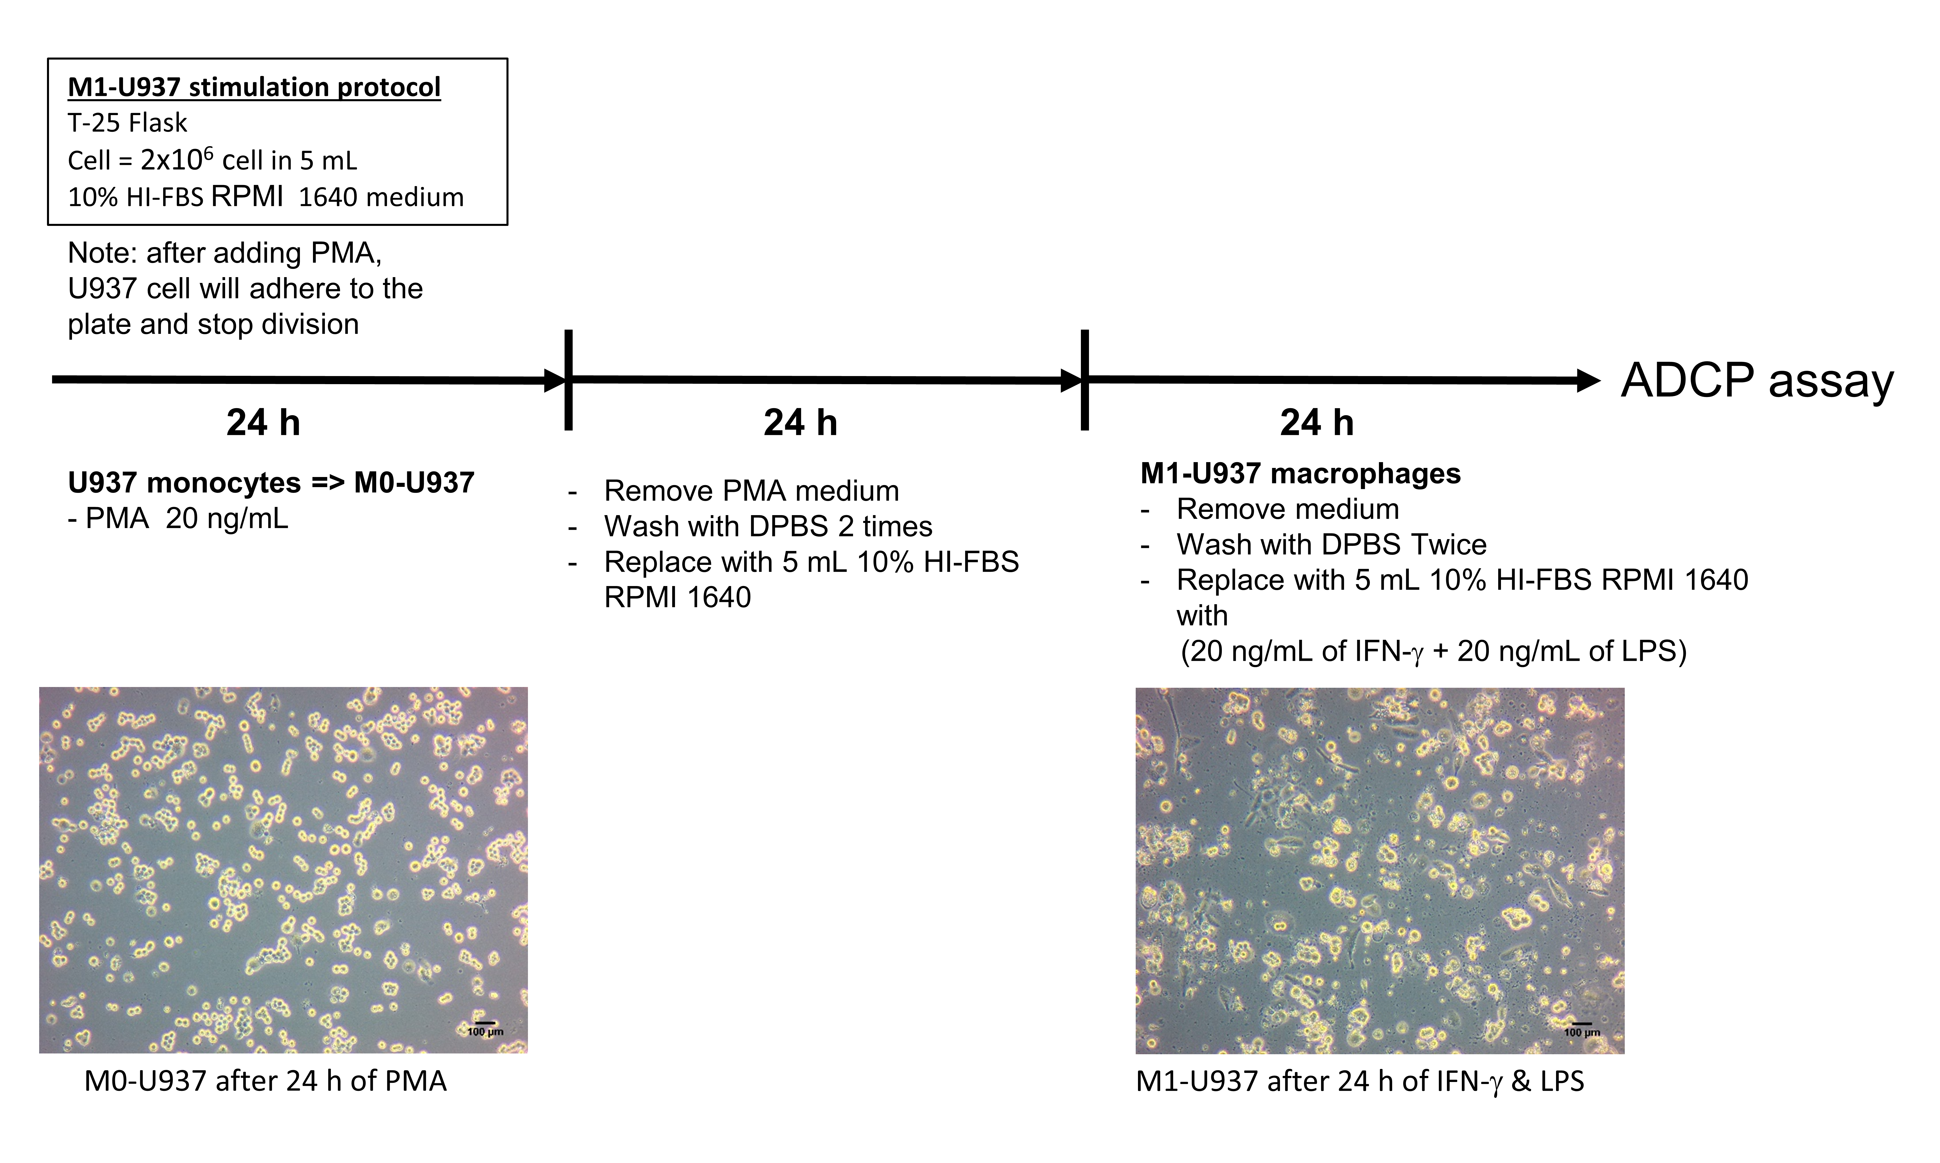
Supplementary Fig. 1: Differentiation of U937 cells into M1 macrophages for ADCP assay. U937 monocytes were stimulated with PMA (20 ng/mL) for 24 h to induce differentiation into M0-U937, followed by 24 h of resting periods in fresh medium. For M1 polarization, M0-U937 cells were further stimulated with IFN-γ (20 ng/mL) and LPS (20 ng/mL) for 24 h. Representative microscopic images show M0-U937 cells after 24 h of PMA stimulation (left) and M1-U937 macrophages after 24 h of IFN-γ and LPS stimulation (right). Scale bar = 100 μm. RPMI, Roswell Park Memorial institute (medium); ADCP, antibody-dependent cellular phagocytosis; PMA, phorbol 12-myristate 13-acetate; DPBS, Dulbecco’s Phosphate-Buffered Saline; HI-FBS, Heat-Inactivated Fetal Bovine Serum; IFN-γ, interferon gamma; LPS, lipopolysaccharide.
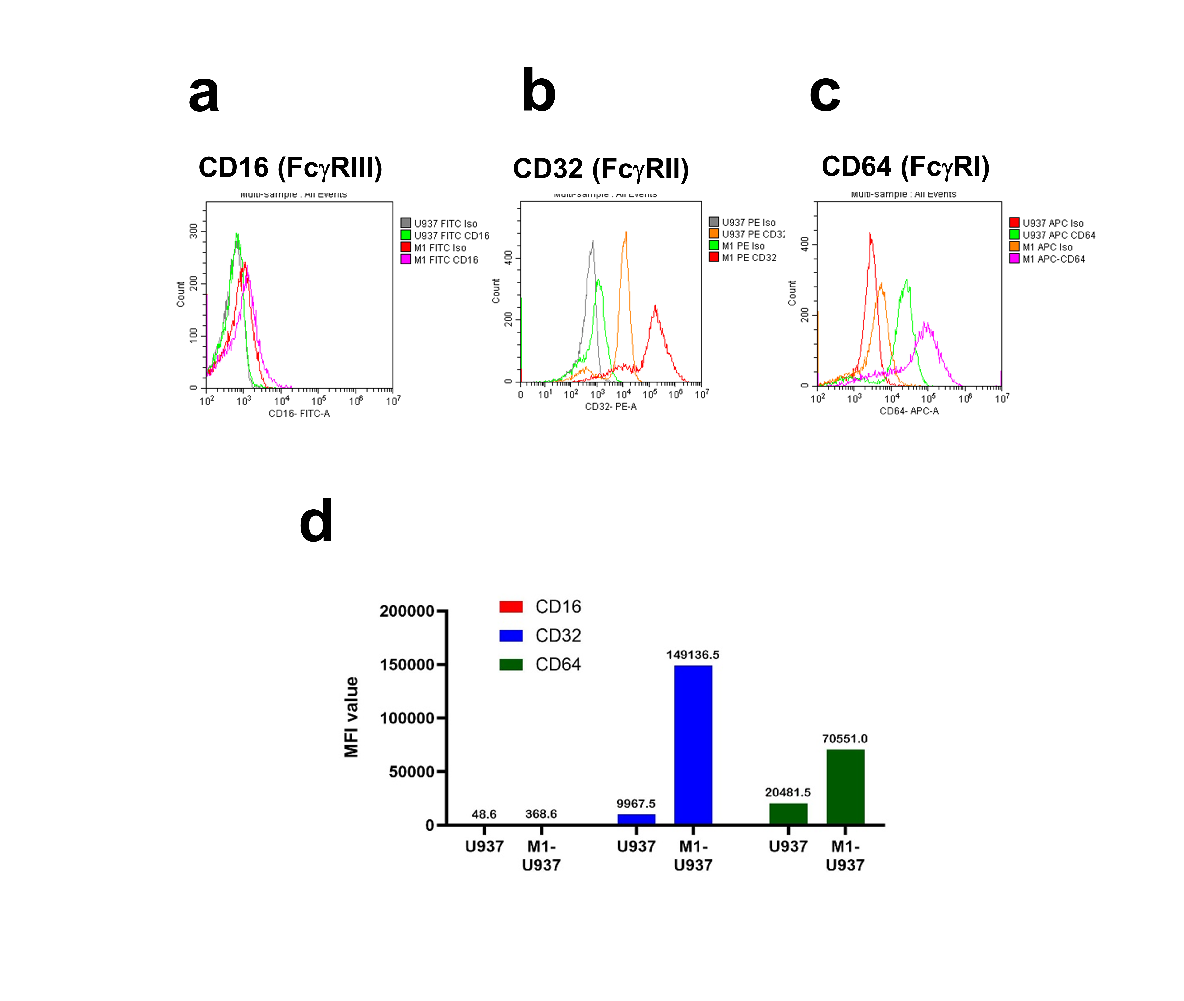
Supplementary Fig. 2: Expression of Fcγ receptors in U937 and differentiated M1-U937 cells. a–c Flow cytometric analysis of CD16 (FcγRIII), CD32 (FcγRII), and CD64 (FcγRI) expression in U937 and M1-U937 cells. d Mean fluorescence intensity (MFI) values showing marked upregulation of CD32 and CD64 in differentiated M1-U937 cells compared with U937 cells. MFI, Mean fluorescence intensity; Fcγ. Fc gamma; CD16, cluster of differentiation 16, CD32, cluster of differentiation 32; CD64, cluster of differentiation 64.

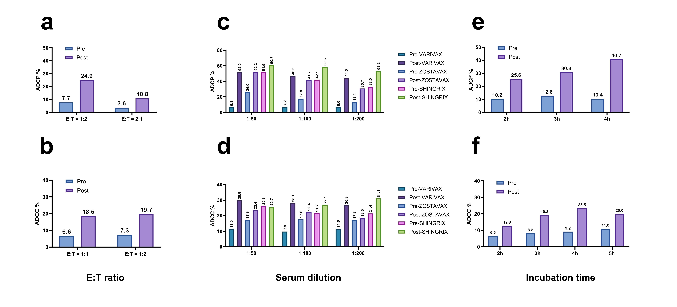

Supplementary Fig. 3: Optimization of ADCP and ADCC assay conditions. a, b Determination of optimal effector-to-target (E:T) cell ratios for (a) ADCP and (b) ADCC assays using pre- and post-vaccination sera. c, d Optimization of serum dilutions for (c) ADCP and (d) ADCC assays. e, f Incubation time optimization for (e) ADCP and (f) ADCC assays. Analyses were performed using paired pre- and post-vaccination sera from participants vaccinated with VARIVAX, ZOSTAVAX, or SHINGRIX. Final assay conditions are summarized in Supplementary Table 1. ADCP, antibody-dependent cellular phagocytosis; ADCC, antibody-dependent cellular cytotoxicity; Pre, pre-vaccination; Post, post-vaccination.

