Supplementary materials
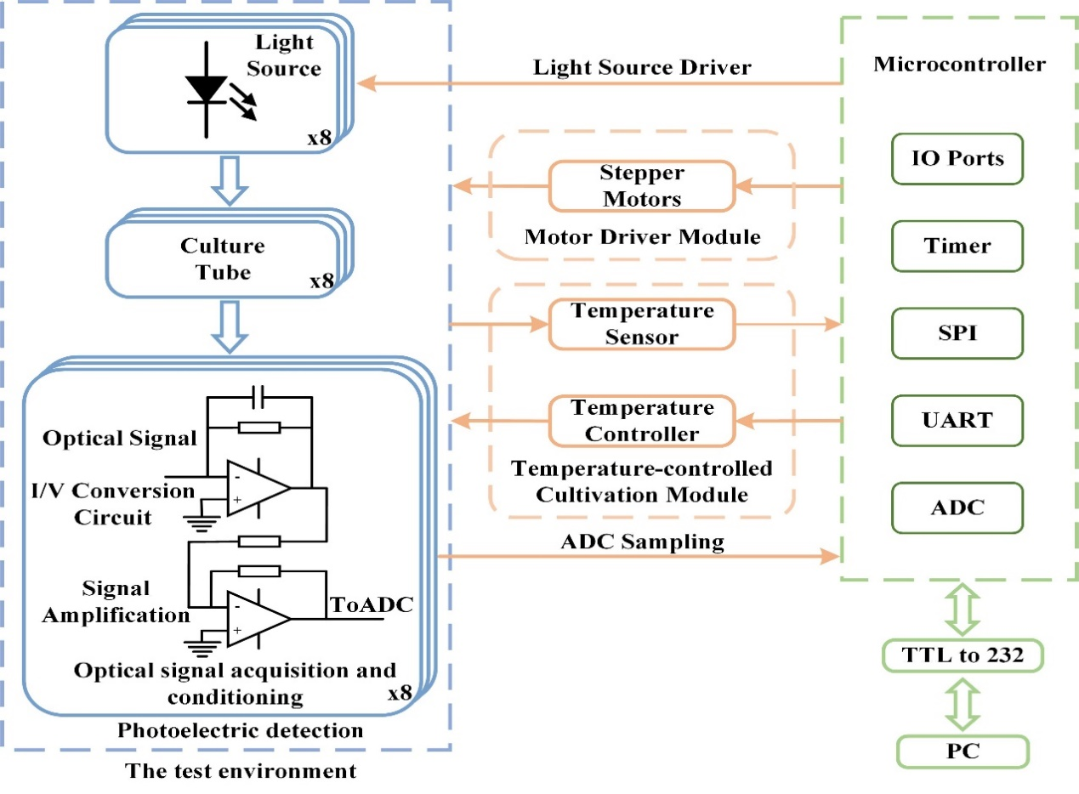

Fig. S1. Control Logic of AR-AST System.
Fig. S2. Hardware composition diagram of AR-AST System.

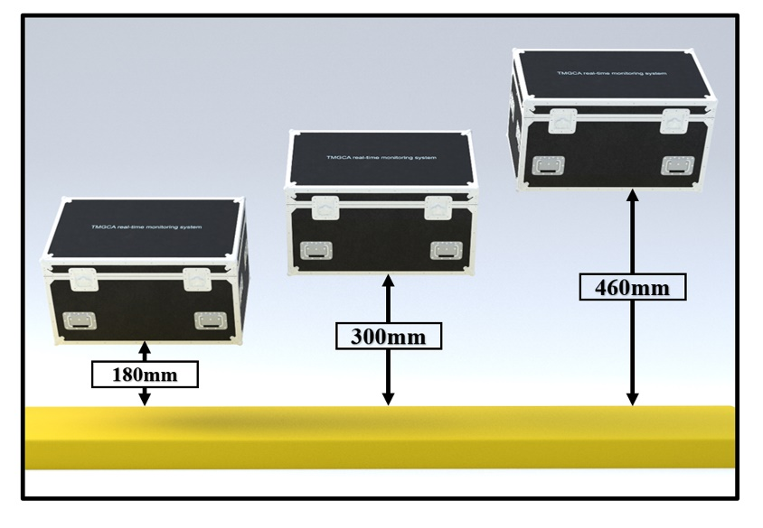

Fig. S3. The anti-interference performance test results of AR-AST System; Schematic diagram of edge drop test
Fig. S4. Comparison results of AR-AST System's anti-interference ability test; Before testing the anti-interference ability, use the system to obtain the growth trend curve of Bacillus subtilis under the same concentration gradient.

Fig. S5. Comparison results of anti-interference ability test of AR-AST system; Before testing the anti-interference ability, use the system to obtain the growth trend curve of Bacillus subtilis at different and the same concentration gradient.
Fig. S6. Comparison results of anti-interference ability test of AR-AST system; Before testing the anti-interference ability, use the system to obtain the linear correlation between the inflection point detection time of Bacillus subtilis at different and the same concentration gradient.

Fig. S7. E. coli 15017 of quantitative standard curve for E. coli 15017 using AR-AST system; Different concentrations of agar plates were cultured and counted.

Table S1. Experimental strain.
Strain name | Strain number
Acinetobacter baumannii | 186
Escherichia coli | 15017
Lactobacillus plantarum | CICC 24936
Micrococcus luteus | CICC 10209
Klebsiella aerogenes | ATCC 13048
Vibrio harveyi | ATCC 14126
Bacillus subtilis | CICC 24713

Table S2. Inoculation culture media for different bacteria
Strain name | Inoculation medium | Antimicrobial susceptibility test medium
Acinetobacter baumannii | LB | MHB
Escherichia coli | LB | LB
Lactobacillus plantarum | LB | /
Micrococcus luteus | LB | /
Klebsiella aerogenes | LB | /
Vibrio harveyi | LB | /
Bacillus subtilis | LB | /

Table S3. Main instruments and their manufacturers used in this experiment.
Instrument Name | Manufacturer
Constant temperature shaker | Shanghai Yiheng Technology Co., Ltd, China
A magnetic stirrer | Aika, Germany
Constant temperature incubator | Shanghai Yiheng Technology Co., Ltd, China
Water bath | Ningbo Xinzhi Technology Biotechnology Co., Ltd, China
PH meter | Leici Shanghai Yidian Scientific Instrument Co., Ltd, China
High-Pressure Steam Sterilization Pot | Shanghai Boxun Medical Biological Instrument Co., Ltd, China
Ultra clean workbench | Suzhou Purification Equipment Co., Ltd, China
Vortex oscillator | Scientific Industries， USA
Ultra pure water system | Milli-Q， USA
Refrigerator | Haier group, China
Ultra low temperature freezer | Haier group, China
Analytical balance | Sadolis, USA
Simulated vibration table for automobile transportation | Xiamen Qunlong Instrument Co., Ltd, China
Constant temperature blast drying oven | Shanghai Jinghong Experimental Equipment Co., Ltd, China
Microwave Oven | Midea, China

Table S4. Antimicrobial susceptibility test execution standard CLSI M100-S32 (E. coli).
Antimicrobial drugs | MIC discount point, ug/mL
Polymyxin B | ≥4
Polymyxin E | ≥4
Kanamycin | ≥64

Table S5. Antimicrobial susceptibility test execution standard CLSI M100-S32 (A. baumannii).
Antimicrobial drugs | MIC discount point, ug/mL
Polymyxin B | ≥4
Polymyxin E | ≥4
Gentamicin | ≥16

