Supplementary Fig. S1. Subcellular localization and secretion activity of PsAvh208. a. Co-localization of PsAvh208 with PsAvh181 under plasmolysis conditions, showing PsAvh208 accumulation in the apoplast. b. Immunoblot analysis of PsAvh208 and PsAvh181 in intracellular and extracellular protein fractions, confirming secretion of PsAvh208. c. Yeast signal sequence trap assay showing that PsAvh208 and PsAvr1d enable yeast growth on YPRAA medium by reducing 2,3,5-triphenyltetrazolium chloride (TTC) to triphenyl formazan (TPF), indicating functional signal peptides.
Supplementary Fig. S2 Generation and phenotypic characterization of PsAvh208 knockout mutants. a. Schematic diagram of PsAvh208 gene knockout using the CRISPR/Cas9 system. Knockout mutants were verified by PCR using primers F and R. b. PCR validation of PsAvh208 knockout transformants. c. Comparison of mycelial growth rates among PsAvh208 knockout mutants, wild-type, and control strains. Images were taken after 5 days of growth on V8 medium.
d. Measurement of mycelial colony diameter on V8 medium. e. Quantification of oospore production induced by P. sojae. Data in d and e are presented as mean ± standard deviation (s.d.). P values were calculated using a two-tailed unpaired Student’s t-test. Three independent biological experiments produced similar results.

Supplementary Fig. S3 Verification of PsAvh208 protein expression in plants. a. Western blot analysis of RFP (EV) and RFP–PsAvh208 expression in transgenic soybean hairy roots. b. Western blot analysis of GFP and GFP–PsAvh208 expression in N. benthamiana leaves.

Supplementary Fig. S4 Phylogenetic analysis of PIP2 homologs in Arabidopsis thaliana, Nicotiana benthamiana, and Glycine max. A maximum-likelihood phylogeny was constructed from full-length protein sequences, revealing the evolutionary relationship of GmPIP2;6 with its homologs in A. thaliana and N. benthamiana.

Supplementary Fig. S5 Molecular dynamics simulation of the GmPIP2;6 tetramer. a. Construction of the tetrameric protein–lipid bilayer system. A POPE bilayer (120 Å × 120 Å) was built using the Bilayer Builder module, with the tetrameric GmPIP2;6 protein embedded at the center and a 0.4 mmol/L K⁺/Cl⁻ ionic concentration added. b. Root mean square deviation (RMSD) of the channel protein over the course of the simulation. c. Average root mean square fluctuation (RMSF) values for residues within the tetrameric channel protein. d. Definition of the interface based on the geometric midpoint between the terminal carbon atoms of the Ile93 and Val112 side chains. e. Definition of the interface based on the geometric midpoint between the aromatic carbon atoms of the Phe212 side chains from two adjacent monomers.

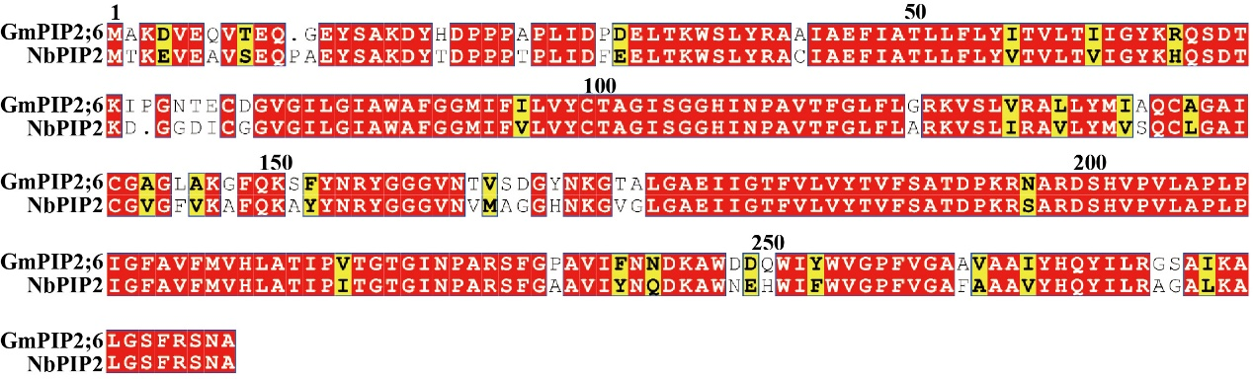
Supplementary Fig. S6 Sequence alignment of GmPIP2;6 and its homologs in N. benthamiana. Sequence alignment showing the high similarity between soybean GmPIP2;6 and its homologous aquaporin sequences in N. benthamiana. Conserved residues are indicated, highlighting structural and functional conservation across species.
Supplementary Fig. S7 Functional analysis of GmPIP2;6 and its homolog NbPIP2;6 in regulating susceptibility to infection. a.b. Quantitative RT–PCR analysis of GmPIP2;6 expression in soybean hairy roots expressing RFP (EV), RFP–GmPIP2;6, or RFP–GmPIP2;6–RNAi. c. Phenotypic observation of Nicotiana benthamiana plants after silencing the GmPIP2;6 homolog (NbPIP2;6). d. Quantitative RT–PCR analysis of NbPIP2;6 expression levels in control and NbPIP2;6-silenced N. benthamiana leaves. e. Infection assay of Phytophthora capsici on NbPIP2;6-silenced leaves, photographed under UV light at 36 h post-inoculation. f. Statistical analysis of lesion diameter caused by P. capsici. g. Quantitative measurement of P. capsici biomass in infected leaves by qPCR. h. Representative UV images showing water-soaked lesions on NbPIP2;6-silenced and GFP control N. benthamiana leaves at 36 h post-inoculation under high humidity. i. Quantification of water-soaked lesion length under high-humidity infection conditions. j. Quantitative analysis of P. capsici biomass in leaves under high-humidity infection conditions. k. Infection assay of P. capsici on NbPIP2;6-silenced N. benthamiana leaves transiently expressing GFP or GFP–GmPIP2;6–Mono, imaged under UV light after water soaking. l. Statistical analysis of lesion diameter following P. capsici infection in GFP- or GFP–GmPIP2;6–Mono–expressing leaves. m. Quantitative analysis of P. capsici biomass in GFP- or GFP–GmPIP2;6–Mono–expressing leaves after infection.Data in (a, b, d, f, g, i, j, l, m) are presented as means ± standard deviation (s.d.). P values were calculated using a two-tailed unpaired Student’s t-test. All experiments were repeated three times with similar results.

Supplementary Fig. S8 Identification and functional validation of key residues required for GmPIP2;6 homomeric interaction. a. Structural prediction of GmPIP2;6 homomeric interaction sites using AlphaFold3. Different regions are shown in distinct colors: pink and blue represent two GmPIP2;6 monomers, and purple indicates the predicted interaction interface. b. Yeast two-hybrid (Y2H) assay showing that mutation of key residues disrupts the interaction between GmPIP2;6 and the monomeric mutant GmPIP2;6–Mono. c. Co-immunoprecipitation (Co-IP) assay confirming that GmPIP2;6–Mono fails to interact with GmPIP2;6 in plant cells. d. Split-luciferase complementation assay demonstrating loss of interaction between GmPIP2;6 and GmPIP2;6–Mono.These results collectively verify that the identified residues are essential for GmPIP2;6 tetramer formation.

