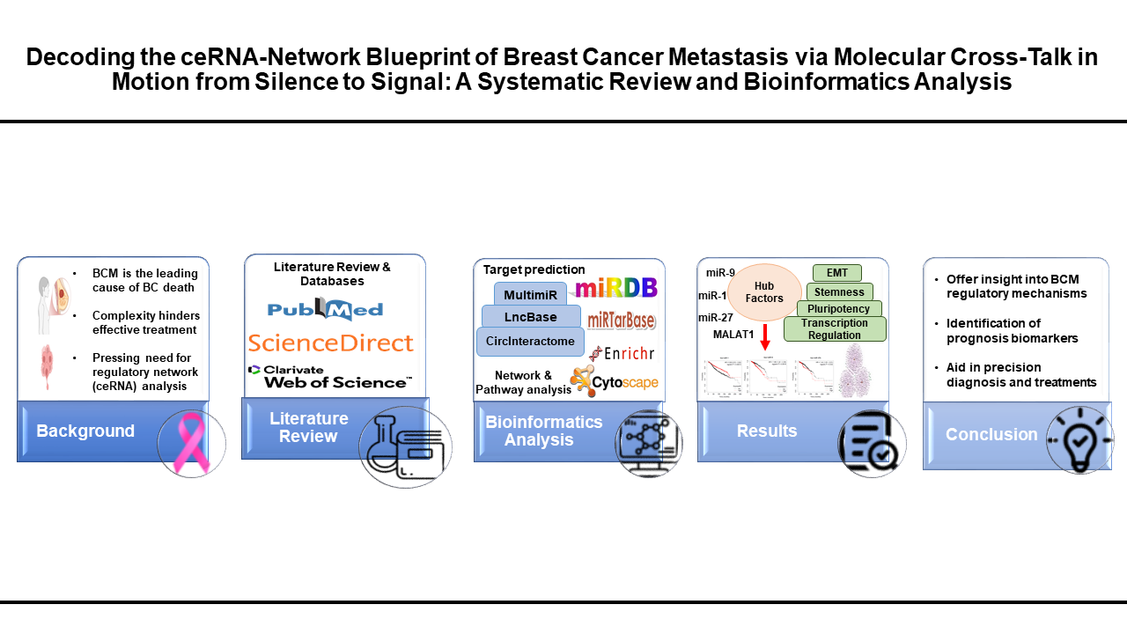
Graphical Abstract:

An integrative overview of the study workflow exploring the regulatory ceRNA network in BCM. The process includes a literature review from major databases, bioinformatics analysis using target prediction and pathway enrichment tools, and identification of key hub ncRNAs associated with poor prognosis. Results provide insights into transcriptional regulation, stemness, and EMT, offering potential biomarkers for prognosis and strategies for precision therapy.

