Scientific Reports

Predicting Potential Habitats of the Endangered Suweon Treefrog (Dryophytes suweonensis) under Climate Change Scenarios Using an Ensemble Ecological Niche Model

Nakyung Yoo^{1,2,†}, Dae-Seong Lee^{2,†}, Jeongwoo Yoo¹, Kwan-Ik Kwon¹, Chang-Deuk Park¹, Ju-Duk Yoon^{1,*}, Young-Seuk Park^{2,}*
¹Restoration Research Team (Fishes/Amphibians & Reptile), Research Center for Endangered Species, National Institute of Ecology, Yeongyang 36531, Republic of Korea
²Department of Biology, Kyung Hee University, Seoul 02447, Republic of Korea

† These authors contributed equally to this work.

* Correspondence:
E-mail:grandblue@nie.re.kr (J.-D.Y.), parkys@khu.ac.kr (Y.-S.P.)
Tel.: +82-54-680-736
Fax: +82-54-680-7329

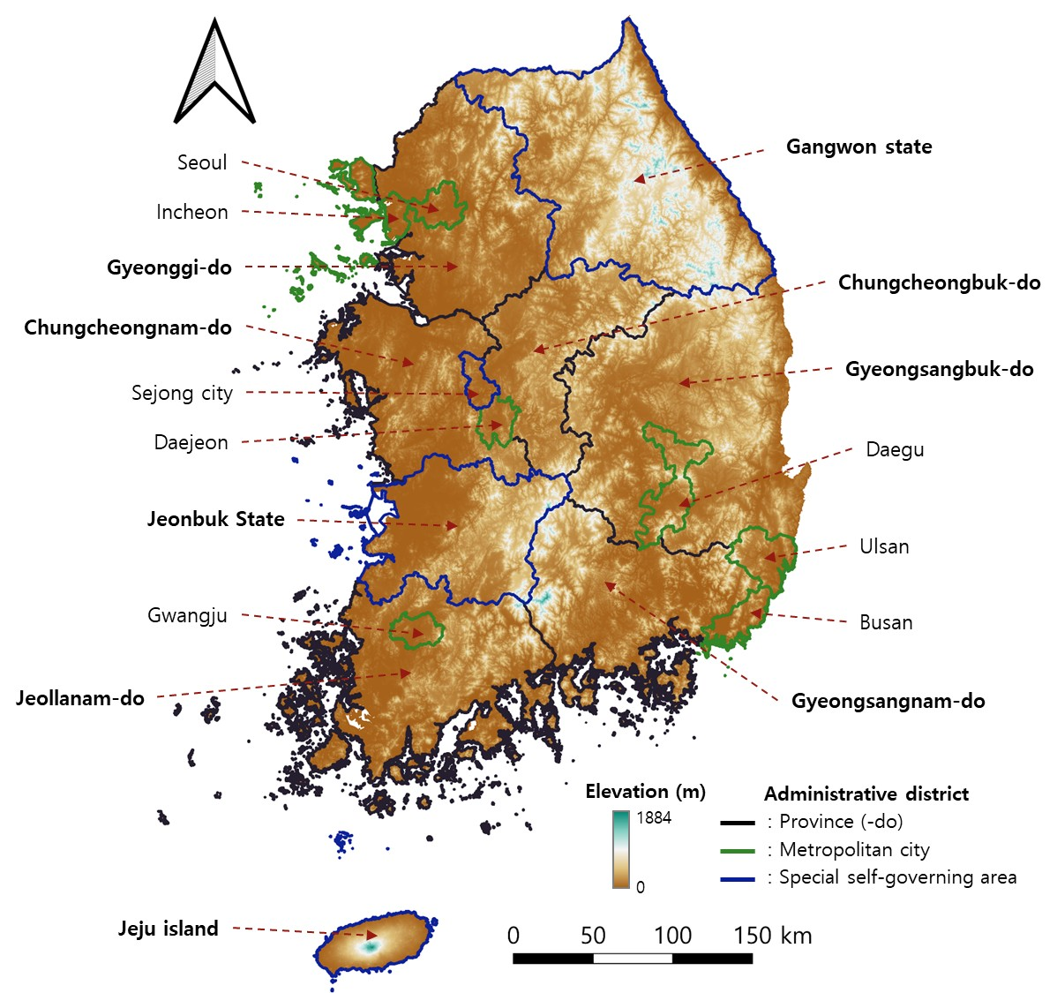
Supplementary Figure 1 The map of South Korea, showing the administrative districts at the si, gun, and gu levels, which correspond to cities, counties, and districts

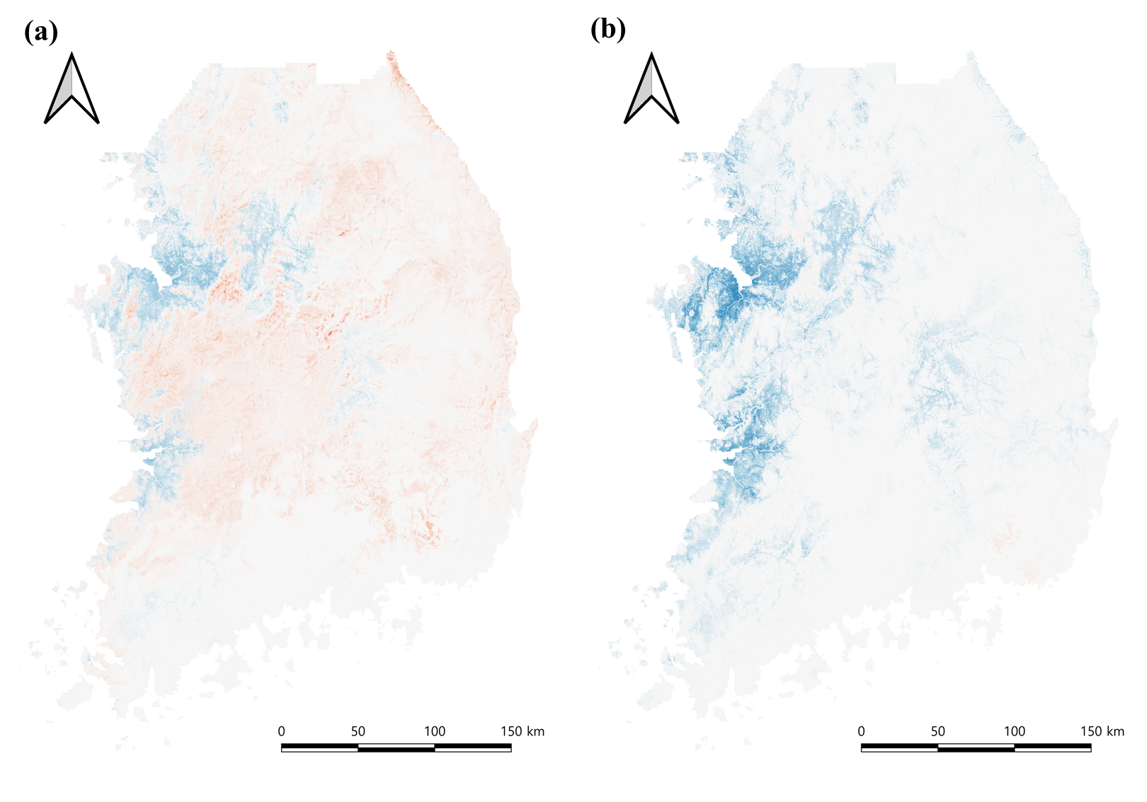
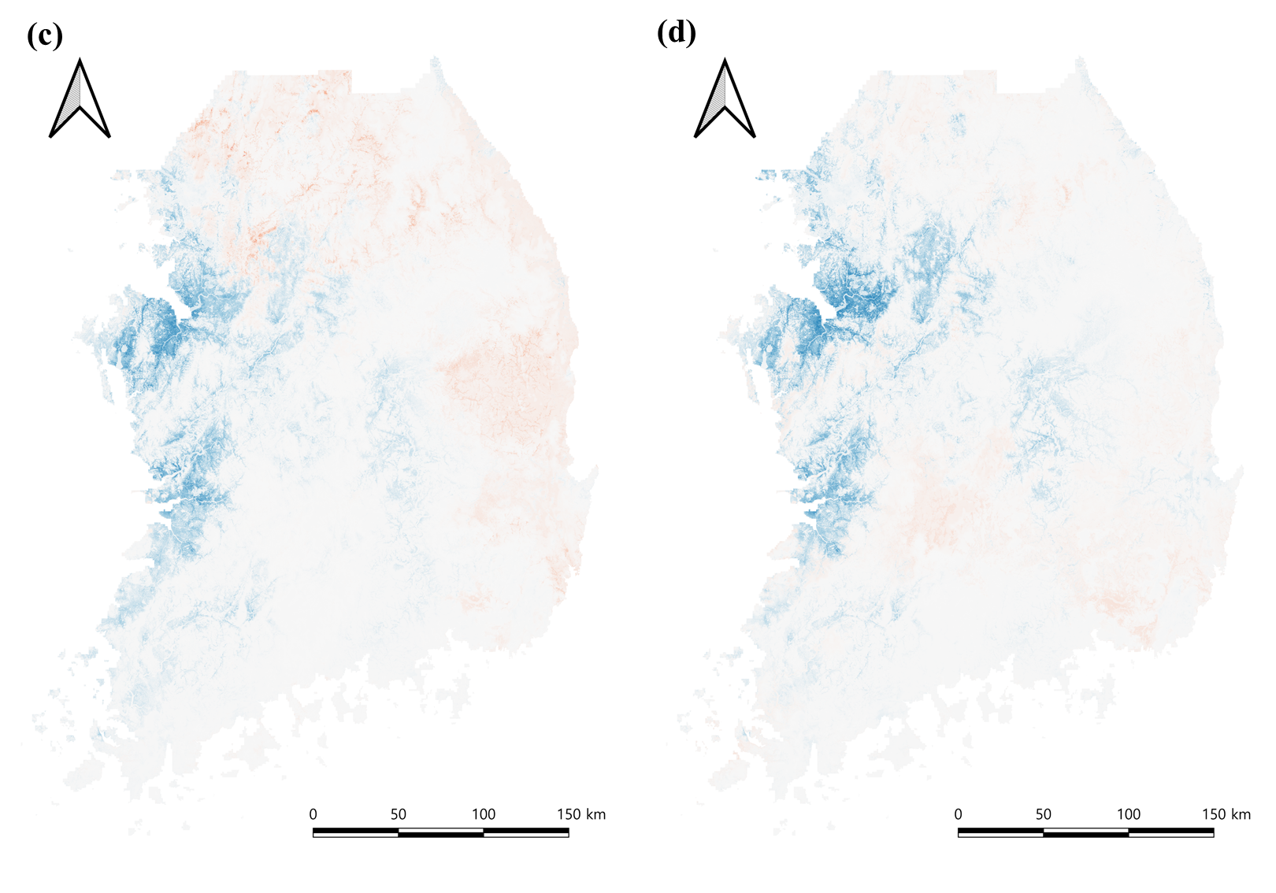
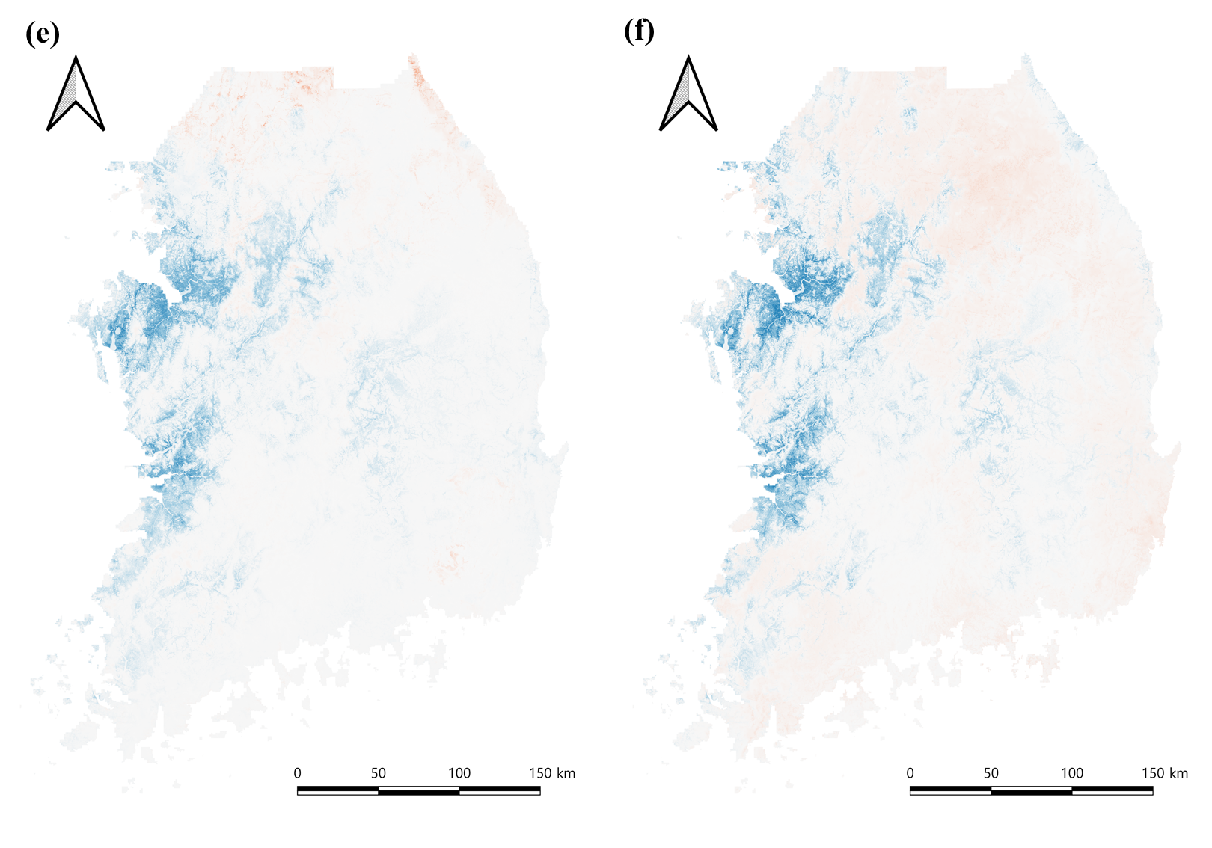
Supplementary Figure 2. Differences between the current and future potential habitats of the Suweon treefrog predicted under climate change scenarios with (a-b) SSP 1-2.6, (c-d) SSP3-7.0, (d-e) SSP5-8.5, (a, c, e) 2050s and (b, d, f) 2080s. The Redder the area, the higher the future habitat suitability; the bluer the area, the greater the current suitability.

No. | Authors,  year of publication | No. of Study Location | No. of presence sites | No. of absence sites | Title
1 | Borzée et al., 2017 | 2 | 0 | 2 | Impact of land reclamation and agricultural water regime on the distribution and conservation status of the endangered Dryophytes suweonensis
2 | Borzée et al., 2013 | 7 | 5 | 2 | Morphometrics of two sympatric species of tree frogs in Korea: a morphological key for the critically endangered Hyla suweonensis in relation to H. japonica
3 | Jang et al., 2011 | 7 | 5 | 2 | Geographic Variation in Advertisement Calls in a Tree Frog Species: Gene Flow and Selection Hypotheses
4 | Park et al., 2013 | 7 | 5 | 2 | No reproductive character displacement in male advertisement signals of Hyla japonica in relation to the sympatric H. suweonensis
5 | Koo et al., 2022 | 1 | 1 | 0 | A REPORT ON THE LARGEST POPULATION OF A CRITICALLY ENDANGERED TREEFROG, Dryophytes suweonensis, IN REPUBLIC OF KOREA
6 | National Institue of Biological Resources, 2013 | 42 | 42 | 0 | Final Research Report on the Conservation Breeding and Restoration of Dryophytes suweonensis, an Endangered Species (Ⅰ)
7 | National Institue of Biological Resources, 2013 | 102 | 24 | 78 | Final Research Report on the Conservation Breeding and Restoration of Dryophytes suweonensis, an Endangered Species (Ⅱ)
8 | Park et al., 2021 | 1 | 1 | 0 | Defining Conservation Requirements for the Suweon Treefrog (Dryophytes suweonensis) Using Species Distribution Models
9 | Rahman et al., 2023 | 5 | 5 | 0 | Population-level call properties of endangered Dryophytes suweonensissensu lato (Anura: Amphibia) in South Korea
10 | Borzée et al., 2016 | 6 | 6 | 0 | Asymmetric competition over calling sites in two closely related treefrog species
11 | Borzée et al., 2018 | 37 | 37 | 0 | Introduced bullfrogs are associated with increased Batrachochytrium dendrobatidis prevalence and reduced occurrence of Korean treefrogs
12 | Borzée et al., 2018 | 17 | 14 | 3 | Variations in boldness, behavioural and physiological traits of an endangered and a common hylid species from Korea
13 | Amaël and Yikweon, 2018 | 1 | 1 | 0 | INTERFERENCE COMPETITION DRIVEN BY HYDRIC STRESS IN KOREAN HYLIDS
14 | Ham, 2014 | 1 | 1 | 0 | Morphology, Age Structure and Mating Call Characteristics of Japanese tree frog (Hyla Japonica) and Suweon tree frog (Hyla Suweonensis)
15 | Andersen et al., 2023 | 93 | 90 | 3 | Influence of landscape and connectivity on anuran conservation: population viability analyses to designate protected areas
Supplementary Table 1. Summary of references on the Suweon Treefrog since 2000

Administrative regions | Threshold values
Administrative regions | Unsuitable |  |  | Suitable |  |  |  | Highly suitable
Administrative regions | [0-0.1) | [0.1-0.2) | [0.2-0.296) | [0.296-0.3) | [0.3-0.4) | [0.4-0.5) | [0.5-0.6) | [0.6-0.7) | [0.7-0.8) | [0.8-0.9) | [0.9-1]
South Korea | 73989.83 | 5528.603 | 2741.085 | 88.068 | 1766.635 | 1222.76 | 895.349 | 704.645 | 546.399 | 328.324 | 74.659
Seoul | 589.978 | 7.093 | 5.633 | 0.226 | 6.853 | 4.526 | 2.13 | 1.505 | 0.385 | 0 | 0
Busan | 685.283 | 28.299 | 0.008 | 0 | 0 | 0 | 0 | 0 | 0 | 0 | 0
Daegu | 842.385 | 29.398 | 12.819 | 0.357 | 3.296 | 0 | 0 | 0 | 0 | 0 | 0
Incheon | 293.302 | 8.487 | 13.39 | 0.73 | 20.14 | 22.199 | 16.495 | 12.454 | 3.288 | 0.004 | 0
Gwangju | 437.853 | 31.948 | 26.085 | 1.52 | 6.477 | 0.013 | 0 | 0 | 0 | 0 | 0
Daejeon | 492.071 | 38.179 | 10.869 | 0.157 | 2.929 | 1.893 | 0.289 | 0 | 0 | 0 | 0
Ulsan | 1021.803 | 18.339 | 3.139 | 0 | 0 | 0 | 0 | 0 | 0 | 0 | 0
Sejong | 355.12 | 59.095 | 28.247 | 0.627 | 10.337 | 6.269 | 6.241 | 1.904 | 0.143 | 0 | 0
Gyeonggi-do | 6188.357 | 679.289 | 440.364 | 17.906 | 432.716 | 358.364 | 260.856 | 185.482 | 137.822 | 110.069 | 21.727
Gangwon state | 12984.68 | 368.985 | 143.129 | 3.651 | 62.776 | 26.566 | 10.698 | 3.924 | 1.665 | 0.001 | 0
Chungcheongbuk-do | 6195.064 | 531.564 | 298.983 | 9.802 | 191.735 | 111.814 | 72.676 | 33.954 | 7.131 | 0.073 | 0
Chungcheongnam-do | 4432.233 | 847.781 | 519.117 | 19.395 | 436.035 | 370.379 | 312.095 | 284.382 | 259.332 | 185.977 | 52.932
Jeonbuk State | 5814.752 | 573.312 | 331.497 | 11.696 | 261.602 | 226.374 | 202.79 | 180.373 | 136.633 | 32.2 | 0
Jeollanam-do | 7746.29 | 706.567 | 333.896 | 9.103 | 140.168 | 35.713 | 5.81 | 0.369 | 0 | 0 | 0
Gyeongsangbuk-do | 16939.19 | 1271.317 | 483.447 | 12.149 | 186.91 | 58.65 | 5.269 | 0.298 | 0 | 0 | 0
Gyeonsangnam-do | 8971.47 | 328.95 | 90.462 | 0.749 | 4.661 | 0 | 0 | 0 | 0 | 0 | 0
Supplementary Table 2. Area by province according to the suitability of Suweon treefrog habitat

